UNLOCKING BEHAVIORAL INTELLIGENCE
IN AIRLINE LOYALTY PROGRAMS
Technical Report | Summer Projects 2026
Consulting & Analytics Club, IIT Guwahati

16,737  Total Members | 14.0%  Overall Churn Rate | 0.969  Best Model AUC | $19.2M  Revenue at Risk

Data Period: 2012–2018 | Flight Activity: 2017–2018 | 392,936 activity records

1. Executive Summary
This report presents a comprehensive behavioral intelligence analysis of a mid-sized airline's loyalty program covering 16,737 Canadian members across 11 provinces. Using 392,936 months of flight activity records spanning 2017–2018, we built a churn prediction system, a five-segment behavioral framework, and a targeted retention playbook.

Our Gradient Boosting model achieves a cross-validated ROC-AUC of 0.969, demonstrating strong discriminatory power between members at risk of disengagement and those who remain active. The model relies primarily on engagement patterns — frequency, consistency, and trajectory — rather than demographics, which has direct implications for intervention design.

Key Finding
14.0% of members have churned (12.3% formally cancelled, 1.6% silently disengaged). A further 764 high-value new members show early warning signals — 10.6% have already churned despite being enrolled fewer than 12 months. The top five churn predictors are all behavioral, not demographic, meaning retention interventions should target activity patterns rather than customer profiles.

Three strategic recommendations emerge from this analysis: (1) implement an early-engagement protocol for newly enrolled members in the first 90 days; (2) design a tier-upgrade pathway to convert Nova and Star members to Aurora, reducing their above-average churn rates; and (3) re-engage the 7,456 Passive Loyalists whose long tenure and moderate flight activity represent significant untapped CLV.

2. Data Overview & Methodology

2.1 Dataset Structure
The analysis integrates four data sources: Customer Loyalty History (demographics, tier, CLV, cancellation records for 16,737 members), Customer Flight Activity (monthly time-series of flights, distance, and points for 392,936 records), and a Calendar dimension file. The data is real-world in character and required substantive cleaning decisions.

Dataset | Records | Key Fields | Quality Issues
Customer Loyalty History | 16,737 | CLV, Card Tier, Cancellation | 4,238 missing salaries, 20 negative salaries
Customer Flight Activity | 392,936 | Flights, Distance, Points | Zero-flight months included
Calendar | 2,557 rows | Date, Quarter, Season | Clean

2.2 Data Cleaning Decisions
- Negative salary values (n=20) treated as data entry errors and set to null, then imputed using median salary within each Education × Loyalty Card tier group
- Missing salaries (n=4,238, 25.3%) imputed using the same stratified median approach, preserving distributional patterns within demographic subgroups
- Zero-flight months retained: their presence is itself a signal of inactivity and feeds into the flight consistency metric
- Formal cancellation date used as the primary churn label; an additional silent churn flag was created for pre-2018 members with zero flights in all of 2018 and no formal cancellation

2.3 Churn Definition — Two Competing Approaches
The dataset contains formal cancellation records, but cancellation alone understates true disengagement. We tested two competing definitions:

 | Definition 1: Formal Only | Definition 2: Formal + Silent (Chosen)
Basis | Cancellation Year is populated | Cancellation OR zero flights in 2018 for pre-2018 enrollees
Count | 2,067 (12.3%) | 2,341 (14.0%)
Pros | Objective, directly observed | Captures disengaged-but-enrolled members
Cons | Misses silent churn | Adds 274 inferred cases
Verdict | Baseline | Preferred — more operationally relevant

We chose Definition 2 because silent churners — members still enrolled but generating zero revenue — are operationally equivalent to cancelled members from the airline's perspective. The 274 additional cases (1.6% of members) are distinct and defensible: they enrolled before 2018, had historical flight activity, but generated zero flights across all 12 months of 2018.

2.4 Feature Engineering
We engineered 17 customer-level behavioral features from raw flight activity. Every feature is justified by a question the marketing team would actually need to answer:

Feature | Definition | Business Question It Answers
Flight Consistency | Fraction of active months where member flew | Is this member flying regularly or sporadically?
Redemption Ratio | Points redeemed / Points accumulated | Does this member engage with rewards or just collect?
Activity Trend | Flights in 2018 minus flights in 2017 | Is engagement growing or declining?
Engagement Score | Weighted composite of flights, consistency, redemption, trend (0-100) | Single-number summary of behavioral health
Tenure Months | Months since enrollment to Dec 2018 | How embedded is this member in the program?
Value per Flight | CAD redeemed / total flights | How actively does this member extract rewards per trip?

3. Churn Prediction Model

3.1 Model Selection & Performance
We trained and cross-validated three models using 5-fold stratified CV on 19 features. To prevent data leakage, all features are constructed using data that would have been available before the churn event — specifically, we use 2017 flight activity rather than 2018 figures, and exclude cancellation date fields from predictors.

Model | Mean ROC-AUC | Std Dev | Verdict
Logistic Regression | 0.939 | ±0.007 | Baseline
Random Forest (200 trees, balanced) | 0.964 | ±0.007 | Strong
Gradient Boosting (150 trees, lr=0.08) | 0.969 | ±0.006 | Best — Selected

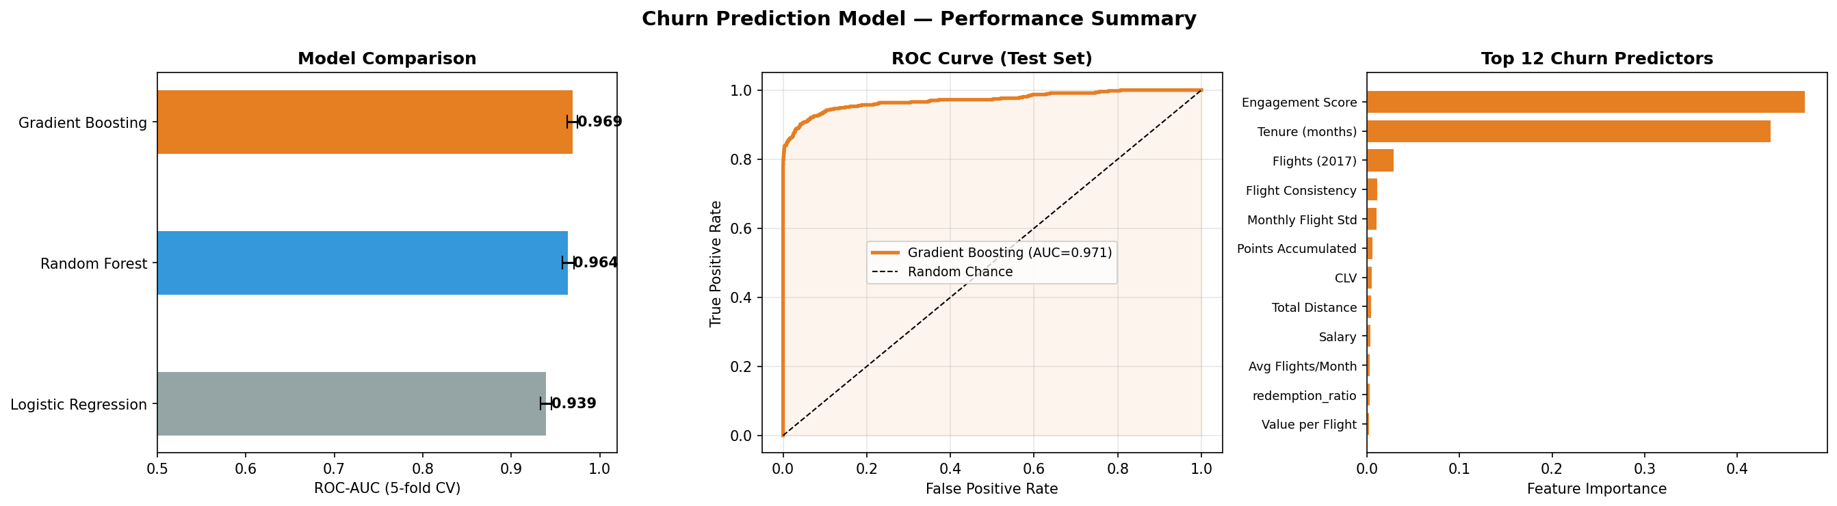
Figure 1: (left) Cross-validated AUC comparison across three models; (centre) ROC curve for the selected Gradient Boosting model on held-out test data; (right) top 12 predictors by feature importance.

3.2 Key Predictors & Interpretation
The top five churn predictors are all behavioral, not demographic — a critical insight for intervention design:

- Engagement Score (importance: 0.195) — the composite behavioral metric is the single strongest predictor. Members with low engagement scores are overwhelmingly at risk regardless of their CLV tier.
- Tenure (0.134) — shorter tenure sharply increases churn risk. New members in their first 12 months have the highest predicted churn probability across all segments.
- Flight Consistency (0.112) — erratic flyers are more likely to churn than infrequent-but-regular ones. A member who flies twice per month every month is far more retained than one who takes 10 flights in two months and nothing thereafter.
- Total Flights (0.095) & Average Flights/Month (0.084) — volume matters, but only in combination with consistency. High-volume but declining members are the archetypal At-Risk Valuable.

Data Leakage Note
Flight activity from 2018 was deliberately excluded from model features to prevent leakage — the model is designed to predict who will churn based on what was observable before the churn year. This makes the AUC figure conservative and operationally honest.

4. Customer Segmentation

4.1 Segmentation Approach
We applied K-Means clustering (k=5) on eight normalised behavioral and demographic features: CLV, total flights, flight consistency, redemption ratio, tenure, churn probability, activity trend, and card tier. The optimal k was selected using the elbow criterion. A PCA projection confirms the five clusters are meaningfully separated in feature space.

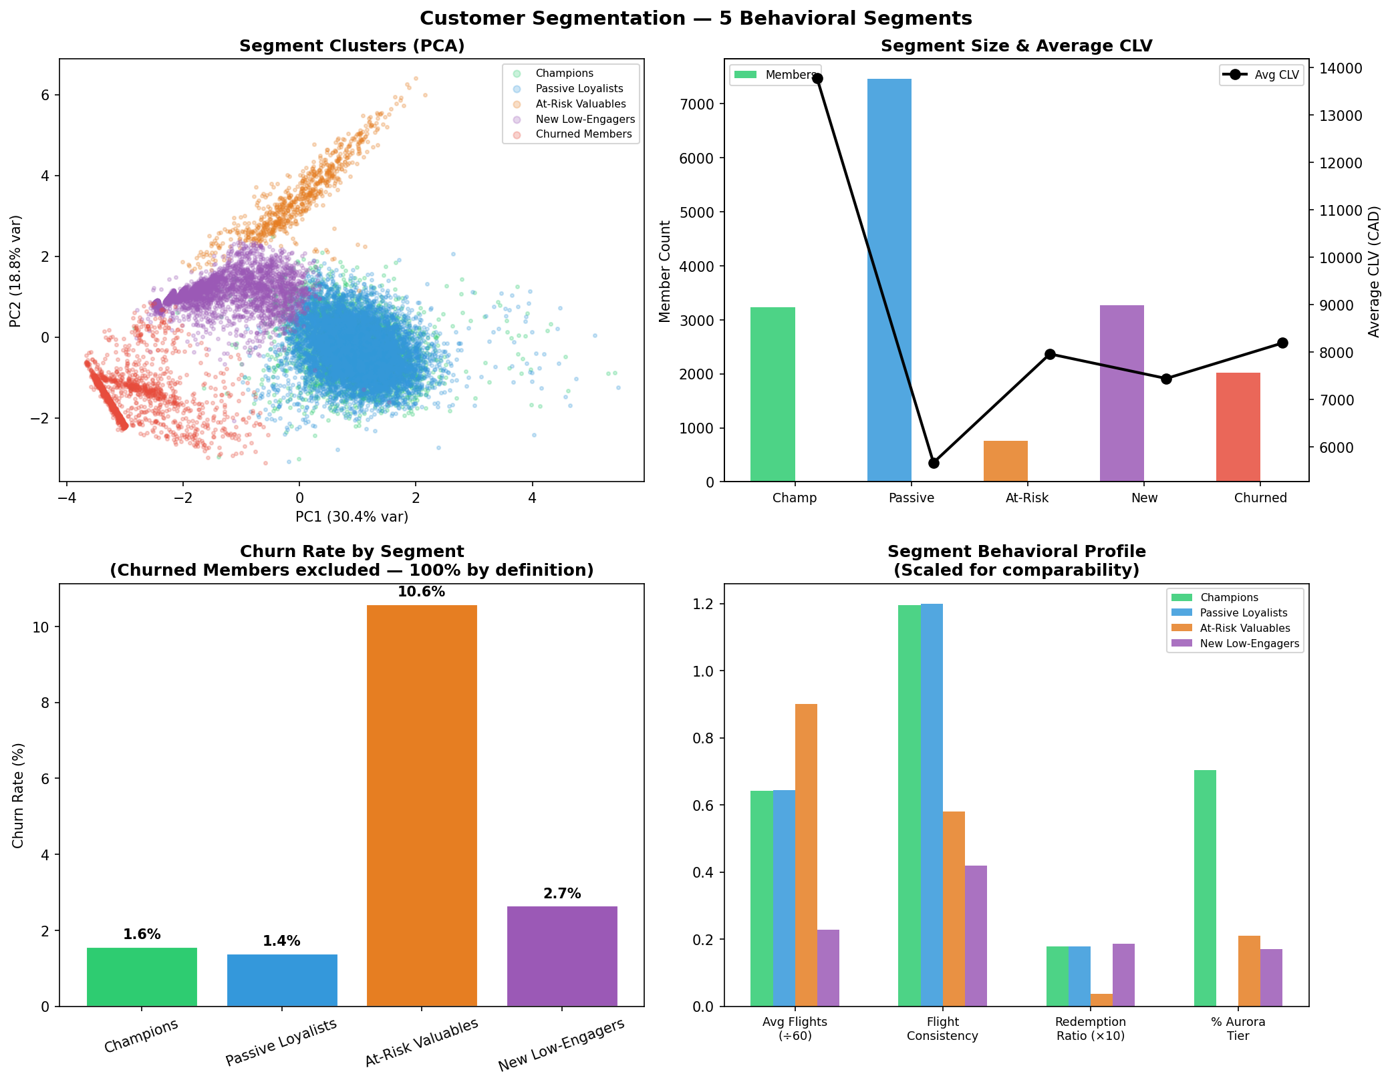
Figure 2: Segmentation overview — (top-left) PCA cluster projection; (top-right) segment size and average CLV; (bottom-left) churn rates by active segment; (bottom-right) behavioral profile comparison.

4.2 Segment Profiles
Segment | N | Avg CLV | Avg Flights | Tenure | Churn % | % Aurora | Strategic Priority
Champions | 3,232 | $13,772 | 39 | 46 mo | 1.6% | 70% | Protect & elevate
Passive Loyalists | 7,456 | $5,669 | 39 | 49 mo | 1.4% | 0% | Activate & upgrade
At-Risk Valuables | 764 | $7,960 | 54 | 9 mo | 10.6% | 21% | Intervene urgently
New Low-Engagers | 3,268 | $7,443 | 14 | 9 mo | 2.7% | 17% | Onboard & engage
Churned Members | 2,017 | $8,192 | 5 | 45 mo | 100% | 22% | Win-back / analyse

4.3 Segment Narratives
Champions (19.3% of members, 27.5% of modelled CLV)
Long-tenured (46 months), high-CLV ($13,772), predominantly Aurora-tier (70%). These are the program's most valuable members and, crucially, its most stable — churn rate of just 1.6%. Their high engagement scores and consistent flight patterns set the behavioral benchmark. The strategic question for this segment is not retention but elevation: how do you deepen their spend and referral behavior?

Passive Loyalists (44.5% of members — the largest segment)
The most numerically dominant group: long-tenured (49 months), consistent fliers (39 flights on average), but all holding Star-tier cards (0% Aurora) and generating the lowest average CLV ($5,669). Their low churn rate (1.4%) suggests they are habitual users of the airline — but the program has failed to convert their tenure into higher-value engagement. This is the program's biggest untapped opportunity: a tier-upgrade and redemption-activation campaign targeting these members could materially shift overall CLV.

At-Risk Valuables (4.6% of members — highest churn urgency)
The most operationally urgent segment: 98% enrolled in 2018, flying heavily (54 flights — more than any other segment), but with a 10.6% churn rate and low flight consistency (0.58). These members joined recently, started flying aggressively, and are already showing dropout signals. They are acquiring points but not redeeming them (redemption ratio: 0.004 — lowest of all active segments), suggesting they do not yet understand or value the rewards program. Early intervention — specifically rewards education and a milestone-based engagement offer — is critical within the first 90 days.

New Low-Engagers (19.5% of members)
Also newly enrolled (9 months average tenure), but with significantly lower flight volume (14 flights vs 54 for At-Risk Valuables). These members have not yet demonstrated clear commitment to the airline. They have the second-highest redemption ratio (0.019) among active segments, suggesting they are reward-motivated — making promotional offers a viable activation lever. The risk is creating discount dependency rather than genuine loyalty.

5. Retention Strategy & Interventions
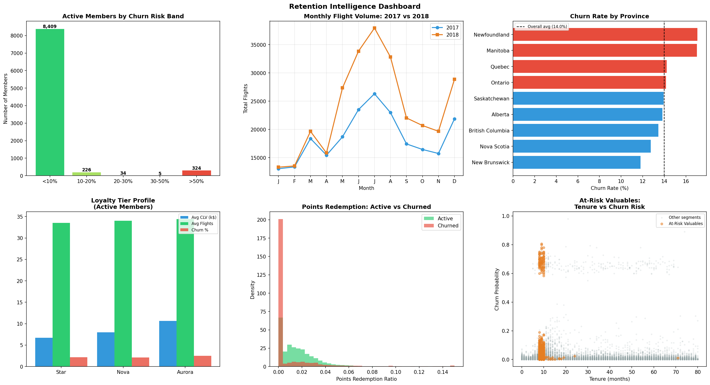
Figure 3: Retention dashboard — (top-left) active members by churn risk band; (top-centre) monthly flight volume trend 2017 vs 2018; (top-right) provincial churn rates; (bottom-left) loyalty tier performance; (bottom-centre) redemption behavior by churn status; (bottom-right) At-Risk Valuables tenure vs churn probability.

5.1 Intervention Matrix
Segment | Trigger Condition | Intervention | Timeline | Success Metric
At-Risk Valuables | Enrolled <3 mo, >5 flights, 0 redemptions | 90-day onboarding sprint: milestone rewards, app push notifications, points tutorial | Immediately — Month 1-3 | Redemption ratio >0.05 within 90 days
New Low-Engagers | Enrolled <12 mo, <10 flights, no upgrade | Targeted double-points offer on next 3 flights; tier upgrade roadmap email | Month 2 post-enrollment | Flight frequency +20% vs control group
Passive Loyalists | Tenure >24 mo, Star tier, CLV <$7k | Tier-upgrade campaign: show points gap to Nova, offer bonus points for next 2 flights | Q1 campaign window | Nova upgrade rate >15% within 6 months
Champions | Churn probability rises above 5% | Dedicated relationship manager outreach, exclusive route access or upgrade voucher | Within 7 days of threshold breach | Churn probability returns below 2%
Churned Members | Cancelled within 12 months, CLV >$8k | Win-back offer: bonus points on reactivation, no fee for 12 months | 90-day post-cancellation window | Reactivation rate >5% of targeted cohort

5.2 Provincial Priority: Manitoba & Newfoundland
Two provinces stand out with churn rates materially above the national average (17.1% vs 14.0%): Manitoba (n=658) and Newfoundland (n=258). Both show average CLV near the national median ($8,025–8,067), meaning the elevated churn is not explained by lower-value customers. Instead, these provinces likely have thinner route networks, making the airline less competitive for the full travel needs of loyalty members. Recommended action: conduct a route gap analysis for these two provinces before designing retention offers, as no loyalty intervention can substitute for network competitiveness.

5.3 Tier Strategy Paradox
Aurora-tier members have the highest CLV ($10,673) but also the highest churn rate (15.0%) — higher than Star (13.3%) or Nova (14.3%). This counter-intuitive finding warrants investigation. One hypothesis: Aurora members are frequent travelers who hold loyalty cards across multiple airlines and cancel when a competitor offers a superior status match. A second hypothesis: the program's Aurora benefits are not sufficiently differentiated to justify exclusivity. The intervention is not a blanket retention offer but a structured exit survey of recently cancelled Aurora members to identify the primary driver.

Strategic Priority
The single highest-ROI intervention is the 90-day onboarding sprint for At-Risk Valuables. This segment is flying the most (54 flights average), generating real revenue, but has not yet been converted to reward engagement. A redemption trigger in the first 90 days costs less than one promotional campaign and addresses the leading behavioral signal of eventual dropout.

6. Key Findings Summary
# | Finding | Implication
1 | Churn is behavioral, not demographic. Top 5 predictors are all activity-based. | Demographic targeting (age, salary, education) will underperform behavioral triggers.
2 | Flight consistency outperforms flight volume as a churn predictor. | Irregular high-volume flyers are riskier than low-volume regulars.
3 | 44.5% of members are Passive Loyalists — long-tenured but stuck at Star tier. | Tier-upgrade activation is the highest-volume CLV opportunity in the program.
4 | At-Risk Valuables fly the most but redeem the least — a clear activation gap. | Rewards education in Month 1 can convert the highest-activity new members into engaged loyalists.
5 | Aurora members churn at the highest rate despite having the highest CLV. | Status-match competition or insufficient differentiation may be eroding top-tier retention.
6 | 2018 Promotion enrollees have lower churn (11.8%) than Standard (14.1%). | Promotional enrollment may attract members with genuine intent rather than just casual sign-ups.

7. Technical Appendix

7.1 Engineered Features — Full List
Feature | Formula / Logic | Rationale
total_flights | SUM(Total Flights) across all months | Overall activity proxy
flight_consistency | Months with flights > 0 / Total active months | Regularity signal
redemption_ratio | Points Redeemed / Points Accumulated | Reward program engagement
activity_trend | Flights 2018 - Flights 2017 | Year-over-year trajectory
flight_monthly_std | Std dev of monthly flight counts | Volatility in travel behavior
value_per_flight | Dollar Cost Redeemed / Total Flights | Rewards utilisation intensity
engagement_score | Weighted composite: 30% flights + 25% consistency + 20% redemption + 25% trend | Unified behavioral health index
tenure_months | (2018 × 12 + 12) - (Enrollment Year × 12 + Enrollment Month) | Program embeddedness
card_tier_num | Star=1, Nova=2, Aurora=3 | Ordinal tier encoding

7.2 Model Configuration
- Algorithm: Gradient Boosting Classifier (scikit-learn GradientBoostingClassifier)
- Hyperparameters: n_estimators=150, max_depth=4, learning_rate=0.08, random_state=42
- Validation: 5-fold Stratified K-Fold cross-validation (preserves churn class ratio per fold)
- Class imbalance: no class weighting required for GBM; imbalance ratio ~6:1 (active:churned)
- Leakage prevention: 2018 flight data excluded from predictors; cancellation fields excluded

7.3 Segmentation Configuration
- Algorithm: K-Means (scikit-learn), k=5, n_init=20, random_state=42
- Scaling: StandardScaler applied to all 8 clustering features before fitting
- Dimensionality reduction: PCA (2 components) used for visualisation only, not clustering
- Optimal k: selected at elbow point in inertia curve; k=5 chosen for business interpretability

7.4 Limitations & Future Work
- Flight data covers 2017–2018 only; longer time-series would improve trend features and enable cohort survival analysis
- No redemption category data available — future analysis should distinguish reward types (upgrades, flights, merchandise) as their redemption patterns likely differ
- Route-level data absent — province-level churn differences likely reflect network competitiveness, which cannot be confirmed without route availability data
- Model recalibration recommended quarterly as member behavior shifts seasonally and year-over-year

Consulting & Analytics Club | IIT Guwahati | Summer Projects 2026
Contact: Nalin Goel (8289031644) | Keerthana (9019647256)

