
KCA UNIVERSITY
SCHOOL OF TECHNOLOGY
AI-NIDR: AN AI-POWERED NETWORK INTRUSION DETECTION AND AUTOMATED RESPONSE SYSTEM
PROJECT PROPOSAL
FELIX OCHIENG
Registration number: 24/06618
Supervisor: Joseph Mugai
A project proposal submitted in partial fulfilment of the requirements for the award of the degree of Bachelor of Science in Applied Computing
October 2026

Declaration
I declare that this project proposal is my original work and has not been presented for an award in this or any other institution. All sources of information used have been acknowledged through citations and references.
Candidate: Felix Ochieng
Registration number: 24/06618
Signature: ____________________ Date: ____________________
This proposal has been submitted for examination with my approval as the project supervisor.
Supervisor: Joseph Mugai
Signature: ____________________ Date: ____________________
Table of contents

Declaration 2
Chapter One: Introduction 4
1.1 Background 4
1.2 Problem statement 4
1.3 Proposed system 5
1.4 Objectives 6
1.5 Significance of the project 7
Chapter Two: Literature Review 8
2.1 Intrusion detection techniques 8
2.2 Review of similar systems 8
2.3 Gap and comparison 9
Chapter Three: Methodology 11
3.1 Research methodology 11
3.2 Development methodology 11
Budget and resources 14
Project schedule 15
References 17

Chapter One: Introduction

1.1 Background
Network intrusion detection is the branch of cyber security that watches network traffic for signs of attack. An intrusion detection system raises an alert when traffic matches a known attack pattern or departs from normal behaviour (Khraisat et al., 2019).
Organisations in Kenya now depend on their networks for email, payments, records and shared files. A firewall and antivirus software are the usual defences. They stop known threats at the edge, but they do not show what is happening inside the network.
The client is [client organisation name], an organisation in Kenya with about [number] networked computers and servers. Its network is protected by a firewall and antivirus software. Nobody watches the network traffic continuously, and logs are read only after something has gone wrong.
This practice leaves attacks unnoticed while they are in progress. A port scan, repeated password guessing or a flood of requests looks like ordinary traffic unless a tool is examining it. When an attack is noticed, the response depends on a person being available to act.

1.2 Problem statement
The client has no way to detect a network attack while it is happening, to judge how serious it is, or to respond quickly. The current situation creates six problems.
- Attacks arrive in very large numbers. Kenya's national response team detected 11.12 billion cyber threat events between July 2025 and June 2026, a rise of 29% on the year before (IT News Africa, 2026). Between January and March 2026 alone it recorded 46,384,747 brute-force attempts and 8,202,803 denial-of-service attacks (Communications Authority of Kenya, 2026).
- Intrusions are found late. Organisations take an average of 181 days to identify a breach and a further 60 days to contain it (IBM, 2025).
- Late detection is costly. The global average cost of a data breach is USD 4.44 million. Organisations that use artificial intelligence and automation widely in security pay USD 1.9 million less per breach (IBM, 2025).
- Rule-based tools miss changed attacks. Signature-based detection recognises only attacks that match a stored rule, so a new or altered attack passes unnoticed (Khraisat et al., 2019).
- Response is manual and slow. Blocking an attacker depends on a member of staff seeing the alert and acting. Outside working hours nobody does.
- No incident record exists. There is no single record of what was detected, how serious it was and what was done, so incidents cannot be reviewed or reported.
No published figure describes attacks on the client's own network. The project's data collection will establish how the client monitors its network today and what incidents it has met.

1.3 Proposed system
AI-NIDR is a network security system that monitors traffic continuously, uses machine learning to detect and classify attacks, scores the risk of each one, and responds automatically to the most serious. An administrator follows events and manages incidents on a web dashboard.
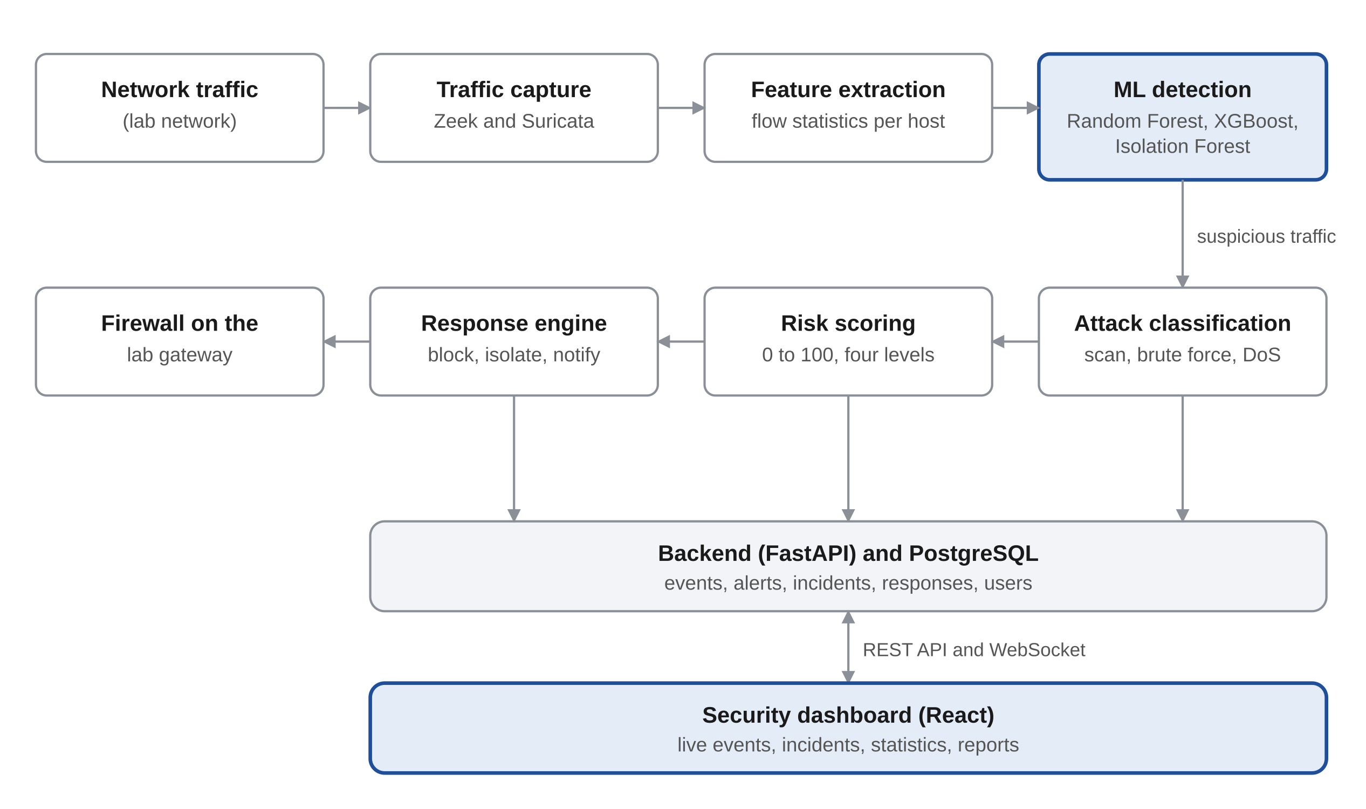
Figure 1: Architecture of the proposed system
The major features are:
- Traffic capture. Zeek and Suricata observe the traffic on the monitored network and record every connection.
- Feature extraction. Connection records are turned into numerical features for each source host, such as connection count, ports contacted, failed connections, bytes and duration.
- Machine learning detection. Trained models separate normal traffic from malicious traffic. Random Forest and XGBoost detect known attack behaviour, and Isolation Forest flags behaviour that is simply unusual.
- Attack classification. Malicious traffic is labelled by type: port scanning, brute-force login attempts or denial of service.
- Risk scoring. Each detection receives a score from 0 to 100 and a severity of low, medium, high or critical. The score combines model confidence, attack type, number of hosts affected and how often the source has attacked.
- Automated response. For a critical incident the system blocks the source address on the firewall, records the action and notifies the administrator. Blocks are time-limited, trusted addresses can never be blocked, and the administrator can reverse any action.
- Security dashboard. A web dashboard shows live events, attack statistics, top attacking addresses, most targeted devices and an attack timeline.
- Incident management. Every incident is stored with its source, target, type, confidence, severity, action taken and status, so that it can be investigated later.
- Secure access. Administrators sign in with a password and a second factor, and every action is logged.
The system is developed and tested in an isolated laboratory network owned by the researcher. Figure 2 shows the laboratory.
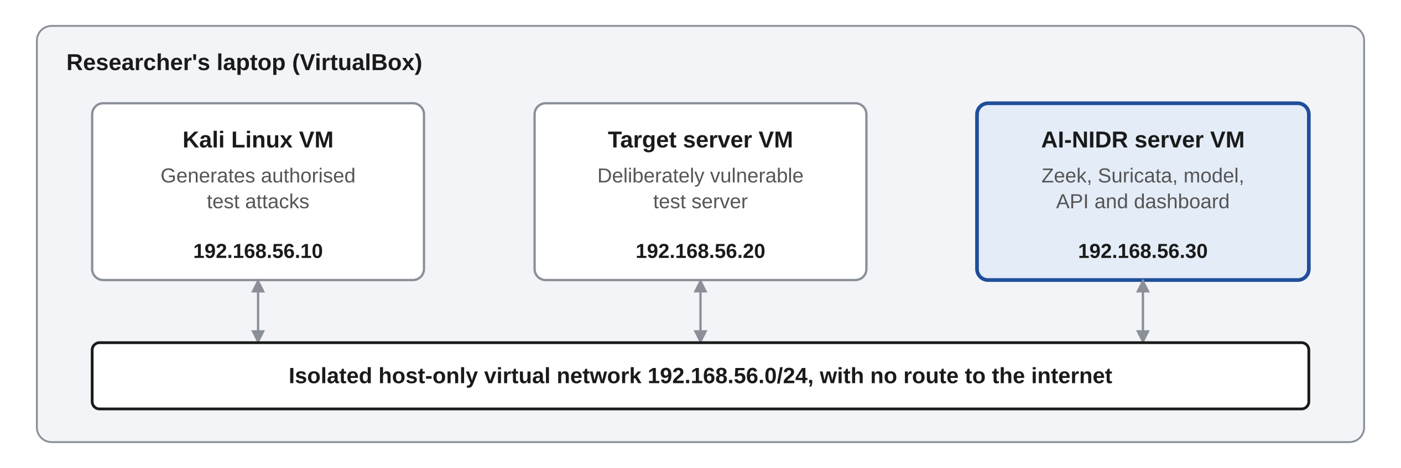
Figure 2: Laboratory network for development and testing

1.4 Objectives

System objectives
- To detect malicious network traffic with an F1-score of at least 90% and a false positive rate below 5% on the test data.
- To reduce the time between the start of an attack and an alert to under 60 seconds.
- To classify each detected attack into one of at least three types and assign it a risk score from 0 to 100.
- To block the source of a critical attack within 10 seconds of the alert and record every incident and response for review.

Research objectives
- To find out how the client monitors its network at present and the problems that arise.
- To investigate existing intrusion detection techniques and systems and identify their gaps.
- To design a system that detects, classifies, scores and responds to network attacks using machine learning.
- To develop the system using Python, Zeek, Suricata and machine learning libraries.
- To test and evaluate the system against rule-based detection in a controlled laboratory, using accuracy, precision, recall, F1-score, false positive rate and detection time.

1.5 Significance of the project
- To the client. Attacks are seen within a minute instead of after the damage is done. The most serious are blocked without waiting for a person, and every incident leaves a record.
- To other organisations. Small and medium organisations that cannot afford a security operations centre can run the same system on open source tools.
- To institutions. Universities and training centres can use the laboratory and the system to teach network defence safely.
- To society. Faster detection and response reduce the losses and disruption that attacks cause to services people depend on.
- To research. The project produces labelled traffic from a controlled laboratory and a measured comparison of machine learning detection with rule-based detection.

Chapter Two: Literature Review

2.1 Intrusion detection techniques
Intrusion detection systems use two main approaches, and each has a weakness that the other covers. The proposed system combines them.
- Signature-based detection. Traffic is compared with stored rules that describe known attacks. It is accurate for known attacks and raises few false alarms, but it cannot recognise an attack that has no rule (Roesch, 1999; Khraisat et al., 2019).
- Anomaly-based detection. The system learns what normal traffic looks like and flags departures from it. It can find new attacks, but it raises more false alarms (Buczak & Guven, 2016).
- Supervised machine learning. Models such as Random Forest (Breiman, 2001) and XGBoost (Chen & Guestrin, 2016) are trained on labelled traffic and classify new traffic by attack type.
- Unsupervised machine learning. Isolation Forest finds unusual records without needing labelled attacks (Liu et al., 2008).
- Datasets. Public datasets such as CIC-IDS2017 (Sharafaldin et al., 2018) and UNSW-NB15 (Moustafa & Slay, 2015) provide labelled traffic for training and testing.
Sommer and Paxson (2010) warn that machine learning detectors often perform well on datasets and poorly on real networks, where false alarms are costly. For that reason this project tests the models on traffic from its own laboratory as well as on a public dataset, and measures the false positive rate directly.

2.2 Review of similar systems

Snort
Snort is a free, open source intrusion detection and prevention system. It inspects packets against a set of rules and raises an alert, or drops the traffic, when a rule matches (Roesch, 1999).
Missing features:
- It detects only what its rules describe. It has no machine learning detection.
- It gives each alert a fixed priority, not a risk score based on context.
- It has no built-in dashboard or incident management.
- Its alerts must be collected and reviewed with separate tools.

Suricata
Suricata is a free, open source intrusion detection and prevention engine maintained by the Open Information Security Foundation. It uses rules, runs on several processor cores and logs detailed records of network protocols (Open Information Security Foundation, n.d.).
Missing features:
- Detection is rule-based. It has no trained model to classify attack behaviour.
- It can drop traffic when placed in line, but it has no risk-based decision on when to respond.
- It has no built-in dashboard or incident records.
- A separate log platform is needed to view and manage its alerts.

Zeek
Zeek is a free, open source network monitoring framework. It records detailed logs of every connection and protocol and lets analysts write scripts to examine them (Paxson, 1999; Zeek Project, n.d.).
Missing features:
- It records and analyses traffic but does not classify attacks with machine learning.
- It has no risk scoring.
- It takes no action against an attacker.
- It has no dashboard or incident management.

2.3 Gap and comparison
The three systems are strong at capturing traffic and matching rules. None learns attack behaviour, scores risk, manages incidents and shows the results in one place. AI-NIDR builds on Zeek and Suricata and adds those parts.
Feature | Snort | Suricata | Zeek | AI-NIDR (proposed)
Rule-based detection | Yes | Yes | By scripts | Yes, through Suricata
Connection logging | Limited | Yes | Yes | Yes, through Zeek
Machine learning detection | No | No | No | Yes
Attack classification by a trained model | No | No | No | Yes
Risk score from 0 to 100 | No | No | No | Yes
Automated response | In-line mode only | In-line mode only | No | Yes, by risk level
Web dashboard | No | No | No | Yes
Incident records with status | No | No | No | Yes

Chapter Three: Methodology

3.1 Research methodology
The study uses primary data from the client and from a controlled laboratory, and secondary data from a public traffic dataset.

Data collection methods
- Interviews. The client's information technology staff and manager will be interviewed on how the network is monitored, what incidents have occurred and how they were handled.
- Questionnaires. A short questionnaire will go to information technology staff in other organisations to measure how they detect and respond to network attacks.
- Document review. The client's network diagram, security policy and past incident records will be reviewed, with identifying details removed.
- Secondary data. The CIC-IDS2017 dataset (Sharafaldin et al., 2018) will be used to train and test the models.
- Laboratory experiment. Normal traffic and authorised test attacks will be generated in the isolated laboratory in Figure 2 and captured as labelled data.

Target population
The target population is the staff responsible for networks and security in small and medium organisations in Kenya.

Sampling
Purposive sampling will select the client's information technology staff and manager, since they hold the needed knowledge. Convenience sampling will select 30 information technology staff in other organisations for the questionnaire.

Ethical considerations
Participation is voluntary and based on informed consent. Test attacks are run only inside the researcher's own isolated laboratory, never against the client's network or any other system. Traffic from the client's network is used only with written permission, and addresses are masked in all stored data and in the report.

3.2 Development methodology
The system will be developed using Rapid Application Development (RAD) with iterative prototyping. RAD suits this project because detection accuracy can only be judged by building, testing and refining the models. It also lets the client see working prototypes early.
The four RAD phases map to the project as follows.
- Requirements planning. Data collection, analysis of the current situation, and the software requirements specification.
- User design. Architecture, database and interface design, with screen prototypes reviewed by the client.
- Construction. The system is built in four increments: the laboratory with traffic capture and feature extraction, the detection and classification models, the risk scoring and response engine with the backend, and the dashboard. Each increment is tested before the next begins.
- Cutover. System testing, evaluation, deployment in the laboratory, user training and documentation.

Development tools
Layer | Tools
Network monitoring | Zeek, Suricata
Packet analysis | Scapy, Wireshark
Data processing | Python 3, Pandas
Machine learning | Scikit-learn, XGBoost
Backend and API | FastAPI, WebSockets
Database | PostgreSQL
Dashboard | React, TypeScript, Tailwind CSS
Authentication | JSON Web Tokens with multi-factor authentication
Laboratory | VirtualBox, Kali Linux, Ubuntu Server
Environment | Docker, Visual Studio Code, Git and GitHub

Testing and evaluation
- Detection performance. Accuracy, precision, recall, F1-score and false positive rate, measured on held-out CIC-IDS2017 data and on laboratory traffic.
- Comparison. The same laboratory traffic is passed through Suricata's rules and through the trained models, and the results are compared.
- Detection time. The time from the start of a test attack to the alert, against the 60-second target.
- Response. Whether critical incidents are blocked within 10 seconds, and whether trusted addresses are never blocked.
- Security. Tests of authentication, access control and input validation on the dashboard and API, guided by the OWASP Top 10.
- Usability. The client's staff will complete set tasks on the dashboard and rate it using a standard usability questionnaire.

Budget and resources
The project needs an estimated KES 24,200, because all the software is open source and the laptop is already owned. Figures are approximate and should be adjusted to actual prices.
Item | Category | Purpose | Estimated cost (KES)
Laptop with a processor that supports virtualisation | Hardware | Development and the laboratory | 0 (already owned)
Memory upgrade to 16 GB | Hardware | Running three virtual machines together | 6,000
External storage, 64 GB or more | Hardware | Datasets, captures and backups | 2,000
Zeek, Suricata, Python, Scikit-learn, XGBoost, FastAPI, PostgreSQL, React, VirtualBox, Kali Linux, Ubuntu, Docker | Software | Development and laboratory tools, all free | 0
Internet, 4 months | Other | Research, datasets and software downloads | 8,000
Transport and airtime | Other | Interviews and questionnaires | 2,000
Printing and binding | Other | Proposal, specification and final report | 4,000
Developer (the candidate) | Human | Research, design, development, testing | 0
Supervisor | Human | Guidance and review | 0
Contingency, 10% | Other | Unplanned costs | 2,200
Total |  |  | 24,200

Project schedule
The project takes 300 hours over 11 weeks, from 5 October to 18 December 2026. Dates assume this semester's calendar and should be matched to the department's deadlines. Actual dates stay blank at proposal stage.
Task No. | Description | Task hrs | Subtask hrs | Planned start | Actual start | Planned completion | Actual completion | Deliverables
1 | Proposal | 20 | Topic research 6, planning 4, writing 10 | 5 Oct 2026 |  | 9 Oct 2026 |  | Approved project proposal
2 | SRS | 30 | Data collection 12, analysis 8, writing 10 | 12 Oct 2026 |  | 23 Oct 2026 |  | Software requirements specification
3 | Design | 36 | Architecture and database 14, interface 8, laboratory setup 14 | 26 Oct 2026 |  | 6 Nov 2026 |  | System design document
4 | System development | 120 | Capture and features 25, models 35, risk, response and backend 30, dashboard 30 | 2 Nov 2026 |  | 4 Dec 2026 |  | Working system and source code
5 | Test plan | 10 | Test cases 6, test data 4 | 9 Nov 2026 |  | 11 Nov 2026 |  | Test plan
6 | Testing and evaluation | 30 | Detection tests 14, response and security tests 8, usability tests 8 | 30 Nov 2026 |  | 9 Dec 2026 |  | Test results report
7 | Implementation plan | 8 | Deployment steps 5, training plan 3 | 7 Dec 2026 |  | 9 Dec 2026 |  | Implementation plan
8 | Maintenance plan | 6 | Writing 6 | 10 Dec 2026 |  | 11 Dec 2026 |  | Maintenance plan
9 | User manual | 10 | Writing 7, screenshots 3 | 10 Dec 2026 |  | 14 Dec 2026 |  | User manual
10 | Final report | 30 | Writing 22, review and corrections 8 | 7 Dec 2026 |  | 18 Dec 2026 |  | Final project report

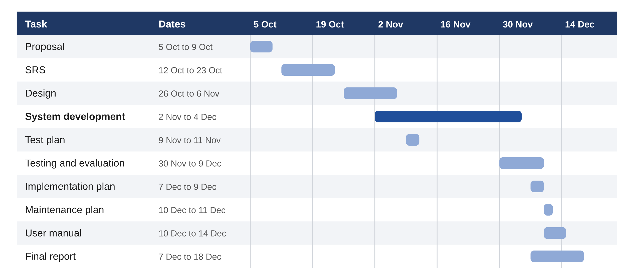
Figure 3: Gantt chart of the project schedule

References
Breiman, L. (2001). Random forests. Machine Learning, 45(1), 5–32.
Buczak, A. L., & Guven, E. (2016). A survey of data mining and machine learning methods for cyber security intrusion detection. IEEE Communications Surveys & Tutorials, 18(2), 1153–1176.
Chen, T., & Guestrin, C. (2016). XGBoost: A scalable tree boosting system. In Proceedings of the 22nd ACM SIGKDD International Conference on Knowledge Discovery and Data Mining (pp. 785–794). ACM.
Communications Authority of Kenya. (2026). Cybersecurity report: January to March 2026. https://www.ca.go.ke/sites/default/files/2026-04/Cyber%20Security%20Report%20Q3%202025-2026_0.pdf
IBM. (2025). Cost of a data breach report 2025. IBM Security.
IT News Africa. (2026). Kenya cyber threats hit 11 billion as DDoS attacks double. https://www.itnewsafrica.com/cybersecurity/kenya-cyber-threats-hit-11-billion/
Khraisat, A., Gondal, I., Vamplew, P., & Kamruzzaman, J. (2019). Survey of intrusion detection systems: Techniques, datasets and challenges. Cybersecurity, 2(1), Article 20.
Liu, F. T., Ting, K. M., & Zhou, Z.-H. (2008). Isolation forest. In 2008 Eighth IEEE International Conference on Data Mining (pp. 413–422). IEEE.
Moustafa, N., & Slay, J. (2015). UNSW-NB15: A comprehensive data set for network intrusion detection systems. In 2015 Military Communications and Information Systems Conference (pp. 1–6). IEEE.
Open Information Security Foundation. (n.d.). Suricata. https://suricata.io
Paxson, V. (1999). Bro: A system for detecting network intruders in real-time. Computer Networks, 31(23–24), 2435–2463.
Roesch, M. (1999). Snort: Lightweight intrusion detection for networks. In Proceedings of the 13th USENIX Conference on System Administration (pp. 229–238). USENIX.
Sharafaldin, I., Lashkari, A. H., & Ghorbani, A. A. (2018). Toward generating a new intrusion detection dataset and intrusion traffic characterization. In Proceedings of the 4th International Conference on Information Systems Security and Privacy (pp. 108–116).
Sommer, R., & Paxson, V. (2010). Outside the closed world: On using machine learning for network intrusion detection. In 2010 IEEE Symposium on Security and Privacy (pp. 305–316). IEEE.
Zeek Project. (n.d.). Zeek. https://zeek.org

