
KCA UNIVERSITY
SCHOOL OF TECHNOLOGY
AI-NIDR: AN AI-POWERED NETWORK INTRUSION DETECTION AND AUTOMATED RESPONSE SYSTEM
SOFTWARE DESIGN SPECIFICATION
FELIX OCHIENG
Registration number: 24/06618
Supervisor: Joseph Mugai
Client: [client organisation name]
Bachelor of Science in Applied Computing
Version 1.0 (draft)
October 2026

Revision history
Version | Date | Description | Author
1.0 | 4 October 2026 | First draft, based on the approved proposal | Felix Ochieng

Table of contents

1. Introduction 4
1.1 Purpose 4
1.2 Scope 4
1.3 Definitions, acronyms and abbreviations 4
1.4 References 5
1.5 Overview 5
2. Design overview 6
2.1 Design goals 6
2.2 Design approach 6
2.3 Key design decisions 6
3. System architecture 8
3.1 Architecture 8
3.2 Components 8
3.3 Technology stack 9
3.4 Deployment and laboratory 10
4. Process design 11
4.1 Data flow 11
4.2 Detection and response flow 12
4.3 Time budget 12
5. Data design 14
5.1 Entity relationship diagram 14
5.2 Table definitions 14
5.3 File storage 18
6. Component design 19
6.1 Class structure 19
6.2 Sensor and feature extraction 20
6.3 Detection models 20
6.4 Attack classification 21
6.5 Risk scoring 21
6.6 Response engine 22
6.7 Incident management 22
6.8 Authentication and access control 23
6.9 Live events and notifications 23
7. Interface design 24
7.1 Dashboard screens 24
7.2 API 25
8. Security design 27
9. Error handling 28
10. Requirements traceability 29
10.1 Approval 29

1. Introduction

1.1 Purpose
This document describes how AI-NIDR will be built. It turns the system proposed in the project proposal into an architecture, a database, components and interfaces that the developer can implement.
It is written for the project supervisor and examiners, and for the developer during construction and testing.

1.2 Scope
The design covers the whole system: traffic capture, feature extraction, machine learning detection, attack classification, risk scoring, automated response, incident management, the dashboard and the laboratory it runs in. It does not cover the test plan or the user manual, which have their own documents.

1.3 Definitions, acronyms and abbreviations
Term | Meaning
Alert | One detection of suspicious behaviour by one source in one time window
Allowlist | Addresses the system must never block
API | Application Programming Interface
DFD | Data Flow Diagram
DoS | Denial of service
ERD | Entity Relationship Diagram
Feature window | The numerical summary of one source's traffic over a short period
Incident | A group of related alerts from one source, managed as one case
JWT | JSON Web Token, a signed token that proves a user has signed in
ML | Machine learning
nftables | The firewall built into current Linux systems
Sensor | The part of the system that observes network traffic
SRS | Software Requirements Specification
TOTP | Time-based one-time password, the code produced by an authenticator app
Zeek, Suricata | Open source network monitoring and intrusion detection tools

1.4 References
- Ochieng, F. (2026). AI-NIDR: An AI-powered network intrusion detection and automated response system [Project proposal]. KCA University.
- Ochieng, F. (2026). AI-NIDR: Software requirements specification (Version 1.0). KCA University.
- IEEE. (2009). IEEE standard for information technology: Systems design: Software design descriptions (IEEE Std 1016-2009).
- OWASP Foundation. (2021). OWASP Top 10: 2021.
- Sharafaldin, I., Lashkari, A. H., & Ghorbani, A. A. (2018). Toward generating a new intrusion detection dataset and intrusion traffic characterization. In Proceedings of the 4th International Conference on Information Systems Security and Privacy (pp. 108–116).

1.5 Overview
Section 2 gives the design goals and main decisions. Section 3 describes the architecture and the laboratory. Sections 4 and 5 give the process and data design. Section 6 details each component. Section 7 covers the dashboard and the API. Sections 8 and 9 cover security and error handling. Section 10 traces the design back to the requirements.

2. Design overview

2.1 Design goals
The design is driven by five goals taken from the proposal.
Goal | How the design meets it
Detect attacks that rules miss | Trained models judge behaviour, and Suricata's rules run beside them as a second opinion
Raise an alert within 60 seconds | Traffic is summarised every 10 seconds and scored as soon as each summary is ready
Respond to critical attacks within 10 seconds | The response engine acts on the risk score without waiting for a person
Never harm legitimate users | Trusted addresses cannot be blocked, every block expires, and an administrator can reverse any action
Stay easy to extend | Every model and every firewall implements a common interface, so one can be replaced alone

2.2 Design approach
AI-NIDR is designed as a pipeline of small services that run in containers on one server. Each stage reads the output of the stage before it, so a stage can be tested and replaced without touching the others.
The code is object-oriented Python on the server and TypeScript in the dashboard. The system is built in the four increments named in the proposal: capture and feature extraction, the models, risk scoring and response with the backend, and the dashboard.

2.3 Key design decisions
Decision | Choice | Reason
How traffic is observed | Zeek connection logs, with Suricata alerts beside them | Zeek gives one clean record per connection, and Suricata provides the rule-based baseline for comparison
What the models see | Features for each source address over a sliding window | Attacks such as scans and password guessing show in a source's behaviour over time, not in one connection
Main classifier | XGBoost, with Random Forest as a comparison | Both are strong on tabular data and can be explained in a defence
Unknown attacks | Isolation Forest | It flags unusual behaviour without needing labelled examples
Training data | CIC-IDS2017 packet captures replayed through Zeek, plus laboratory traffic | Training and live traffic then have exactly the same features
Backend | FastAPI | Fast, typed, and supports WebSockets for live events
Database | PostgreSQL | Reliable, free, and stores feature windows as structured data
Where a block is enforced | The firewall of each protected host, reached over SSH | The laboratory has one network segment and no separate gateway. The engine talks to a firewall through one interface, so a gateway firewall can be added later
Sign-in | Password and a code from an authenticator app, then a JWT | A stolen password alone does not give access to a system that can block traffic
Deployment | Docker Compose | The whole system starts with one command and runs the same on any machine

3. System architecture

3.1 Architecture
AI-NIDR has four layers above the monitored network, and each layer uses the one below it. All layers share one data store.
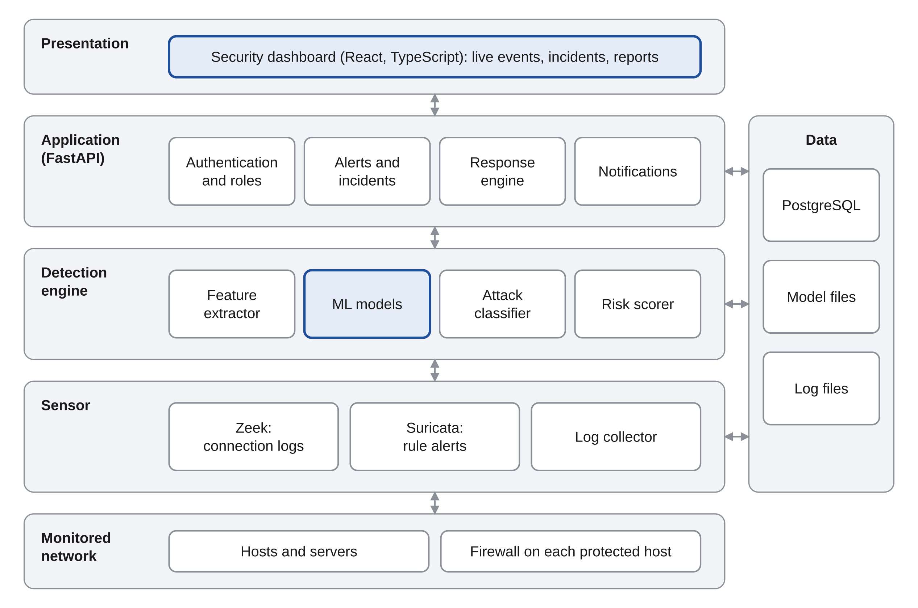
Figure 1: Layered architecture of AI-NIDR
Layer | Responsibility
Presentation | The security dashboard, where analysts follow events and manage incidents
Application | Sign-in, alerts and incidents, the response engine and notifications
Detection engine | Features, models, attack classification and risk scoring
Sensor | Observes the traffic and turns it into connection records and rule alerts
Data | The database, the trained models and the raw logs

3.2 Components
Component | Responsibility | Requirements
Authentication and roles | Sign-in with two factors, tokens, roles, lockout | FR-01 to FR-06
Sensor | Zeek and Suricata observe traffic; the log collector passes their records on | FR-07 to FR-11
Feature extractor | Summarises each source's traffic into feature windows | FR-12 to FR-15
ML models | Decide whether a window is normal or an attack | FR-16 to FR-20
Attack classifier | Names the type of attack | FR-21 to FR-23
Risk scorer | Gives each alert a score from 0 to 100 and a severity | FR-24 to FR-27
Response engine | Blocks and releases sources, within the safeguards | FR-28 to FR-33
Alerts and incidents | Groups alerts into incidents and tracks their status | FR-34 to FR-38
Dashboard | Live events, statistics, incidents and reports | FR-39 to FR-43
Audit log | Records every action by users and by the system | FR-44 to FR-46
API | Serves the dashboard and receives records from the sensor | FR-47 to FR-49

3.3 Technology stack
Layer | Technology | Minimum version
Network monitoring | Zeek | 6
Rule-based detection | Suricata | 7
Packet tools | Scapy, Wireshark | Scapy 2.5
Language | Python | 3.12
Data processing | Pandas, NumPy | Pandas 2
Machine learning | Scikit-learn, XGBoost | Scikit-learn 1.4, XGBoost 2
Backend | FastAPI, with Uvicorn and SQLAlchemy | FastAPI 0.110
Database | PostgreSQL | 16
Dashboard | React, TypeScript, Tailwind CSS | React 18
Authentication | JSON Web Tokens, TOTP, Argon2id password hashing | Not applicable
Firewall | nftables | 1.0
Containers | Docker and Docker Compose | Docker 24
Laboratory | VirtualBox, Kali Linux, Ubuntu Server | VirtualBox 7

These minimum versions are from the developer's knowledge and are confirmed when the tools are installed. The exact versions used are recorded in the project's dependency files.

3.4 Deployment and laboratory
The whole system runs as six containers on one virtual machine. It watches an isolated network that also holds an attacking machine and a target server.
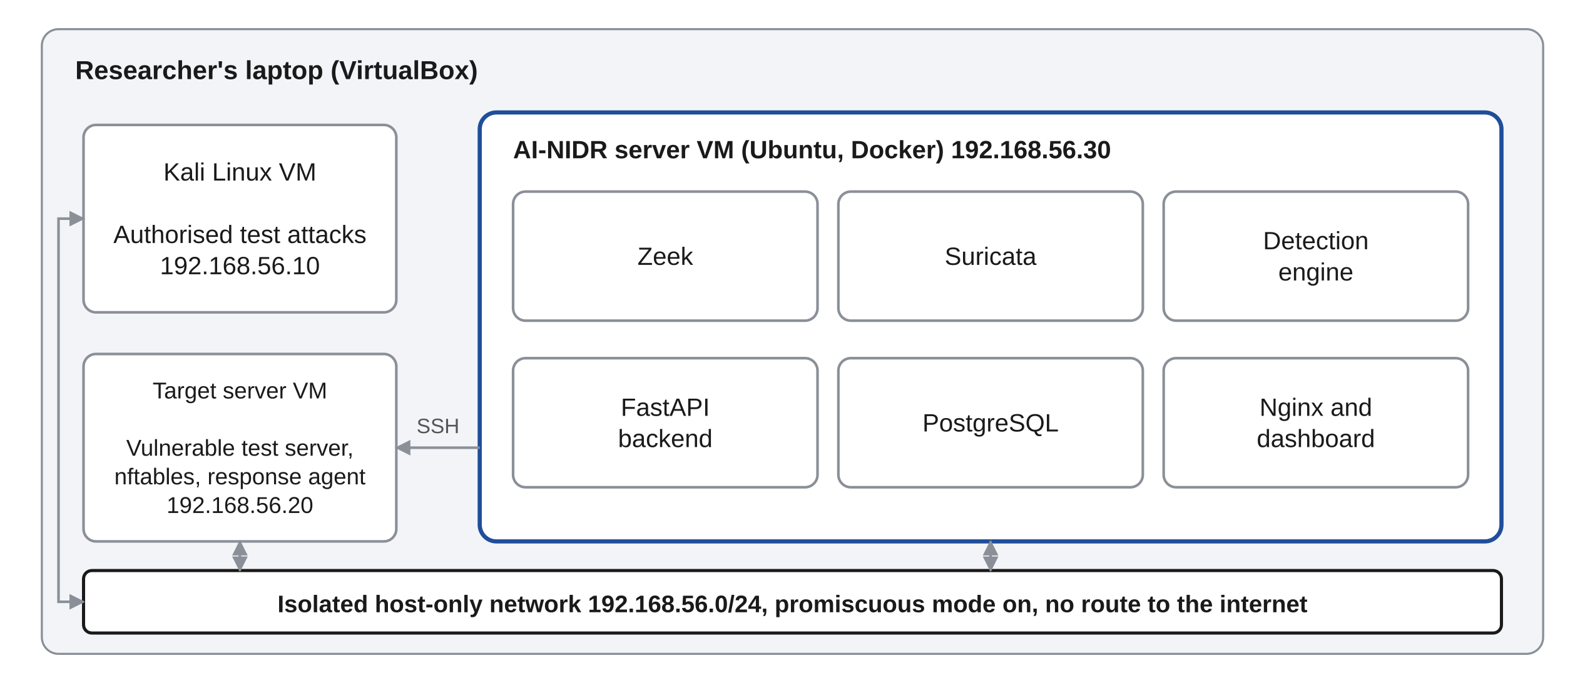
Figure 2: Deployment in the laboratory
Machine | Address | Role
Kali Linux | 192.168.56.10 | Generates authorised test attacks
Target server | 192.168.56.20 | A deliberately vulnerable server, with nftables and the response agent
AI-NIDR server | 192.168.56.30 | Runs the sensor, detection engine, backend, database and dashboard

The network is a VirtualBox host-only network with no route to the internet. Promiscuous mode is turned on for the AI-NIDR server's network card, so that the sensor sees the traffic between the other two machines.

4. Process design

4.1 Data flow
Seven processes move data between two kinds of user, the monitored network, the host firewall and five data stores. Figure 3 is the level 1 data flow diagram.
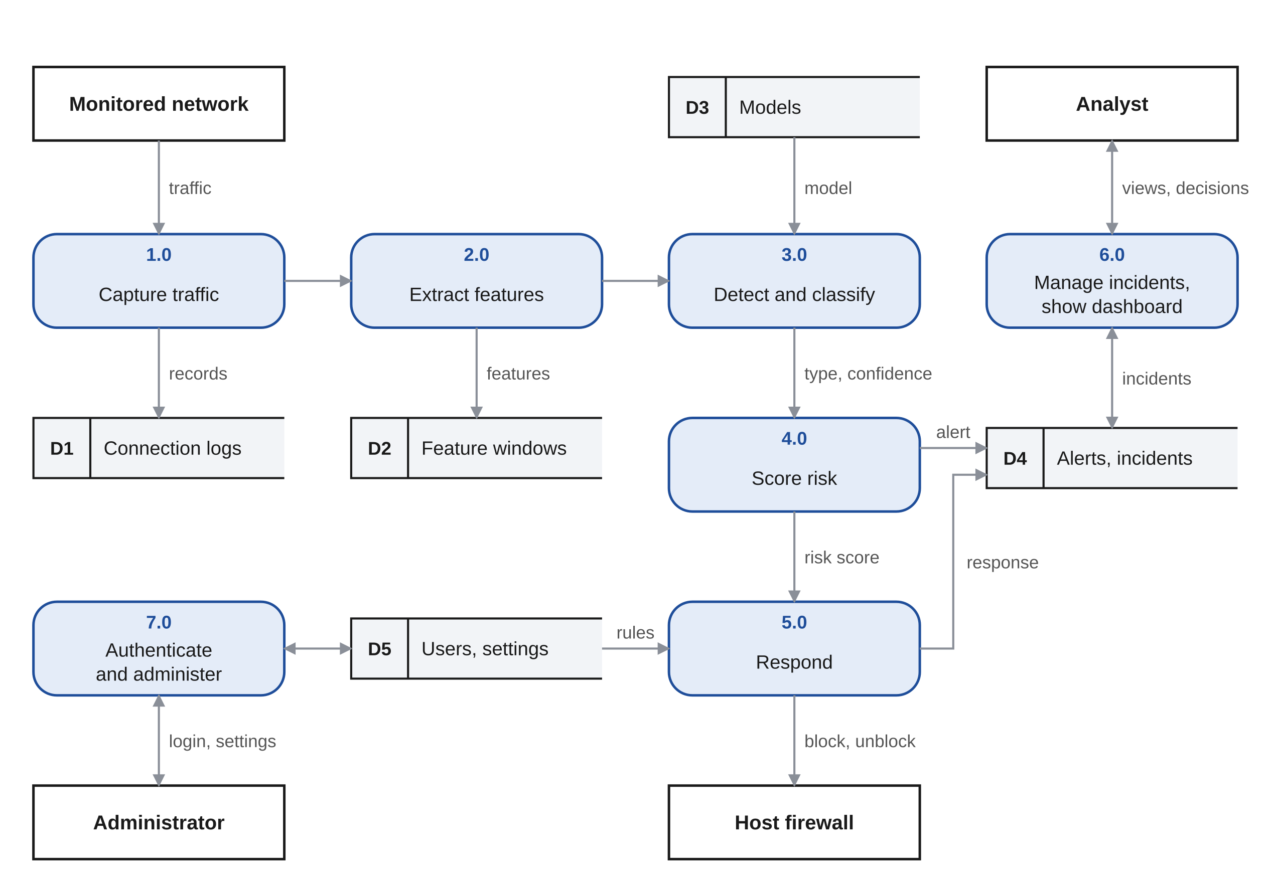
Figure 3: Level 1 data flow diagram
Every process also writes to the audit log, which is left out of the figure to keep it readable.
Process | Input | Output
1.0 Capture traffic | Packets on the monitored network | Connection records and rule alerts
2.0 Extract features | Connection records | One feature window for each active source
3.0 Detect and classify | Feature window, trained model | Attack type and confidence, or normal
4.0 Score risk | Attack type, confidence, history of the source | Risk score, severity and an alert
5.0 Respond | Risk score, allowlist and settings | A block or release on the host firewall, and a response record
6.0 Manage incidents, show dashboard | Alerts, responses, the analyst's decisions | Incidents with status, live events, reports
7.0 Authenticate and administer | Sign-in details, settings | Sessions, user accounts, allowlist and thresholds

4.2 Detection and response flow
Figure 4 shows the decisions the system makes for the traffic of one source, from capture to the action taken.
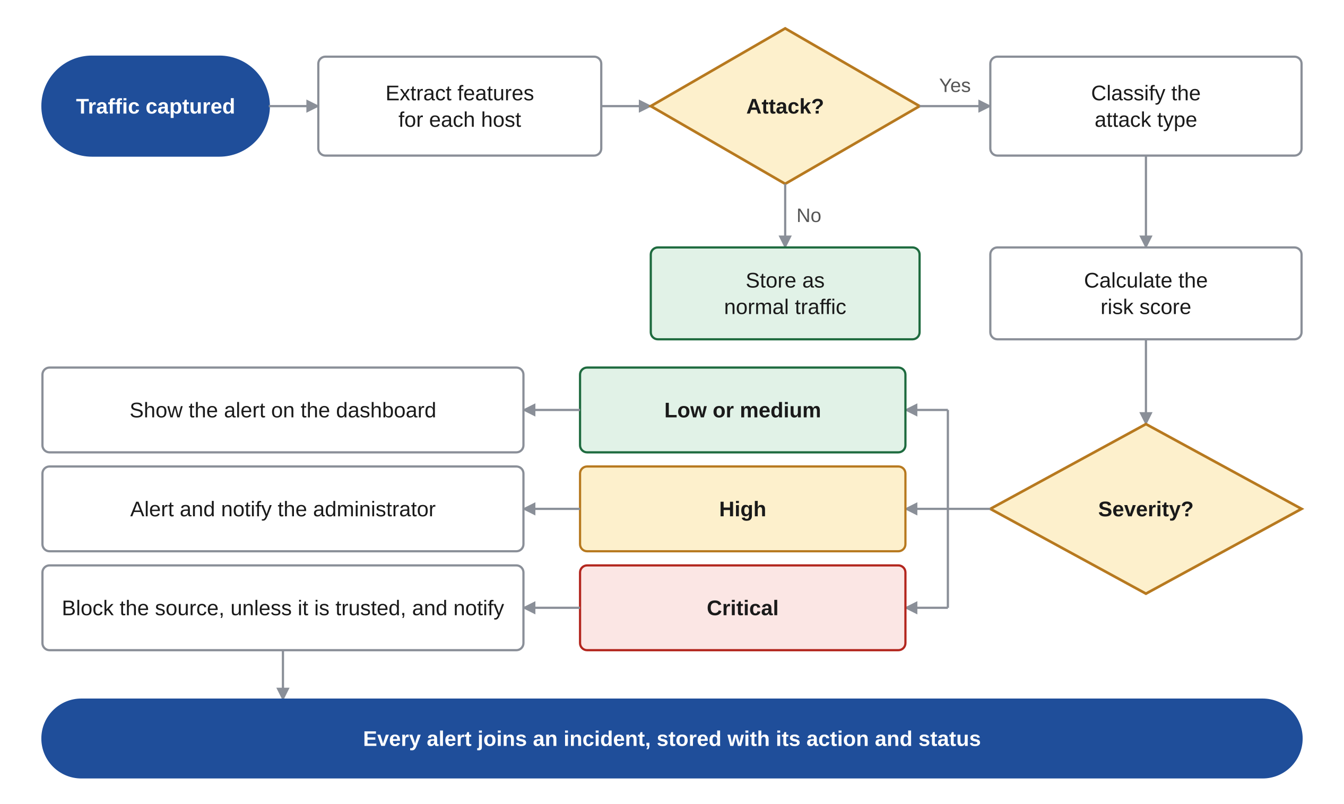
Figure 4: Flowchart of detection and response

4.3 Time budget
The design allows 45 seconds from the start of an attack to an alert, which leaves 15 seconds of margin under the 60-second target.
Stage | Budget (seconds)
Zeek writes the connection records | 15
Window closes and features are computed | 10
Models score the window | 2
Risk is scored and the alert is stored | 3
Alert reaches the dashboard | 2
Allowance for an attack that builds up slowly | 13
Total | 45

A block on a critical alert is sent within 5 seconds of the alert, against the 10-second target.

5. Data design

5.1 Entity relationship diagram
The database has eleven tables. The alert is the central record: it comes from one feature window and one model, and it belongs to one incident.
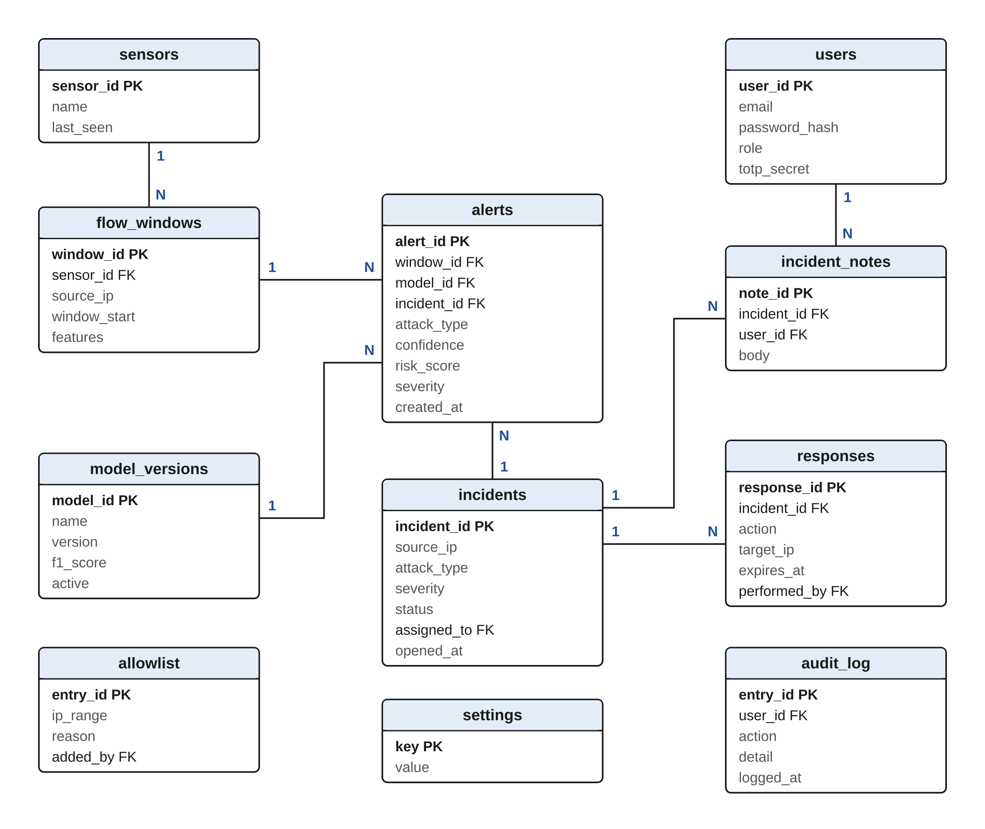
Figure 5: Entity relationship diagram
Links from the users table to incidents, responses, the allowlist and the audit log are shown as foreign keys, not as lines, to keep the figure readable.

5.2 Table definitions
Every table has a primary key. Times are stored in Coordinated Universal Time.
users
Column | Type | Constraints | Description
user_id | integer | Primary key | Unique user number
name | varchar(100) | Not null | Full name
email | varchar(255) | Unique, not null | Sign-in name
password_hash | varchar(255) | Not null | Argon2id hash
role | varchar(20) | Not null | administrator, analyst or viewer
totp_secret | varchar(64) | Nullable | Secret for the authenticator app, stored encrypted
status | varchar(20) | Not null | active or deactivated
failed_logins | integer | Default 0 | Count used for lockout
locked_until | timestamp | Nullable | End of a lockout

sensors
Column | Type | Constraints | Description
sensor_id | integer | Primary key | Unique sensor number
name | varchar(50) | Unique, not null | Name of the sensor
key_hash | char(64) | Not null | SHA-256 of the key the sensor signs in with
network | varchar(43) | Not null | The address range it monitors
last_seen | timestamp | Nullable | Time of its last record, used to detect a silent sensor

flow_windows
Column | Type | Constraints | Description
window_id | bigint | Primary key | Unique window number
sensor_id | integer | Foreign key to sensors | Sensor that saw the traffic
source_ip | inet | Not null, indexed | The source the window describes
window_start | timestamp | Not null, indexed | Start of the window
window_seconds | integer | Not null | Length of the window
features | jsonb | Not null | The feature values in section 6.2
label | varchar(20) | Nullable | Known label, for laboratory traffic used in training

model_versions
Column | Type | Constraints | Description
model_id | integer | Primary key | Unique model number
name | varchar(30) | Not null | xgboost, random_forest or isolation_forest
version | varchar(20) | Not null | Version of the trained model
file_path | varchar(255) | Not null | Location of the model file
f1_score | numeric(5,4) | Nullable | F1-score on the test data
false_positive_rate | numeric(5,4) | Nullable | False positive rate on the test data
active | boolean | Not null | Whether the detection engine uses it
trained_at | timestamp | Not null | Date of training

alerts
Column | Type | Constraints | Description
alert_id | bigint | Primary key | Unique alert number
window_id | bigint | Foreign key to flow_windows | The window that raised it
model_id | integer | Foreign key to model_versions | The model that raised it
incident_id | integer | Foreign key to incidents | The incident it belongs to
source_ip | inet | Not null, indexed | Source of the traffic
target_ip | inet | Nullable | Most contacted destination
attack_type | varchar(20) | Not null | port_scan, brute_force, dos or anomaly
confidence | numeric(4,3) | 0 to 1 | Confidence of the model
risk_score | integer | 0 to 100 | Score from the risk scorer
severity | varchar(10) | Not null | low, medium, high or critical
rule_match | boolean | Not null | Whether Suricata also raised an alert for this source
created_at | timestamp | Not null, indexed | Time of the alert

incidents
Column | Type | Constraints | Description
incident_id | integer | Primary key | Unique incident number
source_ip | inet | Not null, indexed | Source of the attack
attack_type | varchar(20) | Not null | Type of attack
severity | varchar(10) | Not null | Highest severity among its alerts
risk_score | integer | 0 to 100 | Highest score among its alerts
status | varchar(20) | Not null | new, investigating, resolved or false_positive
assigned_to | integer | Foreign key to users, nullable | Analyst handling it
opened_at | timestamp | Not null | Time of the first alert
last_alert_at | timestamp | Not null | Time of the latest alert
closed_at | timestamp | Nullable | Time it was resolved

incident_notes
Column | Type | Constraints | Description
note_id | integer | Primary key | Unique note number
incident_id | integer | Foreign key to incidents | The incident
user_id | integer | Foreign key to users | Who wrote it
body | text | Not null | The note
created_at | timestamp | Not null | Time written

responses
Column | Type | Constraints | Description
response_id | integer | Primary key | Unique response number
incident_id | integer | Foreign key to incidents | The incident it answers
action | varchar(20) | Not null | block, release or notify
target_ip | inet | Nullable | Address blocked or released
automatic | boolean | Not null | True when the system acted without a person
performed_by | integer | Foreign key to users, nullable | The user, for manual actions
status | varchar(20) | Not null | applied, failed, expired or reversed
created_at | timestamp | Not null | Time of the action
expires_at | timestamp | Nullable | When a block ends

allowlist
Column | Type | Constraints | Description
entry_id | integer | Primary key | Unique entry number
ip_range | cidr | Unique, not null | Address or range that must never be blocked
reason | varchar(200) | Not null | Why it is trusted
added_by | integer | Foreign key to users | Administrator who added it

audit_log
Column | Type | Constraints | Description
entry_id | bigint | Primary key | Unique entry number
user_id | integer | Foreign key to users, nullable | Who acted; empty for the system
action | varchar(40) | Not null | What was done
detail | jsonb | Nullable | The values involved
logged_at | timestamp | Not null | Time of the action

settings
Column | Type | Constraints | Description
key | varchar(50) | Primary key | Name of the setting
value | varchar(200) | Not null | Current value

5.3 File storage
Models, logs and captures are kept in folders outside the database. Raw packet captures are kept only in the laboratory.
data/
zeek/ conn.log, ssh.log, http.log (rotated every hour)
suricata/ eve.json (rule alerts)
pcap/ laboratory captures for training and replay
models/
xgboost_v1.json
random_forest_v1.joblib
isolation_forest_v1.joblib

6. Component design

6.1 Class structure
The detection engine is built from five kinds of object. Detectors and firewalls each implement a common interface, so a new model or a different firewall can be added without changing the rest.
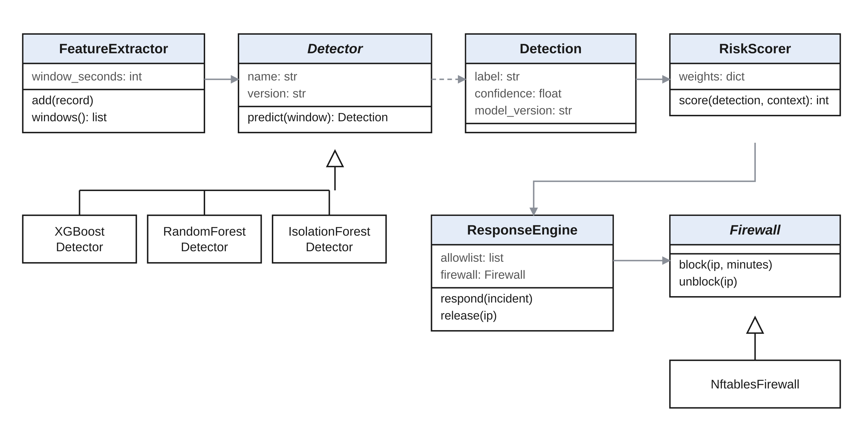
Figure 6: Class diagram of the detection and response engine
class Detector(ABC):
name: str
version: str

@abstractmethod
def predict(self, window: FeatureWindow) -> Detection: ...

@dataclass
class Detection:
label: str # "normal", "port_scan", "brute_force", "dos" or "anomaly"
confidence: float # 0 to 1
model_version: str

class Firewall(ABC):
@abstractmethod
def block(self, ip: str, minutes: int) -> None: ...

@abstractmethod
def unblock(self, ip: str) -> None: ...

6.2 Sensor and feature extraction
Zeek writes one record for every connection, in JSON. The log collector reads new records as they are written and sends them to the backend. Suricata's rule alerts are collected the same way and kept for comparison.
The feature extractor keeps the last 60 seconds of records for each source address. Every 10 seconds it produces one feature window for each source that has been active.
Feature | Meaning
connection_count | Connections started by the source
unique_destinations | Different addresses contacted
unique_ports | Different destination ports contacted
failed_ratio | Share of connections that were refused or never answered
syn_only_count | Connections that sent a SYN and nothing more
mean_duration | Average connection length in seconds
bytes_sent, bytes_received | Total bytes in each direction
mean_bytes | Average bytes for each connection
max_per_port | Most connections to any one destination port
ssh_count, ftp_count, http_count | Connections to each of those services
tcp_share, udp_share, icmp_share | Share of connections using each protocol
mean_gap | Average time between connections in seconds

6.3 Detection models
Three models examine every feature window. The supervised models name known attacks, and the unsupervised model catches behaviour that is simply unusual.
Item | Design
Main classifier | XGBoost, with four classes: normal, port scan, brute force and denial of service
Comparison classifier | Random Forest with the same classes, used to check the main model
Anomaly detector | Isolation Forest, trained on normal traffic only
Public training data | CIC-IDS2017 packet captures, replayed through Zeek and labelled from the dataset's published attack schedule
Laboratory training data | Normal traffic and authorised test attacks generated in the laboratory, labelled by the test schedule
Data split | 70% training, 15% validation, 15% test, split by time so that no attack appears in more than one part
Class balance | Class weights, because normal windows far outnumber attack windows
Tuning | Grid search on the validation data, judged by F1-score
Versioning | Each trained model is stored with its version, F1-score and false positive rate

A window is reported as an attack when the main classifier's confidence passes the detection threshold. The threshold starts at 0.80 and is set again from the validation data.

6.4 Attack classification
The label comes from the models in three steps.
- If the main classifier names an attack with confidence above the threshold, that attack type is used.
- If it does not, but the anomaly detector flags the window, the alert is labelled as an anomaly of unknown type.
- Otherwise the window is stored as normal traffic and no alert is raised.
Suricata's result is recorded on each alert as a second opinion. It is not used to decide the label, so the two methods can be compared fairly in testing.

6.5 Risk scoring
The risk score combines four factors, each scaled from 0 to 1.
risk_score = round(100 * (0.50 * confidence
+ 0.35 * attack_weight
+ 0.075 * spread
+ 0.075 * repeat))

Factor | How it is calculated
confidence | The model's confidence in the detection
attack_weight | Denial of service 0.9, brute force 0.8, port scan 0.5, anomaly 0.3
spread | Number of hosts targeted, divided by 5, to a maximum of 1
repeat | Incidents from the same source in the last 24 hours, divided by 3, to a maximum of 1

Score | Severity | Action
0 to 24 | Low | Recorded
25 to 49 | Medium | Shown on the dashboard
50 to 74 | High | Shown on the dashboard, and the administrator is notified
75 to 100 | Critical | The source is blocked, and the administrator is notified

With these weights a confident first denial-of-service or brute-force attack on one host is critical, and a first port scan is high. The weights are starting values. They are adjusted from the test results and can be changed by an administrator.

6.6 Response engine
The response engine blocks a source only when every safeguard allows it.
- The alert is critical, and automatic response is switched on.
- The source is not on the allowlist.
- The source is inside the monitored network range. The system never acts against addresses outside it.
- The number of active blocks is below the limit, which starts at 50.
- The engine tells the firewall on each protected host to block the source for 30 minutes.
- The response is stored, the incident is updated, and the administrator is notified.
The engine reaches each protected host over SSH, with an account that is allowed to run only the block and release commands. The firewall holds blocked addresses in an nftables set whose entries expire by themselves, so a block ends even if the AI-NIDR server is switched off.
An administrator can release any address at once, block an address by hand, and switch automatic response off with one control. In that state the engine records what it would have done, which is how it is tested before being trusted.

6.7 Incident management
Alerts from one source with one attack type are grouped into one incident, as long as they arrive within 15 minutes of each other. An alert of unknown type joins the incident already open for that source. An incident moves through four states.
State | Meaning | Next states
New | Opened by the system and not yet looked at | Investigating, false positive
Investigating | An analyst has taken it | Resolved, false positive
Resolved | The attack was real and has been dealt with | None
False positive | The traffic was legitimate | None

Marking an incident as a false positive releases any block it caused. The windows behind it are labelled as normal, so they can be used when the models are next trained.

6.8 Authentication and access control
Users sign in with an email address, a password and a six-digit code from an authenticator app. The server then issues an access token that lasts 15 minutes and a refresh token kept in a cookie that scripts cannot read.
Function | Viewer | Analyst | Administrator
View dashboard, alerts and incidents | Yes | Yes | Yes
Take, note and close incidents | No | Yes | Yes
Block or release an address by hand | No | Yes | Yes
Download reports | No | Yes | Yes
Manage the allowlist | No | No | Yes
Change thresholds, weights and automatic response | No | No | Yes
Manage users and sensors | No | No | Yes
Activate a model version | No | No | Yes
View the audit log | No | No | Yes

The sensor signs in with its own key, which may only submit records. It cannot read data or change settings.

6.9 Live events and notifications
The dashboard keeps a WebSocket connection to the backend. Each new alert, incident change and response is pushed to every connected dashboard within 2 seconds.
High and critical incidents are also sent to the administrator by email. Notifications about the same incident are limited to one every 10 minutes.

7. Interface design

7.1 Dashboard screens
The dashboard is designed for a desktop screen, since analysts work at a desk, and it adapts to a tablet. Figure 7 shows the main screen.
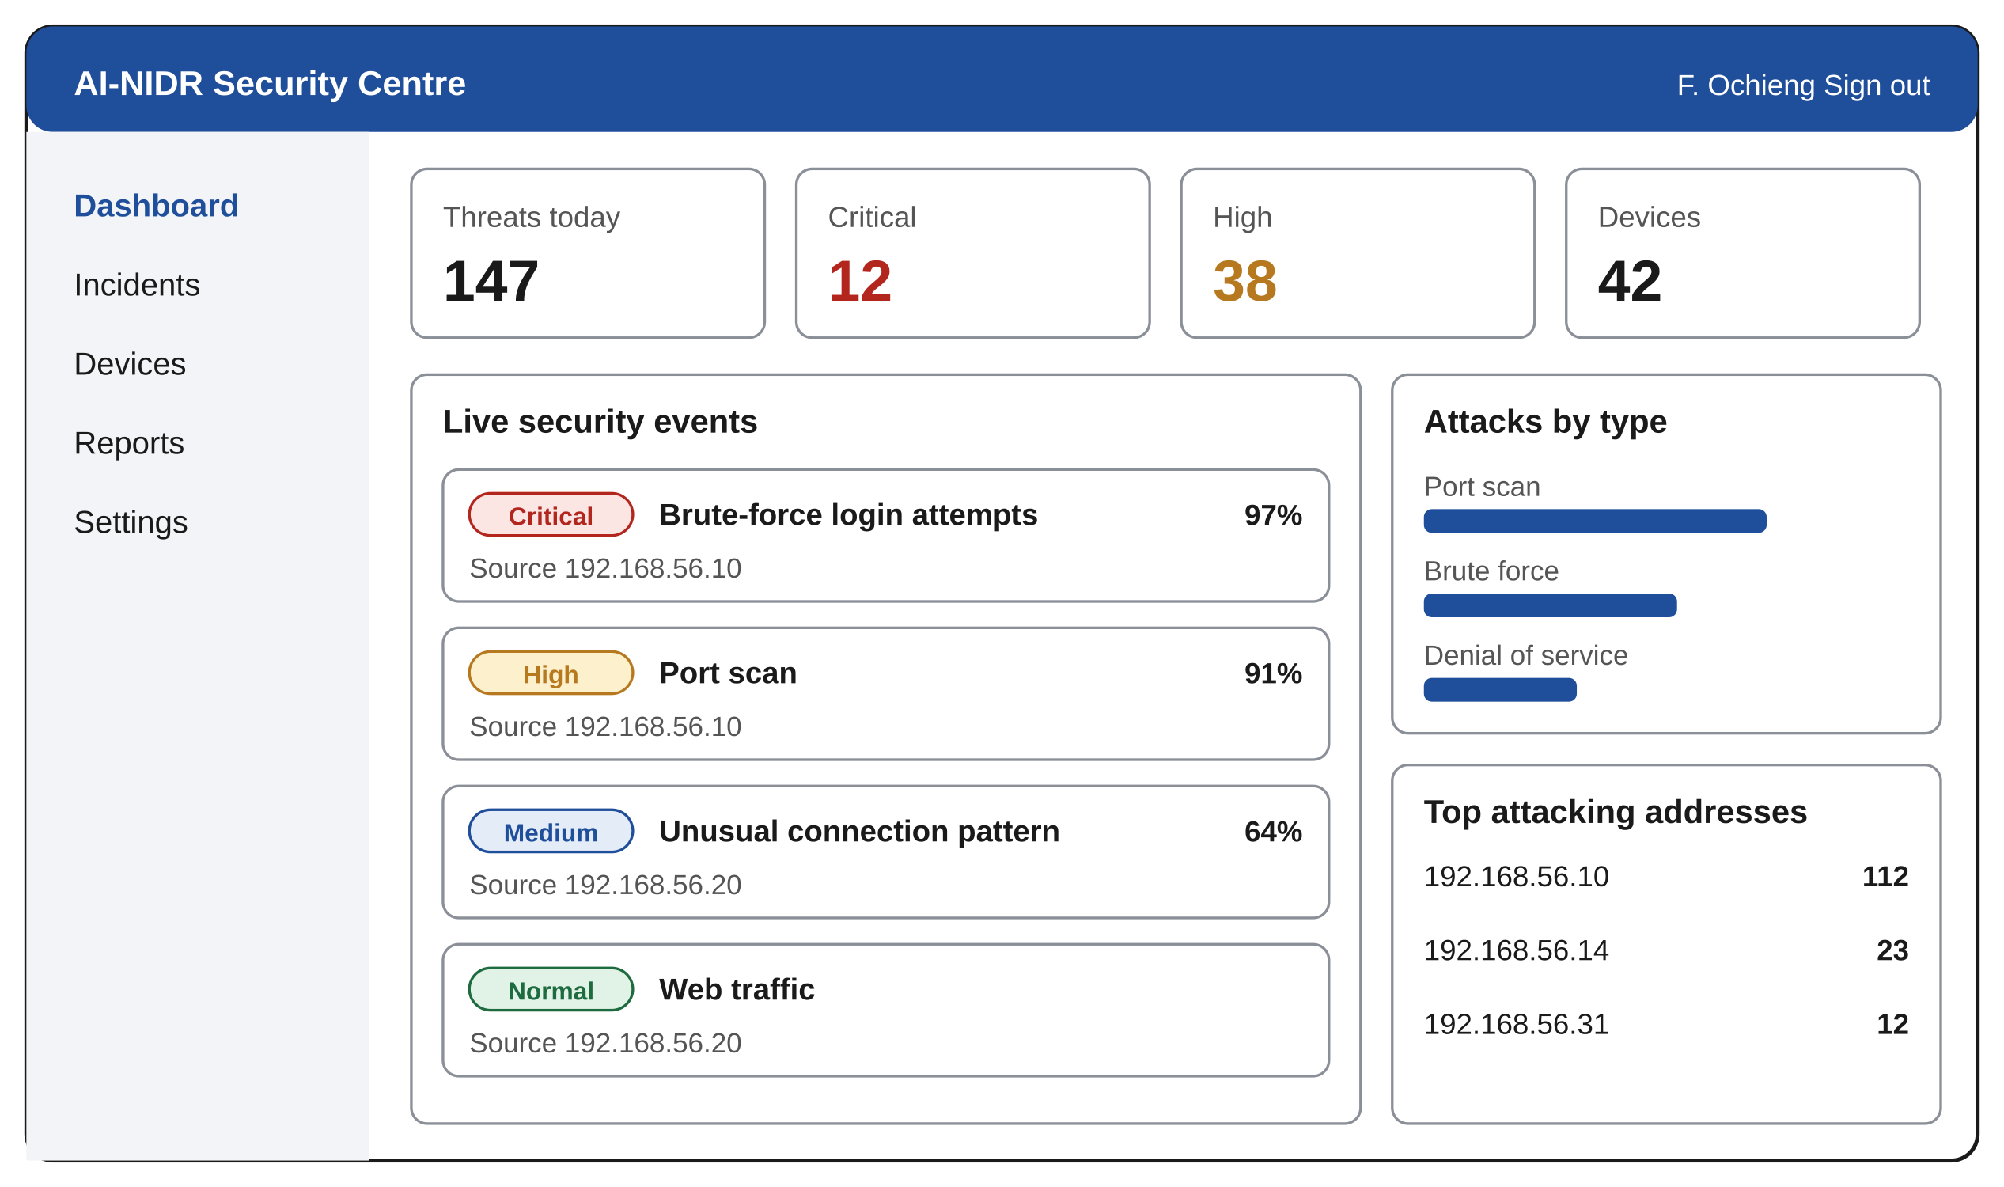
Figure 7: Prototype of the main dashboard screen
The values in Figure 7 are examples for layout only.
Screen | Address | Roles
Sign in | /login | All
Dashboard | / | All
Incidents | /incidents | All
Incident detail | /incidents/{id} | All; actions for analyst and administrator
Devices | /devices | All
Reports | /reports | Analyst, administrator
Settings | /settings | Administrator
Audit log | /audit | Administrator

7.2 API
The backend exposes a REST API under /api/v1 and one WebSocket. Requests and responses use JSON.
Method | Path | Purpose | Who
POST | /auth/login | Sign in with email, password and code | All
POST | /auth/refresh | Get a new access token | All
POST | /ingest/connections | Submit connection records | Sensor
GET | /alerts | List alerts, with filters | All
GET | /incidents | List incidents, with filters | All
GET | /incidents/{id} | One incident with its alerts, notes and responses | All
PATCH | /incidents/{id} | Change status or assignment | Analyst, administrator
POST | /incidents/{id}/notes | Add a note | Analyst, administrator
POST | /responses/block | Block an address by hand | Analyst, administrator
POST | /responses/release | Release a blocked address | Analyst, administrator
GET | /stats/summary | Figures for the dashboard | All
GET, PUT | /settings | Read or change settings | Administrator
GET, POST, DELETE | /allowlist | Manage trusted addresses | Administrator
WebSocket | /ws/events | Live alerts, incidents and responses | All

Example of an alert sent over the WebSocket:
{
"type": "alert",
"alert_id": 20931,
"incident_id": 1047,
"source_ip": "192.168.56.10",
"target_ip": "192.168.56.20",
"attack_type": "brute_force",
"confidence": 0.97,
"risk_score": 78,
"severity": "critical",
"created_at": "2026-11-20T02:14:32Z"
}

Example of an error:
{"error": "address_on_allowlist",
"message": "This address is trusted and cannot be blocked."}

8. Security design
AI-NIDR can block traffic, so it must itself be hard to misuse. Each control below answers a named threat.
Threat | Control | Requirement
Stolen password | A second factor is required at every sign-in | FR-02
Stolen password database | Argon2id hashes with a salt for each password | NFR-07
Password guessing | Lockout for 15 minutes after five failures; request limits | FR-05
Eavesdropping | HTTPS with TLS 1.2 or later on every connection | NFR-08
Forged sensor data | Each sensor signs in with its own key, which can only submit records | FR-11
An attacker tricking the system into blocking a legitimate host | Allowlist, blocks limited to the monitored range, a limit on active blocks, and expiry of every block | FR-29 to FR-32
Misuse of the response agent | An SSH account that can run only the block and release commands | NFR-11
SQL injection | Parameterised queries through the ORM | NFR-10
Cross-site scripting | React escapes all output; a content security policy | NFR-12
Use of another role's functions | Role check on the server for every request | FR-03
Denied actions afterwards | Every action by users and by the system is written to the audit log | FR-44

9. Error handling
The system fails safely: when it is unsure or a part has failed, it alerts a person and does not block.
Situation | System response
The sensor sends nothing for 60 seconds | Show a sensor warning on the dashboard and notify the administrator
A record cannot be read | Skip it, count it, and continue
A model file cannot be loaded | Keep the last working model active and warn the administrator
The models disagree strongly | Raise the alert with the lower confidence and mark it for review
The firewall cannot be reached | Mark the response as failed, keep the incident critical, and notify the administrator
The limit on active blocks is reached | Stop automatic blocking, notify the administrator, and continue alerting
The database is unavailable | Hold records in memory for up to 5 minutes, then drop the oldest and log the loss
An unknown error occurs in the API | Return a plain error with a reference number; details go to the server log only

10. Requirements traceability
Every group of requirements is covered by a part of this design. The requirement numbers are those of the AI-NIDR Software Requirements Specification.
Requirements | Design section
FR-01 to FR-06: accounts and access | 6.8 Authentication and access control
FR-07 to FR-11: traffic capture | 3.4 Deployment and laboratory, 6.2 Sensor and feature extraction
FR-12 to FR-15: feature extraction | 6.2 Sensor and feature extraction
FR-16 to FR-20: detection | 6.1 Class structure, 6.3 Detection models
FR-21 to FR-23: attack classification | 6.4 Attack classification
FR-24 to FR-27: risk scoring | 6.5 Risk scoring
FR-28 to FR-33: automated response | 6.6 Response engine
FR-34 to FR-38: incident management | 6.7 Incident management
FR-39 to FR-43: dashboard | 6.9 Live events and notifications, 7.1 Dashboard screens
FR-44 to FR-46: audit log | 5.2 Table definitions
FR-47 to FR-49: API | 7.2 API
NFR-01 to NFR-03: performance | 4.3 Time budget
NFR-04 to NFR-06: detection quality | 6.3 Detection models
NFR-07 to NFR-12: security | 8 Security design
NFR-13 to NFR-15: reliability and safe failure | 9 Error handling

10.1 Approval
Role | Name | Signature | Date
Candidate | Felix Ochieng
Supervisor | Joseph Mugai

