
KCA UNIVERSITY
SCHOOL OF TECHNOLOGY
AI-NIDR: AN AI-POWERED NETWORK INTRUSION DETECTION AND AUTOMATED RESPONSE SYSTEM
SOFTWARE REQUIREMENTS SPECIFICATION
FELIX OCHIENG
Registration number: 24/06618
Supervisor: Joseph Mugai
Client: [client organisation name]
Bachelor of Science in Applied Computing
Version 1.0 (draft)
October 2026

Revision history
Version | Date | Description | Author
1.0 | 4 October 2026 | First draft, based on the approved proposal | Felix Ochieng

Table of contents

1. Introduction 4
1.1 Purpose 4
1.2 Scope 4
1.3 Definitions, acronyms and abbreviations 5
1.4 References 5
1.5 Overview 6
2. Overall description 7
2.1 Product perspective 7
2.2 Product functions 7
2.3 User classes and characteristics 7
2.4 Operating environment 8
2.5 Design and implementation constraints 8
2.6 Assumptions and dependencies 8
3. Current system and requirements gathering 9
3.1 Current process 9
3.2 Problems and the needs they create 9
3.3 Requirements gathering 9
3.4 Findings 10
4. Functional requirements 11
4.1 Accounts and access 11
4.2 Traffic capture 11
4.3 Feature extraction 11
4.4 Detection 12
4.5 Attack classification 12
4.6 Risk scoring 12
4.7 Automated response 13
4.8 Incident management 13
4.9 Dashboard 13
4.10 Audit log 14
4.11 API 14
5. Use cases 15
5.1 Use case list 15
5.2 UC-11 Detect and respond automatically 16
5.3 UC-03 Investigate an incident 16
5.4 UC-04 Block or release an address 17
5.5 UC-07 Configure detection and response 17
6. External interface requirements 19
6.1 User interfaces 19
6.2 Hardware interfaces 19
6.3 Software interfaces 19
6.4 Communication interfaces 20
7. Non-functional requirements 21
7.1 Performance 21
7.2 Detection quality 21
7.3 Security 21
7.4 Reliability and safe failure 21
7.5 Usability 22
7.6 Maintainability and portability 22
7.7 Legal and ethical 22
8. Data requirements 23
9. Acceptance criteria and traceability 24
9.1 Approval 24
Appendix: data collection instruments 26
A. Interview guide for the client's IT staff and manager 26
B. Questionnaire for IT staff in other organisations 26
C. Document review checklist 27

1. Introduction

1.1 Purpose
This document states what AI-NIDR must do and how well it must do it. It is the agreed basis for design, development and testing.
It is written for three readers: the project supervisor and examiners, the developer, and the client whose staff will use the system.

1.2 Scope
AI-NIDR is a network security system that monitors traffic continuously, uses machine learning to detect and classify attacks, scores the risk of each one, and responds automatically to the most serious. Staff follow events and manage incidents on a web dashboard.
In scope:
- Capture of network traffic with Zeek and Suricata.
- Extraction of numerical features for each source address.
- Machine learning detection and classification of port scanning, brute-force login attempts and denial of service.
- A risk score from 0 to 100 with four severity levels.
- Automatic and manual blocking of a source on the firewall, with safeguards.
- Incident management, a live dashboard, reports and an audit log.
- User accounts with roles and two-factor sign-in.
Out of scope:
- Reading the content of communications. The system examines how connections behave, not what they carry.
- Protection of individual computers against malware, which antivirus software provides.
- Naming attack types beyond the three listed. Other unusual behaviour is reported as an anomaly of unknown type.
- Installation on the client's live network during this project. The system is developed and tested in an isolated laboratory.
- A mobile application.

1.3 Definitions, acronyms and abbreviations
Term | Meaning
Alert | One detection of suspicious behaviour by one source in one time window
Allowlist | Addresses the system must never block
API | Application Programming Interface
Brute force | Repeated guessing of passwords against a login service
CIC-IDS2017 | A public dataset of labelled network traffic used for training and testing
Denial of service | Flooding a server with requests so that it cannot serve legitimate users
F1-score | A single measure that combines precision and recall
False positive rate | The share of normal traffic wrongly reported as an attack
Feature window | The numerical summary of one source's traffic over a short period
Incident | A group of related alerts from one source, managed as one case
Port scan | Probing many ports on a host to find services that can be attacked
Sensor | The part of the system that observes network traffic
SRS | Software Requirements Specification
TLS | Transport Layer Security
Zeek, Suricata | Open source network monitoring and intrusion detection tools

1.4 References
- Ochieng, F. (2026). AI-NIDR: An AI-powered network intrusion detection and automated response system [Project proposal]. KCA University.
- IEEE. (1998). IEEE recommended practice for software requirements specifications (IEEE Std 830-1998).
- ISO/IEC/IEEE. (2018). Systems and software engineering: Life cycle processes: Requirements engineering (ISO/IEC/IEEE 29148:2018).
- OWASP Foundation. (2021). OWASP Top 10: 2021.
- Republic of Kenya. (2019). The Data Protection Act, 2019.
- Sharafaldin, I., Lashkari, A. H., & Ghorbani, A. A. (2018). Toward generating a new intrusion detection dataset and intrusion traffic characterization. In Proceedings of the 4th International Conference on Information Systems Security and Privacy (pp. 108–116).

1.5 Overview
Section 2 describes the product and its users. Section 3 describes the current situation. Sections 4 to 8 give the functional, interface, non-functional and data requirements. Section 9 links the requirements to the project objectives and states how each will be accepted.

2. Overall description

2.1 Product perspective
AI-NIDR is a new system that sits beside the network it protects. It does not replace the client's firewall or antivirus software. It adds what they lack: continuous examination of traffic inside the network, a judgement of how serious each attack is, and a fast response.
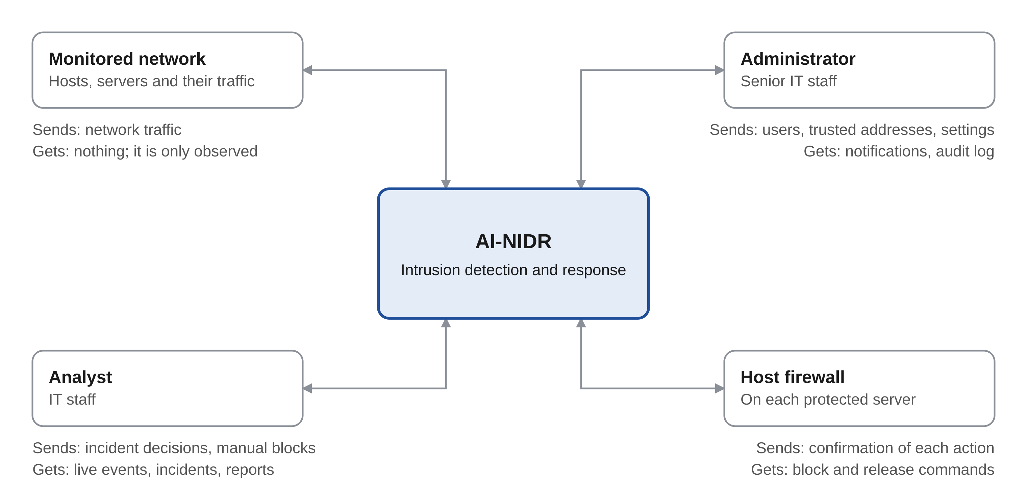
Figure 1: Context diagram of AI-NIDR
Figure 1 shows what each party sends to AI-NIDR and gets back. The monitored network is only observed, and the system acts on it through the firewall of each protected server.

2.2 Product functions
- Observe the traffic on the monitored network and record every connection.
- Summarise the behaviour of each source address as numerical features.
- Detect attacks with trained machine learning models.
- Name the type of each attack and score its risk from 0 to 100.
- Block the source of a critical attack, within strict safeguards.
- Group alerts into incidents and track each one to its close.
- Show live events, statistics and reports on a dashboard.
- Record every action by users and by the system.

2.3 User classes and characteristics
User class | Who | Main tasks | Skill level
Viewer | Manager or auditor | Follow the dashboard and read incidents | Basic computer skills
Analyst | IT staff | All viewer tasks, plus investigate incidents, block and release addresses, download reports | Working knowledge of networks
Administrator | Senior IT staff | All analyst tasks, plus manage users, sensors, trusted addresses and settings | Good knowledge of networks and security
Sensor | Software on the AI-NIDR server | Submits connection records automatically | Not a person

2.4 Operating environment
- Server. A Linux machine with Docker, at least four processor cores and 8 GB of memory.
- Laboratory. A laptop with 16 GB of memory running three virtual machines in VirtualBox on an isolated network.
- Client. Current versions of Chrome, Edge and Firefox on a desktop or tablet screen at least 1,024 pixels wide.
- Network. The sensor must be able to see the traffic it monitors, through a mirror port or a network card in promiscuous mode.

2.5 Design and implementation constraints
- The project must be complete by 18 December 2026 and is built by one developer.
- Only free and open source tools may be used, within a budget of KES 24,200.
- Test attacks may be run only inside the isolated laboratory owned by the researcher.
- Automatic blocking may act only on addresses inside the monitored network.
- The system stores facts about connections, not the content of communications.

2.6 Assumptions and dependencies
- The laptop can run three virtual machines at once.
- The CIC-IDS2017 dataset and its packet captures remain available for training.
- The attacks of interest can be recognised from connection behaviour without reading content.
- The client allows interviews with its IT staff and a review of its network documents.
- Detection thresholds and risk weights are set from test results, not fixed in advance.
- A person still reviews incidents. AI-NIDR supports that work and does not replace it.

3. Current system and requirements gathering

3.1 Current process
The client's network is protected at its edge, and nobody examines the traffic inside it. The steps below come from the proposal and must be confirmed during data collection.
- Traffic enters and leaves the network through the firewall.
- The firewall and antivirus software stop the threats they already know.
- Traffic inside the network is not examined.
- A problem is noticed by users, for example a slow system or a locked account.
- IT staff read the logs afterwards to find out what happened.
- The fix is applied by hand, and no record of the incident is kept.

3.2 Problems and the needs they create
Problem in the current situation | What the new system must provide
Attacks inside the network go unseen | Continuous monitoring of all traffic
Rule-based tools miss changed attacks | Detection that learns attack behaviour
Staff cannot tell which alerts matter | A risk score and severity for every alert
Response waits for a person | Automatic blocking of critical attacks
A wrong block would disrupt work | Trusted addresses, expiring blocks and manual release
No record of incidents | Stored incidents with status, action and notes

3.3 Requirements gathering
Requirements are gathered between 12 and 23 October 2026, using three methods. The instruments are in the appendix.
Method | Participants | What it must establish
Interviews | The client's IT staff and manager | How the network is monitored, what incidents have occurred and how they were handled
Questionnaire | 30 IT staff in other organisations | How attacks are detected and responded to elsewhere, and what staff want from a tool
Document review | Network diagram, security policy, incident records | The size of the network, the tools in use and the incidents on record

3.4 Findings
Findings are added here once data collection is complete. Until then, the requirements in this document rest on the proposal.
Question | Finding
Number of networked devices | [to be recorded]
Security tools in use | [to be recorded]
Who monitors the network, and when | [to be recorded]
Security incidents in the past 12 months | [to be recorded]
How each incident was detected, and how long it took | [to be recorded]
How long the response took | [to be recorded]
Features staff rank as most important | [to be recorded]

4. Functional requirements
AI-NIDR has 49 functional requirements in eleven groups. High priority requirements are needed for the system to meet its objectives. Medium and low priority requirements are built once those are working.

4.1 Accounts and access
ID | Requirement | Priority
FR-01 | The system shall require users to sign in with an email address and a password. | High
FR-02 | The system shall also require a one-time code from an authenticator app at every sign-in. | High
FR-03 | The system shall give each user one role, viewer, analyst or administrator, and restrict each function to the roles permitted to use it. | High
FR-04 | The system shall let an administrator create, edit and deactivate users and reset their passwords and authenticator codes. | High
FR-05 | The system shall lock an account for 15 minutes after five failed sign-in attempts. | Medium
FR-06 | The system shall end a session after 30 minutes without activity. | Medium

4.2 Traffic capture
ID | Requirement | Priority
FR-07 | The system shall observe all traffic on the monitored network and record every connection, using Zeek. | High
FR-08 | The system shall run Suricata's rules on the same traffic and record its alerts. | High
FR-09 | The system shall pass each new record to the detection engine within 5 seconds of it being written. | High
FR-10 | The system shall accept packet capture files and process them in the same way as live traffic. | Medium
FR-11 | Each sensor shall sign in with its own key, which permits it only to submit records. | High

4.3 Feature extraction
ID | Requirement | Priority
FR-12 | The system shall keep the last 60 seconds of connection records for each source address. | High
FR-13 | The system shall produce a feature window for each active source every 10 seconds. | High
FR-14 | Each feature window shall include counts of connections, destinations and ports, the share of failed connections, bytes, durations, and counts by protocol and service. | High
FR-15 | The system shall store each feature window with its source address, its time and, for laboratory traffic, its known label. | Medium

4.4 Detection
ID | Requirement | Priority
FR-16 | The system shall classify each feature window as normal or as an attack, using a trained model. | High
FR-17 | The system shall flag feature windows that are unusual, using a model trained on normal traffic only. | High
FR-18 | The system shall give each detection a confidence from 0 to 1. | High
FR-19 | The system shall raise an alert when the confidence passes a threshold that an administrator can change. | High
FR-20 | The system shall record the model version on each alert and let an administrator activate another version without stopping the system. | Medium

4.5 Attack classification
ID | Requirement | Priority
FR-21 | The system shall label each detected attack as port scanning, brute force or denial of service. | High
FR-22 | The system shall label a window flagged only as unusual as an anomaly of unknown type. | Medium
FR-23 | The system shall record on each alert whether Suricata also raised an alert for the same source. | Medium

4.6 Risk scoring
ID | Requirement | Priority
FR-24 | The system shall give each alert a risk score from 0 to 100. | High
FR-25 | The score shall combine the model's confidence, the attack type, the number of hosts targeted and earlier incidents from the same source. | High
FR-26 | The system shall give each alert a severity: low for 0 to 24, medium for 25 to 49, high for 50 to 74, and critical for 75 to 100. | High
FR-27 | The system shall let an administrator change the weights used in the score. | Low

4.7 Automated response
ID | Requirement | Priority
FR-28 | The system shall block the source of a critical alert on the firewall of each protected server, without waiting for a person. | High
FR-29 | Every block shall end by itself after a set period, which starts at 30 minutes. | High
FR-30 | The system shall never block an address on the allowlist. | High
FR-31 | The system shall block only addresses inside the monitored network. | High
FR-32 | The system shall limit the number of active blocks. When the limit is reached it shall stop blocking automatically and notify the administrator. | Medium
FR-33 | The system shall let an analyst block or release an address by hand, let an administrator switch automatic response off, and record every response. | High

4.8 Incident management
ID | Requirement | Priority
FR-34 | The system shall group alerts from one source with one attack type into one incident when they arrive within 15 minutes of each other. | High
FR-35 | The system shall store each incident with its source, target, attack type, confidence, severity, action taken and status. | High
FR-36 | The system shall let an analyst move an incident between new, investigating, resolved and false positive. | High
FR-37 | The system shall let an analyst take an incident and add notes to it. | Medium
FR-38 | When an incident is marked as a false positive, the system shall release any block it caused and label its traffic as normal for future training. | Medium

4.9 Dashboard
ID | Requirement | Priority
FR-39 | The dashboard shall show each new alert, incident and response within 2 seconds, without the page being reloaded. | High
FR-40 | The dashboard shall show counts by severity, attacks by type, top attacking addresses, most targeted devices and an attack timeline. | High
FR-41 | The dashboard shall let users search and filter incidents by date, severity, attack type, status and address. | Medium
FR-42 | The system shall notify the administrator by email of high and critical incidents, at most once every 10 minutes for the same incident. | Medium
FR-43 | The system shall produce a report of incidents over a chosen period as a PDF file and as a CSV file. | Medium

4.10 Audit log
ID | Requirement | Priority
FR-44 | The system shall record every sign-in, incident change, response and settings change, with the user, the time and the values involved. | High
FR-45 | The system shall record the actions it takes by itself in the same log. | High
FR-46 | The system shall let an administrator view and search the audit log. No user shall be able to change or delete its entries through the application. | Medium

4.11 API
ID | Requirement | Priority
FR-47 | The API shall serve the dashboard with alerts, incidents, responses, statistics and settings. | High
FR-48 | The API shall accept a request only with a valid access token from a user or a valid key from a sensor. | High
FR-49 | The system shall limit the number of requests each user and each sensor can make in a minute. | Medium

5. Use cases
Five actors use the system through eleven use cases. The four most important use cases are described in full below.
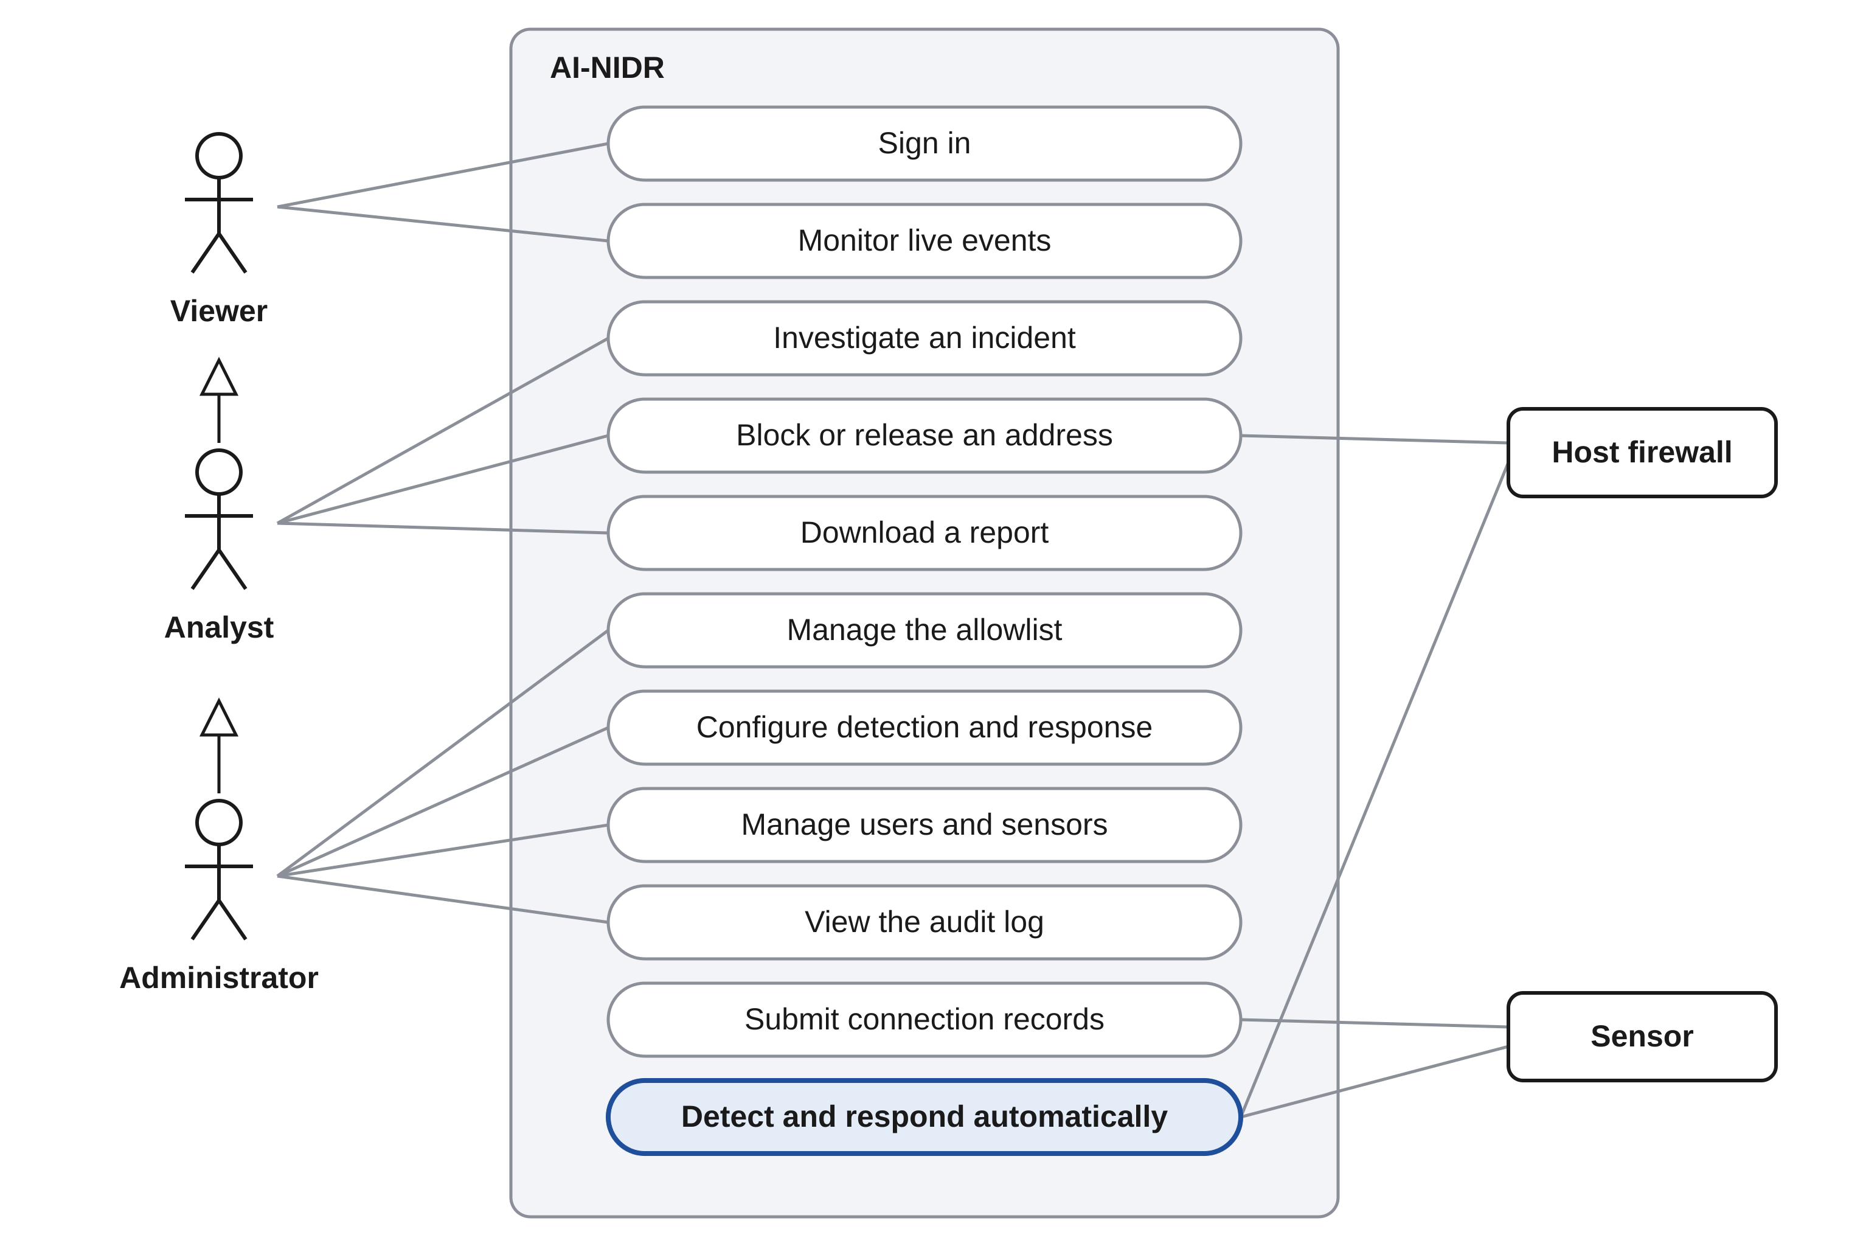
Figure 2: Use case diagram of AI-NIDR
In Figure 2 an arrow from one actor to another means the first can do everything the second can. An administrator is also an analyst, and an analyst is also a viewer.

5.1 Use case list
ID | Use case | Actors | Requirements
UC-01 | Sign in | Viewer, analyst, administrator | FR-01 to FR-06
UC-02 | Monitor live events | Viewer | FR-39, FR-40
UC-03 | Investigate an incident | Analyst | FR-34 to FR-38, FR-41
UC-04 | Block or release an address | Analyst, host firewall | FR-29 to FR-33
UC-05 | Download a report | Analyst | FR-43
UC-06 | Manage the allowlist | Administrator | FR-30
UC-07 | Configure detection and response | Administrator | FR-19, FR-20, FR-27, FR-32, FR-33
UC-08 | Manage users and sensors | Administrator | FR-03, FR-04, FR-11
UC-09 | View the audit log | Administrator | FR-44 to FR-46
UC-10 | Submit connection records | Sensor | FR-07 to FR-11
UC-11 | Detect and respond automatically | Sensor, host firewall | FR-12 to FR-35

5.2 UC-11 Detect and respond automatically
- Actors: sensor and host firewall.
- Precondition: the sensor is running and at least one model is active.
- Trigger: the sensor submits new connection records.
- Postcondition: any attack has an alert, a risk score and an incident, and a critical attack has been blocked.
Main flow:
- The system adds the records to the recent traffic of each source address.
- Every 10 seconds the system produces a feature window for each active source.
- The models examine each window.
- For a window judged to be an attack, the system names the attack type and calculates the risk score.
- The system stores the alert and adds it to an incident.
- The dashboard shows the alert.
- For a critical alert, the system blocks the source on the host firewall, records the response and notifies the administrator.
Alternative flows:
- Normal traffic. At step 3 the window is judged normal. It is stored and no alert is raised.
- Unknown behaviour. At step 4 only the anomaly model flags the window. The alert is labelled as an anomaly of unknown type.
- Trusted source. At step 7 the source is on the allowlist or outside the monitored network. The alert stays critical, no block is made, and the administrator is notified.
- Firewall unreachable. At step 7 the firewall does not answer. The response is recorded as failed and the administrator is notified.

5.3 UC-03 Investigate an incident
- Actor: analyst.
- Precondition: the analyst is signed in and an incident exists.
- Trigger: a new incident appears on the dashboard.
- Postcondition: the incident is closed as resolved or as a false positive, with notes.
Main flow:
- The analyst opens the incident and takes it.
- The system shows its alerts, risk score, source, targets and any response.
- The analyst adds notes on what was found.
- The analyst marks the incident as resolved.
- The system records the change in the audit log.
Alternative flow:
- False positive. At step 4 the analyst marks the incident as a false positive. The system releases any block it caused and labels the traffic as normal.

5.4 UC-04 Block or release an address
- Actors: analyst and host firewall.
- Precondition: the analyst is signed in.
- Trigger: the analyst decides that an address should be blocked, or that a block should end.
- Postcondition: the firewall reflects the decision and the response is recorded.
Main flow:
- The analyst chooses an address and selects block or release.
- The system checks the address against the allowlist and the monitored network.
- The system sends the command to the host firewall.
- The firewall confirms the action.
- The system records the response against the incident and in the audit log.
Alternative flow:
- Not allowed. At step 2 the address is trusted or outside the monitored network. The system refuses the block and explains why.

5.5 UC-07 Configure detection and response
- Actor: administrator.
- Precondition: the administrator is signed in.
- Trigger: test results or experience show that a setting should change.
- Postcondition: the new setting applies to traffic from that moment and the change is logged.
Main flow:
- The administrator opens the settings.
- The administrator changes the detection threshold, the risk weights, the block period, the limit on active blocks, or switches automatic response on or off.
- The system checks that the values are within range.
- The system saves the change and records it in the audit log.
Alternative flow:
- Automatic response off. The system keeps detecting and alerting. For each critical alert it records the block it would have made, without making it.

6. External interface requirements

6.1 User interfaces
The dashboard has eight screens. An analyst must reach any incident in no more than three steps from the main screen.
Screen | Purpose | Roles
Sign in | Sign in with password and one-time code | All
Dashboard | Live events, counts by severity, attacks by type, top sources | All
Incidents | Search and filter incidents | All
Incident detail | Alerts, notes and responses of one incident; actions on it | All; actions for analyst and administrator
Devices | Monitored hosts and the sensors watching them | All
Reports | Produce incident reports | Analyst, administrator
Settings | Users, sensors, trusted addresses, thresholds and weights | Administrator
Audit log | View and search the audit log | Administrator

Interface rules:
- Severity shall be shown in words as well as colour.
- Every automatic action shall be shown with the reason for it.
- An action that blocks or releases an address shall ask for confirmation.
- Error messages shall state what went wrong and what the user should do next.

6.2 Hardware interfaces
The sensor needs a network card that can see the monitored traffic, through a mirror port on a switch or promiscuous mode on a virtual network. No other special hardware is needed.

6.3 Software interfaces
Component | Purpose
Zeek | Records every connection on the monitored network
Suricata | Applies rules to the same traffic for comparison
Scikit-learn, XGBoost | Trained detection models
PostgreSQL | Stores feature windows, alerts, incidents, responses, users and settings
FastAPI | Backend and API
React | Dashboard
nftables | The firewall on each protected server
Email server | Sends notifications to the administrator

Exact versions are fixed in the design document.

6.4 Communication interfaces
All traffic between the dashboard, the sensor and the backend shall use HTTPS with TLS 1.2 or later. The API exchanges data in JSON, and live events are sent over a WebSocket. Commands to a host firewall are sent over SSH.
Status code | Meaning
400 | The request is incomplete or malformed
401 | The access token or sensor key is missing, wrong or expired
403 | The user's role does not allow the action
409 | The action is refused, for example a block on a trusted address
429 | The request limit has been exceeded

7. Non-functional requirements
AI-NIDR has 23 non-functional requirements. Each is written so that it can be tested.

7.1 Performance
ID | Requirement
NFR-01 | The system shall raise an alert within 60 seconds of the start of an attack.
NFR-02 | The system shall apply a block within 10 seconds of a critical alert.
NFR-03 | The system shall process at least 500 connection records a second without falling behind.

7.2 Detection quality
ID | Requirement
NFR-04 | The system shall reach an F1-score of at least 90% on the test data.
NFR-05 | The false positive rate on normal test traffic shall be below 5%.
NFR-06 | Results shall be reported separately for CIC-IDS2017 and for laboratory traffic, and beside Suricata's results on the same traffic.

7.3 Security
ID | Requirement
NFR-07 | Passwords shall be stored only as salted hashes, using Argon2id.
NFR-08 | All traffic to and from the backend shall be encrypted with TLS 1.2 or later.
NFR-09 | Authenticator secrets shall be stored encrypted, and sensor keys shall be stored as hashes.
NFR-10 | All input shall be validated on the server, and all database queries shall be parameterised.
NFR-11 | The account used to reach a host firewall shall be able to run only the block and release commands.
NFR-12 | The system shall resist the applicable OWASP Top 10 (2021) risks, confirmed by security testing.

7.4 Reliability and safe failure
ID | Requirement
NFR-13 | The system shall warn the administrator when a sensor has sent nothing for 60 seconds.
NFR-14 | When a part of the system fails or is unsure, the system shall alert a person and shall not block.
NFR-15 | A block shall end at its set time even if the AI-NIDR server is switched off.

7.5 Usability
ID | Requirement
NFR-16 | A new analyst shall find, open and close an incident unaided after 30 minutes of training.
NFR-17 | The client's staff shall give the dashboard an average System Usability Scale score of at least 70.

7.6 Maintainability and portability
ID | Requirement
NFR-18 | Each model and each firewall shall sit behind a common interface, so that one can be replaced without changing the rest.
NFR-19 | The whole system shall start with one command on any machine that runs Docker.
NFR-20 | Feature extraction, risk scoring and the response safeguards shall have automated tests.

7.7 Legal and ethical
ID | Requirement
NFR-21 | The system shall store facts about connections only, and handle addresses as personal data under the Data Protection Act, 2019.
NFR-22 | Test attacks shall be run only inside the isolated laboratory, and the system shall take no automatic action outside the monitored network.
NFR-23 | Connection records shall be deleted after a retention period set by the administrator. The default is 90 days, to be confirmed with the client.

8. Data requirements
The system stores eleven kinds of record. The full database design, with keys and types, is in the design document.
Entity | Main attributes
User | Name, email, password hash, role, authenticator secret, status
Sensor | Name, key hash, monitored network, time last seen
Feature window | Sensor, source address, start time, length, feature values, label
Model version | Name, version, file location, F1-score, false positive rate, whether active
Alert | Feature window, model, incident, source, target, attack type, confidence, risk score, severity, time
Incident | Source, attack type, severity, risk score, status, assigned analyst, times opened and closed
Incident note | Incident, author, text, time
Response | Incident, action, address, whether automatic, who performed it, status, time, expiry
Allowlist entry | Address or range, reason, who added it
Audit entry | User or system, action, values involved, time
Setting | Name, value

Data rules:
- Every alert shall belong to exactly one incident.
- Every response shall name the incident it answers and whether it was automatic.
- Audit entries shall only be added, never changed or removed.
- Packet captures shall be kept only in the laboratory and shall not be stored in the database.

9. Acceptance criteria and traceability
The system is accepted when all nine tests below pass. The first four correspond to the system objectives in the proposal.
Objective | Requirements | Acceptance test
Detect malicious traffic with an F1-score of at least 90% and a false positive rate below 5% | FR-12 to FR-20, NFR-04 to NFR-06 | Run the held-out CIC-IDS2017 windows and the laboratory traffic. Both measures meet the targets.
Alert within 60 seconds of the start of an attack | FR-07 to FR-13, NFR-01 | Launch each attack type ten times in the laboratory. Every alert arrives within the limit.
Classify each attack into one of at least three types and score its risk | FR-21 to FR-27 | Each test attack is labelled with its true type, and its score falls in the expected severity.
Block the source of a critical attack within 10 seconds and record every incident and response | FR-28, FR-29, FR-33 to FR-35, NFR-02 | Run a critical attack. The firewall on the target holds the source within the limit, and the incident and response are stored.
Never block a legitimate host | FR-30 to FR-32, NFR-14, NFR-15 | Attack from a trusted address and from outside the monitored range. Alerts are raised and no block is made. A block ends at its set time.
Compare with rule-based detection | FR-08, FR-23, NFR-06 | Pass the same laboratory traffic through Suricata's rules and the models. Both sets of results are reported side by side.
Restrict functions by role | FR-01 to FR-06, FR-48 | Each role attempts every function. Only permitted functions succeed.
Resist common attacks | NFR-07 to NFR-12 | A security test covering the applicable OWASP Top 10 risks finds no open high-risk issue.
Be usable by the client's staff | NFR-16, NFR-17 | Staff complete set tasks unaided and give an average usability score of at least 70.

9.1 Approval
Role | Name | Signature | Date
Candidate | Felix Ochieng
Supervisor | Joseph Mugai
Client representative | [client representative's name]

Appendix: data collection instruments
These three instruments produce the findings for section 3.4. All participants give informed consent, and no names or network addresses are recorded.

A. Interview guide for the client's IT staff and manager
- How many computers, servers and other devices are on the network?
- What protects the network today, and who looks after those tools?
- Does anyone watch network traffic or logs regularly? How often?
- What security incidents have you had in the past 12 months?
- How did you find out about each incident, and how long after it started?
- What did you do in response, and how long did that take?
- Have you ever blocked or disconnected something by mistake? What happened?
- Who should be told when an attack is detected, and how?
- Which machines or services must never be blocked automatically?
- What would you need from a tool that watches the network for you?

B. Questionnaire for IT staff in other organisations
No. | Question | Answer options
1 | How many devices are on your organisation's network? | Under 20, 20 to 50, 51 to 200, over 200
2 | Which of these do you use? | Firewall, antivirus, intrusion detection system, log management, none
3 | How often does someone review network logs or alerts? | Continuously, daily, weekly, only after a problem, never
4 | Has your network been attacked in the past 12 months? | Yes, no, not sure
5 | If yes, which kinds? | Port scanning, password guessing, denial of service, malware, other
6 | How was the last attack discovered? | By a security tool, by IT staff, by users, by an outside party
7 | How long after it started was it discovered? | Minutes, hours, days, weeks or more, not known
8 | How long did the response take once it was discovered? | Minutes, hours, days, weeks or more
9 | Would you trust a system to block an attacker automatically? | Yes, only with safeguards, no
10 | Which feature matters most to you? | Fast detection, few false alarms, automatic response, clear reports

C. Document review checklist
☐ Network diagram, with the number and kinds of devices
☐ Security tools installed and how they are configured
☐ Security policy and incident response procedure, if any
☐ Records of past incidents, with dates and actions taken
☐ Addresses and services that must always remain reachable

