The Australian Times
October 31, 1932
EMUS ON THE OFFENSIVE |  | 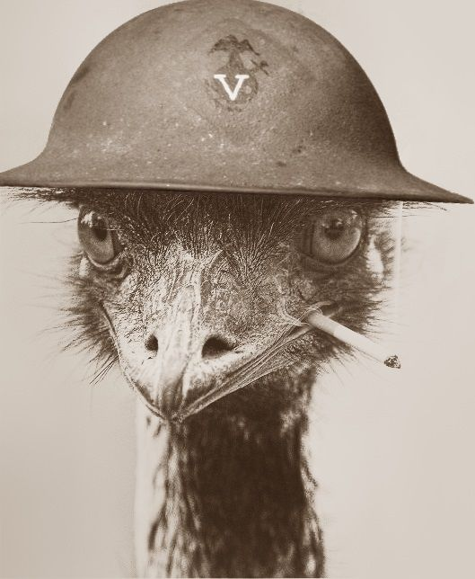
Lorem ipsum dolor sit amet, consectetur adipiscing elit, sed do eiusmod tempor incididunt ut labore et dolore magna aliqua. Ut enim ad minim veniam, quis nostrud exercitation ullamco laboris nisi ut aliquip ex ea commodo consequat. Duis aute irure dolor in reprehenderit in voluptate velit esse cillum dolore eu fugiat nulla pariatur. | Excepteur sint occaecat cupidatat non proident, sunt in culpa qui officia deserunt mollit anim id est laborum. The Australian times actually can’t find the original source of this emu image. A reverse image search shows it goes back to Pinterest in 2016 but we can’t find the original author to credit them. “It’s such a funny picture.” says Sir George Pearce, Minister of Defence.
THE GREAT DEPRESSION IS AMONG US  Lorem ipsum dolor sit amet, consectetur adipiscing elit, sed do eiusmod tempor incididunt ut labore et dolore magna aliqua.  HEADLINE 2  Lorem ipsum dolor sit amet, consectetur adipiscing elit, sed do eiusmod tempor incididunt ut labore et dolore magna aliqua. Ut enim ad minim veniam, quis nostrud exercitation ullamco laboris nisi ut aliquip ex ea commodo consequat. Duis aute irure dolor in  Exit to Desktop | About / Credits  Lorem ipsum dolor sit amet, consectetur adipiscing elit, sed do eiusmod tempor incididunt ut labore et dolore magna aliqua. Ut enim ad minim veniam, quis nostrud exercitation ullamco laboris nisi ut aliquip ex ea commodo consequat.  Lorem ipsum dolor sit amet, labore et dolore magna aliqua.  SEND ME A MESSAGE!  Have ideas for features? Do you want to see this game further developed? Chuck me a message through the feedback form. | HEADLINE 5  Lorem ipsum dolor sit amet, consectetur adipiscing elit, sed do eiusmod tempor incididunt ut labore et dolore magna aliqua. Ut enim ad minim veniam, quis nostrud exercitation ullamco laboris nisi ut aliquip ex ea commodo consequat.  HEADLINE 1  Lorem ipsum dolor sit amet, consectetur adipiscing elit, sed do eiusmod tempor incididunt ut labore et dolore magna  HEADLINE 6  Lorem ipsum dolor sit amet, consectetur adipiscing elit, sed do eiusmod tempor incididunt ut labore et ullamco laboris nisi ut aliquip ex ea. ullamco laboris nisi ut aliquip ex ea. ullamco laboris nisi ut . | HEADLINE 7  Lorem ipsum dolor sit amet, consectetur adipiscing elit, sed do eiusmod tempor  VOLUNTEERS WANTED  Under the leadership of Major Gwynydd Purves Wynne-Aubrey Meredith, the Royal Australian Artillery are looking for keen young soldiers to join the ranks of the 7th Heavy Artillery division.
 |  |  | DEPLOY NOW
 |  |  | to be remembered in the history books for decades to come!

