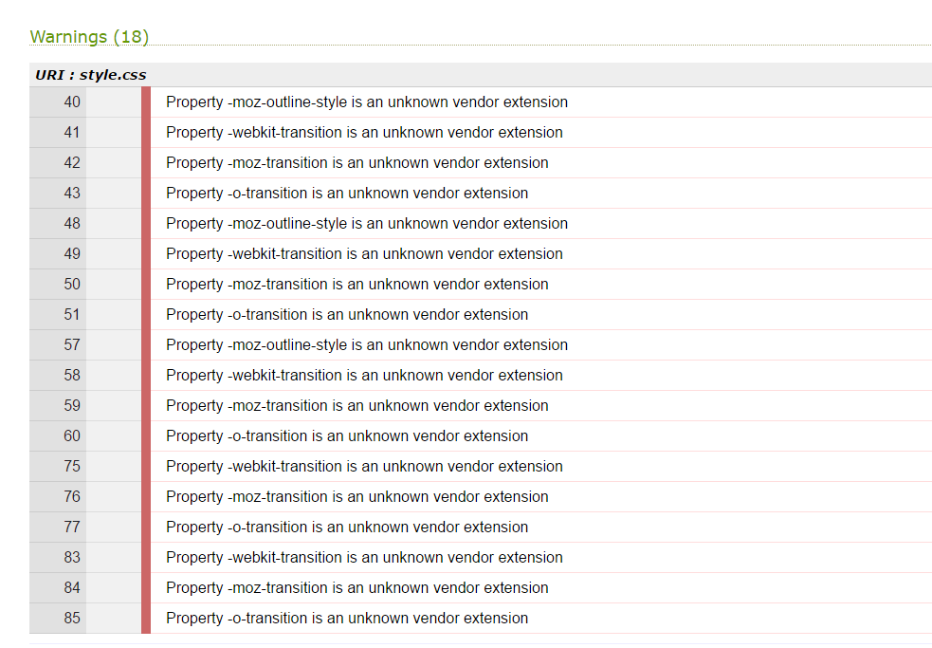
There is nothing you can do to validate vendor extensions except to not use them. Please explain to your client that there is nothing you can do about this since those errors will help support browser compatibility efforts. The validator only validates against valid code. The vendor extensions are proprietary code. As such it will always be invalid.
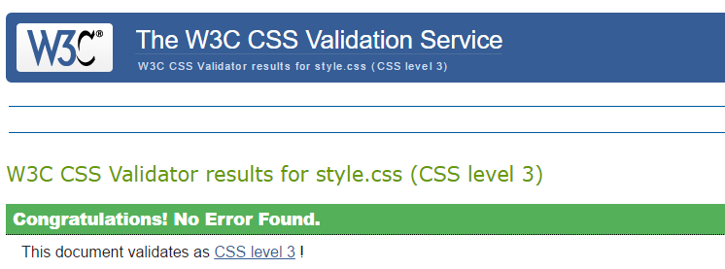

DESIGN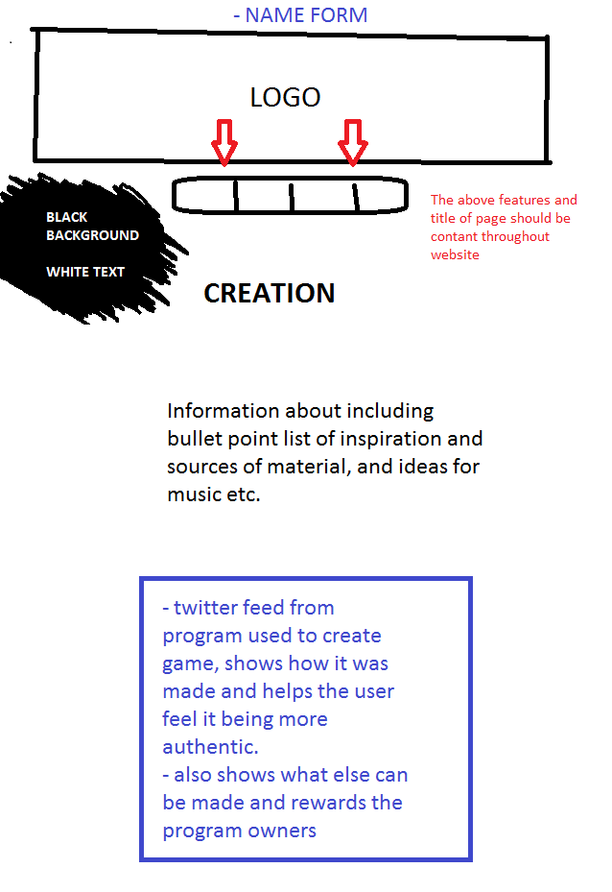
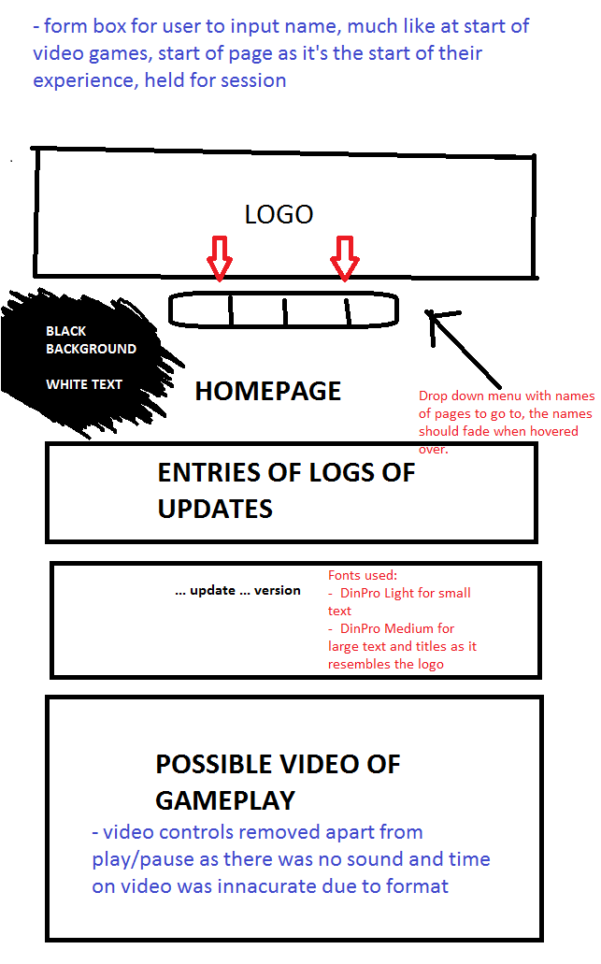

EVALUATION

Overall the implementation feels relevant and modern, with stark simple colours, ways of communication in with different sources for example the twitter integration yet still holding core information unique to the website. The features may be more confusing for some people as the information is sources from different websites, but I aim this to act more as an integration of different content to coalesce in one site. Especially the video will help solidify the interest and hold the attention yet having a simplistic feel, while the personalisation of being addressed by your own name will also act with this in mind. At a later day this could align with such things as a YouTube integrated video rather than being held on the website.
The website is based around a game and so the presentation and features of the website should align with that, such as classic features such as inputting your name at the start of a game.

ARCHETECTURE OF THE WEB

Hyper Text Mark-up Language, otherwise as HTML is the code used to represent almost every modern day website. Each specific website is a/or part of a server that holds a collection of documents that hold this code. It is only by the documents referencing each other that navigation was originally possible through a browser.
A browser in itself is a piece of software which is able to display these documents of html code, much like viewing a word file or pdf.
Due to these documents referencing each other it creates links. And so with numerous links we produce the web, a collection of interlinked HTML documents. This differs from the internet in that while the web is the connection of these documents, the internet is a connection of all the servers that they are hosted on, using specific protocols (TCP/IP) to navigate safely and specifically between the servers.
Some of the data is simply requested and delivered in packets between the servers to display on websites via the servers and users, while others are downloaded by the user to be seen from their specific IP address.
CSS or “Cascading Style Sheets” are used to define the way in which the elements on the webpage are to be displayed. This is due to the used of only HTML made defining such elements as fonts, and colors very laborious and overcomplicated as it created lots of repeated details. The way to define this was in a separate CSS file. This could then be reference by multiple sources to pull details of information used for these elements.

