2018年上海市初中毕业统一学业考试
英语试卷
考生注意
本卷有7大题,共94小题
2.试卷满分150分。考试时间100分钟。
全部试题均采用连续编号。请将所有答案做在答题纸的指定位置上,做在试卷上一律不给分。
Part I Listening(第一部分听力)
1. Listening comprehension(听力理解)(共30分)
A. Listen and choose the right picture(根据你听到的内容,选出相应的图片)(6分)
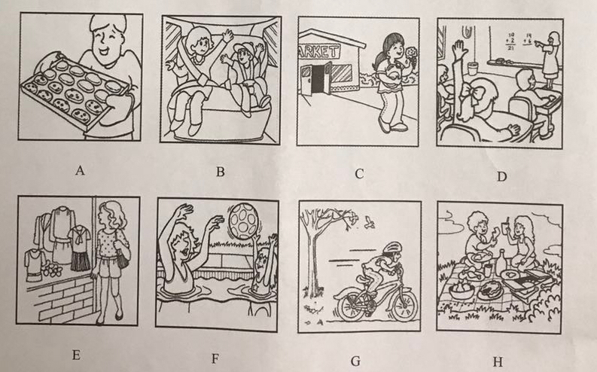
1、________2、_________3、__________4、__________5、__________6、__________
上海市教育考试院保留版权
初中学业考试(2018)英语试卷第1页(共10页)
B. Listen to the dialogue and choose the best answer to the question you hear(根据你听到的对话和问题,选出最恰当的答案)(8分)
7. A)Apple. B)Banana.
C) Orange . D)Pear.
8.A)At8:45. B)At 9:00.
C)At9:15. D)At 9:30.
9. A)By bus. B)By bike.
C) By car. D)By underground.
10. A)Rainy. B) Cloudy.
C)Sunny. D )Windy.
11. A)Visit his uncle. B)Visit his classmates.
C) Go to London. D) Go to a language camp.
12. A)In a store. B)At home.
C) At the cinema. D)In a restaurant.
13.A) Husband and wife. B) Doctor and patient.
C)Shop assistant and customer. D)Teacher and student.
14. A) Talk to Lucy. B)Go to the supermarket.
C) Eat more. D)Lose some weight.
C. Listen to the dialogue and tell whether the following statements are true or false TF列句子是否符合你听到的对话内容,符合的用“T”表示,不符合的用“F”表示)(6分)
15. Mary has just become a college student.
16. Simon doesn’t enjoy classroom discussions.
17. Mary has nothing interesting to do after class.
18. Simon will volunteer for an international exhibition in Shanghai.
19. Mary and Simon will go to Shanghai together in five months.
20. Simon gives Mary some suggestions about how to choose a job in China.
D. Listen to the passage and complete the following sentences(听短文,完成下列内容。每空格限填一词)(10分)
21. Kitty wanted to plant a _____ ______with beautiful flowers for Mum's birthday.
22. Dad found that the flowers were _______ ______. They were plastic.
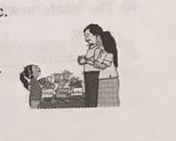
23. Dad went to Mr. White _______ _______some flower seeds.
24. Kitty and Dad worked for _______ ______ before Mum came back.
25. After Mum heard the ________ ________ she was moved to tears.

初中学业考试(2018)英语试卷第2页(共10页)

Part 2 Phonetics, Grammar and Vocabulary
第二部分语语音、语法和词汇
II. Choose the best answer(选择最恰当的答案)(共20分)
26, Which of the following underlined parts is different in pronunciation？
A) back B) chat C) hate D) taxi
27. Hurry up! The concert will begin in_________ minute.
A) a B) an C)the D)/
28.My father is a good doctor. __________works hard to help his patients.
A) He B)Him C)His D)Himself
29. Karen and Lily will go to Russia to watch the 2018 World Cup______July.
A) on B)in C)at D)of
30. Peter spent half a day fishing by the river,______he didn't catch anything.
A)so B)or C)for D)but
31. Catherine has two cousins. One is quiet, and______is noisy.
A)another B)the other C)other D) others
32. The bridge between the two islands is _______ one in Shanghai.
A)long B) longer C)longest D)the longest
33. Frank is an independent boy. His parents are proud ____ him.
A) On B)to C) in D)of
34. -Must I do the project on my own?
-No, you____.You can work with your classmates.
A)needn’t B)can’t C)shouldn’t D)mustn’t
35. Michael_________in a school in Yunnan from February to June next year.
A) teach B)taught C)will teach D)was teaching
36. Mr. Black walked around and offered help____we were doing an experiment.
A)while B)although C)until D)unless
37. Old Mr. Green doesn't feel_____because some students visit him regularly.
A)sadly B)gently C) lonely D)angrily
38. The film Operation Red Sea_____a lot of praise since its first show months ago.
A)wins B)win C)will win D)has won
39. Mr. Zhou is good at cooking and he has decided______his own restaurant.
A)open B)opened C)to open D) opening
40. The debate on whether to keep pets_____forty minutes yesterday afternoon.
A)last B)lasted C)will last D)has lasted
41. Sue practises______the violin hard and often gives wonderful performances.
A)play B)played C)to play D)playing
初中学业考试2018)英语试卷第3页(共10页)

42. The self-driving plane proves to be useful in many ways.___smart invention it is!
A)What B)What a C)What an D) How
43. Please______the rubbish into diferent litter bins according to the signs.
A)puts B)put C)putting D) to put
44. -I'm awfully sorry for bringing you so much trouble.
- __________
A)Never mind. B)it's a pleasure. C)Of course not. D)You are welcome
45.-_____________________
- That's a good idea.
A)I've got the first prize in the English speech contest.
B)I'd like to invite you to my birthday party tomorrow.
C)Shall we go to the farm to pick peaches this weekend?
D)Would you mind opening the window a bit more?
Ill. Complete the following passage with the words in the box. Each can be used only once(将下列词填入空格。每空格限填一词,每词只能填一次)(共8分)
A)downstairs B )discovered C)answered D)invitation E)advantage
Everything went black! All the lights in our flat turned off, including the Tv. Mum took out the candles and Dad went to see what was going on. One_ 46___ of living in a tall building is that you always have help nearby. So I went to our next-door neighbour, Mr.Smith. With a candle in his hand, Mr. Smith_ 47___the door. Uh-oh! He didn’t have lights, either. I _ 48___ that all the buildings in our neighbourhood were dark. Our neighbours went _ 49___ and began chatting outside. They were not worried at all.
A)event B)cause C)corectly D)frightening E)suddenly
Then we heard a _ 50___ sound after a bright flash of lightning.
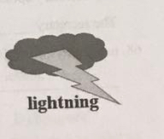
It started to rain heavily in no time. In order to get some information, Mr Smith turned on the battery-powered radio. The weatherman said that the storm was the _ 51___ of all the problems. It hit a tower at the power station before the first flash of lightning. That was the reason why the lights_ 52__went out before the rain came. Finally, the lights came back. We cheered loudly. The _ 53___ made it possible for the neighbours to have a chance to be together.

初中学业考试(2018)英语试卷第4页(共10页)

IV. Complete the sentences with the given words in their proper forms(用括号中所给单词的适当形式完成下列句子。每空格限填一词)(共8分)
54. My cousin likes to collect __________in his spare time. (stamp)
55. Look! The_______lady from the left in the photo is my favourite teacher. (six)
56. Jessie cooked a meal for her big family by______on New Years Eve. (she)
57. Shirley is an early bird. It was_____for her to be late for school today.(usual)
58. Fortunately, no one was______hurt in the earthquake several weeks ago.(serious)
59.The ____of Al(人工智能) will enable us to learn more about our brains.( develop)
60. I will never____the days I spent with my host family in Britain. (forgetful)
61. As we all know, a___ driver is always a danger to the public.(care)
V. Complete the following sentences as required(据所给求完成句子。62-67小题每
空格限填一词)(共14分)
62. John went to church with his brother last Sunday morning.(改为否定句)
John_____ ______ to church with his brother last Sunday morning.
63. Grace does online shopping four times a month.(对划线部分提问)
_____ ______ does Grace do online shopping?
64. We will hold a class meeting to talk about team work next Friday(改为被动语态)
A class meeting will _____ ______ to talk about team work next Friday.
65. “How are you getting along with your new roommate?" Franklin asked me.(改为宾语从句)
Franklin asked me_____ ______was getting along with my new roommate.
66. Keep working hard, and you will achieve success.(保持句意不变)
_____ ______ keep working hard, you will achieve success.
67. The secretary apologized to the manager for making the same mistake again.(保持句意不变)
The secretary_____ ______to the manager for making the same mistake again.
68. many ways, for us, are, to keep in touch, there(连词成句).
___________________________________________________________________
Par3 Reading and Writing(第三部分读写)
V. Reading comprehension(读理解)(共50分)

初中学业考试2018)英语试卷第5页(共10页)

A, Choose the best answer(根据以下内容,选择最恰当的答案)(12分)
Summer is a great time to improve your child’s reading!Reading over the summer can help your child keep up his reading gains during the past school year AND also help prepare him for the next year!
How to sign up:
We are inviting you to sign up for free to help your child be an active reader this summer!
*Go to www. readfun org
*Select"Parent"(NOT"Teacher")
*Click on the blue"Sign Up"
What we provide:
We provide you with thousands of free, high-quality articles with questions and activities. To make summer reading easy, we have selected interesting and knowledge-filled articles of different levels. You can go to www. Readfun.org/summer-reading to download and print the articles for free.
How to use:
TIP 1: Articles for summer reading should be accessible, so be sure to choose articles at your child’s reading level. Don’t be afraid to star with articles of lower grade levels. The important thing is that he reads, reads, reads!
TIP 2: It,s also important to help your kid develop good reading habits Help him keep a good record of his summer reading. Besides, encourage him to discuss what he has read with family members. That way, you will all have a good time.
We wish you and your family a great summer!
69. The first two sentences of the text above are about________.
A)different types of books B)the coming school year
C)the importance of summer reading D)good places for summer reading
70. One of the steps for parents to sign up on www. readfun.org is to______.
A) select“Parent " B )finish a test C)choose a tip D)print an article
71. What does www. readfun.org provide?
A)Online teachers. B)Pen friends' information.
C)Interesting videos D )Articles of different levels
72.The underlined word "accessible"in the text means"easy to_____”.
A) write B)discuss C)understand D)compare
73. According to TIP 2, parents should help their kids develop___good reading habit(s).
A) 1 B)2 C)3 D)4
74. The text above is written to ____.
A)introduce a reading programme B)sell books to school kids
C)encourage parents to read more D) share reading experience
初中学业考试(2018)英语试卷第6页(共10页)
B. Choose the best answer and complete the passage(选择最恰当的选项完成短文)(12分)
Chins Mobille 4G 16:74 43%
Teaching material discussion group (15)
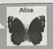
Hi! I 'm doing a survey am teaching materials in school. What kind of
textbooks do you use? Do you think the use g∫ photocopied(复印的)
netbooks and newspaper articles in the classroom can be accepted? Please
give your_____75.

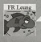
The use of such materials is certainly not ____76 for writers. Textbooks
are like other creative works. Many people have to put their efforts in the
writing of a book. The efforts of the writers and publishers will be totally
wasted if everyone photocopies their textbooks. I cant imagine that!


I don' t think it right to use photocopied materials even in the classroom
because it's against the law. Teachers should set a good example for their
students by ______77 the law.


Copied books are as good as copyrighted(正版的)ones, but they don't
_____78 much, usually less than half the price. In addition, it is so
_____79 to use copied materials. When we want to share something good
we just have it photocopied. I think photocopying is OK because publishers are still making a lot of money anyway.


Most of the time, teachers make sure their students do not use photocopied
materials. But I know some teachers do use photocopied newspaper articles
sometimes, as their students are eager to learn more to widen their views. As you know, teachers always put the _____80 of students above anything else. After all, you can't expect all the students to buy newspapers
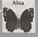
Wow! Thank you for sharing so many ideas!

初中学业考试(2018)英语试卷卷第7页(共10页)

75. A)thanks B)lessons C) excuses D)opinions
76.A)easy B)fair C)common D)traditional
77.A)changing B)explaining C)respecting D)making
78.A)save B)affect C)offer D)cost
79 A)convenient B)strange C)exciting D)difficult
80.A)actions B)needs C)records D)attitudes
C. Fill in the blanks with proper words(在短文的空格内填入适当的词,使其通顺。
每空格限填一词,首字母已给)(14分)
"Olivia, love is simple. You don t have to do much to make someone happy. "That was what my mother said to me when I was a child. Over a year ago, I had a chance. My good friend Kaylee told me about her t_____81 to a small town called Gary, and how it was a life-changing experience. I made up my mind to go there myself.
When I told my parents about the decision, they didn’t a_____ 82 at first. They said I didn’t know much about the place. They were worried that it was not s_____83 for me to go there. Thankfully, after I explained my plan to them in detail, they said yes.
When our group arrived in Gary, I noticed how different the town was from where I lived. There were few stores or restaurants in the town; most had closed. So you would be very l_______84 if you could find a place to buy food or drinks. Houses were built on small hills. Many of them had broken doors or windows. My job was to help the local people to r_______ 85 houses.The work days were long and hot, but it was really good to see the houses taking on a new look day by day.
The children there were also different. They seemed to enjoy every moment in life though they were poor. The smallest things would make these kids happy. I couldn’t find words to describe their j _____86 when they received an ice-cream, a ball or even a kiss. The community was like a big family. Everyone knew each other and was there when someone needed help.
I am so glad that I had this unforgettable experience. I truly learned the m____ 87 of what my mother said. You don t need to do much to make a difference to others' lives.

初中学业考试(2018)英语试卷第8页(共10页)

D. Answer the questions(根据以下内容回答问题)(12分)
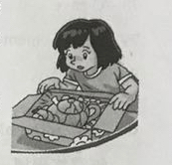
Last month some thieves stole a valuable teapot from a museum in Hong Kong. They took the teapot to America, but the American police found it. The museum sent Mr. Chan, a member of the museum staff, to collect the teapot. On the plane back to Hong Kong, he noticed two men. They were watching him closely. "Perhaps they're going to steal the teapot again. I must think of a plan,” he thought。
Mr Chan, s daughter, Amy, met him at Hong Kong Afimor. Mr Chan NS was carrying two boxes. He gave his daughter the pink box and said to her in a low voice, "Take this gift box home with great care. " He walked away with the brown one. The two men followed him.
Amy opened the box at home. She was expecting a pair of sports shoes, but she just found an old teapot. "This is not a very interesting gift, " said Amy, a bit disappointed."Thats all right. Lets make some tea in it, "said her mother. Then they found a note in the teapot. It said, " Dear Amy ,______93____Love Dad.”
The two men kidnapped(绑架)Mr. Chan on his way to the museum. They opened his box and found a pair of sports shoes inside."Wheres the teapot? the two thieves shouted at the top of their voice with red faces." How dare you cheat us? We saw you give your daughter a box at the airport. Come with us! We’re going to search your home, one of them said。
When the thieves entered Mr. Chans flat, it was dark and quiet. All of a sudden, the door closed and the lights went on. The police were waiting inside.
Amy and her mother came out of the bedroom with the teapot."That teapot is very valuable, said Mr. Chan. "A long time ago it belonged to an emperor. He drank tea from it.”
“We were going to drink tea from it, too, "said Amy, laughing.
88 Was the teapot found in America?
89. What did Mr Chan notice on the plane back to Hong Kong?
90. What was in the pink box?
91. How did the two thieves feel when they didn’t find the teapot?
2. Where were the thieves caught?
93. What did Mr. anrbably we o Amy in the note? Fill in the blank with TWO sentences.
初中学业考试(208)英语试卷第9页
VI. Writing(作文)(共20分)
94. Write at least 60 words on the topic" My progress(以“进步了”为题,写一信不少
于60个词的短文,标点符号不占格)
你在生活或学习中一定取得过不少进步,比如生活枝能的获得、学习方法的掌握、良好习慣的养成。请选取其中一个方面,结合自身经历,谈一谈你是如何取得这一进步的。
（注意:短文中不得出现任何人名、校名及其它相关信息,否则不予评分。)
The following is for reference only(以下表达仅供参考)

used to do/be…
try my best to do…
make progress in( doing)…

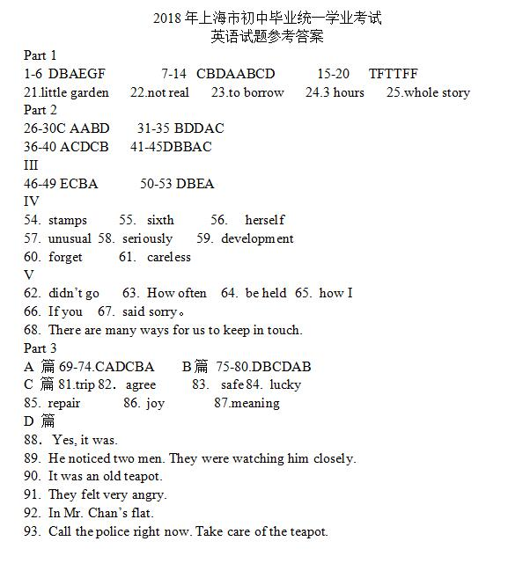

初中学业考试(2018)英语试卷第10页(共10页)

