**2017年上海市初中毕业统一学业考试**

**英语试卷**

**Part 1 Listening （第一部分 听力）**

**I. Listening comprehension（听力理解）（共30分）**

**A. Listen and choose the right picture（根据你听到的内容，选出相应的图片）（6分）**

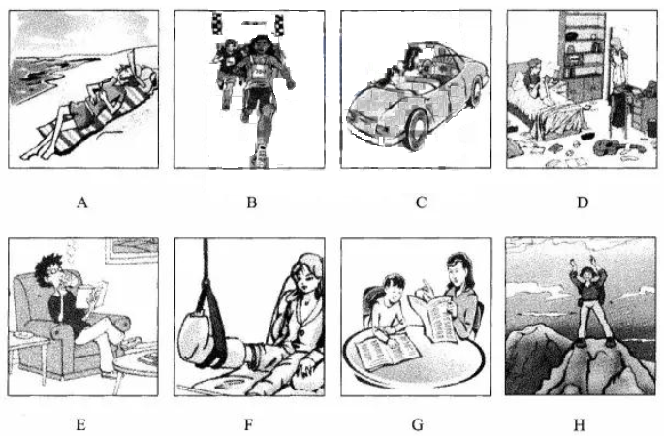

1. ________ 2. ________ 3. ________ 4. ________ 5. ________ 6. ________

**B. Listen to the dialogue and choose the best answer to the question you hear（根据你听到的对话和问题，选出最恰当的答案）（8分）**

7. A. Pink. B. Blue.

C. White. D. Brown.

8. A. For one week. B. For one year.

C. For two weeks. D. For two years.

9. A. By making a call. B. By sending an email.

C. By writing a letter. D. By leaving a message.

10. A. On Monday. B. On Wednesday.

C. On Thursday. D. On Friday.

11. A. To visit China. B. To try something new.

C. To make friends. D. To learn something easy.

12. A. Work on her project. B. Go to the school dance.

C. Take a physics exam. D. Meet her dance teacher.

13. A. In a hotel. B. In a bookshop.

C. In a cinema. D. In a classroom.

14. A. The food. B. Their car.

C. The supermarket. D. Their house.

**C. Listen to the passage and tell whether the following sentences are true or false（判断下列句子是否符合你听到的短文内容，符合的用“T”表示，不符合的用“F”表示）（6分）**

15. Peter makes hamburgers for customers in a fast food restaurant.

16. Once, Peter delivered 30 sets of hamburger meals to a school with his partner.

17. The students were waiting at the school gate when Peter arrived.[来源:学.科.网Z.X.X.K]

18. There would be a sports meeting for the student the next day.

19. The teacher ordered the hamburger meals to encourage the students.

20. Peter loves his job as he gains happiness from his working experiences.

**D. Listen to the dialogue and complete the following sentences（听对话，完成下列内容。每空格限填一词）（10分）[来源:Zxxk.Com]**

21. Jessica was ________ ________ the website, so she is late for dinner.

22.“Living green”is to take responsibility for protecting _______ __________.

23. Jessica tells her bad about some simple ways ________ ________ energy use.

24. The guest speaker says that people can wash clothes in _______ _______.

25. Dad think学科网(www.zxxk.com)--教育资源门户，提供试卷、教案、课件、论文、素材及各类教学资源下载，还有大量而丰富的教学相关资讯！s“living green ”can also _______ ______ on the electric bill.

**Part 2 Phonetics, Grammar and Vocabulary**

**（第二部分 语音、语法和词汇）**

**Ⅱ. Choose the best answer（选择最恰当的答案）（共20分）**

26. Which of the following underlined parts in different in pronunciation?

A. fly B. lazy C. already D. cloudy

27. Christine is selling her house, but on ______ other hand she doesn’t want to move.

A. a B. an C. the D. /

28. We won! The honor belongs ______ all the member of our team.

A. by B. of C. at D. to

29. Shirley is still waiting for her flight to New York City ____ the airport.

A. at B. under C. on D. with

30. The headmaster introduced ______ to the German visitors before the welcome party.

A. we B. us C. our D. ours

31. _______ knowledge and experience are important to finish that task.

A. Either B. Neither C. None D. Both

32. Did the pol学科网(www.zxxk.com)--教育资源门户，提供试卷、教案、课件、论文、素材及各类教学资源下载，还有大量而丰富的教学相关资讯！iceman give much _______ on how to protect personal informa学科网(www.zxxk.com)--教育资源门户，提供试卷、教案、课件、论文、素材及各类教学资源下载，还有大量而丰富的教学相关资讯！tion?

A. note B. tip C. advice D. book

33. Alex believes he will soon be able to play chess as ______ as the computer.

A. well B. better C. best D. the best

34. Nowadays people wish to have ______ food than before as their life improves.

A. healthy B. healthier

C. healthiest D. the healthiest

35. Some exchange students _______ with their host families this time yesterday.

A. are chatting B. will chat

C. were chatting D. have chatted

36. –Do you know ______ a 5-day trip to Hong Kong costs?

–I guess it’s about ¥4,000.

A. how fast B. how long

C. how soon D. how much

37. Several journalists _______ the lawyer about the international case an hour ago.

A. interview B. interviewed

C. will interview D. had interviewed

38. The museum _____ next month to celebrate the Science & Technology Festival.

A. is decorated B. will decorate

C. is decorating D. will be decorated

39. Vivian refuses ______ her children to the weekend training centre for extra classes.

A. to send B. sending C. sent D. sends

40. The workers are busy _______ windows to the new building these days.

A. fix B. fixed C. fixing D. to fix

41. –______ I park my car here for a while?

–No, you mustn’t. Do you see the sign“NO PARKING”?

A. Would 学科网(www.zxxk.com)--教育资源门户，提供试卷、教案、课件、论文、素材及各类教学资源下载，还有大量而丰富的教学相关资讯！ B. May C. Must D. Should

42. The two companies decided to work together ______ they had common interest.

A. because B. unless C. but D. or

43. Professor Tu Youyou never stops doing research on Chinese medicine, ______?

A. is she B. does she C. isn’t she D. doesn’t she

44. –Would you like to join me in making cakes tomorrow?

–______.

A. It doesn’t matter. B. Don’t worry. C. You’re welcome. D. I’d love to.

45. –________.

–Congratulations!

A. Sorry for breaking the glass.

B. How are you feeling today?

C. I was awarded first prize in the writing contest.

D学科网(www.zxxk.com)--教育资源门户，提供试卷、教案、课件、论文、素材及各类教学资源下载，还有大量而丰富的教学相关资讯！. Why not take the underground to the university?

**Ⅲ. Complete the following passage with the words in the box. Each can be used only once（将下列单词填入空格。每空格限填一词，每词只能填一次）（共8分）**

|  |
| --- |
| A. changeable B. disaster C. responsible D. situation E. exciting |

Nowadays more and more people prefer to go fish学科网(www.zxxk.com)--教育资源门户，提供试卷、教案、课件、论文、素材及各类教学资源下载，还有大量而丰富的教学相关资讯！ing or hiking in the 学科网(www.zxxk.com)--教育资源门户，提供试卷、教案、课件、论文、素材及各类教学资源下载，还有大量而丰富的教学相关资讯！woods. Experiencing nature is ___46___, but when you’re doing this, always keep yourself safe. It’s important to remember several basic rules if you don’t want to turn a pleasant outing into a ___47___.

First, be fully prepared for different weather. Before you set out, always get warm clothes and raincoats ready, just in case! This is especially true in the ___48___ of travelling in the mountain areas. The weather is really ___49___ in high mountains. Sometimes you can experience two or three seasons in one day.

|  |
| --- |
| A. appear B. heavily C. nearby D. pack E. probably |

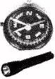Second, ___50___ a map, a compass, and a flashlight in your bag. Even experienced travelers get lost. Before you start your trip, study the map to get familiar with the area you are going to. The flashlight is important if you do get lost. Many trips that start out in daylight will ___51___ become nighttime adventures when people can’t find their way.

Third, bring a first-aid kit and know how to use it. Small cuts can be more serious when there is no doctor ___52___.

Finally, tell people where you are going and when you plan to come back. That way, someone will go search for you if troubles ___53___. This will increase your chance of being found quickly.

**Ⅳ. Complete the sentences with the given words in their proper forms（用括号中所给单词的适当形式完成下列句子。每空格限填一词）（共8分）**

54. A seat belt can help protect passengers in many car ________.（accident）

55. Last week the students went skating and enjoyed ________ very much.（them）

56. My school is going to have an open day on the ________ of next month.（ten）

57. Failure isn’t always bad. It can teach you ________ lessons.（use）

58. For your ________, smoking is not allowed during the whole flight.（safe）

59. Our manager greeted the guest _______ with a smile at the entrance.（polite）

60. Scientists often ________ that farmers use natural ways to grow fruits.（suggestion）

61. When they felt ________ after the flood, the charity offered them food and clothes.（help）

**Ⅴ. Complete the following sentences as required（根据所给要求完成句子。62-67小题每空格限填一词）（共14分）**

62. The invention of smart phones changed the world in many ways.（改为一般疑问句）

___________ the invention of smart phones _________ the world in many ways?

63. That amusement park has lots of 学科网(www.zxxk.com)--教育资源门户，提供试卷、教案、课件、论文、素材及各类教学资源下载，还有大量而丰富的教学相关资讯！tourists during the holiday.（就划线部分提问）

_________ ________ that amusement park have lots of tourist?

64. The local government organizes the film festival every autumn.（改为被动语态）

The film festival ________ _________ by the local government every autumn.

65. Shared-bikes are very popular in some big cities.（改为感叹句）

__________ __________ shared-bikes are in some big cities!

66.“Have you ever been in a hot air ballon?”Melissa asked her mom.（改为宾语从句）

Melissa asked her mom _________ she _________ ever been in a hot air ballon.

67. PM 2.5 does harm to people’s health and the environment.（保持句意基本不变）

P学科网(www.zxxk.com)--教育资源门户，提供试卷、教案、课件、论文、素材及各类教学资源下载，还有大量而丰富的教学相关资讯！M 2.5 is ________ ________ people’s health and the environment.

68. enables, various information, the Internet, to collet, teenagers（连词成句）

_____________________________________________________________________________

Part 3 Reading and Writing （第三部分 读写）

**VI. Reading comprehension （阅读理解）（共50分）**

**A. Choose the best answer （根据以下内容，选择最恰当的答案）（12分）**

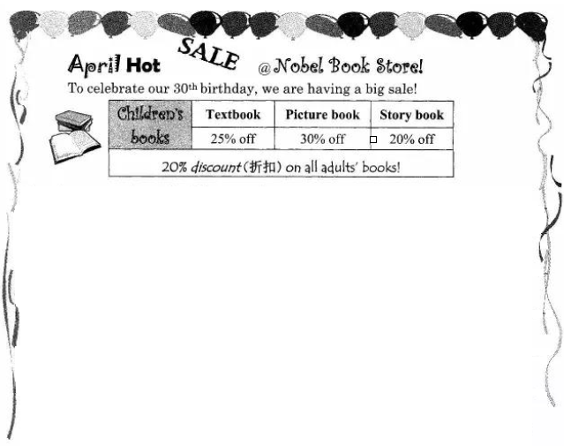

[来源:学+科+网]

Amazing events in our birthday month:

|  |  |  |
| --- | --- | --- |
| **Time & Place** | **Event** | **Speaker** |
| 25 April, 4 pm  Fanta Centre, 3F | Introduction:  *The School Diaries* | Claire Tay,  writer of the book |
| 26 April, 1 pm  Retro Mall, 2F | Discussion:  *How to improve through reading* | Michael Hawes,  English professor |
| 28 April, 7 pm  Winkle Mall, 1F | Lecture:  *The most popular books of the year* | David Koh,  director of the book store |
| 29 April, 8 pm  Fanta Centre, 3F | Question & Answer:  *Face to face with a* ***renowned*** *writer* | Kate White,  winner of many international awards |

Spend over $50 and get a chance to win a $10 gift card.

 Spend over $100 and get a chance to win prizes, from Nobel membership, e-dictionaries to concert tickets!

69. April is the birthday month of ________.

A. Nobel Book Store B. Fanta Centre

C. Retro Mall D. Winkle Mall

70. You can get the biggest discount on ________.

A. adults’ story books B. all magazines

C. children’s picture books D. all textb学科网(www.zxxk.com)--教育资源门户，提供试卷、教案、课件、论文、素材及各类教学资源下载，还有大量而丰富的教学相关资讯！ooks

71. ________ will help you know more about the most popular books this year.

A. Claire Tay B. Michael Hawes C. David Koh D. Kate White

72. The underlined word “**renowned**” means ________.

A. new B. young C. humourous D. famous

73. If you spend $65, you will get a chance to win ________.

A. an e-dictionary B. a $10 gift card C. Nobel membership D. a concert ticket

74. The main purpose of the advertisement is to ________.

A. find excellent writers B. attract more book buyers

C. celebrate Children’s Day D. introduce new reading courses

**学科网(www.zxxk.com)--教育资源门户，提供试卷、教案、课件、论文、素材及各类教学资源下载，还有大量而丰富的教学相关资讯！B. Choose the best answer and complete the passage（选择最恰当的选项完成短文）（12分）**

**The following are the posts in an Internet chat room. In this chat room, parents talk about some of the problems they have with their children.**

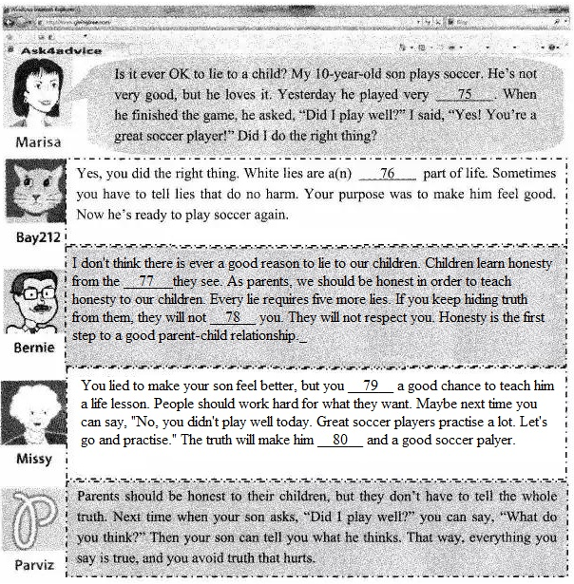

75. A. seriously B. carefully C. happily D. badly

76. A. necessary B. difficult C. dishonest D. interesting

77. A. films B. details C. examples D. teachers

78. A. trouble B. remember C. answer D. trust

79. A. took B. missed C. created D. found[来源:学科网]

80. A. strong B. confident C. honest D. active

**C. Fill in the blanks with proper words（在短文的空格内填入适当的词，使其内容通顺。每空格限填一词，首字母已给）（14分）**

**A Delicious Meal**

Tony is Chinese American. His family members gather together and serve a traditional Chinese meal once a week. Last week Tony i_______81______his friend Amy for it.

Tony’s family was preparing dinner when Amy arrived. The family was cooking vegetables with hot oil. The k______82____ was filled with many good smells. “You can help me set the table.” Tony told his friend. They gave each person a pair of chopsticks, a soup bowl, a soup spoon, and a rice bowl on a plate.

“Where are the forks and knives?”学科网(www.zxxk.com)--教育资源门户，提供试卷、教案、课件、论文、素材及各类教学资源下载，还有大量而丰富的教学相关资讯！ Amy asked.

“Oh, you won’t n ____83_____those.” Tony explained.” I will show you how to use chopsticks. Don’t worry.”

Tony’s mother put different foods which were unfamiliar to Amy onto big plates. She asked the kids to carry the food-filled plates out to the table. Amy carried roast duck. It was one of the f _____84_____dishes she recognized.

Amy was a little nervous about eating with chopsticks. Tony gave her instructions on how to do it. Amy finally managed to hold the chopsticks. Just when she picked up a piece of chicken in her chopsticks, her fingers s___85_____ lost control of them, and the chicken flew across the table. It landed in Tony’s soup with a splash(飞溅). E___86______ at the table smiled.

Tony’s father kindly brought out a fork and knife. He handed them to Amy .Amy felt more c__87_______. She ate the rest of her dinner easily. It was delicious!

At the end of the meal, Amy was given a fortune cookie(签语饼干). She broke it open and read the small note inside,” If you practice hard, you will learn many things.” Amy laughed and said,” if you let me take home a pair of chopsticks, my fortune may come true!

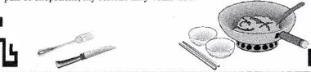

**D. Answer the questions（根据以下内容回答问题）（12分）**

It was Saturday again. Grace and Karen disliked Saturdays. That was another thing the twins had in common. They shared the same clothes and tied their hair in the same manner. In fact, it was hard for their classmates and teachers to tell them apart sometimes.

Unlike their classmates, they had to get up early at seven every Saturday to prepare for their lessons. Grace had to attend the art lesson and Karen had to attend her ballet lesson. “How I wish I could do something different today,” said the twins with one voice. All at once, an idea came to Grace and Karen at the same time. “How would you like to be me for a day?” they asked each other. It seemed like a wonderful plan to them. After giving each other a description of their own friends, Grace put on Karen’s ballet dress while Karen put Grace’s brushes and paints into her bag. Then they left for their classes.

When the art lesson started, Karen was lost. Unlike Grace, Karen was poor at drawing. When the art lesson finally ended, Karen didn’t dare to hand in her work.

Meanwhile, Grace was struggling in the ballet class as well. As she had no idea about the dance steps, she had to follow her classmates blindly. As a result, she kept knocking into them. Their ballet teacher became impatient with her, “Karen, you should remember the basic steps. You can’t rely on copying what others are doing.”

When Karen and Grace got home, they were tired out. They decided that they would never try to be someone else they were not. It seemed that **the grass was not always greener on the other side**.

88. Did Grace and Karen like Saturdays?

89. When did the twins get up on Saturdays?

90. What was the twins’ plan when they decided to do something different?

91. How did Karen feel at the beginning of the art lesson?

92. Why did the ballet teacher become impatient?

93. What does the underlined part “**the grass was not always greener on the other side**” at the end of the story try to tell us?

**VII. Writing（作文）（共20分）**

94. Write at least 60 words on the topic “There’s always hope”（以“常怀希望”为题，写一篇不少于60个词的短文，标点符号不占格）

面临困惑的时候、经历变化的时候、感觉挫败的时候、遭遇逆境的时候……来自内心的坚持、他人的帮助、社会的关爱和科技的发展等，总能让人常怀希望。请选取一个方面谈谈你的理解（可结合自身或他人的经历）。

The following is for reference only （以下表达仅供参考）

* get out of difficulty
* give … a hand
* never lose hope

2017年上海市初中毕业统一学业考试

英语试卷答案要点

**Part 1**

I. A. 1. D 2. F 3. H 4. E 5. A 6. C

B. 7. C 8. D 9. B 10. D 11. B 12. A 13. A 14. C

C. 15. F 16. T 17. F 18. F 19. T 20. T

D. 21. looking at 22. the earth 23. to reduce 24. cold water

25. save money

**Part 2**

II. 26. A 27. C 28. D 29. A 30. B 31. D 32. C 33. A 34. B 35. C

36. D 37.学科网(www.zxxk.com)--教育资源门户，提供试卷、教案、课件、论文、素材及各类教学资源下载，还有大量而丰富的教学相关资讯！ B 38. D 39. A 40. C 41. B 42. A 43. B 44. D 45. C

III. 46. E 47. B 48. D 49. A 50. D 51. E 52. C 53. A

IV. 54. accidents 55. themselves 56. tenth 57. useful 58. safety 59.学科网(www.zxxk.com)--教育资源门户，提供试卷、教案、课件、论文、素材及各类教学资源下载，还有大量而丰富的教学相关资讯！ politely

60. suggest 61. helpless

V. 62. Did, change 63. When does 64. is organized 65. How popular

66. if/ whether, had 67. bad for harmful to

68. The Internet enables teenagers to collect various information.

**Part 3**

VI. A. 69. A 70. C 71. C 72. D 73. B 74. B

B. 75. D 76. A 77. C 78. D 79. B 80. A

C. 81. invited 82. kitchen 83. need 84. few 85. suddenly

86. Everyone 87. comfortable

D. 88. No, they didn’t. / No. Both of them disliked Saturdays.

89. (They got up) at seven on Saturdays.

90. (Their plan was to) pretend to be the other one / exchange roles for a day.

91. She felt lost (when the art lesson started).

92. (Because “Karen” couldn’t) remember the basic steps / dance well.

93. (Any reasonable answer is acceptable.)

VII. 94. 略

附英文对话

1. 根据你听到的内容选出相应的图片，并在答题纸上填涂相应的字母代号。每个句子念两遍。
2. Jerry, look at your room. Could you clean it up, please?
3. She had to rest at home because of her broken leg.
4. Tom’s hobby is climbing mountains at weekends.[来源:学科网ZXXK]
5. Does he have a habit of drinking coffee while reading?
6. It is relaxing to lie on the beach in such lovely weather.
7. You’d better not use your mobile phone when you drive.
8. 学科网(www.zxxk.com)--教育资源门户，提供试卷、教案、课件、论文、素材及各类教学资源下载，还有大量而丰富的教学相关资讯！根据你听到的对话和问题选出最恰当的答案，并在答题纸上填涂相应的字母代号。对话和问题都念两遍。
9. M: I’d like to paint our bedroom blue. What do you think?

W: I prefer the color white. White makes the room brighter.

Q: What color does the woman prefer?

1. M: Hi, my name is Linda. I move in last week.

W: Welcome, I’m Jack. I’ve lived here for two years.

Q: How long had Jack lived here?

1. M: Did Harry telephone you about his job interview?

W: No. But he sent me an e-mail about the result.

Q: How did Harry tell the woman about his job interview?

1. W: My speech on Monday was not good enough. Can I do again, sir?

W: Of course, but I’m busy on Wednesday and Thursday. Friday should be fine.

Q: When will the woman probably give the speech again?

1. M: I’m thinking about learning Chinese with my friends. I want to try something new.

W: Oh, Allen. But it’s not easy to learn Chinese.

Q: Why does Allen want to learn Chinese?

1. M: I’m really looking forward to the school dance this evening.

W: Hmm……….I don’t think I’m going. I haven’t finished my physics project.

Q: What will the woman most probably do this evening?

1. M: Good evening. We’ve booked two rooms online.

W: May I know your name, please?

Q: Johnson, David Johnson.

W: Let me see………Yes! Here we are. Two double rooms for three nights, right?

Q: Where is Mr. Johnson now?

1. M: It’s convenient to shop here. The supermarket has almost everything we want.

W: Yes, and the food is so fresh.

M: It’s close to our house so we don’t have to drive a car.

Q: What are the two speakers talking about?

1. 判断下列句子是否符合你听到的短文内容。 符合的用T表示，不符合的用F表示，并在答题纸还是那个填涂相应的字母代号。短文念两遍。

Peter works for a fast-food restaurant. His job is to deliver food to his customers. He enjoys going to different places and meeting different people.

Once, he received an order from a school. A teacher had ordered 30 sets of hamburger meals. As Peter wasn’t able to deliver them all by himself, he make the trip with a partner. When they reached the school, the teacher greeted them at the school gate, and asked for their help to bring the hamburger meals to the classroom.

When Peter got there, he saw 30 students waiting eagerly for their food. As soon as they saw Peter and his partner, they knew that their food had arrived and cheered loudly. After a talk with the teacher, Peter knew that a singing competition would start the next day. The teacher had provided extra help for the students the whole day. The students had practiced so hard that the teacher decided to encourage them by ordering the hamburger meals.

In the past two years, Peter has experienced many happy moments when serving customers like these.

1. 听对话， 完成下列内容。 对话念两遍。

D: Jessica, we’re been waiting for you!

J: Sorry, I’m late for dinner, dad. I was looking at the website for a great organization called Living Green.

D: Living Green? What does that mean? I don’t even like that colour.

L: It means taking responsibility for protecting the earth. We had a guest speaker today in the science class, and he mentioned some simple ways to reduce our energy use and protected the earth.

D: Like what?

J: OK, well, first of all, he said we should cut down on driving. So we’d better walk, ride bicycle , or take public transportation.

D: I would do those things if I could.

J: Another idea was to turn off unnecessary lights. Look at this house------lights on in every room! He also advised us to wash our clothes in cold water.

D: Cool! I never realized how simple it could be to ………What did you call it? Live Green?

J: Yeah! The speaker said that if everyone did even one of these things every day, it would do a lot to reduce global warming.

D: I agree. That will also save money on the electric bill.