Model Summary Report (Flextable)

R Markdown
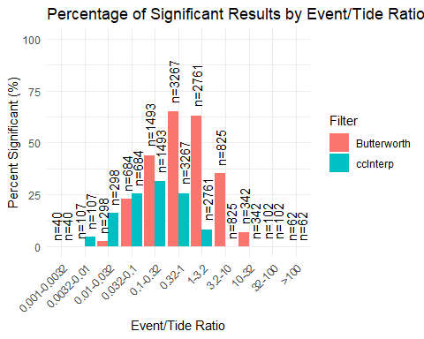
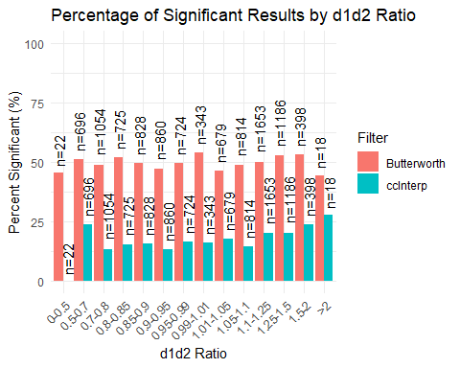
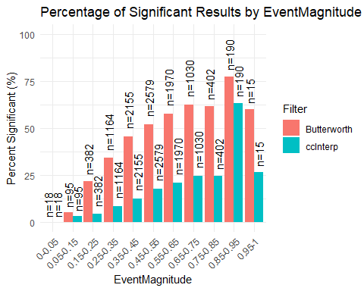
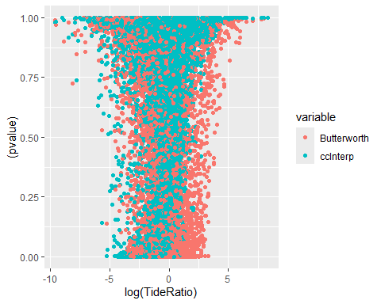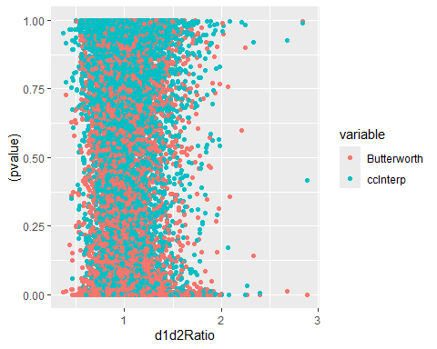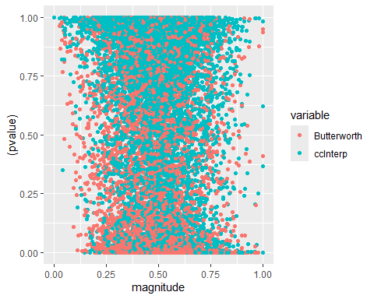
## [1] 4996
## [1] "49.96% Significant"
## [1] 1754
## [1] "17.54% Significant"
## cci bwf
## 9995 17.53877 49.95498
## 9996 17.53701 49.95998
## 9997 17.53526 49.95499
## 9998 17.53351 49.95999
## 9999 17.53175 49.95500
## 10000 17.54000 49.96000
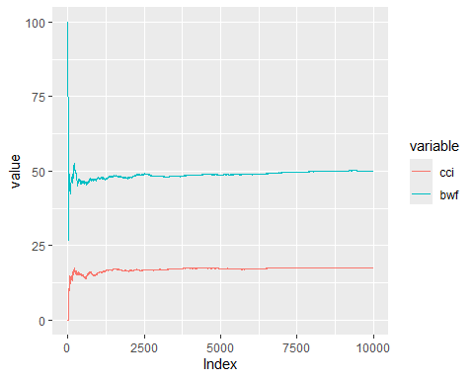

Including Plots
Considering both models of the actual values and the absolute residuals provides complementary insights. Modelling the actual values helps assess how well each method predicts the signal itself, identifying biases and systematic structure in the predictions. In contrast, modelling the absolute residuals focuses on the magnitude of the errors, which speaks to the reliability and consistency of each method across varying conditions. Together, these perspectives help distinguish between methods that may appear similarly accurate on average but differ in how stable or error-prone they are under different hydrodynamic scenarios.
Here you’re fitting error ~ predictors directly, so low p-values mean the predictors help explain the variation in the estimated flow values. The significance (or lack of it) here tells you:
For both CCI and BWF, nearly all terms are statistically significant in both datasets—this suggests that your model structure captures key relationships well.
However, look at log(TideRatio) for BWF:
It’s not significant (p = 0.69) in the noInteractions dataset.
It becomes weakly significant (p = 0.03) when interactions are included.
This indicates that tide effects only show up in BWF when there’s a complex interaction, and even then, not very strongly.
In contrast, CCI shows strong significance across the board, which suggests it’s better at capturing relationships involving the tide and its interactions.
P-Value Summary for Linear Model Terms
 | CCI |  | BWF
Term | cciWith Interactions | cciNo Interactions | bwfWith Interactions | bwfNo Interactions
(Intercept) | < 0.01 | < 0.01 | < 0.01 | 0.03
value | < 0.01 | < 0.01 | < 0.01 | < 0.01
magnitude | < 0.01 | 0.01 | < 0.01 | < 0.01
log(TideRatio) | < 0.01 | 0.07 | < 0.01 | 0.06
d1d2Ratio | < 0.01 | 0.05 | < 0.01 | < 0.01
magnitude:log(TideRatio) | < 0.01 | < 0.01 | < 0.01 | < 0.01
magnitude:d1d2Ratio | < 0.01 | < 0.01 | < 0.01 | < 0.01
log(TideRatio):d1d2Ratio | < 0.01 | < 0.01 | 0.01 | 0.06
magnitude:log(TideRatio):d1d2Ratio | < 0.01 | < 0.01 | < 0.01 | < 0.01
Model Performance Metrics (R² and RMSE)
 | CCI |  | BWF
Metric | cciWith Interactions | cciNo Interactions | bwfWith Interactions | bwfNo Interactions
R2 | 1.00 | 1.00 | 1.00 | 1.00
RMSE | 3.44 | 3.33 | 2.99 | 2.21
This is especially useful as a proxy for heteroscedasticity (non-constant variance). Here, a significant term suggests that the magnitude of errors varies depending on the value of that predictor. So:
In CCI, notice how log(TideRatio) and d1d2Ratio lose significance in the withInteractions dataset.
This suggests that once the model accounts for tide/flood interactions, those variables no longer drive error variance—they’ve been successfully “explained away”.
That’s evidence of a better fit: the model captures the structure of variability.
In BWF, the p-values remain low across both datasets, including for interaction terms.
This implies that residuals still vary systematically with those variables, even after fitting the model.
This may mean that BWF isn’t adequately capturing the nonlinearities introduced by tide-flood interactions—it’s leaving structure in the residuals.
P-Value Summary for Linear Model Terms
 | CCI |  | BWF
Term | cciWith Interactions | cciNo Interactions | bwfWith Interactions | bwfNo Interactions
(Intercept) | < 0.01 | < 0.01 | 0.01 | < 0.01
magnitude | 0.20 | < 0.01 | < 0.01 | < 0.01
log(TideRatio) | < 0.01 | < 0.01 | < 0.01 | < 0.01
d1d2Ratio | < 0.01 | < 0.01 | < 0.01 | < 0.01
magnitude:log(TideRatio) | 0.40 | < 0.01 | < 0.01 | < 0.01
magnitude:d1d2Ratio | 0.27 | < 0.01 | < 0.01 | < 0.01
log(TideRatio):d1d2Ratio | 0.03 | 0.08 | < 0.01 | < 0.01
magnitude:log(TideRatio):d1d2Ratio | 0.38 | < 0.01 | < 0.01 | < 0.01
Model Performance Metrics (R² and RMSE)
 | CCI |  | BWF
Metric | cciWith Interactions | cciNo Interactions | bwfWith Interactions | bwfNo Interactions
R2 | 0.01 | 0.01 | 0.02 | 0.02
RMSE | 3.20 | 3.11 | 2.48 | 1.80
Low p-values for interaction terms in the residual models suggest that those interactions are not being fully accounted for—they still explain some of the error.
In CCI, those terms often become non-significant once interactions are modeled → this implies better model adequacy.
In BWF, persistent low p-values across terms (even in the residuals) suggest the method doesn’t fully explain the structure introduced by tidal interactions.

