Ecosystem Modeling of Mesocosm Studies
Documentation for the StoLam+ model

Jana Gerhard
Tido Strauss

26 July 2024

This documentation template follows the TRACE documentation structure (Grimm et al., 2014; Schmolke et al., 2010), but is adapted for the current project. Specific documentation requirements for our project, reflecting the EFSA good modeling practice (EFSA, 2014) are listed in each section in red.

The template will be expanded going forward, providing more detailed structures of documentation in chapters most relevant to the project. See Chapter 6.1 (Calibration to control data) for the subheadings included. A similar structure for the documentation of the calibration to effect data will be included in Chapter 6 and for the documentation of the validation to control data in Chapter 9.

Some parts of the documentation will correspond across models and will be developed by the whole group. In the following, ‘mesocosm studies’ specifically references the mesocosm studies available for the current project and their specific designs.

Input parameters and other input data will be listed in a separate table (using the template “Model_input_documentation.xlsx”). In the table, references to this document should be included where detailed descriptions are warranted.

Table of Contents
1. Problem formulation 4
2. Model description 4
2.1 StoLaM 4
2.2 Macrophyte model as a submodule for the StoLaM lake model 5
2.3 IBM Chaoborus model 10
2.4 Daphnia Model IDamP 11
2.5 DEB model for Copepods (Mesocyclops leukarti) 11
2.6 STREAMcom 17
3. Data evaluation 18
4. Conceptual model evaluation 18
4.1 The StoLaM+ approach 18
4.2 STREAMcom 19
4.3 DEB IBM models 20
5. Implementation verification 21
6. Model output verification 22
6.1 Calibration to mesocosm control data 22
6.1.1 Calibration strategy: 22
6.1.2 StoLaM 23
6.1.3 IBM Chaoborus model 25
6.1.4 IBM Daphnia model (IDamP) 26
6.1.5 Copepods model 26
6.1.6 STREAMcom 27
6.1.7 Sampling of parameter space 30
6.1.8 Species groups with discrepancies in calibration 31
6.1.9 Decision criteria 32
6.2 Calibration to mesocosm treatment data 32
6.2.1 Summary of effect representation in the model 32
6.2.2 Model changes during calibration 34
6.2.3 Parameters calibrated 34
6.2.4 Calibration initial conditions and time period 35
6.2.5 Step-wise calibration 35
6.2.6 Sampling of parameter space 38
6.2.7 Species groups with discrepancies in calibration 38
6.2.8 Effect summary 41
6.2.9 Decision criteria 41
7. Uncertainty 42
8. Model analysis 42
9. Model output corroboration 42
9.1 Further evaluation with mesocosm control data 42
9.1.1 Model version 42
9.1.2 Initial conditions and time period 42
9.1.3 Species groups with discrepancies in further model evaluation 42
9.2 Validation with 2021 mesocosm control data 43
9.2.1 Model version and parameterization 43
9.2.2 Validation initial conditions and time period 43
9.2.3 Species groups with discrepancies in validation 44
9.3 Validation with 2021 mesocosm treatment data 46
9.3.1 Model version and parameterization 46
9.3.2 Validation initial conditions and time period 46
9.3.3 Simulated effects of treatments in 2021 study 2ApplS 46
10. References 50
11. Appendix A: GUTS parametrisation 52
11.1 Zooplankton 52
11.1.1 Daphnia 52
11.1.2 Copepods 54
11.1.3 Chaoborus crystallinus 55
11.2 Macroinvertebrates 56
11.2.1 Cloeon dipterum 56
11.2.2 Gammarus pulex 57
11.2.3 Asellus aquaticus 58
11.2.4 Lymnea stagnalis 59
11.2.5 Chironomus riparius 60

Problem formulation
The aim of the project is to establish an aquatic systems model (ASM) as a virtual mesocosm, i.e., as a tool to simulate mesocosm dynamics and pesticide effects under time-varying pesticide exposure profiles. Four ASMs will be applied to mesocosm study data in the project, and their performance with respect to simulating mesocosm community dynamics will be compared (ASM ring study). This ASM ring study will provide insights into the capabilities of the ASMs to simulate species dynamics in mesocosms over time as well as effects and recovery from pesticide exposures. It is anticipated that the ring study will identify strengths and weaknesses of each model with respect to representing mesocosm study data, and a comparison of these differences will be used to select one model for further evaluation.

Model description

StoLaM
The lake model StoLaM is a general mechanistic ecosystem model (water quality model), which integrates physico-chemical dynamics of standing waters, phytoplankton and zooplankton communities responding to weather data with a high temporal resolution (Strauss, 2009). The use of an hourly resolution of weather data ensures realistic integration of dynamic climate data. Therefore, a mechanistic, dynamic hydrodynamic module (HyLaM) is linked to the StoLaM to provide the physical environment in terms of water temperature, underwater light conditions, vertical turbulence and thermal stratification. This one-dimensional vertical structured hydrodynamic model HyLaM as part of the StoLaM allows a high resolution of the lake internal physical environment which is required for simulating the nutrient cycles for phosphorus, nitrogen and silicon, as well as the plankton dynamics for relevant phyto- and zooplankton species/groups in detail.
StoLaM contains generic and easily parametrizable modules for phytoplankton and zooplankton species. These consist of unstructured compartment models with differential equations and case study independent parametrization.
The phytoplankton module contains a generic model structure that allows the modelling of several different phytoplankton species through case study independent parametrization. This module consists of standard physiological processes covering the main important processes of nutrient uptake (phosphorus, nitrogen, silicon), nutrient-, light- and temperature-dependent growth, and loss processes (zooplankton grazing, sedimentation, natural mortality and respiration).
The phytoplankton module for simulating pelagic primary producers is linked to abiotic parameters and consumers (zooplankton), and can describe the trophic-dependent capacity of the system under dynamic conditions.
Selected zooplankton species can be replaced by individual-based models (IBMs), such as the compartment model for daphnids by the IDamP (Preuss et al., 2009, Strauss et al., 2017).

A more detailed description of StoLaM is provided in the Supplementary Information S1 of (Strauss et al., 2017).

Macrophyte model as a submodule for the StoLaM lake model

Executive summary
The submodule for macrophytes was designed and parameterized for the species Myriophyllum spicatum. The aim of this module is to simulate the population dynamics of Myriophyllum in mesocosms, where nutrient transport from the sediment to the water column is an important process. The model is currently only valid for bodies of water with uniform water depth where macrophyte growth is possible over the entire sediment surface (e.g. mesocosms).

The StoLaM lake model is divided into horizontal layers (segments) in which Myriophyllum can grow upwards from the sediment. While in the water column the focus is on vertical growth to reach the water surface, the main biomass of this canopy-forming species is only achieved at the surface through horizontal growth.

The interface to the StoLaM lake model is, on the one hand, light attenuation by macrophytes and, on the other hand, the release of nutrients into the water column. The implemented processes are light- and temperature-dependent growth, temperature-dependent mortality and dark respiration, and light-dependent excretion.

Conceptually, Myriophyllum receives the required phosphorus and nitrogen from the sediment, and no limitation of growth by nutrients is assumed. Likewise, no additional nutrient uptake from the water column is modeled. Thus, the modeled macrophytes in the lake model act as a nutrient pump by unlimited uptake from the sediment and release of detritus-bound and organically dissolved nitrogen and phosphorus into the water column.

The macrophytes are simulated in the unit g dw m⁻³ (= mg dw L⁻¹), and the total biomass is summed up vertically across all layers as g dw m⁻² to display the results.
The basic model is based on (Collins and Wlosinski, 1989).

Technical model description
The temperature function of macrophyte growth is described by two equations below and above the temperature optimum of the macrophytes:
f (T_{i})_{M} = $\left\{\begin{matrix}\begin{aligned}& \text{if} T_{i}>T_{\text{opt,M}}\text{ then} \text{exp }\left(\frac{\text{-2,3 }(T_{i}\text{-}{\text{T}}_{\text{opt,M}})^{2}}{(T_{\text{max,M}}\text{-}{\text{T}}_{\text{opt,M}})^{2}}\right) \\ &\end{aligned} \\ \text{if} T_{i}≤T_{\text{opt,M}}\text{ then} \text{exp }\left(\frac{\text{-2,3 }(T_{i}\text{-}{\text{T}}_{\text{opt,j}})^{2}}{(T_{\text{min,M}}-T_{\text{opt,M}})^{2}}\right) \end{matrix}\right.$ (Eq. 1)
with f (T_{i})_{M} : Temperature function of macrophyte M for Segment i [ - ]
Ti : Water temperature in Layer i [°C]
T_{opt,M} : Temperature optimum of macrophyte M [°C]
T_{max,M} : Temperature maximum of macrophyte M [°C]
T_{min,M} : Temperature minimum of macrophyte M [°C]

The light attenuation coefficient of every segment i (k_{Att,i}) in the lake model must be supplemented by the additional attenuation caused by macrophytes:
k_{Att,i} = k_{Att,i} + Att_{M} · Macrophyte_{i} [m⁻¹] (Eq. 2)
with k_{Att,i} : Attenuation coefficient in segment i [m⁻¹]
Att_{M} : Attenuation coefficient of macrophyte M [m² ⋅ mg dw⁻¹]
Macrophyte_{i} : Biomasse of macrophyte M in segment i [mg dw ⋅ m⁻³]

The limitation of the macrophyte growth rate by light, depending on the photosynthetically active radiation (400-700nm, PhAR), can be written including photoinhibition as:
f (I_{i})_{M} = $\frac{\text{PhA}{\text{R}}_{i}}{I_{\text{opt,M}}}⋅\text{exp} \left(1-\frac{\text{PhA}{\text{R}}_{i}}{I_{\text{opt,M}}}\right)$ (Eq. 3)
with f (I_{i})_{M} : Light function for macrophytes in Segment i [ - ]
PhAR_{i} : Medium radiation (PhAR) in Segment i [J · m⁻² · s⁻¹]
I_{opt,M} : Light optimum of macrophyte M [J · m⁻² · s⁻¹]

The gross growth of macrophytes in segment i (G_{M,i}) could be obtained by multiplying the maximum potential growth rate G_{max,M} [day⁻¹] with the functions for light and temperature dependence. In the uppermost segment (i=1), growth is also reduced in relation to the maximum capacity at the surface as biomass increases. The maximum achievable biomass is limited by the capacity.
G_{M,i} = Macrophyte_{i} · G_{max,M} · f(T_{i})_{M} · f(I_{i})_{M} · (1- (Macrophyte_{i} / Macrophyte_{Max,surface}))
[g dw · m⁻³ · day⁻¹] (Eq. 4 )
with Macrophyte_{Max,surface} : Maximal macrophyte biomass in the surface layer
[g dw · m⁻³ · day⁻¹]
At all other depths, the only limitation is the maximum possible biomass:
G_{M,i} = Macrophyte_{i} · G_{max,M} · f(T_{i})_{M} · f(I_{i})_{M} [g dw · m⁻³ · day⁻¹] (Eq. 5 )

The mortality is composed of a constant background mortality and an additional mortality that is negatively correlated with the water temperature:
MortM,i = ${(K_{{Mort}_{M}}+(1-exp}^{(-{T_{Mort}}_{M} ∙ (1-{ f(T_{i})}_{M})}$) · Macrophytei [g dw · m-3 · day-1] (Eq. 6 )
with Mort_{M,i} : Mortality of macrophytes in segment i [g dw · m⁻³ · day⁻¹]
K_{MortM} : Background mortality rate [day⁻¹]
T_{MortM} : Temperature dependent mortality rate [day⁻¹]

Dark respiration was expressed as a function of temperature:
Resp_{M,i} = Macrophyte_{i} · K_{respM} · ${θ_{RespM}}^{(Τ_{i}-Τ_{opt,M})}$ [g dw · m⁻³ · day⁻¹] (Eq. 7)
with K_{RespM} : Macrophyte respiration rate at T_{opt} [day⁻¹]
θ_{RespM} : Temperature coefficient of macrophyte respiration [ - ]

The excretion of macrophytes (= photorespiration) is given as a function of light:
Excret_{M,i} = Macrophyte_{i} · (1- f (I_{i})_{M}) · K_{excretM} [g dw · m⁻³ · day⁻¹] (Eq. 8)
with K_{excretM} : Macrophyte excretion rate [day⁻¹]

The change of macrophyte biomass (netto growth, d_{M,i}) in segment i can be summarised as:
d_{M,i} = G_{M,i} - Mort_{M,i} - Resp_{M,i} - Excret_{M,i} [g dw · m⁻³ · day⁻¹] (Eq. 9)
The macrophyte Myriophyllum spicatum grows vertically upwards from the sediment (lowest layer), only in the uppermost layer does it develop higher biomasses up to the maximum capacity (Macrophyte_{Max,surface}). In winter, growth always starts from the sediment, with a minimum biomass (Macrophyte_{Min,bottom}) in the lowest segment.
If the resulting biomass exceeds the maximum with ((Macrophyte_{i} + d_{M,i}) > Macrophyte_{Max}) and the upper layer i-1 does not contain any biomass or the maximum biomass has not yet been reached, it grows into layer i-1. However, if the resulting biomass falls below the minimum with ((Macrophyte_{i} + d_{M,i}) < Macrophyte_{Min}) and the upper layer i-1 does not contain any biomass, layer i is also emptied. Only the bottom layer retains at least the biomass Macrophyte_{Min,bottom}.
The total macrophyte biomass is summed vertically across all layers to represent the model output and is given as g dw m⁻² by area.
The macrophyte biomass lost through mortality is added to the detritus pool in StoLaM:
Detr_{i} = Detr_{i} + Mort_{M,i} · k_{wDetr} (Eq. 10)
with k_{wwDetr} : Conversion factor ww/ dw detritus [ - ]
Detr_{i} : Detritus in segment i [mg ww L⁻¹]

The release as organically dissolved nutrients (respiration, excretion) or as detritus-bound nutrients (mortality) is calculated by conversion with fixed stoichiometric factors for P and N:
QP_{Detr,i} = QP_{Detr,i} + Mort_{M,i} · QP_{M} (Eq. 11)
QN_{Detr,i} = QN_{Detr,i} + Mort_{M,i} · QN_{M} (Eq. 12)
DOP_{i} = DOP_{i} + (Excret_{M,i} + Resp_{M,i}) · QP_{M} (Eq. 13)
DON_{i} = DON_{i} + (Excret_{M,i} + Resp_{M,i}) · QN_{M} (Eq. 14)
with QP_{M} : Phosphorus content per macrophyte biomass [g P g dw⁻¹]
QN_{M} : Nitrogen Phosphorus content per macrophyte biomass [g N g dw⁻¹]
QP_{Detr,i} : Detritus phosphorus in segment i [mg P L⁻¹]
QN_{Detr,i} : Detritus nitrogenin segment i [mg P L⁻¹]
DOP_{i} : Dissolved organic phosphorus in segment i [mg P L⁻¹]
DON_{i} : Dissolved organic nitrogen in segment i [mg N L⁻¹]

Parameterisation and model testing
The parameterisation and validation was carried out for a mesocosm of 1 m water depth, which was devided into 5 vertical layers with a height of 20 cm per layer.
According to experimental data in mesocosms (gaiac mesocosm studies), a maximum area coverage of Myriophyllum in the water column of 20 % was assumed; a coverage of 100 % can only be achieved in the uppermost layer.

Table 2.2.1 Parameter list for the macrophyte model, parameterised for Myriophyllum spicatum.
Parameters | Unit | Description | Value | Ref
C:dw | % | Carbon to biomass ratio | 46 | 1
C:N | - | Carbon to nitrogen ratio | 30
C:P | - | Carbon to phosphorus ratio | 300
QN_{M} | gN /g dw | Nitrogen content per biomass | 0.015
QP_{M} | gP /g dw | Phosphorus content per biomass | 0.0015
Macrophyte_{Min} | g dw m⁻³ | Minimum biomass per layer (excluding bottom layer) | 0.100
Macrophyte_{Min,bottom} | g dw m⁻³ | Minimum biomass in the bottom layer | 1
Macrophyte_{Max,surface} | g dw m⁻³ | Maximal biomass in the surface layer | 250 | 5
Macrophyte_{Max} | g dw m⁻³ | Maximal biomass per layer (excluding surface layer) | 50 | 5
G_{max,M} | day⁻¹ | Max. growth rate | 0.30 | 3
K_{excretM} | day⁻¹ | Excretion rate | 0.01
K_{RespM} | day⁻¹ | Respiration rate at opt. Temperature | 0.01
θ_{RespM} | - | Temperature coefficient for respiration | 1.045 | 4
K_{wwDetr} |  | Conversion factor ww/ dw for detritus | 2.4
T_{MortM} | day⁻¹ | Temperature dependent mortality rate | 0.05
K_{MortM} | day⁻¹ | Background mortality rate | 0.01
Att_{M} | m² g dw⁻¹ | Attenuation coefficient macrophyte | 0.006 | 2
T_{min,M} | °C | Minimal temperature | 0
T_{opt,M} | °C | Optimal temperature | 21 | 1
T_{max,M} | °C | Maximum temperature | 34 | 1
I_{opt,M} | J m⁻² s⁻¹ | Light constant | 130.5 | 1*

1: Collins, C. D., & Wlosinski, J. H. (1989). A macrophyte submodel for aquatic ecosystems. Aquatic botany, 33(3-4), 191-206.
2: Best, E. P., & Boyd, W. A. (1999). A simulation model for growth of the submersed aquatic macrophyte Eurasian watermilfoil (Myriophyllum spicatum L.).
3: He, L., Wang, R., Zhang, H., Zhang, M., Liu, Y., Zhu, G., ... & Ge, G. (2021). Growth and Anchorage of Myriophyllum spicatum L. in Relation to Water Depth and the Content of Organic Matter in Sediment. Frontiers in Environmental Science, 9, 766413.
4: Park R.A., Clough J.S. (2018). AQUATOX (RELEASE 3.2). Volume 2: Technical documentation. U.S. Environmental Protection.
5: Maximum values were estimated from experimental data with Myriophyllum spicatum (gaiac mesocosm studies). In the water column: 10 g dw m⁻² per 20 cm height of water column (= 50 g dw m⁻³). At the water surface: 50 g dw m⁻² in the uppermost 20 cm water column (= 250 g dw m⁻³).
*: Light conversion factor: 1 J m⁻² s⁻¹ = 4.6 µE m⁻² s⁻¹ (Thimijan and Heins, 1983)

Figure 2.2.1 Measurements (red dots) and simulations (black lines) of Myriophyllum spicatum biomass dynamics over seven years (2013-2019) in aquatic mesocosms (mesocosm GmbH, Homberg, Germany). Conversion of coverage to biomass of the field data (Mesocosm GmbH) with 99.7 g dw m⁻² at 100 % surface coverage.

IBM Chaoborus model
The IBM Chaoborus population model (vers. 3.9.5) explicitly considers the life history of each individual chaoborid in the population. The mixed age structure of the population caused by overlapping generations emerges from the developmental dynamics of each individual chaoborid. The life course of an individual Chaoborus crystallinus, as implemented into the model, moves through six developmental stages: four larval stages (L1–L4), a pupal stage and the adult phase, whereas the adults are winged and disperse by flight. Important processes, like development, mortality, induction of dormancy, moulting to the next larval or pupal stage, emergence and egg deposition, are incorporated into the model. The overall mortality in the population consists of a constant background mortality for each larval stage, and the first larval instar mortality caused by density-dependent cannibalism. Input data are daily values of water temperature and day length. Water temperature has an impact on larval developmental and cannibalism. Dormancy is induced by the combined action of a critical photoperiod and temperature. The food level is assumed to be constant throughout the entire simulation. The density dependent individual food saturation level is calculated once per day. In this model, only the developmental rate is directly influenced by the food level. It is assumed that the chaoborids are homogeneously distributed in the water column. The model proceeds in discrete daily time steps (Strauss et al., 2016).
For a more detailed explanation of the model, please see (Strauss et al., 2016)

Daphnia Model IDamP
The population dynamics of Daphnia magna is modelled using the IDamP model. IDamP is an individual-based population model (IBM) that predicts D. magna population dynamics under different feeding conditions and temperatures. IDamP is structured in three ecologically relevant hierarchical levels − individual, population and ecosystem − represented by three corresponding objects in the IDamP. The state variables in IDamP are defined on the individual level (Preuss et al., 2009). Each individual daphnid is modelled by its life-cycle, and is characterized by its actual filtration rate, body size, spent juvenile development and lifetime. Reproduction is calculated by the brood size and the spent embryo-development (see Preuss et al., 2009). At the population level, IDamP counts the total number of individuals and the number of dead and newborn organisms per day. In addition, the number of organisms per age or size class is calculated. On the ecosystem level, the exchange of environmental state variables such as phytoplankton density and phosphorus content as well as water temperature between IDamP and the StoLaM model was implemented (Strauss et al., 2017).
A full ODD description of IDamP is provided in the Supplementary Information S1 of (Strauss et al., 2017).

DEB model for Copepods (Mesocyclops leukarti)
An extensive introduction to the Dynamic Energy Budget (DEB) theory and DEB modeling can be found in the book “Dynamic Energy Budget theory for metabolic organisation” by (Kooijman, 2009). The book also provides a large body of theoretical concepts and exemplary case studies to justify the model design choices that were made. Derivations from the so-called “standard DEB model”, like the abp model for copepods are specified in the document “Comments on Dynamic Energy Budget theory for metabolic organisation” by (Kooijman, 2010).
Here, we provide an overview of the state variables, model parameters, and model equations used in the abp model to simulate a copepod’s life history in a time-energy-body length system. Model assumptions that go beyond what is clearly described in the DEB theory, or that need to be made on a species or group-specific basis (such as the regularity with which eggs are laid) were based on the DEB models presented by Koch and De Schamphelaere (2023, 2019) for the copepod Nitocra spinipes.
DEB model parameters for M. leukarti were obtained from the Add-my-Pet database on February 24, 2022. Whereas the model here is formulated with time as a continuous variable (using ordinary differential equations), its implementation uses discrete time steps of 1 h (24 time steps per day).

State variables and parameters
The model follows the four state variables energy reserve $E$ (J), body structure $V$ (cm³), maturity $E_{H}$ (J), and reproduction buffer $E_{R}$ (J). It should be noted that maturity, despite being quantified by the invested energy in joules, is considered a state of information rather than energy or structure. In the process of creating maturity information, the invested energy is lost to the environment in the form of heat.
In addition to these four core state variables, which are all closely connected, the DEB theory also includes a framework for age-related mortality, which is argued to result from the formation and accumulation of free radicals, or related reactive oxygen species. The submodel for age-related mortality uses two additional state variables, the aging acceleration $\ddot{q}$ (d⁻²) and the hazard rate $\dot{h}$ (d⁻¹).
The model parameters for M. leukarti are presented in Table 2.5.1.

Table 2.5.1 Parameters of the abp-type DEB model for M. leukarti obtained from the Add-my-Pet database on February 24, 2022.
Symbol | Value | Unit | Interpretation
$$κ_{X}$$ | 0.8 | − | Assimilation efficiency
$${\{\dot{p}}_{Am}\}$$ | 17.6044 | J d⁻¹ cm⁻² | Surface-area-specific maximum assimilation rate
$${\{F}_{m}\}$$ | 6.5 | L d⁻¹ cm⁻² | Surface-area-specific maximum searching rate
$$\dot{v}$$ | 0.00703 | cm d⁻¹ | Energy conductance
$$κ$$ | 0.9893 | − | Allocation fraction to soma
$$κ_{R}$$ | 0.65 | − | Reproduction efficiency^{[1]}
$${[\dot{p}}_{M}]$$ | 1400 | J d⁻¹ cm⁻³ | Volume-specific somatic maintenance rate
$${\dot{k}}_{J}$$ | 0.002 | d⁻¹ | Maturity maintenance rate coefficient
$$[E_{G}]$$ | 4400 | J cm⁻³ | Volume-specific costs for structure
$$E_{H}^{b}$$ | 7.041e-06 | J | Maturity level at birth
$$E_{H}^{p}$$ | 0.0006173 | J | Maturity level at puberty
$$K$$ | 7.74 × 10⁻⁵ | mg C mL⁻¹ | Half saturation-coefficient^{[2]}
$$T_{A}$$ | 10380 | K | Arrhenius temperature
$$T_{REF}$$ | 293.15 | K | Reference temperature
$${\ddot{h}}_{a}$$ | 4.109 × 10⁻⁵ | d⁻² | Weibull aging acceleration
$$s_{G}$$ | 0.0001 | − | Gompertz stress coefficient
[1] Parameter $κ_{R}$ was re-fitted for this study
[2] Parameter $K$ was estimated as $K={\{\dot{J}}_{XAm}\}/{\{F}_{m}\}$ using default assumptions for the surface-area-specific maximum ingestion rate:${\{\dot{J}}_{XAm}\}=\frac{{\{\dot{p}}_{Am}\}}{κ_{X}}\frac{{12×10}^{3} mg C/mol C}{{5.25×10}^{5} J/mol C}=0.502 mg C d^{-1}{cm}^{-2}$

The model assumes identical parameters for males and females. The only difference between the two is that the investment in reproduction by adult females goes to the reproduction buffer whereas for males it is considered lost (e.g., as energy expended during active mate searching). The sex of a new individual is decided at the time of its creation according to a fixed probability, here set to 50%-50%.
Metabolic acceleration:
In the abp model, parameters $\dot{v}$ and $\left\{{\dot{p}}_{Am}\right\}$ are multiplied with an acceleration factor $M\left(L\right)$, which increases proportionally to the structural body length ($L=V^{1/3}$) between birth ($E_{H}≤E_{H}^{b}$) and puberty ($E_{H}≤E_{H}^{p}$):

$$M\left(L\right)=1$$ | if | $E_{H}<E_{H}^{b}$; | $$M\left(L\right)=\frac{L}{L_{b}}$$ | if | ${E_{H}^{b}≤E}_{H}<E_{H}^{j}$; | $$M\left(L\right)=\frac{L_{j}}{L_{b}}$$ | if | $$E_{H}≥E_{H}^{j}$$

Inter-individual variability
Upon creation each individual receives slightly different DEB parameter values. In previous works it was found that adding inter-individual variability to a single parameter, namely the surface-area-specific maximum assimilation rate $\left\{{\dot{p}}_{Am}\right\}$ delivered adequate approximations of variation found in empirical data (Koch and De Schamphelaere, 2020). The individual adjustment factor that $\left\{{\dot{p}}_{Am}\right\}$ is multiplied with, is sampled for each new individual from a log-normal distribution, around a mean value of 1. The skewness of this log-normal distribution is defined by the standard deviation $σ$ of its natural logarithm, which was set to a value of 0.15.

Energy Fluxes pre puberty
The parameters presented in Table 2.5.1 are used to calculate six key energy fluxes. For a growing copepod that has not yet reached the reproductive stage, the energy fluxes are:

Assimilation: ${\dot{p}}_{A}=f\left(X\right){ \{\dot{p}}_{Am}\} V^{2/3}$

with the scaled functional response $f$ (−) for a food density $X$ (mg C mL⁻¹):

$$f=\frac{X}{K+X}$$

Embryos that have not yet hatched ($E_{H}≤E_{H}^{b}$) do not feed, resulting in $f=0$.

The ingestion rate can be calculated as ${\dot{p}}_{X}={\dot{p}}_{A}/κ_{X}$.

Mobilization: ${\dot{p}}_{C}=E\left(\frac{\left[E_{G}\right]\dot{ v }V^{\frac{2}{3}}+{\dot{ p}}_{S}}{κ E+\left[E_{G}\right] V}\right)$
Somatic maintenance: ${\dot{p}}_{S}={[\dot{p}}_{M}] V$
Growth: ${\dot{p}}_{G}= κ {\dot{p}}_{C}-{\dot{p}}_{S}$
Maturity maintenance: ${\dot{p}}_{J}={\dot{k}}_{J} E_{H}$
Maturity / Reproduction: ${\dot{p}}_{R}=\left(1-κ\right){ \dot{p}}_{C}-{\dot{p}}_{J}$

Changes in the state variables are computed as:

$\frac{d}{dt}E= {\dot{p}}_{A}-{\dot{p}}_{C}$; $\frac{d}{dt}V= \frac{{\dot{p}}_{G}}{[E_{G}]}$; $\frac{d}{dt}E_{H}= {\dot{p}}_{R}$; $\frac{d}{dt}E_{R}= 0$

The specific growth rate $\dot{r}$ (d⁻¹) of the body structure $V$ is computed as:

$$\dot{r}=\frac{E \dot{v}/V^{\frac{4}{3}}-{\dot{p}}_{s}/(V κ) }{E/V+[E_{G}]/κ}$$

Changes in the structural body length ($L=V^{1/3}$) over time are computed as $\frac{d}{dt}L=L \dot{r}/3$.

Starvation rules
If at conditions of severe food scarcity, the change in the structural length of a pre-adult would theoretically become negative, the rules described above are partially overwritten by the so-called “starvation rules” until food conditions have improved again allowing for further growth.
The change in the structural length is temporarily set to zero:

$$\frac{d}{dt}L=0$$

The mobilization flux is temporarily reduced to only cover the somatic maintenance costs:

$${\dot{p}}_{C}={\dot{p}}_{S}$$

Maturation just like growth is temporarily halted:

$$\frac{d}{dt}E_{H}=0$$

If the reserve is completely depleted ($E<0$), the pre-adult individual dies.

Energy Fluxes post puberty
As soon as the maturity $E_{H}$ reaches the maturity threshold for puberty $E_{H}^{p}$, the copepod stops growing and all mobilized energy not needed for maintenance is invested in the reproduction buffer $E_{R}$. The associated energy fluxes then change to:

Mobilization: ${\dot{p}}_{C}=E\frac{\dot{v}}{L}$
Growth: ${\dot{p}}_{G}= 0$
Maturity / Reproduction: ${\dot{p}}_{R}={\dot{p}}_{C}-({\dot{p}}_{S}+{\dot{p}}_{J})$

Changes in the state variables are then computed as:

$\frac{d}{dt}E= {\dot{p}}_{A}-{\dot{p}}_{C}$; $\frac{d}{dt}V= 0$; $\frac{d}{dt}E_{H}= 0$; $\frac{d}{dt}E_{R}= {\dot{p}}_{R}$

Males:
For adult males, all mobilized energy that is not needed to account for maintenance costs and that would normally be invested in the reproduction buffer is considered lost (e.g., as energy expended during active mate searching)
The same starvation rules apply to adult individuals as to juveniles.

Age-related mortality
Starting at birth ($E_{H}=E_{H}^{b}$), the following rules apply for the change in the aging acceleration $\ddot{q}$ (d⁻²) and the hazard rate $\dot{h}$ (d⁻¹).

$\frac{d}{dt}\ddot{q}=\left(\ddot{q}\frac{L^{3}}{L_{m}^{3}}s_{G}+{\ddot{h}}_{a}\right)e\left(\frac{\dot{v}}{L}-\dot{r}\right)-\dot{r}\ddot{q}$ with $L_{m}=κ\frac{\left\{{\dot{p}}_{Am}\right\}}{M(L)\left[{\dot{p}}_{M}\right]}$

$$\frac{d}{dt}\dot{h}= \ddot{q}-\dot{r}\dot{h}$$

The daily survival probability of an individual is calculated as $e^{-\dot{h}}$. Since the model is implemented with 24 discrete time steps per day, this means that in any given time step the individual dies if $e^{-\dot{h}/24}$ is smaller than a random number sampled from a uniform distribution between 0 and 1. Although currently not implemented, the cumulative survival chance of an individual over time S (−) can theoretically be followed up as an additional state variable. Initialized at 1 (100 %) the decline in the cumulative survival chance over time is given by:
$$\frac{d}{dt}S=-\dot{h}S$$

Reproduction rules
The energetic costs for a new egg ($E_{0}$, J) are computed numerically from the DEB parameters in such a way that the nauplius (after having drawn energy exclusively from the reserve during its embryonic development) has a scaled reserve density $e=E\frac{\dot{v}}{L^{3}{\{\dot{p}}_{Am}\}}=1$ when it hatches.
If a female has reached the adult stage, instant fertilization by a male is assumed. As long as the female is not breeding an egg sack, it is evaluated in each time step whether the reproduction buffer contains enough energy to produce at least one egg.
As soon as this criterion is fulfilled, the female creates an egg sack containing as many new embryos as the reproduction buffer allows and the appropriate amount of energy is deducted from the reproduction buffer. The number of embryos that a reproducing female can create from its reproduction buffer is computed as

$$new_embryos=floor\left(\frac{κ_{R} E_{R}}{E_{0}}\right)$$

The change in the reproduction buffer during a reproductive event is calculated as

$${∆E}_{R}=- new_embryos\left(\frac{E_{0}}{κ_{R}}\right)$$

Newly created embryos start with a structural length $L$ of 1 × 10⁻⁵ cm, $E=E_{0}$, $E_{H}=0$, $E_{R}=0$, $\ddot{q}=0=0$, and $\dot{h}=0$. During the breeding, embryos follow the same rules for energy fluxes and changes in their state variables as described above with the distinctive feature that they do not feed externally but draw energy from their reserves instead.
As soon as the embryos within an egg sack are mature enough ($E_{H}≥E_{H}^{b}$), they hatch and the mother can create a new egg sack following the same procedure described above.

Temperature dependency
A temperature correction is applied to the time-dependent processes $\frac{d}{dt}E$, $\frac{d}{dt}V$, $\frac{d}{dt}E_{H}$ $\frac{d}{dt}E_{R}$, $\frac{d}{dt}\ddot{q}, \frac{d}{dt}\dot{h}$, which are by default computed for a reference temperature $T_{REF}=20 °C$. These rates are multiplied by the temperature correction factor $TC$ which is calculated for a given environmental temperature $T$ via:

$$TC=\exp\left(\frac{T_{A}}{T_{REF}}-\frac{T_{A}}{T}\right)$$

with the Arrhenius temperature $T_{A}$, a species-specific model parameter. Note that the change in the aging acceleration $\ddot{q}$ (d⁻²) needs to be multiplied with ${TC}^{2}$ as it carries a unit per time squared.

STREAMcom
The STREAMcom model has been developed at gaiac within a CEFIC project (2015-2018) to simulate macrozoobenthos communities. The life history cycle of each species within the individual-based population models are implemented based on dynamic energy budget (DEB) theory. All individuals interact within the total benthic community of this IBM approach.
The spatial scenario in STREAMcom is constructed as a raster map in which each cell (patch) can have different habitat characteristics and contains a dynamic resource density. The simulated individuals can choose their location according to habitat and food preferences, and feed on the chosen patch until they change their location.
Potential food sources for the animals include detritus (detritivory), suspended particulate matter (filter feeder), leaves (shredderer), dynamically growing periphyton (grazers), and other animals as prey for predators. Species foraging and habitat preferences control migration between spatial cells and foraging as a function of respective food availability in each spatial patch.
Resource density is calculated daily as a function of temperature and, in the case of detritus, as a function of settling rate, and with regard to the foraging and daily ingestion by all individuals.
The whole life cycle of the individuals is simulated based on DEB theory. Ingestion by individuals depends on the availability of the energy content of the preferred food on the preferred habitats, as well as on their calculated energy requirements as a function of environmental conditions.
Based on the individual energy intake, the processes associated with DEB such as assimilation, growth, maintenance and reproduction are then calculated. Life histories of individuals depend on the actual food intake, the ambient water temperature, and the day length. They grow, reproduce, and ultimately die, depending on aging and/or starvation rules (e.g., under food-limiting inter- and/or intraspecific competitive situations).
The movement of an individual depends on the probability of leaving the current patch, which is calculated based on values derived from microhabitat preferences and actual food availability in each patch.
For a more detailed model description, please see the STREAMcom ODD for STREAMcom Version 3.3.0.

Data evaluation
Overall, the available data for parameterization of the model parts was sourced from peer-reviewed literature. The DEB parameters utilized were obtained from the Add-my-Pet database without modification. All calibrated parameters are further discussed in Chapter 6.1 and Chapter 6.2.

Conceptual model evaluation

The StoLaM+ approach
StoLaM+ is a model framework for the simulation of plankton and invertebrate communities in aquatic mesocosms, which, based on the lake model StoLaM, was extended with two additional complex simulation models for additional pelagic and benthic macroinvertebrates.
The basic concept is that zooplankton species and macroinvertebrates, which are potentially sensitive to pesticides, will be simulated using individual-based models (IBMs) whenever possible, as these can realistically represent lethal and sublethal effects by coupling with TKTD effects models using laboratory data. In addition to empirical models, IBMs formulated based on the dynamic energy budget (DEB) concept are increasingly used in this framework.

The hydrodynamic-biogeochemical lake model StoLaM, which covers the processes in the water column including nutrient balance and simulation of physical conditions (water temperature and light conditions), acts here as an ecosystem model for the pelagial. It also models the population dynamics of several phytoplankton and zooplankton groups using compartment modules.
Within StoLaM, the IDamP model for Daphnids, the DEB Copepod model and the Macrophyte model are available and can be used within the lake model to simulate the population dynamics of these species.

StoLaM provides water temperature and zooplankton densities to an existing individual-based model for Chaoborus crystallinus (IBM Chaoborus). Based on these environmental conditions, this IBM model calculates the population dynamics of the pelagic, predatory phantom midge.

The benthic macroinvertebrate community, on the other hand, is modeled with the STREAMcom model, which uses DEB-IBMs exclusively for the benthic species. The StoLaM lake model provides both water temperatures and detritus to the STREAMcom. While the benthic community competes for available food resources within STREAMcom, no significant feedback to the pelagic community in StoLaM is expected and therefore not implemented.

STREAMcom

Although STREAMcom was originally designed for running water communities, it can also be applied to standing water bodies with only minor adaptations in the environment.
In this project, we use the STREAMcom model to simulate the population development of Gammarus pulex, Asellus aquaticus, Cloeon dipterum, Chironomus riparius, and Lymnea stagnalis.
The individual-based STREAMcom model (IBM) integrates information on habitat scenarios, functional traits, life history parameters (DEB) and chemical effects (TKTD) to simulate community dynamics of benthic invertebrates temporally and spatially. Figure 4.2.1 provides an overview of the individual related processes and the environmental influencing factors.

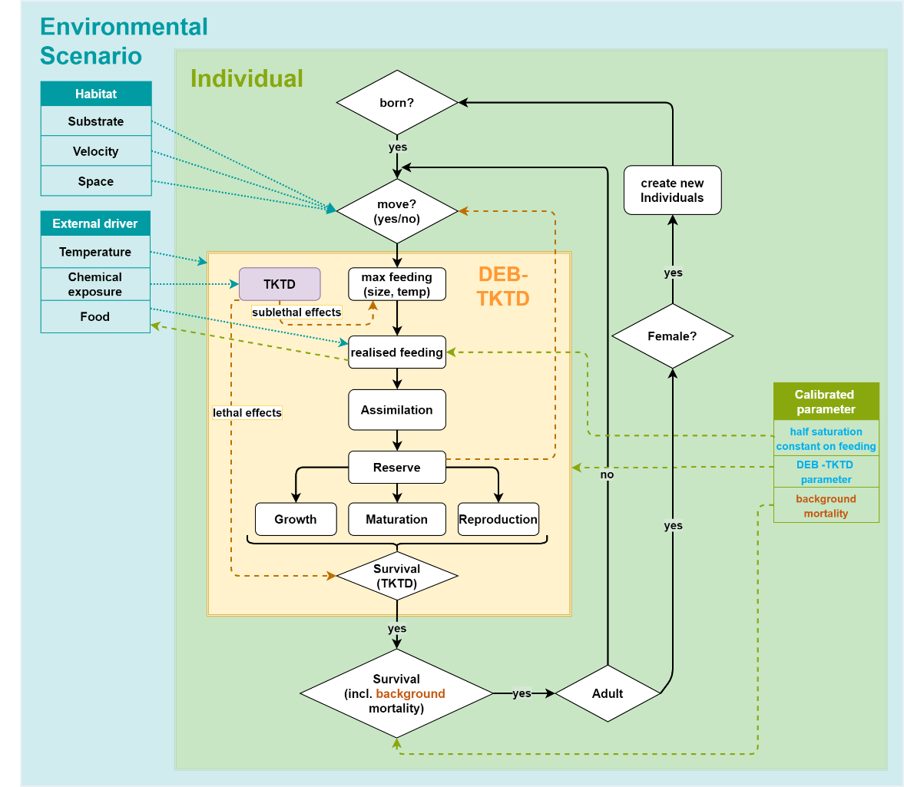
Figure 4.2.1 : Flow chart of the processes within individual life cycle. Flowchart diagram for the STREAMcom population model (black arrows). The ecological module includes an IBM (green) with the physiological DEB module (yellow) coupled to a toxicological TKTD module (grey). The DEB-TKTD module is schematically simplified as a box.

DEB IBM models
In addition to using individual-based IBMs whose physiology is based on empirical dependencies (for example, IDamP for Daphnia magna, IBM Chaoborus for Chaoborus crystallinus), other individual-based organisms are modeled using the dynamic energy budget (DEB) approach.
We used different adaptations of the standard DEB model (std) to simulate the different life histories of the modeled species as accurately as possible. The DEB model types and parameters were adopted from the Add-my-Pet portal, a database that had existing entries for each modeled species. The main difference between the standard model std and the typified models is that std-animals follow a typical von Bertalanffy growth curve whereas the typified models have a more upcurved growth (simulated with a metabolic acceleration phase) during early development.
Asellus aquaticus, Gammarus pulex, and Lymnaea stagnalis are modeled with the model type abj, which is highly similar to std but includes metabolic acceleration at the beginning of its growth period. Cloeon dipterum and Chironomus riparius are modeled with the hep model, similar to the abj model with the only difference that offspring are not produced at regular intervals but at the life event emergence. Lastly, the copepod Mesocyclops leukarti is modeled with the model type abp, whose metabolic acceleration phase lasts until the adult stage. Furthermore, once the adult stage is reached, growth in abp ends abruptly (in analogy with the final molt of a real copepod).

Implementation verification

Various tests were performed to ensure that the implemented code operates in accordance with the specifications in the models description. In addition to visual testing, print statements, code reviews and stress tests, tools from the modelling platform for syntax checking were also used for verification.

The models were thoroughly tested on several complexity levels to verify that the models behave as expected. The models were implemented in Delphi using different versions of the IDE RAD Studio.
Syntax checking. The automated validation of the Delphi code was performed using different software tools to ensure the code conforms to the specified syntax rules of the programming language. Apart from verifying the code solely for deviations from the language syntax to prevent runtime errors, it underwent examination and refactoring to align with certain established object-oriented design patterns. By promoting encapsulation, inheritance, and polymorphism, these patterns enable to build robust, adaptable, and efficient systems that align with object-oriented principles and thus help to minimise the occurrence of sematic errors.
Code reviews. The code of the DEB-TKTD part, as well as the code for the reproduction submodule, was reviewed by a DEB-TKTD expert. Thus, a direct review of the program codes was possible.
Visual testing of model output. The simulated population dynamics over time were checked iteratively using different independent data sets. Both published laboratory data and field data were used to compare the simulated population patterns. The comparison was done for varying scenarios and endpoints e.g. emergence behaviour, larvae abundances over time, mortality patterns, number of eggs.

Print statements. We programmed the model to display additional output information to check that the individuals and the population are developing in the expected way and reacting correctly to different influences. For example, we compared the DEB state variables at every time step to the output of the original DEB models. To check the consistency of the population development the model reports the age distribution and the mortality rates of the total population for each time step.

Stress test. Varying parameter values were used in stress tests, comparing the simulation output against expectations. For instance, the GUTS model were examined by altering chemical concentrations, population dynamics were assessed by changing reproduction-related parameters, and food levels were tested on their influence (e.g. starvation events)

Model output verification

Calibration to mesocosm control data

Calibration strategy:

The present calibration concept is based on the idea of recalibrating as few study-independent parameters as possible for a use case of the model. Hence, we have to calibrate the system-specific parameters (e.g., food web composition and interactions, sediment nutrient release and nutrient turnover, etc.), and, with regard to the ecophysiology of the organisms, parameters such as background mortality and migration rates, which are either uncertain and/or also system-specific. Species-specific DEB parameters should be taken as a complete physiological dataset from the add-my-Pet database where possible, as calibration is often already based on a high number of underlying studies.
In particular, parameters are calibrated that are essential for population dynamics or competition between species, and for which no (sufficient) experimental data are available (e.g. half-saturation coefficient for ingestion, emigration rate (dispersal), mortality rate). Since these are primarily parameters with poor experimental data, biologically and/or physiologically plausible assumptions are made within a value range. If avoidable, parameters with a preset value from literature or own experiments are not calibrated further.
Especially for the benthic community modelled with the STREAMcom model, we use a step-wise approach: first, the overall plausibility of individual populations are simulated and tested against field data. Afterwards, the interaction of the coupled benthic models is tested and parameters with a high uncertainty, which are important for the species interaction, are calibrated. The planktonic community has to be calibrated together due to its highly dynamic and coupled processes; but again, we pre-tested single planktonic IBMs for plausibility first (e.g. daphnids, chaoborids, copepods). This step-wise approach is done to avoid an overfitting of too many parameters to the mesocosm data, as long as the respective parameters are independent from the case study conditions.
Calibrations are performed either by hand, or using the downhill simplex algorithm to optimize selected sets of values during Monte Carlo simulations.

StoLaM

StoLaM Model version
- StoLaM starting version (before calibration) 4.1.1 (Strauss et al., 2017)
- StoLaM version used for calibration 4.1.3
- Simulated species: Daphnids, Rotifera, Green Algae, Diatoms, Cryptophytes
- An update of an existing ODD (see Strauss et al., 2017) based on the full model description (Strauss, 2009) is in preparation.

Model changes during calibration
- Integration of the individual-based daphnia model IDamP for Daphnia magna into StoLaM instead of the previous coupling of the autonomous execution files of IDamP and StoLaM via text file exchange.
- Development and integration of a DEB-IBM Copepod model for Mesocyclops leukarti (Koch J. 2021, unpublished) based on (Koch and De Schamphelaere, 2023).
- Development and integration of a macrophyte model. The model is parameterised for Myriophyllum spicatum, und is based on the work of Collins et al. (1985, 1989).

Parameters calibrated
The ecological parts of the lake model StoLaM were mainly parametrized using literature and some laboratory data and are thus valid independently of new case studies. Only few water body specific dependent parameters (e.g., nutrient release from sediment or other sources, turbidity of the water column) have to be re-calibrated or specified in each case of model application.
At the community level, the composition of the food web and their interactions (e.g., prey selectivity of consumers) will massively influence population dynamics, and therefore must be set and justified with special care for the scenarios being simulated.

The hydrodynamic module HyLaM has been fully parameterised and validated beforehand, without the need for further case study-specific adjustments. An exception may be an adaptation of the input weather data from climate stations in individual cases.

The IBMs that can be coupled in this modelling approach should have been previously parameterised using independent laboratory data and tested independently of case studies. Therefore, these IBMs can usually be used in new case studies without further adaptation.

The following parameters were parameterised for mesocosm modelling:

HyLaM (hydrodynamic module):

A 20 % reduction in global radiation of the meteorological measurements was calibrated to better simulate the measured water temperatures in the mesocosms.

StoLaM:

Following system-specific parameters has to be set or calibrated:

Food web interactions (selectivity indices for all predator-prey relationships).
Nutrient release (nitrogen, phosphorus, silicon) from the sediment. The silicon release rate has a strong influence on the dynamics of the diatoms.
The nutrient content of the macrophytes. These parameters determine the nitrogen and phosphorus release from the macrophytes into the water column through excretion and degradation, assuming that the nutrients required by the macrophytes could be taken up from the sediment indefinitely.
A reliable denitrification rate has to be adjusted with regard to other nitrogen sources.
The basic turbidity of the water body (independent of algae or detritus).
Oxygen depletion in the water body and on the sediment surface.
The minimum phytoplankton density that cannot be undercut by zooplankton feeding.

Calibration initial conditions and time period
Start of the simulation was always the beginning of the respective year (01 January). The initial conditions observed at the beginning of each mesocosm study were not used as starting dates for the simulations.
The calibrations also started at the beginning of the respective year and were carried out over the course of one year. During calibration, changed parameters and initial values at the beginning of the year were compared and adjusted against all monitoring data of the mesocosms.
The initial conditions of the simulations at the beginning of the simulated year were chosen or calibrated to be valid for all years and not to be further adjusted for single runs.
All state variables must be provided with initial values. For the initial values of nutrient concentrations, algal and zooplankton biomass or abundance, water temperature and oxygen, typical values for winter conditions in aquatic field mesocosms were used; these were also adjusted during calibration if necessary.
For the IBM models for daphnids and copepods, the simulated water volume (default setting: 10 litres) for the population must be specified. This volume can be above one litre in order to avoid extinction events at low abundances. In addition, assumptions must be made about the distribution of the starting number of individuals among the age classes (neonates, juveniles, and adults in the case of daphnids, nauplii, copepodites and adult stages in the case of copepods).

IBM Chaoborus model

IBM Chaoborus version
- IBM Chaoborus starting version (before calibration) 4.2.3 (Strauss et al. 2016)
- IBM Chaoborus version used for calibration 4.2.3 (Strauss et al. 2016)
- Simulated species: Chaoborus crystallinus
- An ODD is available in Strauss et al. (2016).

Model changes during calibration
No model changes during calibration.

Parameters calibrated
The ecological components of the IBM Chaoborus model were parameterized based on species-specific laboratory data at the individual level (all physiological dependencies) and semi-field tests (clutch number per female, estimation of migration), and are therefore considered generally applicable to new case studies for this species.
Only the net emigration rate of adult females was roughly calibrated as an important and test site-specific parameter.

Calibration initial conditions and time period
The start of the simulation is always January 1 of each year, and was conducted over a duration of one year. For the mesocosm studies to be modelled, there are no reliable data on larval density and size composition of the Chaoborus population at test start. Hence, we always started with overwintering L4 larvae, and the starting densities were pre-selected (calibrated).
The initial conditions of the simulations at the beginning of the simulated year were chosen or calibrated to be valid for all years and not to be further adjusted for single runs.

In the case of Chaoborus, the model was tested for stable and realistic population dynamics in a continuous simulation over 7 years with regard to larval density and emergence of adults.

IBM Daphnia model (IDamP)

IDamP version
- IDamP starting version: as published in Strauss et al., 2017
- IDamP version used unchanged for calibration
- Simulated species: Daphnia magna
- Published in (Preuss et al., 2009; Strauss et al., 2017)

Model changes during calibration
No model changes during calibration.

Parameters calibrated
Only the assimilation rate for daphnids was increased to an value of 1.

Calibration initial conditions and time period
See chapter 6.1.2.4

Copepods model

Model version
- Copepod model starting version (before calibration) 1.0
- Copepod model version used for calibration 1.0
- Simulated species: Mesocyclops leukarti

Model changes during calibration
No model changes during calibration.

Parameters calibrated
The default DEB assimilation efficiency ($κ_{X}$) of 0.8 was increased to the resulting value of 0.9.

Calibration initial conditions and time period
See chapter 6.1.2.4

STREAMcom

Model version
- STREAMcom starting version (before calibration) 2.0.19
- STREAMcom version used for calibration 3.3.0
- Published only in CEFIC-Report (version 1.x)
- Simulated species: Gammarus pulex, Asellus aquaticus, Lymnaea stagnalis, Cloeoen dipterum, Chironomus riparius

Model changes during calibration
- Include the DEB- and life-history parameters of Cloeon dipterum and Chironomus riparius to the spec.xml input file, so that these two additional species can be simulated
- DEB-parameters of Asellus aquaticus were adjusted to the recent add-my-pet entry
- Feeding rate is not affected by crowding stress
- Egg development is separated from embryo development in mother
- Metabolic acceleration (Type M) for hep- and abj-model implemented
- Inclusion of background mortality, migration rate and half saturation constant as new input parameters
- Implementation of a Downhill-Simplex algorithm for an auto-calculated calibration routine (calibration of background mortality, migration rate, half saturation constant for feeding)
- Diapause for reproduction of Lymnaea stagnalis implemented, due to the lag of temperature dependence in DEB parameters
- Include map of mesocosm as input file
- Habitat- and resource separation between the different species (see 6.1.2.3)

Spatial adaption of the environmental scenario
The simulated ecosystem is designed as a 2D raster map for a mesocosm. We translated the mesocosm into a square area with a total size of 6.55 m² (Figure 6.1.1). Part of the area (1.6 m²) is defined as sediment and thus represents the bottom of the mesocosm. The remaining 4.95 m² represent the wall area of the mesocosm. The area of a single cell (patch) is defined as 0.0655 m². Periphyton is allowed to growth on the total area of the mesocosm, while detritus is only available on the bottom area.
- 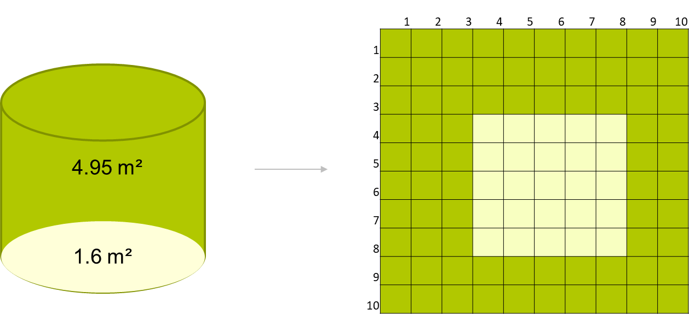
Figure 6.1.1 Raster map for a 6.55 m² mesocosm area. The sedimental area is colored yellow
(1.6 m²), wall surfaces are colored green (4.95 m²)

Adaptations to standing water bodies
Flow velocity as a habitat property and species trait was switched off. Periphyton and sediment with detritus layer were used as the only food resources for macroinvertebrates.

Parameters calibrated
We used already published DEB parameters, mostly calibrated using limited short-term laboratory data with little or no temperature dependence and which assume unlimited food availability. All DEB parameters for the DEB-IBMs were sourced from the AmP-database and were not adjusted for the specific scenario, except for the half saturation constant for food ingestion.
Following parameters were calibrated based on the validity criteria for the specific macroinvertebrate populations: The half-saturation coefficient for ingestion, background mortality, and (in case of emerging insects) the emigration rate of adult females (dispersal). For all three parameters, very little or no literature data is available, thus these parameters are highly sensitive and allowed us to calibrate the population abundancies to the reported control data.
Table 6.1.1 shows the calibrated parameters for all species. These parameters are independent of the DEB-model. They are constant throughout the whole simulation and are not influenced by environmental or individual conditions.
The background mortality works as a daily lost rate on the individuals of a population and therefore reduces the probability of an individual to survive. It is independent of the survival probability of the DEB-model and the starvation processes. The migration rate affects the probability of the individual to reproduce at the study site and the half saturation defines the feeding inhibition of the individuals by reduced food availability.

Table 6.1.1 Calibrated species parameter

Additionally, we implemented habitat- and food separations by using habitat- and resource preferences for the different species from the literature.
Of the five simulated species, the wall is a preferred habitat only for the snail Lymnaea stagnalis. All other species have a high preference for the bottom area with sediment.
Chironomids feed only on detritus, C. riparius feeds on both food sources, and all other species graze only the periphyton. Both food compartments are evenly distributed across the entire map, and we calibrated the growth rate and capacity of the periphyton module so that the simulated abundances matched the monitored species densities.

Calibration initial conditions and time period

For the mesocosm studies to be modelled, there are no reliable data on the size composition of the benthic macroinvertebrates at defined points in time, neither as starting conditions nor as measurements during the course of the study. Therefore, plausible assumptions have to be made, whereby especially in the case of large animals with high reproductive output, such as the snail Lymnea, the number of individuals can fluctuate massively depending on the population structure.

Start densities were adjusted for appropriate population dynamics, and a plausible population structure was determined for the start time. In STREAMcom, benthic macroinvertebrates were simulated with a one-year lead time before the actual simulation of each year began. This allows the DEB individuals with relatively long generation times to adequately and consistent pre-set the DEB physiological parameters. The one-year lead time started with only juvenile individuals and relatively low start abundances (Table 6.1.2). During the initialization, the species habitat preferences were tested on all available mesocosm cells. Thus the initial start individual abundances were not reduced during initialization.

The calibrations were carried out separately for the individual taxa after the one-year lead time over a 7-year period. The benthic community with all species was then analysed for coexistence and plausible population dynamics in further simulations over 7 years. These steps were iteratively repeated several times (see chapter 6.1.7). All simulations and calibrations started at the beginning of the respective year (01 January). The first measurement day of the experimental mesocosm study was only used as a normal comparison data set for model testing, not as the starting point for a simulation.

Table 6.1.2 Initial abundance of simulated species

The initial conditions of the simulations at the beginning of the simulated year were chosen or calibrated to be valid for all years and not to be further adjusted for single runs.
Based on several years of simulations, a typical initial energy content was set for the periphyton.

Step-wise calibration
In a first step, simulations of individual populations were performed to calibrate stable and realistic population dynamics over a seven-year period. As input only the seven-year temperature profile was used.
To calibrate the life history parameters, a downhill simplex algorithm was implemented that used the calibration criteria (upper and lower abundance level) as optimisation criteria. Afterwards all five species groups were simulated together, within the seven years. In this step the calibrated life history parameters and habitat- and resource preferences were iteratively refined manually, so that all species could form stable populations despite the competitive situation.
The resulting parameters were used to perform the control simulations and to calculate and compare the calibration criteria.

Sampling of parameter space
For joint calibration in the case of the STREAMcom macroinvertebrate community, Monte Carlo simulations were used in combination with the Downhill-Simplex method to adjust the selected parameters to be calibrated to the calibration criteria. During this process, all implemented stochasticity in the model was turned off.
In case of the StoLaM model (including the IDamp, the IBM copepod model, and the macrophyte module) as well as for the IBM Chaoborus model, the optimisation of the individual parameters and initial conditions to be calibrated was carried out manually and consecutively. The calibration results were evaluated using the resulting simulation patterns in comparison with the measurement data and calibration criteria.

Species groups with discrepancies in calibration
For some taxa, validity criteria were missed in some years due to inflated peaks (diatoms, cryptomonads, daphnids), which can be attributed to their high dynamics. Nevertheless, the simulations are mostly within the intended biomasses or abundances.

The DEB-based IBM model for cyclopoid copepods describes the dynamics in essentially the correct order of magnitude, both for the naupliar larvae and for the older stages (copepodites and adults). However, in some years the abundance peaks proved to be too high. A bigger problem at present is the unsatisfactory results of fall-winter population dynamics at low temperature. In particular, the mortality module needs to be readjusted, as also the required minimum abundances were not achieved in some cases.
The dynamics of small, but at times highly abundant rotifers were somewhat exceeded at times in two years.
The two rotifer groups were distinguished, particularly on the basis of their different responses in treated mesocosms, although no clear distinction by taxonomy or their position in the food web is apparent.
StoLaM uses a parameter set for the taxon Keratella cochlearis, and is seen as representative of both rotifer groups 1 and 2. We used only the validity criteria of herbivorous rotifers 2, whereas using the sum of rotifers 1 and 2 would have resulted in having met the criteria.

We decided to calibrate the emerged insects using the emerged data, not larval abundances. Therefore, the calibration of the cumulative emergence until study end for Cloeon dipterum and Chironomus riparius fits the data very well. However, the simulated larval abundance is strongly overestimated. For Cloeon by a factor of 15 and for Chironomus by a factor of 880. With the used approach of modelling individuals by the DEB approach, we need the simulated larval abundance to generate the measured emergence.
Simulations for Gammarus exceeded the required maximum abundance of 15.1 individuals by 1-3 individuals per m², which is considered a negligible deviation at this generally very low abundance.

Decision criteria
We used maximum and minimum abundance as initial calibration criteria for all calibrated species. In addition, we visually examined the temporal population development over the different seasons and compared these patterns with available literature data from field studies.

Calibration to mesocosm treatment data

Summary of effect representation in the model

In this chapter, based on the previously calibrated StoLaM+ model frame works, the effect model calibrations and the effects of the mesocosm exposure scenarios are shown and briefly discussed in comparison with the experimental data for the year 2019.

The simulations always started on 01 January 2019.
The simulations of the pelagic planktonic system were calculated with StoLaM with 50 Monte Carlo simulations each. Chaoborus was simulated with the IBM Chaoborus model with 200 Monte Carlo simulations, the number of Monte Carlo simulations for the benthic invertebrates with the STREAMcom model was set to 100.

The GUTS framework (Jager et al., 2011) was used as effect models to simulate the influence of azoxystrobin for the pelagic and benthic invertebrates.

The day of the first application of azoxystrobin (06/13/2019) is day 0 in the mesocosm study, and in terms of the whole simulated year, day 164 (day of the year). The exposure scenarios used for the simulation were read in daily from a file (see Figure 1).

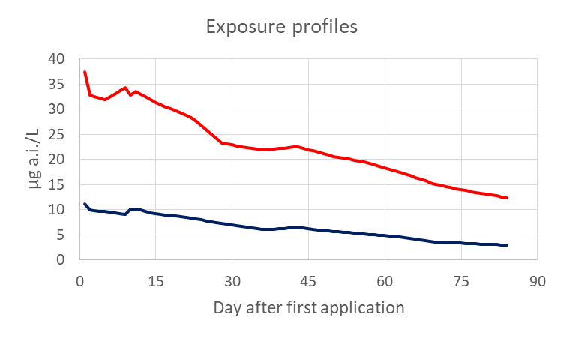
Figure 6.2.1 Azoxystrobin exposure profiles for the 30 µg/L (red line) and the 10 µg/L (black line) azoxystrobin profile of the mesocosm study 2019b.

The GUTS framework involves different dose metrics and toxicodynamic assumptions. The dose metric links an external concentration to internal damage and includes toxicokinetic processes such as bioaccumulation and distribution as well as damage accrual, recovery and physiological compensation processes (Jager et al., 2011).
We used the reduced version (GUTS-RED) which combines all those processes and makes use of the scaled internal concentration as the dose metric, selected stochastic death (SD) as the toxicodynamic assumption.
In case of GUTS-RED-SD, the model setting refers to three major parameters: the dominant rate constant kd, the effect threshold z, and the killing rate kk, which describe the effect and depend on the specific species/substance combination.

Inhibition of growth rates in phytoplankton as a function of toxic concentration in water is implemented in the StoLaM model as an ECx approach.
However, it was decided not to include the available effect data for algae in this project. First, most ECx values were well above the highest concentration in the 2019b mesocosm study.
In addition, there is no clear evidence of direct adverse effects for the exposure scenarios in the mesocosm studies. On the contrary, most phytoplankton-related endpoints tend to show promotions at high toxicant levels.
Only for the fluorescence values assigned to the cryptophyceae, slight acute adverse effects cannot be excluded, but especially for this group of algae no test data from the laboratory are available.
To summarise, it should be emphasised that no toxic effects were therefore taken into account in the simulation of phytoplankton.

Model changes during calibration
STREAMcom Version 3.0.2:
The TKTD Processes in the STREAMcom model were revised, including the separation of toxicological hazard and ageing or starvation hazard.

Parameters calibrated

The TKTD Parameter for the GUTS effect model were calibrated either with OpenGUTS (vers. 1.0) or MORSE package (vers. 3.3.1).
For the joint calibration of multiple data sets without (Daphnia) or with (copepod) size dependence, the GUTSplus (vers. 1.1) program was used.

The laboratory tests were conducted with azoxystrobin [µg a.i./L] over 48 h (Table 6.2.1). For GUTS calibration, only the values for the technical material were used.

Conceptually, it would be optimal to use the GUTS parameters calibrated in laboratory tests, measured for the correct species and over an appropriately long period of time for the concentration range needed in the application, unchanged in the simulation of field scenarios.
However, in these laboratory tests available in this project, the organisms were only tested for 48 h at mostly much higher concentrations than in the mesocosm study. In addition, the species and/or size stages were often different.

Table 6.2.1 GUTS calibrations based on the single species laboratory tests
Parameter | kd | z | Kk | Study information*
Description | dominant  rate constant | threshold  for lethal effect | killing rate
Unit | 1/d | µg/L | l/(µg*d) | References | size /  stage | calibration program
Cloeon dipterum | 4.5 | 2050 | 0 | Farelly et al. (1995): ICIA5504: Comparative toxicity of the technical material in solution and a 500 g kg-1 WG formulation to the mayfly nymph Cloeon dipterum. Confidential report series RJ1795B. | 5 mm | openGUTS
Gammarus pulex | 1.06 | 132 | 0.007 | Farelly et al. (1995): ICIA5504: Comparative toxicity of the technical material in solution and a 500 g kg-1 WG formulation to the mayfly nymph Gammarus pulex. Confidential report series RJ1782B. | 5 mm | openGUTS
Asellus aquaticus | 0.122 | 471.8 | 0.002 | Farelly et al. (1995): ICIA5504: Comparative toxicity of the technical material in solution and a 500 g kg-1 WG formulation to the mayfly nymph Asellus aquaticus. Confidential report series RJ1789B. | 5 mm | openGUTS
Lymnaea stagnalis | 0.474 | 2064 | 0 | Farelly et al. (1995): ICIA5504: Comparative toxicity of the technical material in solution and a 500 g kg-1 WG formulation to the mayfly nymph Lymnaea stagnalis. Confidential report series RJ1796B. | 15 mm | openGUTS
Chironomus riparius | 1.704 | 209 | 5.448 | Farelly et al. (1995): ICIA5504: Comparative toxicity of the technical material in solution and a 500 g kg-1 WG formulation to the mayfly nymph Chironomus riparius. Confidential report series RJ1790B. | second instar | openGUTS
Daphnia longispina | 28.56 | 224 | 0.2849 | Farelly et al. (1995): ICIA5504: Comparative toxicity of the technical material in solution and a 500 g kg-1 WG formulation to the mayfly nymph Daphnia magna. Confidential report series RJ1797B. | first instar | openGUTS
Cyclopoid copepods | 43.65 | 92.32 | 0.01968 | Farelly et al. (1995): ICIA5504: Comparative toxicity of the technical material in solution and a 500 g kg-1 WG formulation to the mayfly nymph Macrocyclops fuscus. Confidential report series RJ1793B. | 2 mm | openGUTS
Chaoborus crystallinus | 11.952 | 464 | 0.0002558 | Farelly et al. (1995): ICIA5504: Comparative toxicity of the technical material in solution and a 500 g kg-1 WG formulation to the mayfly nymph Chaoborus crystallinus. Confidential report series RJ1792B. | Phatom midge larvae | MORSE
* study duration always 48 h; only data for technical material used for calibration

Table 6.2.2 GUTS calibrations considering mesocosm data (see text for explanation)
Parameter | kd | z | kk | Study information*
Description | dominant  rate constant | threshold  for lethal effect | killing rate
Unit | 1/d | µg/L | l/(µg*d) | References | size /  stage | calibration program
Daphnia longispina | 2.508 | 28 | 0.09368 | Mesocosm study 2019b | first instar | GUTSplus
Cyclopoid copepods | 0.0539 | 9 | 0.025 | Mesocosm study 2019b | 2 mm | GUTSplus

All calibrations based on the laboratory data are shown graphically in Appendix A: GUTS parametrisation.

Calibration initial conditions and time period
The model set-ups for the effect calibration were identical to the initial conditions of the control calibrations.

Step-wise calibration
For benthic macroinvertebrates and Chaoborus larvae, the unmodified GUTS parameterisations from the lab studies were used (see Table 6.2.1 and Chapter 7: Appendix A: GUTS parameterisation). For these species, there was no evidence of inconsistencies with the mesocosm data. However, the only plausibility check on the results was that no direct effects should be apparent in either the simulation or the experimental mesocosm study for the given exposure scenarios.

In the case of Daphnia, its sensitivity in the short-term laboratory tests with technical material is too low to reproduce the clear adverse effects in the mesocosms in the 30 µg/L exposure scenario (Figure 6.2.2, left panel).
Therefore, the GUTS parameters were recalibrated directly on the mesocosm data 2019b from the two upper exposure scenarios (Figure 6.2.2, middle panel).
Although the data can be reproduced well with this parameter set, the threshold z for the daphnids was additionally lowered from 31.31 to 28 based on the population modeling results. Although a pure GUTS simulation does not fit the mesocosm data set as well (Figure 6.2.2, middle panel), the prediction on population level has become better.
The GUTS parameters ultimately used are given in Chapter 6.2.3 (Table 6.2.2).

This calibration strategy now provides a GUTS parameter set for Daphnia that can well reproduce the calibration data from the 2019b mesocosm study.
The laboratory data set was not further used for calibration. Unfortunately, the NOEC for sublethal effects in a Daphnia reproduction study for the same compound was also above the highest exposure concentration in the mesocosm study and therefore was not considered further as an alternative data set for calibration.

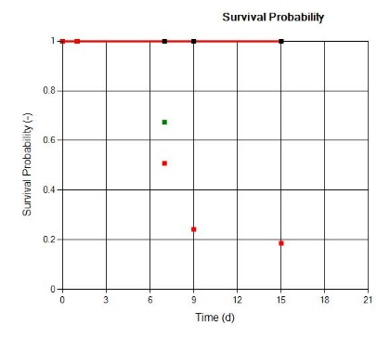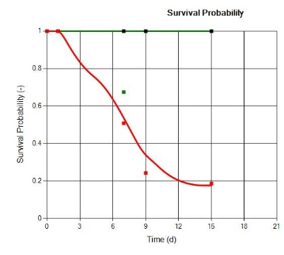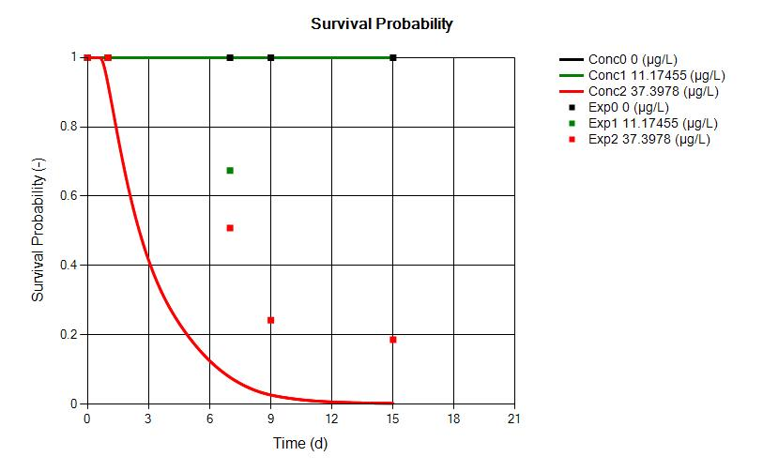
Figure 6.2.2 Simulations of daphnid survival using mesocosm data 2019b (red: 30 µg/L exposure scenario, green: 10 µg/L exposure scenario); dots: mesocosm data, lines: simulations. X-axis: day after first application in the mesocosm study. Left: GUTS parameters obtained from the laboratory study (OpenGUTS); middle: GUTS parameters calibrated to mesocosm data (GUTSplus, z=31.3); right: GUTS parameters re-calibrated to mesocosm data during the population modelling (z=28).

Also in the case of the cyclopoid copepods (Macrocyclops fuscus), its sensitivity in the short term laboratory tests with technical material is too low to reproduce the clear adverse effects in the mesocosms in the 30 µg/L exposure scenario neither for the adults nor the smaller copepodite and nauplius stages (Figure 6.2.3, upper panels).
On the other hand, the mesocosm data show clear sensitivity differences between copepod stages of different sizes, with higher sensitivity of the small larvae.
For these reasons, the laboratory data set was not used further, but the information for calibrating the size-sensitive GUTS parameters for the cyclopoid copepods was taken from the acute effect phase of the 2019b mesocosm study.

The length correction of the GUTS parameter kd was calculated as:

kd*=kd*Lm/L
with kd: value for the largest size class
Lm: Maximum length of the largest size class (here: 2 mm)
L: Current length of the individual [mm]
kd*: size corrected value for kd

With these calibrations made simultaneously for all size stages using the GUTSplus program, the size-dependent effects are well represented in the 30 µg/L exposure scenario, and shows only a very slight effect in the 10 µg/L exposure scenario for the very small nauplius larvae (Figure 6.2.3, lower panels). The GUTS parameters ultimately used are given in (Table 6.2.2, Chapter 6.2.3).

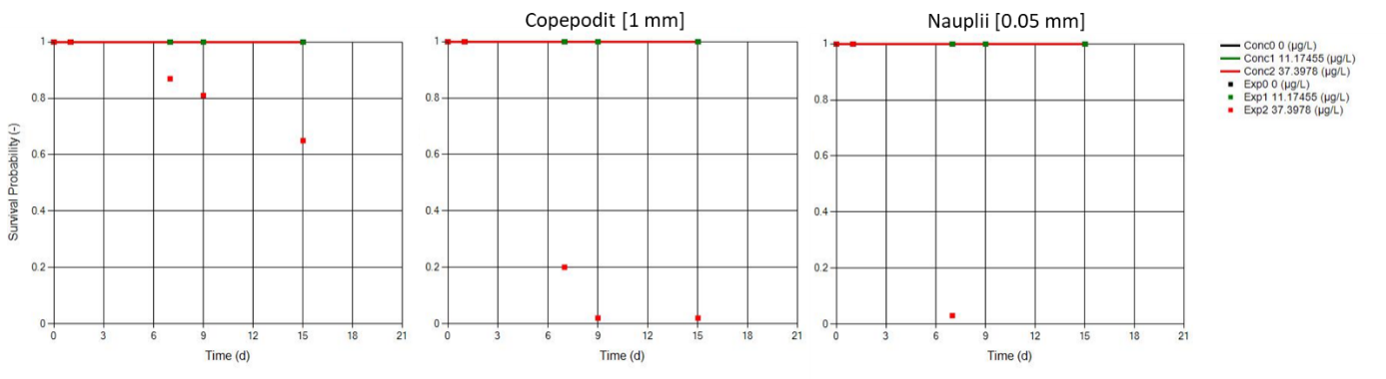
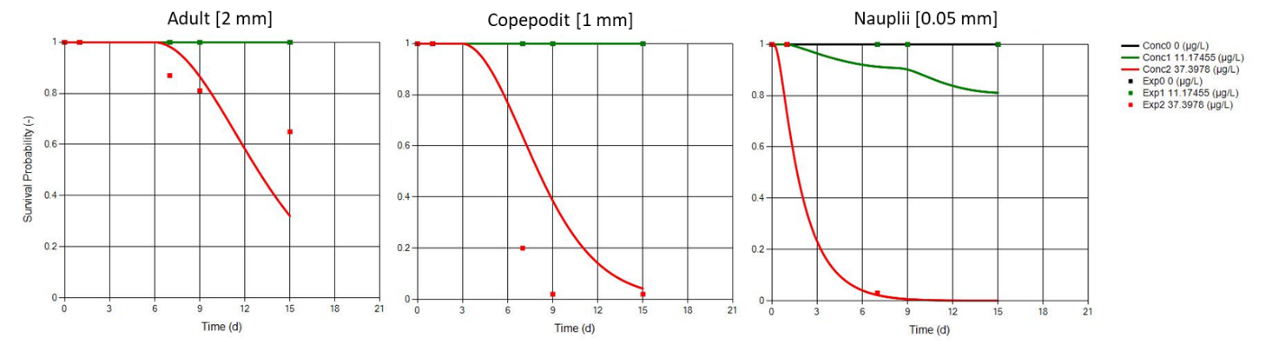
Figure 6.2.3 Simulations of copepod survival using mesocosm data 2019b (red: 30 µg/L exposure scenario, green: 10 µg/L exposure scenario); dots: mesocosm data, lines: simulations. X-axis: day after first application in the mesocosm study. Upper panels: GUTS parameters obtained from the laboratory study (OpenGUTS); lower panels: GUTS parameters calibrated to mesocosm data with size dependence of the copepods (GUTSplus). Left: adult copepods with 2mm length; middle: Copepodits with an assumed mean length of 1 mm; right: Nauplius larvae.

Sampling of parameter space

For benthic macroinvertebrates and Chaoborus larvae, the unmodified GUTS parameterisations from the lab studies were used, which were previously obtained from laboratory data using calibration tools (e.g., openGUTS).
The toxicological parameters for the IBMs for Daphnia and copepods were calibrated with the GUTS calibration tool GUTSplus using mesocosm effect data from the two-week acute phase after application of the effect calibration study (for details see chapters 6.2.3 and 6.2.5).

Species groups with discrepancies in calibration
In the simulations, Daphnia shows clear direct, negative effects after application in the 30 µg/L scenario with clear undercutting of the MDD values and a very similar effect curve as derived from the mesocosms. The recovery has an almost identical timing as in the mesocosms, particularly well visible in the figure with log-scaling.
In the 10 µg/L scenario, the initial decrease in abundance is already visible before application in the field data of the mesocosms, so a clear toxic effect cannot be assumed here. Subsequently, the daphnia show no negative deviation from the controls that falls below the MDD. In the simulations, no clear effect can be seen, which confirms the transferability of the used TKTD (GUTS) parameterisation.
Overall, by integrating the TKTD effect model into the IBM daphnia model, the effect size and the recovery for both high exposure scenarios can be well catched with this simulation approach.

The simulated naupliar larvae and the sum of the older cyclopoid copepod stages show a very realistic direct, negative effect in the 30 µg/L scenario, whereby the mortality rate for the small stages (nauplii) is higher than for the larger ones.
As this is an IBM Model, all individuals are simulated individually but simultaneously, and are only summarised as nauplii or larger stages for the simulation output. The size-dependent sensitivity in the course of individual development and the temporal interaction of sensitive stages and temporal exposure play an important role.
In the 10 µg/L scenario, there is no (nauplii) or only a very slight negative short-term effect (older copepods) on the population detectable, which corresponds well with the field data.

Due to the physiological parameterisation of the DEB-IBM copepod model, which is not yet fully developed, the late recovery of older copepod stages cannot yet be satisfactorily represented. In particular, the lifespan under suboptimal feeding and temperature conditions still needs to be revised.
Another problem for the development of the nauplii larvae could be the somewhat too high simulated densities for daphnia and rotifers, which change the feeding conditions to the disadvantage of the nauplii.
However, this is not seen as a problem in principle of this approach, but rather of the still outstanding, more intensive model testing of the new developed copepod module.
All in all, the IBM copepod model makes it possible to apply the TKTD effect model to the population, and to integrate size-dependent sensitivities to the toxic substance.

The rotifers show clear and strong long lasting indirect promotion in the 30 µg/L scenario, which agrees very well in the timing of both the onset of the effect and its recovery with the field data.
In the 10 µg/L scenario, on the other hand, no significant effect on rotifers is detectable either in the field data nor the simulations.

In the total phytoplankton, the abundance in the mesocosms is significantly increased over 2 weeks in the 30 µg/L scenario approx. 14 days after application. This promoting, indirect food effect can be reproduced well with the model as a result of decreased grazing pressure by daphnids and copepods.
Again, in the 10 µg/L scenario, no significant effect on algae is detectable in either the field data or the simulations in the 7 weeks following application.

Mainly responsible for this promoting effect in the 30 µg/L scenario are the green algae, which show clear significant indirect promoting effects in the mesocosms as well as in the simulations. Here, the oscillating overshooting is partially well matched in both timing and magnitude.

Diatoms show no clear effect in the 30 µg/L scenario in the 8 weeks after application, with only a small but non-significant increase two weeks after application visible in both measurements and simulations.
The reduction in diatom fluorescence signal that occurs late in the study cannot be represented by the model.

The cryptophyceans are basically not well covered in the simulation at the moment, especially the increase of the fluorescence signal in the mesocosms is not representable in the model, because the cryptophyceans with their productivity are an essential part of the zooplankton food. Therefore, a reduction of cryptophyceans detectable very late in the field study in the 30 µg/L scenario compared to the controls is not reproducible in the model, because there are already too few cryptophyceans in the simulated controls.

Mesocosm data for Chaoborus larvae from the macroinvertebrate dataset were used to compare field data and simulation.
On day 177, one single but significant NOEC of 10 µg/L was found in the mesocosm experiment with an MDD of 25 %, indicating a possible slight adverse effect on Chaoborus larvae abundance.
The simulated deviations on larval abundance in the 30 µg/L exposure scenario from the controls due to the toxic substance alone from the day of application ranged from -3.6% to +7.6% (mean + 1.7%), and were thus within the range of variations between Monte Carlo simulations (data not shown graphically). Therefore, a direct toxic effect based on the GUTS calibrations with laboratory studies can be excluded.

But indirect adverse dietary effects could be simulated for the 30 µg/L exposure scenario as described below:
In the IBM Chaoborus model, the larval stages L1 and L2 feed on rotifers and nauplii larvae, the older stages (L3 and L4) on daphnids.
To simulate the indirect food effects, the relative change over time from the StoLaM simulation of the 30 µg/L scenario of daphnia, nauplii and rotifers was evaluated and given to the IBM Chaoborus model as a data input (see Figure 6.2.4).

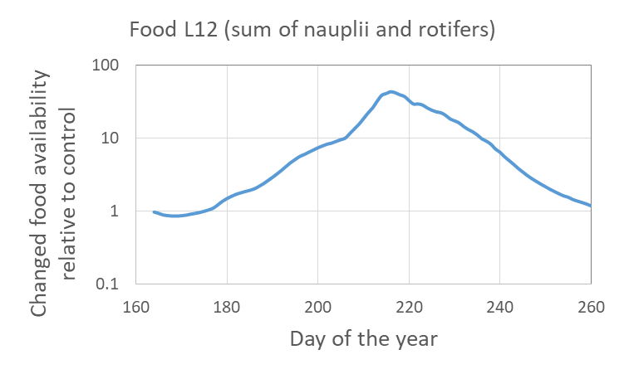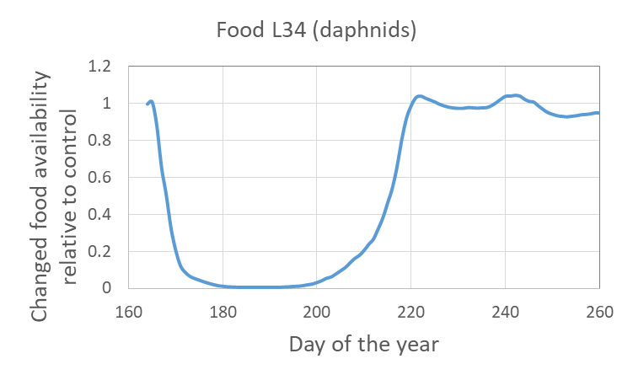
Figure 6.2.4 Simulated relative changes (StoLaM) output in the 30 µg/L scenario compared to the control for the sum of nauplii and rotifers (left panel) and daphnids (right panel) used as an influencing factor on the food availability of the respective Chaoborus larval stages.
The simulation of the 30 µg/L scenario shows the simulated strength of the diet-related indirect effects in the range of the measured MDD values. Therefore, an indirect effect on the Chaoborus population cannot be excluded. In any case, with the model approach, the pattern of the mesocosm studies can be well reproduced within the model concept, and thus hypotheses can be established and substantiated.

Overall, a direct toxic effect on Chaoborus larvae cannot be excluded in principle. However, the simulated direct lethal effects do not show any impact on the population, on the other hand, by including reduced food availability (mainly due to direct effects on daphnids), a similarly strong reduction in population density can be simulated for the older larvae as was found in the mesocosms. These results indicate an indirect, adverse effect.

In the STREAMcom model, the benthic individual-based modelled taxa Asellus aquaticus, Gammarus pulex, Lymnaea stagnalis, Cloeon dipterum and Chironomus riparius were coupled with the TKTD effect model GUTS.
GUTS parameterisations from the 48 h laboratory studies with azoxystrobin using the TKTD calibration tool openGUTS were available for all 5 macroinvertebrate species (Cloeon, Gammarus, Asellus, Lymnea, Chironomus), and these were used to simulate the effects of the exposure scenarios on the populations.
However, as all threshold values for lethal effects (GUTS parameter z) were significantly above the highest simulated exposure concentration of 30 µg/L, no negative effects were observed in the simulation for any of these organisms, as expected. These results are consistent with the evaluation of the mesocosm study, in which no significant negative effects were observed.

Effect summary
• Clear direct adverse effects in the exposure scenario 30 µg/L on daphnids and copepods were found that can be well simulated with the TKTD approach.
• Significant indirect effects in the 30 µg/L exposure scenario emerged from model behavior as a result of direct effects on cladocerans and copepods: Promotion of rotifers and green algae, slight reduction of Chaoborus larvae abundance.
• For the most part, the timing of (direct and indirect) effects and their recovery was well matched (exception: recovery in copepods).
• No significant direct or indirect effects on plankton in the second highest treatment (10 µg/L exposure scenario) using the same toxicological parameterisation for the simulations.
• No adverse effects on benthic macroinvertebrates could be found in the mesocosm study as well as in the simulations using the GUTS parameter derived from laboratory short-term experiments.

Decision criteria
In a first step, the TKTD Goodness of fit values were used as evaluation criteria. Subsequently, the overall population patterns of the effect calibration were compared to the mesocosm data, including the recovery behavior of the species.

Uncertainty
Uncertainties in input parameters and other inputs need to be identified along with the definition of uncertainty ranges if possible. Sources of parameter uncertainty in the model approach should be listed.

Model analysis
Model analysis beyond model validation is not expected for the current project (Phase 3). [If analysis were conducted in the context of the project, they should be described here.] In addition, previous analyses conducted with the model, including sensitivity analysis or uncertainty analyses, should be summarized here and referenced.

Model output corroboration

Further evaluation with mesocosm control data
In the calibration of the ASMs to mesocosm control data in the ASM ring study, data from four studies was used (studies 14a, 16a, 18c and 19b). Three additional study data sets were available for the project (studies 18a, 18b and 19a) which were used to conduct a further evaluation of the models (Loerracher et al., in prep). All seven control data sets were used to inform the control calibration criteria which were used as indicators of model performance. Because the three additional studies were conducted in the same years (2018 and 2019) as two studies included in the calibration data sets, their simulation does not correspond to a validation with independent data. Environmental conditions (physical and chemical measures in the water) were similar to corresponding studies conducted in the same year. Initial species composition (particularly abundances by species group) differed between the studies and the calendar date of study initiation.

Model version
For the validation the same model versions were used as for the effect calibration (see 6.1)

Initial conditions and time period
For the evaluation with the mesocosm control data the same initial conditions and time period were used as for the control calibration to mesocosm control data(see 6.1.2.4)

Species groups with discrepancies in further model evaluation
For all simulation approaches of this study, we simulated the entire simulation year without adjusting the initial species abundances at the start of the study to match those of the study. Therefore, the simulations performed for this evaluation would be consistent with the control calibration performed for the 18c and 19b studies. Given that the calibration criteria for this evaluation were also matched those of the control calibration, there was no necessity to repeat the simulations for 2018 and 2019. Thus, the discrepancies remain the same as discussed in section 6.1.8.

Validation with 2021 mesocosm control data
In addition to the seven mesocosm control data sets (Loerracher et al., in prep), control data sets from two mesocosm studies conducted in 2021 at the same facility were available for the project. These two study data sets did not inform the control calibration criteria. The 2021 studies provide independent data for model validation with year- and study-specific conditions that differ from the data used for calibration and further evaluation of the model (see previous sections). To ensure blind validation, only the initial conditions (species abundance in zooplankton and macroinvertebrates, coverage of macrophytes, and chlorophyll-a content of phytoplankton and periphyton on the first sampling day) and the physicochemical data were available to the modelers. The control validation criteria were the same as the control calibration criteria.

Model version and parameterization
For the validation the same model versions were used as for the effect calibration (see 6.1)

Validation initial conditions and time period
The simulations always started on 01 January 2021 with the meteorological weather data from that year.
The simulations of the pelagic planktonic system were calculated with StoLaM with 50 Monte Carlo simulations each. Chaoborus was simulated with the IBM Chaoborus model with 200 Monte Carlo simulations, the number of Monte Carlo simulations for the benthic invertebrates with the STREAMcom model was set to 100.

The adjustment to the new control data set of the mesocosm study in 2021 was limited to a few parameters of the newly developed submodel for copepods. As the focus was on validating the existing model including its parameters, no further parameters were adjusted and violations of the validity criteria were accepted.

A few of the following parameters, concerning copepods only, were changed when the model was fitted to the control density data on day 158 (07/06/2021) of the study in 2021:

Selectivity coefficients (pelagic food web)
Nauplii | Cyclotella sp. | 0.2
Nauplii | Chlorococcales | 0.1
Cyclopoid copepodits | Cyclotella sp. | 0.8
Cyclopoid copepodits | Chlorococcales | 0.5
Adult copepods | Cyclotella sp. | 1.0
Adult copepods | Chlorococcales | 0.5

The starting densities of adult copepods on 01.01.2021(day 1) was set on 50 Ind / L.

The weather data for 2021 were taken from the weather station of RWTH Aachen University with an overall increase of wind speed of 30%, and a decrease of global radiation of 20 %.

Species groups with discrepancies in validation
Zooplankton:
The simulation results for the daphnids (IDamP module) are within the minimum and maximum validity limits. The simulated population peak for 2021 is earlier than required by the criteria. However, the field data do not show a clear population dynamic pattern and are overall slightly below the simulated values in 2021.

The DEB-based IBM model for cyclopoid copepods describes the dynamics essentially in the correct order of magnitude, both for the naupliar larvae and for the older stages (copepodites and adults). The overall pattern for the nauplii stages fits well with the measured abundances, whereas the cyclopid copepods show an overestimation of the summer peak with a slight excess of the maximum limit value. Possibly the DEB-IBM model-internal distinction between nauplius stages and young copepodid stages and the associated allocation of individuals to size stages should be re-examined.
Both developmental stages of the copepods show an excessive decline in late summer and fall. This is due to the as yet unbalanced processes of food intake and assimilation. In particular, the mortality module in this IBM for copepods still needs to be improved with regard to DEB parameterization.

The simulated dynamics of small but at times very abundant rotifers (Rotifera_herbivorous2) covers the data range of the experiments. However, the patterns deviate from the experimental data over time. In addition, the model slightly exceeds the maximum limits of the validity criteria in the short term. This summer peak could be avoided by further calibration and is also subject to uncertainty due to the chosen conversion factor between the simulated rotifer biomass and the measured number of individuals. Nevertheless, the timing of the simulated rotifer peak meets the validity criteria, even if the 2021 study does not show this.

Phytoplankton:
Comment: Overall, the measurement of phytoplankton is subject to significant uncertainties for methodological reasons. This is true for the quantification as well as especially for the differentiation of algal groups in phytoplankton via fluorescence measurements.
The green algae meet the validation criteria well. Possibly, in the later course of the mesocosm studies, the algal count is artificially increased by interspersing epiphytic algae from the macrophytes into the phytoplankton samples.
In the StoLaM simulations, the diatoms regularly have a clear peak in spring. Without having any information on possible peaks before the experimental period of the mesocosm study, the chlorophyll-a content of the diatoms is well met during the experimental phase, even if the diatoms in the study were estimated to be slightly lower than in the simulation.
In contrast, the cryptophytes show higher chlorophyll-a contents in the study than were simulated. Nevertheless, the simulations were still within the range of the validity criteria except for a few days with a minimal excess of the validity threshold.
The total phytoplankton meets also the validation criteria.

Simulations with the IBM Chaoborus module:
The larval density of Chaoborus is within the range of the measured data, which show high variability without clear population dynamic patterns in the Mesocosmos study.
Although the simulated abundance in 2021 exceeds the upper limit of the validity criteria, many measured values in the 2021 study are also well above the maximum value extracted from the older control studies.

Benthic macroinvertebrates:

Asellus meets the requirements of the validation criteria and is in line with the overall pattern of the experiment.
The simulated dynamics for Gammarus exceed the upper validity criteria by a few animals per m2, during the course of the study. However, no data on Gammarus are available in the 2021 study.
For the gastropods, represented by Lymnea stagnalis, the requirements of the validation criteria were met. The simulation slightly overestimates the abundance in 2021 and reproduces the field data satisfactorily in its dynamics.

For the mayfly species Cloeon dipterum, the dynamics of cumulative emergence is in the range of the previous control data sets, and reached similar cumulative numbers per m2 as in the study 2021. The dynamics of the larvae also give a consistent picture, as long as a conversion factor of 10 is assumed, which was derived from the control calibrations. If this conversion factor for larval abundance in the mesocosms derived from the emergence data and modeled life cycles is accepted, the simulated larval densities and cumulative emergence for 2021 are still within the vailidity criteria.

For the chironomids a similar picture as for Cloeon was obtained. Here, we used again the former calibrated conversion factor for the larval abundance per m2 of 880.
However, in the 2021 mesocosm study, the sampled number of chironomid larvae were much higher than in the previous studies used for model calibration and extraction of the validity criteria. This possibly indicates a slightly higher larval catchability in the 2021 mesocosm study, whereas the quantification of larval abundance remains a major uncertainty for Chironomus.
As in the calibration studies, the simulated larval densities in 2021 using the adjusted conversion factor remain within the range of the validity criteria. The simulated cumulative emergence is again within the range of the calibration data sets, although the sum of the chironomids is lower.

The requirements of the validation criteria for total periphyton were met also for the year 2021. However, there is a large uncertainty in the quantification of periphyton, as exemplary measurements on the mesocosm wall indicate a significantly increased periphyton biomass over the year compared to the used measurements on glass slides. Additionally, algal availability to benthic grazers on sediment and macrophytes has not been quantified. Therefore, there is a large source of uncertainty given for the benthic food web modelling.

Validation with 2021 mesocosm treatment data
From the two 2021 studies used for control validation, the treatment data were also available. One of the studies (2ApplS) was a repeat of the study with azoxystrobin (19b) which was used for control and effect calibration but limited only to the two highest azoxystrobin treatments (see sections 6.1 and 6.2). The second 2021 study (3PeakS) had 3 applications of azoxystrobin in intervals of 8 days. The day after each application, azoxystrobin was removed by water filtering, resulting in 3 distinct exposure peaks. Effect criteria were the same as the effect calibration criteria for the 2ApplS scenario, whereas new criteria were defined for the 3PeakS scenario (but not shared with the modelers). To ensure a blind validation, only exposure profiles were provided to the modelers.

Model version and parameterization
For the validation the same model versions were used as for the effect calibration (see 6.1)

Validation initial conditions and time period
For the validation with the 2021 mesocosm treatment data the same initial conditions and time period were used as for the validation with 2021 mesocosm control data (see 9.2.2)

Simulated effects of treatments in 2021 study 2ApplS

9.3.3.1 Direct effects
Daphnids
In the 33 µg/L scenario, the effect strength is in the right order of magnitude after application. However, the recovery starts a little too early in the simulation, although the pattern is correct.
In the 10 µg/L scenario, the negative effects were not reflected in the mesocosm study.
For the daphnids, the TKTD threshold for lethal effects, z, was set on 28 µg/L by calibration on the mesocosm study 2019b. In the effect calibration in the 2019 mesocosm study with only two relevant concentration levels, one with extremely strong effects, one with no clear significant effects. Therefore, due to the insufficient calibration data for the TKTD module, a simulation of toxic effects in daphnids at the second highest concentration is not possible.

Cyclopoid copepods and nauplii
Although the effect in the 33 µg/L scenario is clearly pronounced in the simulation of the copepod nauplii, it is underestimated compared to the measurements in the mesocosms. This could partly also be due to reproductive compensation in the simulation, while in the mesocosms at the time of application the abundance of nauplii decreased in the controls at the beginning.
No significant effects could be simulated for the 10 µg/L scenario, which is consistent with the relatively small effects in the mesocosms. Slight effect in the 2021 mesocosm study is in contrast to the results in the 2019b study, where no negative effect or only slight enhancements were seen at a similar maximum exposure concentration of 10 µg a.i/L.

Despite the different overall population dynamics, the effect pattern for the older stages of the predatory (cyclopoid) copepods is consistent with the measurements for the 33 µg/L exposure scenario.
Although the effects on the copepods in the mesocosm study are somewhat stronger, they start before the first application and are therefore at least partially not attributable to toxic effects. These differences between treatments and controls before application could possibly also have had an effect on the nauplii.

As expected, the simulation shows no effects at 10 µg/L, while in the mesocosms, again in contradiction to the 2019b study, clear negative effects can be observed, although these again begin before application.

There are two explanations for the deviations between simulations and measured effects:
a) in the 2021 study, the toxic effects are overestimated, as a non-toxic effect was already visible before application.
b) Robust laboratory data were not available for effect calibration for the cyclopoid copepods, calibration was again performed directly on the 2019 study. The TKTD threshold for lethal effects, z, was set on 9 µg/L by calibration on the mesocosm study 2019b. The z value has been set in a similar concentration range as the initial concentration of the 10 µg/L scenarios. Small differences in the calibration of z can strongly influence the sensitivity to this exposure scenario and thus reduce the accuracy of the simulation at the second highest concentration.

Since higher effects occurred at the highest concentration in the 2021 study despite lower toxic exposure, it is obvious that the selection of mesocosm data for calibration and validation must lead to inaccuracies in the calibration. A (hypothetical) reverse order might have achieved a better fit. In any case, TKTD models require a more informative data set for calibration ls in the present example for the cyclopoid copepods.
Nevertheless, considering the size-specific sensitivity of the copepod stages, this effect modeling approach including size-specific TKTD modules yields overall plausible results.

9.3.3.2 Indirect effects
Rotifers
The simulated rotifers in the highest test concentration showed clear promotion effects of the same magnitude in the post-treatment phase as those measured in the mesocosms, although the positive deviations of the treatments in the mesocosms lasted longer.
These indirect effects can be attributed to the reduced grazing of the daphnids and copepods and the resulting increase in algae availability.
At the second-highest concentration, the beneficial effects during the post-treatment phase are comparably low in simulations and measurements.

Phytoplankton
The phytoplankton groups were generally assumed to be insensitive to azoxystrobin on the basis of laboratory studies. Negative deviations in the mesocosms can therefore hardly be attributed to direct effects on phytoplankton.

The total chlorophyll-a content in the 33 µg/L scenario shows a clear tendency towards indirect promotion after application in the simulations with a clear recovery. These patterns can also be found in the mesocosm data. In the second-highest concentration, these promoting effects have disappeared in the simulation as well as in the mesocosm.

The green algae in particular show these promoting effects, which can be found even more clearly for this group in the mesocosms at the highest exposure.

A similar picture emerges for the diatoms, where the simulations and measurements agree most clearly in their patterns. At the second highest concentration, these promoting effects can no longer be found in the post-treatment phase.

The cryptomonads show neither negative effects nor promotion in the simulations, whereas a slight fluctuation with slight negative deviations in the post-treatment period in the mesocosms could be found. A slight negative effect of azoxystrobin on cryptomonads directly after application cannot be excluded, but effect models can hardly be reliably calibrated in this case due to the lack of laboratory data and uncertain data situation in the mesocosms.
Chaoborus crystallinus
Toxic effects on Chaoborus at the tested concentrations is almost impossible based on the laboratory tests, but indirect effects via food availability (nauplii, rotifers, daphnia) are feasible.
A small indirect reduction in larval density due to negative effects on the food organisms was simulated but, in contrast to the calibration study, is not reflected in the mesocosm data. However, the measured and simulated fluctuations in the larval abundance in this validation study were generally lower.

Toxicologically unaffected benthic taxa
In the StreamCOM model, the benthic individual-based modelled taxa Asellus aquaticus, Gammarus pulex, Lymnaea stagnalis, Cloeon dipterum and Chironomus riparius were coupled with the TKTD effect model GUTS. Based on the GUTS parameters calibrated by 48 h laboratory studies, no effect on these organisms could be shown for the 33 µg/L exposure scenario, which is also in line with the evaluations of the mesocosm study.

9.3.3.3 Summary

Overall, the relevant direct and indirect effects on plankton organisms could also be shown in the validation study using the StoLaM+ simulation model.
Clear direct adverse effects in the exposure scenario 33 µg/L on daphnids and copepods were found that can be simulated with the TKTD approach. Significant indirect effects in the 33 µg/L exposure scenario emerged from model behavior as a result of direct effects on cladocerans and copepods: Promotion of rotifers, diatoms and green algae.
However, the need to use one mesocosm study for calibration and one for validation results in a somewhat arbitrary assignment of the studies to the modeling steps, as both studies slightly contradict each other in their sensitivity.

For the calibration of the TKTD effect models, robust laboratory tests with an appropriate test duration for several days of exposure and a concentration selection tailored to the mesocosm study (use case) would have been more favorable. Especially for the calibration of the TKTD parameter z, which defines the lower limit of the toxic sensitivity of the effect model, calibration data of a relevant duration and appropriate concentration selection are important. In the best case scenario, the two mesocosm studies then would have been available to validate the transferability of laboratory experiments to field experiments, which would also have reflected the
variability of mesocosm studies in their slightly different reponso to azostrobin exposure.

Note: Effect outputs from the models in the 3PeakS study will be provided by the modelers to the study coordinators (Waterborne Environmental) in the same format as for effects in studies 19b and 2021 (2ApplS), but the observed effects (and MDD values) will not be shared with the modelers prior to project completion. Thus, simulated effects in 3PeakS do not need to be discussed in this section of the TRACE documentation. Effect result tables with observed effects added for 3PeakS will be made available before publication.

References
EFSA, 2014. Scientific Opinion on good modelling practice in the context of mechanistic effect models for risk assessment of plant protection products. EFSA J. 12, 3589. https://doi.org/10.2903/j.efsa.2014.3589
Grimm, V., Augusiak, J., Focks, A., Frank, B.M., Gabsi, F., Johnston, A.S.A., Liu, C., Martin, B.T., Meli, M., Radchuk, V., Thorbek, P., Railsback, S.F., 2014. Towards better modelling and decision support: Documenting model development, testing, and analysis using TRACE. Ecol. Model., Population Models for Ecological Risk Assessment of Chemicals 280, 129–139. https://doi.org/10.1016/j.ecolmodel.2014.01.018
Grimm, V., Berger, U., Bastiansen, F., Eliassen, S., Ginot, V., Giske, J., Goss-Custard, J., Grand, T., Heinz, S.K., Huse, G., Huth, A., Jepsen, J.U., Jørgensen, C., Mooij, W.M., Müller, B., Pe’er, G., Piou, C., Railsback, S.F., Robbins, A.M., Robbins, M.M., Rossmanith, E., Rüger, N., Strand, E., Souissi, S., Stillman, R.A., Vabø, R., Visser, U., DeAngelis, D.L., 2006. A standard protocol for describing individual-based and agent-based models. Ecol. Model. 198, 115–126. https://doi.org/10.1016/j.ecolmodel.2006.04.023
Grimm, V., Berger, U., DeAngelis, D.L., Polhill, J.G., Giske, J., Railsback, S.F., 2010. The ODD protocol: A review and first update. Ecol. Model. 221, 2760–2768. https://doi.org/10.1016/j.ecolmodel.2010.08.019
Grimm, V., Railsback, S.F., Vincenot, C.E., Berger, U., Gallagher, C., Deangelis, D.L., Edmonds, B., Ge, J., Giske, J., Groeneveld, J., Johnston, A.S.A., Milles, A., Nabe-Nielsen, J., Polhill, J.G., Radchuk, V., Rohwäder, M.S., Stillman, R.A., Thiele, J.C., Ayllón, D., 2020. The ODD protocol for describing agent-based and other simulation models: A second update to improve clarity, replication, and structural realism. J. Artif. Soc. Soc. Simul. 23.
Schmolke, A., Thorbek, P., DeAngelis, D.L., Grimm, V., 2010. Ecological models supporting environmental decision making: a strategy for the future. Trends Ecol. Evol. 25, 479–486. https://doi.org/10.1016/j.tree.2010.05.001
Collins, C.D., Park, R.A., Boylen, C.W., 1985. A mathematical model of submersed aquatic plants (Report). U.S. Army Engineer Waterways Experiment Station.
Collins, C.D., Wlosinski, J.H., 1989. A macrophyte submodel for aquatic ecosystems. Aquat. Bot. 33, 191–206. https://doi.org/10.1016/0304-3770(89)90037-5
Jager, T., Albert, C., Preuss, T.G., Ashauer, R., 2011. General Unified Threshold Model of Survival - a Toxicokinetic-Toxicodynamic Framework for Ecotoxicology. Environ. Sci. Technol. 45, 2529–2540. https://doi.org/10.1021/es103092a
Koch, J., De Schamphelaere, K.A.C., 2023. Investigating Population-Level Toxicity of the Antidepressant Citalopram in Harpacticoid Copepods Using In Vivo Methods and Bioenergetics-Based Population Modeling. Environ. Toxicol. Chem. 42, 1094–1108. https://doi.org/10.1002/etc.5599
Koch, J., De Schamphelaere, K.A.C., 2020. Estimating inter-individual variability of dynamic energy budget model parameters for the copepod Nitocra spinipes from existing life-history data. Ecol. Model. 431, 109091. https://doi.org/10.1016/j.ecolmodel.2020.109091
Koch, J., De Schamphelaere, K.A.C., 2019. Two dynamic energy budget models for the harpacticoid copepod Nitocra spinipes. J. Sea Res., Ecosystem based management and the biosphere: a new phase in DEB research 143, 70–77. https://doi.org/10.1016/j.seares.2018.02.003
Kooijman, S.A.L.M., 2010. Comments on: Dynamic Energy Budget theory for metabolic organisation, 3rd ed. Cambridge University Press, Cambridge.
Kooijman, S.A.L.M., 2009. Dynamic Energy Budget Theory for Metabolic Organisation, 3rd ed. Cambridge University Press, Cambridge. https://doi.org/10.1017/CBO9780511805400
Preuss, T.G., Hammers-Wirtz, M., Hommen, U., Rubach, M.N., Ratte, H.T., 2009. Development and validation of an individual based Daphnia magna population model: The influence of crowding on population dynamics. Ecol. Model. 220, 310–329. https://doi.org/10.1016/j.ecolmodel.2008.09.018
Strauss, T., 2009. Dynamische Simulation der Planktonentwicklung und interner Stoffflüsse in einem eutrophen Flachsee, Akademische Edition Umweltforschung. Shaker, Aachen. https://doi.org/10.18154/RWTH-CONV-113654
Strauss, T., Gabsi, F., Hammers-Wirtz, M., Thorbek, P., Preuss, T.G., 2017. The power of hybrid modelling: An example from aquatic ecosystems. Ecol. Model. 364, 77–88. https://doi.org/10.1016/j.ecolmodel.2017.09.019
Strauss, T., Kulkarni, D., Preuss, T.G., Hammers-Wirtz, M., 2016. The secret lives of cannibals: Modelling density-dependent processes that regulate population dynamics in Chaoborus crystallinus. Ecol. Model. 321, 84–97. https://doi.org/10.1016/j.ecolmodel.2015.11.004

Appendix A: GUTS parametrisation

Zooplankton

Daphnia

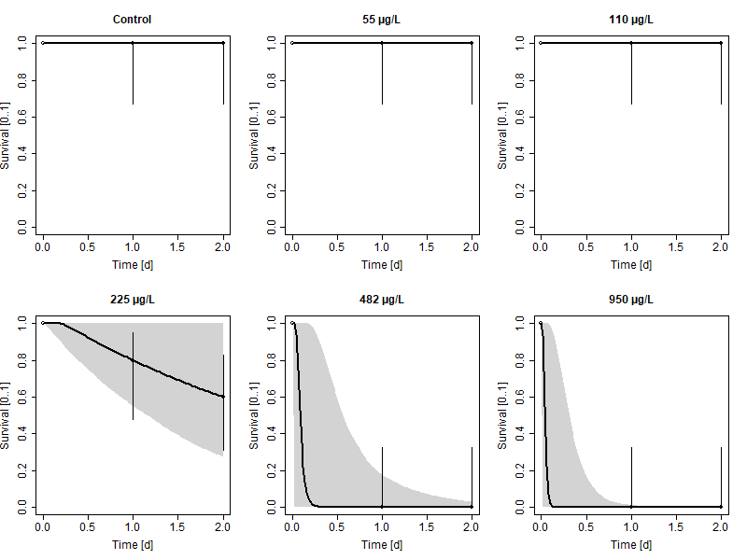
Figure 11.1.1: Daphnia magna: Survival plots for the calibration of GUTS-RED-SD (OpenGUTS)

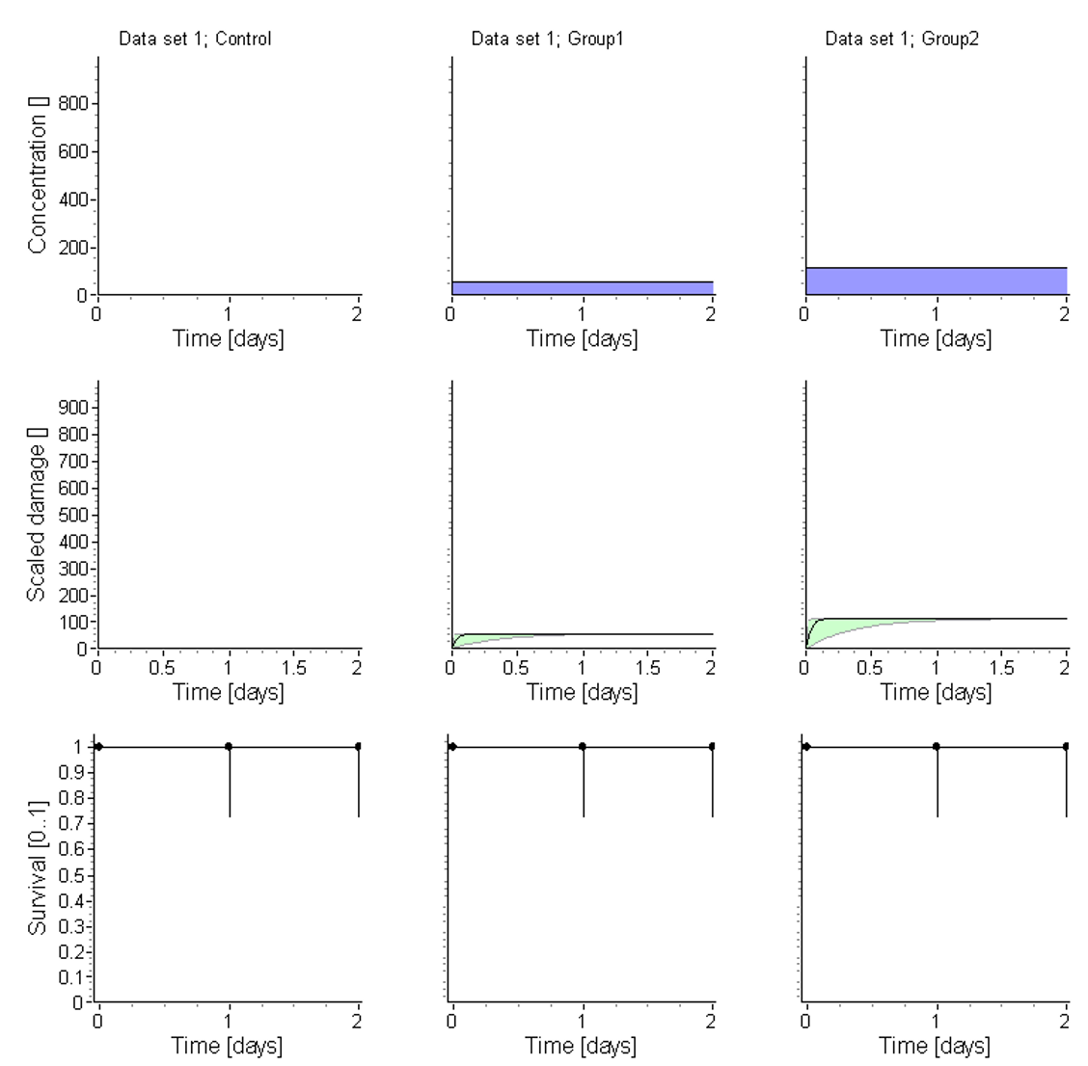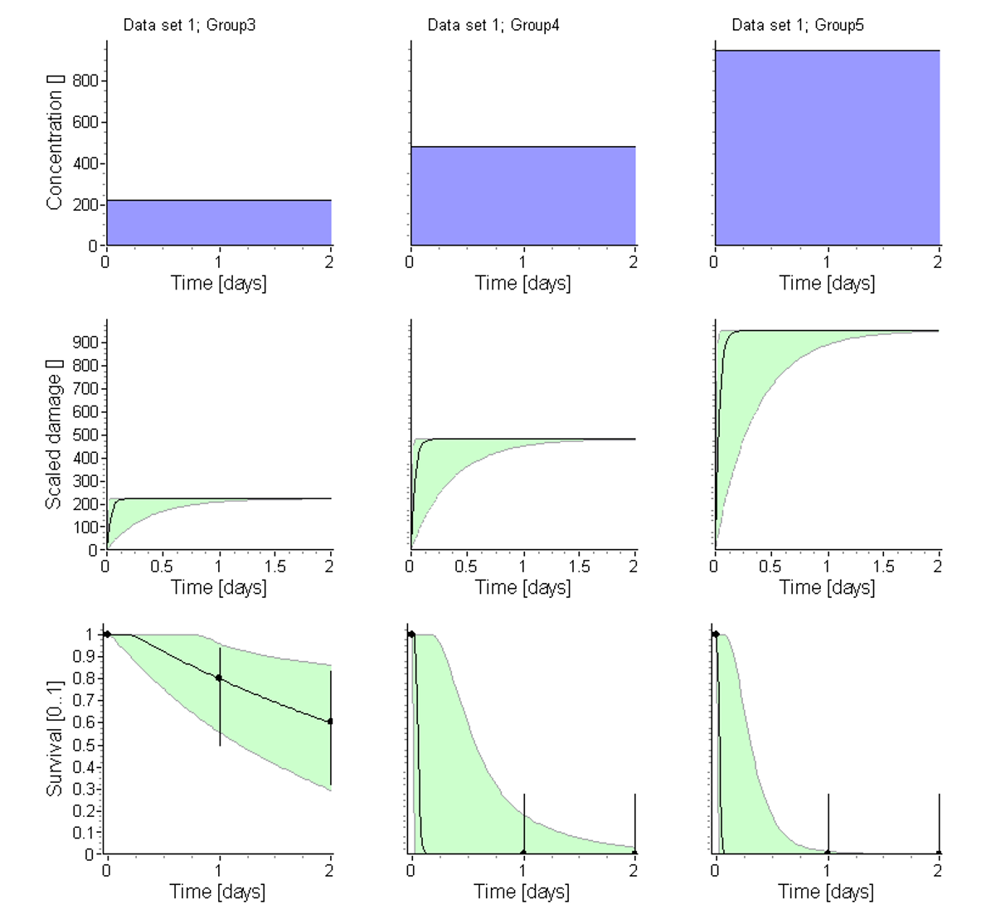
Figure 11.1.2: Daphnia magna: Exposure, damage and survival plots for the calibration of GUTS-RED-SD (OpenGUTS)
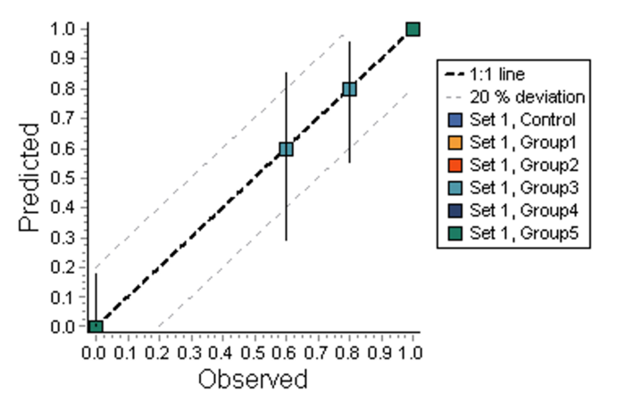
Figure 11.1.3: Daphnia magna: Observed vs. Predicted survival (PPC) plot for the calibration of GUTS-RED-SD (OpenGUTS)

Copepods

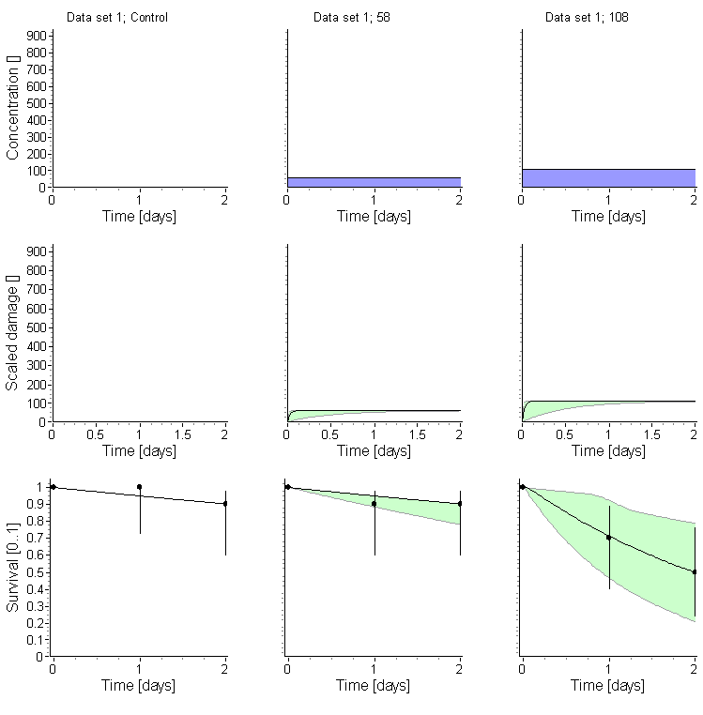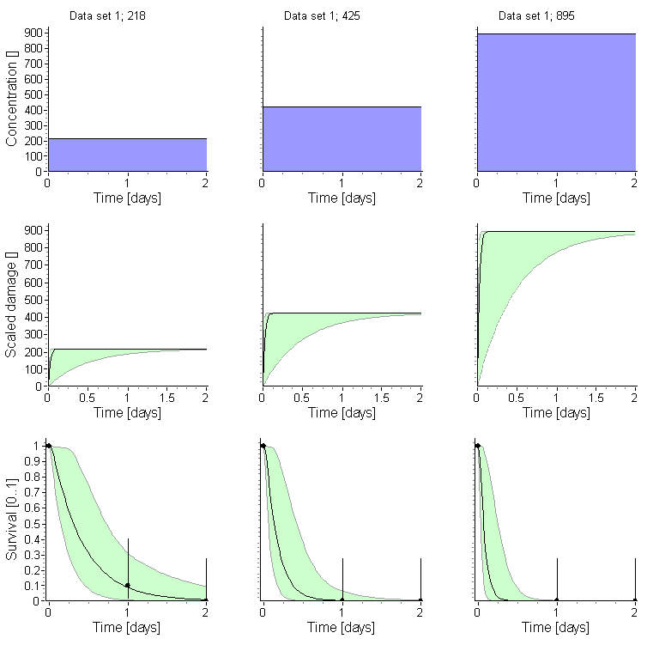
Figure 11.1.4: Macrocyclops fuscus: Exposure, damage and survival plots for the calibration of GUTS-RED-SD (OpenGUTS)
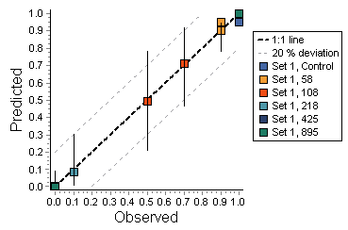
Figure 11.1.5: Macrocyclops fuscus: Observed vs. Predicted survival (PPC) plot for the calibration of GUTS-RED-SD (OpenGUTS)

Chaoborus crystallinus
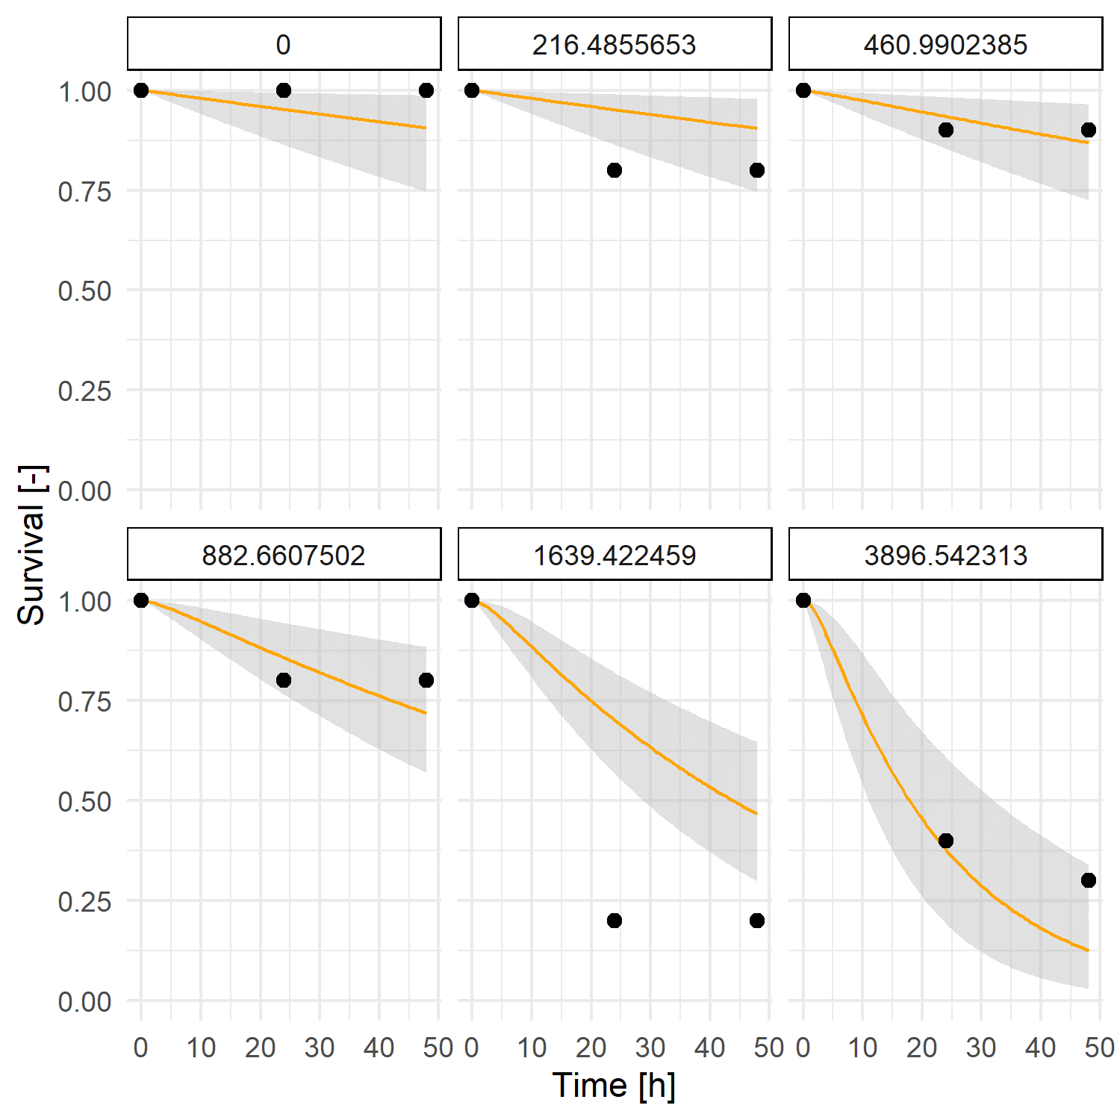
Figure 11.1.6: Chaoborus crystallinus: Survival plots for the calibration of GUTS-RED-SD (MORSE)

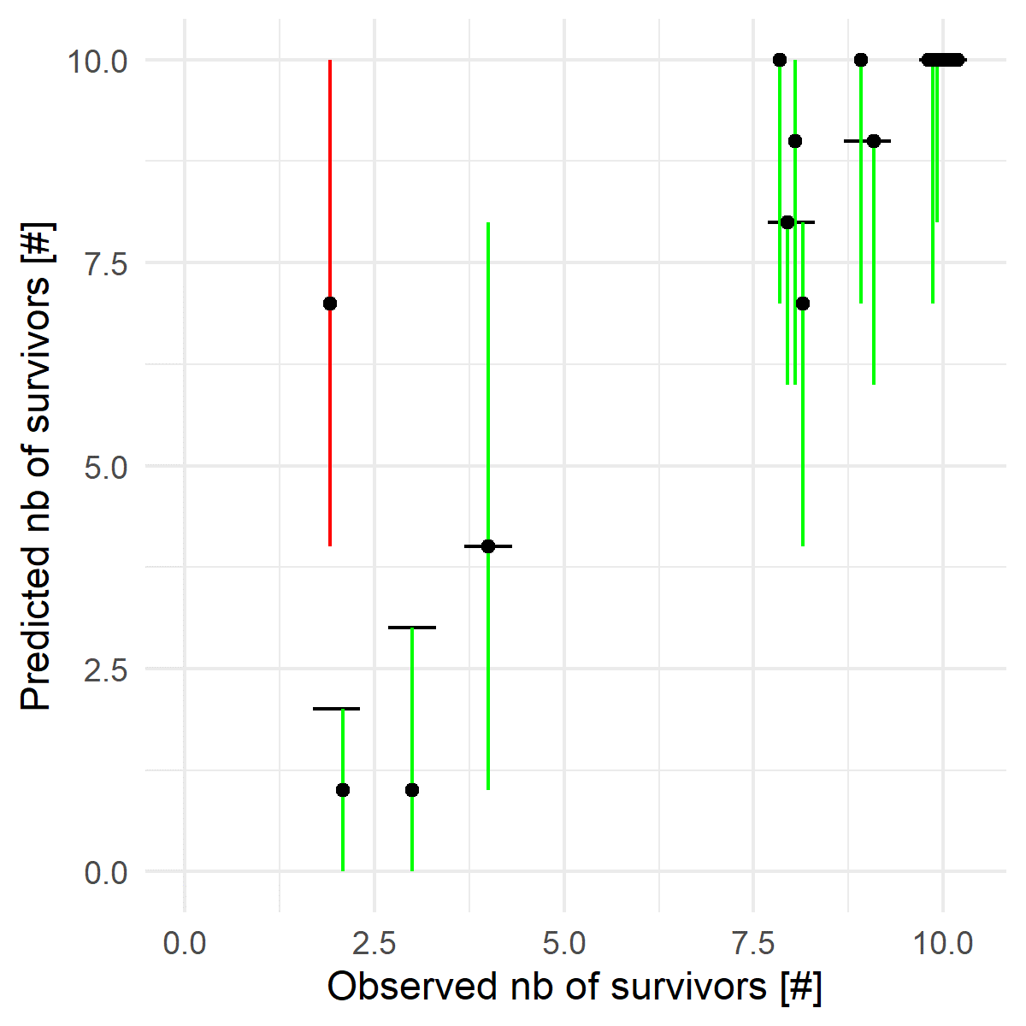
Figure 11.1.7: Chaoborus crystallinus: Observed vs. Predicted survival (PPC) plot for the calibration of GUTS-RED-SD (MORSE)

Macroinvertebrates

Cloeon dipterum

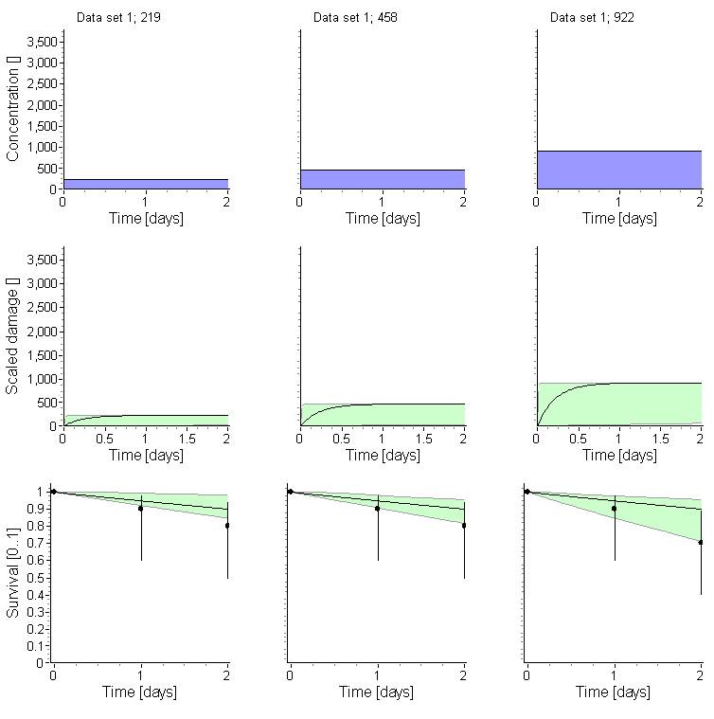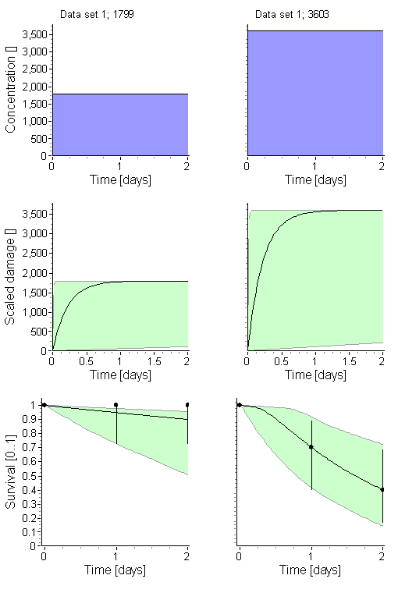

Figure 11.2.1: Cloeon dipterum: Exposure, damage and survival plots for the calibration of GUTS-RED-SD (OpenGUTS)
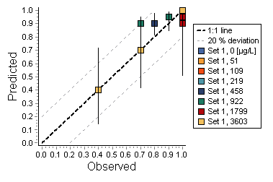
Figure 11.2.2: Cloeon dipterum: Observed vs. Predicted survival (PPC) plot for the calibration of GUTS-RED-SD (OpenGUTS)

Gammarus pulex
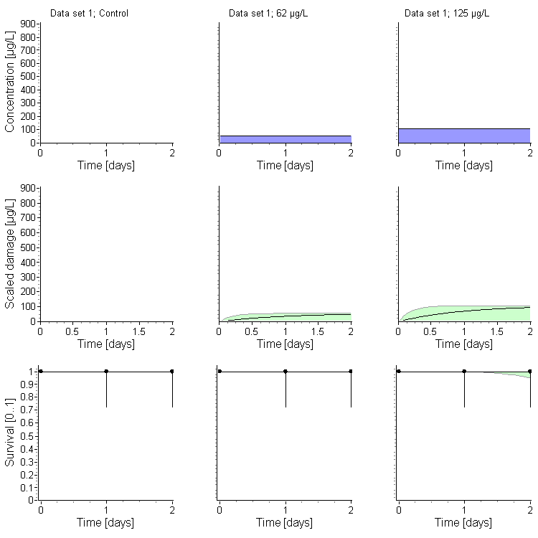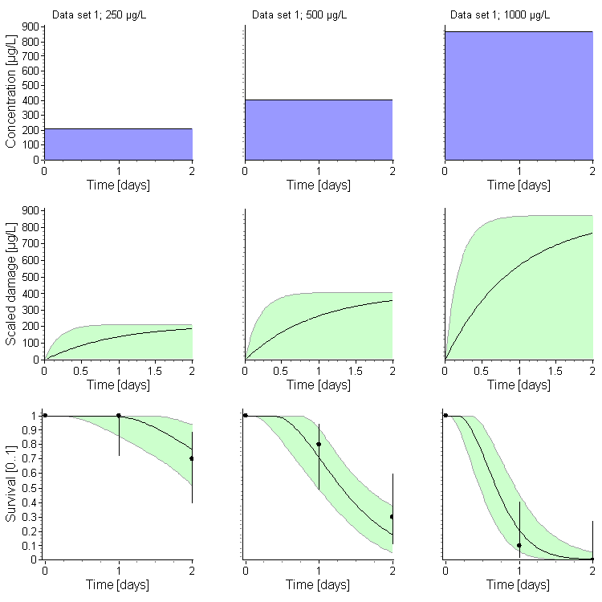

Figure 11.2.3: Gammarus pulex: Exposure, damage and survival plots for the calibration of GUTS-RED-SD (OpenGUTS)

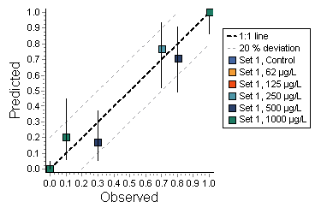
Figure 11.2.4: Gammarus pulex: Observed vs. Predicted survival (PPC) plot for the calibration of GUTS-RED-SD (OpenGUTS)

Asellus aquaticus

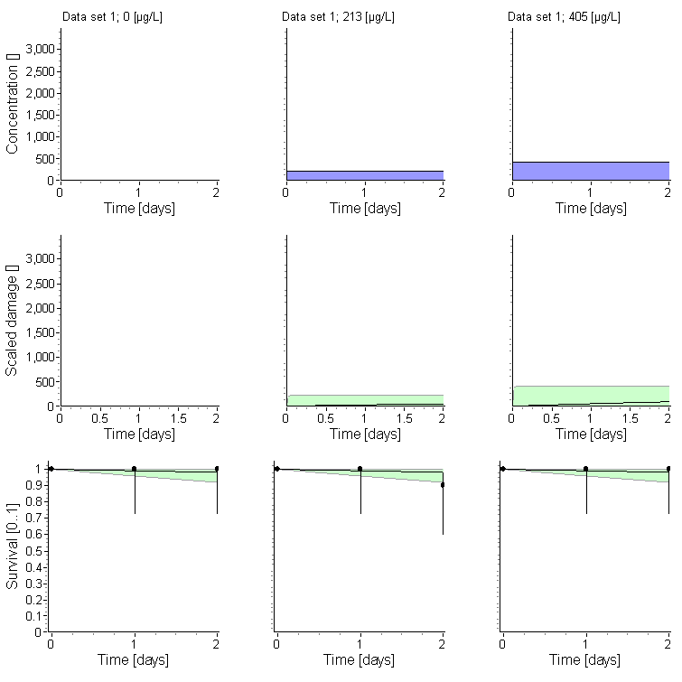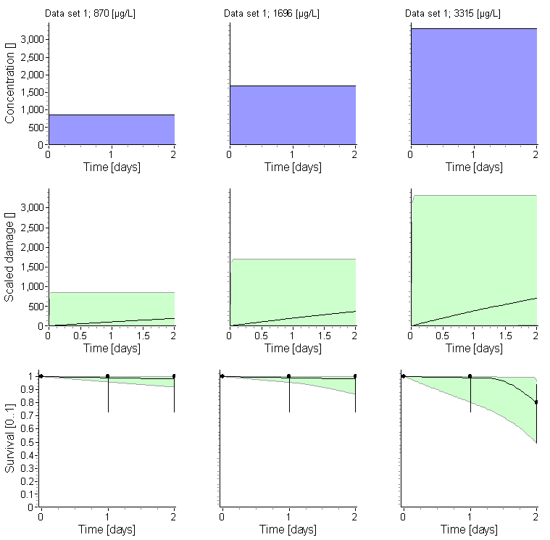

Figure 11.2.5: Asellus aquaticus: Exposure, damage and survival plots for the calibration of GUTS-RED-SD (OpenGUTS)

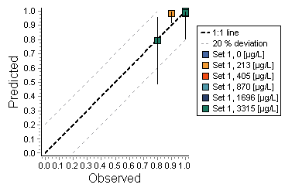
Figure 11.2.6: Asellus aquaticus: Observed vs. Predicted survival (PPC) plot for the calibration of GUTS-RED-SD (OpenGUTS)

Lymnea stagnalis

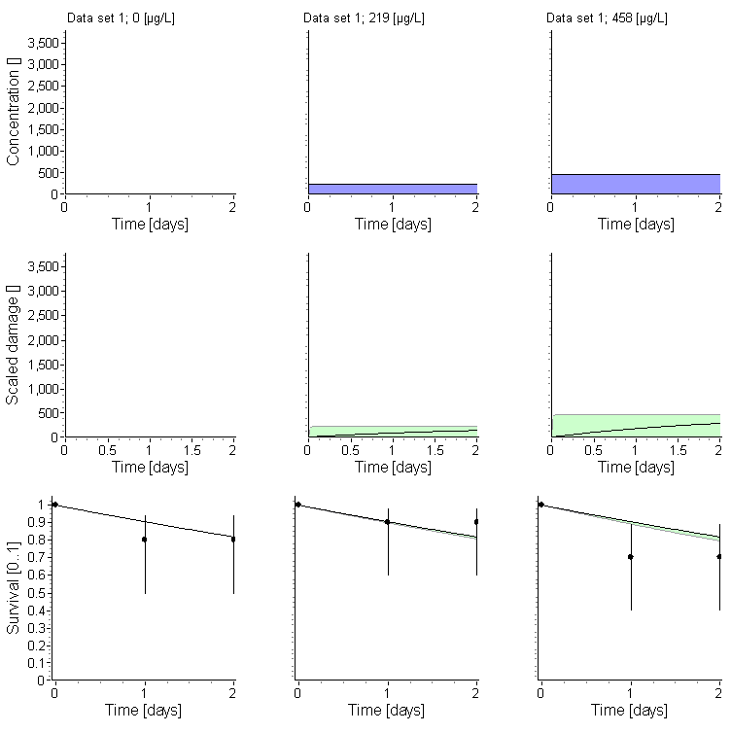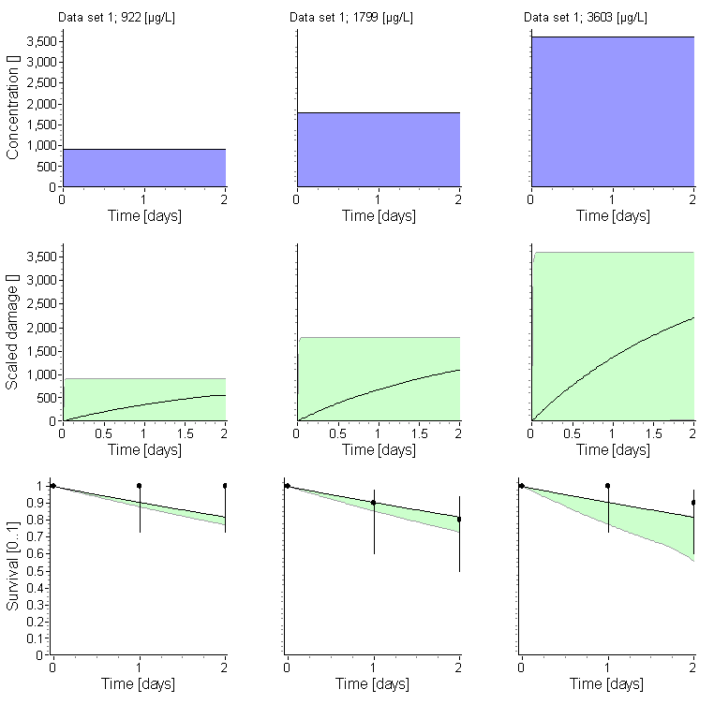

Figure 11.2.7: Lymnaea stagnalis: Exposure, damage and survival plots for the calibration of GUTS-RED-SD (OpenGUTS)

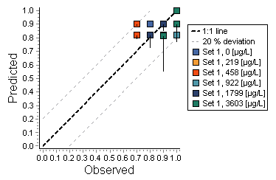
Figure 11.2.8: Lymnaea stagnalis: Observed vs. Predicted survival (PPC) plot for the calibration of GUTS-RED-SD (OpenGUTS)

Chironomus riparius

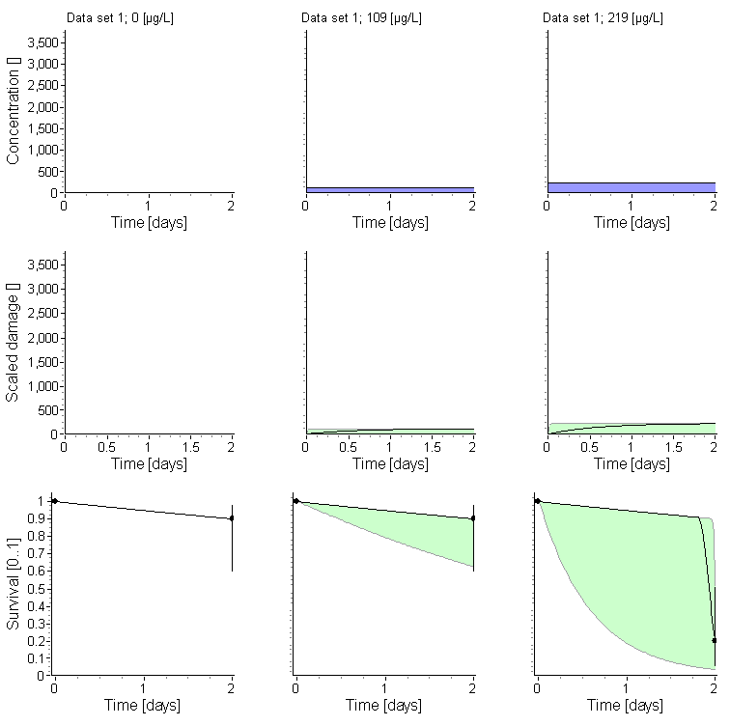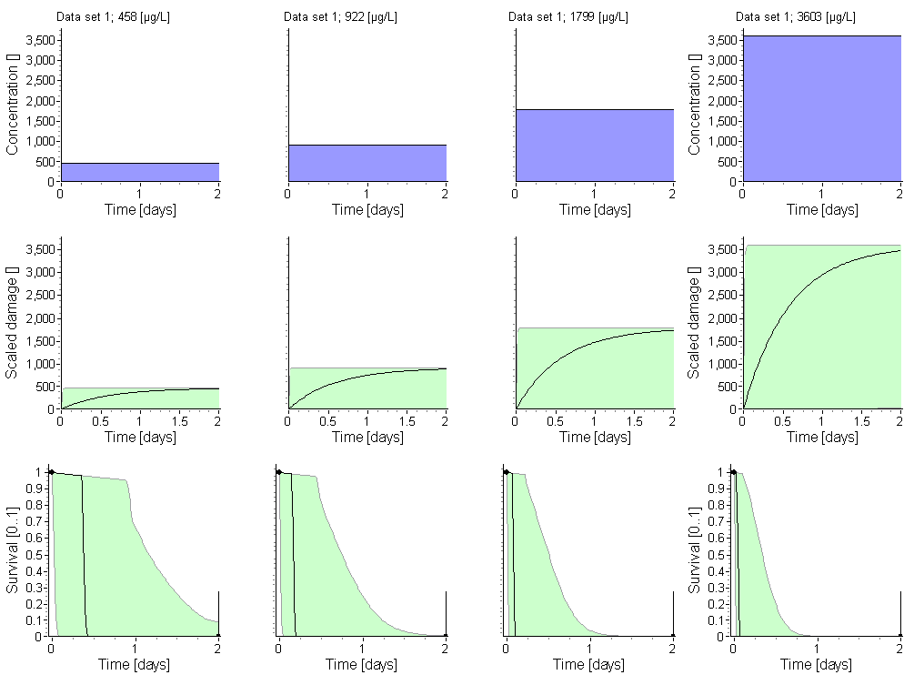

Figure 11.2.9: Chironomus riparius: Exposure, damage and survival plots for the calibration of GUTS-RED-SD (OpenGUTS)
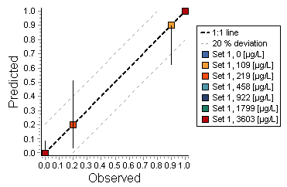
Figure 11.2.10: Chironomus riparius: Observed vs. Predicted survival (PPC) plot for the calibration of GUTS-RED-SD (OpenGUTS)

