Ecosystem Modeling of Mesocosm Studies
Documentation Template for the Aquatic Systems Models

Date: 5 October 2021 (last updated: 14 December 2022)

This documentation template follows the TRACE documentation structure (Grimm et al., 2014; Schmolke et al., 2010), but is adapted for the current project. Specific documentation requirements for our project, reflecting the EFSA good modeling practice (EFSA, 2014) are listed in each section in red.

The template will be expanded going forward, providing more detailed structures of documentation in chapters most relevant to the project. See Chapter 6.1 (Calibration to control data) for the subheadings included. A similar structure for the documentation of the calibration to effect data will be included in Chapter 6 and for the documentation of the validation to control data in Chapter 9.

Some parts of the documentation will correspond across models and will be developed by the whole group. In the following, ‘mesocosm studies’ specifically references the mesocosm studies available for the current project and their specific designs.

Input parameters and other input data will be listed in a separate table (using the template “Model_input_documentation.xlsx”). In the table, references to this document should be included where detailed descriptions are warranted.

Table of Contents
1. Problem formulation 4
2. Model description 4
3. Data evaluation 4
4. Conceptual model evaluation 4
5. Implementation verification 5
6. Model output verification 5
6.1 Calibration to mesocosm control data 5
6.1.1 Model version (prior to calibration) 5
6.1.2 Model changes during calibration 5
6.1.3 Parameters calibrated 5
6.1.4 Calibration initial conditions and time period 6
6.1.5 Step-wise calibration 6
6.1.6 Sampling of parameter space 6
6.1.7 Species groups with discrepancies in calibration 7
6.1.8 Decision criteria 7
6.2 Calibration to mesocosm treatment data 8
6.2.1 Summary of effect representation in the model 8
6.2.2 Model changes during calibration 8
We used the same implementation of the model calibrated to control data. 8
6.2.3 Parameters calibrated 8
6.2.4 Calibration initial conditions and time period 12
6.2.5 Step-wise calibration 12
6.2.6 Sampling of parameter space 13
Parameter sets and corresponding simulations were generated using the in-built “Uncertainty Mode” tool in AQUATOX. As mentioned above, parameter space was initially sampled using uniform distributions using a Latin Hypercube design. Although AQUATOX simulations require 3-4 minutes apiece, we were able to run a large number of simulations by running multiple instances of AQUATOX across different desktop computers. Seed values for AQUATOX’s random number generator were set manually to ensure reproducibility of results across different desktop computers. We used a custom R-script to process and summarize simulation results, and then a manual review in MS Excel to determine appropriate sampling ranges and an optimal calibration set. 13
6.2.7 Species groups with discrepancies in calibration 13
6.2.8 Decision criteria 13
7. Uncertainty 14
8. Model analysis 16
9. Model output corroboration 16
9.1 Further evaluation with mesocosm control data 16
9.1.1 Model version 17
9.1.2 Initial conditions and time period 17
9.1.3 Species groups with discrepancies in further model evaluation 17
9.2 Validation with 2021 mesocosm control data 17
9.2.1 Model version and parameterization 17
9.2.2 Validation initial conditions and time period 18
9.2.3 Species groups with discrepancies in validation 18
9.3 Validation with 2021 mesocosm treatment data 18
9.3.1 Model version and parameterization 18
9.3.2 Validation initial conditions and time period 18
9.3.3 Simulated effects of treatments in 2021 study 2ApplS 18
References 19

Problem formulation
The aim of the project is to establish an aquatic systems model (ASM) as a virtual mesocosm, i.e., as a tool to simulate mesocosm dynamics and pesticide effects under time-varying pesticide exposure profiles. Four ASMs will be applied to mesocosm study data in the project, and their performance with respect to simulating mesocosm community dynamics will be compared (ASM ring study). This ASM ring study will provide insights into the capabilities of the ASMs to simulate species dynamics in mesocosms over time as well as effects and recovery from pesticide exposures. It is anticipated that the ring study will identify strengths and weaknesses of each model with respect to representing mesocosm study data, and a comparison of these differences will be used to select one model for further evaluation.

Model description
Ideally, a comprehensive description of the model as implemented is provided here, e.g., following the ODD protocol (Grimm et al., 2020, 2010, 2006). Alternatively, an existing model documentation can be provided as a separate file. The model description needs to reflect the model version used for the project.

Data evaluation
All data (from the scientific literature and other sources) used for model parameterization, input files, calibration, and validation have to be described in detail. All data transformations, calculations, conversions, etc. applied to obtain model parameters, input data and outputs (model state variables) to match empirical measurements, have to be described. Data sources need to be discussed in the context of their quality and how study conditions, species, etc. relate to the mesocosm studies. All data compilations and analyses (e.g., scripts) should be provided as an appendix or separate files.

Toxicology data will be exclusively derived from provided laboratory toxicity studies and the mesocosm effects studies. The description of these studies and data extrapolations applied will be compiled as part of Phase 2 of the project and provided for the corresponding documentation of all models. Further data analysis, transformations, etc. necessary to parameterize the model need to be provided by the modelers.

Conceptual model evaluation
The structure of the model should be compared to the mesocosm studies, and a justification should be provided why the mesocosm studies fall within the domain of applicability of the ASM. The following questions should guide the description of the model structure:

- What physical and chemical conditions of the aquatic ecosystem are represented in the model and which ones are not explicitly represented? Why are they important to represented explicitly in the context of the mesocosms or do not need to be considered, respectively?
- Which species or taxonomic groups of the mesocosms are represented and to what detail? How do they interact (specify the food web interactions) with each other and the physical and chemical characteristics of the waterbody?
- How do the represented species or taxonomic groups relate to species reported present in the mesocosms? How were species combined into groups or assigned to a surrogate species?
- If species observed in the mesocosms are not represented at all, why were they left out? What implications could that have for the representation of the ecosystem?
- Which processes drive the dynamics of the model, i.e., for each simulated compartment or species/taxonomic group, what mechanisms are represented? Are there important processes that are not represented in the model?
- What adaptations of the model were applied to make it applicable to the mesocosms?
- How do model state variables and outputs relate to measurements available from the mesocosm studies? Reference data transformations etc. (3.0 Data Evaluation) necessary.

Implementation verification
Provide documentation of changes applied to the model implementation if applicable, and tests conducted to verify the correct implementation and functioning of the adaptations. All model adaptations and verifications need to be linked to the model versions.

Model output verification

Calibration to mesocosm control data

Model version (prior to calibration)
AQUATOX version R3.2 Beta (custom version of EPA published AQUATOX 3.2 provided to Integral on 10/12/2017) was used for this project. This version was modified by Jonathan Clough, a co-developer of AQUATOX, to provide Integral with the ability to prescribe a carrying capacity to macrophytes and prescribe a toxicant time-series exposure profile. Integral hasn’t made any adjustments to this custom version prior to or during use in this project.

Model changes during calibration
Once the model was parameterized, only the initial conditions and selected parameters in species records were adjusted to achieve calibration to the control dataset. No changes were made to the underlying model form or specific equations.

Parameters calibrated
We initially focused on the growth-related parameters of primary producers, including the Optimum Temperature, Saturating Light, and Maximum Photosynthetic Rate, to develop a resource base of the food web that would allow for the community of consensus species at other trophic levels to persist throughout each of the mesocosm study periods. Parameters adjusted for the calibration of macroinvertebrates and zooplankton were sensitive organism-level parameters (primarily related to growth, reproduction, and background-mortality), including Optimum Temperature, Maximum Consumption Rate, Minimum Prey for Feeding, Half Saturation Feeding and Trophic Matrix Preference Factors. Based on our experience, the above parameters for plants and animals are frequently found to be important model drivers supported by available, ecologically plausible data.

As we have achieved sufficient calibration relative to Waterborne’s calibration criteria, we do not anticipate additional need for calibration at this time. It is anticipated a separate calibration may be needed relating to the characterization of toxicological effects. In the case of AQUATOX, we typically experience the need for calibration of parameters used in the model related to toxicant-specific dose response and timing of effects.

Calibration initial conditions and time period
A single parameterization of AQUATOX was applied to simulate each control mesocosm study, resulting in four simulations corresponding to the studies in years 2014, 2016, 2018, and 2019. A standard set of initial conditions for all four simulations was generated from a 6-year model “spin-up” prior to the simulation years. Median values of simulated biomass or chlorophyll-a values observed during the first sampling event after “spin-up” were used as the initial conditions for the study-specific simulations of mesocosm experiments. The model “spin-up” consisted of average meteorological data with all species present. Because there is substantial uncertainty about the biomass and functional role of leeches in the mesocosm studies, this group was added near the end of calibration.

The simulation period is from May through September, which spans the length of all four mesocosm control studies used for calibration. Year-specific meteorological conditions were used in each simulation.

Step-wise calibration
Calibration was performed using a step-wise approach with the primary initial focus being on the primary producers, followed by animals (see Section 1.3.1). Each model species was calibrated individually, with sequential calibrations focusing on those farthest outside calibration criteria and/or their respective food resource(s) and grazers/predators. This approach is necessary because adjustments of certain model species have effects throughout the whole model community.

Sampling of parameter space
Calibration was performed by changing one parameter at a time in an iterative fashion. See above, Section 1.1.3 for parameters selected as calibration variables.

While stochastic sensitivity and uncertainty analyses can be run in AQUATOX, our initial model set up and calibration approach was iterative using the driving model parameters described above in Section 1.13. We do not normally advocate the use of “solver” type functions for optimizing the calibration according to strictly mathematical consideration of how well simulations meet the calibration criteria. Rather, we prefer that initial calibration consider intrinsic mechanistic principles within AQUATOX while adjusting sensitive parameters within biologically plausible ranges. We favor the examination of sensitivity and uncertainty analysis at later stages of model development.

Species groups with discrepancies in calibration
The most pronounced discrepancies between our model simulations and the calibration criteria were related to the magnitude and timings of peak biomass in seasonal cycles of model species. As AQUATOX is a bioenergetics model, it requires that plants and animals be represented in the model as biomass. A likely reason for the discrepancies is the high level of uncertainty in the conversions of the sampling metric to biomass; i.e., from count of individuals per sample of an animal species/group to total biomass (as ug/L or mg/m²), from chlorophyll-a in a sample of phytoplankton/periphyton to biomass (as ug/L or mg/m²), and from percent cover to biomass for macrophytes (as mg/m²).

For animals, given the lack of size/age distribution data from the mesocosm control studies, Integral applied one mean weight derived from allometric equations to each of the model species. We could not apply more fine-tuned estimates on true biomass in the system on a given sampling date. For phytoplankton, uncertainty exists in both the measurements taken for chlorophyll-a and the extrapolation to biomass based on the ratio of phytoplankton cellar carbon:chlorophyll-a (C:Chl a). For AQUATOX we typically assume a ratio of 45 for blue green algae species and a value of 28 for diatoms, greens and cryptophytes. However, as concentrations of chlorophyll a and extent of carbon accumulation are widely variable across species, light conditions and nutrient levels, ratios can range across 1-2 orders of magnitude (Jakobson and Markager 2016). For macrophytes, while sacrificial sampling to obtain biomass was performed separate from the studies during follow on work, percent cover extrapolation to biomass from the actual studies proved difficult to reconstruct with certainty. For both plants and animals, uncertainty exists not only with respect to the conversion of biomass on a per sample basis, but also extrapolation from per sample to total biomass per mesocosm.

For all consensus species, because mesocosm sampling is not continuous, but occurs at a limited number of discrete times/dates, the peak magnitude measured in the mesocosms may not capture the true peak. This creates opportunity for a potential mismatch between the peak in the model simulation and that in each mesocosm data set.

Decision criteria
Initially, a qualitative pattern-oriented approach based on professional judgment was used to decide whether the temporal patterns of model species were ecologically plausible. Peak biomass values were checked to ensure they were within plausible ranges for small ponds or mesocosms. To compare with the calibration criteria set forth for the project, we performed a quantitative comparison and summarized these comparisons in the specified tabular format. This approach was complemented by visual observations done on plots of all the individual-replicate data from the respective mesocosm-year experiment generated internally using R. For model species where calibration criteria were available, we applied this general approach and where criteria were lacking, we used simple visual comparison of the simulation output of biomass values to all the individual-replicate data from the respective mesocosm-year experiment. Magnitude of biomass corresponding with anticipated or observed seasonal dynamics were also qualitatively considered.

Calibration to mesocosm treatment data

Summary of effect representation in the model
Exposure in AQUATOX was simulated through the direct input of water concentrations of the toxicant via a daily time-series, provided by Waterborne. Direct toxicological effects to organisms from exposure were simulated differently depending for animals and plants. For animal groups, a Weibull dose response (DR) function causes proportional mortality based on time-varying water concentrations and the corresponding LC50 and Slope Factor parameters of the DR function. The LC50 is the concentration expected to cause mortality to 50% of the population. Instead of specifying individual slope parameters for the Weibull function, the user inputs in a Slope Factor, defined as the functional-group specific slope multiplied by the LC50. This approach allows AQUATOX to derive a slope for each functional group such that the dose response curve shapes are functionally equivalent for groups with the same Slope Factor. In this version of the model a global Slope Factor was used across all functional groups (i.e., the toxicant is assumed to result in the same DR shape across all organisms). For plants, the same DR function is used to model effects as reductions in photosynthesis with exposure; that is, growth instead of mortality. Thus, an EC50 is used instead of an LC50. Functional group-specific effects are reflected as changes in biomass, with total biomass for each group output for each day of the simulation.

Model changes during calibration

We used the same implementation of the model calibrated to control data.

Parameters calibrated
AQUATOX has a large number of parameters that can be manipulated to produce a calibration with very good fit. However, under the assumption that all boundary conditions are identical to control conditions except for chemical exposure, we manipulated only the DR function parameters for the effects model calibration. The calibration of these parameters would then be based on the assumption that mesocosm conditions (e.g, chemical fate, food-web interactions, etc.) likely influenced exposure effects compared to laboratory studies. So, calibration allowed for laboratory-derived DR values to be adjusted to semi-field conditions. We decided to only calibrate LC50 and EC50 values, and not Slope Factors. This is primarily because we did not have experimentally-derived Slope Factor values against which to evaluate calibrated values. As mentioned below (Section 7. Uncertainty), we did conduct a post-hoc sensitivity analysis to gauge the influence of the Slope Factor parameter on responses to exposure. See Table 1 for all LC50/EC50 values available in the AQUATOX model.

Table 1. EC/LC50 Parameters of all functional groups in the AQUATOX Model.
Species Name | Provided EC/LC50 | Applied EC/LC50
Phyto Greens | 120 | 120
Peri Greens | 120 | 120
Phyto BlueGreen | 9500 | 9500
Peri BlueGreen | 9500 | 9500
Phyto Diatom | 14 | 31.9
Peri Diatom | 120 | 120
Phyto Crypto | 120 | 120
Chara | 3200 | 3200
Myriophyllum | 3200 | 3200
Gastropod | 4000 | 4000
Odonata | 4000 | 4000
CladoceranPhyt | 207 | 207
CladoceranSmall | 87 | 87
Calanoida | 130 | 130
Cyclopidae | 130 | 9.55
Daphnidae | 87 | 35.67
Simocephalus | 238 | 238
Keratella | 4000 | 4000
RotiferBranch | 4000 | 4000
Asellus | 4000 | 4000
Chaoborus | 1600 | 1600
ChironomidOther | 210 | 210
Cloeon | 3200 | 3200
Hirudinea | 4528 | 4528
Notonecta | 4000 | 4000
Oligochaeta | 4528 | 4528
Tanypodinae | 210 | 210
Gammarus | 350 | 350

Following initial simulations with default LC50 values provided by Waterborne, we observed that the default EC50 value for Peri Diatom caused the populations for both Peri Diatom and Peri Blue-Green to collapse unrealistically. To remedy these population collapses we increased the EC50 value assigned to Peri Diatom (from 14 to 120 ug/L) so that a stable population could be sustained. Following the addressing of this issue, we decided to focus our calibration efforts on the LC50/EC50’s of the 6 functional groups identified by Waterborne as having significant treatment-related effects. Upon additional consideration, we decided to further refine our calibration set to only functional groups with clear, direct-effect patterns; i.e., changes in biomass occurring shortly after exposure. The subset of functional groups that met this criterium, and thus were the focus of the effects model calibration included Cyclopidae, Daphnidae, and Phyto Diatom.

For comparison between simulated model results and measured data, the measured abundances of each species per day were converted to biomass using a set of assumptions, equations, and input parameters as the model calibration to control exercise. Biomass was averaged across replicate enclosures to report one value per species group, sampling data, and treatment level.

To assess goodness-of-fit with the measured abundances for a given functional group, we calculated the effect size of each modeled output (simulated effect size) and the absolute differences in effect sizes between the measured and modeled outputs (mean error). The simulated effect size was calculated as:
% effect_{sim} = (treatment biomass – control biomass)*100 / control biomass

Smaller absolute differences in effect size were considered better fits than larger ones. An overall average effect size difference for each parameter set (i.e., a grand mean) was calculated by averaging across the average effect sizes of all functional groups in that set. Similarly, average effect size differences were calculated using the 6 functional groups identified by Waterborne as having significant treatment-related effects, and the 3 functional groups selected by Integral for the final effects model calibration.
We used an iterative, supervised uncertainty calibration approach to vary input parameters and determine our best LC/EC50 values (see sections 1.1.5 and 1.1.6). The final list of calibrated parameters, their initial and final sampled ranges, and final calibrated values are shown in Table 2.

Table 2: Parameters included in calibration, initial and final sampling ranges, and final calibrated values.
Parameter | Initial Value (ug/L) | Initial Sampled Range (Uniform distribution) (µg/L) | Final Sampled Range (µg/L) (triangular distribution, most likely, min, max) | Calibrated Value (µg/L)
LC50: Cyclopidae | 130 | 0-1300 | 5,0,10 | 9.55
LC50: Daphnidae | 87 | 0-870 | 35,25,45 | 35.67
EC50: Phyto Diatoms | 14 | 0-140 | 30,20,40 | 31.90

We used partial rank correlation analysis to determine the relative influence that the calibration parameters had on the goodness of fit metrics (Marino et al. 2008). Using the 1250 Monte Carlo simulations run during the final calibration iteration, we used the sensitivity package in program R (Iooss et al. 2022) to calculate partial ranked correlation coefficients between the three calibrated parameters and two goodness of fit metric based on the mean absolute differences in effect size (MADES) between measured and modeled data. The first MADES metric was calculated using all functional groups in the model. The second MADES metric was calculated using only the 6 functional group identified by Waterborne as having significant measured effects.

In both cases (Fig 1, 2), the LC50/EC50 parameters for Daphnidae and Phyto Diatoms were significantly more influential than the LC50 of Cyclopidae on values of MADES, this is likely because Phyto Diatoms and Daphnidae make up larger proportions of the food resources of several functional groups in the underlying food web of AQUATOX than Cyclopidae. For example, Phyto Diatoms make up 25% of the food resources of several groups (Daphnidae, Calanoida, Cladoceran_Small, Rotifer_Branch, Simocephalus), and Daphnidae makes up 25% of the food resources of Notonecta. In contrast, Cyclopodidae makes up at most 15% of one functional group (Chaoborus). This suggests that additional fine-tune calibration of the values for DR parameters for Daphnidae and Phyto Diatoms, but not Cyclopidae, could result in an improved overall fit between the modelled and measured data.

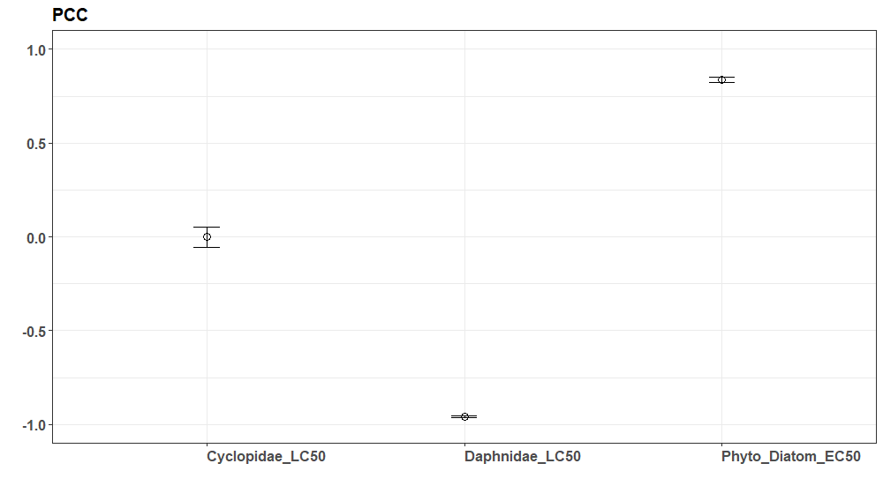
Figure 1. Partial Ranked Correlation Coefficient analysis of the three calibrated parameters on MADES when calculated using all functional groups.
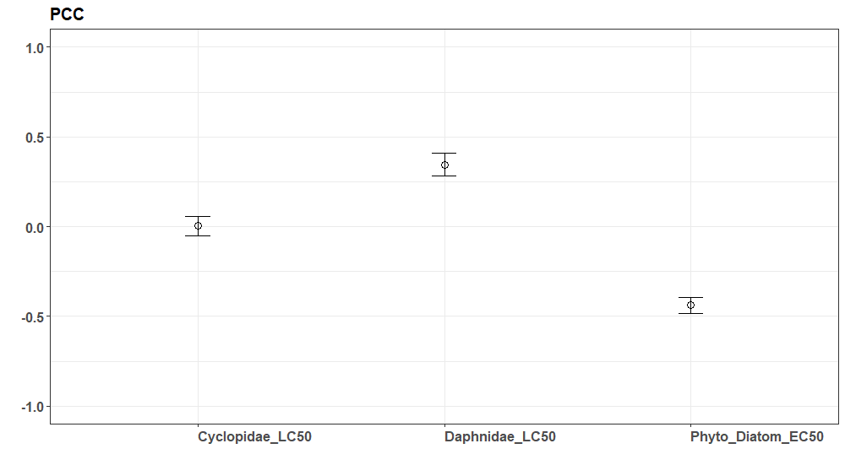
Figure 2. Partial Ranked Correlation Coefficient analysis of the three calibrated parameters on MADES when calculated using the 6 functional species identified by Waterborne as having significant effects.

Calibration initial conditions and time period
Model simulations ran from 05/10/19-09/30/19. We used the same initial conditions as our control calibrations.

Step-wise calibration
We first developed the model using default parameter values to determine where further adjustments were needed. This work showed that when using default EC50 values, Periphyton groups (Diatom and Blue-Green) both unrealistically went extinct. By adjusting the EC50 of the Periphyton Diatom up (14 ug/l to 120 ug/l), this issue was alleviated for both Periphyton groups.

We developed a supervised uncertainty evaluation approach to gain intuition into model dynamics and to guide our calibration. In this approach, we simultaneously adjusted all calibration parameters. First, we used AQUATOX Uncertainty tool to generate a large number of perturbed model simulations (n = 1250) using LC50 and EC50 values randomly sampled from uniform distributions using a Latin Hypercube Design. Parameter ranges were sampled from a uniform distribution using 0-10x as the default parameter sampling range. After simulations were completed, models were sorted and the top 2% (i.e., n = 25) simulations were evaluated using the goodness-of-fit metrics described above. From these results, we determined refined parameter sampling ranges for the calibration parameters.

In the batch of simulations, parameters were sampled from triangular distributions, as parameter uncertainty had been reduced by the evaluation of prior batches of model simulations. From this final batch of simulations (n = 1250) outputs were processed, and a single ‘best’ parameter set was selected. See the Decision Criteria section for a description of this process. See Table 1 for a list of the parameters and ranges used for all of the functional groups included in the final calibration set.

Sampling of parameter space

Parameter sets and corresponding simulations were generated using the in-built “Uncertainty Mode” tool in AQUATOX. As mentioned above, parameter space was initially sampled using uniform distributions using a Latin Hypercube design. Although AQUATOX simulations require 3-4 minutes apiece, we were able to run a large number of simulations by running multiple instances of AQUATOX across different desktop computers. Seed values for AQUATOX’s random number generator were set manually to ensure reproducibility of results across different desktop computers. We used a custom R-script to process and summarize simulation results, and then a manual review in MS Excel to determine appropriate sampling ranges and an optimal calibration set.

Species groups with discrepancies in calibration
Half (11) of the 22 functional groups without observed effects at the highest exposure concentration treatment (33 ug/l) had simulated effects greater than the 20% effect size, more than two times over the course of the simulation period (i.e., the criteria laid out by Waterborne to identify discrepancies with non-effects functional groups). One of the functional groups (Chironomidae) also exceeded these criteria at the 10 ug/l treatment concentration. For some functional groups with large, simulated effect sizes (e.g., Chironomidae, max effect size ≈ 2000), discrepancies are due to unrealistically low biomasses (compared to measured values) being simulated by AQUATOX during both control and effects simulations. This resulted in very small biomass differences appearing as large effect size differences. In contrast, biomass for Phyto Blue-Green was significantly overpredicted for the treatment simulations, resulting in large effect sizes (max effect size ≈ 2500). For many other groups, however, simulated biomasses of observed and treatment simulations are often within a factor of 10 of observed values, and/or are within the variance of the observed values over much of the simulation period. Therefore, discrepancies for many species groups may be due to the stochasticity of the measured data, in comparison to the deterministic nature of the simulated data.

Decision criteria
As discussed above, the optimal parameter set was selected from the final set of 1250 simulations. We used mean absolute differences in effect size (MADES) between measured and modeled data as the decision metric in a three step, hierarchical process:
- Selected the 50 simulations (4% of total) with the lowest MADES calculated across only the 6 functional groups found by Waterborne to have measured effects.
- Selected 10 simulations from the 50 identified in Step 1 with the lowest MADES calculated across all functional groups.
- Computed a weighted mean in which the MADES of each of the 6 functional groups proportionally contributed to an average based on the number of sample days (out of a total 33) in which significant effects were found. Thus, functional groups with more/fewer days of significant effects contributed more/less to the weighted average. The single simulation from the previous subset (10) with the lowest weighted average was selected as the overall ’best’ simulation.

Uncertainty
Our calibration methodology explicitly considered uncertainty in the parameters that the calibration focused on. A supplemental ad hoc sensitivity analyses was run to identify the effects of uncertainty with the DR curve Slope Factors. For this analysis, we adjusted DR Slope Factors for each functional group one at a time, including both lower bound (0.1 x default value) and upper bound (10 x default value) simulations. We found that for all functional groups, adjustment to the upper bound had very little impact to the biomass following chemical exposure. We found that for most functional groups, using the lower bound Slope Factor reduced biomass relative to the default over the course of simulations.

For most plants (Fig 3) and animals (Fig 4), biomass reductions ranged from 0 to approximately 60% relative to default values. This makes sense, as a lower Slope Factor translates to a more gradual, and less sigmoidal influence of the toxicant exposure, allowing lower concentrations in the mesocosm to have more pronounced toxicological effects. For most of the animal functional groups, the influence of changing the Slope Factor on biomass persists for the remainder of the simulation following exposure (i.e., a new equilibrium is reached), while the biomass of most plants reverts to the biomass observed in the exposure simulation using the default Slope Factor (1.58). In contrast to most functional groups, for the predatory Cyclopidae, the lower bound significantly increased biomass relative to the simulation using the default Slope Factor (shown as the positive green line in Fig 4), effectively negating the effect of the toxicant. This is further illustrated in Fig 5, in which projected biomass for Cyclopidae under control conditions and effect conditions using the lower bound Slope Factor are very similar. In this case, a positive response to a lower Slope Factor is expected. This is because the calibrated LC50 for Copepod (9.55 µg/l) is below the environmental concentrations present over most of the simulation (31-14 µg/L), and the shallower DR curve results in lower mortality at those concentrations than the default, steeper curve. The takeaway from these analyses is that there is considerable uncertainty around the DR Slope Factors that varies by functional group. This is particularly for animal groups, and especially when the probability of toxicological effects increases more gradually (i.e., with lower values) rather than sigmoidally (i.e. with higher values) with increasing concentration.
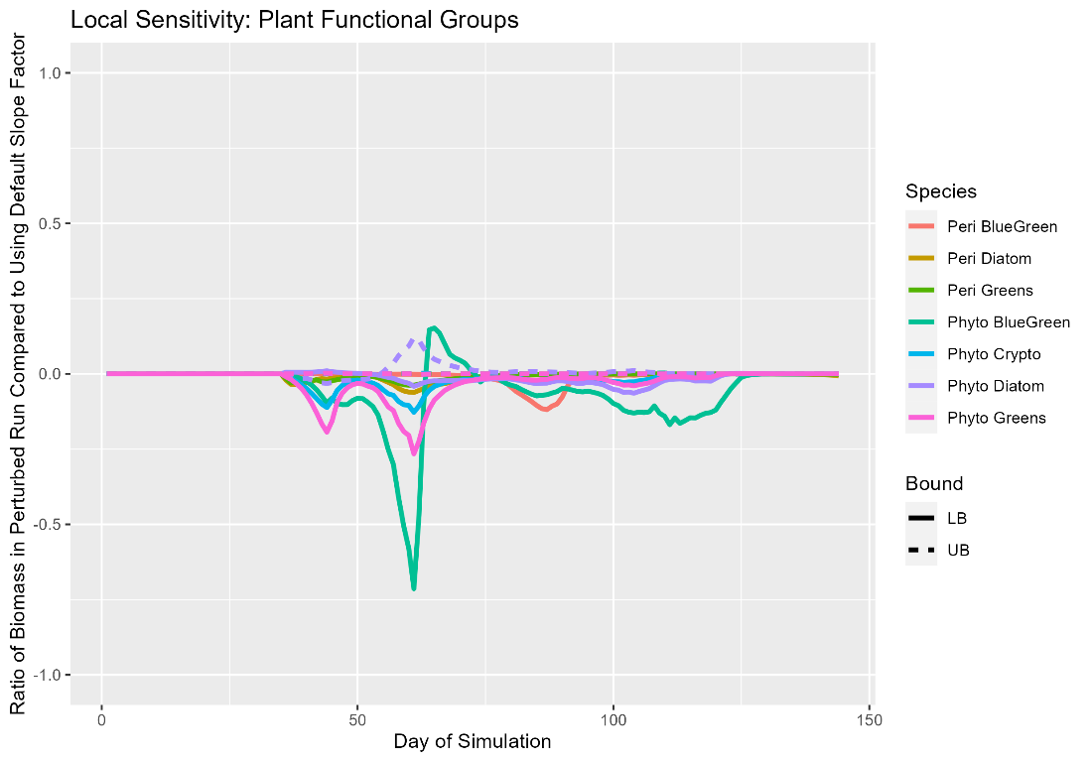
Figure 3. Local sensitivity analysis of DR Slope Factor on plant functional groups.

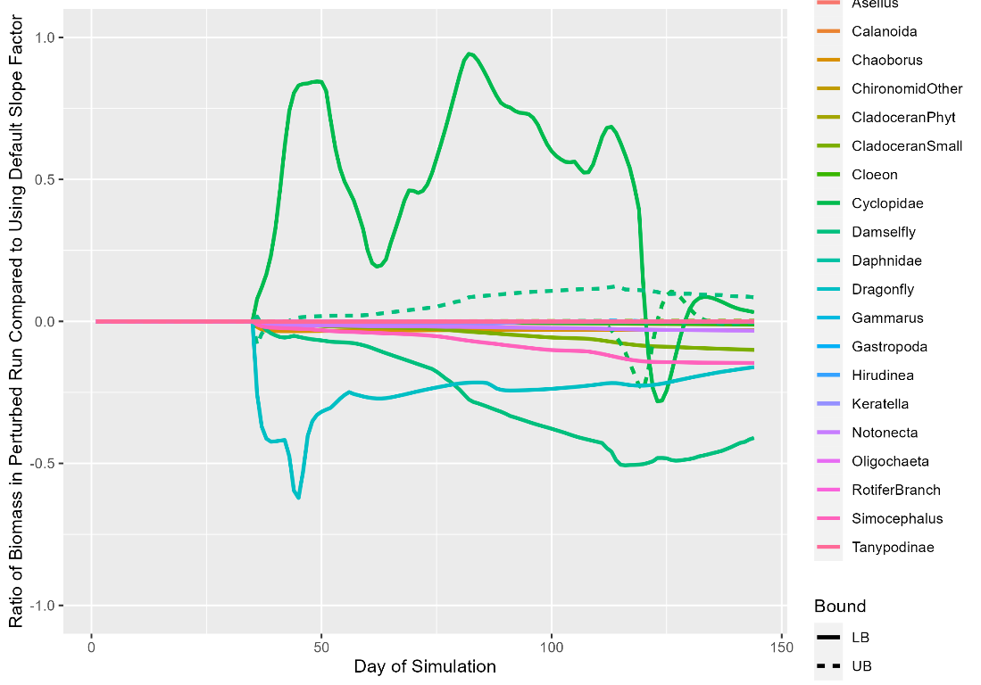
Figure 4. Local sensitivity analysis of DR Slope factor for animal functional groups. Note that Cyclopidae (green) has a significantly larger biomass with the lower bound DR Slope Factor than the default Slope Factor.

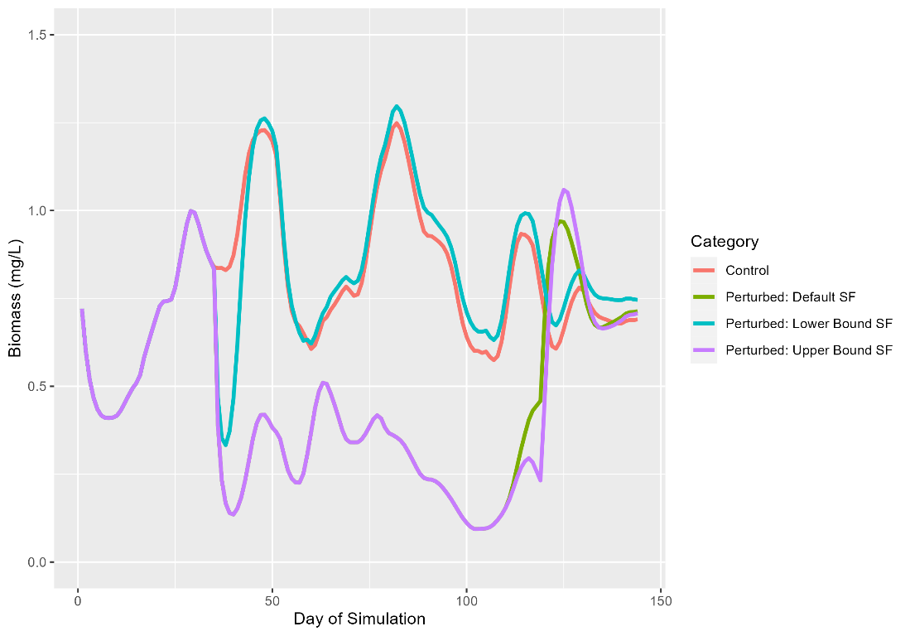
Figure 5. Comparison of biomass for control and perturbed runs with different DR Slope Factors (SF) for Cyclopidae, including control conditions (red), perturbed run using default DR Slope Factors (green), perturbed run using the lower bound Slope Factor of the of the sensitivity analysis (blue), and perturbed run using the upper bound Slope Factor of the sensitivity analysis (purple)

Model analysis
Model analysis beyond model validation is not expected for the current project (Phase 3). [If analysis were conducted in the context of the project, they should be described here.] In addition, previous analyses conducted with the model, including sensitivity analysis or uncertainty analyses, should be summarized here and referenced.

Model output corroboration

Further evaluation with mesocosm control data
In the calibration of the ASMs to mesocosm control data in the ASM ring study, data from four studies was used (studies 14a, 16a, 18c and 19b). Three additional study data sets were available for the project (studies 18a, 18b and 19a) which were used to conduct a further evaluation of the models (Loerracher et al., in prep). All seven control data sets were used to inform the control calibration criteria which were used as indicators of model performance. Because the three additional studies were conducted in the same years (2018 and 2019) as two studies included in the calibration data sets, their simulation does not correspond to a validation with independent data. Environmental conditions (physical and chemical measures in the water) were similar to corresponding studies conducted in the same year. Initial species composition (particularly abundances by species group) differed between the studies and the calendar date of study initiation.

Model version
The same version of AQUATOX (version R3.2 Beta) that was used for model calibration to control was used for further evaluation of the mesocosm control data.

Initial conditions and time period
To further evaluate our model, Integral generated control model outputs for the 2018 and 2019 study years and analyzed these results against the additional control studies (18a, 18b, 19a).

The simulation period of our calibrated control model was from May through September, which spans the length of these three additional control studies.

The same standard set of initial conditions that were derived from our control “spin-up” approach (detailed in section 6.1.4) were used for this evaluation and year-specific meteorological conditions were applied to each simulation.

Species groups with discrepancies in further model evaluation
The peak date metrics were not met for herbivorous rotifers (Keratella), Chaoborus, Gammarus, and Tanypodinae. The maximum biomass criteria were not met for Gastropoda, herbivorous rotifers (Rotifera Branch) and periphyton diatoms. Minimum biomass criteria were not met for only one species group: periphyton blue greens. Overall, 87 percent of criteria were met for all studies and groups. If peaks are excluded, 93 percent of criteria are met across all studies and groups. The results of the simulations of the additional studies closely match the initial calibration studies with respect to the calibration criteria.

Validation with 2021 mesocosm control data
In addition to the seven mesocosm control data sets (Loerracher et al., in prep), control data sets from two mesocosm studies conducted in 2021 at the same facility were available for the project. These two study data sets did not inform the control calibration criteria. The 2021 studies provide independent data for model validation with year- and study-specific conditions that differ from the data used for calibration and further evaluation of the model (see previous sections). To ensure blind validation, only the initial conditions (species abundance in zooplankton and macroinvertebrates, coverage of macrophytes, and chlorophyll-a content of phytoplankton and periphyton on the first sampling day) and the physicochemical data were available to the modelers. The control validation criteria were the same as the control calibration criteria.

Model version and parameterization
The same version of AQUATOX (version R3.2 Beta) and the same suite of calibrated parameters used for model calibration to control and further evaluation of the model were used for this exercise.

Validation initial conditions and time period
The simulation period of our validation runs was from May through September, which spans the length of the two 2021 studies.

The same standard set of initial conditions that were derived from our control “spin-up” approach (detailed in section 6.1.4) were used for this evaluation and year-specific (2021) meteorological conditions were applied to each simulation.

Species groups with discrepancies in validation
The criteria were not met for peak dates for Chaoborus, Tanypodinae, and herbivorous rotifers (Keratella). The minimum biomass criteria was not met for periphtyon blue greens. Overall, the 2021 validation performed better than the initial calibration using the seven studies from 2014, 2016, 2018, and 2019. The percent criteria met (including peaks) across all studies and groups rose to 94 percent (from 87 percent). The 2021 simulation did not meet criteria for similar species groups and metrics as those in the initial calibration, suggesting uncertainty remains when predicting peak dates for certain species. The model seems to have improved for predictions of peak dates for Gammarus and maximum biomass for Gastropoda, herbivorous rotifers (Rotifera Branch) and periphyton diatoms.

We presume the reasons for discrepancy can be attributed to the change in year-specific meteorological (Light and Water Temperature) conditions.

Validation with 2021 mesocosm treatment data
From the two 2021 studies used for control validation, the treatment data were also available. One of the studies (2ApplS) was a repeat of the study with azoxystrobin (19b) which was used for control and effect calibration but limited only to the two highest azoxystrobin treatments (see sections 6.1 and 6.2). The second 2021 study (3PeakS) had 3 applications of azoxystrobin in intervals of 8 days. The day after each application, azoxystrobin was removed by water filtering, resulting in 3 distinct exposure peaks. Effect criteria were the same as the effect calibration criteria for the 2ApplS scenario, whereas new criteria were defined for the 3PeakS scenario (but not shared with the modelers). To ensure a blind validation, only exposure profiles were provided to the modelers.

Model version and parameterization
The same version of AQUATOX (version R3.2 Beta) and the same suite of calibrated parameters (both control and effect) used for model calibration to control, further evaluation of the model, and model calibration to effects were used for this exercise.

Validation initial conditions and time period
The treated mesocosm simulations consisted of the same initial conditions and time period as applied in the simulations to the 2021 control data.

Simulated effects of treatments in 2021 study 2ApplS
Several species groups showed effects (results outside the %MDD window) in the 2021 2ApplS study, including predatory copepods, daphnidae, herbivorous rotifers (Keratella), phytoplankton diatoms, and phytoplankton cryptophytes. Predatory copepod biomass decreased in the simulated treatment results compared to simulated control, whereas the biomass of Daphnidae increased under simulated treatment conditions compared to the simulated control results. Effects of treatment on herbivorous rotifer (Keratella) varied throughout the simulation in an oscillatory manner, with increases in biomass relative to control occurring in several peaks (4) above the %MDD for a few days at a time before falling back within the %MDD window. Simulated treatment effects on phytoplankton diatoms are also oscillatory, but with smaller peaks (sometimes just above the %MDD threshold) rising above the %MDD than with herbivorous rotifers. Finally, phytoplankton cryptophyte biomass increased in the treatment simulation compared to control simulation early in the study but decreased rapidly to fall back inside the %MDD window by July.

Results for the 2019b study were qualitatively similar to results from the 2021 2ApplS simulation. While there were fine scale differences in the patterns of variability between the two studies, these differences can be attributed to differing exposure profiles, water temperatures, and light profiles used in each simulation (e.g., water temperatures were warmer in first days of the 2021 simulation as compared to 2019 and exposure concentrations were consistently lower in 2021 as compared to 2019). Predatory copepods and herbivorous rotifers have similar negative and positive impacts of treatment, relative to control, on biomass between 2019b study simulation and the 2021 2ApplS simulation. The rotifers slightly differ with treatment results leading to a single peak above the %MDD instead of the multiple peaks in the 2ApplS simulation. Somewhat similarly, phytoplankton diatoms in the 2021 study simulation show peaks above the %MDD throughout the simulation period, whereas the phytoplankton diatoms in the 2019 simulation decreased early in the study (below the %MDD) then increase later in the study (above the %MDD), with a few fluctuations in between.

That said, the Daphnidae biomass and growth trajectory was notably different between the 2019b and 2021 2ApplS effects scenarios (more growth relative to control in 2021 vs. 2019). In the 2019b simulation peak exposure concentrations were higher and dropped off more slowly as compared to the 2021 2ApplS exposure profile. In the 2019b simulation these higher exposure concentrations reduced Daphnidae biomass (relative to control) from mid-Juneto mid-July. In contrast, in the 2021 2ApplS simulation the lower exposure concentrations early in the growing season only reduced Daphnidae biomass from mid-June to early-July at which point biomass was similar to control (i.e., recovery was observed approximately 2 weeks earlier). These differing patterns are expected given that exposure concentrations only approached the LC50 for Daphnidae (35.67 ug/L) in the first few weeks of the simulations. We expect that the differing predictions of effects between the two studies for Daphnidae could be refined with additional optimization of the slope factor chosen for the dose-response curve.

Note: Effect outputs from the models in the 3PeakS study will be provided by the modelers to the study coordinators (Waterborne Environmental) in the same format as for effects in studies 19b and 2021 (2ApplS), but the observed effects (and MDD values) will not be shared with the modelers prior to project completion. Thus, simulated effects in 3PeakS do not need to be discussed in this section of the TRACE documentation. Effect result tables with observed effects added for 3PeakS will be made available before publication.

References
EFSA, 2014. Scientific Opinion on good modelling practice in the context of mechanistic effect models for risk assessment of plant protection products. EFSA J. 12, 3589. https://doi.org/10.2903/j.efsa.2014.3589
Clough, J.S. 2018a. AQUATOX (Release 3.2). Modeling Environmental Fate and Ecological
Effects in Aquatic Ecosystems, Vol. 1, User’s Manual. US Environmental Protection Agency, Washington, DC. EPA/600/B-18/233. August.
Clough, J.S. 2018b. AQUATOX (Release 3.2). Modeling Environmental Fate and Ecological
Effects in Aquatic Ecosystems, vol. 2, Technical Documentation. US Environmental Protection Agency, Washington, DC. EPA/600/B-18/241. August.
Grimm, V., Augusiak, J., Focks, A., Frank, B.M., Gabsi, F., Johnston, A.S.A., Liu, C., Martin, B.T., Meli, M., Radchuk, V., Thorbek, P., Railsback, S.F., 2014. Towards better modelling and decision support: Documenting model development, testing, and analysis using TRACE. Ecol. Model., Population Models for Ecological Risk Assessment of Chemicals 280, 129–139. https://doi.org/10.1016/j.ecolmodel.2014.01.018
Grimm, V., Berger, U., Bastiansen, F., Eliassen, S., Ginot, V., Giske, J., Goss-Custard, J., Grand, T., Heinz, S.K., Huse, G., Huth, A., Jepsen, J.U., Jørgensen, C., Mooij, W.M., Müller, B., Pe’er, G., Piou, C., Railsback, S.F., Robbins, A.M., Robbins, M.M., Rossmanith, E., Rüger, N., Strand, E., Souissi, S., Stillman, R.A., Vabø, R., Visser, U., DeAngelis, D.L., 2006. A standard protocol for describing individual-based and agent-based models. Ecol. Model. 198, 115–126. https://doi.org/10.1016/j.ecolmodel.2006.04.023
Grimm, V., Berger, U., DeAngelis, D.L., Polhill, J.G., Giske, J., Railsback, S.F., 2010. The ODD protocol: A review and first update. Ecol. Model. 221, 2760–2768. https://doi.org/10.1016/j.ecolmodel.2010.08.019
Grimm, V., Railsback, S.F., Vincenot, C.E., Berger, U., Gallagher, C., Deangelis, D.L., Edmonds, B., Ge, J., Giske, J., Groeneveld, J., Johnston, A.S.A., Milles, A., Nabe-Nielsen, J., Polhill, J.G., Radchuk, V., Rohwäder, M.S., Stillman, R.A., Thiele, J.C., Ayllón, D., 2020. The ODD protocol for describing agent-based and other simulation models: A second update to improve clarity, replication, and structural realism. J. Artif. Soc. Soc. Simul. 23.
Jakobsen, H.H. and Markager, S. (2016), Carbon-to-chlorophyll ratio for phytoplankton in
temperate coastal waters: Seasonal patterns and relationship to nutrients. Limnol. Oceanogr., 61: 1853-1868. https://doi.org/10.1002/lno.10338
Iooss B, Veiga SD, Janon A, Pujol G, Broto wcfB, Boumhaout K, Delage T, Amri RE, Fruth J,
Gilquin L, Guillaume J, Herin M, Idrissi MI, Le Gratiet L, Lemaitre P, Marrel A, Meynaoui A, Nelson BL, Monari F, Oomen R, Rakovec O, Ramos B, Roustant O, Sarazin G, Song E, Staum J, Sueur R, Touati T, Verges V, Weber F (2022). sensitivity: GlobalSensitivity Analysis of Model Outputs. R package version 1.28.0. URL:https://CRAN.R-project.org/package=sensitivity.
Marino, S., Hogue, I. B., Ray, C. J., & Kirschner, D. E. (2008). A methodology for performing
global uncertainty and sensitivity analysis in systems biology. Journal of Theoretical Biology, 254(1), 178–196. https://doi.org/10.1016/j.jtbi.2008.04.011
Pastorok, R.A., Bartell, S.M., Ferson, S., Ginzburg, L.R. (Eds.), 2002. Ecological Modeling in
Risk Assessment: Chemical Effects on Populations, Ecosystems, and Landscapes. Lewis Publishers, Boca Raton, FL.
Schmolke, A., Thorbek, P., DeAngelis, D.L., Grimm, V., 2010. Ecological models supporting environmental decision making: a strategy for the future. Trends Ecol. Evol. 25, 479–486. https://doi.org/10.1016/j.tree.2010.05.001

