Ecosystem Modeling of Mesocosm Studies
Documentation Template for the Aquatic Systems Models

Date: 5 October 2021

This documentation template follows the TRACE documentation structure (Grimm et al., 2014; Schmolke et al., 2010), but is adapted for the current project. Specific documentation requirements for our project, reflecting the EFSA good modeling practice (EFSA, 2014) are listed in each section in red.

The template will be expanded going forward, providing more detailed structures of documentation in chapters most relevant to the project. See Chapter 6.1 (Calibration to control data) for the subheadings included. A similar structure for the documentation of the calibration to effect data will be included in Chapter 6 and for the documentation of the validation to control data in Chapter 9.

Some parts of the documentation will correspond across models and will be developed by the whole group. In the following, ‘mesocosm studies’ specifically references the mesocosm studies available for the current project and their specific designs.

Input parameters and other input data will be listed in a separate table (using the template “Model_input_documentation.xlsx”). In the table, references to this document should be included where detailed descriptions are warranted.

Table of Contents
1. Problem formulation 5
2. Model description 5
2.1 Food web 5
2.2 Governing equations 5
2.3 Physical-chemical environment 7
3. Data evaluation 8
3.1 Data sources for parameter estimation 8
3.1.1 Photosynthetic rates 8
3.1.2 Light saturation constants 8
3.1.3 Photorespiration 9
3.1.4 Dark respiration 9
3.1.5 Nutrient limitation 9
3.1.6 Sinking rates 9
3.1.7 Mortality rates 9
3.1.8 Consumption rates 9
3.1.9 Standard respiration rates 10
3.1.10 Specific dynamic action 10
3.1.11 Egestion rates 10
3.1.12 Excretion rates 10
3.1.13 Mortality rates 10
3.1.14 Prey preferences 10
3.1.15 Assimilation efficiencies 10
3.1.16 Prey-handling efficiencies 11
3.2 Data transformations 11
3.3 Quality of data sources 11
3.4 Toxicology data and population benchmarks 11
3.5 Toxicity data transformation 11
4. Conceptual model evaluation 12
4.1 Physical and chemical conditions 12
4.2 Modeled mesocosm species and taxonomic groups 12
4.3 Processes and model dynamics 14
4.4 Model adaptations to produce the CASM-cosm 14
4.5 State variables and outputs 14
5. Implementation verification 14
6. Model output verification 14
6.1 Calibration to mesocosm control data 14
6.1.1 Model version (prior to calibration) 15
6.1.2 Model changes during calibration 15
6.1.3 Parameters calibrated 15
6.1.4 Calibration initial conditions and time period 16
6.1.5 Step-wise calibration 16
6.1.6 Sampling of parameter space 16
6.1.7 Species groups with discrepancies in calibration 17
6.1.8 Decision criteria 17
6.2 Calibration to mesocosm control data 17
6.2.1 Periphyton 18
6.2.2 Phytoplankton 22
6.2.3 Zooplankton 26
6.2.4 Macroinvertebrates 33
6.3 Calibration to mesocosm treatment data 43
6.3.1 Azoxystrobin (AZT) exposure profile 43
6.3.2 CASM-cosm toxic effects factors 44
6.3.3 Graphical summary of model results 45
6.3.4 Phytoplankton 45
6.3.5 Zooplankton 47
6.3.6 Indirect effects in the CASM-cosm 51
6.3.7 Summary of CASM-cosm performance 53
6.3.8 Resulting toxicity benchmark values 54
6.3.9 CASM-cosm calibration summary 54
7. Uncertainty 57
8. Model analysis 57
8.1 Sensitivity analysis 57
8.1.1 Consumer populations bioenergetics model sensitivities 57
8.1.2 Aquatic food web model sensitivities 59
9. Model output corroboration 59
9.1 Simulation of 2021 mesocosm control data: 2 applications control 60
9.2 Simulation of 2021 mesocosm control data: 3 peaks control 68
9.3 Simulation of 2021 mesocosm treatment data: study 21-a1, two applications 77
9.3.1 Toxicity benchmark values 77
9.3.2 Study 21-a1, two applications exposure profile 78
9.3.3 Direct toxic effects simulated for study 21-a1, two applications 79
9.3.4 Indirect effects simulated for study 21-a1, two applications 83
9.4 Simulation of 2021 mesocosm treatment data: 3 peaks applications 84
9.4.1 Toxicity benchmark values for study 21-a2, three peaks 84
9.4.2 Study 21-a2, three peaks exposure profile 84
9.4.3 9.4.3 Direct toxic effects simulated for study 21-a2, three peaks 85
9.4.4 9.4.4 Indirect effects simulated for study 21-a2, three peaks 90
References 91

Problem formulation
The aim of the project is to establish an aquatic systems model (ASM) as a virtual mesocosm, i.e., as a tool to simulate mesocosm dynamics and pesticide effects under time-varying pesticide exposure profiles. Four ASMs will be applied to mesocosm study data in the project, and their performance with respect to simulating mesocosm community dynamics will be compared (ASM ring study). This ASM ring study will provide insights into the capabilities of the ASMs to simulate species dynamics in mesocosms over time as well as effects and recovery from pesticide exposures. It is anticipated that the ring study will identify strengths and weaknesses of each model with respect to representing mesocosm study data, and a comparison of these differences will be used to select one model for further evaluation.

Model description
The Comprehensive Aquatic Systems Model (CASM) is an integrated aquatic food web – ecosystem model that has been developed to assess the implications of various environmental stressors on the structure and function of aquatic systems (Bartell et al. 1999, 2000, 2013, 2017; Nair et al. 2015; DeAngelis et al. 1989; Schmolke et al. 2019).

Food web
The model permits specification of individual populations of aquatic plants (phytoplankton, periphyton, submerged aquatic vegetation, and emergent aquatic vegetation). As many as ten populations can be defined for each of the four guilds of aquatic plants. The model correspondingly allows the specification of as many as eight populations in each of the following guilds of consumer organisms: zooplankton, pelagic-oriented omnivorous fishes, pelagic piscivorous fishes, benthic macroinvertebrates, benthic-oriented omnivorous fishes, benthic piscivorous fishes, planktonic bacteria, and sediment bacteria. The CASM also includes a generalized decomposition algorithm to represent other non-bacteria decomposer organisms (e.g., protozoa, fungi). Populations can be defined in terms of taxonomy, ecology, or some combination of these two. The exact food web structure of an individual application of the CASM will be determined by the nature of the aquatic system and the overall modeling objectives – for example, the assessment of ecological impacts of a pesticide.

Governing equations
The CASM uses the biomass (carbon) equivalent of bioenergetic equations to simulate daily changes in the biomass of each modeled population. Table 1 presents the governing equation that describes the daily change in biomass for populations of modeled aquatic plants.

Table 1. Governing equation for CASM STA aquatic plants (phytoplankton, periphyton, SAV, EAV).
dB_{i}/dt = B_{i} [Pmax_{i} {h(T), f(I), g(N), hmod}(1-presp_{i})] – B_{i} [dresp_{i} , h(Tp)] –
B_{i} (s_{i} + m_{i}) – Gr(B_{i})

where, for plant population i,

B_{i} biomass of plant population i g C/m²
Pmax_{i} maximum photosynthetic rate g C/g C/d
h(Tp) temperature dependence of photosynthesis unitless
f(I) light dependence of photosynthesis unitless
g(N) nutrient dependence of photosynthesis unitless
hmod habitat quality modifier of growth unitless
presp_{i} photorespiration rate unitless
dresp_{i} dark respiration rate 1/d
s_{i} sinking rate (phytoplankton only) 1/d
m_{i} mortality rate 1/d
Gr grazing loss g C/m²/d

and Gr(Bi) = ∑_{j}[h(Tc) B_{j} Cm_{j} w_{ij} a_{ij} h_{ij} B_{i} )/ (B_{j} + ∑_{i}w_{ij} a_{ij} h_{ij} B_{i})], where

B_{j} biomass of grazer population j g C/m²
h(Tc) temperature dependence of consumption unitless
Cm_{j} max rate of consumption by grazer j 1/d
w_{ij} preference of grazer j for producer i unitless
a_{ij} assimilation of producer i by grazer j unitless
h_{ij} handling efficiency unitless

∑_{j} summed over j populations grazing on B_{i}

Table 2 presents the corresponding bioenergetics-based governing equation that describes daily changes in biomass of modeled consumer populations.

Table 2. Governing equation for CASM STA consumers (zooplankton, bacteria, benthic invertebrates, fish).
dB_{i}/dt = ∑_{j}[(B_{i} Cm_{i} h(Tc) w_{ij} a_{i} h_{ij} B_{j} )/(B_{i} + ∑_{j} w_{ij} a_{ij} h_{ij} B_{j})](1 - f_{i} - rsda_{i}) –
B_{i} (u_{i} +m_{i}) – B_{i} [r_{i ,}h(Tr)] – Pr (B_{i})

where, for population i

B_{i} consumer population i biomass g C/m²
B_{j} prey population(s) biomass value(s) g C/m²
Cm_{i} maximum consumption rate 1/d
h(Tc) temperature dependence of consumption unitless
w_{ij} preference of consumer i for prey j unitless
a_{ij} assimilation efficiency for consumer i and prey j unitless
h_{ij} handling efficiency unitless
r_{i} standard respiration rate 1/d
h(Tr) temperature dependence of respiration unitless
u_{i} excretion rate 1/d
f_{i} egestion unitless
m_{i} natural mortality rate 1/d
rsda_{i} specific dynamic action (fish only) unitless
Pr loss to predation g C/m²/d

and, Pr(Bi) = ∑_{i}[(Bj Cm_{j} h(Tc) w_{ij} a_{ij} h_{ij} B_{i} )/(B_{j} + ∑_{i}w_{ij} a_{ij} h_{ij} B_{i})], where

Bj biomass of predator population j g C/m²
h(Tc) temperature dependence of consumption unitless
C_{ij} rate of consumption by grazer j 1/d
w_{ij} preference of grazer j for producer i unitless
a_{ij} assimilation of producer i by grazer j unitless
h_{ij} handling efficiency unitless

∑_{i} sum over prey populations

Individual populations are uniquely defined by the values of the parameters derived for the specified aquatic plants (Table 1) and consumers (Table 2) included in food webs for specific model applications (e.g., CASM-cosm).

Physical-chemical environment
The CASM represents an average square meter of water surface area and the corresponding water column defined by user-specified daily values of water depth. The physical environment is further defined by daily values of surface irradiance, current velocity (m/s), salinity (PSU), dissolved oxygen, and water temperature (℃). Surface light intensities (einsteins/m²/d) of photosynthetically active radiation (PAR) drive photosynthesis of the modeled aquatic plants. Surface light intensity is attenuated as a function of depth, as well as concentrations of phytoplankton, suspended particulate organic carbon (detritus), suspended inorganic sediments, and water color. Current velocity, dissolved oxygen, and salinity can influence population growth through specification of population-specific preferences or tolerances for these factors. The water column can be thermally stratified, where daily temperatures are provided on input for the epilimnion and hypolimnion. The model permits specification of daily loadings of suspended inorganic sediments, which settle at a constant user-specified rate. Sediments in the CASM are represented as concentrations of settled particulate organic carbon.

The chemical environment is defined by concentrations of macronutrients that include dissolved inorganic P, dissolved inorganic N, and dissolved silica. The daily concentrations of these nutrients are determined by inputs, uptake by aquatic plants, excretion by consumer populations, and remineralization (decomposition) of modeled detritus by bacteria and generalized decomposers included in the model. The chemical environment in the CASM also includes concentrations of dissolved and particulate organic carbon.

The CASM-cosm is essentially the same model as just described in terms of overall structure and function. The major changes the development of input files that reflect the food web structure and environmental characteristics of the experimental mesocosms used in the ASM study. The resulting CASM-cosm also adds a subroutine that converts the traditional CASM biomass results (g C/m²) to units reported in the mesocosm data for aquatic plants (chlorophyll, per cent cover) and abundance for zooplankton (number/liter) and macroinvertebrates (number/sample).

Data evaluation

Data sources for parameter estimation

All data (from the scientific literature and other sources) used for model parameterization, input files, calibration, and validation have to be described in detail.
Derivation of the growth parameters for the modeled aquatic plant populations was based on published values of photosynthesis (growth rate), optimal temperatures, light saturation, photorespiration, dark respiration, nutrient limitation, sinking, and mortality.

Photosynthetic rates
Maximum photosynthetic rates vary widely among phytoplankton, although values within a range of ~1-3 d⁻¹ are commonly reported (Saravia et al. 1998; Robarts and Zohary 1987; Goldman and Carpenter 1974; Lehman et al. 1975; Sorokin and Kraus 1958). In calibrating the CASM-LR to the Lake Roosevelt ecosystem phytoplankton biomass, selected growth rates ranged from 2.10 to 2.50 for phytoplankton.

Light saturation constants
Values were derived for the modeled phytoplankton populations based on Robarts and Zohary (1987) and Lehman et al. (1975). Bluegreen algae were assigned the value of 10 einsteins/m²/d, which is characteristic of the higher light intensities associated with their generally observed seasonally maximum growth and vertical distribution nearer the surface of the water column.

Photorespiration
Birmingham et al. (1982) provided estimates of photorespiration for diatoms, green algae, bluegreen algae, and other algae. Their estimates ranged from 1.3 to 8.7% of gross photosynthesis.

Dark respiration
Buzzelli et al. (2000) used a basal (dark) respiration rate of 0.1/d in a model of algal production in the Florida Everglades. Burris (1977) measured somewhat higher rates of dark respiration of 0.11 to 0.42/d of gross photosynthesis for several marine algae.

Nutrient limitation
Values of half-saturation (Monod) constants were assigned to model algae populations based on reported values for silica (Paasche 1973), nitrogen (Son and Fujino 2003; Carpenter and Guillard 1971; Lehman et al. 1975; Reuter et al. 1986), and phosphorus (Son and Fujino 2003; Bothwell 1985, 1988; Buzzelli et al. 2000; Lehman et al. 1975). Note that the half-saturation values defined for silica (diatoms) were not actually used in the calculations because dissolved silica data were not available. In the absence of these data, it was assumed that diatom growth was not limited by silica.

Sinking rates
Phytoplankton sinking rates were derived from values reported in Lehman et al. (1975) and Titman and Kilham (1976) for a variety of freshwater taxa. The greatest rate was defined for the modeled diatom population. Cyanophytes were assigned lower sinking rates on the basis of smaller size and gas vacuoles (cyanophytes). Chlorophytes were assigned a sinking rate greater than that of cyanophytes, but less than that of diatoms.

Mortality rates
Natural rates of mortality (d⁻¹) were estimated through calibration of the model to current conditions.

Consumption rates
Zooplankton feeding rates were derived primarily from Peters and Downing (1984), Schindler et al. (1968), and Richman and Dodson (1983). Consumption rates for benthic invertebrates were based on allometric interpolations derived from zooplankton feeding rates.

Standard respiration rates
Respiration rates for zooplankton were derived using results from Schneider (1992) and Schindler et al. (1968). Benthic invertebrate respiration rates were estimated based on Hamburger and Dall (1990).

Specific dynamic action
Rates of specific dynamic action for modeled fish and selected benthic invertebrate populations were estimated using data reported by Hanson et al. (1997).

Egestion rates
Egestion rates for modeled fish and selected benthic invertebrate populations were estimated using data reported by Hanson et al. (1997).

Excretion rates
Zooplankton excretion rates were estimated using the results of Mayzaud (1976), Hargrave and Geen (1968), and Wen and Peters (1994). Excretion rates for modeled fish and selected benthic invertebrate populations were estimated using data reported by Hanson et al. (1997).

Mortality rates
Zooplankton mortality rates were based on studies by Eiane et al. (2002) and Ohman and Hirche (2001). Benthic invertebrate mortality rates were extrapolated from zooplankton mortality rates

Prey preferences
A non-zero prey preference value, w_{ij}, is specified for each trophic interaction between prey i and consumer j. The values of wij range from 0.0 to 1.0, with higher values indicating increased preference. If available, diet composition data can be used to derive w_{ij} values. Qualitative descriptions of diet preferences can be used, with professional judgment, to develop these input parameters as well.

Assimilation efficiencies
CASM-cosm specifies assimilation efficiency for each grazing or predator-prey interaction. The a_{ij} parameters are analogous to the prey preference parameters, except these parameters quantify the fraction of ingested prey converted to new predator biomass. In the CASM, the assimilation efficiency multiplies the calculated amount of food ingested minus losses to egestion. The a_{ij} parameters characterize food quality derived from published values (Richman and Dodson 1983; Lampert 1987); the a_{ij} parameters are constant during a CASM-cosm simulation.

Prey-handling efficiencies
CASM-cosm also permits specification of prey-handling efficiency for each grazing or predator-prey interaction. The h_{ij} parameters are analogous to the prey preference parameters, except these parameters quantify the fraction of prey not ingested as a result of behavioral or mechanical inefficiencies that make the prey more difficult to ingest. All values of h_{ij} were set equal to 1.0 in the CASM-cosm, which means that handling efficiencies were 100%, and no prey biomass was lost to ingestion because of difficulties associated with ingestion.

Data transformations

All data transformations, calculations, conversions, etc. applied to obtain model parameters, input data and outputs (model state variables) to match empirical measurements, have to be described.

Quality of data sources
Data sources need to be discussed in the context of their quality and how study conditions, species, etc. relate to the mesocosm studies. All data compilations and analyses (e.g., scripts) should be provided as an appendix or separate files.

Toxicology data and population benchmarks
Toxicology data will be exclusively derived from provided laboratory toxicity studies and the mesocosm effects studies. The description of these studies and data extrapolations applied will be compiled as part of Phase 2 of the project and provided for the corresponding documentation of all models.

Toxicity data transformation
Further data analysis, transformations, etc. necessary to parameterize the model need to be provided by the modelers.
The initially provided toxicity data (e.g., EC50s) for AZT were not transformed. The CASM-cosm makes direct use of these benchmarks in defining population-specific exposure-response functions that are used during a simulation to compute daily toxic effects factors (TEFs) as a function of the gaily AZT exposure concentration.

Conceptual model evaluation
The structure of the model should be compared to the mesocosm studies, and a justification should be provided why the mesocosm studies fall within the domain of applicability of the ASM. The following questions should guide the description of the model structure:

Physical and chemical conditions
- What physical and chemical conditions of the aquatic ecosystem are represented in the model and which ones are not explicitly represented? Why are they important to represented explicitly in the context of the mesocosms or do not need to be considered, respectively?
The CASM-cosm includes the effects of surface light (attenuated in the water column), water temperature, depth, current velocity (assumed zero), and concentrations of DIP, DIN, and dissolved silica on the production dynamics of modeled primary producers.

Rates of consumption and respiration are influenced by water temperature for modeled populations of zooplankton and macroinvertebrates.

Modeled mesocosm species and taxonomic groups
- Which species or taxonomic groups of the mesocosms are represented and to what detail? How do they interact (specify the food web interactions) with each other and the physical and chemical characteristics of the waterbody?
- How do the represented species or taxonomic groups relate to species reported present in the mesocosms? How were species combined into groups or assigned to a surrogate species?
- If species observed in the mesocosms are not represented at all, why were they left out? What implications could that have for the representation of the ecosystem?
The food web structure of the CASM-cosm reflects an ASM group consensus concerning relevant populations of periphyton, phytoplankton, SAV, zooplankton, and macroinvertebrates (Table 4.2.1). In some cases, the modeled populations map directly to taxa monitored in the mesocosms (e.g., several zooplankton and macroinvertebrate species). Other state variables include aggregated populations (e.g., predatory copepods, phytophyllous Cladocera, herbivorous rotifers). Not all of the populations reported in the mesocosms were included in the model food web; species that were comparatively low in abundance were excluded. The impacts of omitted taxa on model performance are essentially unknown, but presumed to be minimal.

CASM-cosm food web components
Periphyton
Diatoms
Chlorophytes
Cyanophytes
Phytoplankton
Diatoms
Chlorophytes
Cyanophytes
Cryptophytes
SAV
Chara
Myriophyllum
Zooplankton
Phytophyllous Cladocera
Small Cladocera
Copepods – herbivorous
Copepods – predatory
Nauplii
Daphnidae
Simocephalus
Rotifers – herbivorous 1
Rotifers – herbivorous 2
Macroinvertebrates
Asellus
Chironomidae
Cloeon
Gammarus
Gastropoda
Odonata
Oligochaeta
Tanypodinae
Chaoborus
Hirudinea
Table 4.1. List of mesocosm populations defined as state variables in the CASM-cosm food web.

Processes and model dynamics
- Which processes drive the dynamics of the model, i.e., for each simulated compartment or species/taxonomic group, what mechanisms are represented? Are there important processes that are not represented in the model?
The population dynamics of the mesocosm food web components are determined by the biomass (carbon) equivalent of bioenergetics-based growth as detailed in Section 2.2.

Model adaptations to produce the CASM-cosm
- What adaptations of the model were applied to make it applicable to the mesocosms?
There were no adaptations of the fundamental structure and process-level dynamics of the CASM to produce the CASM-cosm. The application was developed mainly by defining the necessary input files developed for specific control and AZT treatment simulations.

State variables and outputs
- How do model state variables and outputs relate to measurements available from the mesocosm studies? Reference data transformations etc. (3.0 Data Evaluation) necessary.
The unit of biomass for primary producers and consumer populations in the CSM-cosm is carbon. Conversions were added to the model to generate outputs that had the units of data reported for the mesocosm. For example, periphyton and phytoplankton carbon biomass was converted to chlorophyll for direct comparison to mesocosm data; SAV carbon biomass was converted to percent cover. Zooplankton carbon biomass was converted to abundance expressed as individuals/liter for direct comparison with mesocosm zooplankton counts. Macroinvertebrate carbon biomass was converted to individuals/sample. The conversion factors were derived directly from mesocosm data (e.g., individual weights for zooplankton and macroinvertebrates) or the technical literature (e.g., plant carbon to chlorophyll, SAV biomass to percent cover).

Implementation verification
Provide documentation of changes applied to the model implementation if applicable, and tests conducted to verify the correct implementation and functioning of the adaptations. All model adaptations and verifications need to be linked to the model versions.

The only significant change to the CASM-cosm code was the inclusion of the transformation of carbon biomass to units described in Section 4.5 above. The conversions were first implemented and tested in spreadsheet calculations before adding corresponding code to the model.

Model output verification

Calibration to mesocosm control data
The mesocosm control data sets available for our project will be published as supplemental material along with the first manuscript (analysis of mesocosm control study data). The four control data sets used for model calibration are included and can be referenced accordingly here. The description of the calibration criteria developed for the project (and applicable across models) will be provided as a separate document.

Provide a detailed description of the methodology used for model calibration in the context of the project. The detailed description of the calibration to control data should follow the subheadings listed below. The questions under each subheading provide guidance on content of each section. Please also indicate parameters calibrated in the parameter table (file: Model_input_documentation.xlsx).

Model version (prior to calibration)
- The CASM-cosm Version 3.0 was used in the most recent calibration simulations of the control mesocosm study data (i.e., 14a, 16a, 18c, and 19b).
- The CASM-cosm V 3.0 derives from CASM-cosm V 1.5 and V2.0. The CASM-cosm derives ultimately from a previous version of the CASM used to assess pesticide risks posed to low-order streams, ponds, and wetlands (Bartell et al. 2020, 2017, 2013; Schmolke et al. 2019; Nair et al. 2015).
- The initial adaptation of the previously published version of the CASM produced CASM-cosm V 1.5 – the starting point for the ASM modeling study. This original version has been revised to produce V 2.0 and V 3.0. The modifications focused on re-coding several model input parameters to be input from external files instead of having the parameter values embedded in the code. The key parameters define rates of decomposition of DOC and POC (V 2.0) and carbon weights (µg C/ind) for the modeled consumer populations (V 3.0). A subroutine was added to convert population biomass (g C/m2) values to chlorophyll (phytoplankton, periphyton), percent cover (macrophytes), number/L (zooplankton populations), and number/sample (macroinvertebrate populations).

Model changes during calibration
- The implementation of the CASM-cosm was not modified from previously published versions of the model. The basic structure of the model and its corresponding input files were not changed. The procedures for compiling and executing the CASM-cosm using the gfortran environment remained unchanged from previous model implementation.
- A major change was made to the CASM-cosm output file structure. Previous versions of the CASM created individual files that contained the daily biomass values of the modeled populations and water quality results (e.g., DIN, DIP, DOC, POC, DO). The CASM-cosm instead puts all the daily values of biomass and water quality into a single ascii file. This file also includes the converted values for chlorophyll, percent cover, and abundance (i.e., no/L, no/sample).

Parameters calibrated
- All of the main model inputs (i.e., bioenergetics growth parameters, diet matrix values) are considered available for use in the CASM-cosm calibrations. The relative sensitivity of model results to parameter values has been previously examined through detailed numerical sensitivity and uncertainty analysis (Bartell et al. 1992; Bartell et al. 1988, 1986). The results of these extensive analyses and previous experience in CASM applications guided the selection of parameters that were adjusted in calibrating the CASM-cosm to the available control study data.
- The model is mainly sensitive to values of daily rates of maximum photosynthesis (Pmax), consumption (Cmax), and respiration (Rmax). Given the bioenergetics-based input-output structure of the governing equations for the modeled populations, it is not surprising that the parameters that control (energy/biomass) inputs (Pmax, Cmax) are important; correspondingly, the major (energy/biomass) loss term is respiration (Rmax). In addition, these parameters provide computational connections to the environmental factors that differentiate, in part, the four control studies. Daily adjustments to Pmax are nonlinear functions of light intensity, water temperature, DIN, DIP, dissolved silica (diatoms only). Daily adjustments to Cmax and Rmax are determined by nonlinear functions of water temperature.
- The values of the CASM-cosm bioenergetics (growth) parameters used in the V 3.0 calibration simulations are included as a separate file. The ranges of values used in the calibration were guided by previous model applications and values in the technical literature.
- The CASM-cosm results for periphyton, phytoplankton, and macrophytes are most sensitive to selected values of Pmax for each modeled population. The results for the modeled populations of zooplankton and benthic macroinvertebrates are most sensitive to population-specific values of Cmax.
- The overall approach to continued calibration of the CASM-cosm will remain the same going forward.

Calibration initial conditions and time period
- The CASM-cosm simulates daily values for one year (365 days). However, the analysis of the model results for purposes of calibration focuses on a period of model days 132 through 265, which span the period (11 May – 21 September) of data collection across the four control studies (14a, 16a, 18c, and 19b).
- The most comprehensive data set was developed for study 16a and these data were used to define initial conditions (i.e., biomass values on day 1). These same initial conditions were used in calibrations across the four control studies.
- Separate time series of 365-daily values of surface light intensity, water temperature, and wind velocity were constructed for each control study. The initial biomass conditions, food web matrix, and values of the growth parameters were the same in all calibration simulations.

Step-wise calibration
- The overall food web structure of the CASM-cosm generally precludes a step-wise approach to calibration. Instead, the approach undertaken to date has focused on simultaneous adjustments to the sensitive parameters across multiple populations.
- As the results of calibration simulations improve for modeled populations, less emphasis is placed on adjusting their parameter values in successive calibration simulations, unless the results demonstrate reduced agreement between the model results and the available data.

Sampling of parameter space
- In calibrating the CASM-cosm, values of model parameters have been systematically adjusted (increased/decreased) manually. Values have been doubled (or halved) initially, with smaller adjustment (10-20%) made as the agreement between modeled and reported values increased.

Species groups with discrepancies in calibration
- The most pronounced discrepancy between the CASM-cosm results and the control data remains for the periphyton and phytoplankton. The model tends to overestimate the maximum chlorophyll concentrations, although the results are mixed across the various control data comparisons. The CASM-cosm also demonstrates an early peak of periphyton production that is replaced by phytoplankton production over the latter portion of the simulations. The temporal pattern of phytoplankton production also influences the associated temporal patterns of the modeled zooplankton, although the modeled peaks for phytophilous Cladocera and Daphnidae lie within the observed periods – in contrast, the modeled peak for herbivorous rotifer2 lies outside the reported period.
- The temporal pattern of the results for periphyton and phytoplankton suggest that phytoplankton biomass shades periphyton growth as the simulation progresses. The parameter values that define the degree of shading per unit biomass of phytoplankton need to be reviewed and adjusted if suggested by any additional data from the technical literature. The calibration goal is to have populations of periphyton and phytoplankton that persist through the entire 365-period.

Decision criteria
- The results of the calibration simulations are first visually inspected to determine if the modeled values are within an order of magnitude compared to the control data. The initial calibration efforts have focused on control study 16a, but all of the control data are examined subsequently in evaluating CASM-cosm performance. Note that the control studies are interpreted as individual and independent experiments and the reported results are compared with the model results in terms of 1-year simulations. The control studies are not interpreted as a 2014 – 2019 time series. Simulations that suggest agreement are analyzed further by computing the seasonal mean biomass, minimum biomass, and maximum biomass. Corresponding values for the control study period are also computed. Finally, plots of model results versus time are constructed for simulation results that appear in good agreement with the control study data.
- The same calibration criteria are applied across all calibrations to the available control study data.

Calibration to mesocosm control data
The CASM-cosm was calibrated to reproduce the transient dynamics in abundance of consensus-selected representative aquatic plants and consumer organisms measured in control mesocosms. Control data were made available for four mesocosm studies: 14a, 16a, 18c, and 19b. The overall calibration efforts initially focused on study 16a because it provided the most extensive data sets among the four studies. However, additional independent simulations were performed using physical-chemical data specific to each of the studies as inputs to the CASM-cosm. The calibration efforts subsequently attempted to balance the performance of the model across all four control studies.

The following sections present the results of the CASM-cosm calibrations plotted against the mesocosm control data for the individual studies. The model simulates daily values for 365 days. However, the plots include only the model results for periods when mesocosm control data were reported.

Periphyton
The mesocosm periphyton (attached algae) was represented in the CASM-cosm food web by four generalized taxonomic populations: diatoms, green algae, bluegreen algae, and cryptophytes. The abundance of the mesocosm periphyton was presented as a chlorophyll per area (185 cm²). The CASM-cosm transformed its simulated biomass from g C/m² to µg chlorophyll/185 cm² to facilitate comparison with the reported control periphyton data.

Diatoms

Figure 6.1 shows the model:data comparisons for the calibrated control periphytic diatoms. Except for study 18c, the model overestimates the abundance of diatoms. Results for studies 14a and 19b indicate that the timing of the peak biomass was captured by the calibration. However, the model misses the peak biomass for diatoms reported for study 16a, although the magnitudes of modeled and measured biomass were reasonably similar.
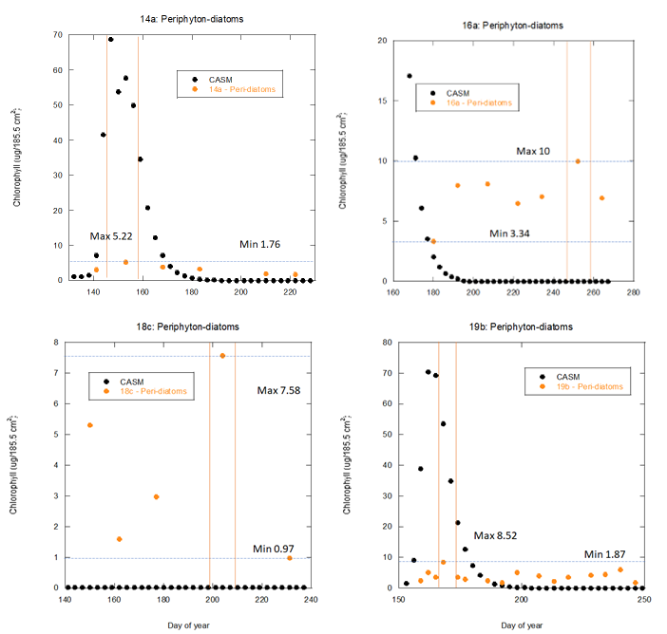
Figure 6.1. Calibration of the CASM-cosm to periphyton diatoms for mesocosm control studies (14a, 16a, 18c, and 19b).

Green algae

The calibrated CASM-cosm appears to represent the peak of green algae biomass reasonably well, but it underestimates the abundance measured during the latter part of the simulation (Figure 6.2). The model misses the reported peak biomass of green algae in study 16a. The model does not grow periphytic green algae for environmental input conditions defined by study 18c. The model overestimates green algae periphyton biomass for study 19b during the initial period of measurement and underestimates abundance during the latter reporting period (Figure 6.2).
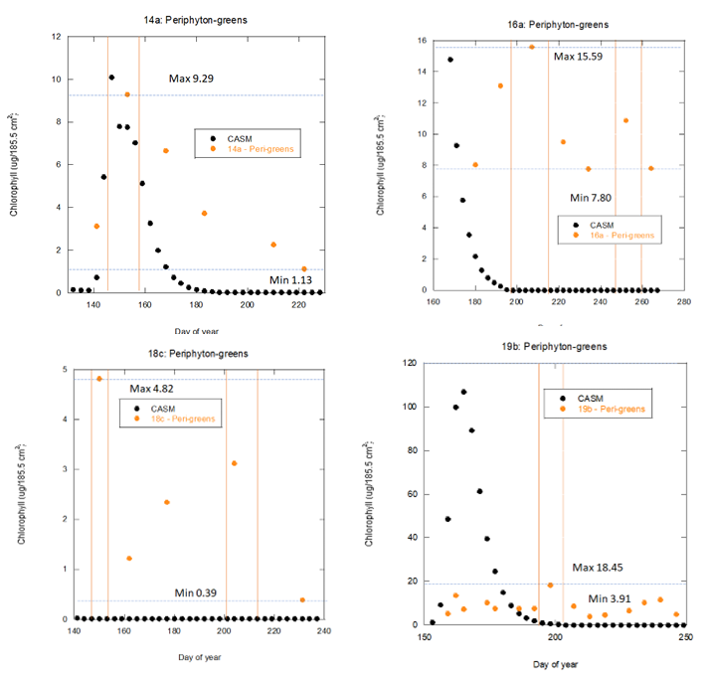
Figure 6.2. Calibration of the CASM-cosm to periphyton green algae for mesocosm control studies (14a, 16a, 18c, and 19b).

Bluegreen algae

Measured abundance of attached bluegreen algae were most abundant in studies 16a and 19b, compared to studies 14a and 18c (Figure 6.3). The calibrated CASM-cosm consistently underestimated the abundance of periphytic bluegreen algae across all four control studies. The model, however, does reproduce the period of peak abundance for control study 14a reasonably well even if the modeled biomass is less than the reported biomass. The model simulates the early period of bluegreen algae production as measured in study 19b, but then underestimates bluegreen biomass for the latter part of the measured period (Figure 6.3).
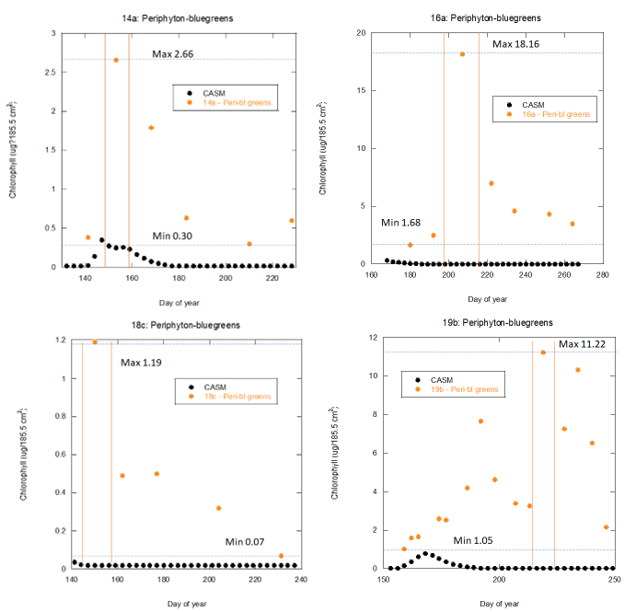
Figure 6.3. Calibration of the CASM-cosm to periphyton blue-green algae for mesocosm control studies (14a, 16a, 18c, and 19b).

Cryptophytes

The CASM-cosm calibration to the control studies similarly underestimated the biomass production of attached cryptophytes (Figure 6.4).
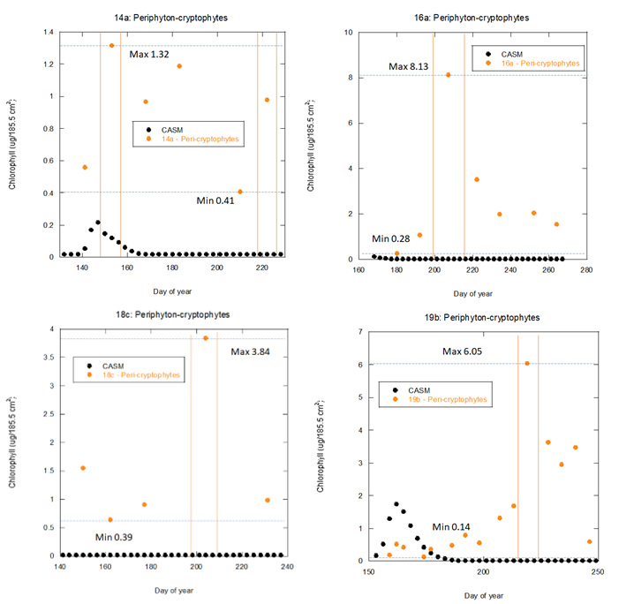
Figure 6.4. Calibration of the CASM-cosm to periphyton diatoms for mesocosm control studies (14a, 16a, 18c, and 19b).

Phytoplankton
Phytoplankton abundance in the control mesocosms was reported in units of µg chlorophyll/Liter. Modeled phytoplankton biomass was converted from g C/m² to µg chlorophyll/Liter for convenient comparison during the calibration process.

Diatoms

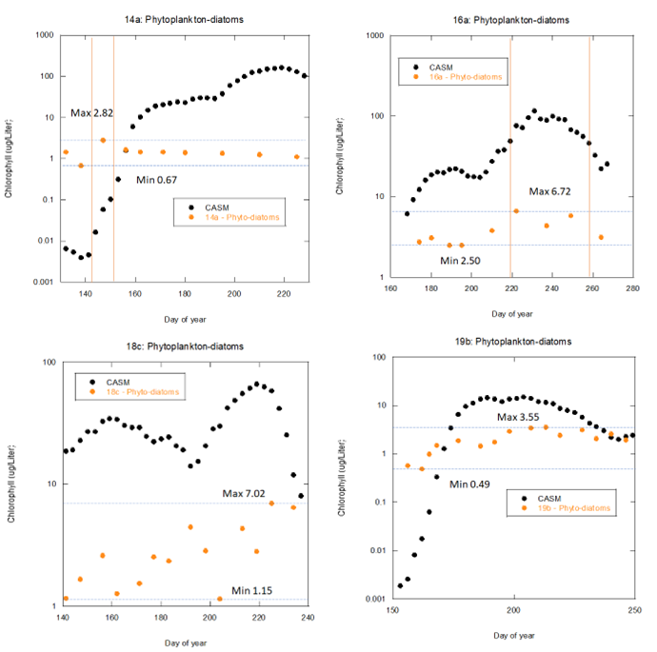

Figure 6.5. Calibration of the CASM-cosm to phytoplankton diatoms for mesocosm control studies (14a, 16a, 18c, and 19b).

Green algae

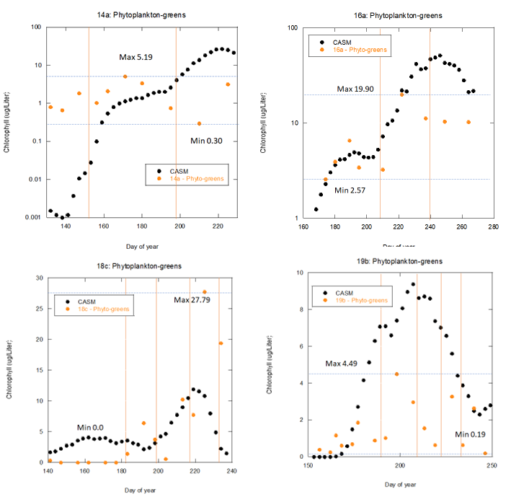
Figure 6.6. Calibration of the CASM-cosm to phytoplankton green algae for mesocosm control studies (14a, 16a, 18c, and 19b).

Bluegreen algae
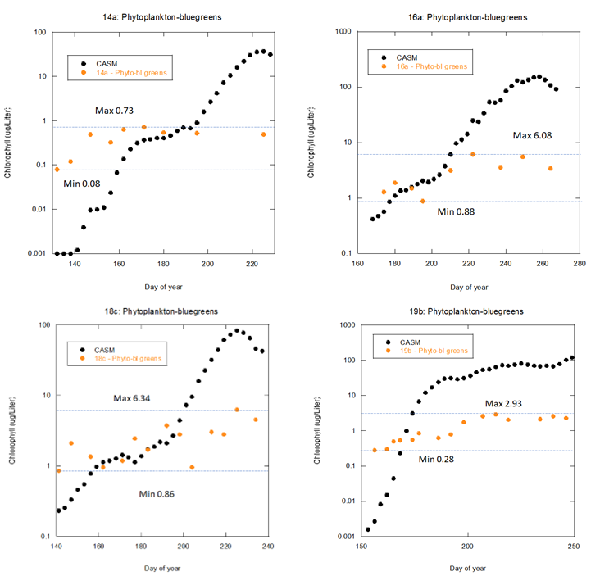
Figure 6.7. Calibration of the CASM-cosm to phytoplankton bluegreen algae for mesocosm control studies (14a, 16a, 18c, and 19b).

Cryptophytes

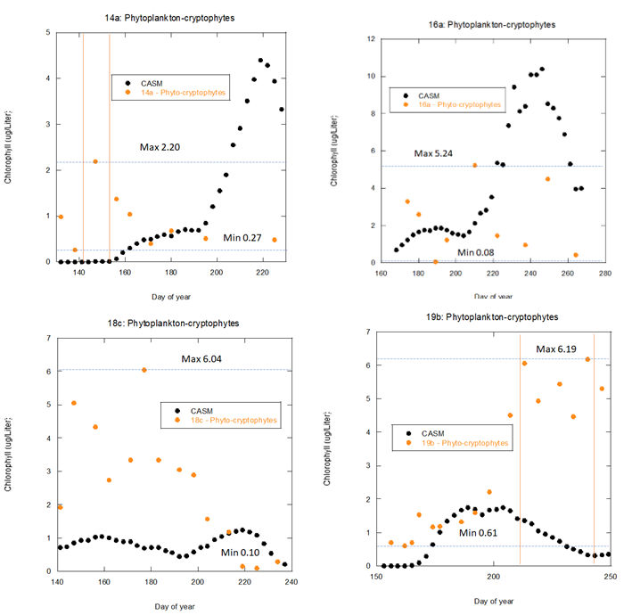
Figure 6.8. Calibration of the CASM-cosm to phytoplankton cryptophyte algae for mesocosm control studies (14a, 16a, 18c, and 19b).

Zooplankton

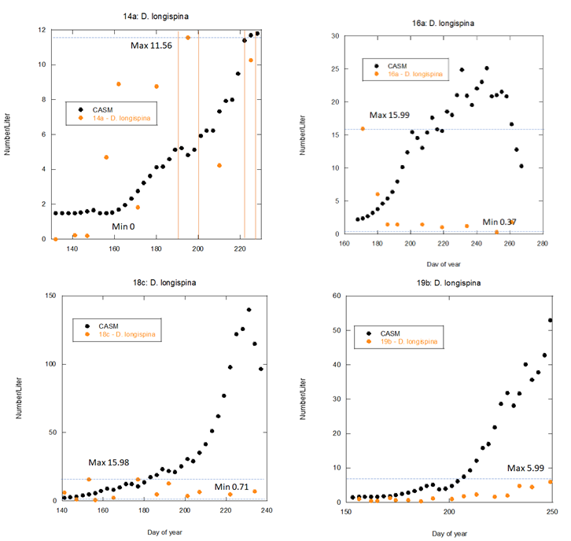

Figure 6.9. Calibration of the CASM-cosm to Daphnia longispina abundance (number/liter) for mesocosm control studies (14a, 16a, 18c, and 19b).

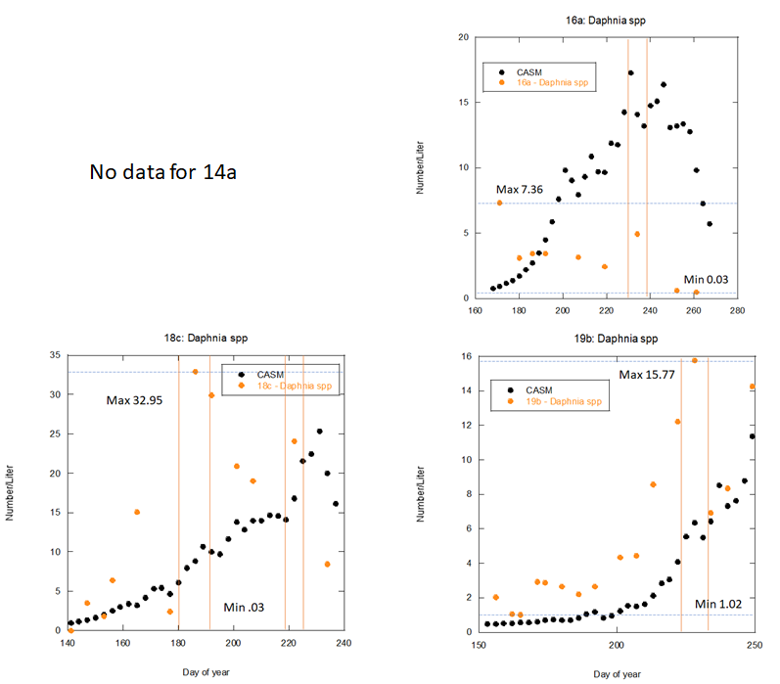
Figure 6.10. Calibration of the CASM-cosm to Daphnia spp. abundance (number/liter) for mesocosm control studies (16a, 18c, and 19b).

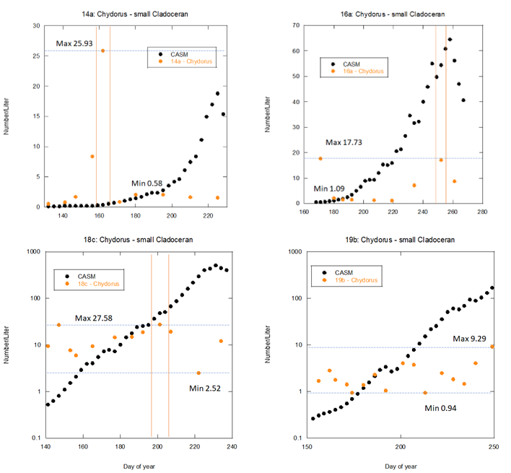
Figure 6.11. Calibration of the CASM-cosm to Chydorus (small Cladoceran) abundance (number/liter) for mesocosm control studies (14a, 16a, 18c, and 19b).

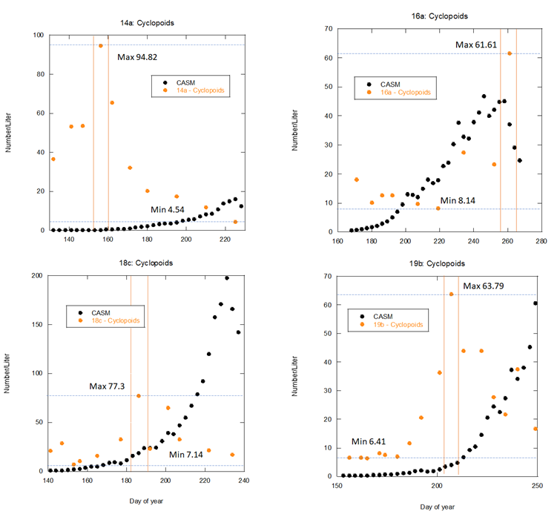
Figure 6.12. Calibration of the CASM-cosm to cyclopoid abundance (number/liter) for mesocosm control studies (14a, 16a, 18c, and 19b).

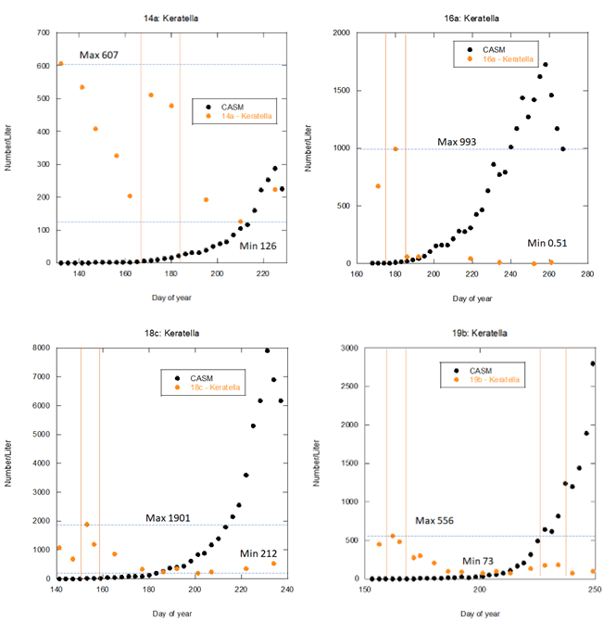
Figure 6.13. Calibration of the CASM-cosm to Keratella abundance (number/liter) for mesocosm control studies (14a, 16a, 18c, and 19b).

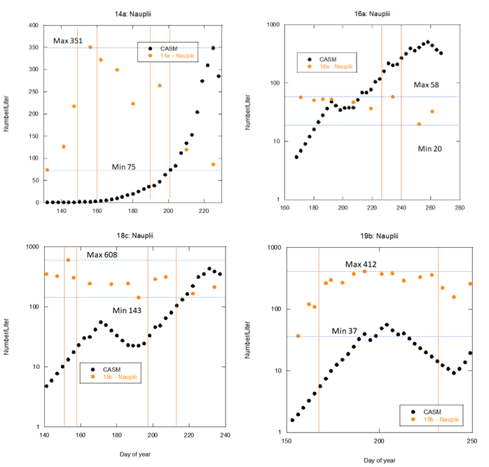
Figure 6.14. Calibration of the CASM-cosm to nauplii abundance (number/liter) for mesocosm control studies (14a, 16a, 18c, and 19b).

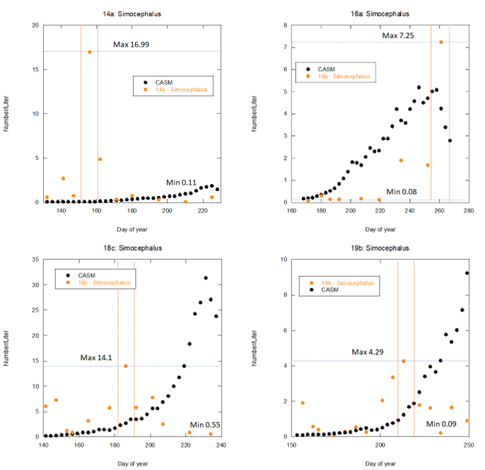
Figure 6.15. Calibration of the CASM-cosm to Simocephalus abundance (number/liter) for mesocosm control studies (14a, 16a, 18c, and 19b).

Macroinvertebrates

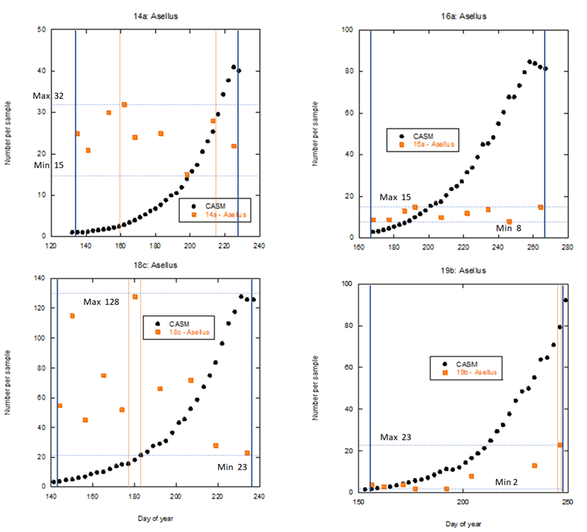
Figure 6.16. Calibration of the CASM-cosm to Asellus abundance (number/sample) for mesocosm control studies (14a, 16a, 18c, and 19b).

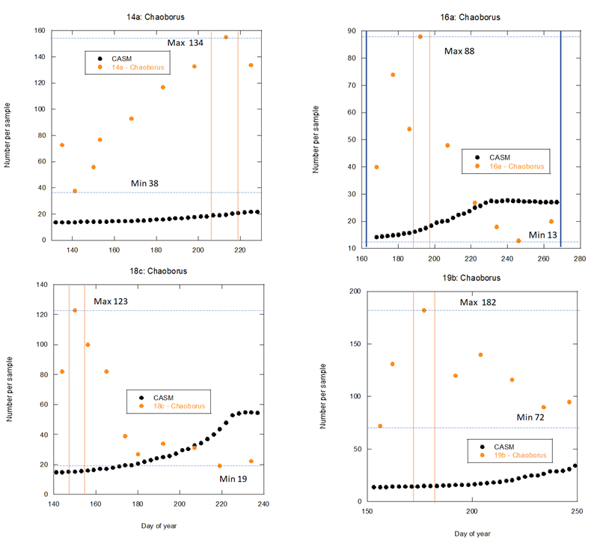
Figure 6.17. Calibration of the CASM-cosm to Chaoborus abundance (number/sample) for mesocosm control studies (14a, 16a, 18c, and 19b).

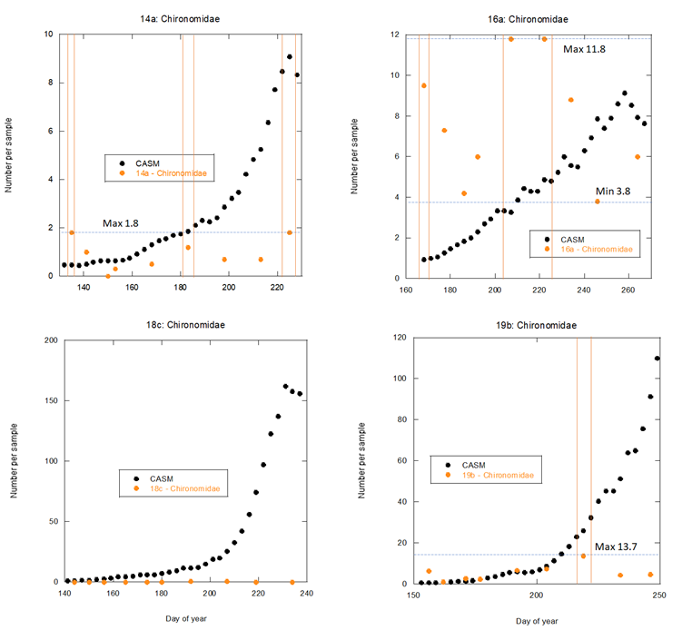
Figure 6.18. Calibration of the CASM-cosm to Chironomidae abundance (number/sample) for mesocosm control studies (14a, 16a, 18c, and 19b).

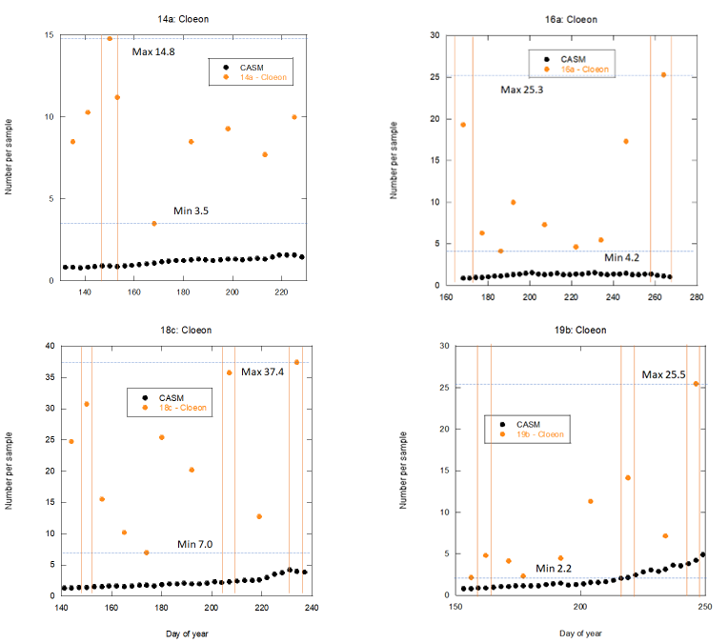
Figure 6.19. Calibration of the CASM-cosm to Cloeon abundance (number/sample) for mesocosm control studies (14a, 16a, 18c, and 19b).

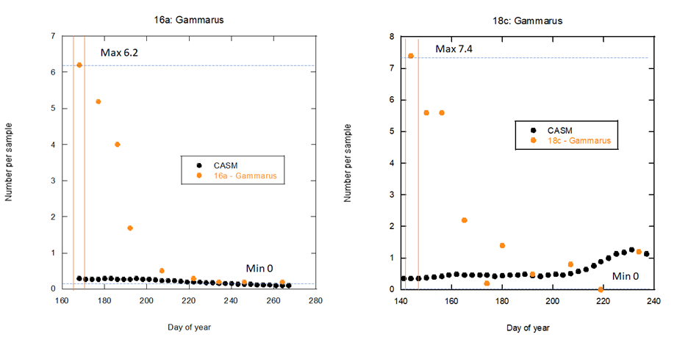
Figure 6.20. Calibration of the CASM-cosm to Gammarus abundance (number/sample) for mesocosm control studies (14a, 16a, 18c, and 19b).

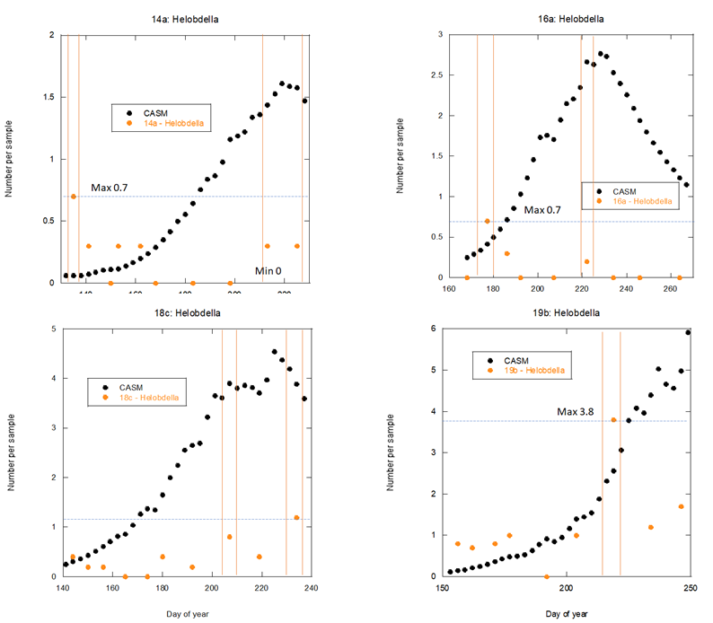
Figure 6.21. Calibration of the CASM-cosm to Helobdella abundance (number/sample) for mesocosm control studies (14a, 16a, 18c, and 19b).

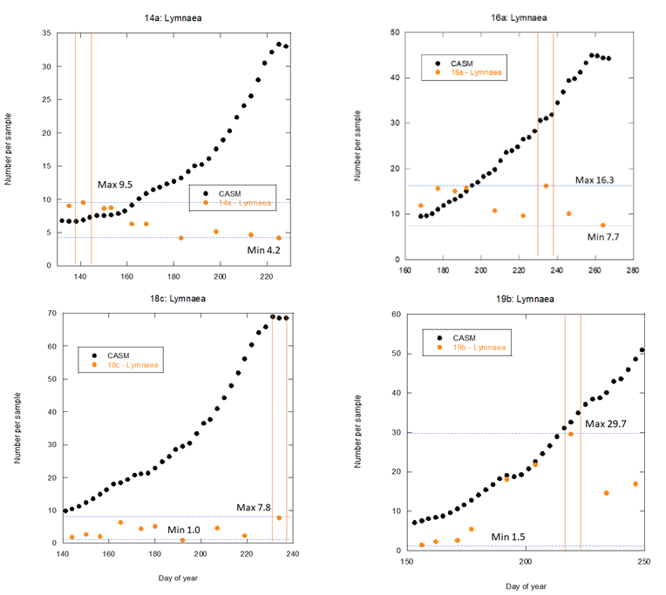
Figure 6.22. Calibration of the CASM-cosm to Lymnaea abundance (number/sample) for mesocosm control studies (14a, 16a, 18c, and 19b).

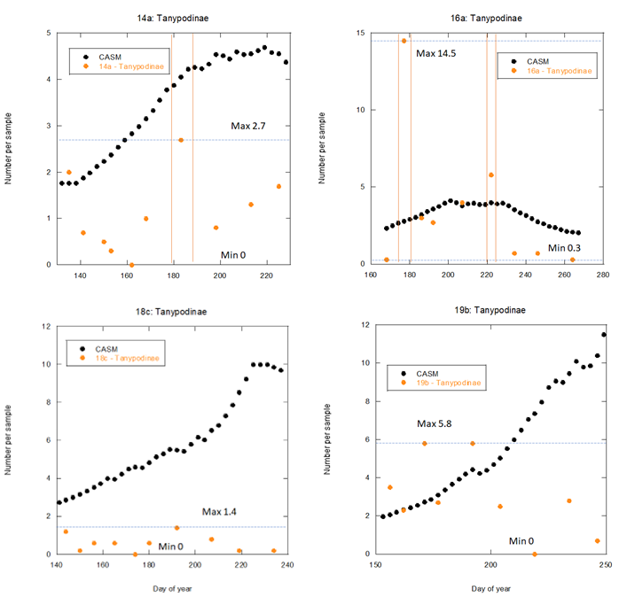
Figure 6.23. Calibration of the CASM-cosm to Tanypodinae abundance (number/sample) for mesocosm control studies (14a, 16a, 18c, and 19b).

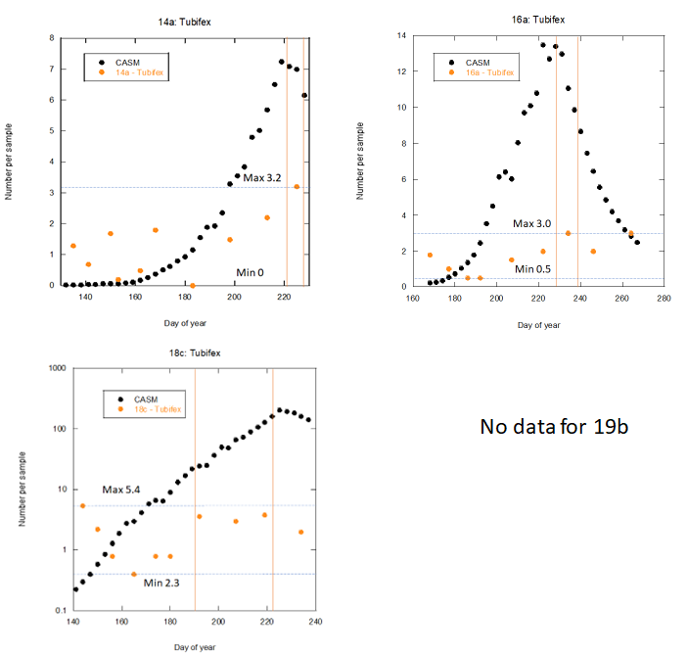
Figure 6.24. Calibration of the CASM-cosm to Tubifex abundance (number/sample) for mesocosm control studies (14a, 16a, and 18c).

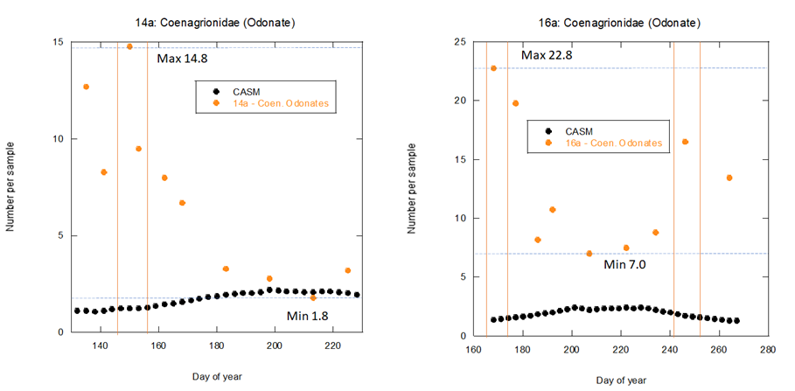
Figure 6.25. Calibration of the CASM-cosm to Coenagrionidae (Odanata) abundance (number/sample) for mesocosm control studies (14a, 16a, 18c, and 19b).

Calibration to mesocosm treatment data

The CASM-cosm that was calibrated to the mesocosm control data was used subsequently to calibrate to toxic effects derived from the study 19b treatment data. The calibration to the treatment data involved the estimation of toxicity benchmark values (i.e., EC50 and NOECs) for the individual populations modeled by the CASM-cosm. These benchmark values were systematically and manually adjusted in repeated simulations to produce agreement between modeled and measured impacts on population abundance for selected populations of phytoplankton and zooplankton. Only the benchmark values were manipulated in these calibration simulations. The initial conditions, bioenergetics parameters, food web interactions, and environmental inputs to the CASM-cosm were the same as those used in the calibration of the model to the study 19b control mesocosm data.

Azoxystrobin (AZT) exposure profile
Figure 6.26 illustrates the time-varying (daily) concentrations of AZT that were used to calibrate the CASM-cosm to the study 19b treatment mescocosm data that described toxic effects for selected populations of phytoplankton (Section 9.2.2) and zooplankton (Section 9.2.3).

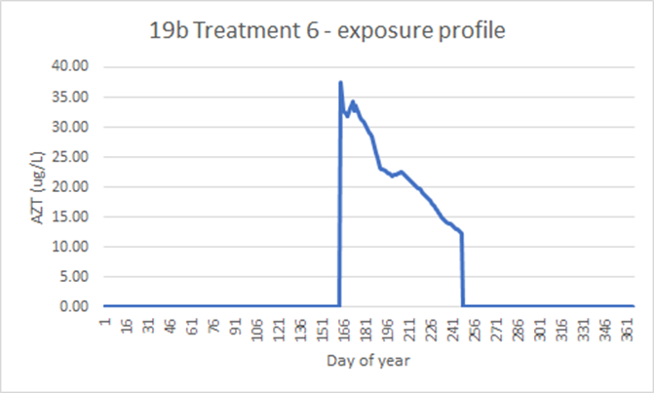

Figure 6.26. Daily concentrations (µg/Liter) of azoxystrobin (AZT) used in the ASM Ring Study simulations of toxic effects for mesocosm study 19b.

The maximum exposure concentration was 37.4 µg/Liter on model day 166 (June 15). The exposure concentration decreased to ~12 µg/Liter on model day 247 (September 4).

CASM-cosm toxic effects factors
The CASM-cosm translates daily exposure concentrations of AZT to toxic effects factors (TEFs) that adjust the baseline bioenergetics parameter values for modeled populations using population-specific exposure-response functions (e.g., Bartell et al. 2020, 2017, 1992). The exposure-response functions are defined by the toxicity benchmark values (i.e., EC50s, NOECs) developed uniquely for each modeled population. The TEFs are fractions that increase or decrease the values of the baseline biological growth parameters to produce the expected effect of a daily exposure, given the sensitivity of the population described by its exposure-response function. The baseline values are those obtained for each modeled population as the result of calibration to the mesocosm control studies.

For example, if a population would be expected to show a 30 percent reduction in abundance (biomass) over 48 hours for a specific exposure, the model internally solves the growth equation to find the fractional adjustment (TEF) that simulates the expected effect. Absent information on a specific mode of toxicity (e.g., a photosynthetic inhibitor, such as atrazine), the model computes and applies the fraction equally across the growth parameters, with anabolic processes (e.g., photosynthesis, consumption) decreased and catabolic processes (e.g., respiration, excretion, mortality) increased. This “general stress syndrome” was the approach used to compute TEFs for the AZT simulations.

For each exposure profile, in this case study 19b (Figure 6.26), a population-specific TEF is computed each day for each modeled population. If the daily exposure concentration is zero, the baseline values of the bioenergetics are used to simulate growth for that day.

Graphical summary of model results
The results of the calibration of the CASM-cosm to the 19b effects data are illustrated using two plots for each calibrated population. The first plot presents the 19b control and treatment mean abundance data (+/- 1 SE) and the daily modeled values for the control and treatment simulations. The CASM-cosm is executed as a deterministic model; no error/uncertainty estimats are assigned to each daily value.

The second plot compares the percent effect (positive or negative) measured and modeled over the exposure period. Values of minimum detectable difference (MDD) are also plotted to provide an indication of the likely significance of measured and modeled impacts in the context of variability among the treatment mesocosms.

Phytoplankton

The calibrated results for the phytoplankton diatoms indicate similar temporal patterns in abundance (chlorophyll) for the period of data collection (Figure 6.27 – left panel). However, the model overestimates the diatioms by approximately an order of magnitude. The model also indicates a secondary peak of production later in the model year. Data are not available to evaluate the accuracy of this model result.

The percent effects on diatoms for the calibration demonstrate a steadily decreasing trend (Figure 6.27 – right panel). The calibration does not capture the percent increases measured in the early period of exposure. However, the model results for the period from July 21 to August 18 are similar to the measured percent effects. Note that nearly all of the measured and modeled values lie within the range defined by +/- MDD. While the impacts of AZT to diatoms might have been on the order of 50 percent changes in population size, the variability among the data suggest that the effects are not likely significant. The calibration values are nearly all within the MDD “envelope,” which is consistent with the data.

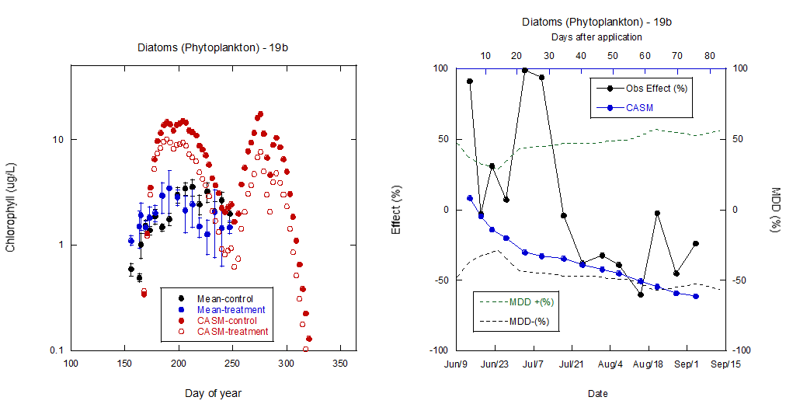
Figure 6.27. Measured (mean +/- 1 SE) and modeled phytoplankton diatom chlorophyll (µg/Liter) for study 19b (left panel); measured and modeled percent effect of pesticide exposure in relation to the computed minimum detectable difference (MDD) (right panel).

The modeled temporal values of chlorophyll for 19b control phytoplankton cryptophytes peak around model days 190-210, while the data suggest a peak in production around days 225-250. The modeled production is about nine-fold less than the data indicate (Figure 6.28 – left panel). The data indicate substantial toxic effects for cryptophytes with some evidence of a recovery at the last sample data. The model results also demonstrate direct toxic effects for cryptophytes, but the modeled impacts are somewhat less. The model results also show a second peak in production during the period for which there are no measurements. The model calibration does not capture the recovery suggested by the observations.

Similar to the diatoms, the data indicate a cryptophyte recovery in mid-July that is not represented by the calibration (Figure 6.28 – right panel). The calibrated and measured values lie within the MDD envelope during the early period of exposure to AZT. Both the model and the data demonstrate negative effects during the latter part of the exposure. However, the modeled effects are less intense than those suggested by the data. Again, the indications of recovery by cryptophytes in the data are not represented in the model calibration (Figure 6.28 – right panel).

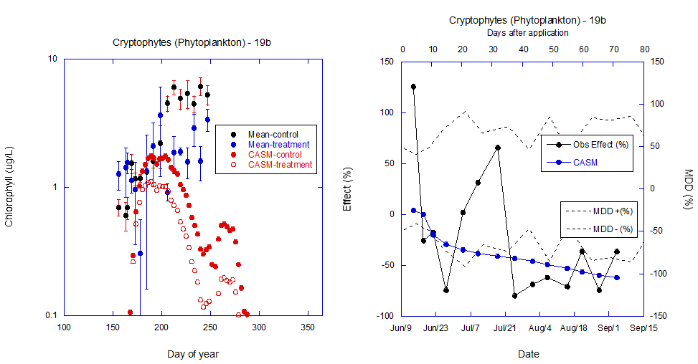
Figure 6.28. Measured (mean +/- 1 SE) and modeled phytoplankton cryptophyte chlorophyll (µg/Liter) for study 19b (left panel); measured and modeled percent effect of pesticide exposure in relation to the computed minimum detectable difference (MDD) (right panel).

Zooplankton
The CASM-cosm was calibrated to effects of AZT measured for populations of study 19b zooplankton that included small cladocerans (e.g., Chydorus), Daphnidae, predatory copepods, nauplii, and herbivorous rotifers. Only the AZT benchmark toxicity values (i.e., EC50s) were adjusted in the calibration.

The degree of success of the calibration to measured toxic effects for small cladocerans was constrained in large part by the calibration to the control mesocosm data. The modeled control biomass passes through the control data, but peaks at values approximately an order of magnitude higher (Figure 6.29 – left panel). The data indicate initial increases in abundance following exposure to AZT, followed by an apparent decline in abundance. Most of the measued effects were within the MDD envelope. The corresponding calibration to the measured effects shows a monotonic increase in abundance, but not to the extent suggested by the data. The calibration is consistent with the observations in the sense that all of the modeled results lie within the MDD envelope (Figure 6.29 – right panel). Calibration simulations that produced greater percentage increases in abundance for the early period of exposure also projected increases that were greater than the MDD values for the latter period of exposure.

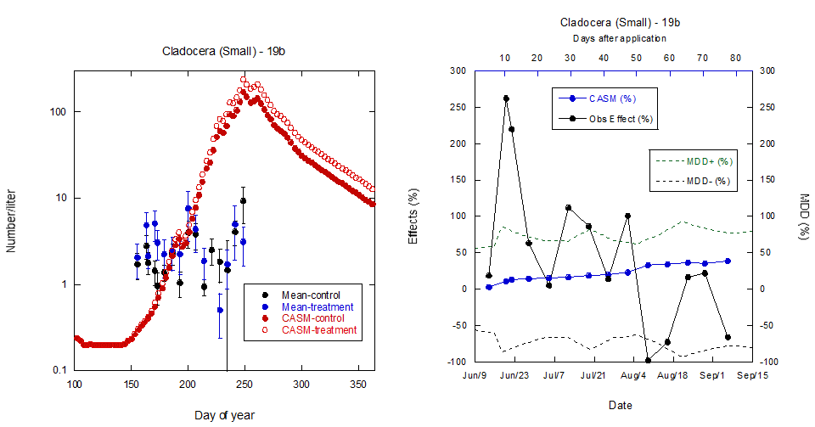
Figure 6.29. Measured (mean +/- 1 SE) and modeled abundance (number/Liter) of small Cladocera (Chydorus) for study 19b (left panel); measured and modeled percent effect of pesticide exposure in relation to the computed minimum detectable difference (MDD) (right panel).

The 19b treatment data indicate an initial severe (almost 100 percent) toxic effect of AZT on daphnids, followed by a period of recovery and a general increasing trend in abundance (Figures 9.30 – left and right panels). The measured effects were also demonstrably variable with MDDs between 50 – 90 percent or so. The CASM-cosm calibration to the control data slightly underestimates Daphindae abundance, although the temporal patterns between measured and modeled values are reasonably similar. Attempts to capture the severe early measured negative impacts through calibration did not permit a corresponding recovery, as suggested by the data. Constraining the calibration to produce an increasing population of daphnids in the latter part of the exposure required initial negative impacts to be much lower than the measured impacts. The calibration represents a compromise by simulating smaller negative impacts early on and a smaller increase in abundance during the latter period of measurement (Figure 6.30 – right panel).

There currently is no mechanism in the CASM-cosm that permits remaining population biomass, following an initial direct toxic effect, to become less sensitive to continued exposure. Recovery could result in the CASM-cosm as an indirect food web effect. That is, if predators on Daphnidae were comparatively more sensitive to the AZT exposure, the remaining daphnids could subsequently increase. However, the main predators of daphnids in the CASM-cosm food web include predatory copepods and Chaoborus. Measured and modeled predatory copepods are also increasing during the latter part of the study (Figure 6.31), as are modeled Chaoborus (Figure 6.35). This would seem to detract from a simple explanation in terms of indirect food web effects.
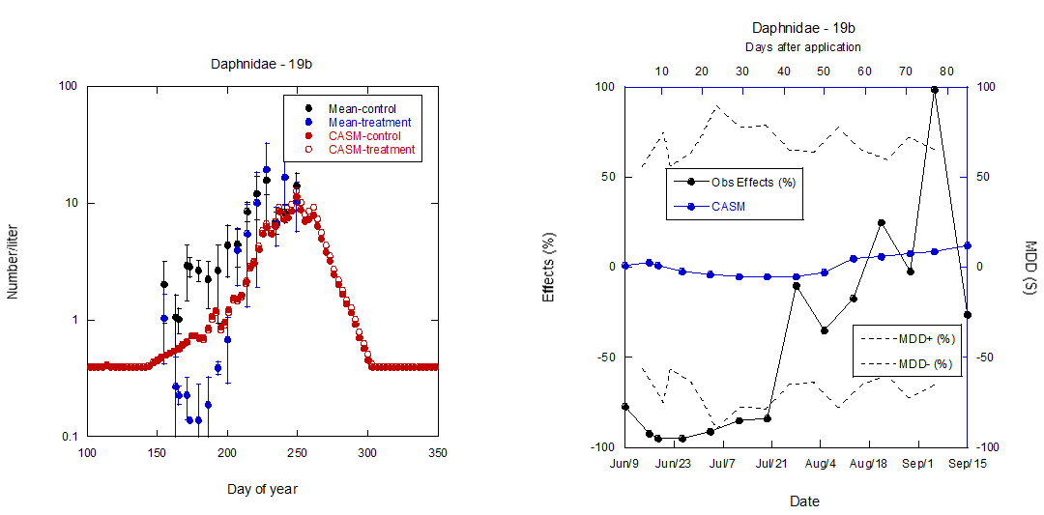

Figure 6.30. Measured (mean +/- 1 SE) and modeled abundance (number/Liter) of Daphnidae for study 19b (left panel); measured and modeled percent effect of pesticide exposure in relation to the computed minimum detectable difference (MDD) (right panel).

The results of the 19b AZT treatment indicated a substantial (>50%) decline in the abundance of predatory copepods throughout most of the period of exposure (Figure 6.31 – right panel), followed a possible recovery observed for the last three sampling dates (Figure 6.31 – left panel). The calibration of the CASM-cosm to the observed impacts during the initial period of exposure produced similarly severe negative impacts on the abundance of predatory copepods. However, the model was not able to correspondingly produce the recovery indicated by the data.
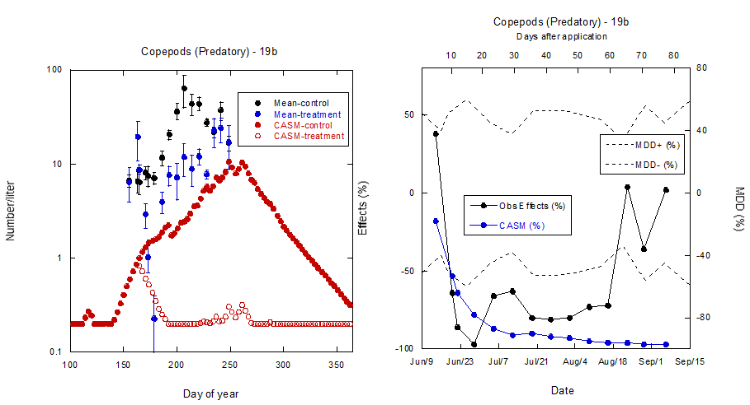

Figure 6.31. Measured (mean +/- 1 SE) and modeled abundance (number/Liter) of predatory copepods for study 19b (left panel); measured and modeled percent effect of pesticide exposure in relation to the computed minimum detectable difference (MDD) (right panel).

The results of the 19b AZT treatment underscored severe and continued toxic effects on the abundance of nauplii (Figure 6.32). One data point suggests recovery to within the MDD envelope (Figure 6.32 – right panel). This population appears to demonstrate the most severe and continued response to AZT among those populations reported for this study. The CASM-cosm control calibration underestimates the abundance of nauplii – not the log scale of Figure 6.32 – left panel. However, the calibration of the model to toxic effects was able to describe the observed severe and continued toxic effect in relative abundance (Figure 6.32 – right panel).

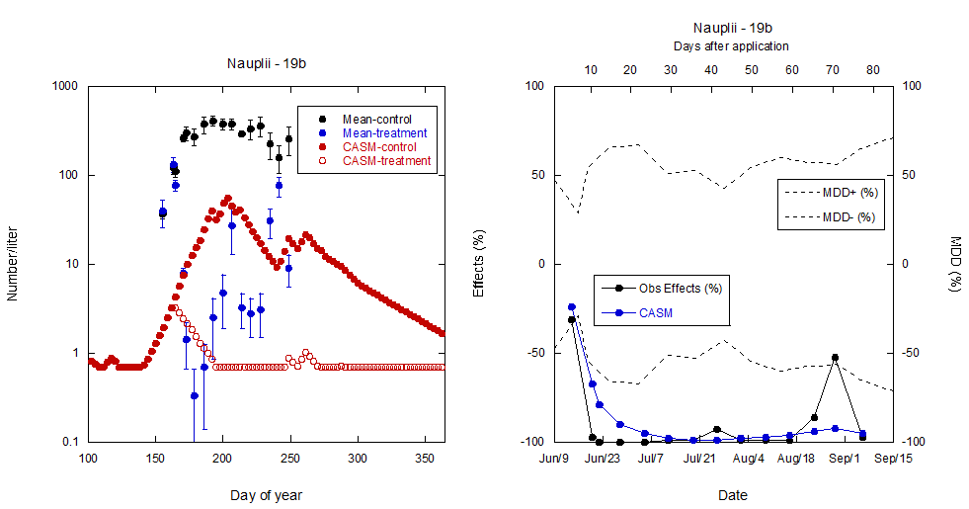

Figure 6.32. Measured (mean +/- 1 SE) and modeled abundance (number/Liter) of nauplii for study 19b (left panel); measured and modeled percent effect of pesticide exposure in relation to the computed minimum detectable difference (MDD) (right panel).

The results of the 19b treatment study indicate that the measured abundance of herbivorous rotifers was positively impacted (Figure 6.33 – left panel). The measured control data indicate a decreasing trend in abundance during the course of the experiment. The toxic effects data show increases in abundance compared to the control data, although the overall trend still appears to be a decline in abundance as the experiment progressed. This apparent increase in rotifer abundance could be the result of the relative insensitivity of these rotifers to AZT, an indirect food web effect, or some combination of these two processes. The CASM-cosm calibration to the 19b control data, however, shows an opposite trend of increasing abundance for the period for which data are available (Figure 6.33 – left panel). The modeled values pass through the data points, but the modeled trend is opposite of the data. Calibration to the effects data simply entailed no change to the initial toxicity benchmark (4,000 ppb). This value ensured that TEFs were not computed for this modeled population of rotifers. The slight increase in abundance relative to the control simulation has to result from an indirect food web effect. The calibration was able produce a monotonic increase in abundance, but not to the degree suggested by the data.

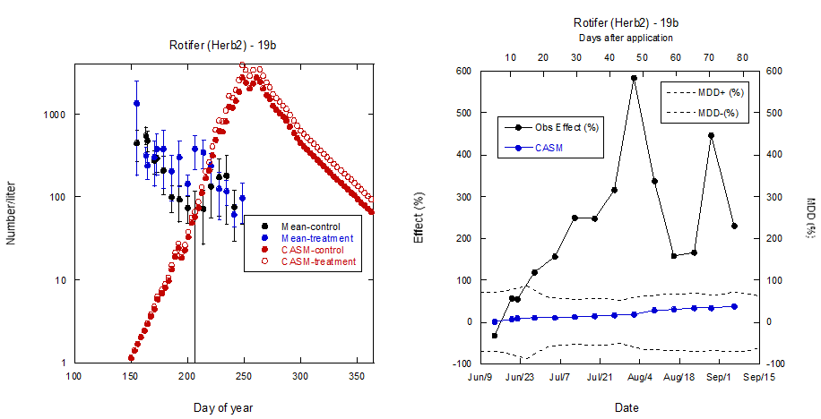

Figure 6.33. Measured (mean +/- 1 SE) and modeled abundance (number/Liter) of herbivorous rotifers for study 19b (left panel); measured and modeled percent effect of pesticide exposure in relation to the computed minimum detectable difference (MDD) (right panel).

Indirect effects in the CASM-cosm
Evaluation of the performance of the CASM-cosm in simulating toxic effects of AZT in the mesocosm also included an assessment of indirect effects that propagate throughout the modeled food web. Indirect effects are defined in the CASM-cosm as differences between modeled control and treatment biomass for populations not directly impacted by the AZT, as evidenced by their comparatively high toxicity benchmarks in relation to the exposure concentrations. Given the measured and modeled direct effects on zooplankton, it might be reasonable to expect possible indirect effects on other modeled zooplankton populations – for example, through competitive release. Small, but computable, indirect effects were obtained for populations of phytophilous cladocerans, herbivorous cpopepods, Simocephalus, and herbivorous rotifer 1 included in the CASM-cosm food web (Figure 6.34).
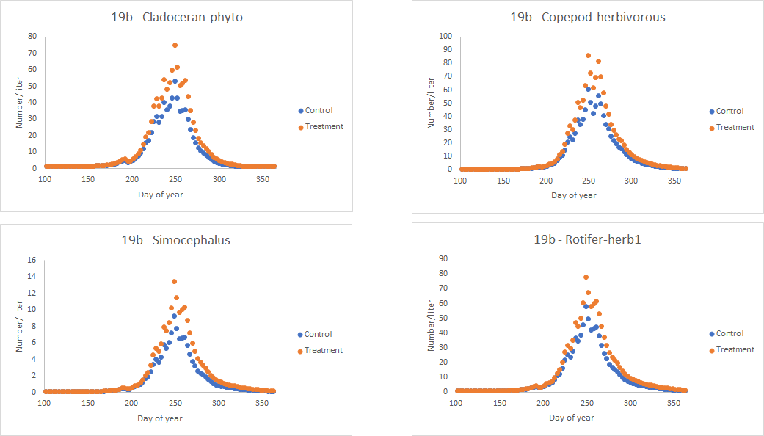

Figure 6.34. CASM-cosm simulated control and treatment abundance (number/liter) for selected zooplankton not directly impacted in study 19b.

The benthic macroinvertebrates are functionally disconnected from the more pelagic populations in the CASM-cosm food web, except for Chaoborus, which preys upon modeled zooplankton. Therefore, indirect effects might be less anticipated for the benthic macroinvertebrates. Importantly, the toxicity benchmark values for these populations were not adjusted from their initial values during the process of calibration to the study 19b measured effects. The calibrated control and treatment simulations for study 19b appear to support this suggestion and results are shown for simulated control and treatment biomass of Asellus, Chaoborus, oligochaetes, and gastropods (Figure 6.35). The control and treatment biomass values are essentially identical for all populations, except perhaps Chaoborus, which indicates a slight indirect effect. Chaoborus larvae might be considered more realistically a component of the pelagic portion of the mesocosm food web. These modeled results, which demonstrate minimal indirect effects as expected, provide another dimension in evaluating the performance of the CASM-cosm in simulating the toxic effects of AZT in the mesocosms.

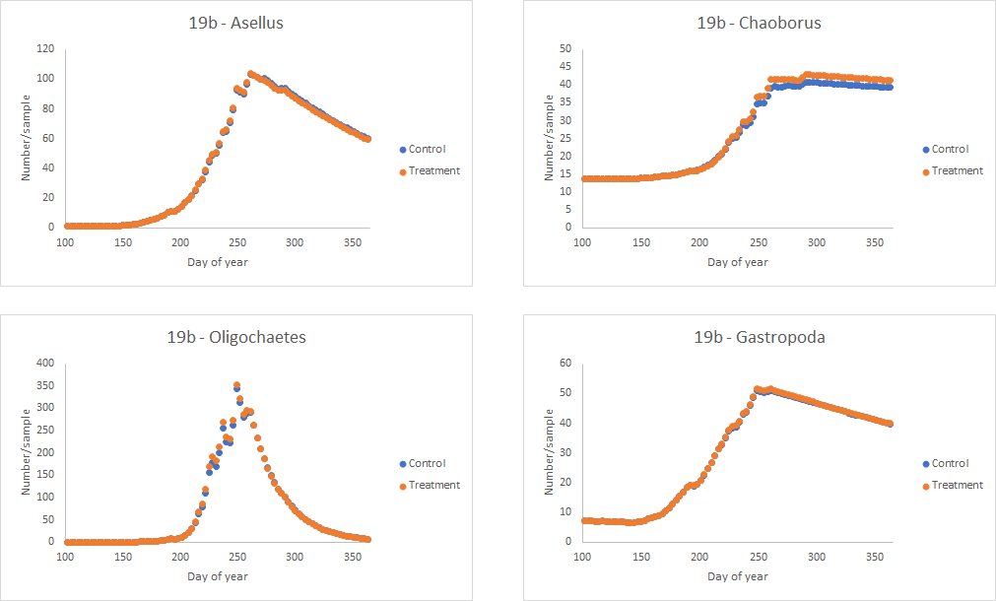
Figure 6.35. CASM-cosm simulated control and treatment abundance (number/sample) for selected macroinvertebrates not directly impacted in study 19b.

Summary of CASM-cosm performance
The temporal values of modeled toxic effects were compared with corresponding measured effects for several sample dates analyzed for the treatment microcosms in study 19b. Table 9.5 lists the numbers of false negatives and false positives determined for the measured populations of phytoplankton and zooplankton. Average differences between the measured and modeled percent effects (ME) were also computed for each population across all the sample dates (Table 9.5). An average ME of zero describes perfect agreement between the modeled and measured toxic effect; increasing values of ME indicate increasing differences between modeled and measured effects.

Summary of CASM-cosm performance for 19b treatment mesocosms.
Modeled population | False negatives | False positives | Average ME
Phytoplankton - diatoms | 3 | 1 | 38
Phytoplankton - cryptophytes | 3 | 1 | 40
Copepods - predatory | 0 | 3 | 36
Nauplii | 0 | 0 | 10
Cladocera - small | 7 | 0 | 83
Daphnidae | 0 | 7 | 59
Herbivorous rotifers | 10 | 0 | 307

Table 9. 5. Summary of false negatives, false positives, and average ME for modeled and measured populations in the 19b treatment mesocosms.

The CASM-cosm performed well for modeled effects on nauplii and poorly for herbivorous rotifers. Intermediate values of ME were obtained for predatory copepods, diatoms, and cryptophytes. Slightly higher values of ME resulted for Daphnidae and small Cladocera (Table 9.5).

Resulting toxicity benchmark values
The calibration of the CASM-cosm to the 19b toxic effects data was accomplished by systematically increasing or decreasing the EC50 values for the calibrated populations. The calibration began with benchmark values derived from existing data and information (filename?) provided for the ASM Ring Study (Table 6.1). The results of the calibration produced a subsequent set of benchmark values that represent a hypothesis for AZT toxicity based the study 19b treatment mesocosms (Table 6.1). The expectation is that the CASM-cosm would simulate the effects of other AZT mesocosm treatment scenarios with similar performance. That is, the calibrated benchmark toxicity values are presumed to apply generally across treatment scenarios that involve different exposure profiles applied to the experimental mesocosms.

Model population | Initial EC50 (µg/Liter) | Calibrated EC50 (µg/Liter)
Phytoplankton - diatoms | 14 | 146
Phytoplankton - cryptophytes | 9,500 | 128
Cladocera - small | 102 | 40
Copepods - predatory | 130 | 16
Herbivorous rotifers 2 | 4,000 | 4,000
Nauplii | 100,000 | 1
Daphnidae | 159 | 57

Table 6.1. Initial and calibrated toxicity benchmark EC50 values (µg/Liter) for populations directly impacted in study 19b treatment mesocosms.

CASM-cosm calibration summary

Calibration criteria were developed as ranges of chlorophyll values for three populations of periphyton: blue green algae, green algae, and diatoms (Table 6.2). Simulation results for the four mesocosm control studies were compared with these criteria to evaluate the overall performance of the model with respect to periphyton production.

Of the 32 possible comparisons, the model calibration results for the periphyton populations produced two acceptable results with data for study 14a, one acceptable result for study16a, one acceptable result for study 18c, and no agreement with study 19b (Table 6.2). Thirteen percent of the overall model results were comparable to the calibration criteria for periphyton.

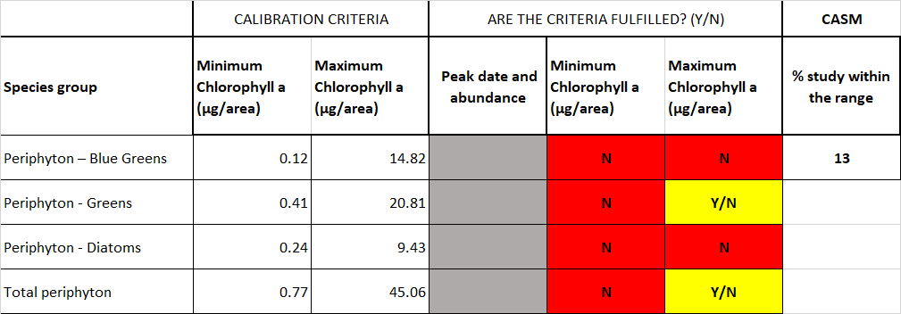

Table 6.2. Qualitative summary of CASM-cosm calibration to mesocosm control periphyton data.

Similarly, calibration criteria for phytoplankton in the control mesocosm data were defined as a range of chlorophyll values for the modeled populations (Table 6.3). There were 40 possible comparisons between model results of control phytoplankton data. The CASM-cosm calibration produced two comparable results for study 14a, one each for studies 16a and 18c, and no favorable comparisons for study 19b. Ten percent of the model results were within range of the control phytoplankton data (Table 6.3).

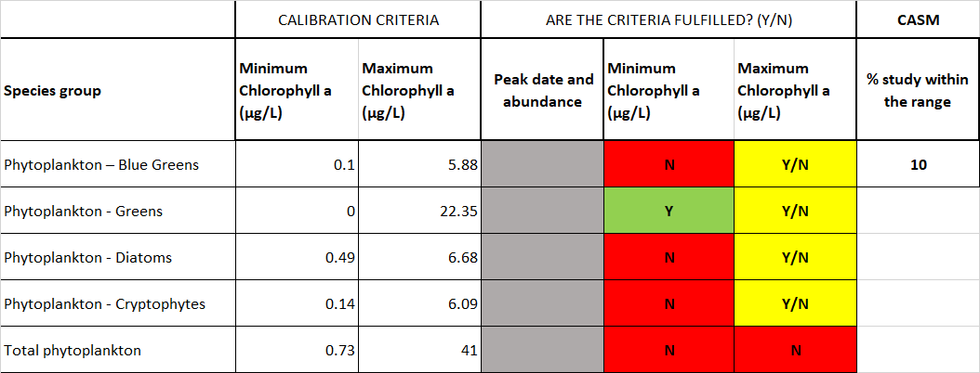
Table 6.3. Qualitative summary of CASM-cosm calibration to mesocosm control phytoplankton data.

Calibration criteria in addition to the minimum and maximum abundance were derived for the control mesocosm zooplankton data. The set of criteria included dates of the earliest and latest peaks in abundance, as well as minimum and maximum peak abundances (Table 6.4). Analysis of the detailed CASM-cosm calibration simulations demonstrated that 26 favorable model:data comparisons were produced for study 14a, 26 favorable comparisons for study 16a, 22 for study 18c, and 20 for study 19b. Overall, 71 percent of the possible comparisons across the population endpoints and calibration criteria were favorable (Table 6.4).

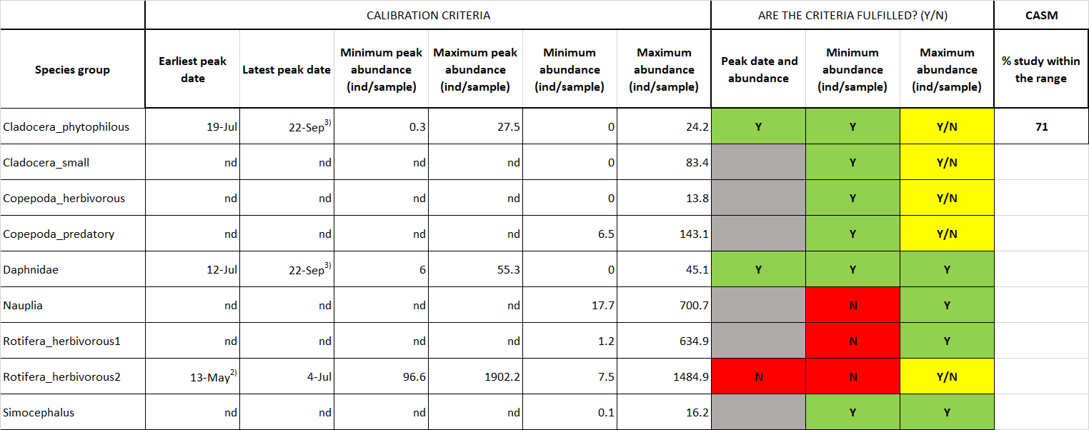
Table 6.4. Qualitative summary of CASM-cosm calibration to mesocosm control zooplankton data.

The same categories of criteria developed for zooplankton were also used to evaluate the calibrations for modeled macroinvertebrates using corresponding macroinvertebrate data from the four control mesocosm studies (Table 6.5). Results of the CASM-cosm calibration simulations for each control study indicated that 34 favorable comparisons were obtained for each of studies 14a and 16a, while 30 favorable comparisons resulted for study 18c and 29 acceptable comparisons were found for study 19b. Overall, 88 percent of the model:data comparisons were in agreement with the calibration criteria for macroinvertebrates (Table 6.5).

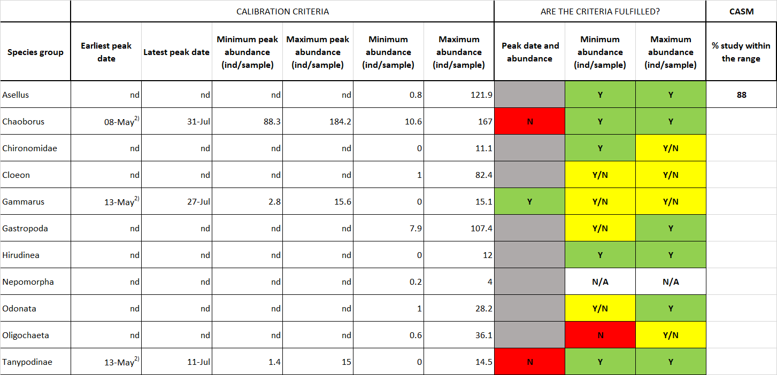
Table 6.5. Qualitative summary of CASM-cosm calibration to mesocosm control macroinvertebrate data.

Uncertainty
Uncertainties in input parameters and other inputs need to be identified along with the definition of uncertainty ranges if possible. Sources of parameter uncertainty in the model approach should be listed.

Model analysis
Model analysis beyond model validation is not expected for the current project (Phase 3). [If analysis were conducted in the context of the project, they should be described here.] In addition, previous analyses conducted with the model, including sensitivity analysis or uncertainty analyses, should be summarized here and referenced.

Sensitivity analysis
The CASM-cosm has not directly been the subject of detailed model analysis. However, other versions of the CASM have been analyzed in detail (e.g., Bartell et al. 2013). In addition, the sensitivities of the basic fish bioenergetics model formulations to parameter uncertainty have been characterized (e.g., Bartell et al. 1992, 1988, 1986). The CASM-cosm does not include fish as state variables; fish were not included in the mesocosm studies. However, the same bioenergetics-based equations for fish are used with different parameter values to simulate the population dynamics of zooplankton and benthic invertebrates. Similar model sensitivities would be anticipated for zooplankton and benthic invertebrates. The following sections briefly summarize the previous findings that can be used to inform additional model sensitivity analysis that might be warranted.

Consumer populations bioenergetics model sensitivities
Bartell et al. (1986) compared the results of individual parameter perturbation (e.g., +/- 10%) and quantitative error analysis in describing the sensitivity of three fish bioenergetics models, including largemouth bass. Error analysis was performed using Monte Carlo simulations that sampled distributions of model parameter values and used statistical measures (e.g., relative partial sums of squares) to quantify model sensitivity to uncertain parameter estimates. Figure 23. identifies the key model parameters that influence model results; Table 8 identifies and defines the parameters. The pattern of parameter sensitivity differs with model usage: simulating fish growth with parameter estimates shows somewhat different sensitivity than fitting the model to observed fish growth by estimating consumption.
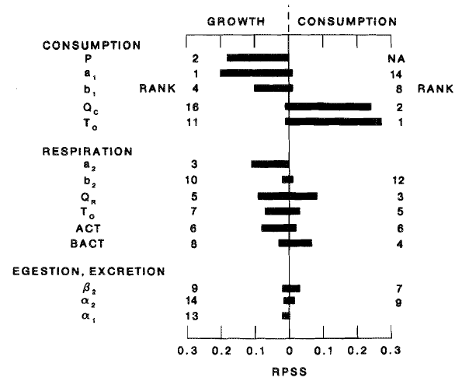
Figure 23. Sensitivity of fish bioenergetics model to parameter uncertainty based on quantitative error analysis (adapted from Bartell et al. 1986).

Parameter | Parameter definition
Consumption
P | Proportion of Cmax expressed (not used in the CASM-cosm
a₁ | Scalar of allometric function relating consumption to fish body weight
b₁ | Exponent of function relating consumption to fish body weight
Q_{C} | Slope of Q-10 function relating consumption to water temperature
To | Temperature where consumption is at Cmax
Respiration
a₂ | Scalar of allometric function relating respiration to fish body weight
b₂ | Exponent of function relating respiration to fish body weight
Q_{R} | Slope of Q-10 function relating respiration to water temperature
To | Temperature where respiration is at Rmax
ACT | Specific dynamic action, the metabolic cost of digestion
BACT | Respiration associated with swimming activity
Egestion, excretion
β₂ | Exponent of function relating excretion to water temperature
α₂ | Scalar in the function relating excretion to water temperature
α₁ | Scalar in the function relating egestion to water temperature
Table 8. Bioenergetics parameters identified as sensitive by Bartell et al. (1986).

The CASM-cosm is used to simulate consumer population growth from initial estimates of biomass and associated growth parameters for the species included in the mesocosm food web. The results of Bartell et al. (1986) point to the importance of the allometric parameters a₁ and b₁ in defining fish specific consumption rates. (P is not included in the bioenergetics formulations in the CASM-cosm). The allometric respiration value of a₂ and the temperature dependence (Q_{R}, T_{O}) of respiration are also sensitive model parameters for estimating fish growth. The corresponding parameters that relate organism size to consumption and respiration, as well as parameters that define the temperature dependence of consumption and respiration are key parameters in determining the results of the CASM-cosm.

Aquatic food web model sensitivities
Bartell et al. (1992, 1988) performed a detailed analysis of the daily sensitivity of modeled aquatic populations of producers and consumers in a pelagic food web model similar in structure to the CASM-cosm. These analyses underscored the scale-dependence of sensitivity analysis of bioenergetics-based models of aquatic food webs. The analysis identified parameters associated with the environmental influences on population growth (i.e., “bottom-up” factors such as light, temperature, and nutrient parameters) as important controlling factors during the onset of growth during the spring months. Key parameters shifted to those associated with “top-down” control of biomass production (e.g., maximum feeding and respiration rates of consumer populations) during the summer and fall months. These results emphasized the importance of precisely specifying the focus of a sensitivity analysis of dynamic models in relation to overall modeling objectives. There is no single answer to the sensitivity question for dynamic bioenergetics-based models of aquatic food webs.

Model output corroboration
In this section, the model validation with mesocosm control data will be described. The three data sets used for validation will be published along with a separate manuscript that can be referenced here (see also section 6.1).

Validation results applying the agreed evaluation methods should be presented for the validation against each separate data set. The results should be discussed, particularly if pre-defined validation criteria are not met.
[Subheadings for the description of the validation to control data will be included here.]

Simulation of 2021 mesocosm control data: 2 applications control
The time-varying values of abundance of primary producers and consumer populations were simulated for control conditions for the study 21a-1 (Two Applications). Daily values of surface light, water temperature and nutrient inputs (DIN, DIP) were developed from reported data for the control mesocosms. The initial biomass values and CASM-cosm population growth parameters were the same as used in previous calibration to control data (e.g., studies 14a, 16a, 18b, and 19c).

The following plots illustrate the temporal values of abundance for the 21a-1 control conditions. The plots are described briefly, because there were no mesocosm data available for comparison with the model results, which are presented simply at face value.

The resulting simulations for periphyton show peak production from approximately model days 164 – 172 (Figure 9.1.1). For the simulated 2021 control environmental conditions, periphyton production was dominated by chlorophytes, cyanophytes, and diatoms with minimal cryptophyte production.

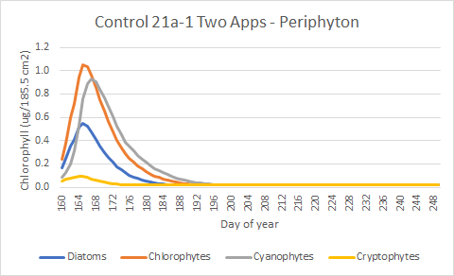
Figure 9.1.1. CASM-cosm simulated control biomass for modeled periphyton populations using control 21-a1 environmental conditions.

Phytoplankton, particularly the bluegreen algae, dominated the later portion of the simulation with chlorophyll values approaching 60 µg/L, which is clearly not realistic (Figure 9.1.2). Values of 10 µg/L or less were obtained for the phytoplankton chlorophytes, diatoms, and cryptophytes.

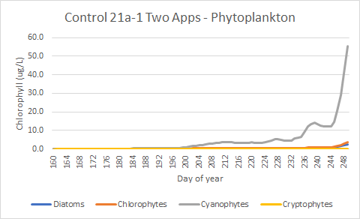

Figure 9.1.2. CASM-cosm simulated control biomass for modeled phytoplankton populations using control 21-a1 environmental conditions.

The control simulations for phytophyllous and small Cladocera showed minimal production with numbers ranging from 2 individuals/L or less during the course of the control simulation (Figure 9.1.3).

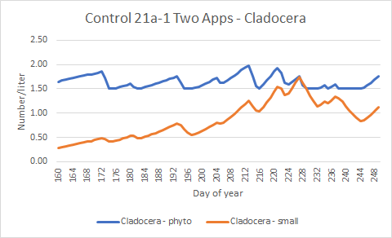
Figure 9.1.3. CASM-cosm simulated control biomass for modeled phytophyllous and small Cladocera populations using control 21-a1 environmental conditions.

Similar to the two Cladocera, the simulated abundances of herbivorous and predatory copepods for the 2021 control conditions were generally much less than 2 individuals/L during the course of the 21a-1 study (Figure 9.1.4).

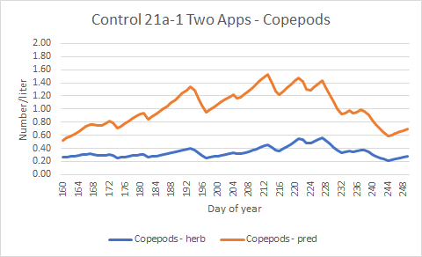
Figure 9.1.4. CASM-cosm simulated control biomass for modeled herbivorous and predatory populations using control 21-a1 environmental conditions.

The control simulation produced somewhat greater abundances for nauplii with peak abundance of about 10 individuals/L (Figure 9.1.5).

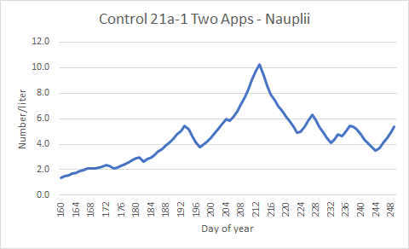
Figure 9.1.5. CASM-cosm simulated control biomass for modeled nauplii using control 21-a1 environmental conditions.

Similar to the other modeled zooplankton, control results for Daphnidae and Simocephalus were very low, less than 1 individual/L (Figure 9.1.6).

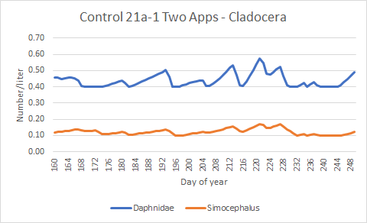
Figure 9.1.6. CASM-cosm simulated control biomass for modeled Daphnidae and Simocephalus populations using control 21-a1 environmental conditions.

Simulated abundance of rotifers (herb 1) for the 21a-1 control conditions peaked at about 12 individuals/L, similar to the results obtained for nauplii (Figure 9.1.7). Other simulated control rotifers (herb 2) were substantially less abundant, <2 individuals/L.

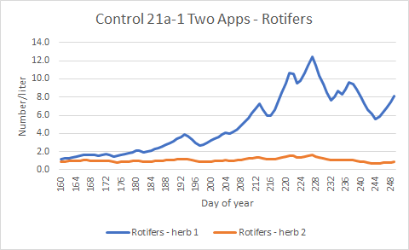
Figure 9.1.7. CASM-cosm simulated control biomass for modeled herbivorous rotifer populations using control 21-a1 environmental conditions.

The simulated control population of Asellus increased throughout the study period and approach 45 individuals/sample by the end of the modeled experiment (Figure 9.1.8).
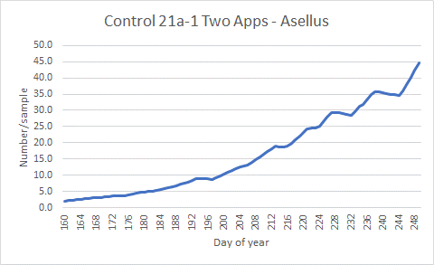
Figure 9.1.8. CASM-cosm simulated control biomass for the modeled Asellus population using control 21-a1 environmental conditions.

The simulated control population of chironomids similarly increased during the course of the experiment and approached 25 individuals/sample (Figure 9.1.9).

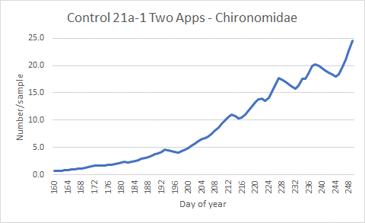
Figure 9.1.9. CASM-cosm simulated control biomass for the modeled Chironomidae population using control 21-a1 environmental conditions.

The abundance of mayflies (Cloeon) increased slightly during the course of the 21a-1 control simulations to about 1.2 individuals/sample (Figure 9.1.10).
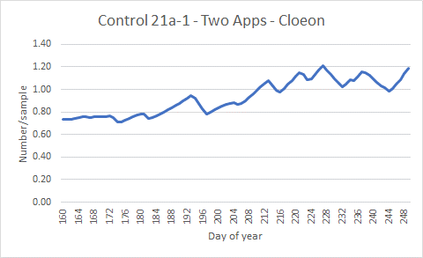
Figure 9.1.10. CASM-cosm simulated control biomass for the modeled Cloeon population using control 21-a1 environmental conditions.

Gammarus production was minimal during the control 21a-1 simulation with modeled abundances generally less than 1 individual for every two samples (Figure 9.1.11).

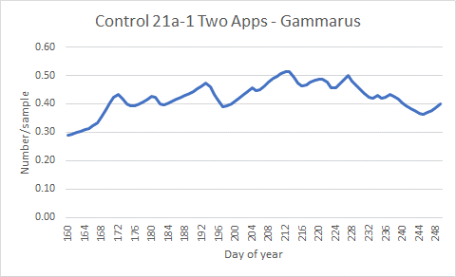
Figure 9.1.11. CASM-cosm simulated control biomass for the modeled Gammarus population using control 21-a1 environmental conditions.

Gastropods were among the most abundant macroinvertebrates in the simulation of the study 21a-1 control conditions with abundances of nearly 40 individuals/sample by the end of the modeled experiment (Figure 9.1.12).
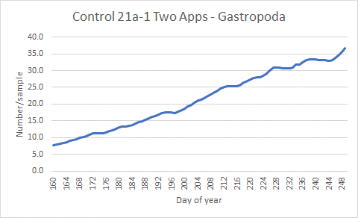
Figure 9.1.12. CASM-cosm simulated control biomass for the modeled gastropod population using control 21-a1 environmental conditions.

Modeled odonates more than doubled their abundance in the control 21a-1 simulation, but overall abundance was <3 individuals/sample (Figure 9.1.13).

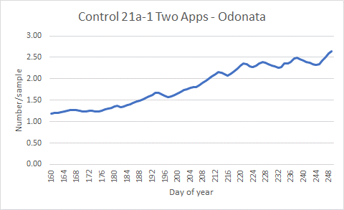
Figure 9.1.13. CASM-cosm simulated control biomass for the modeled odonate population using control 21-a1 environmental conditions.

Oligochaetes were among the most abundant macroinvertebrates in the control 21a-1 simulations with abundances steadily increasing to 45 individuals/sample (Figure 9.1.14).
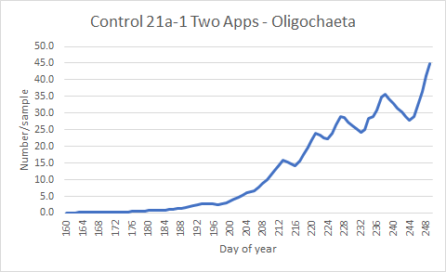
Figure 9.1.14. CASM-cosm simulated control biomass for the modeled oligochaete population using control 21-a1 environmental conditions.

Modeled tanypodinae larvae increased steadily from 2 to about 7 individuals/sample in the control 21a-1 simulation (Figure 9.1.15).

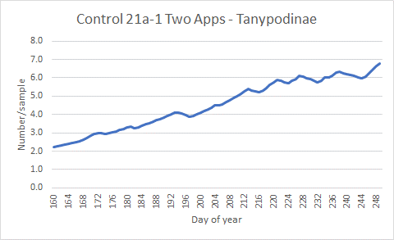
Figure 9.1.15. CASM-cosm simulated control biomass for the modeled Tanypodinae population using control 21-a1 environmental conditions.

The modeled population of chaoborus in the control 21a-1 simulation increased from about 14 to 16 individuals/sample during the course of the experiment (Figure 9.1.16).
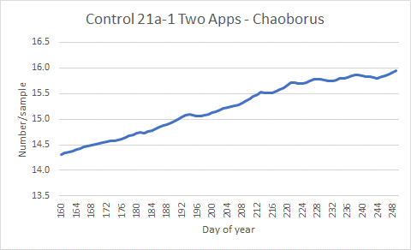
Figure 9.1.16. CASM-cosm simulated control biomass for the modeled Chaoborus population using control 21-a1 environmental conditions.

Modeled leeches (Hirudinea) increased in abundance during the control 21a-1 simulation, but remained relatively rare at 2 individuals/sample by the end of the simulated experiment (Figure 9.1.17).

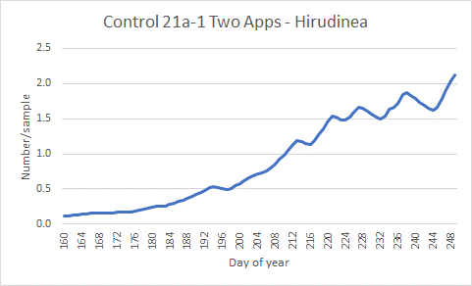
Figure 9.1.17. CASM-cosm simulated control biomass for the modeled Hirudinea population using control 21-a1 environmental conditions.

Simulation of 2021 mesocosm control data: 3 peaks control
Surface light, water temperature, and nutrient (DIN, DIP) data reported for the 21-a2 control mesocosms were used to construct the corresponding environmental data input file for the CASM-cosm. Initial population abundances and growth parameter values were the same as used in the 21-a1 control simulation. These values were developed as the result of the previous calibration to control study (14a, 16a, 18c, and 19b) data.

Similar to the control simulations for the 21-a1 study, the results of the 21-a2 control simulations showed a substantial decrease in abundance across the modeled populations compared to the previous calibrated control simulations. Figures 9.2.1 – 9.2.17 present the time-varying abundance values for the modeled 21-a2 control CASM-cosm populations. Given the absence of data to evaluate the results and the overall similarity to 21-a1 control simulations, the individual plots that follow are not described in detail.

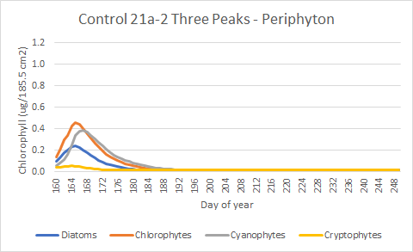
Figure 9.2.1. CASM-cosm simulated control biomass for the modeled periphyton populations using control 21-a2 environmental conditions.

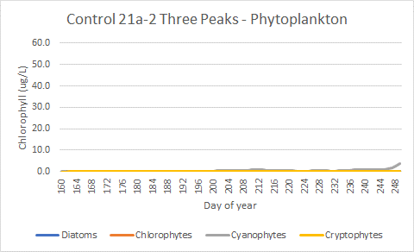
Figure 9.2.2. CASM-cosm simulated control biomass for the modeled phytoplannkton populations using control 21-a2 environmental conditions.

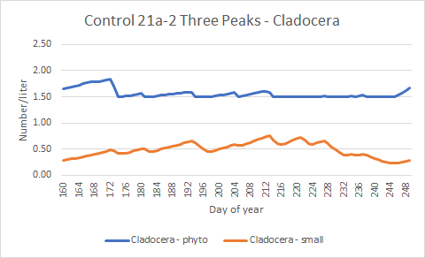
Figure 9.2.3. CASM-cosm simulated control biomass for the modeled phytophyllous and small Cladocera populations using control 21-a2 environmental conditions.

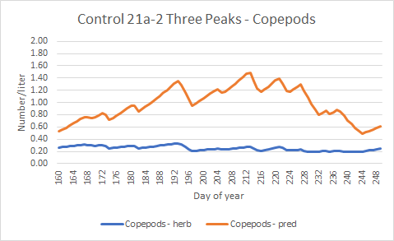
Figure 9.2.4. CASM-cosm simulated control biomass for the modeled copepod populations using control 21-a2 environmental conditions.

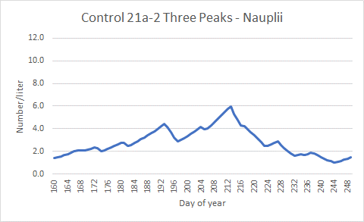
Figure 9.2.5. CASM-cosm simulated control biomass for the modeled nauplii population using control 21-a2 environmental conditions.

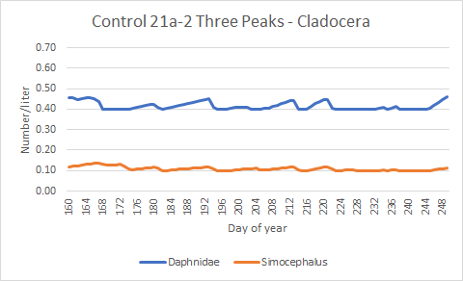
Figure 9.2.6. CASM-cosm simulated control biomass for the modeled Daphnidae and Simocephalus populations using control 21-a2 environmental conditions.

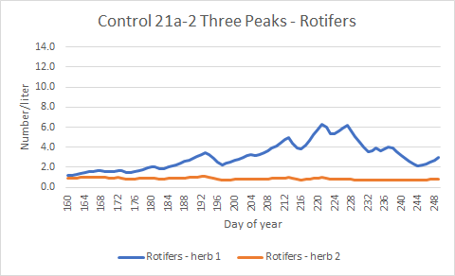
Figure 9.2.7. CASM-cosm simulated control biomass for the modeled herbivorous rotifer populations using control 21-a2 environmental conditions.

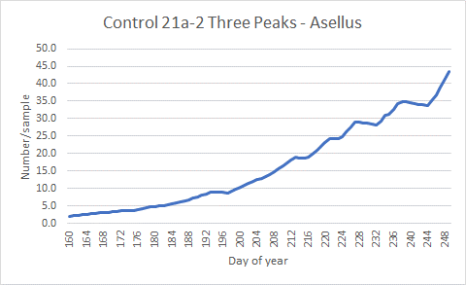
Figure 9.2.8. CASM-cosm simulated control biomass for the modeled Asellus population using control 21-a2 environmental conditions.

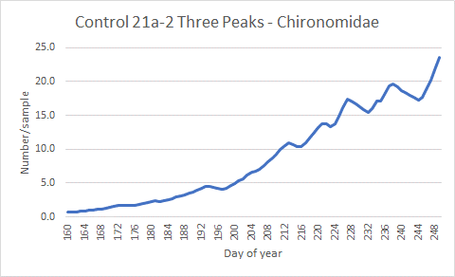
Figure 9.2.9. CASM-cosm simulated control biomass for the modeled Chironomidae population using control 21-a2 environmental conditions.

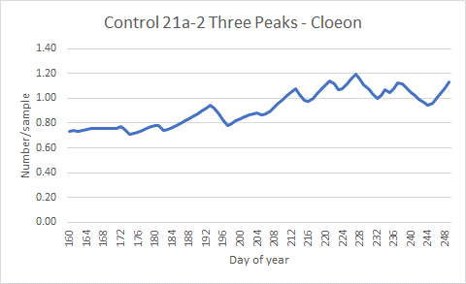
Figure 9.2.10. CASM-cosm simulated control biomass for the modeled Cloeon population using control 21-a2 environmental conditions.

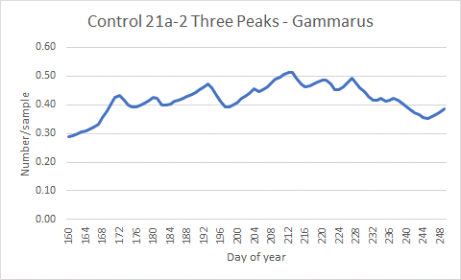
Figure 9.2.11. CASM-cosm simulated control biomass for the modeled Gammarus population using control 21-a2 environmental conditions.

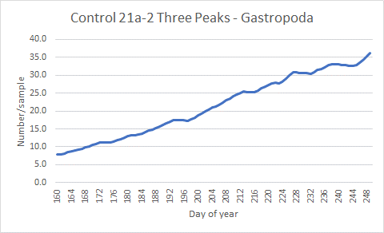
Figure 9.2.12. CASM-cosm simulated control biomass for the modeled gastropod population using control 21-a2 environmental conditions.

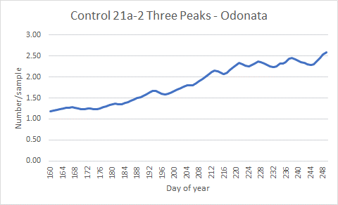
Figure 9.2.13. CASM-cosm simulated control biomass for the modeled odonate population using control 21-a2 environmental conditions.

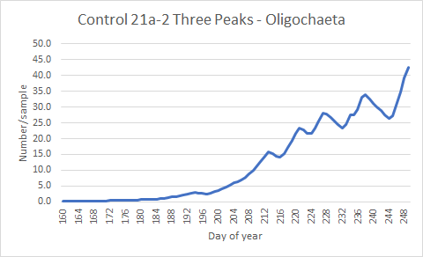
Figure 9.2.14. CASM-cosm simulated control biomass for the modeled oligochaete population using control 21-a2 environmental conditions.

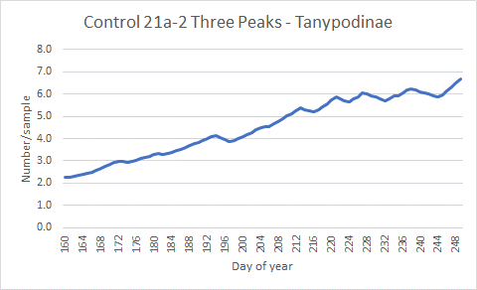
Figure 9.2.15. CASM-cosm simulated control biomass for the modeled Tanypodinae population using control 21-a2 environmental conditions.

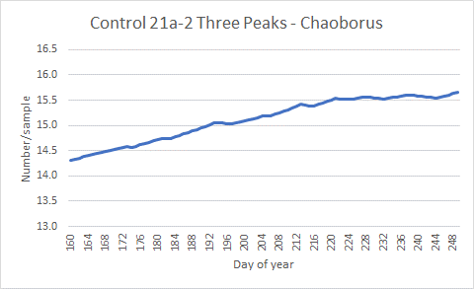
Figure 9.2.16. CASM-cosm simulated control biomass for the modeled Chaoborus population using control 21-a2 environmental conditions.

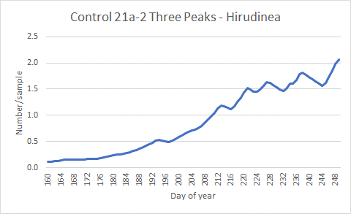
Figure 9.2.17. CASM-cosm simulated control biomass for the modeled Hirudinea population using control 21-a2 environmental conditions.

Simulation of 2021 mesocosm treatment data: study 21-a1, two applications
The control conditions for the 21-a1 study were used in combination with the previously de eloped toxicity benchmark values and the daily concentrations of AZT for the “two applications” scenario to simulate toxic effects in the mesocosms. The simulation did not involve any additional calibration or modifications to the CASM-cosm.

Toxicity benchmark values
The toxicity benchmark values obtained through calibration of model results to the treatment study 19b measured toxic effects were used without modification to simulate the toxic effects of AZT in the 2021 treatment studies (Table 9.3.1).

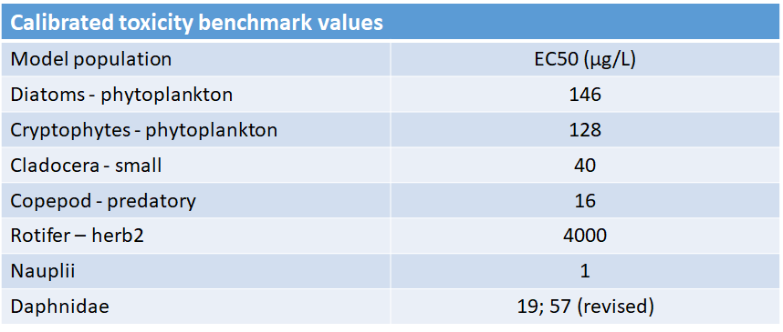
Table 9.3.1. Toxicity benchmark values used in the CASM-cosm simulations for the 21-a1 (Two Applications) and 21-a2 (3 Peaks) treatment simulations.

Study 21-a1, two applications exposure profile
The exposure profile constructed for the 21-a1 (Two Applications) scenario used in the CASM-cosm simulation shows peak AZT concentrations of >30 µg/L on model days 169 and 178 (Figure 9.3.1). Concentrations of AZT declined steadily following the second application.

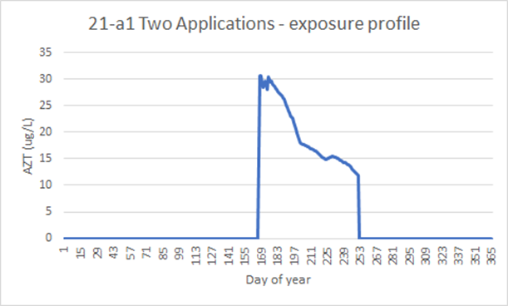

Figure 9.3.1. Daily AZT exposure concentrations (µg/L) for the 21-a1 study (Two Applications) treatment simulations using the CASM-cosm.

Direct toxic effects simulated for study 21-a1, two applications
The following figures present the results of the study 21-a1 treatment simulation. For each population presented, one plot was developed to compare the modeled time course of control and treatment population abundance. A second companion plot was constructed to show the percent difference between the control and treatment population abundance. Absent MDD values for the populations of interest, it was assumed that a ±20% difference between the control and treatment abundance values would indicate a toxic effect worthy of consideration.

The results for the modeled diatoms (phytoplankton) indicated a steady decline in abundance during the course of the simulation that leveled off around 40% by the end of the experiment (Figure 9.3.2).
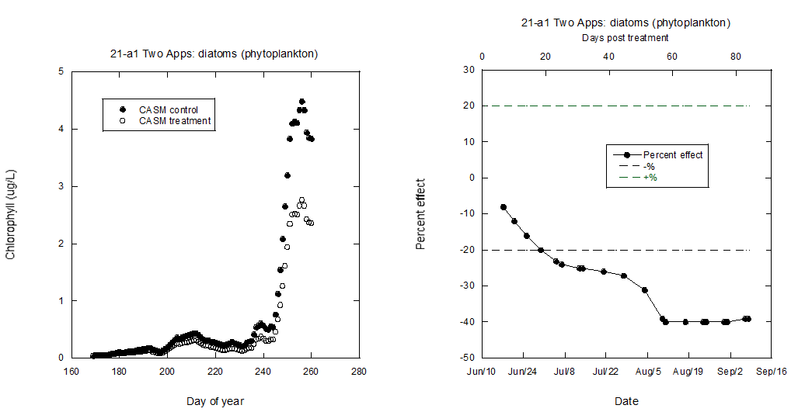

Figure 9.3.2. Left panel - Simulated daily control and treatment phytoplankton diatom biomass (chlorophyll); right panel – simulated daily percent difference between control and treatment biomass.

The modeled cryptophytes (phytoplankton) showed a direct toxic response similar to diatoms, except the impact was about a 50% decrease compared to the control biomass (chlorophyll) (Figure 9.3.3).
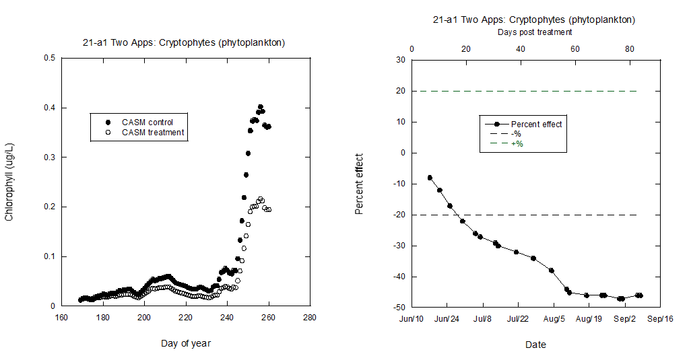
Figure 9.3.3. Left panel - Simulated daily control and treatment phytoplankton cryptophyte biomass (chlorophyll); right panel – simulated daily percent difference between control and treatment biomass.

Predatory copepods were negatively impacted in the study 21-a1 treatment simulation (Figure 9.3.4). The model results indicated an approximate 80% decrease in abundance throughout most of the simulated time period. The suggested recovery in the percent impact towards the end of the simulation reflects a modeled decrease in control copepod abundance, while the treatment abundance remained essentially constant.

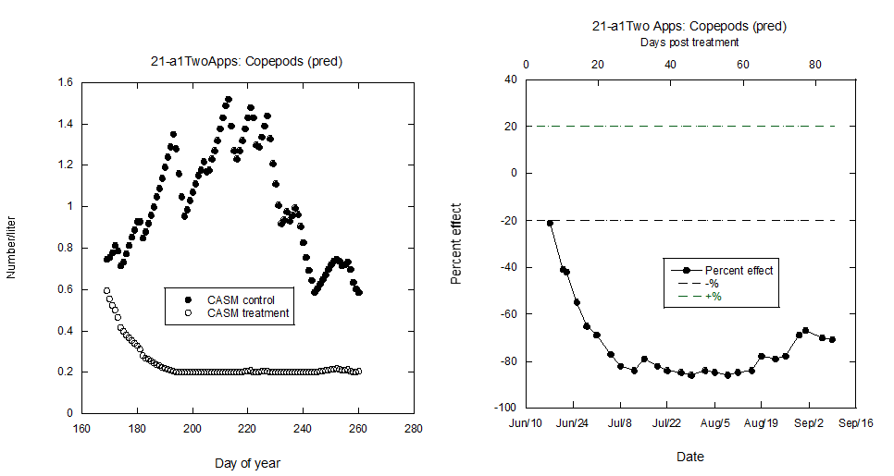
Figure 9.3.4. Left panel - Simulated daily control and treatment predatory copepod abundance (number/L); right panel – simulated daily percent difference between control and treatment abundance.

The toxicity benchmark values identify nauplii as the most sensitive modeled population to AZT exposures (Table 9.3.1). Correspondingly, the results of the 21-a1 treatment simulation indicate a >80% reduction in nauplii abundance throughout most of simulated time period (Figure 9.3.5). Again, a suggestion of some recovery in the latter portion of the experiment results from a modeled decrease in control abundance while the treatment abundance remained essentially constant.

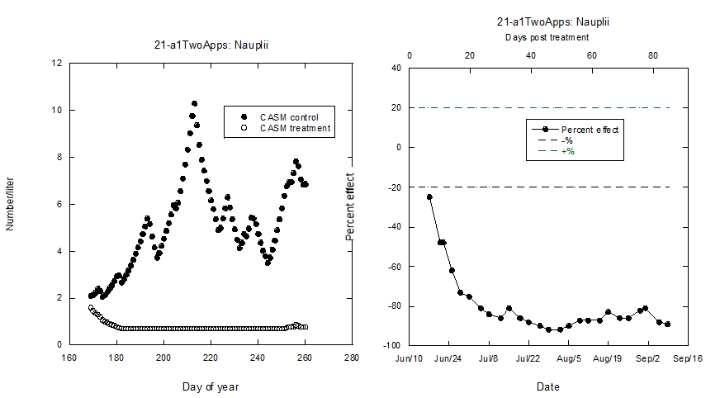
Figure 9.3.5. Left panel - Simulated daily control and treatment nauplii abundance (number/L); right panel – simulated daily percent difference between control and treatment abundance.

The modeled herbivorous rotifer 2 population increased by as much as 80% during the course of the 21-a1 treatment simulation (Figure 9.3.6). This response is presumed to result from a decrease in predation pressure by predatory copepods that were severely impacted by the AZT exposures.
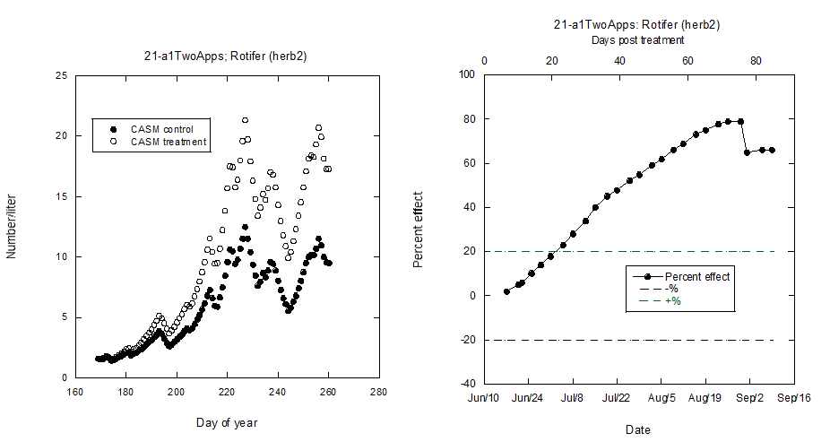
Figure 9.3.6. Left panel - Simulated daily control and treatment herbivorous rotifer 2 abundance (number/L); right panel – simulated daily percent difference between control and treatment abundance.

Modeled small Cladocera showed a response similar to the rotifers, where abundance steadily increased to more than 120% of the control population towards the end of the simulated treatment (Figure 9.3.7). The results for the small Cladocera are also assumed to reflect a decrease in predation pressure from predatory copepods.

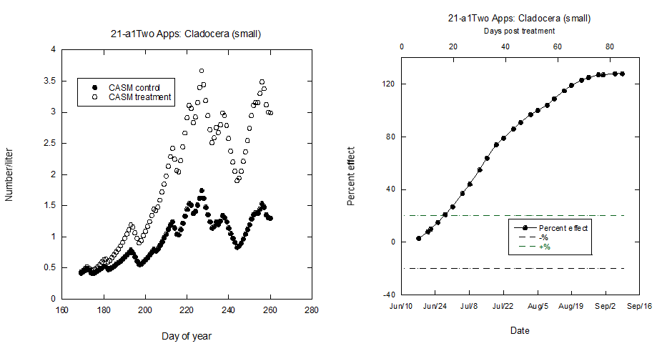
Figure 9.3.7. Left panel - Simulated daily control and treatment small Cladocera abundance (number/L); right panel – simulated daily percent difference between control and treatment abundance.

The modeled control and treatment population abundances of the Daphnidae population fluctuated during the course of the CASM-cosm simulations (Figure 9.3.8). The results do not show any percent decrease in abundance that might be attributed to AZT exposure. The fluctuations are likely determined by time-varying food availability and predation pressure during the course of the simulations.

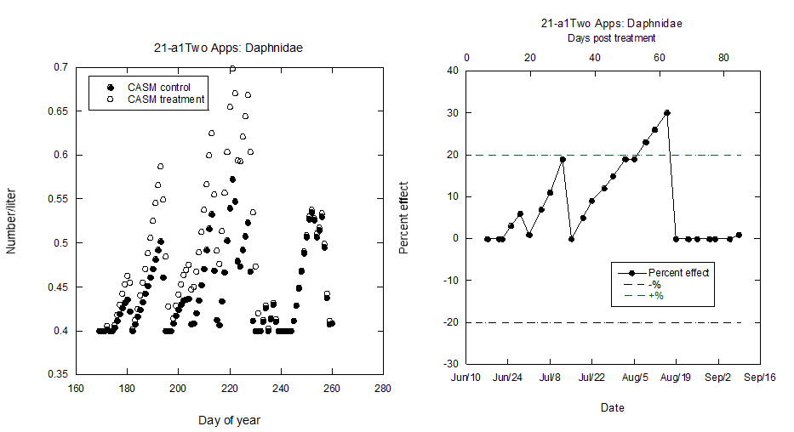
Figure 9.3.8. Left panel - Simulated daily control and treatment Daphnidae abundance (number/L); right panel – simulated daily percent difference between control and treatment abundance.

Indirect effects simulated for study 21-a1, two applications
In addition to the positive indirect impacts of the study 21-a1 AZT exposures on herbivorous rotifer 2, small Cladocera, and perhaps Daphnidae, modeled populations of phytophyllous Cladocera, Simocephalus, herbivorous rotifer 1, and Chaoborus also showed increases in abundance compared to the control simulation (Figure 9.3.9).

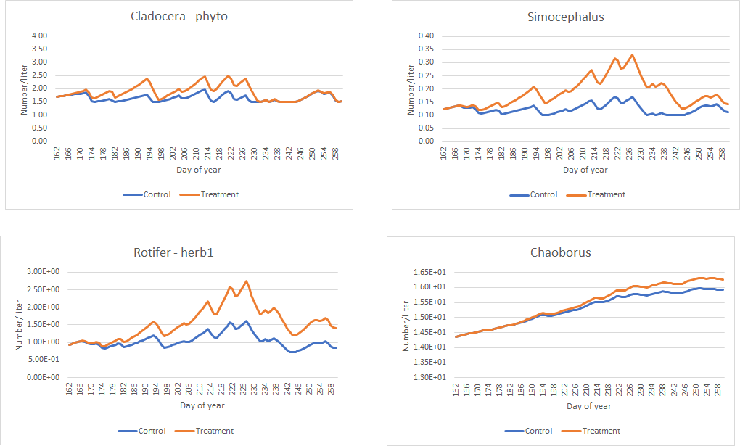
Figure 9.3.9. Control and treatment abundance (number/L) for CASM-cosm populations indirectly impacted by the study 21-a1 (Two Applications) exposure scenario.

Simulation of 2021 mesocosm treatment data: 3 peaks applications
Toxic effects were also simulated for the study 21-a2, “3-peaks” scenario. The approach was the same as for the 21-a1 study. The control conditions for the 21-a2 were used in combination with the toxicity benchmark data (Table 9.3.1) and daily AZT exposure concentrations reported for study 21-a2. No revisions or modifications of the CASM-cosm were made in performing the 21-a2 treatment simulation.

Toxicity benchmark values for study 21-a2, three peaks
The toxicity benchmark values derived from calibration of the CASM-cosm to the study 19b treatment data were applied without modification in simulating toxic effects for the 21-a2 treatment.

Study 21-a2, three peaks exposure profile
Figure 9.4.1 illustrates the time-varying concentrations of AZT that make up the 21-a2 3-peaks exposure scenario. CASM-cosm simulations were performed only for the highest treatment with peak concentrations of about 30-35 µg/L.

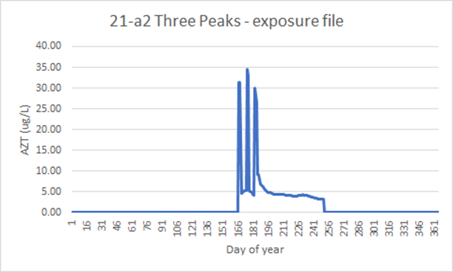

Figure 9.4.1. Daily AZT exposure concentrations (µg/L) for the 21-a2 study (Three Peaks) treatment simulations using the CASM-cosm.

9.4.3 Direct toxic effects simulated for study 21-a2, three peaks
As with the previous toxic effects simulations, plots were constructed for selected model populations to show the time-varying abundances for the control and treatment simulations. Corresponding plots of the percent difference were constructed as well. Absent MDD values for the 21-a2 study, a ±20% difference between control and treatment simulations was considered a toxic effect.

Modeled diatoms (phytoplankton) decreased by about 20% compared to control abundance towards the end of the experiment (Figure 9.4.2).
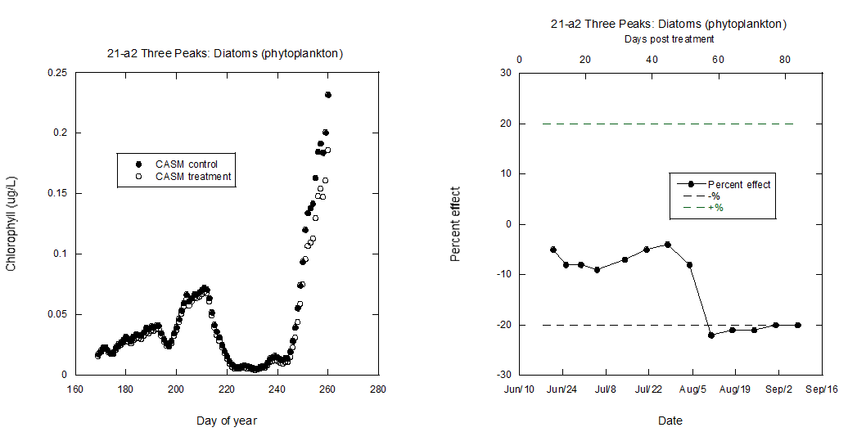
Figure 9.4.2. Left panel - Simulated daily control and treatment phytoplankton diatom biomass (chlorophyll); right panel – simulated daily percent difference between control and treatment biomass.

The modeled cryptophytes (phytoplankton) showed a response similar to diatoms, with a decrease in abundance of about 22% during the latter course of the study (Figure 9.4.3).

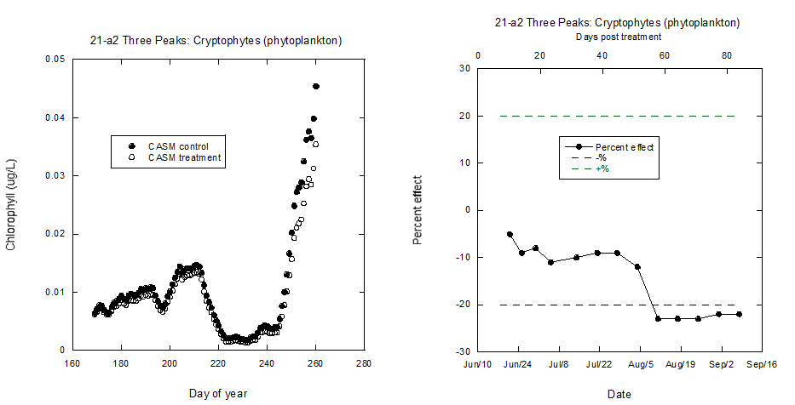
Figure 9.4.3. Left panel - Simulated daily control and treatment phytoplankton cryptophyte biomass (chlorophyll); right panel – simulated daily percent difference between control and treatment biomass.

Simulated predatory copepods decreased relative to the control population during the early period of exposure, then appeared to subsequently recover (Figure 9.4.4).

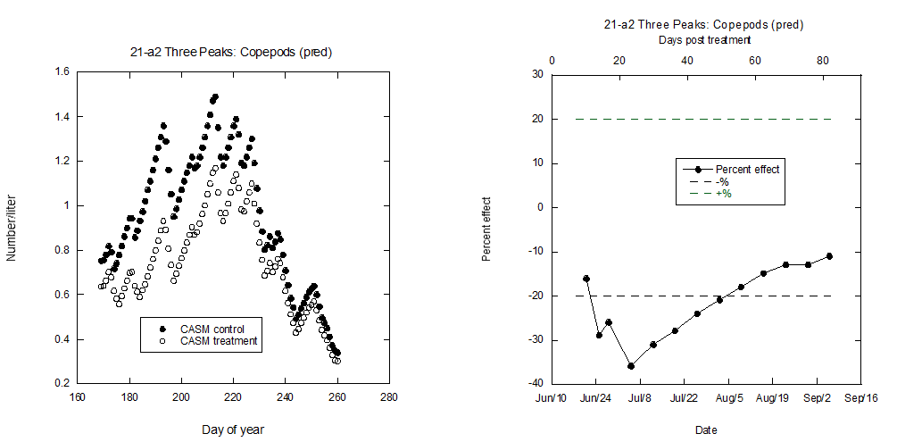

Figure 9.4.4. Left panel - Simulated daily control and treatment predatory copepod abundance (number/L); right panel – simulated daily percent difference between control and treatment abundance.

Similar to the 21-a1 treatment simulation, the 21-a2 exposures resulted in severe direct toxic effects to nauplii (Figure 9.4.5). Population abundance decreased by about 80%. The apparent recovery actually results from a decrease in the modeled control abundance, while the treatment population remained essentially constant and <1individual/L.
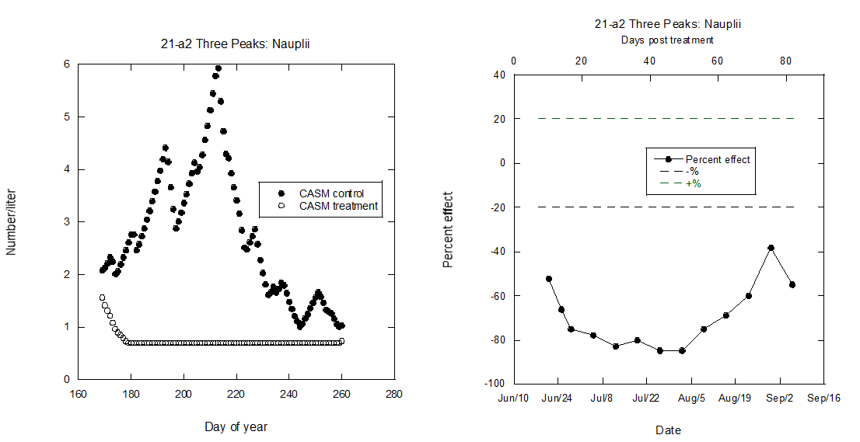
Figure 9.4.5. Left panel - Simulated daily control and treatment nauplii abundance (number/L); right panel – simulated daily percent difference between control and treatment abundance.

The modeled herbivorous rotifer 2 treatment population steadily increased relative to the control population during the course of the study 21-a2 simulation (Figure 9.4.6). The treatment population increased by about 40% at the end of the experiment.

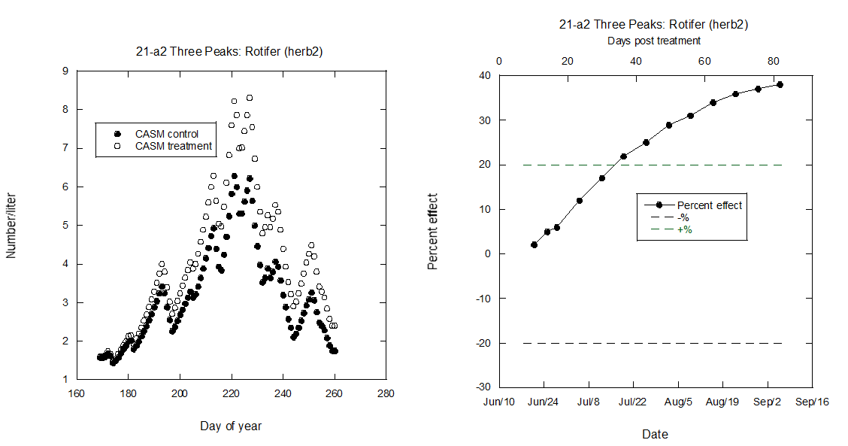
Figure 9.4.6. Left panel - Simulated daily control and treatment herbivorous rotifer 2 abundance (number/L); right panel – simulated daily percent difference between control and treatment abundance.

The modeled small Cladocera population fluctuated in abundance during the course of the control and treatment simulations (Figure 9.4.7). However, the overall response suggested a steady relative increase by as much as 60%.
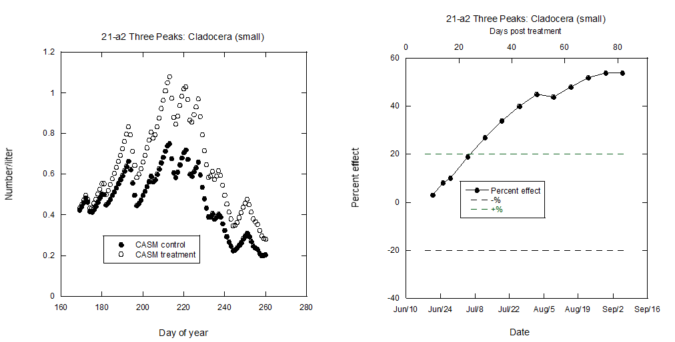
Figure 9.4.7. Left panel - Simulated daily control and treatment small Cladocera abundance (number/L); right panel – simulated daily percent difference between control and treatment abundance.

Simulated control and treatment abundance of Daphnidae also fluctuated during the course of the 21-a2 study (Figure 9.4.8). However, the Daphnidae showed a ~15% increase during the early part of the experiment, but subsequently, there were differences of 5% or less between control and treatment modeled abundance.

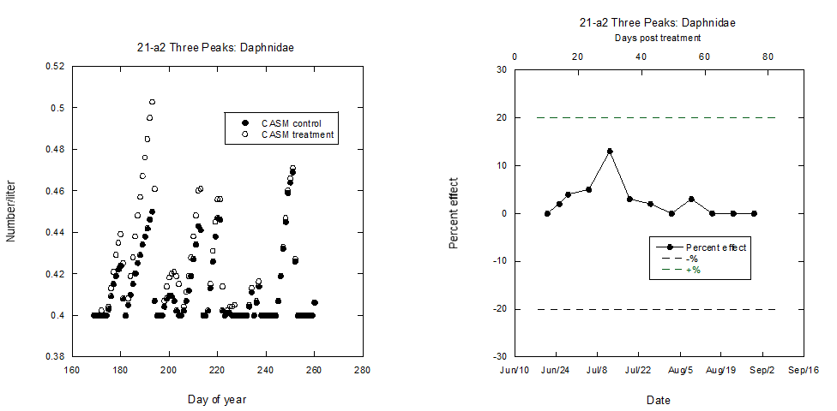
Figure 9.4.8. Left panel - Simulated daily control and treatment Daphnidae abundance (number/L); right panel – simulated daily percent difference between control and treatment abundance.

9.4.4 Indirect effects simulated for study 21-a2, three peaks
Similar to the 21-a1 treatment results, the 21-a2 exposures produced additional indirect effects on CASM-cosm simulations. For example, the population of herbivorous rotifer 1 increased in abundance relative to the control population (Figure 9.4.9).

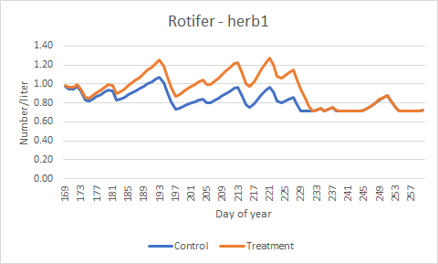

Figure 9.4.9. Control and treatment abundance (number/L) for CASM-cosm herbivorous rotifer 1 population indirectly impacted by the study 21-a2 (Three Peaks) exposure scenario.

Modeled Simocephalus populations in the control and 21-a2 treatment simulations were very low in abundance (Figure 9.4.10). However, the treatment simulation showed slightly higher abundance compared to the modeled control population.

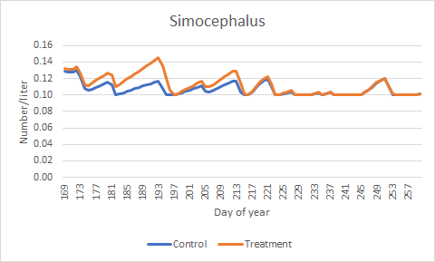

Figure 9.4.10. Control and treatment abundance (number/L) for CASM-cosm Simocephalus population indirectly impacted by the study 21-a2 (Three Peaks) exposure scenario.

References
Bartell, S.M., S.K. Nair, N. Galic, and R.A. Brain. 2020. The comprehensive aquatic systems model (CASM): advancing computational capability for ecosystem simulation, Environmental Toxicology and Chemistry: 39:2298-2303.
Bartell, S.M., Nair, S.K., and R.A. Brain. 2017. Modeling the effects of thiamethoxam on Midwestern farm ponds and emergent wetlands. Environmental Toxicology and Chemistry 37:738-754.

Bartell, S.M., R.A. Brain, P. Hendley, and S.K. Nair. 2013. Modeling the potential effects of atrazine on aquatic communities in Midwestern streams. Environmental Toxicology and Chemistry 32:2402-2411.

Bartell, S.M. and Campbell, K.R. 2000. Ecological risk assessment of the effects of the incremental increase of commercial traffic (25, 50, 75 and 100 percent increase of 1992 baseline traffic) on fish. U.S. Army Corps of Engineers, ENV Report 16. Rock Island District, Rock Island, IL
Bartell, S.M., R.H. Gardner, and R.V. O’Neill. 1992. Ecological Risk Estimation. Lewis Publishers, Inc., Chelsea, Michigan. 233 p.
Bartell, S.M., A.L. Brenkert, R.V. O’Neill, and R.H. Gardner. 1988. Temporal variation in regulation of production in a pelagic food web model, pp. 101-118. In, Carpenter, S.R. (Ed.), Complex interactions in lake communities. Springer-Verlag, New York.

Bartell, S.M., A.L. Brenkert, J.E. Breck, and R.H. Gardner. 1986. Comparison of numerical sensitivity and uncertainty analyses of bioenergetic models of fish growth. Canadian Journal of Fisheries and Aquatic Sciences 43:160 168.

Benke, A.C. 1998. Production dynamics of riverine chironomids: extremely high biomass turnover rates of primary consumers. Ecology 79:899-910.

Best, E.P.H.; Kiker, G.A.; Rycyzyn, B.A.; Kenow, K.P.; Fischer, J.; Nair, S.K.; and Wilcox, D.B. 2005. Aquatic plant growth model refinement for the Upper Mississippi River–Illinois Waterway System Navigation Study. ENV Report 51. 87 p.

Birmingham, B.C.; Coleman, J.R.; and Colman, B. 1982. Measurement of photorespiration in algae. Plant Physiol. 69:259–262.

Bothwell, M.L. 1985. Phosphorus limitation of lotic periphyton growth rates: An intersite comparison using continuous-flow troughs (Thompson River system, British Columbia). Limnol. Oceanogr. 30(3):527–542.

Bothwell, M.L. 1988. Growth rate responses of lotic periphytic diatoms to experimental phosphorus enrichment: The influence of temperature and light. Can. J. Fish. Aquat. Sci. 45:261–270.

Brinkhurst, R.O., Chapman, P.M. and Farrell, M.A. 1983. A comparative study of respiration rates of some aquatic oligochaetes in relation to sublethal stress. Hydrobiologia 68:683-699.

Burris, J.E. 1977. Photosynthesis, photorespiration, and dark respiration in eight species of algae. Marine Biology 39:371–379.Buzzelli, C.P.; Childers, D.L.; Dong, Q.; and Jones, R.D. 2000. Simulation of periphyton phosphorus dynamics in Everglades National Park. Ecological Modelling 134:103–115.

Carpenter, E.J. and Guillard, R.R.L. 1971. Intraspecific differences in nitrate half-saturation constants for three species of marine phytoplankton. Ecology 52:183-185.

Cheng, K.M. 2015. The Asian clam Corbicula fluminea: seasonal filtration rates of representative populations in two tributaries of the Delaware River. MS Thesis, Drexel University. 138 p.

Cincotta, D.A. and Stauffer, J.R., Jr. 1984. Temperature preference and avoidance studies of six North American freshwater fish species. Hydrobiologia 109:173-177.

Collins, C.D. and Wlosinski, J.H. 1989. A macrophyte submodel for aquatic ecosystems. Aquatic Botany 33:191–206.

Cummins, K.W. 1973. Trophic relationships of aquatic insects. Annual Reviews of Entomology 18:183–206.

EFSA, 2014. Scientific Opinion on good modelling practice in the context of mechanistic effect models for risk assessment of plant protection products. EFSA J. 12, 3589. https://doi.org/10.2903/j.efsa.2014.3589
Eiane, K.; Aksnes, D.L.; Ohman, M.D.; Wood, S.; Martinussen, M.B. 2002. Stage-specific mortality of Calanus spp. under different predation regimes. Limnol. Oceanogr. 47(2):636–645.

Foy, R.H., Gibson, C.E., and Smith, R.V. 1976. The influence of daylength, light intensity, and temperature on the growth rates of planktonic blue-green algae. British Phycology Journal 11:151-163.

Gergs, R., and Rothhaupt, K.-O. 2009. Feeding rates, assimilation efficiencies and growth of two amphipod species on biodeposited material from zebra mussels. Konstanzer Online-Publikations-System (KOPS). URL: http://kops.ub.uni-konstanz.voltexte/2009/7511

Goldman, J.C. and Carpenter, E.J. 1974. A kinetic approach to the effect of temperature on algal growth. Limn. Oceanog. 19(5):756–766.

Grimm, V., Augusiak, J., Focks, A., Frank, B.M., Gabsi, F., Johnston, A.S.A., Liu, C., Martin, B.T., Meli, M., Radchuk, V., Thorbek, P., Railsback, S.F., 2014. Towards better modelling and decision support: Documenting model development, testing, and analysis using TRACE. Ecol. Model., Population Models for Ecological Risk Assessment of Chemicals 280, 129–139. https://doi.org/10.1016/j.ecolmodel.2014.01.018
Grimm, V., Berger, U., Bastiansen, F., Eliassen, S., Ginot, V., Giske, J., Goss-Custard, J., Grand, T., Heinz, S.K., Huse, G., Huth, A., Jepsen, J.U., Jørgensen, C., Mooij, W.M., Müller, B., Pe’er, G., Piou, C., Railsback, S.F., Robbins, A.M., Robbins, M.M., Rossmanith, E., Rüger, N., Strand, E., Souissi, S., Stillman, R.A., Vabø, R., Visser, U., DeAngelis, D.L., 2006. A standard protocol for describing individual-based and agent-based models. Ecol. Model. 198, 115–126. https://doi.org/10.1016/j.ecolmodel.2006.04.023
Grimm, V., Berger, U., DeAngelis, D.L., Polhill, J.G., Giske, J., Railsback, S.F., 2010. The ODD protocol: A review and first update. Ecol. Model. 221, 2760–2768. https://doi.org/10.1016/j.ecolmodel.2010.08.019
Grimm, V., Railsback, S.F., Vincenot, C.E., Berger, U., Gallagher, C., Deangelis, D.L., Edmonds, B., Ge, J., Giske, J., Groeneveld, J., Johnston, A.S.A., Milles, A., Nabe-Nielsen, J., Polhill, J.G., Radchuk, V., Rohwäder, M.S., Stillman, R.A., Thiele, J.C., Ayllón, D., 2020. The ODD protocol for describing agent-based and other simulation models: A second update to improve clarity, replication, and structural realism. J. Artif. Soc. Soc. Simul. 23
Hamburger, K.; and Dall, P.C. 1990. The respiration of common benthic invertebrate species from the shallow littoral zone of Lake Esrom, Denmark. Hydrobiologia 199:117–130.

Hanson, P.C, Johnson, T.B., Schindler, D.E., and Kitchell, J.F. 1997. Wisconsin Fish Bioenergetics Model 3.0 for Windows. University of Wisconsin Sea Grant Institute, WISCU-T-97-001. Madison, WI.

Hargrave, B.T. 1971. An energy budget for a deposit-feeding amphipod. Limnol. Oceanogr. 16:99-103.

Hargrave, B.T. and Geen, G.H. 1968. Phosphorus excretion by zooplankton. Limnol. Oceanogr. 13:332–342.

Hauer, F.R. and Benke, A.C. 1991. Rapid growth of snag-dwelling chironomids in a blackwater river: the influence of temperature and discharge. J. N. Am. Benthol. Soc. 10:154-164.

Hornbach, D.J., Wissing, T.E. and Burky, A.J. 1984. Energy budget for a stream population of the freshwater clam, Sphaerium striatinum Lamarck (Bivalvia: Pisidiidae). Can. J. Zool. 62:2410-2417.

Kelly, M.G.; Thyssen, N.; and Moeslund, B. 1983. Light and the annual variation of oxygen- and carbon-based measurements of productivity in a macrophyte-dominated river. Limnol. Oceangr. 28(3):503–515.

Kitchell, J.F.; Koonce, J.F.; O’Neill, R.V.; Shugart, H.H.; Magnuson, J.J.; Booth, R.S. 1974. Model of fish biomass dynamics. Trans. Am. Fish. Soc. 103:786–798.

Lawton, J.H. 1971. Maximum and actual field feeding rates in the larvae
of the damselfly Pyrrhosoma nymphula (Sulzer) (Odonata: Zygoptera) Freshwater Biology 1:99-111.

Lehman, J.T.; Botkin, D.B.; and Likens, G.E. 1975. The assumptions and rationales of a computer model of phytoplankton population dynamics. Limn. Oceanogr. 20(3):343–364.

Mayzaud, P. 1976. Respiration and nitrogen excretion of zooplankton. IV. The influence of starvation on the metabolism and the biochemical composition of some species. Marine Biology 37:47–58.

Muthukrishnan, J. and Palavesam, A. 1993. A method for the estimation of food consumption by chironomids. Current Science 64:112-115.
Nair, S.K., S.M. Bartell, and R.A. Brain. 2015. A comparative study of the modeled effects of atrazine on aquatic plant communities in Midwestern streams. Environmental Toxicology and Chemistry 34:1-13.
Nalepa, T.F., Gardner, W.S., and Malczyk, J.M. 1991. Phosphorus cycling by mussels (Unionidae: Bivalvia) in Lake St. Clair. Hydrobiologia 219:239-250.

Nielsen, S.L. and Sand-Jensen, K. 1989. Regulation of photosynthetic rates of submerged rooted macrophytes. Oecologia 81:364–368.

O’Neill, R.V.; Goldstein, R.A.; Shugart, H.H.; and Mankin, J.B. 1972. Terrestrial ecosystem energy model. Eastern deciduous forest biome, International Biological Program Report 72–19.

Ohman, M.D. and Hirche, H.-J. 2001. Density-dependent mortality in an oceanic copepod population. Nature 412:638–641.

Paasche, E. 1973. Silicon and the ecology of marine plankton diatom. II. Silicate-uptake kinetics in five diatom species. Marine Biology 19:262–269.

Palavesam, A., Somanath, B. and Immanuel, G. 2009. Effects of detritus quality on energy allocation in chironomids. European Journal of Biological Science 1:1-9.

Park, R.A.; Cough, J.S.; and Wellman, M.C. 2004. AQUATOX (Release 2): Modeling environmental fate and ecological effects in aquatic ecosystems. Volume 1: User’s Manual. EPA-823-R-04-001. Office of Water, U.S. Environmental Protection Agency, Washington, D.C. 20460.

Peters, R.H. and Downing, J.A. 1984. Empirical analysis of zooplankton filtering and feedings rates. Limnol. Oceanogr. 29(4):763–784.

Rempel, R.S. and Carter, J.C.H. 1987. Temperature influences on adult size, development, and reproductive potential of aquatic Diptera. Canadian Journal of Fisheries and Aquatic Science 44:1743–1752.

Reuter, J.E.; Stanford, L.L.; and Goldman, C.R. 1986. Inorganic nitrogen uptake by epilithic periphyton in a N-deficient lake. Limnol. Oceanogr.31:149–160.

Richman, S. and Dodson, S.I. 1983. The effect of food quality on feeding and respiration by Daphnia and Diaptomus. Limnol. Oceanogr. 28(5):948–956.

Riisgard, H.U. 2001. On measurement of filtration rates in bivalves – the stony road to reliable data: review and interpretation. Mar. Ecol. Prog. Ser. 211:275-291.

Robarts, R.D. and Zohary, T. 1987. Temperature effects on photosynthetic capacity, respiration, and growth rates of bloom-forming cyanobacteria. New Zealand Journal of Marine and Freshwater Research 21:391–399.

Saravia, L.A.; Momo, F.; and Lissin, L.D.B. 1998. Modelling periphyton dynamics in running water. Ecological Modelling 114:35–47.

Schindler, D.W. 1968. Feeding, assimilation and respiration rates of Daphnia Magna under various environmental conditions and their relation to production estimates. J. Animal Ecology 39:369–385.

Schmolke A., S.M. Bartell, C. Roy, N. Green, N. Galic and R. Brain. 2019. Species-specific population dynamics and their link to an aquatic food web: a hybrid modeling approach. Ecological Modelling 405:1-14.

Schmolke, A., Thorbek, P., DeAngelis, D.L., Grimm, V., 2010. Ecological models supporting environmental decision making: a strategy for the future. Trends Ecol. Evol. 25, 479–486. https://doi.org/10.1016/j.tree.2010.05.001
Schneider, G. 1992. A comparison of carbon-specific respiration rates in gelatinous and non-gelatinous zooplankton: a search for general rules in zooplankton metabolism. Helgolander Meeresunters. 46:377–388.

Son, D.H. and Fujino, T. 2003. Modeling approach to periphyton and nutrient interaction in a stream. Journal of Environmental Engineering 129(9):834–843

Sorokin, C. and Krauss, R.W. 1958. The effects of light intensity on the growth rates of green algae. Plant Physiology 33:109–113.

Storey, A.W. 1987. Influence of temperature and food quality on the life history of an epiphytic chironomid. Ent. Scand. Suppl. 29:339-347.

Sweeney, B.W. 1978. Bioenergetics and developmental response of a mayfly to thermal variation. Limnol. Oceanogr. 23:461–477.

Thomann, R.V. and Mueller, J.A. 1987. Principles of surface water quality modeling and control. Harper Collins, New York, NY. 644 p.

Thornton, K.W. and Lessem, A.S. 1978. A temperature algorithm for modifying biological rates. Transactions of the American Fisheries Society 107:284–287.

van der Westhuizen, A.J. and Eloff, J.N. 1985. Effects of temperature and light on the toxicity and growth of the blue-green alga Microcystis aeruginosa (UV-006). Planta 163:55-59.

Wen, Y.H. and Peters, R.H. 1994. Empirical models of phosphorus and nitrogen excretion rates by zooplankton. Limnol. Oceanogr. 39(7):1669–1679.

Wu, R.S.S. and Or, Y.Y. 2005. Bioenergetics, growth, and reproduction of amphipods are affected by moderately low oxygen regimes. Mar. Ecol. Prog. Ser. 297:215-223.

