PreMerge
A Git History-Based Predictive System for Early Merge Conflict Detection in Collaborative Software Development
Software Engineering — Digital Assignment 3 / Review 3
Project team
Vikram (@Waterbottles792) | Core engine, CLI, GitHub Action
Kanika Rathore (@kanika10-hub) | Documentation & planning
Repository | https://github.com/Waterbottles792/PreMerge
Register No. / Name / Slot | [to be filled by student]
Contents of this document
Part A — Evidence pack: testing, version management & building, functionality screenshots, tools used
Part B — Project demo script
Part C — Project report: problem statement, user stories, architecture & design, design of tests, appendix (SRS, DFD, ERD, UML, code)

Table of Contents

PART A — Evidence Pack
Integration / regression / mutation testing, version management and system building, screenshots of developed functionalities, and tools and technologies used.

A1. Integration, Regression and Mutation Testing
All screenshots below were captured by running the commands shown on the PreMerge source tree (Python 3.13, pytest 9.1, pytest-cov 7.1, mutmut 3.8). The suite builds throw-away git repositories, so every run is hermetic.

A1.1 Integration testing
Eight end-to-end tests drive the real premerge analyze CLI (via click's CliRunner) against synthetic git repositories, exercising CLI → scoring → overlap → coupling → git_utils → report together: pair mode, all-pairs mode, --base mode, hidden-coupling detection, JSON/table rendering, custom config, and cold-vs-cached equivalence.
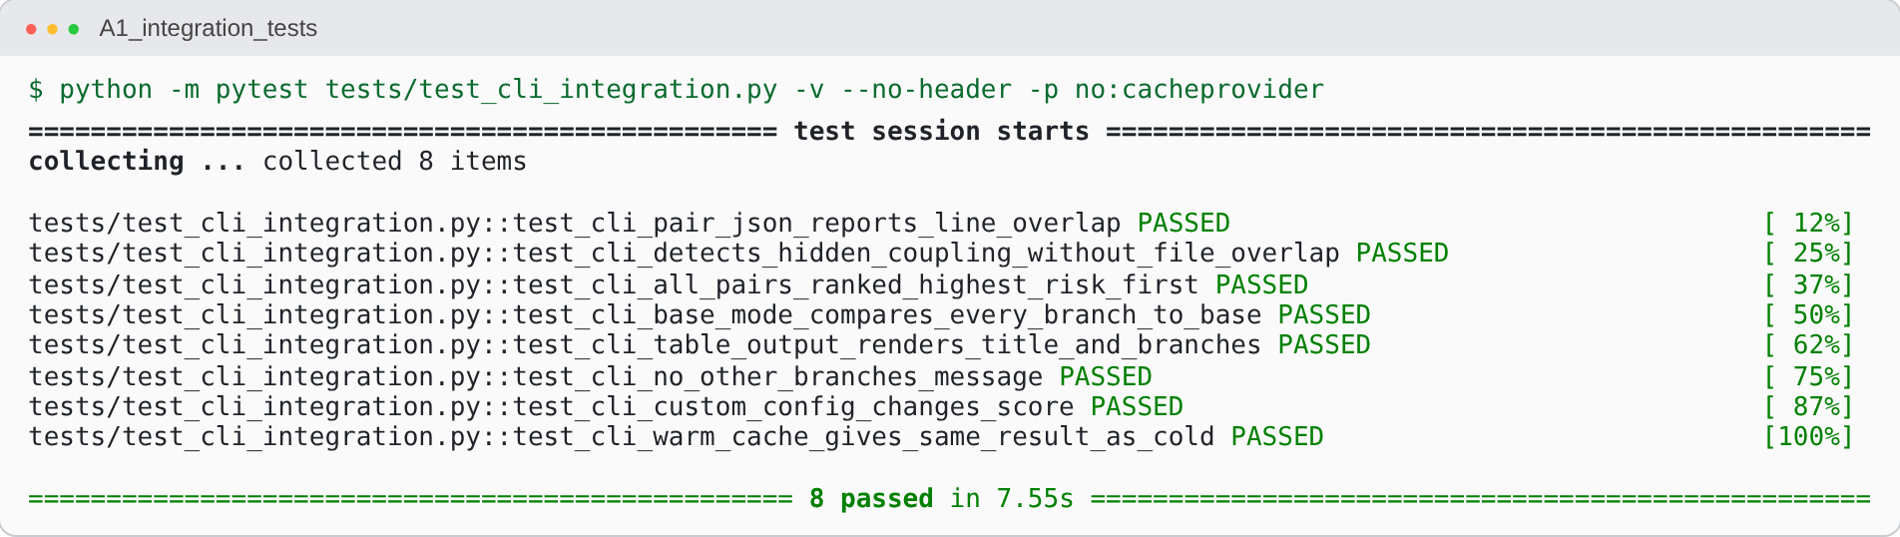
Figure 1 — 8/8 CLI integration tests passing (tests/test_cli_integration.py)

A1.2 Regression testing
The regression suite re-runs every unit, integration and GitHub-Action test on each change (locally and in GitHub Actions on Python 3.11 and 3.12). It pins previously untested behaviour: range-intersection boundaries, pure-deletion hunks, binary files, merge-commit exclusion, partial/missing config, JSON schema stability and the file-overlap-without-line-overlap score.
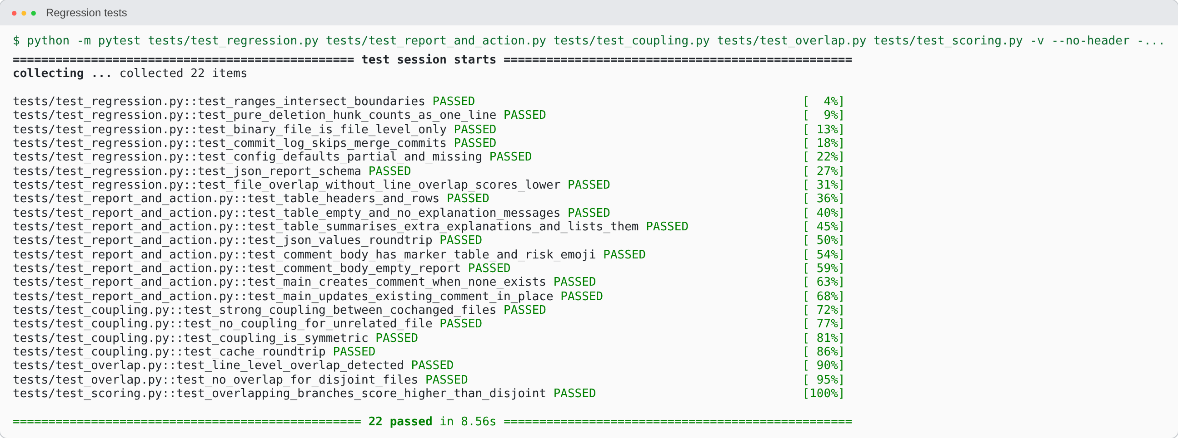
Figure 2 — Regression run: unit + regression + report/GitHub-Action tests
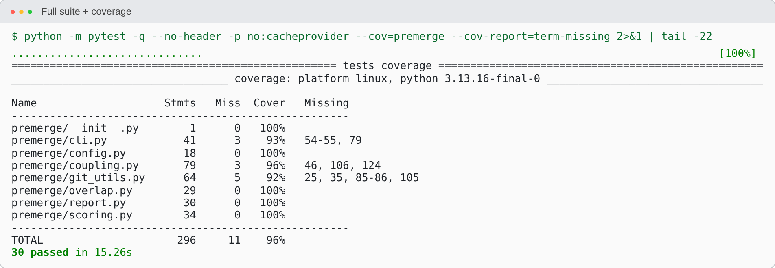
Figure 3 — Coverage report: 30 passed, 96 % statement coverage (was 7 tests / 67 % before this review)

A1.3 Mutation testing
Mutation testing was run with mutmut over all eight modules of premerge/. mutmut injects small faults (operator swaps, constant changes, string edits) and checks that the test suite fails; a surviving mutant marks a test gap.
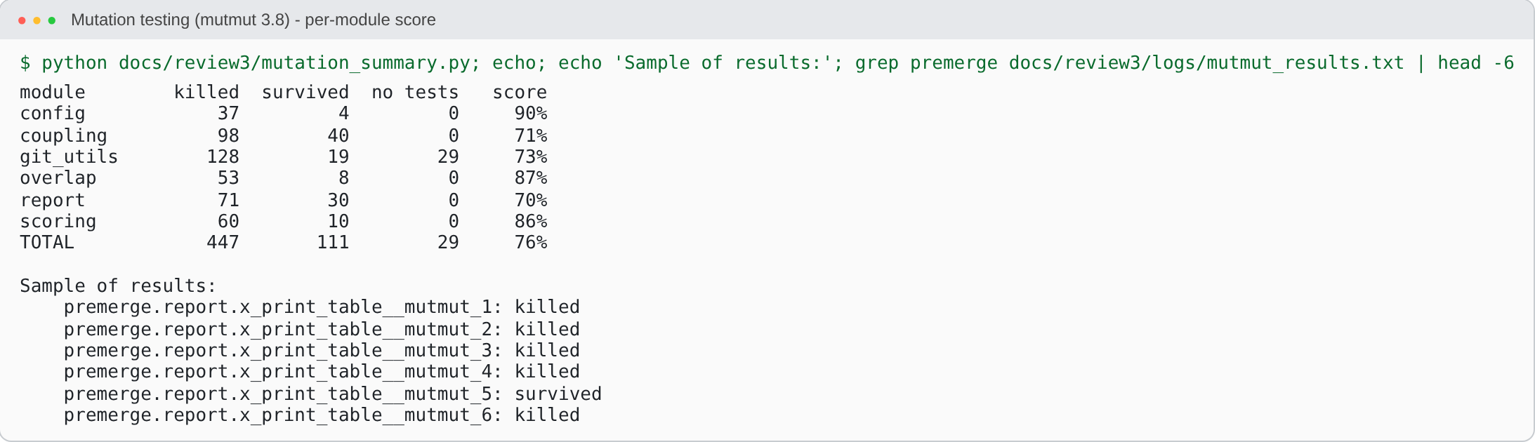
Figure 4 — Mutation score per module: 447 of 587 mutants killed (76 %)
Interpretation. The core algorithm modules score well — config 90 %, overlap 87 %, scoring 86 %. The weakest modules are coupling (71 %) and report (70 %, up from 49 % after report/GitHub-Action tests were added): most surviving report mutants change Rich colour styles and cosmetic strings that tests intentionally do not pin. git_utils has 29 mutants in error-handling paths no test reaches. Surviving mutants are listed in docs/review3/logs/mutmut_results.txt and are the backlog for further tests.

A2. Version Management and System Building

A2.1 Version management (Git + GitHub, GitHub Flow)
The project uses GitHub Flow: a protected main, short-lived feature/* branches, pull requests with required checks, squash/merge and branch deletion. The history below shows the feature branches feature/project-documentation (PR #28) and feature/docker-and-docs (PR #29) merged into main.
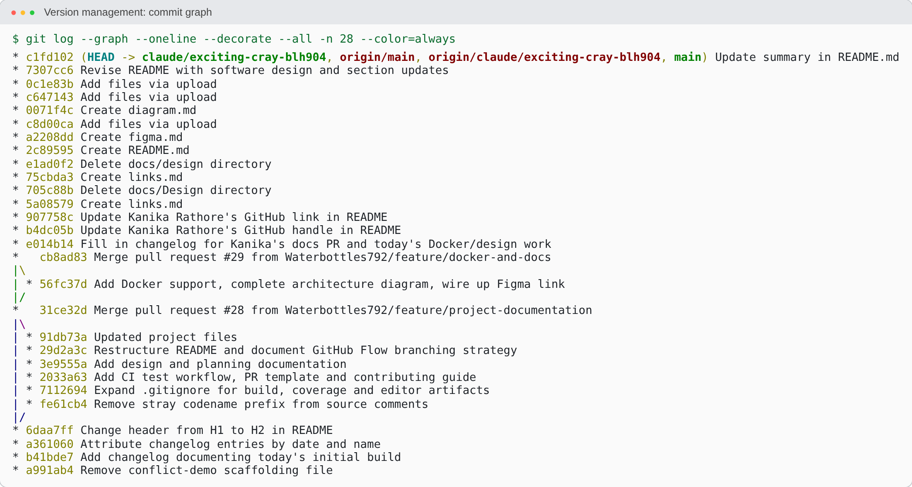
Figure 5 — git log --graph: feature branches merged through pull requests
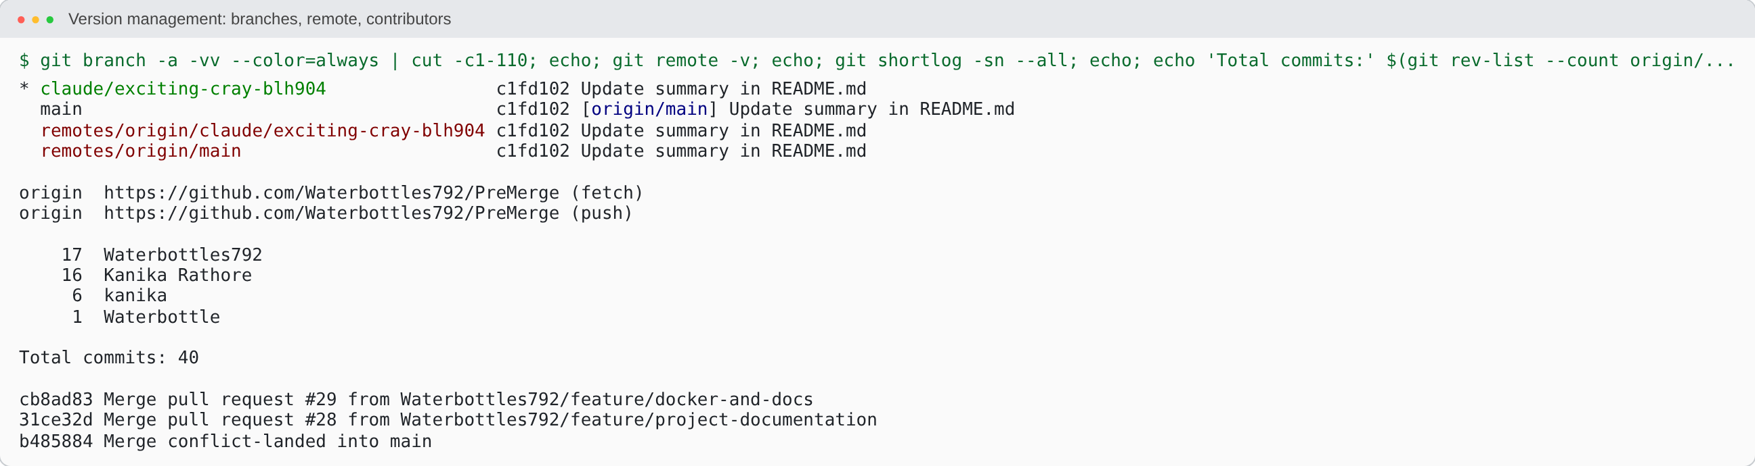
Figure 6 — Branches, remote, contributors and merge commits
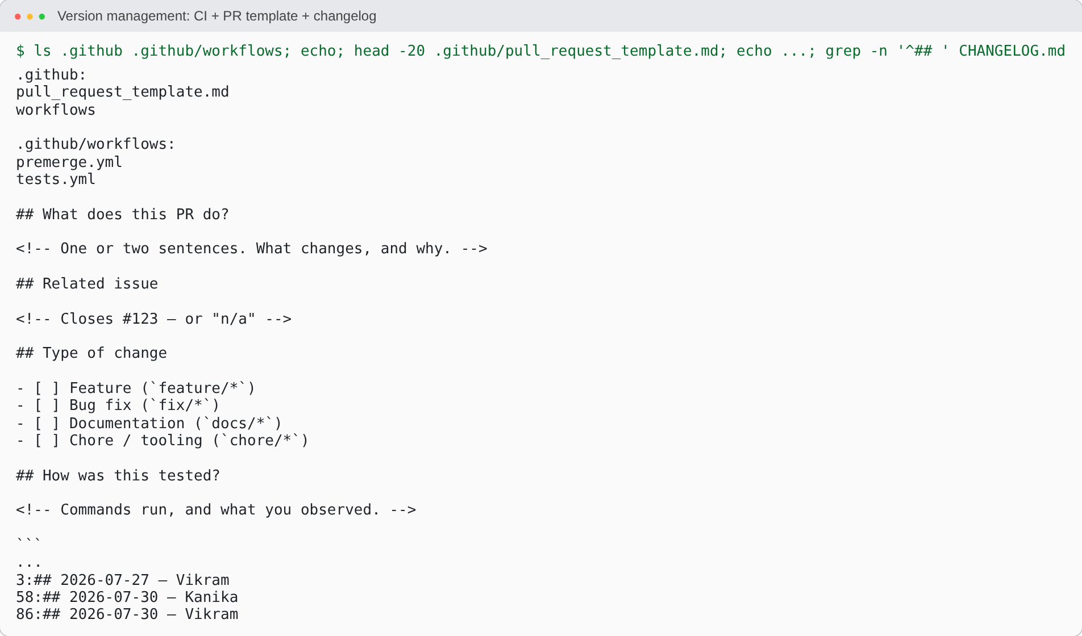
Figure 7 — Version-management assets: CI workflows, PR template, CHANGELOG

A2.2 System building
PreMerge is packaged with setuptools (pyproject.toml), installed with pip install -e ., built into a wheel with python -m build, and can be containerised with the provided Dockerfile. GitHub Actions (tests.yml) builds and tests on every push and PR across Python 3.11 and 3.12.
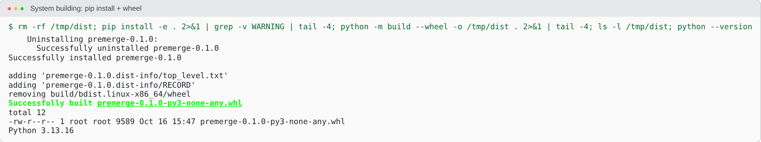
Figure 8 — Editable install and wheel build (premerge-0.1.0-py3-none-any.whl)
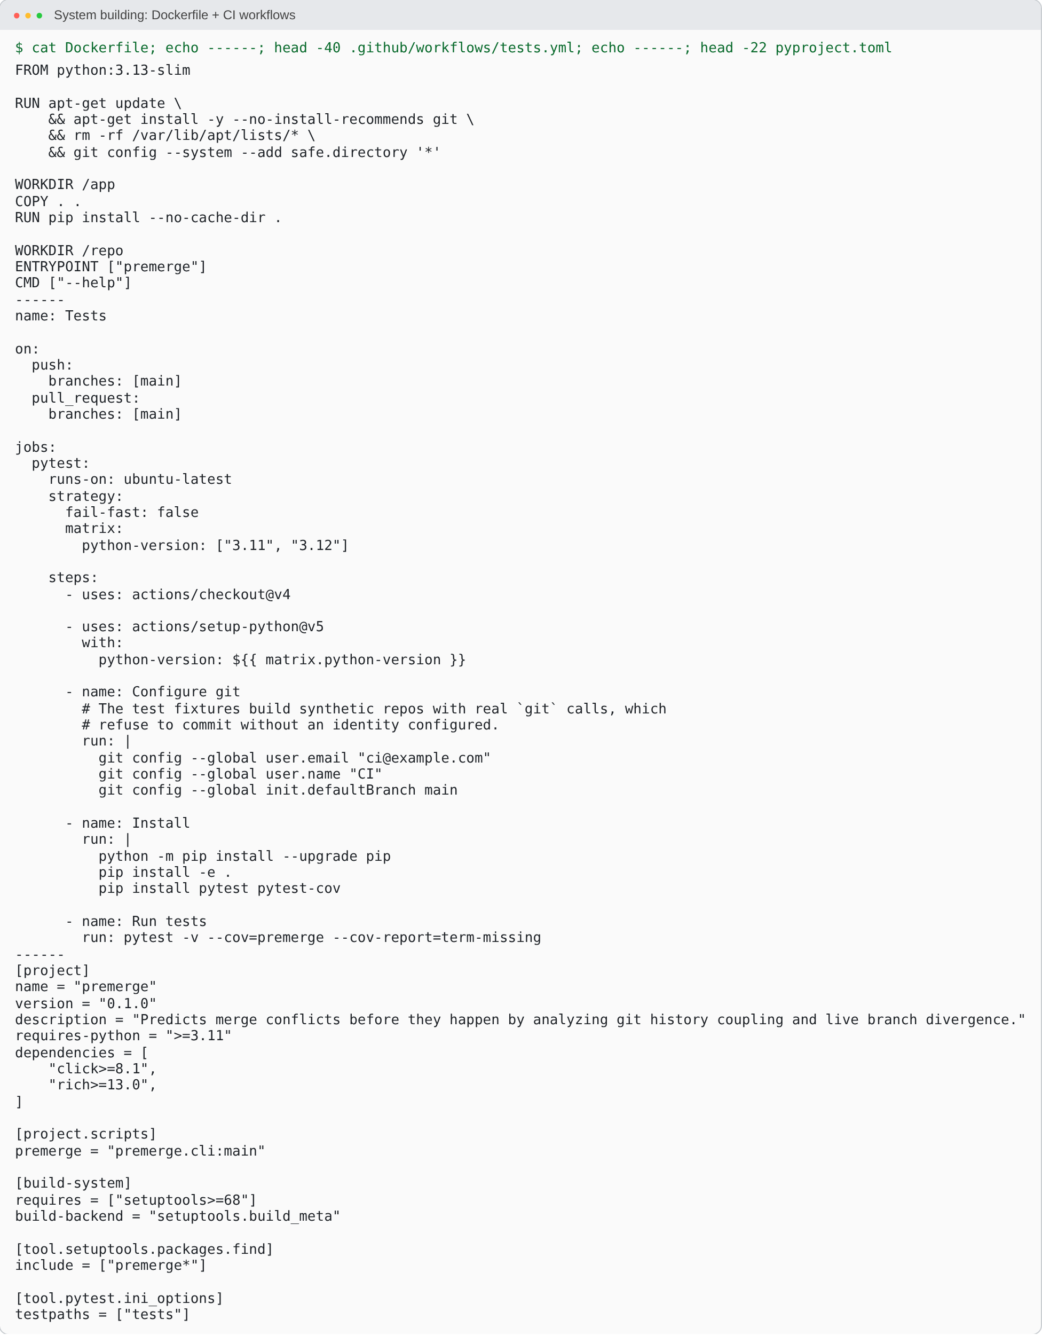
Figure 9 — Build configuration: Dockerfile, CI workflow and pyproject.toml
The Docker image could not be built in the sandbox used to prepare this pack (no Docker daemon). The Dockerfile is shown above; run docker build -t premerge . on your machine and add that screenshot here before submission.

A3. Screenshots of Developed Functionalities
Every feature is demonstrated on a reproducible demo repository created by docs/review3/demo.sh: history in which auth.py and session.py always change together; feature-a/b/c edit the same lines of auth.py; feature-d edits only session.py; feature-e edits an unrelated file.

A3.1 CLI and built-in help
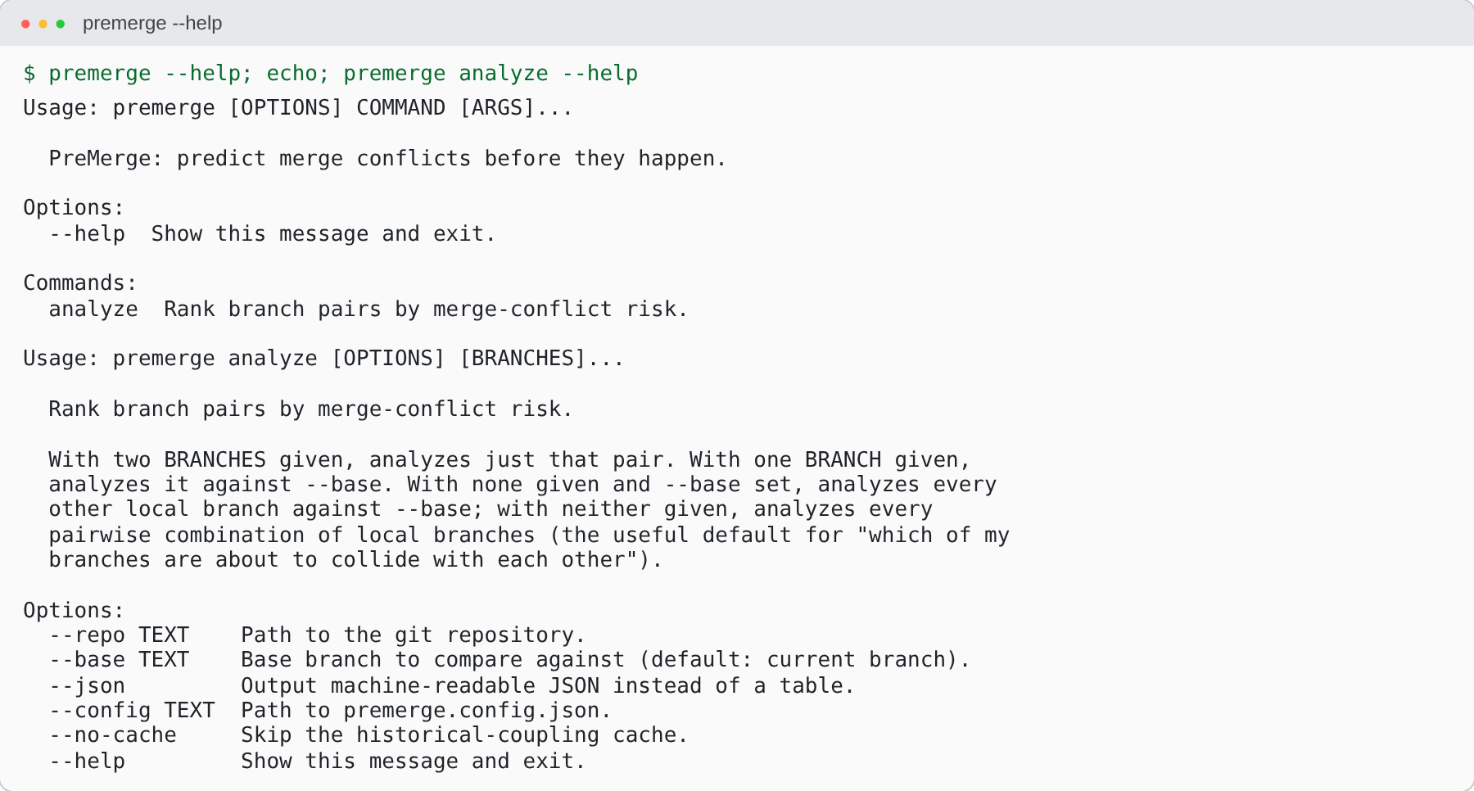
Figure 10 — Built-in CLI help (US-26)

A3.2 All-pairs ranked analysis
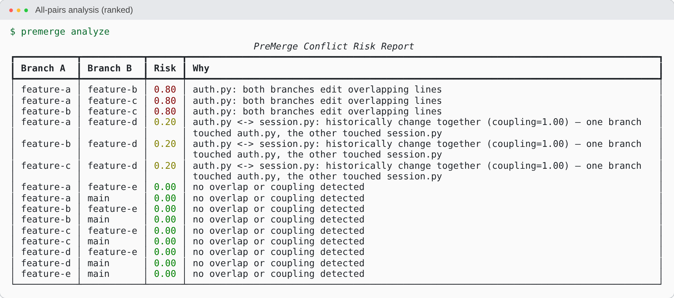
Figure 11 — All branch pairs ranked by risk, colour-coded red/yellow/green (US-4, 16, 17)

A3.3 Single pair — direct line overlap
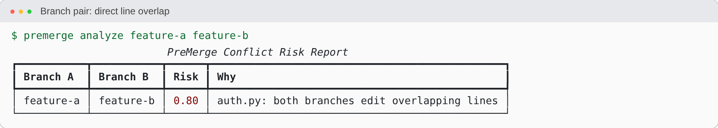
Figure 12 — Line-level overlap → risk 0.80 (US-3, 5, 6, 7)

A3.4 Single pair — hidden historical coupling
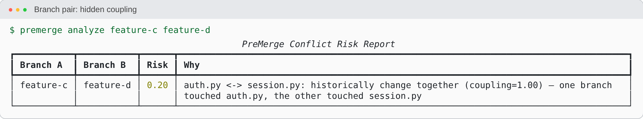
Figure 13 — No shared file, yet coupling 1.00 → risk 0.20: the hidden-conflict signal (US-8–11, 14)

A3.5 Base-branch mode
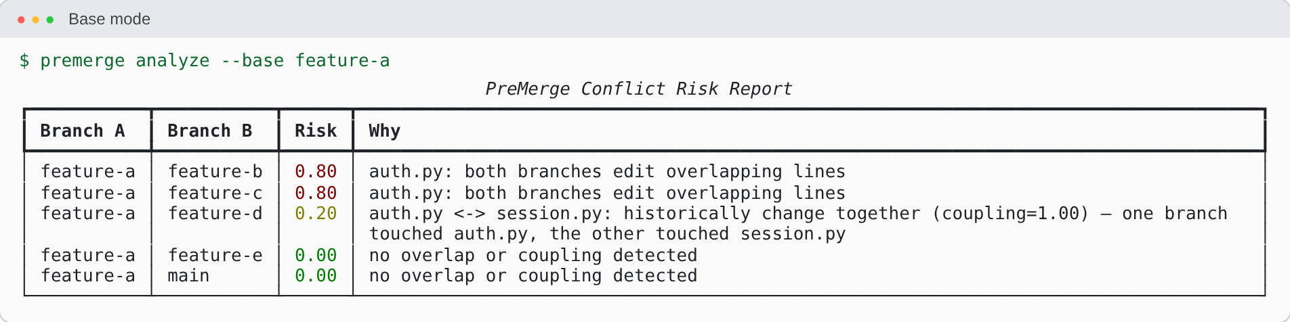
Figure 14 — One branch vs. all others (US-25)

A3.6 JSON output
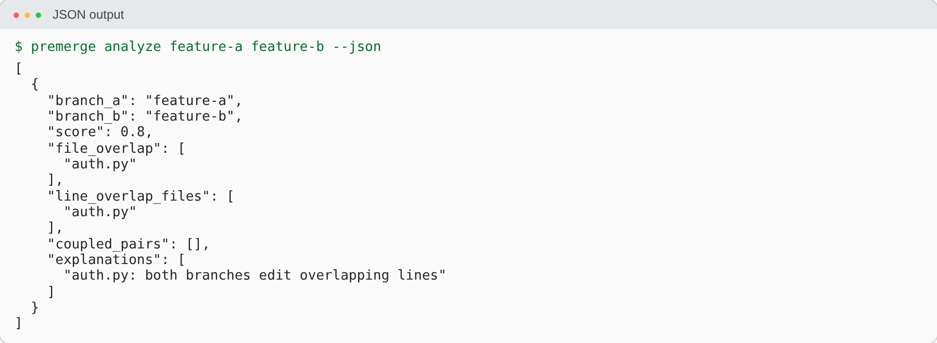
Figure 15 — Machine-readable JSON consumed by the GitHub Action (US-15)

A3.7 Configurable weights and SQLite cache
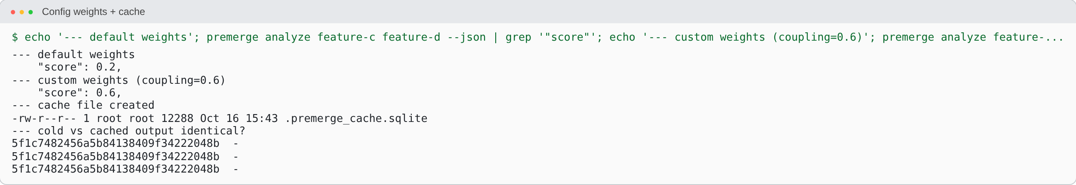
Figure 16 — Tunable weights change the score; SQLite cache yields identical results (US-12, 18, 19)

A3.8 Validation against real git
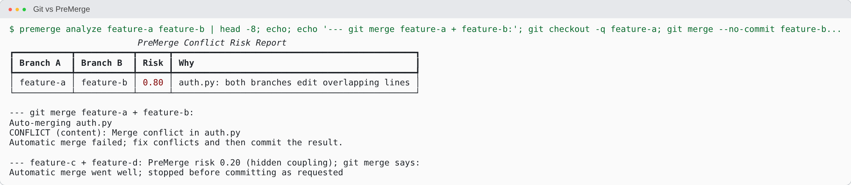
Figure 17 — PreMerge’s 0.80 prediction matches a real git merge conflict; the 0.20 pair merges textually clean but is flagged as logically coupled

A3.9 GitHub Action (CI integration)
On every pull_request event the composite action (github_action/action.yml) installs PreMerge, runs premerge analyze origin/<base> origin/<head> --json and post_comment.py posts a single comment identified by the marker <!-- premerge-report -->, updating it in place on later pushes (US-21–23). The workflow is dogfooded on this repository.

A3.10 UI design (Figma prototype of the proposed dashboard)
The planned web dashboard (MoSCoW item C1) is designed in Figma; six screens are shown below.
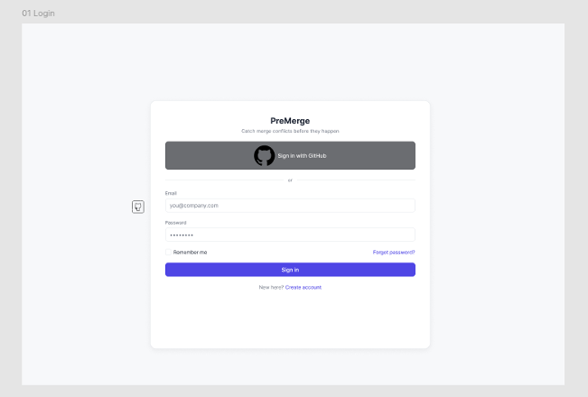  Login | 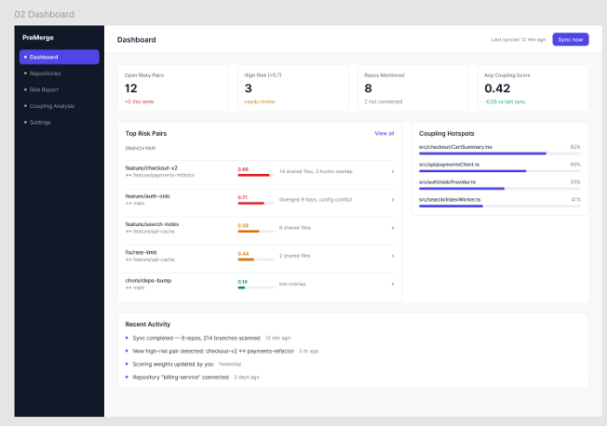  Dashboard | 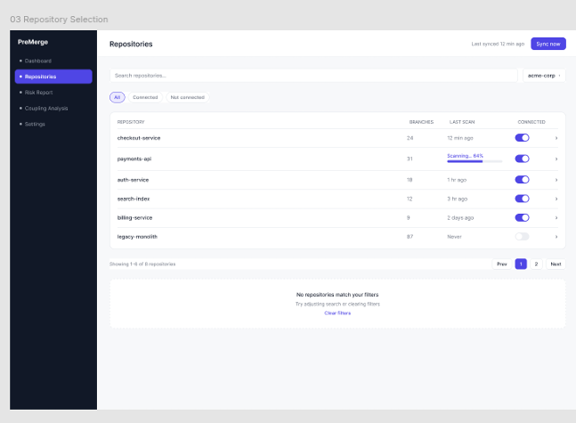  Repository selection
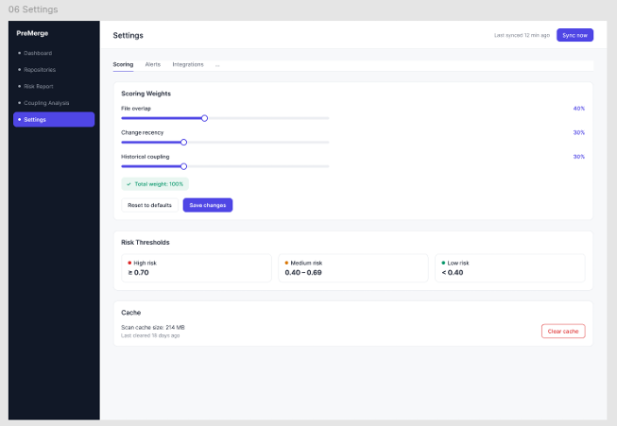  Conflict risk report | 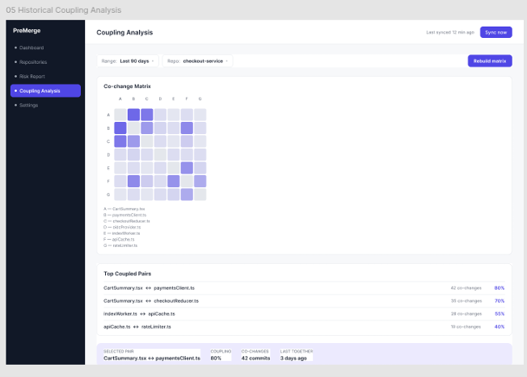  Coupling analysis | 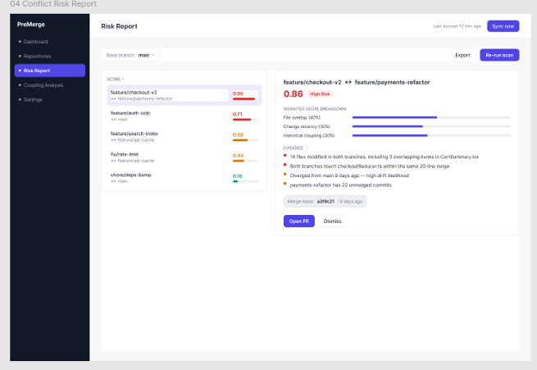  Settings

A4. Tools and Technologies Used
Category | Tool / Technology | Purpose in PreMerge
Language | Python 3.11+ (developed on 3.13) | All application code; modern typing, dataclasses
CLI framework | click ≥ 8.1 | Command/option parsing, built-in help
Terminal UI | rich ≥ 13 | Colour-coded risk table
VCS engine | git CLI via subprocess | log, diff -U0, merge-base, rev-parse (no GitPython)
Storage | SQLite (stdlib sqlite3) | Coupling cache keyed by HEAD commit
Data format | JSON (stdlib) | Config file and machine-readable output
CI integration | GitHub Actions (composite action), stdlib urllib | PR comment posting via GitHub REST API
Testing | pytest, pytest-cov, click CliRunner | Unit, integration, regression tests and coverage
Mutation testing | mutmut 3.8 | Test-suite quality measurement
Packaging / build | setuptools, pip, build | Installable package and wheel
Containerisation | Docker (python:3.13-slim) | Zero-setup execution
Version control | Git, GitHub, GitHub Flow, PR template | Collaboration, review, branch protection
Design | Figma, draw.io, hand-built SVG | UI prototype, architecture, DFD/ERD/UML
Project management | GitHub Issues & Projects, MoSCoW | 25 tracked user stories

PART B — Project Demo
Setup (before the demo): pip install -e . then bash docs/review3/demo.sh /tmp/pm-demo && cd /tmp/pm-demo
Min | Say | Run / show
0:00 | Problem: conflicts are found only at merge time; git merge can't see logical coupling. | Slide / README §3
0:45 | Idea: two signals — direct overlap + historical coupling → one risk score. | docs/PreMergeArchitecture.drawio.png
1:30 | Built-in help. | premerge --help
2:00 | Ranked view of every branch pair. | premerge analyze — point at red 0.80 rows, yellow 0.20 rows, green 0.00 rows
2:45 | Direct overlap: same lines of auth.py. | premerge analyze feature-a feature-b
3:15 | Proof it is real. | git checkout feature-a && git merge --no-commit feature-b → CONFLICT; then git merge --abort && git checkout main
3:45 | Hidden coupling (the differentiator): different files, git merges cleanly, PreMerge still flags 0.20. | premerge analyze feature-c feature-d
4:30 | Merge-queue view, JSON, config, cache. | premerge analyze --base feature-a · premerge analyze feature-a feature-b --json · premerge analyze feature-c feature-d --json --config /tmp/w.json
5:15 | Quality evidence: 30 tests, 96 % coverage, 76 % mutation score. | cd <repo> && pytest -q --cov=premerge
5:45 | CI: GitHub Action comment on a PR (open the PR page / docs/screenshots), updated in place. | Browser
6:15 | Limitations & future work: validation study, rename tracking, ML scoring, dashboard (Figma). | README §16
Likely viva questions: why Jaccard? (symmetric, bounded 0–1, ignores commits touching neither file); why no ML? (no labelled dataset yet); what if history is rewritten? (--no-cache); what are the false-positive risks? (large "misc" commits inflate coupling).

PART C — Project Report

Report overview
Section | Content
1 | Problem Statement
2 | User Stories
3 | System Architecture and System Design
4 | Design of Tests
5 | Appendix — (a) SRS · (b) DFD · (c) ERD · (d) UML diagrams · (e) Code listing / GitHub link

Abstract
PreMerge predicts merge conflicts before they happen. It reads a repository’s commit history and live branch diffs, scores every pair of active branches for conflict risk, and explains each score in plain English. Two independent signals are combined: direct overlap (do the branches edit the same files and the same line ranges?) and historical coupling (do they edit files that have always changed together in the past?). The second signal reveals hidden logical conflicts that git merge cannot. PreMerge ships as a CLI (premerge analyze), a Docker image, and a GitHub Action that posts and updates one risk-report comment on each pull request.

C1. Problem Statement
In collaborative development, merge conflicts are discovered at the worst possible moment — at merge time, after both sides have finished their work and built on incompatible assumptions. The cost of resolving a conflict grows with the time two branches have diverged, yet developers receive no signal until the divergence is complete.

Limitations of existing tooling
- git merge / git rebase report conflicts only when the merge is attempted.
- CI merge checks (e.g. “this branch has conflicts”) also fire only at merge time and only against the base branch — never branch-to-branch.
- Nothing in the standard toolchain detects logical coupling: two branches can merge cleanly and still break because the files they touched are historically interdependent (e.g. auth.py and session.py co-changed in 9 of the last 10 commits).

Objective
Provide a continuously available, ranked view of which in-flight branches are on a collision course, early enough that the cheap fix — a conversation, a rebase, a re-sequencing of work — is still available.

Vision statement
For software teams working in parallel on a shared codebase, who discover merge conflicts only when they are already expensive, PreMerge is a git-history analysis tool that predicts and ranks conflict risk between branches days before a merge is attempted. Unlike merge dry-runs and CI merge checks, which are reactive and text-level, PreMerge combines live divergence with learned historical coupling and explains its reasoning.

Scope, assumptions and constraints
In scope (v1) | Assumptions / constraints
Pairwise branch risk ranking; file- and line-level overlap; Jaccard historical coupling; weighted score; CLI, JSON, SQLite cache; GitHub Action PR comment. | Standard git repo with full history (no shallow clone); append-only history; reasonably scoped commits; merge commits excluded; file/line-level analysis (no AST); scores are comparative rankings, not calibrated probabilities; Python 3.11+ and git on PATH; GitHub Actions only.

Success metrics
Metric | Target | Status
Unit-test coverage of core logic | > 80 % | 96 % achieved
Runtime dependencies | ≤ 3 | 2 (click, rich)
Warm (cached) re-run | < 1 s | Sub-second on the small demo repo (≈0.3 s); not yet benchmarked on large repos
Precision / Recall / F1 | ≥ 0.70 / 0.75 / 0.72 | Not yet measured — requires validation study (future work)

C2. User Stories
Personas: Priya (developer), Arjun (tech lead / reviewer), Meera (DevOps), Dr. Rao (engineering manager / researcher). The 25 stories are tracked as GitHub Issues #3–#27 with one MoSCoW label each (16 must, 8 should, 1 could).
ID | As a… | I want… | So that… | Pri.
US-3 | Priya | compare two branches for merge-conflict risk | I know before merging whether my work overlaps with someone else’s | M
US-4 | Arjun | every branch pair analysed automatically | I get a full risk picture without specifying pairs | M
US-5 | Priya | file-level overlap detection | I can see which files both branches touched | M
US-6 | Arjun | line-level overlap detection | I can tell real conflicts from files merely both edited | M
US-7 | Arjun | one combined risk score per branch pair | I can rank and sequence merges | M
US-8 | Dr. Rao | historical file coupling calculated | hidden conflicts across related files are caught | M
US-9 | Dr. Rao | coupling derived from real git history | the signal reflects how the team actually works | M
US-10 | Dr. Rao | logically dependent files identified | conflicts hidden behind indirection still surface | M
US-11 | Dr. Rao | coupling expressed as Jaccard similarity | relationship strength is quantified | M
US-12 | Meera | coupling results cached | repeat CI runs are fast | S
US-13 | Priya | the report displayed in the terminal | I can read results without leaving my workflow | M
US-14 | Arjun | plain-English explanations per pair | I can quote them in review | S
US-15 | Meera | results exported as JSON | other tools and the GitHub Action can consume them | S
US-16 | Arjun | branch pairs ranked by risk | I can sequence merges to minimise pain | M
US-17 | Arjun | high-risk conflicts visually highlighted | I don’t hunt for the ones that matter | S
US-18 | Dr. Rao | to configure the scoring weights | I can tune the model to our data | S
US-19 | Dr. Rao | configuration loaded from a JSON file | weight changes need no source edits | S
US-20 | Meera | to point PreMerge at a repository path | I can analyse repos other than the current directory | S
US-21 | Meera | PreMerge to run as a GitHub Action | risk is checked automatically on every PR | M
US-22 | Arjun | the report posted as a PR comment | I see it where I make merge decisions | M
US-23 | Arjun | the PR comment updated in place | I am not spammed with duplicates | M
US-24 | Meera | improved performance on large repos | PreMerge stays usable as history grows | C
US-25 | Arjun | every branch compared against main in one command | I get the merge-queue view | S
US-26 | Priya | built-in CLI help | I can discover options without external docs | M
US-27 | Arjun | a comprehensive combined conflict report | I have one place to review risk | M

Acceptance criteria for key stories (Given / When / Then)
Story | Acceptance criteria
US-6 Line-level overlap | Given two branches editing the same lines of auth.py, when I run premerge analyze A B, then auth.py is reported as “both branches edit overlapping lines” and risk ≥ 0.5. Verified by test_cli_pair_json_reports_line_overlap.
US-8/11 Coupling | Given history where two files always change together and branches that each touch only one of them, then no file overlap is reported, coupling = 1.00 and risk > 0. Verified by test_cli_detects_hidden_coupling_without_file_overlap.
US-16 Ranking | Given several branches, when I run premerge analyze, then C(n,2) pairs are listed in descending score order. Verified by test_cli_all_pairs_ranked_highest_risk_first.
US-12 Cache | Given an unchanged HEAD, then a second run reads the SQLite cache and returns byte-identical output. Verified by test_cache_roundtrip and test_cli_warm_cache_gives_same_result_as_cold.
US-23 In-place comment | Given a PR already carrying a comment with the marker <!-- premerge-report -->, when new commits are pushed, then that comment is edited instead of a new one being created. Verified by test_main_updates_existing_comment_in_place.

MoSCoW summary
Category | Items
Must (M1–M8) | Branch comparison, file overlap, line overlap, historical coupling, risk scoring, CLI, GitHub Action, PR risk comment — all implemented
Should (S1–S10) | JSON output, SQLite cache, configurable weights, explanations, base mode, binary handling, cache bypass implemented; validation study, rename tracking, full SE docs outstanding
Could | Web dashboard (Figma-designed), performance tuning
Won’t (v1) | ML-based scoring, AST/semantic analysis, IDE extension

C3. System Architecture and System Design

C3.1 Architectural style
PreMerge is a layered pipeline. A thin interface layer (CLI / GitHub Action) calls a single scoring engine, which orchestrates two independent signal detectors (overlap and coupling). All access to the repository goes through one adapter module (git_utils) that shells out to the git binary. Modules exchange typed dataclasses only; the module graph is acyclic, so each layer can be tested and replaced independently, and the same pipeline runs unchanged locally, in Docker or in CI.
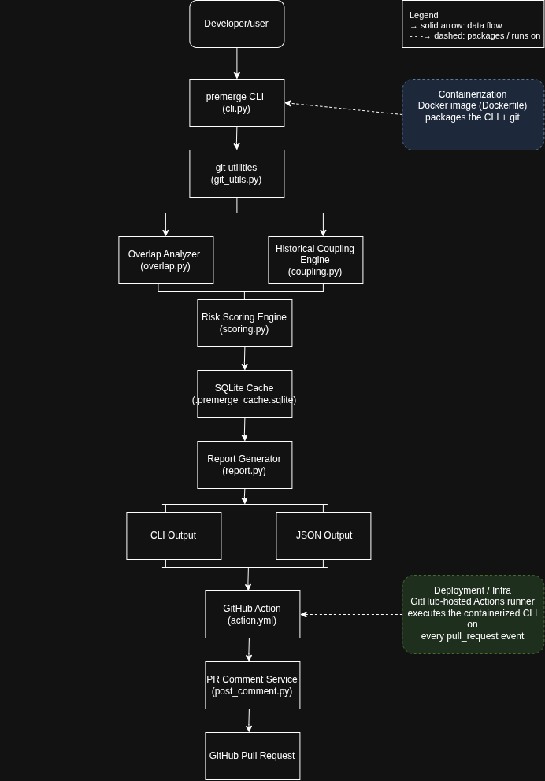
Figure 3.1 — System architecture (with containerisation and deployment), draw.io
Layer | Module | Responsibility
Interface | cli.py, github_action/ | Argument parsing, pair selection (pair / base / all-pairs); PR comment create-or-update
Domain | scoring.py | Weighted combination of the signals; plain-English explanations
Signals | overlap.py, coupling.py | File/line overlap vs merge-base; Jaccard co-change coupling with SQLite cache
Infrastructure | git_utils.py, config.py, report.py | git subprocess wrappers and hunk parsing; weight loading; table/JSON output

C3.2 Scoring model
risk(A,B) = w1 · line_overlap_score + w2 · file_overlap_score + w3 · historical_coupling
line_overlap_score = |files with intersecting hunks| / |files touched by both|
file_overlap_score = |files touched by both| / |files touched by either|
historical_coupling = mean Jaccard of (fileA, fileB) pairs where fileA ∈ only-A, fileB ∈ only-B
coupling(f,g) = commits touching both f and g / commits touching f or g
Default weights: w1 = 0.5, w2 = 0.3, w3 = 0.2 (premerge.config.json)

Worked examples (from the demo repository)
Pair | Computation | Risk
feature-a vs feature-b | both edit the same lines of auth.py → line = 1.0, file = 1.0, coupling = 0 → 0.5·1 + 0.3·1 + 0.2·0 | 0.80 🔴
feature-c vs feature-d | no shared file; auth.py ↔ session.py coupling = 4/4 = 1.0 → 0.2·1.0 | 0.20 🟡
feature-a vs feature-e | disjoint files, no coupling | 0.00 🟢

C3.3 Dynamic behaviour
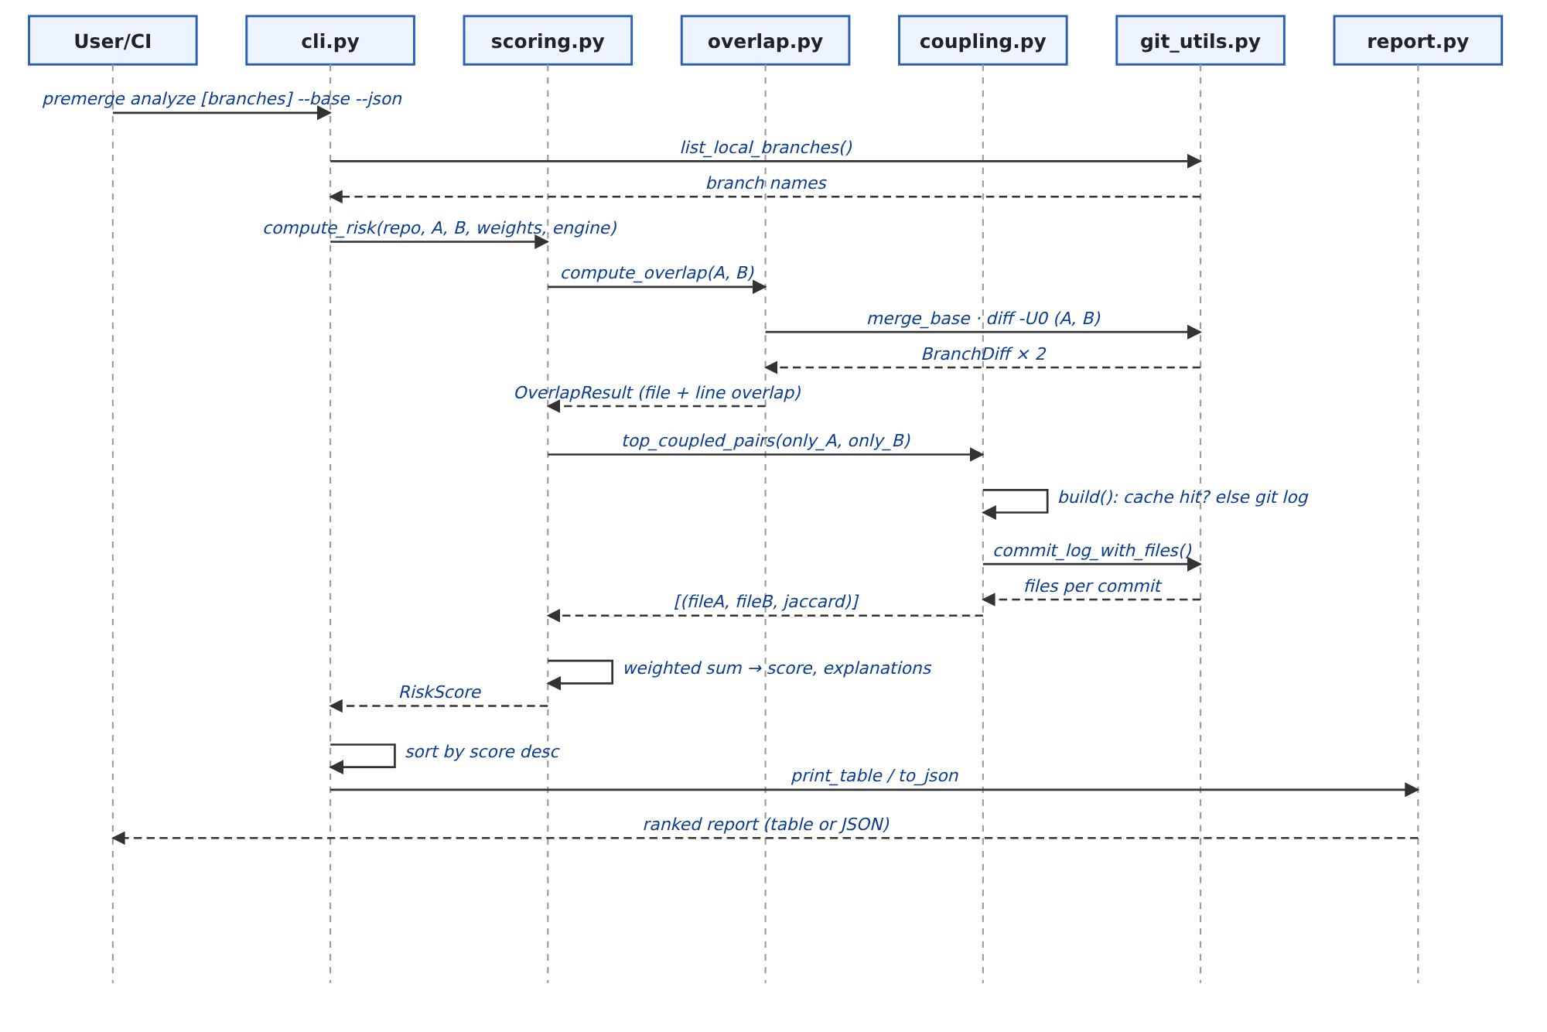
Figure 3.2 — Sequence diagram of one premerge analyze run

C3.4 Detailed design of key components
- git_utils.diff_hunks parses git diff -U0: diff --git lines give the file, @@ -a,b +c,d @@ headers give (start, length) ranges; a pure deletion counts as length 1; binary files are recorded separately and compared at file level only.
- overlap._ranges_intersect — half-open interval test a.start < b.start+b.len and b.start < a.start+a.len.
- coupling.CouplingEngine — one pass over git log --no-merges --name-only builds per-file and per-pair counters; results are serialised to SQLite keyed by (HEAD hash, rev). top_coupled_pairs scores only cross-pairs of files each branch touched exclusively — the hidden-risk signal.
- report — Rich table (red ≥ 0.50, yellow ≥ 0.20, green below) or stable JSON schema.
- post_comment.py — stdlib urllib; finds the existing comment by the HTML marker and PATCHes it, else POSTs a new one.

C3.5 Key design decisions
Decision | Rationale / trade-off
Shell out to git, no GitPython | Exact control of diff format; one fewer dependency. Cost: requires git on PATH.
Heuristic scoring instead of ML | No labelled dataset exists yet; a transparent formula is tunable and explainable. ML is future work.
SQLite cache keyed by HEAD | Near-zero repeat cost in CI. Cost: assumes append-only history (--no-cache escape hatch).
Exclude merge commits from coupling | Their diffs are the union of both parents and would inflate co-change counts.
Layered, acyclic modules + dataclasses | Each module single-responsibility and independently testable.

C3.6 Deployment and build
Install via pip install -e . (console script premerge), run with Docker (docker run --rm -v "$(pwd)":/repo premerge analyze --repo /repo), or use the composite GitHub Action. Branching follows GitHub Flow; tests.yml runs pytest with coverage on Python 3.11/3.12 and premerge.yml dogfoods the tool on its own PRs.

C3.7 User-interface design
The v1 interface is the terminal table and PR comment. A web dashboard is designed in Figma (6 screens: Login, Dashboard, Repository Selection, Risk Report, Coupling Analysis, Settings) as a proposed extension.
Dashboard | Risk report | Coupling analysis
Figure 3.3 — Implemented terminal interface

C4. Design of Tests

C4.1 Test strategy
Level | Scope | Technique / tool
Unit | coupling, overlap, scoring, git_utils, config, report | pytest on synthetic git repositories created in tmp_path with plain git calls — hermetic, no network, no checked-in fixtures
Integration | CLI → all modules → git | click CliRunner invoking premerge analyze against synthetic repos
Regression | Whole suite on every push/PR | GitHub Actions matrix (Python 3.11, 3.12) with coverage
Mutation | All of premerge/ | mutmut 3.8 — measures fault-detection power of the suite
System / validation | Real conflicting PR | Opened a genuinely conflicting PR: PreMerge scored 0.80 before merge; git merge --no-commit confirmed a real content conflict (CHANGELOG, 2026-07-27)

C4.2 Test fixture design
The sample_repo fixture builds a repo where auth.py and session.py change together in 4 commits and unrelated.py changes alone — giving known ground truth (coupling 1.0 and 0.0). Tests then create branches that overlap, are disjoint, or are only hidden-coupled, using equivalence classes: same lines / same file different lines / different files coupled / different files uncoupled / binary / deletions / merge commits, with boundary-value checks on range intersection (overlap by one line, adjacent, containment, disjoint).

C4.3 Test case catalogue (30 automated cases)
ID | Test | Level | Verifies | Story
T1 | test_strong_coupling_between_cochanged_files | Unit | Jaccard = 1.0 for files always co-changed | US-11
T2 | test_no_coupling_for_unrelated_file | Unit | Jaccard = 0.0 for never co-changed files | US-11
T3 | test_coupling_is_symmetric | Unit | coupling(a,b) = coupling(b,a) | US-8
T4 | test_cache_roundtrip | Unit | SQLite file created and re-read correctly | US-12
T5 | test_line_level_overlap_detected | Unit | Same-line edits flagged at line level | US-6
T6 | test_no_overlap_for_disjoint_files | Unit | Disjoint branches report no overlap | US-5
T7 | test_overlapping_branches_score_higher_than_disjoint | Unit | Risky pair outscores safe pair | US-7
T8 | test_ranges_intersect_boundaries | Regression | Boundary values of range intersection | US-6
T9 | test_pure_deletion_hunk_counts_as_one_line | Regression | Deletion hunk length floors at 1 | US-6
T10 | test_binary_file_is_file_level_only | Regression | Binary files: file-level only | S6
T11 | test_commit_log_skips_merge_commits | Regression | Merge commits excluded from coupling | US-9
T12 | test_config_defaults_partial_and_missing | Regression | Missing / partial config falls back to defaults | US-19
T13 | test_json_report_schema | Regression | JSON keys and structure stable | US-15
T14 | test_file_overlap_without_line_overlap_scores_lower | Regression | Same file, distant lines = 0.3 only | US-6
T15 | test_cli_pair_json_reports_line_overlap | Integration | CLI pair mode end-to-end | US-3
T16 | test_cli_detects_hidden_coupling_without_file_overlap | Integration | Hidden coupling surfaced with zero file overlap | US-8
T17 | test_cli_all_pairs_ranked_highest_risk_first | Integration | All-pairs count and descending order | US-4/16
T18 | test_cli_base_mode_compares_every_branch_to_base | Integration | --base mode pair set | US-25
T19 | test_cli_table_output_renders_title_and_branches | Integration | Rich table rendering | US-13
T20 | test_cli_no_other_branches_message | Integration | Graceful message when nothing to compare | US-4
T21 | test_cli_custom_config_changes_score | Integration | --config weights change the score | US-18
T22 | test_cli_warm_cache_gives_same_result_as_cold | Integration | Cold, cache-write and cache-hit outputs identical | US-12
T23 | test_table_headers_and_rows | Unit | Table title, headers and row content | US-13
T24 | test_table_empty_and_no_explanation_messages | Unit | Empty / no-explanation messages | US-4
T25 | test_table_summarises_extra_explanations_and_lists_them | Unit | “+N more” summary and detail list | US-14
T26 | test_json_values_roundtrip | Unit | JSON values and sorted file lists | US-15
T27 | test_comment_body_has_marker_table_and_risk_emoji | Unit | PR comment marker, table, 🔴🟡🟢 thresholds | US-22
T28 | test_comment_body_empty_report | Unit | PR comment when nothing to compare | US-22
T29 | test_main_creates_comment_when_none_exists | Integration | Action POSTs a new comment (mocked API) | US-21
T30 | test_main_updates_existing_comment_in_place | Integration | Action PATCHes the marker comment, never POSTs | US-23

C4.4 Results
Measure | Result
Tests executed / passed | 30 / 30
Statement coverage | 96 % (config, overlap, report, scoring 100 %; coupling 96 %; cli 93 %; git_utils 92 %)
Mutation score | 76 % overall (447 killed / 587): config 90 %, overlap 87 %, scoring 86 %, git_utils 73 %, coupling 71 %, report 70 %
Figure 4.1 — Test and coverage results
Figure 4.2 — Mutation testing results
Known gaps / future tests: the GitHub-Action comment poster is unit-tested with a mocked GitHub API but not against a live PR in CI; no performance benchmark on a 5k-commit repository; precision/recall validation across open-source repositories is planned; remaining survivors (mostly Rich colour/style strings and coupling cache internals) could be killed by snapshot and cache-corruption tests.

C5. Appendix

C5.a Software Requirements Specification (SRS)

C.a.1 Introduction
Purpose. This SRS specifies PreMerge v0.1.0, a tool that predicts merge-conflict risk between git branches. Intended audience: developers, reviewers and course evaluators. Scope: CLI, GitHub Action and supporting configuration/caching; the web dashboard is out of scope for v1. Definitions: hunk — contiguous changed line range in a diff; merge-base — common ancestor of two branches; coupling — Jaccard similarity of two files’ commit sets.

C.a.2 Overall description
Product perspective: stand-alone tool layered on the git CLI; optional GitHub Actions integration. User classes: developer, tech lead, DevOps engineer, researcher. Operating environment: Linux/macOS/Windows with Python 3.11+ and git, or Docker. Constraints: file/line-level analysis only; local branches by default; renames not tracked. Assumptions: full-history clone, append-only history, meaningful commits.

C.a.3 Specific requirements — functional
ID | Requirement | Priority
FR-1 | Resolve two branches to their merge-base and diff each against it. | Must
FR-2 | Report files modified by both branches (file-level overlap). | Must
FR-3 | Report files whose changed line ranges intersect (line-level overlap); binary files are file-level only. | Must
FR-4 | Compute pairwise historical coupling (Jaccard) from non-merge commit history. | Must
FR-5 | Combine line overlap, file overlap and coupling into one weighted risk score in [0, 1]. | Must
FR-6 | Provide premerge analyze with modes: all pairs, one pair, one branch vs --base, all vs --base. | Must
FR-7 | Rank pairs by descending risk and display a colour-coded table (red ≥ 0.5, yellow ≥ 0.2, green otherwise). | Must
FR-8 | Generate a plain-English explanation per pair. | Should
FR-9 | Emit JSON output with --json. | Should
FR-10 | Cache coupling results in SQLite keyed by HEAD; --no-cache bypasses. | Should
FR-11 | Load weights from premerge.config.json or --config; default 0.5/0.3/0.2. | Should
FR-12 | Accept --repo to analyse a repository elsewhere on disk. | Should
FR-13 | Run as a GitHub Action on pull_request events and post one report comment. | Must
FR-14 | Update the existing PR comment in place (identified by marker) instead of posting duplicates. | Must
FR-15 | Provide built-in --help. | Must

C.a.4 Non-functional requirements
ID | Category | Requirement
NFR-1 | Performance | Cold analysis of a ~5k-commit repo < 10 s; cached re-run < 1 s; added CI time < 30 s per PR.
NFR-2 | Usability | Zero-configuration default run; output names files, not only scores.
NFR-3 | Portability | Pure Python + git; also available as Docker image.
NFR-4 | Maintainability | Acyclic layered modules; core-logic test coverage > 80 % (achieved 96 %).
NFR-5 | Reliability | Git failures raise GitError with the stderr text; cache can be bypassed.
NFR-6 | Security / privacy | Read-only analysis; no network access except the Action’s GitHub API call; token passed via environment.
NFR-7 | Transparency | Published, tunable scoring formula; no black-box model.
NFR-8 | Footprint | ≤ 3 runtime dependencies (actual: 2).

C.a.5 External interfaces
User: CLI + Rich terminal table. Software: git CLI (subprocess); SQLite file .premerge_cache.sqlite; GitHub REST API (/repos/{repo}/issues/{pr}/comments). Hardware: none.

C5.b Data Flow Diagrams
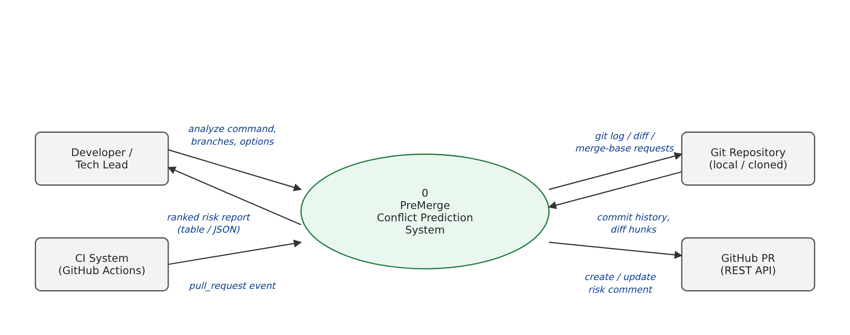
Figure A.1 — DFD Level 0 (context diagram)
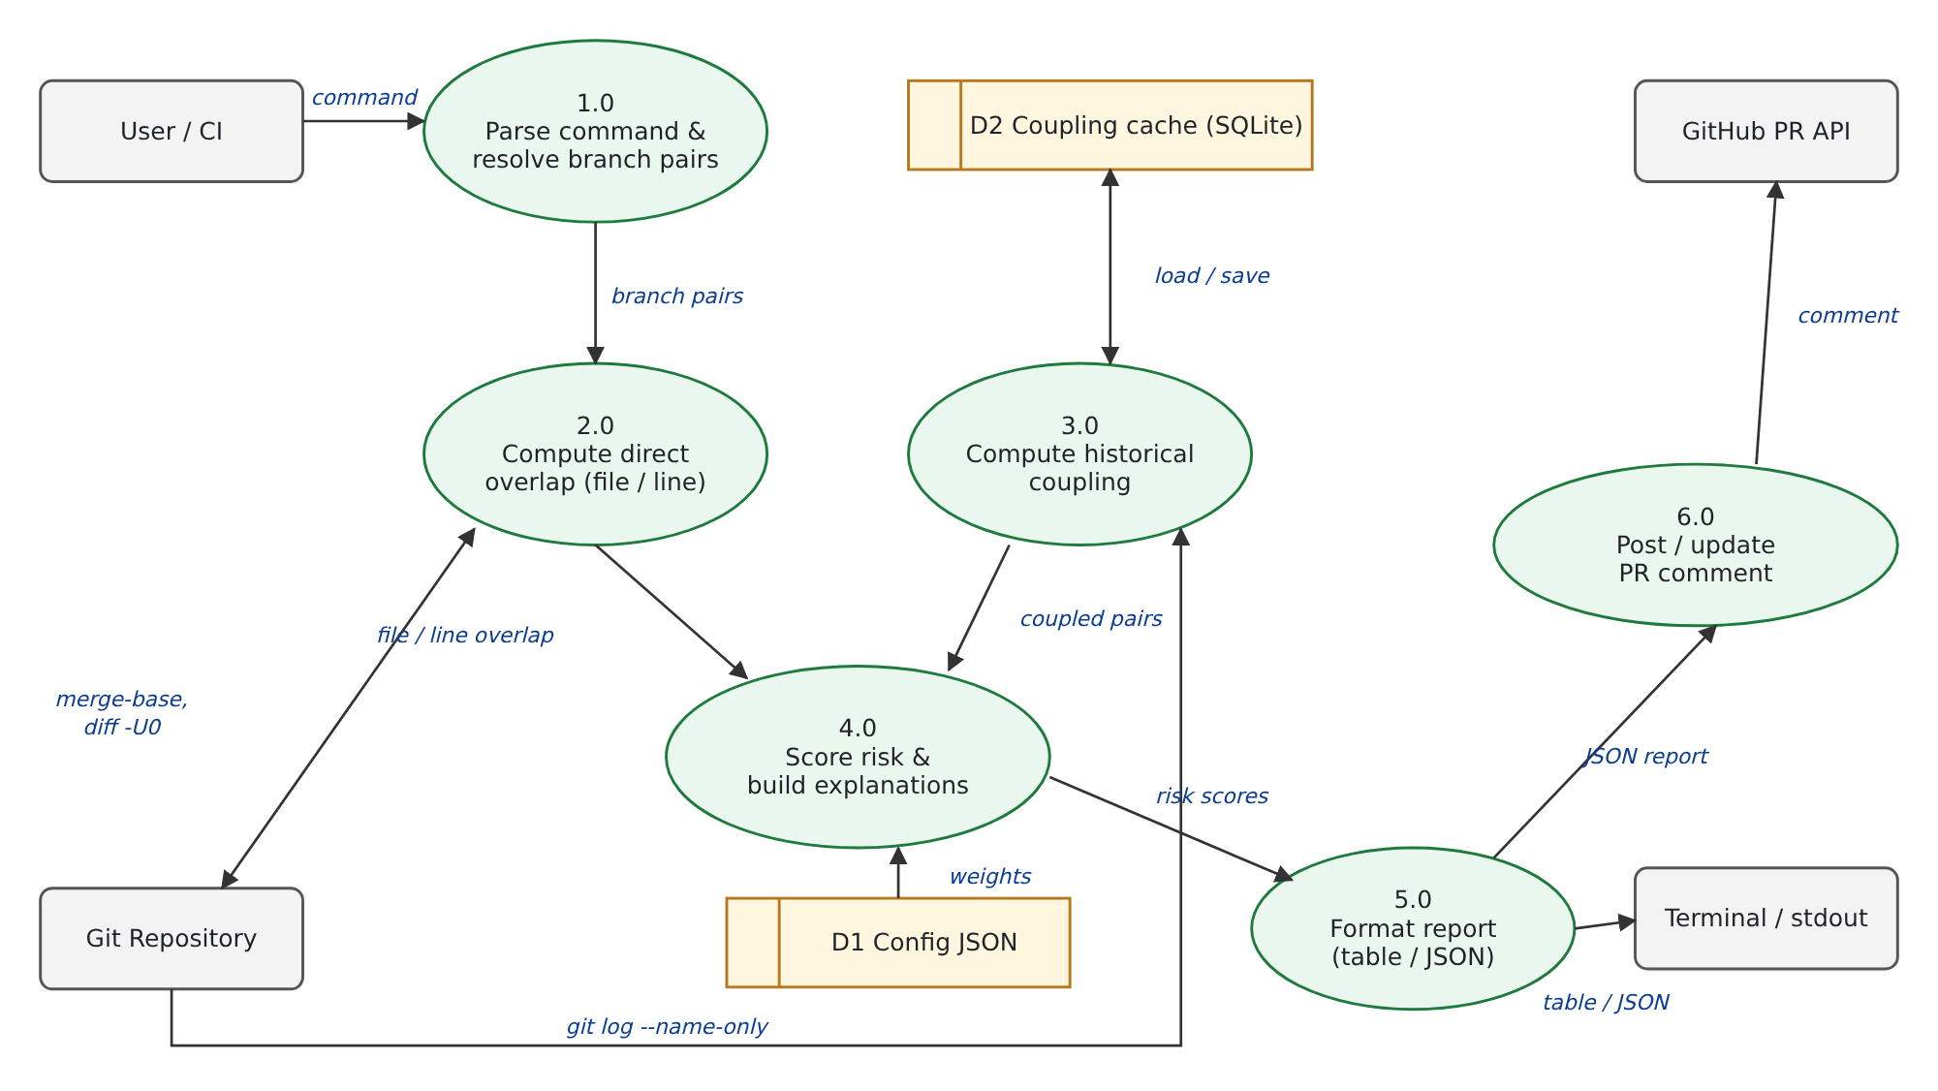
Figure A.2 — DFD Level 1

C5.c Entity-Relationship Diagram
PreMerge has no server database; the ER model describes the conceptual data it manipulates. Git entities (REPOSITORY, BRANCH, COMMIT, FILE_CHANGE) are read from git; COUPLING_CACHE is the only persisted table (SQLite coupling_cache(head_hash, rev, file_counts, pair_counts, PRIMARY KEY(head_hash, rev))); WEIGHTS_CONFIG is the JSON file; RISK_SCORE and PR_COMMENT are outputs.
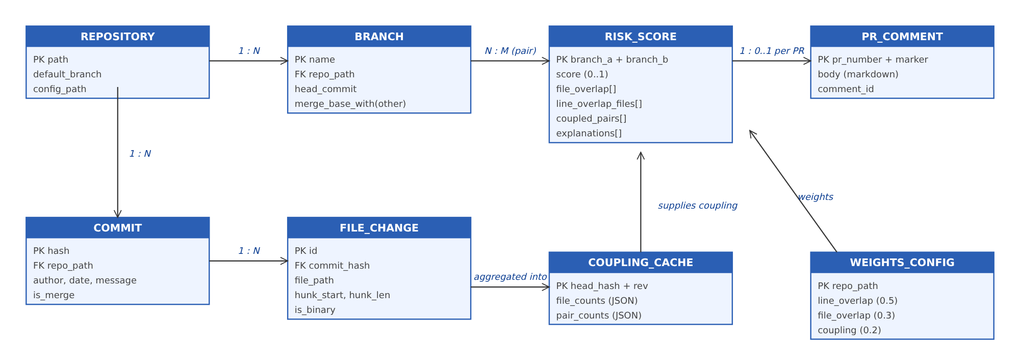
Figure A.3 — ER diagram

C5.d UML Diagrams
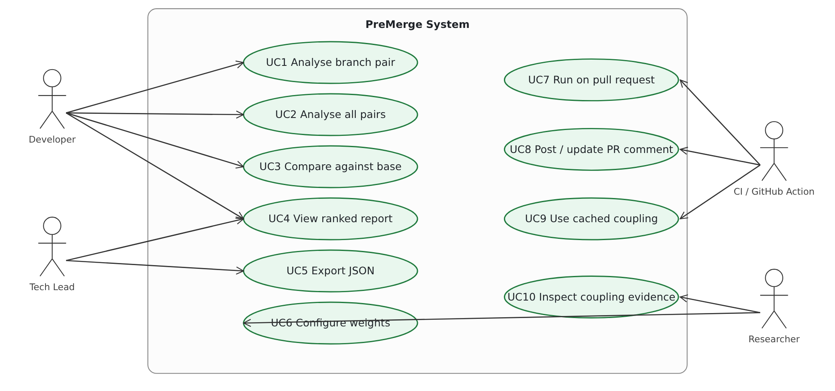
Figure A.4 — Use-case diagram
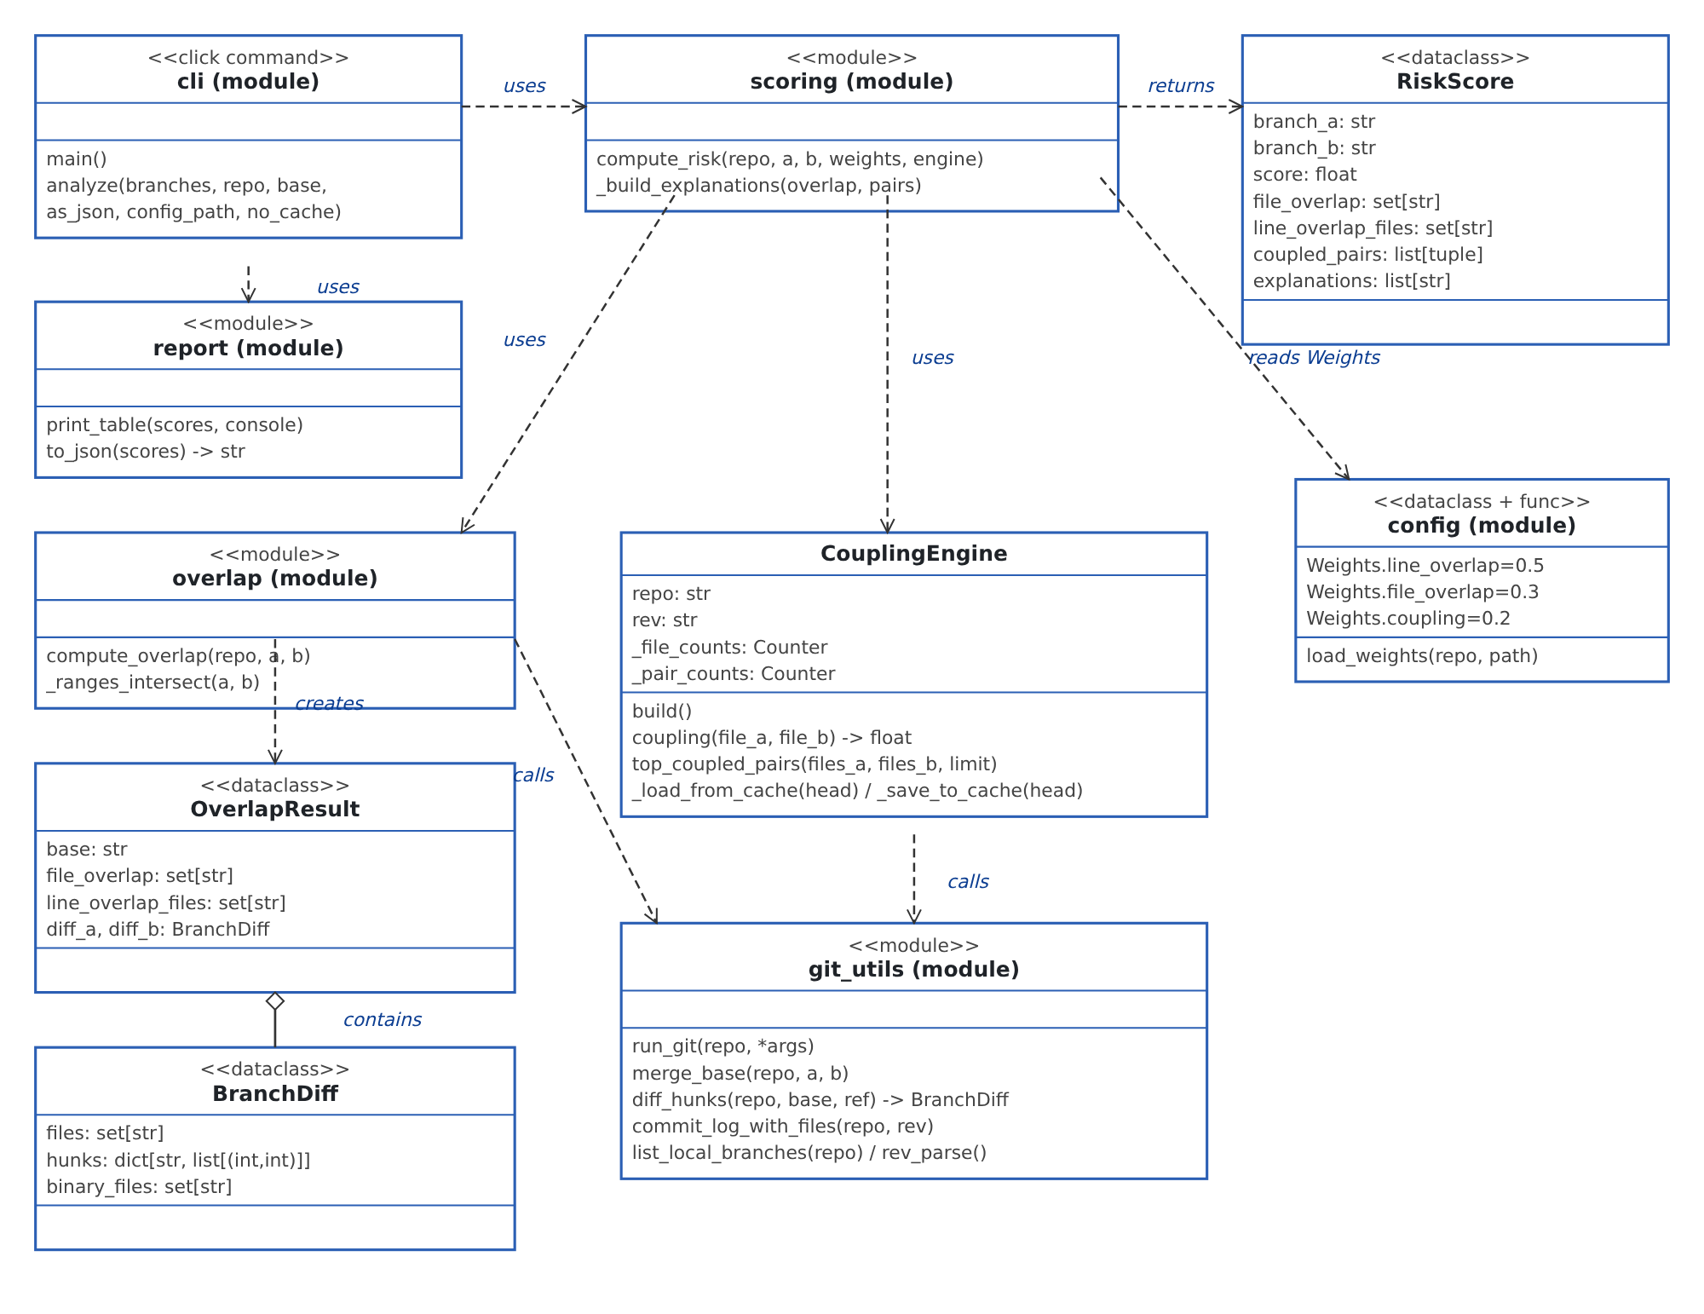
Figure A.5 — Class / module diagram
Figure A.6 — Sequence diagram (analyze run)

C5.e Code Listing / GitHub Link
GitHub repository: https://github.com/Waterbottles792/PreMerge
Contents: premerge/ (core package), github_action/, tests/, docs/, .github/workflows/, Dockerfile, pyproject.toml. Core modules are listed in full below.
premerge/cli.py
"""premerge CLI entrypoint."""
from __future__ import annotations
import itertools
import click
from rich.console import Console
from . import git_utils
from .config import load_weights
from .coupling import CouplingEngine
from .report import print_table, to_json
from .scoring import compute_risk
@click.group()
def main() -> None:
"""PreMerge: predict merge conflicts before they happen."""
@main.command()
@click.argument("branches", nargs=-1)
@click.option("--repo", default=".", help="Path to the git repository.")
@click.option(
"--base", default=None, help="Base branch to compare against (default: current branch)."
)
@click.option(
"--json", "as_json", is_flag=True, help="Output machine-readable JSON instead of a table."
)
@click.option("--config", "config_path", default=None, help="Path to premerge.config.json.")
@click.option("--no-cache", is_flag=True, help="Skip the historical-coupling cache.")
def analyze(
branches: tuple[str, ...],
repo: str,
base: str | None,
as_json: bool,
config_path: str | None,
no_cache: bool,
) -> None:
"""Rank branch pairs by merge-conflict risk.
With two BRANCHES given, analyzes just that pair. With one BRANCH given,
analyzes it against --base. With none given and --base set, analyzes
every other local branch against --base; with neither given, analyzes
every pairwise combination of local branches (the useful default for
"which of my branches are about to collide with each other").
"""
console = Console()
if len(branches) >= 2:
pairs = [(branches[0], branches[1])]
elif len(branches) == 1:
base_branch = base or git_utils.current_branch(repo)
pairs = [(base_branch, branches[0])]
elif base is not None:
other_branches = [b for b in git_utils.list_local_branches(repo) if b != base]
pairs = [(base, b) for b in other_branches]
else:
pairs = list(itertools.combinations(git_utils.list_local_branches(repo), 2))
if not pairs:
console.print("[yellow]No other branches found to compare against.[/yellow]")
return
weights = load_weights(repo, config_path)
coupling_engine = CouplingEngine(repo, rev="HEAD", use_cache=not no_cache)
scores = [compute_risk(repo, a, b, weights, coupling_engine) for a, b in pairs]
scores.sort(key=lambda s: s.score, reverse=True)
if as_json:
click.echo(to_json(scores))
else:
print_table(scores, console)
if __name__ == "__main__":
main()
premerge/git_utils.py
"""Thin wrappers around the git CLI.
Everything PreMerge needs (log, diff, merge-base) is a subprocess call away,
so we shell out directly instead of taking on a GitPython dependency.
"""
from __future__ import annotations
import re
import subprocess
from dataclasses import dataclass, field
class GitError(RuntimeError):
"""Raised when a git subprocess invocation fails."""
def run_git(repo: str, *args: str) -> str:
result = subprocess.run(
["git", "-C", repo, *args],
capture_output=True,
text=True,
)
if result.returncode != 0:
raise GitError(f"git {' '.join(args)} failed: {result.stderr.strip()}")
return result.stdout
def list_local_branches(repo: str) -> list[str]:
out = run_git(repo, "for-each-ref", "--format=%(refname:short)", "refs/heads/")
return [line.strip() for line in out.splitlines() if line.strip()]
def current_branch(repo: str) -> str:
return run_git(repo, "rev-parse", "--abbrev-ref", "HEAD").strip()
def rev_parse(repo: str, ref: str) -> str:
return run_git(repo, "rev-parse", ref).strip()
def merge_base(repo: str, ref_a: str, ref_b: str) -> str:
return run_git(repo, "merge-base", ref_a, ref_b).strip()
def commit_log_with_files(repo: str, rev: str = "HEAD") -> list[list[str]]:
"""Return, per commit (newest first), the list of files it touched.
Merge commits are skipped (--no-merges): their diff is usually the union
of both parents' work and would artificially inflate coupling scores.
"""
out = run_git(
repo, "log", "--no-merges", "--name-only", "--pretty=format:COMMIT:%H", rev
)
commits: list[list[str]] = []
current_files: list[str] | None = None
for line in out.splitlines():
if line.startswith("COMMIT:"):
if current_files is not None:
commits.append(current_files)
current_files = []
elif line.strip():
assert current_files is not None
current_files.append(line.strip())
if current_files is not None:
commits.append(current_files)
return commits
_DIFF_GIT_RE = re.compile(r"^diff --git a/.+ b/(.+)$")
_HUNK_RE = re.compile(r"^@@ -(\d+)(?:,(\d+))? \+(\d+)(?:,(\d+))? @@")
@dataclass
class BranchDiff:
"""Changes on `ref` relative to `base` (typically their merge-base)."""
files: set[str] = field(default_factory=set)
# file -> list of (start_line, length) ranges touched, in the `ref` version
hunks: dict[str, list[tuple[int, int]]] = field(default_factory=dict)
binary_files: set[str] = field(default_factory=set)
def diff_name_only(repo: str, base: str, ref: str) -> list[str]:
out = run_git(repo, "diff", "--name-only", base, ref)
return [line.strip() for line in out.splitlines() if line.strip()]
def diff_hunks(repo: str, base: str, ref: str) -> BranchDiff:
"""Parse `git diff -U0 base ref` into per-file touched line ranges."""
out = run_git(repo, "diff", "-U0", base, ref)
result = BranchDiff()
current_file: str | None = None
for line in out.splitlines():
match_file = _DIFF_GIT_RE.match(line)
if match_file:
current_file = match_file.group(1)
result.files.add(current_file)
result.hunks.setdefault(current_file, [])
elif line.startswith("Binary files ") and current_file:
result.binary_files.add(current_file)
elif line.startswith("@@") and current_file:
hunk_match = _HUNK_RE.match(line)
if not hunk_match:
continue
start = int(hunk_match.group(3))
# A "+c,0" hunk (pure deletion) has no "+" length; treat it as
# touching a single line so it can still collide with an insertion
# at that point in the other branch.
length = int(hunk_match.group(4)) if hunk_match.group(4) is not None else 1
result.hunks[current_file].append((start, max(length, 1)))
return result
premerge/overlap.py
"""Direct-overlap detection between two branches relative to their merge-base."""
from __future__ import annotations
from dataclasses import dataclass, field
from . import git_utils
from .git_utils import BranchDiff
@dataclass
class OverlapResult:
base: str
file_overlap: set[str] = field(default_factory=set)
line_overlap_files: set[str] = field(default_factory=set) # subset of file_overlap
diff_a: BranchDiff = field(default_factory=BranchDiff)
diff_b: BranchDiff = field(default_factory=BranchDiff)
def _ranges_intersect(a: tuple[int, int], b: tuple[int, int]) -> bool:
a_start, a_len = a
b_start, b_len = b
return a_start < b_start + b_len and b_start < a_start + a_len
def compute_overlap(repo: str, branch_a: str, branch_b: str) -> OverlapResult:
"""Diff both branches against their common ancestor and find overlap."""
base = git_utils.merge_base(repo, branch_a, branch_b)
diff_a = git_utils.diff_hunks(repo, base, branch_a)
diff_b = git_utils.diff_hunks(repo, base, branch_b)
file_overlap = diff_a.files & diff_b.files
line_overlap_files: set[str] = set()
for f in file_overlap:
if f in diff_a.binary_files or f in diff_b.binary_files:
# Can't compare line ranges in binaries; a shared touched binary
# file is still a file-level risk, just not a line-level one.
continue
hunks_a = diff_a.hunks.get(f, [])
hunks_b = diff_b.hunks.get(f, [])
if any(_ranges_intersect(ha, hb) for ha in hunks_a for hb in hunks_b):
line_overlap_files.add(f)
return OverlapResult(
base=base,
file_overlap=file_overlap,
line_overlap_files=line_overlap_files,
diff_a=diff_a,
diff_b=diff_b,
)
premerge/coupling.py
"""Historical logical-coupling analysis: files that tend to change together.
coupling(A, B) = |commits touching both A and B| / |commits touching A or B|
(Jaccard similarity of the two files' change-sets across commit history.)
"""
from __future__ import annotations
import itertools
import json
import sqlite3
from collections import Counter
from pathlib import Path
from . import git_utils
CACHE_FILENAME = ".premerge_cache.sqlite"
class CouplingEngine:
"""Computes pairwise file coupling from commit history, with sqlite caching."""
def __init__(self, repo: str, rev: str = "HEAD", use_cache: bool = True):
self.repo = repo
self.rev = rev
self._use_cache = use_cache
self._file_counts: Counter[str] | None = None
self._pair_counts: Counter[tuple[str, str]] | None = None
def _cache_path(self) -> Path:
return Path(self.repo) / CACHE_FILENAME
def _load_from_cache(self, head_hash: str) -> bool:
if not self._use_cache or not self._cache_path().exists():
return False
conn = sqlite3.connect(self._cache_path())
try:
row = conn.execute(
"SELECT file_counts, pair_counts FROM coupling_cache "
"WHERE head_hash = ? AND rev = ?",
(head_hash, self.rev),
).fetchone()
finally:
conn.close()
if row is None:
return False
self._file_counts = Counter(json.loads(row[0]))
self._pair_counts = Counter(
{tuple(k.split("\x00")): v for k, v in json.loads(row[1]).items()}
)
return True
def _save_to_cache(self, head_hash: str) -> None:
if not self._use_cache:
return
assert self._file_counts is not None and self._pair_counts is not None
conn = sqlite3.connect(self._cache_path())
try:
conn.execute(
"CREATE TABLE IF NOT EXISTS coupling_cache ("
"head_hash TEXT, rev TEXT, file_counts TEXT, pair_counts TEXT, "
"PRIMARY KEY (head_hash, rev))"
)
pair_json = json.dumps(
{f"{a}\x00{b}": v for (a, b), v in self._pair_counts.items()}
)
conn.execute(
"INSERT OR REPLACE INTO coupling_cache VALUES (?, ?, ?, ?)",
(head_hash, self.rev, json.dumps(self._file_counts), pair_json),
)
conn.commit()
finally:
conn.close()
def build(self) -> None:
"""Build (or load from cache) the file co-occurrence counts.
The cache key is just the current HEAD hash of `rev` — history is
treated as append-only, so an unchanged HEAD means an unchanged cache.
A rebase/force-push that rewrites history without moving HEAD would
serve a stale entry; delete .premerge_cache.sqlite if that ever bites
you.
"""
head_hash = git_utils.rev_parse(self.repo, self.rev)
if self._load_from_cache(head_hash):
return
file_counts: Counter[str] = Counter()
pair_counts: Counter[tuple[str, str]] = Counter()
for files in git_utils.commit_log_with_files(self.repo, self.rev):
unique_files = sorted(set(files))
for f in unique_files:
file_counts[f] += 1
for a, b in itertools.combinations(unique_files, 2):
pair_counts[(a, b)] += 1
self._file_counts = file_counts
self._pair_counts = pair_counts
self._save_to_cache(head_hash)
def coupling(self, file_a: str, file_b: str) -> float:
"""Jaccard similarity of the two files' change-sets across history."""
if self._file_counts is None:
self.build()
if file_a == file_b:
return 1.0
key = tuple(sorted((file_a, file_b)))
together = self._pair_counts.get(key, 0)
if together == 0:
return 0.0
either = self._file_counts[file_a] + self._file_counts[file_b] - together
return together / either if either else 0.0
def top_coupled_pairs(
self, files_a: set[str], files_b: set[str], limit: int = 5
) -> list[tuple[str, str, float]]:
"""Coupling scores for cross pairs between two file sets, sorted desc."""
if self._file_counts is None:
self.build()
scored = []
for a in files_a:
for b in files_b:
if a == b:
continue
score = self.coupling(a, b)
if score > 0:
scored.append((a, b, score))
scored.sort(key=lambda t: t[2], reverse=True)
return scored[:limit]
premerge/scoring.py
"""Combine branch overlap + historical coupling into a single risk score.
risk(A, B) = w1 * line_overlap_score
+ w2 * file_overlap_score
+ w3 * avg_historical_coupling(files only one branch touched)
"""
from __future__ import annotations
from dataclasses import dataclass, field
from .config import Weights
from .coupling import CouplingEngine
from .overlap import OverlapResult, compute_overlap
@dataclass
class RiskScore:
branch_a: str
branch_b: str
score: float
file_overlap: set[str]
line_overlap_files: set[str]
coupled_pairs: list[tuple[str, str, float]]
explanations: list[str] = field(default_factory=list)
def _build_explanations(
overlap: OverlapResult, coupled_pairs: list[tuple[str, str, float]]
) -> list[str]:
lines = []
for f in sorted(overlap.line_overlap_files):
lines.append(f"{f}: both branches edit overlapping lines")
for f in sorted(overlap.file_overlap - overlap.line_overlap_files):
lines.append(f"{f}: both branches touch this file (different lines)")
for a, b, score in coupled_pairs:
lines.append(
f"{a} <-> {b}: historically change together (coupling={score:.2f}) "
f"— one branch touched {a}, the other touched {b}"
)
return lines
def compute_risk(
repo: str,
branch_a: str,
branch_b: str,
weights: Weights,
coupling_engine: CouplingEngine,
) -> RiskScore:
overlap = compute_overlap(repo, branch_a, branch_b)
touched_files = overlap.diff_a.files | overlap.diff_b.files
file_overlap_score = len(overlap.file_overlap) / len(touched_files) if touched_files else 0.0
line_overlap_score = (
len(overlap.line_overlap_files) / len(overlap.file_overlap)
if overlap.file_overlap
else 0.0
)
# Hidden-coupling signal: files each branch touched that it did *not*
# directly share with the other branch, checked for historical coupling.
only_a = overlap.diff_a.files - overlap.file_overlap
only_b = overlap.diff_b.files - overlap.file_overlap
coupled_pairs = coupling_engine.top_coupled_pairs(only_a, only_b)
coupling_score = (
sum(score for _, _, score in coupled_pairs) / len(coupled_pairs)
if coupled_pairs
else 0.0
)
total = (
weights.line_overlap * line_overlap_score
+ weights.file_overlap * file_overlap_score
+ weights.coupling * coupling_score
)
return RiskScore(
branch_a=branch_a,
branch_b=branch_b,
score=round(total, 4),
file_overlap=overlap.file_overlap,
line_overlap_files=overlap.line_overlap_files,
coupled_pairs=coupled_pairs,
explanations=_build_explanations(overlap, coupled_pairs),
)
premerge/config.py
"""Loads premerge.config.json, falling back to sensible defaults."""
from __future__ import annotations
import json
from dataclasses import dataclass
from pathlib import Path
CONFIG_FILENAME = "premerge.config.json"
@dataclass
class Weights:
line_overlap: float = 0.5
file_overlap: float = 0.3
coupling: float = 0.2
def load_weights(repo: str, config_path: str | None = None) -> Weights:
"""Read `weights` from premerge.config.json if present, else use defaults."""
path = Path(config_path) if config_path else Path(repo) / CONFIG_FILENAME
if not path.exists():
return Weights()
data = json.loads(path.read_text())
weights = data.get("weights", {})
defaults = Weights()
return Weights(
line_overlap=weights.get("line_overlap", defaults.line_overlap),
file_overlap=weights.get("file_overlap", defaults.file_overlap),
coupling=weights.get("coupling", defaults.coupling),
)
premerge/report.py
"""CLI output formatting: rich table for humans, JSON for machines."""
from __future__ import annotations
import json as json_module
from rich.console import Console
from rich.table import Table
from .scoring import RiskScore
def print_table(scores: list[RiskScore], console: Console | None = None) -> None:
console = console or Console()
if not scores:
console.print("[yellow]No branch pairs to analyze.[/yellow]")
return
table = Table(title="PreMerge Conflict Risk Report")
table.add_column("Branch A")
table.add_column("Branch B")
table.add_column("Risk", justify="right")
table.add_column("Why")
for s in scores:
why = s.explanations[0] if s.explanations else "no overlap or coupling detected"
if len(s.explanations) > 1:
why += f" (+{len(s.explanations) - 1} more)"
risk_style = "red" if s.score >= 0.5 else "yellow" if s.score >= 0.2 else "green"
table.add_row(
s.branch_a, s.branch_b, f"[{risk_style}]{s.score:.2f}[/{risk_style}]", why
)
console.print(table)
for s in scores:
if len(s.explanations) > 1:
console.print(f"\n[bold]{s.branch_a} vs {s.branch_b}[/bold] (risk={s.score:.2f}):")
for line in s.explanations:
console.print(f" - {line}")
def to_json(scores: list[RiskScore]) -> str:
payload = [
{
"branch_a": s.branch_a,
"branch_b": s.branch_b,
"score": s.score,
"file_overlap": sorted(s.file_overlap),
"line_overlap_files": sorted(s.line_overlap_files),
"coupled_pairs": [
{"file_a": a, "file_b": b, "coupling": c} for a, b, c in s.coupled_pairs
],
"explanations": s.explanations,
}
for s in scores
]
return json_module.dumps(payload, indent=2)
github_action/post_comment.py
"""Posts (or updates) a PreMerge risk report as a PR comment.
Uses only the stdlib (urllib) against the GitHub REST API — no `requests`
dependency needed for a handful of HTTP calls.
"""
from __future__ import annotations
import json
import os
import urllib.error
import urllib.request
MARKER = "<!-- premerge-report -->"
def _api_request(url: str, token: str, method: str = "GET", data: dict | None = None):
body = json.dumps(data).encode() if data is not None else None
req = urllib.request.Request(url, data=body, method=method)
req.add_header("Authorization", f"Bearer {token}")
req.add_header("Accept", "application/vnd.github+json")
req.add_header("Content-Type", "application/json")
with urllib.request.urlopen(req) as resp:
raw = resp.read()
return json.loads(raw) if raw else None
def build_comment_body(report: list[dict]) -> str:
if not report:
return f"{MARKER}\n### PreMerge Conflict Risk Report\n\nNo other branches to compare — no risk detected."
lines = [
MARKER,
"### PreMerge Conflict Risk Report",
"",
"| Branch A | Branch B | Risk | Why |",
"|---|---|---|---|",
]
for entry in report:
why = entry["explanations"][0] if entry["explanations"] else "no overlap or coupling detected"
risk = entry["score"]
emoji = "\U0001F534" if risk >= 0.5 else "\U0001F7E1" if risk >= 0.2 else "\U0001F7E2"
lines.append(f"| {entry['branch_a']} | {entry['branch_b']} | {emoji} {risk:.2f} | {why} |")
return "\n".join(lines)
def main() -> None:
token = os.environ["GITHUB_TOKEN"]
repo = os.environ["REPO"]
pr_number = os.environ["PR_NUMBER"]
report_path = os.environ.get("REPORT_PATH", "premerge_report.json")
with open(report_path) as f:
report = json.load(f)
body = build_comment_body(report)
comments_url = f"https://api.github.com/repos/{repo}/issues/{pr_number}/comments"
try:
existing = _api_request(comments_url, token) or []
except urllib.error.HTTPError:
existing = []
bot_comment = next((c for c in existing if MARKER in c.get("body", "")), None)
if bot_comment:
update_url = f"https://api.github.com/repos/{repo}/issues/comments/{bot_comment['id']}"
_api_request(update_url, token, method="PATCH", data={"body": body})
else:
_api_request(comments_url, token, method="POST", data={"body": body})
if __name__ == "__main__":
main()
github_action/action.yml
name: "PreMerge Conflict Risk Check"
description: "Predicts merge-conflict risk between a PR's branch and its base by analyzing git history coupling and live branch divergence, then comments on the PR."
inputs:
github-token:
description: "Token used to read/post the PR comment (usually secrets.GITHUB_TOKEN)."
required: true
base-ref:
description: "Base branch to compare against."
required: false
default: ${{ github.event.pull_request.base.ref }}
head-ref:
description: "Head branch being merged."
required: false
default: ${{ github.event.pull_request.head.ref }}
runs:
using: "composite"
steps:
- uses: actions/checkout@v4
with:
fetch-depth: 0
- uses: actions/setup-python@v5
with:
python-version: "3.11"
- name: Install PreMerge
shell: bash
run: pip install "premerge @ git+https://github.com/Waterbottles792/PreMerge.git"
- name: Fetch base and head branches
shell: bash
run: git fetch origin "${{ inputs.base-ref }}" "${{ inputs.head-ref }}"
- name: Run PreMerge analysis
shell: bash
run: >
premerge analyze
"origin/${{ inputs.base-ref }}"
"origin/${{ inputs.head-ref }}"
--json > premerge_report.json
- name: Post PR comment
shell: bash
env:
GITHUB_TOKEN: ${{ inputs.github-token }}
REPORT_PATH: premerge_report.json
REPO: ${{ github.repository }}
PR_NUMBER: ${{ github.event.pull_request.number }}
run: python "${{ github.action_path }}/post_comment.py"
tests/conftest.py
"""Synthetic git repo fixture, built via plain git CLI calls (no GitPython)."""
from __future__ import annotations
import subprocess
from pathlib import Path
import pytest
def run(repo: Path, *args: str) -> None:
subprocess.run(["git", "-C", str(repo), *args], check=True, capture_output=True, text=True)
@pytest.fixture
def sample_repo(tmp_path: Path) -> Path:
"""A repo where auth.py and session.py always change together, and
unrelated.py changes on its own — a clean fixture for coupling scores.
"""
repo = tmp_path / "repo"
repo.mkdir()
run(repo, "init", "-q", "-b", "main")
run(repo, "config", "user.email", "test@example.com")
run(repo, "config", "user.name", "Test")
for i in range(4):
(repo / "auth.py").write_text(f"def login_v{i}(): pass\n")
(repo / "session.py").write_text(f"def refresh_v{i}(): pass\n")
run(repo, "add", "-A")
run(repo, "commit", "-q", "-m", f"auth+session round {i}")
(repo / "unrelated.py").write_text("x = 1\n")
run(repo, "add", "-A")
run(repo, "commit", "-q", "-m", "unrelated change")
return repo
tests/test_cli_integration.py
"""End-to-end tests: drive the real `premerge analyze` CLI against synthetic repos."""
import json
import subprocess
from click.testing import CliRunner
from premerge.cli import main
def run(repo, *args: str) -> None:
subprocess.run(["git", "-C", str(repo), *args], check=True, capture_output=True, text=True)
def _make_conflicting_branches(repo):
run(repo, "checkout", "-q", "-b", "feature-a", "main")
(repo / "auth.py").write_text("def login_v0(): pass\ndef new_a(): pass\n")
run(repo, "commit", "-q", "-am", "a edits auth.py")
run(repo, "checkout", "-q", "-b", "feature-b", "main")
(repo / "auth.py").write_text("def login_v0(): pass\ndef new_b(): pass\n")
run(repo, "commit", "-q", "-am", "b edits auth.py same spot")
run(repo, "checkout", "-q", "main")
def _make_hidden_coupling_branches(repo):
run(repo, "checkout", "-q", "-b", "touch-auth", "main")
(repo / "auth.py").write_text("def login_v0(): pass\ndef extra(): pass\n")
run(repo, "commit", "-q", "-am", "touch auth only")
run(repo, "checkout", "-q", "-b", "touch-session", "main")
(repo / "session.py").write_text("def refresh_v0(): pass\ndef extra(): pass\n")
run(repo, "commit", "-q", "-am", "touch session only")
run(repo, "checkout", "-q", "main")
def test_cli_pair_json_reports_line_overlap(sample_repo):
_make_conflicting_branches(sample_repo)
result = CliRunner().invoke(
main, ["analyze", "feature-a", "feature-b", "--repo", str(sample_repo), "--json"]
)
assert result.exit_code == 0, result.output
report = json.loads(result.output)
assert len(report) == 1
assert report[0]["line_overlap_files"] == ["auth.py"]
assert report[0]["score"] >= 0.5
def test_cli_detects_hidden_coupling_without_file_overlap(sample_repo):
_make_hidden_coupling_branches(sample_repo)
result = CliRunner().invoke(
main, ["analyze", "touch-auth", "touch-session", "--repo", str(sample_repo), "--json"]
)
assert result.exit_code == 0, result.output
entry = json.loads(result.output)[0]
assert entry["file_overlap"] == []
assert entry["coupled_pairs"] and entry["coupled_pairs"][0]["coupling"] > 0
assert entry["score"] > 0
def test_cli_all_pairs_ranked_highest_risk_first(sample_repo):
_make_conflicting_branches(sample_repo)
run(sample_repo, "checkout", "-q", "-b", "safe", "main")
(sample_repo / "unrelated.py").write_text("x = 99\n")
run(sample_repo, "commit", "-q", "-am", "safe change")
result = CliRunner().invoke(main, ["analyze", "--repo", str(sample_repo), "--json"])
assert result.exit_code == 0, result.output
scores = [e["score"] for e in json.loads(result.output)]
assert scores == sorted(scores, reverse=True)
assert len(scores) == 6 # C(4,2) pairs over main, feature-a, feature-b, safe
def test_cli_base_mode_compares_every_branch_to_base(sample_repo):
_make_conflicting_branches(sample_repo)
result = CliRunner().invoke(
main, ["analyze", "--base", "main", "--repo", str(sample_repo), "--json"]
)
assert result.exit_code == 0, result.output
report = json.loads(result.output)
assert {e["branch_b"] for e in report} == {"feature-a", "feature-b"}
def test_cli_table_output_renders_title_and_branches(sample_repo):
_make_conflicting_branches(sample_repo)
result = CliRunner().invoke(
main, ["analyze", "feature-a", "feature-b", "--repo", str(sample_repo)]
)
assert result.exit_code == 0, result.output
assert "PreMerge Conflict Risk Report" in result.output
assert "feature-a" in result.output and "overlapping lines" in result.output
def test_cli_no_other_branches_message(sample_repo):
result = CliRunner().invoke(
main, ["analyze", "--base", "main", "--repo", str(sample_repo)]
)
assert result.exit_code == 0
assert "No other branches" in result.output
def test_cli_custom_config_changes_score(sample_repo, tmp_path):
_make_conflicting_branches(sample_repo)
cfg = tmp_path / "cfg.json"
cfg.write_text(json.dumps({"weights": {"line_overlap": 0.0, "file_overlap": 0.0, "coupling": 0.0}}))
result = CliRunner().invoke(
main,
["analyze", "feature-a", "feature-b", "--repo", str(sample_repo), "--json",
"--config", str(cfg)],
)
assert json.loads(result.output)[0]["score"] == 0.0
def test_cli_warm_cache_gives_same_result_as_cold(sample_repo):
_make_hidden_coupling_branches(sample_repo)
args = ["analyze", "touch-auth", "touch-session", "--repo", str(sample_repo), "--json"]
cold = CliRunner().invoke(main, args + ["--no-cache"]).output
first = CliRunner().invoke(main, args).output # writes cache
warm = CliRunner().invoke(main, args).output # reads cache
assert cold == first == warm

