

Functional Safety Concept Lane Assistance

**Document Version: 1.0**

**Template Version 1.0, Released on 2017-06-21**



# Document history

|  |  |  |  |
| --- | --- | --- | --- |
| Date | Version | Editor | Description |
| Sept 12 2017 | 0.1 | RE | First Draft |
| Sept 13 2017 | 1.0 | RE | INITIAL RELEASE |
|  |  |  |  |
|  |  |  |  |
|  |  |  |  |

# Table of Contents

Document history

Table of Contents

Purpose of the Functional Safety Concept

Inputs to the Functional Safety Analysis

Safety goals from the Hazard Analysis and Risk Assessment

Preliminary Architecture

Description of architecture elements

Functional Safety Concept

Functional Safety Analysis

Functional Safety Requirements

Refinement of the System Architecture

Allocation of Functional Safety Requirements to Architecture Elements

Warning and Degradation Concept

# Purpose of the Functional Safety Concept

A functional safety concept generates functional safety requirements from the general functional safety goals. These requirements are allocated to subsystems and parts of the system. The system architecture may require modification to meet the functional safety requirements. Each of the requirements has attributes relating to the ASIL level, the fault tolerant time interval and the safe state of the system. Verification and validation of the requirements are discussed. The functional safety concept reviews general functionality of an item but does not include the technical implementation of the design.

# Inputs to the Functional Safety Concept

## Safety goals from the Hazard Analysis and Risk Assessment

|  |  |
| --- | --- |
| **ID** | **Safety Goal** |
| Safety_Goal_01 | The oscillating steering torque from the lane departure warning function shall be limited. |
| Safety_Goal_02 | The lane kepping assistance function shall be time limited and the additional steering torque shall end after a given time interval so that the driver cannot misuse the system for autonomous driving. |
| Safety_Goal_03 | The lane keeping assistance shall use self-diagnostics and track a confidence score in the lane measurement and position calculation. The system shall deactivate and warn the driver if the confidence score is too low. |
| Safety_Goal_04 | The lane keep assistance shall deactivate if lane markings are not detected (due to adverse weather or other sensor obstruction). |

## Preliminary Architecture

The overall preliminary architecture of the system is provided in Figure 1.

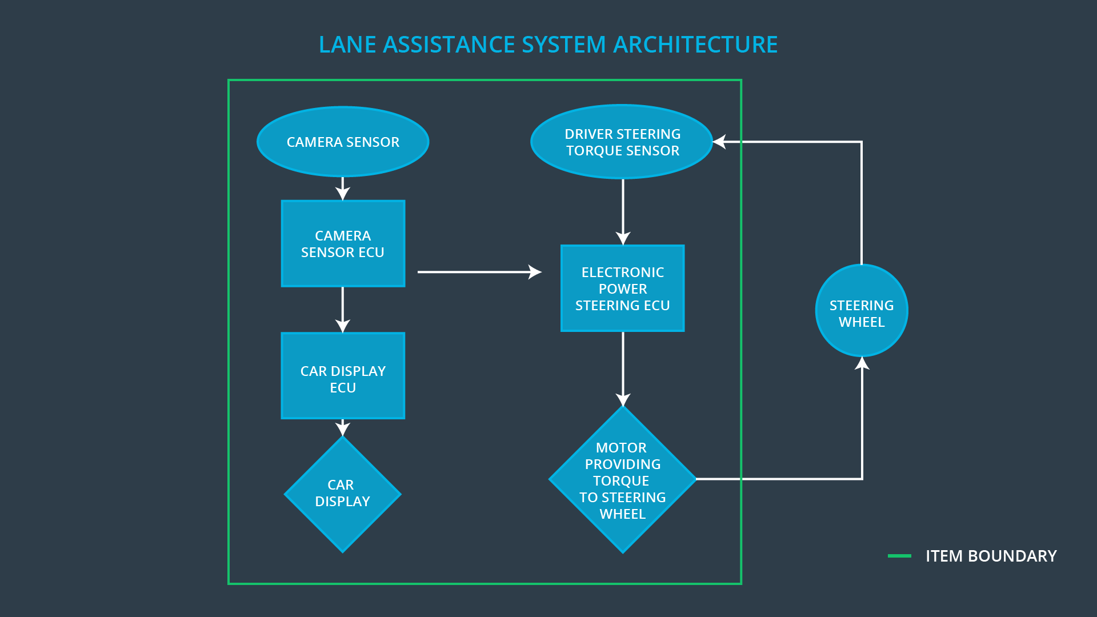

Figure : Preliminary architecture

### Description of architecture elements

|  |  |
| --- | --- |
| **Element** | **Description** |
| Camera Sensor | Physical sensor responsible for detecting lane lines |
| Camera Sensor ECU | Electronics hardware and processor or micro-controller responsible for interpreting camera data, identifying lane markings, determining vehicle position and issuing torque requests to the electronic power steering ECU |
| Car Display | Vehicle dashboard lights or display / screen unit providing status feedback to the driver of vehicle systems. |
| Car Display ECU | Electronics hardware responsible for interpreting input from other systems and controlling the lights or display unit. |
| Driver Steering Torque Sensor | Physical sensor such as an encoder or strain gauge capable of measuring steering torque input on the steering wheel from the driver. |
| Electronic Power Steering ECU | Electronics hardware responsible for accepting torque commands from other systems, monitoring the driver torque input and actuating the vehicle steering motor. |
| Motor | The motor which applies torque to the steering column, accepts voltage / current control from the Power Steering ECU. |

# Functional Safety Concept

The functional safety concept consists of:

* Functional safety analysis
* Functional safety requirements
* Functional safety architecture
* Warning and degradation concept

## Functional Safety Analysis

|  |  |  |  |
| --- | --- | --- | --- |
| **Malfunction ID** | **Main Function of the Item Related to Safety Goal Violations** | **Guidewords (NO, WRONG, EARLY, LATE, MORE, LESS)** | **Resulting Malfunction** |
| Malfunction_01 | Lane Departure Warning (LDW) function shall apply an oscillating steering torque to provide the driver a haptic feedback | The lane departure warning function applies an oscillating torque with very high torque amplitude (above limit) | Driver loses control of the vehicle. Collision with other vehicle or obstacle. |
| Malfunction_02 | Lane Departure Warning (LDW) function shall apply an oscillating steering torque to provide the driver a haptic feedback | The lane departure warning function applies an oscillating torque with very high torque frequency (above limit) | Driver loses control of the vehicle. Collision with other vehicle or obstacle. |
| Malfunction_03 | Lane Keeping Assistance (LKA) function shall apply the steering torque when active in order to stay in ego lane | The lane keeping assistance function is not limited in time duration which leads to misuse as an autonomous driving function. | LKA hardware and function is not adequate for autonomous driving. Collision with other vehicle or obstacle. |
| Malfunction_04 | Lane Keeping Assistance (LKA) function identifies lane markings, determines vehicle position and issues torque requests to the power steering ECU | The lane keeping assistance function wrongly identifies lane markings | The vehicle is steered in an incorrect direction, resulting in a collision with other vehicle or obstacle |
| Malfunction_05 | Lane Keeping Assistance (LKA) function identifies lane markings, determines vehicle position and issues torque requests to the power steering ECU | The lane keeping assistance camera sensor does not detect lane markings due to adverse weather obstructing the markings | The system does not actuate the steering wheel to stay in the lane. |

## Functional Safety Requirements

Lane Departure Warning (LDW) Requirements:

|  |  |  |  |  |
| --- | --- | --- | --- | --- |
| **ID** | **Functional Safety Requirement** | **ASIL** | **Fault Tolerant Time Interval** | **Safe State** |
| Functional  Safety  Requirement  01-01 | The lane keeping item shall ensure that the lane departure oscillating torque amplitude is below Max_Torque_Amplitude | C | 50ms | turn off functionality |
| Functional  Safety  Requirement  01-02 | The lane keeping item shall ensure that the lane departure oscillating torque frequency is below Max_Torque_Frequency | C | 50ms | turn off functionality |

Lane Departure Warning (LDW) Verification and Validation Acceptance Criteria:

|  |  |  |
| --- | --- | --- |
| **ID** | **Validation Acceptance**  **Criteria and Method** | **Verification Acceptance**  **Criteria and Method** |
| Functional  Safety  Requirement  01-01 | Driver testing is used to determine whether the Max_Torque_Amplitude value is controllable for most drivers | Software testing is used to command a torque larger than Max_Torque_ Amplitude, precision timing is used to ensure the system outputs zero torque within 50ms. A precision torque sensor instrument is used to verify that the Max_Torque_Amplitude setting is the value measured at the wheel. |
| Functional  Safety  Requirement  01-02 | Driver testing is used to determine whether the Max_Torque_Frequency value is controllable for most drivers | Software testing is used to command a frequency larger than Max_Torque_ Frequency, precision timing is used to ensure the system outputs zero torque within 50ms. A precision frequency sensor instrument, such as an accelerometer is used to verify that the Max_Torque_Frequency setting is the value measured at the wheel. |

Lane Keeping Assistance (LKA) Requirements:

|  |  |  |  |  |
| --- | --- | --- | --- | --- |
| **ID** | **Functional Safety Requirement** | **ASIL** | **Fault Tolerant Time Interval** | **Safe State** |
| Functional  Safety  Requirement  02-01 | The electronic power steering ECU shall ensure that the lane keeping assistance torque is applied for only Max_Duration. | B | 500ms | turn off functionality |

Lane Keeping Assistance (LKA) Verification and Validation Acceptance Criteria:

|  |  |  |
| --- | --- | --- |
| **ID** | **Validation Acceptance**  **Criteria and Method** | **Verification Acceptance**  **Criteria and Method** |
| Functional  Safety  Requirement  02-01 | Driver testing is used to determine if applying assistance torque for only max_duration dissuades drivers from using the LKA as an autonomous function and keeping their hands off the wheel | Timing is used to verify that the lane keeping assistance function is turned off after max_duration. |

## Refinement of the System Architecture

Based on the functional safety concept and requirements, the refined system architecture is presented in Figure 2. Note that the Camera Sensor ECU is mistakenly labelled as a Car Display ECU.

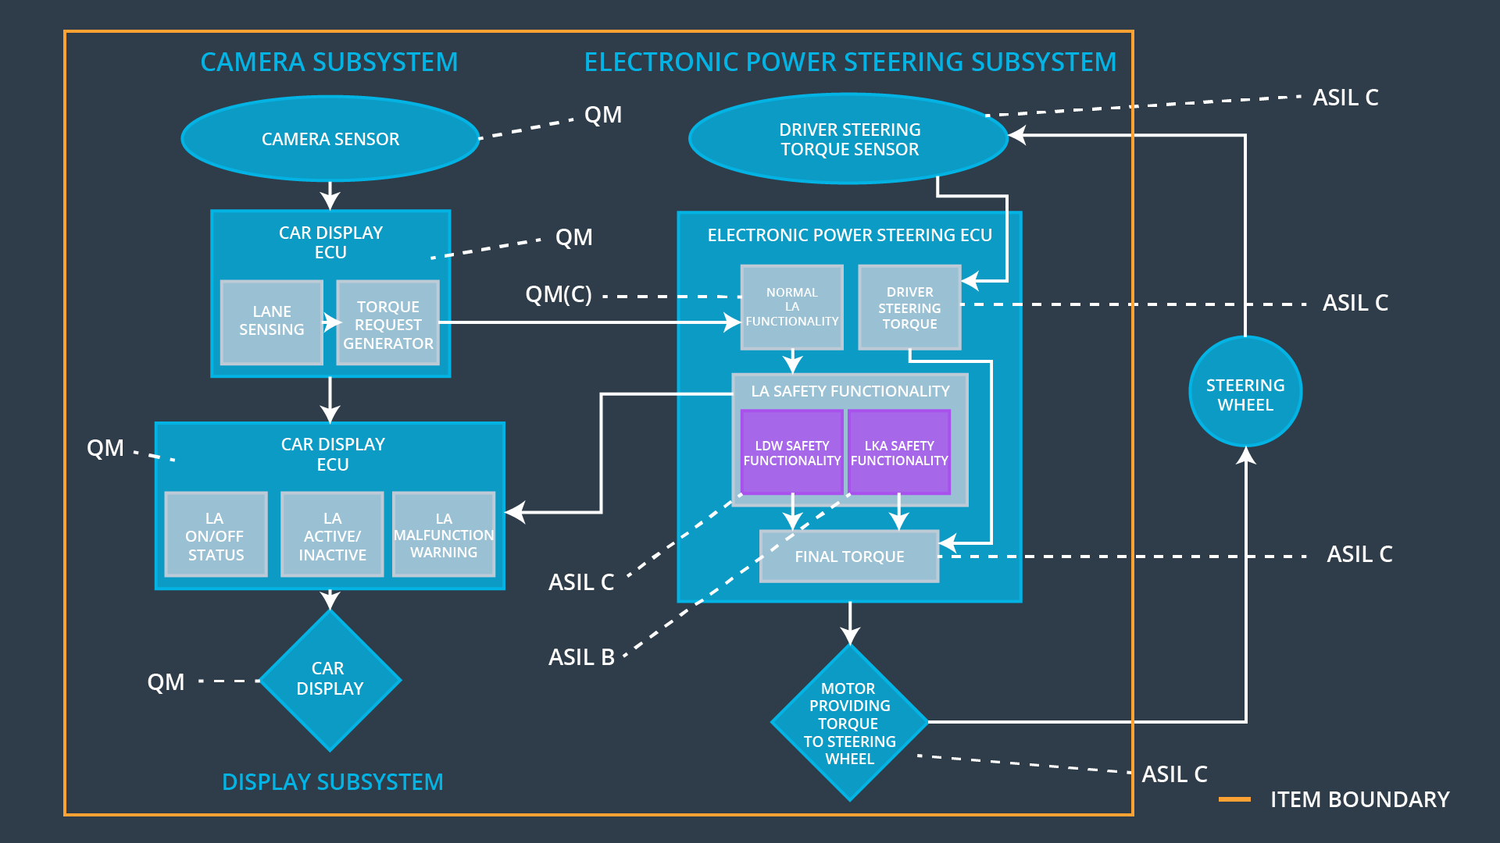

Figure : Refined System Architecture with ASIL labels

## Allocation of Functional Safety Requirements to Architecture Elements

|  |  |  |  |  |
| --- | --- | --- | --- | --- |
| **ID** | **Functional Safety Requirement** | **Electronic Power Steering ECU** | **Camera ECU** | **Car Display ECU** |
| Functional  Safety  Requirement  01-01 | The lane keeping item shall ensure that the lane departure oscillating torque amplitude is below Max_Torque_Amplitude | X | **NA** | **NA** |
| Functional  Safety  Requirement  01-02 | Driver testing is used to determine whether the Max_Torque_Frequency value is controllable for most drivers | **X** | **NA** | **NA** |
| Functional  Safety  Requirement  02-01 | The electronic power steering ECU shall ensure that the lane keeping assistance torque is applied for only Max_Duration. | X | **NA** | **NA** |

## Warning and Degradation Concept

|  |  |  |  |  |
| --- | --- | --- | --- | --- |
| **ID** | **Degradation Mode** | **Trigger for Degradation Mode** | **Safe State invoked?** | **Driver Warning** |
| WDC-01 | turn off the functionality | Malfunction_01/02 | yes | Car display |
| WDC-02 | turn off the functionality | Malfunction_03 | yes | Car display |