Reviewer #1 (REMARKS to AUTHOR(s)):  
  
The author proposed a 2D kinetic Ising model (IM) to simulate Arctic sea ice dynamics on a large length scale. The IM is an idealized model in statistical mechanics, and the author modified this model by introducing continuous spin values between -1 and 1 to describe the mixture between ice and water. The classical Metropolis-Hastings algorithm is used for time evolution, and the author modified this algorithm by introducing a factor to account for the inertia of spin value changes. The parameters of the IM are estimated based on observations, and many observed features are well captured by the IM.  
  
This paper applies statistical physics to an important problem in climate science, so it should be of great interest to both communities. Therefore, I can recommend the publication of this paper after the following minor issues are addressed.  
  
Abstract:  
  
1. The length scale being modeled in this paper should be clearly stated. Arctic sea ice has multiple length scales, and it should be stressed that this paper focuses on a large scale.  
EW: We have revised as your suggestion

2. It should be clarified that the continuous spin values are between -1 and 1. By default, a continuous variable can take values between -infinity and infinity, which is unphysical.

EW: We have revised as suggested.

Section V.A:  
  
1. In Table 1, the last row should be I instead of J. The fluctuations of the parameters I, J and B_0 are quite regular and well explained, but the fluctuations of the parameters B_x and B_y are much wilder and not explained. If unexplained, these fluctuations may imply overfitting. A related question is whether the estimated parameters are consistent across multiple runs of the dual annealing optimization method, especially for B_x and B_y. If not, then the probability density functions of the estimated parameters should be provided.  
EW: We have corrected the last row of table 1 to I.

2. It would be useful to discuss the critical temperature for this version of the IM and whether the estimated IM temperature is below or above this critical temperature. This will provide valuable insights into the role of environmental noise on the time evolution of Arctic sea ice.

EW: You are absolutely right that critical IM temperature will provide valuable insights on environmental noise to the sea ice evolution. However, critical IM temperature is out of scope for this specific research which focuses on the kinetic evolution only. In fact, critical temperature of a 2D Ising lattice with continuous spin value will be a very interesting problem itself.

Reviewer #2:

General Comments

This paper deals with the Ising model with continuous-valued spin configuration for modeling the Arctic sea-ice concentration field. A Monte-Carlo-based optimization technique is used to find optimal parameters to match the final concentration data. The objective function employs an ’inertia’ factor, punishing drastic changes between subsequent configurations in the dynamics.

The paper demonstrates the applicability of the Ising model to sea-ice dynamics, which is interesting

and promising. Once fitted against the initial and final configuration, the model shows excellent agreement between the simulation and actual data for the intermediate time steps. While the paper is generally well written, the tone is often expository and will benefit from making some statements more technical to appeal to the target audience. Some statements are missing relevant citations.

Overall, this is an interesting paper and deserves publication in Journal of Applied Physics after quite a bit of revision and attending to the points below. The idea to use a continuous spin Ising model to describe the values of the sea ice concentration field which takes values between 0 and 1, rather than a binary model, is novel and powerful. The introduction needs to be augmented to better describe up front what is assumed, what is fit, and so on, in other words, what are the inputs and outputs of the model. What would happen if you started with known initial conditions from sea ice data, and then explored different scenarios of evolution for different parameter regimes, regardless of what the actual evolution looked like?

EW:

Add a section I.C to describe upfront what’s done in this paper.

Initial condition and regime, in Section VI discussions?

Specific Comments

1. The first sentence of the paper, “The rapid loss of the Arctic sea ice over the past four decades has been an alarming phenomenon that points to drastic global warming, a serious challenge that calls for collective actions by the entire humankind,” and much of the Introduction, is inappropriate for a publication in a professional physics journal.

EW: We have revised the first sentence per your comment

2. On page 3, “... the feedback loop effect may occur, i.e., less reflection and more absorption of solar energy, leading to even more ice loss and further global warming.” It should be stated that this is usually called “ice-albedo feedback.”

EW: We have revised as suggested

3. Eq 1: It is unclear why the interaction *Jij* cannot be negative (i.e., antiferromagnetic)? Is is enforced in the method, or does it just come out of the optimization process?

EW: You are right that *Jij* is negative for antiferromagnet materials. For the research in this paper, it is natural that the area surrounding ice will be more likely to freeze, and area surrounding water will tend to melt. So *Jij* is expected to be positive with intuitive understanding. In this paper, this is the result coming out of the optimization process instead of being enforced, matching our expectation. We have revised the paper accordingly on page 3 and also for explanations of table 1 on page 9.

4. Allowing in the model introduces the possibility of ‘noninteraction’ (coinciding with *Jij=0* ) with any lattice site with 50% ice. Although it is numerically unlikely for any lattice site to achieve zero value exactly, theoretically, it is not ruled out. This poses a theoretical challenge which should be addressed.

EW: is possible, though numerically extremely unlikely. This is a challenge for the original binary Ising model, however, in the context of this paper, it has a natural physical explanation, i.e. the cell comprises exactly 50% water and 50% ice. The impacts from water and ice to an adjacent cell offset each other, so the net effect is neutral. So this *σi = 0* case is not a problem for the study in this paper.

5. P4 l10: Is the energy same as the Hamiltonian H in Eq 1? Or is it the argument of the exponential in Eq (5)? Please clarify.

EW: H in Eq (5) is the same as Eq (1) in section II.A. The total energy required for a spin flip is , which consists of two parts: the system Hamiltonian change plus the inertia effect. We have added more clarification to the paper.

6. P6: The methodology will benefit from a little more explanation. It is not clear in what order the simulation and the optimization are carried out. I propose adding a subsection to the beginning of Section IV to outline the methodology and how Subsections IV.A - IV.E are tied together.

EW: We have added a paragraph in section IV to outline the methodology.

7. Error analysis: An error plot showing the simulated and actual data would help demonstrate the results better. Section IV.E mentions l1-based optimization, but how small is the tolerance? The author provides the comparison of some useful statistics such as extent and coverage. In addition to the visual similarities (in the ‘eyeball norm’) described in the figures 3, 4, 6, and 7, a pointwise (or lp) error plot would be useful to demonstrate the difference.

EW: Thanks for the advice. We have added a heatmap as figure 5 in the paper to show the difference of the ice percentage of each lattice cell (the l1 measure of difference) between figure 3 and 4. We also added error bar plot in figure 5 for the overall differential for the whole focus area for each period. The heatmaps are very revealing: the small red patches mostly appear around the boundaries between water and ice, which shows that the majority of the discrepancy between the simulated and actual images happens at around these border areas. This result is not surprising, the IM is apparently far from perfectly modeling all these boundary granularities, but IM does a good job at capturing the overall configuration.

Similarly, we have calculated the daily sea ice differentials between Figure 7 and 8 of the paper. The corresponding heatmaps and error bar plot are shown in Figure I below. And the differential between Figure 9 and 10 of the paper is shown in Figure II below. Again, the majority of the discrepancy happens around the border between water and ice, but IM preserves the overall ice/water dynamics in the daily time scale. Please note that the error bars in (r) look larger only because of the different scale of the y axis. The actual errors are consistent as Figure 5 of the paper. Due to the length limit of the paper, these following two figures are not included in the paper.

Heatmap values are doubled, CORRECT!

Error bar values are correct, not doubled.

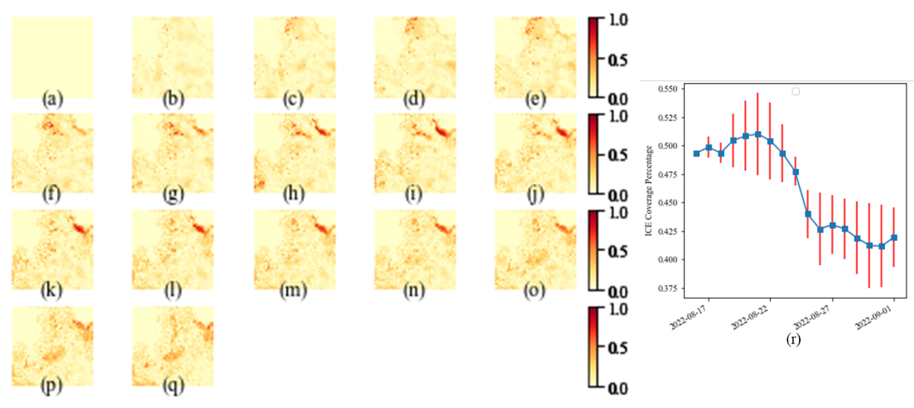

Figure I: Heatmaps illustrating the difference of the daily ice percentage between Figure 7 and 8 of the paper, from (a) Aug. 16th, 2022 to (q) Sept. 1st, 2022. (r) Error bar plot showing the daily average ice percentage differential in this period.

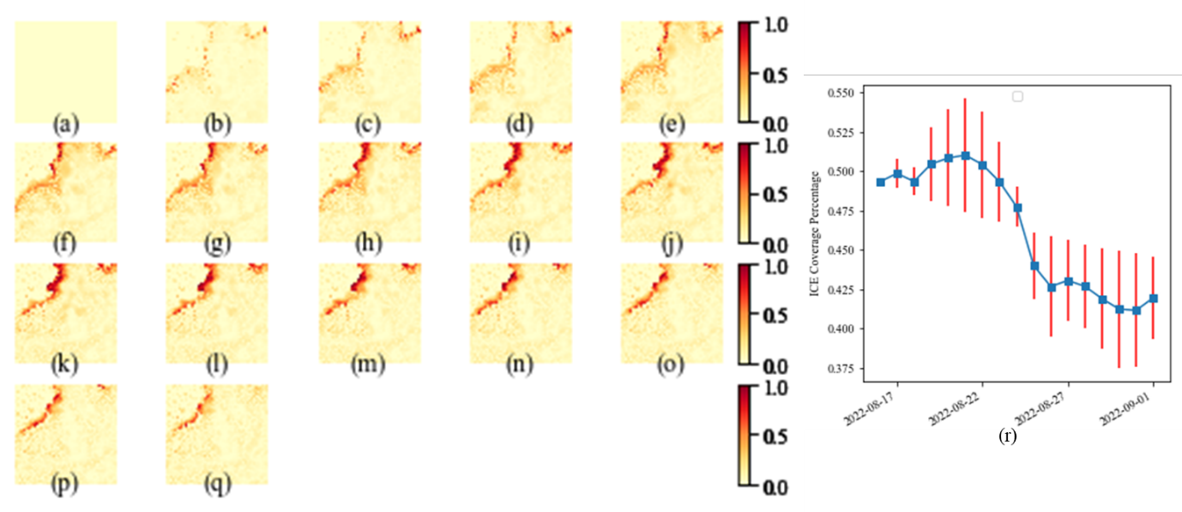

Figure II: Heatmaps illustrating the difference of the daily ice percentage between Figure 9 and 10 of the paper, from (a) Oct. 16th, 2022 to (q) Nov. 1st, 2022. (r) Error bar plot showing the daily average ice percentage differential in this period.

8. Extrapolation: Can the author comment on the extrapolation abilities of the model? For example, once the best-fit parameters are obtained for 2022, to what extent can it be recycled for 2023 or 2021?

EW: Great question. If recycling the full-year best-fit parameters from one year to another year, the results don’t match the observed configuration too well, which is expected because we start with a lattice almost fully covered in ice in June, and end in Dec again fully covered in ice. The idiosyncratic intra-year configurations will not be easily reproduced from the Ising parameters from another different year. However, in August 2023, we did test the projection of Sept to Dec 2023 based on the 2022 best-fit parameters. Specifically, we use the following parameters in Table I below, which is the partial data from Aug. 16, 2022 onwards as Table 1 in the paper.

|  |  |  |  |  |  |
| --- | --- | --- | --- | --- | --- |
|  | **8/16 to 9/1** | **9/1 to 9/16** | **9/16 to 10/1** | **10/1 to 10/16** | **10/16 to 11/1** |
| *J* | 2.7 | 2.3 | 2.6 | 2.7 | 2.6 |
| *B0* | 4.3 | 3.6 | -12.6 | -12.7 | -14.9 |
| *Bx* | -7.5 | -8.2 | -10.0 | -6.1 | -8.5 |
| *By* | -6.4 | 2.9 | 0.1 | -8.4 | -5.6 |
| *I* | 10.7 | 10.9 | 10.6 | 9.3 | 9.4 |

Table I: The best-fit Ising parameters from Aug 16, 2022 to Jan 1, 2023 sea ice evolution.

Then we start with the actual configuration of the focus area as of Aug 16th, 2023, and run the simulation process for 5 periods forward till Nov 1st, 2023 with the above IM parameters to predict how 2023 evolves. The predicted images are shown as (b) Sep 1 to (f) Nov 1 in Figure III, compared to the actual observations of these 2023 periods as (b)-(f) in Figure IV. As we can see that, the first 2 periods as in (b) & (c) match pretty well, but later periods from (d)-(f) show larger deviations, missing certain localized configurations. Nevertheless, the predicts match the general trends of observation.

Figure III: The simulated semi-monthly evolution of sea ice in our focus area in the near future. (a) is the actual image on Aug 16th, 2023 as the start state; (b)-(j) are simulated images (based on the best-fit IM parameters in the 2022 simulations over the corresponding semi-monthly periods) on (b) Sept 1st, (c) Sept 16th, (d) Oct 1st, (e) Oct 16th, (f) Nov 1st, (g) Nov 16th, (h) Dec 1st, (i) Dec 16th, and (j) Jan 1st, 2024.

Figure IV: The actual semi-monthly evolution of sea ice from (a) Aug 16th (b) Sept 1st, (c) Sept 16th, (d) Oct 1st, (e) Oct 16th, (f) Nov 1st, 2023

We also checked the average ice coverage percentage and ice extent based on the above predicts. In Figure V, the blue curves are actual 2023 observations; the orange curve from Jun 16 to Aug 16 are based on 2023 best-fit Ising parameters, From Sep 16 to Nov 1 are based on 2022 best fit parameters as in Figure III and IV above. Even though larger deviations are observed from Sep 1 and later, the orange curve of (b) ice extent did correctly predict that Sep 2023 would experience the second lowest extent for this focus Arctic sea ice area. This shows that recycling the Ising parameters, even though far from perfect, still can give us a lot of insights to different years.

Figure V: (a) The average ice coverage percentage and (b) the sea ice extent for our focus area in 2024. The predicted (orange) curves from Sept 1, 2023 onwards are based on 2022 best-fit parameters.

Due to the length limit of the paper, the above extrapolation analyses are not included in the paper. However, it is discussed briefly in Section VI.A of the paper.

9. A methodological concern: the paper could use a comparison with a simpler model (say, “vanilla Ising”) in order to make the present results compelling. i.e., given a four parameter simplification of this model, are the fits just as good, or only slightly worse? If so, then the conclusion isn’t that the inertia term is needed— it’s that the standard Ising model (as-is) can already describe seasonal variation in sea ice extent. That would also be an interesting result, but it would be fundamentally different from the central claim of this paper, which is that the inertia term is important. It may well be, but it’s not yet compellingly argued. Comparison is necessary to show improvement.

EW: We have tried vanilla Ising model without the inertia factor, which was actually explored at the start of this research. The performance of the simulation for 2022 using vanilla Ising are shown in Figure VI, VII, and VIII. Figure VI, the simulated semi-monthly sea ice configurations, show much more discrepancy from Figure 3 and 4 in the paper even by eyeballing. Figure VII shows the numeric differentials in heatmap and error bar, confirming the same observation as Figure VI. Figure VIII shows the sea ice percentage and extent, which again shows worse performance compared to Figure 6 in the paper which includes the inertia factor.

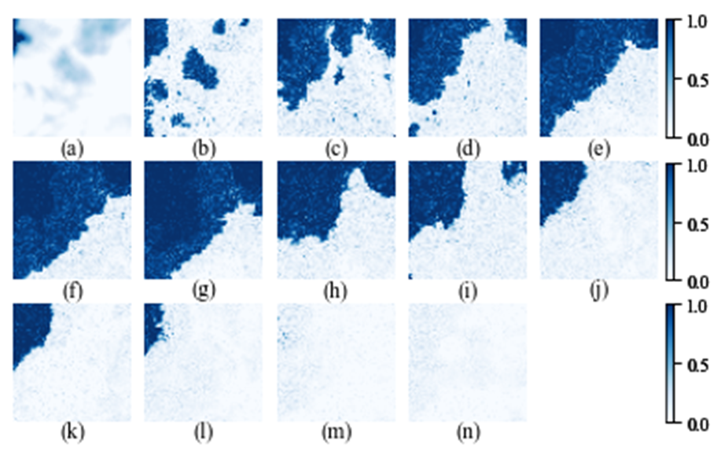

Figure VI: The simulated semi-monthly evolution of sea ice for our focus area in 2022, using the Ising model without the inertia factor

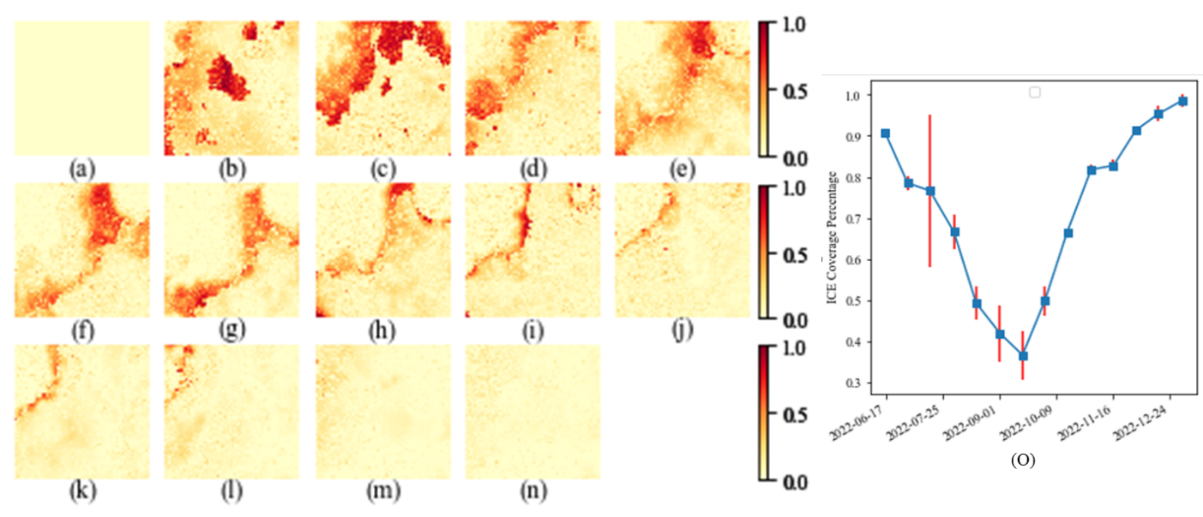

Figure VII: Heatmaps and error bar illustrating the difference of the ice percentage between Figure 3 in the paper and the above Figure VI, using the Ising model without the inertia factor

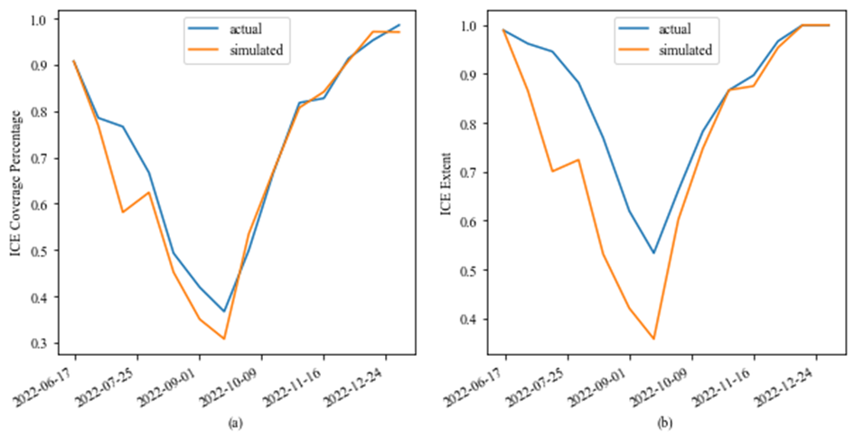

Figure VIII: The average ice coverage percentage and extent of 2022 using the Ising model without the inertia factor

In general, we see that adding the inertia factor makes the simulation process much more robust, showing this added feature has significant strength toward sea ice modeling. That said, we cannot and will not claim that this inertia factor is a must-have. It might be possible to improve the Ising model performance via other routes rather than the inertia factor, e.g. enrich the functional forms of J and B, which is out of scope for our paper.

Due to the length limit of the paper, these analyses to compare with Vanilla Ising model are not included in the paper. However, it is discussed briefly in Section VI.A of the paper.

10. “Use of language” concerns: quite a few instances of opinion and emotional language in the text.

Please read and check

11. Lack of citations for “obvious” claims.

EW: We believe this question refers to section IV.D. We have reworded with more explanation, and added a reference [22] to Stepinski, T.F. et al.

12. The form of the inertia term is a little unmotivated— why this and not something else?

EW: A way to think about the inertia factor is the linkage to latent heat of water/ice phase transition, which motivated and suggested this inertia factor in the dimension of energy. In physics, the total energy change for water/ice phase transition at constant temperature and pressure is proportional to the mass, therefore the simplest and also most sensible assumption is to have our inertia term as , which means that the required additional energy is proportional to ice coverage change. Therefore, we started with the simplest linear form and the IM works pretty well. Nevertheless, it is possible to have other functional forms for the inertia factor, which is out of scope for this paper. We have added more explanation to section II.C of the paper.

13. Its acknowledged in the paper that a different repetition number could have led to different parameter fits; this is potentially problematic, as it introduces an “almost” degree of freedom.

EW: It is common to pick reasonable repetition number for kinetic Ising model simulation. For example, in section 2.1 of reference [22] by Stepinski T.F. et al, it states that “To ensure that the number of dynamic steps taken is proportional to (Δt)i, it is necessary to establish a unit of time that corresponds to the duration of a dynamic step. … A different time unit can be either larger or smaller than 0.876 h, but it must remain consistent throughout the simulation to ensure that the number of steps for each transition is proportional to its duration”. This does introduce a degree of freedom, but the method is not problematic, because we are not going to tie these Ising parameters to the exact physics quantities in real world.

14. Issues of notational clarity in a few places; see below, but especially the (which is actually misleading and not explained until much later in the text) and the use of the word “energy.” It also looks like more clarity is needed with regard to the normalization of the probability density. It may be normalized within the code, but as stated in the manuscript, it’s pretty clearly wrong.

EW: We have added description of in section II.C, the first time it is introduced. Even though Hamiltonian and Energy are often used interchangeably in classical physics, we have clarified per your suggestion. In this paper, Hamiltonian refers to the state of the system; Energy refers the energy change of spin flip process, i.e. Hamiltonian change plus the inertia term. The probability density is normalized in the code as a standard process of the Metropolis Markov Chain Monte Carlo. For more details on this, pleas see the answer to question 23.

15. A few typos/grammatical issues; see below.

EW: Thanks for pointing out. We have revised as your comments.

16. “The fact that the year 2023 has witnessed the most sizzling summer on record and the hottest year in history adds even greater severity to such urgency.” Facts should be cited, and “sizzling summer”feels too informal here— great for an essay, less great for technical writing.

EW: We have reworded and added citation.

17. Ising model or Ising Model? Within the text I think it should be Ising model. Capitalization is a little inconsistent throughout the first couple of paragraphs before changing to just “IM.”

EW: “Ising model” is more commonly used. We have changed all cases to Ising model or IM.

18. “Onsager identified that there exists a critical temperature *Tc = 2.27 J/kB* when the phase transition happens in a 2-D IM. Later studies of IM in higher dimensions have been closely associated with various developments in advanced 20th-century physics and mathematical theories, including the transfer matrix method, quantum field theory, mean- field theory, etc.” I assume that the *2.27 J/KB* figure comes from either Figure 6 or Figure 7 of the Onsager paper cited, but I don’t see the number stated anywhere; is this the correct paper reference for this claim? It would also seem proper to cite the applications in transfer matrix method, etc.

EW: Onsager’s paper is the correct one. *2.27 J/kB*  comes from the first equation in the abstract of Onsager’s paper: , where J and J’ are interaction parameters for two different directions. For a uniform 2-D IM, setting J=J’ we have =1. After a few steps of algebra, this gives .

We have added citation for transfer matrix method, quantum field theory and mean-field theory in the paper.

19. “a major climate change indicator that is of significant environmental, economic, and social significance” Needs citations.

EW: We have added citation.

20. “Moreover, the Arctic ecosystem is directly impacted by the change in sea ice coverage, which, for instance, threatens the lives of polar bears and walruses who rely on sea ice for hunting and breeding.” Citations needed.

EW: We have added citation.

21. “*Jij* is usually positive, meaning that adjacent spins are inclined to maintain the same value to achieve low energy.” ...What does “usually” mean here?

EW: Similar as question #3. We have reworded and explained in the paper.

22. “The probability of each spin flip depends on whether such a flip increases or reduces energy” Energy has never been defined here; she’s almost certainly referring to the Hamiltonian, but it would be nice for that to be made explicit.

EW: We have reworded to Hamiltonian as your comments.

23. “mathematically the probability is determined by , where *Hv* and *Hµ* represent the Hamiltonian of the system before and after the flip. It can be easily seen that a higher IM temperature leads to more thermal fluctuations and greater randomness in the spin value distribution, while a lower IM temperature shows less fluctuations.” I buy what she says about IM temperature T and its influence on the variance... but are we sure that the expression she cites as the probability density on configuration space really sums to unity? It seems like either there are a lot of constraints going on that aren’t stated, or there’s a missing prefactor. Of course, her claim about the variance is insensitive to a missing prefactor. However,“greater randomness” is essentially meaningless. I think she means “greater variance”.

EW: For Equation (2) the Boltzman distribution, we can see that the probability densities sum to unity. Determination of the probability of a spin flip follows the Metropolis-Hastings Markov Chain Monte Carlo method, which states that, starting from a state x, the procedure of next iteration is: choose a candidate x’, the probability of whether accepting x’ is min(1, P(x’)/P(x)), where P(x) is the probability density function. It is mathematically proven that, following this migration process, such a Markov process will asymptotically reach the stationary distribution of P(x). So if we follow computational implementation of the Metropolis algorithm with flip probability as , the final stationary distribution will converge to summing to unity. There is no missing prefactor here. More details can be found on <https://en.wikipedia.org/wiki/Metropolis%E2%80%93Hastings_algorithm> and Metropolis’s paper as reference [42] of the paper. We also added another citation on simulation of Ising model using Metropolis algorithm as reference [36] by Shekaari, A. et al. “Theory and simulation of the Ising model”, where the essence of Metropolis and the factor P(x’)/P(x) is explained.

Thanks for pointing out the wording issue. We have revised “greater randomness” to “greater variance”.

24. “less” should probably be ”fewer”

EW: We have revised.

25. “Most studies of the IM focus on binary values of the spins”, this should be cited; feels impossible to know without a very comprehensive literature review.

EW: It is hard to run a statistics of how many scientific research papers are based on binary spin Ising model, vs. how many on continuous spin values. But most of the literatures cited in section I.A and II.A are based on binary spin values. We have reword this sentence to make it more accurate and also added citations here too.

26. I have the same concern as above re: the normalization of Equation (5).

EW: This follows the same argument as in question 23. The probability density is normalized as a standard process of the Metropolis Markov Chain Monte Carlo.

27. Re: the inertia factor I, I would like to better understand why it’s included this way— i.e., why does it live in the argument of the exponential? Why is this assumption made, and not some other?

EW: A way to think about the inertia factor is the linkage to latent heat of water/ice phase transition, which motivated and suggested this inertia factor in the dimension of energy and heat. And because the Hamiltonian is same dimension of energy, the most natural assumption is to have the inertia factor to be additive to the change of Hamiltonian of the system.

Another reason is that the inertia factor I plays the role only for the Metropolis simulation step. According to Boltzmann distribution and the Metropolis methodology, this requires the factor to be in the exponential to decide the probability of switching to next configuration state.

Above said, it is definitely possible to have other functional form for the inertia factor, or maybe don’t even need the inertia factor at all if we significantly enrich the functional forms of other Ising parameters J and B. The further study on functional forms for inertia factor and other Ising parameters is out of scope for this paper.

28. “In summary, the novelty of our IM is twofold: we introduce to the classical IM the continuous spin values and an inertia factor.” This is a bit misleading; continuous spin values were already considered, the novelty of this IM is in the inertia factor. References [31]-[33] describe continuous spin values in the IM.

EW: You are correct that continuous spin Ising model was already proposed and study by previous research even though they are much less studied than the original binary spin Ising model. Per your comments, we have deleted twofold and reworded the sentence.

29. “not excessively too long” There’s some redundancy here.

EW: We have revised.

30. “β, the inverse Boltzmann temperature, is set to 1 without loss of generality.” It appears that something is then not being considered carefully with the normalization of the probability density.

EW: The probability density is normalized as explained in the answer to question 23. As we follow the Metropolis MCMC simulation process, the probability density distribution will converge to follow the desired Boltzmann distribution. And the probability density only depends on , so it only depends on , but not individually on . So it means that the best-fit J,B,I will be inversed proportionally to . Therefore, we can set to 1 without loss of generality. In this paper, we are not going to tie these Ising parameters to physics quantities in real world, so this means for the best-fit J, B and I, what matters is their relative value, but not the absolute values. A similar approach has been taken in reference [22], for example, which uses Glauber simulation dynamics (an alternative to Metropolis algorithm).

31. “Generate another random variable between -1 and +1” So is the “attempted change”; this should be mentioned much earlier. Also, what is the distribution used to generate the ? The distribution used to generate these will influence the results by skewing which states are accepted first by the algorithm.

EW: We have added description of in section II.C. The distribution of is uniformly random between -1 and +1 – we have added this in the paper now.

32. “n this case, another random variable r between 0 and 1 is generated” ...I think she means uniformly random here; it would make sense given what she’s trying to have the algorithm do.

EW: Yes, it is uniformly random. We have revised the paper.

33. “This specific repetition number is an intuitive pick,” You can’t really just pick things out of intuition - more needs to be said and justified.

EW: We have reworded the sentence and added explanation. This specific repetition number is picked by taking into account the computational complexity of the algorithm and also ensuring each spin cell of the Ising lattice gets sufficiently enough attempts to be changed. What is critical is to ensure the repetition number for each period is proportional to its duration, so the unit time of each metropolis step is the same across the full simulation process. Similar approach is taken by other kinetic Ising model such as reference [22].

34. ...“the fitted parameter values [...] might vary with different repetition numbers.” Yes, exactly! This feels like a significant issue that should be addressed; is it true that you could get nice-looking results just by tweaking the repetition numbers? If so, there’s a hidden tuning parameter here.

EW: As explained in question 13 and 33, what is critical is to ensure the repetition number for each period is proportional to its duration, so the unit time of each metropolis step is the same across the full simulation process. Similar approach is taken for example by reference [22]. Different repetition numbers can lead to varying fitted parameters *(J, B0, Bx, By, I)* as explained in question 30. But in this paper, we are not going to tie these Ising parameters to physics quantities in real world, so what matters for the Ising parameters is their relative value, but not the absolute values.

35. “Euclide” → Euclidean.

EW: We have revised.

36. “Finally, we fit the values of parameters [...] to maximize of the similarity measure” It seems like it should be shown what happens when I isn’t included at all, in order to establish that this really is an improvement; on the other hand, if you include an extra parameter, of course you can fit things better, so it really needs to be a significant improvement in goodness of fit in order to justify the inclusion of I; exactly what constitutes “significant improvement” can be made quantitative.

EW: This is analyzed quantitatively and explained in question 9, 40 and 42. We see that adding the inertia factor makes the simulation process much more robust, showing this added feature has significant strength toward sea ice modeling. However, we will not claim that this inertia factor is a must-have. It might be possible to improve the Ising model performance via other routes rather than the inertia factor, e.g. enrich the functional forms of J and B, which is out of scope for our paper.

37. “succeeding” → “successive” is probably better.

EW: We have revised.

38. “J” in the last row of the table should be “I”, I think.

EW: Thanks for pointing out. We have revised.

39. Figure 4 is very impressive! It might be better to have Figure 3 and 4 closer together (same page?) though; it’s a little tedious flipping back and forth to get to see the main “wow” result from this paper.

EW: Thanks for the suggestion! We will make sure the two figures on the same page in the final published format.

40. re: Figure 5, it would still be nice to see how well “vanilla Ising” does here, without the extra parameter— it isn’t necessarily surprising that having an extra parameter makes fits better.

EW: We analyzed in the answer to question 3 and copied again in Figure IX below, which shows the 2022 average ice percentage and extent using vanilla Ising model without the inertia factor, as compared to Figure 5 (now Figure 6 in the new manuscript) of the paper. It can be seen that figure 5 (6 in new manuscript) in the paper shows much better performance, especially on the ice extent.

Figure IX: The average ice coverage percentage and extent of 2022 using the Ising model without the inertia factor

41. General question: it looks like at least *J* and *I* are pretty similar between Table I and Table II! How different are the other parameters, quantitatively? If they’re all very consistent, this would be a nice story.

EW: Indeed, the spin interaction coefficient J and the inertia factor I are relatively stable. On the other hand, , display large variations across different time periods. This makes sense because J and I represents the inherent interactions in the water/ice system; it is intuitive to believe the strength of such interactions does not change much across different time periods. Whereas, , represents the external force parameters which depends heavily on the external environment change. In particular, the average force is positive from June 1st to Sept 16th but turns negative afterwards, which can be explained intuitively by the seasonal ambient temperature as the dominant external factor for ice/water dynamics. More explanations are included in section V.A of the paper. Please also note that, as described in question 30, we are not going to tie these Ising parameters to physics quantities in real world, so this means for the best-fit J, B and I, what matters is their relative strength, but not the absolute values.

42. Figure 12, same concern; does vanilla Ising do this just as well, or do we need the inertia term?

EW: Figure IX below, which shows the 2023 average ice percentage and extent using vanilla Ising model without the inertia factor, as compared to Figure 12 (Figure 13 in the new manuscript) of the paper. Similar as the 2022 results, including the inertia factor shows much better performance overall, especially on the ice extent.

Figure X: The average ice coverage percentage and extent of 2023 using the Ising model without the inertia factor

43. “Many scientists are concerned that the effect of Arctic sea ice decline on global warming will intensify as the sea ice loss continues” Citations would be good here.

EW: We have added citations.

44. “It is exciting and inspiring to see that the 100-year-old classical Ising model has the potential to bring enormous power towards climate change research and other applied science studies.” This sentence feels a little fluffy, it has the wrong “flavor” for a journal article, and can be re-worded to have a similar spirit.

EW: We have reworded.