Kepler’s law:

Angular Momentum Conservation:

**Shape parameters: *a*: semi-major axis, *b*: semi-minor axis, *c*: linear eccentricity, *p*: semi-latus rectum**

**Orbital and escape velocity. Different orbits:**

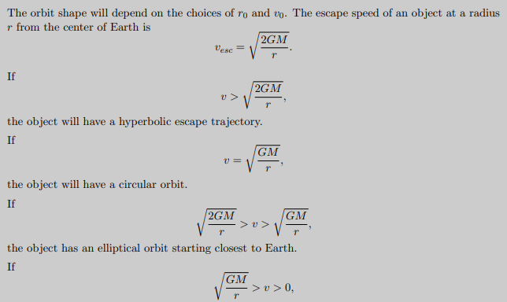



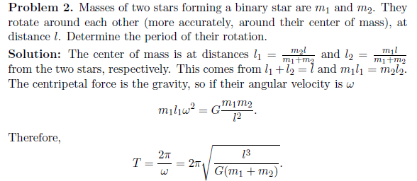

Elastic collision: u is velocity before collision; v is after.

List of moment of inertia:

<https://en.wikipedia.org/wiki/List_of_moments_of_inertia>

**Bernoulli’s principle**

**Venturi Effect**



Rotation from ramp:

Condition for rolling without slip from a ramp:

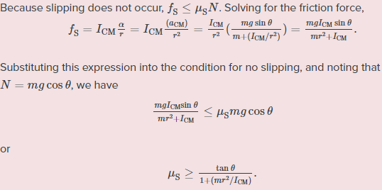

**Period of pendulum with large angle: grows with theta and converges to a finite number**

**Damped simple harmonic motion:**

**Angular frequency for small oscillation around equilibrium point:**

Where V is the potential, x0 is the equilibrium point

**Speed of wave in a string:**

, where µ is mass per unit length.

**Tension in a circular string: restoring force F = 2𝜋T, where T is the tension.**

**Euler-Lagrange Equation:**

, where L = T – V

We say that is a cyclic coordinate, and , if Cartesian coordinates are used then .

**, so if L does not have depend on t explicitly (which is usually the case), the E is conserved.

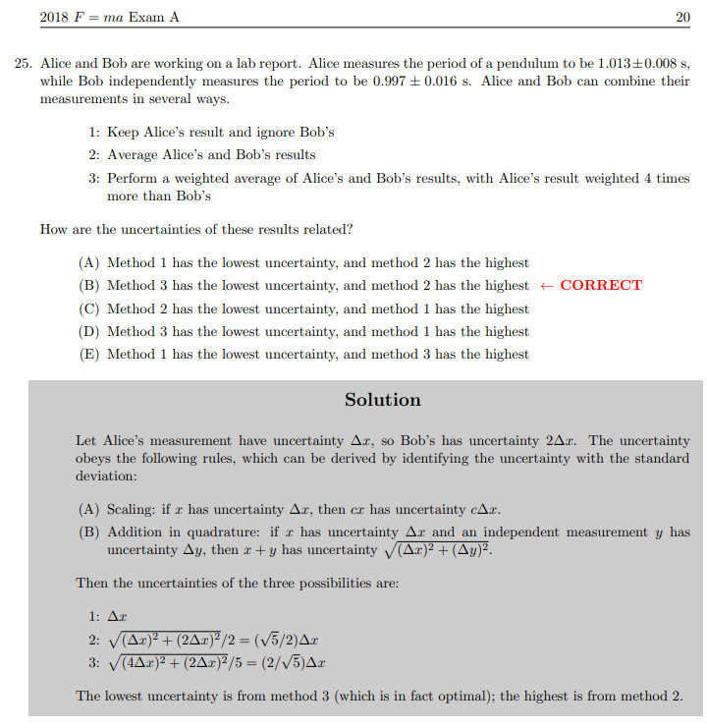

**Taylor expansion**

**Useful integral for Work W and Power P:**





**Spherical coordinate:**

**Spherical coordinate integral:**

**Differentiation: **

**E.g. velocity: **

**Coordinates transformation, gradient, divergence, curl, etc:**

[**https://en.wikipedia.org/wiki/Del_in_cylindrical_and_spherical_coordinates**](https://en.wikipedia.org/wiki/Del_in_cylindrical_and_spherical_coordinates)

**Electric field for electric dipole:**

**, for x >> d.**

**Electric field of general dipole: ** 

**Total Potential energy of a uniformly charged solid sphere: ,** which can be calculated as bringing small charge continuously from infinite distance to build the sphere, or integrating the field intensity over the whole space inside and outside the sphere.

**Image charge of point charge q which is distance b from the center of a grounded conducting sphere. The sphere radius is r:**

Image charge distance: .

Image charge:

The force on the charge is: 

**Image charges for composite grounded sphere + plane:**

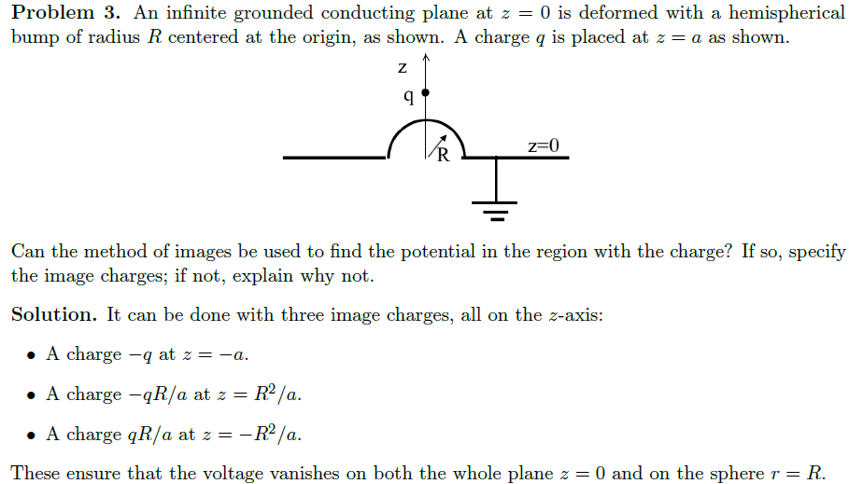

**Image charge of a non-grounded sphere with net charge q:**

**Capacitance of two concentric spherical metal shells with radii a<b:**

**DC circuits / resistors:**

Electromagnetic wave:



Peak energy intensity: ***I0 = 2 Iave***

**Maxwell’s equations**

Integral form:









Heat by radiation:

Change of internal energy equals heat transferred into the system, minus work done by the system to outside:



Kinetic energy of the an atom of monatomic ideal gas is: 

The kinetic energy is the only form of internal energy for monatomic ideal gas, so it’s total internal energy is: 

And for monatomic gas, the molar (1 mole) heat capacity at constant volume is , where *R=NAk* is the gas constant.

The molar (1 mole) heat capacity at constant pressure is . (Extra heat is needed to do work to the environment as volume expands)

Carnot Efficiency: 

Heat pump coefficient of performance: 

Air conditioner and refrigerator performance:  

Carnot cycle: 

Change in entropy: 

Entropy is constant for a reversible process; and it increases for an irreversible process.

Entropy is also the loss of energy available to do work.

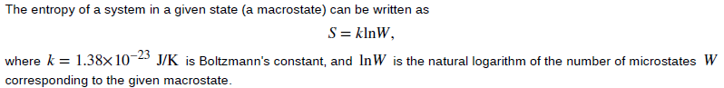

**Wave:**



Standing wave: , where n=1,2,3,…. The longest wavelength for standing wave is 2L.

**Relativity:**

Time dilation:

Length contraction:



Relativistic Doppler effects: 

Where 

Momentum: 

Energy: 





**Lorentz transformation**

Matrix form:

, Where

Similarly for energy and momentum:

**Relativistic momentum and force and effective mass:**

So effective mass: , which can be used to solve for oscillation frequency, etc.

**Electric charge is Lorentz invariant.**