MongoDB Checkpoint
1 Create a database called "contact"

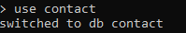
2 Create a collection called "contactlist"

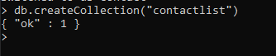
3 Insert these documents in "contactlist" :
Note: i forget to add “Fatnassi Sarra” at the beginning, but i added it later at the end.
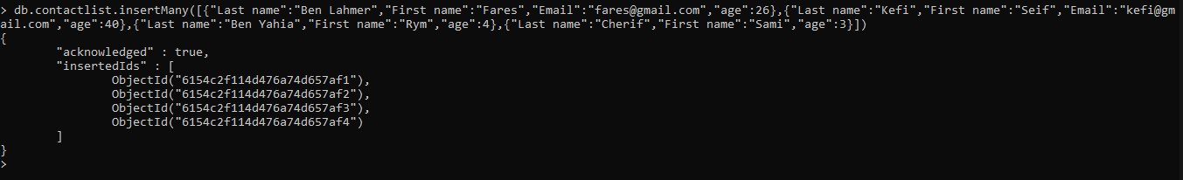
4 Display all of the contacts list
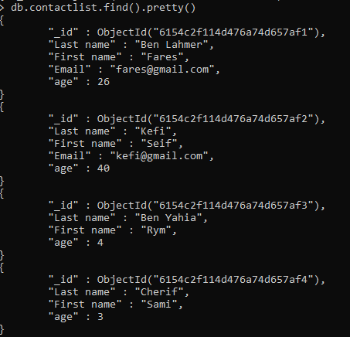
5 Display all the information about only one person using his ID.

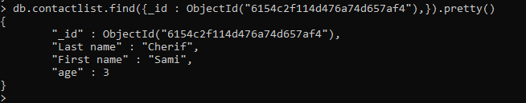
6 Display all the contacts with an age >18
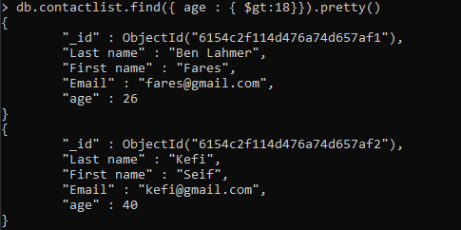
7 Display all the contacts with an age>18 and name containing "ah"
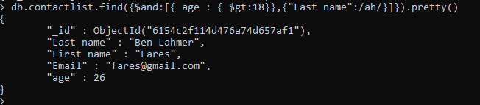
8 Change the contact's first name from"Kefi Seif" to "Kefi Anis".
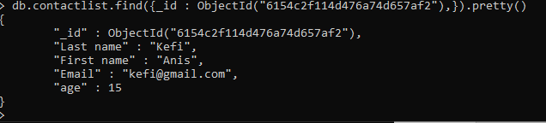
9 Delete the contacts that are aged under <5
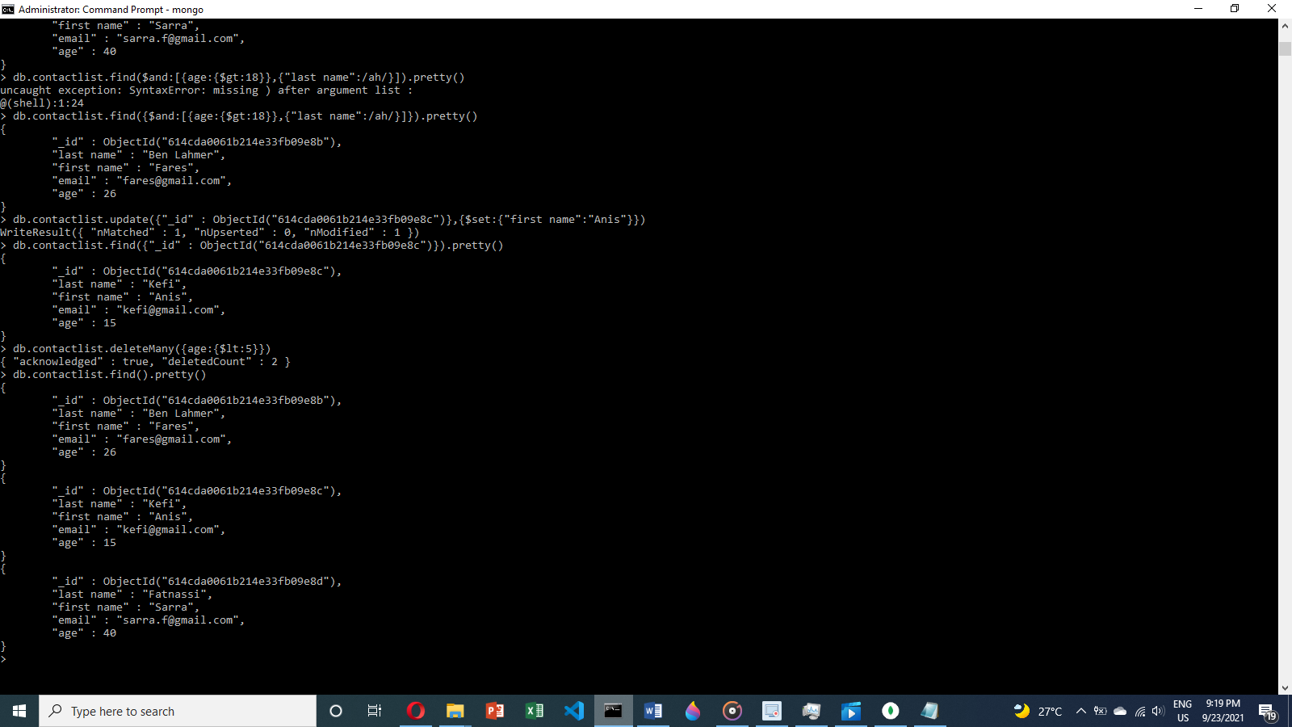
10 Display all of the contacts list
