**Name :** salisu oluwatobiloba boluwatife

**Course code: com 316**

**Course title: introduction to c#**

**Solutions**

1. Question1

using System;

namespace QuestionArray

{

class AscendOrder

{

static void Main(string[] args)

{

Console.Write("Enter the number1: ");

int num1 = int.Parse(Console.ReadLine());

Console.Write("Enter the number2: ");

int num2 = int.Parse(Console.ReadLine());

Console.Write("Enter the number3: ");

int num3 = int.Parse(Console.ReadLine());

int min = Math.Min(Math.Min(num1, num2), num3);

int max = Math.Max(Math.Max(num1, num2), num3);

int middle = (num1 + num2 + num3) - min - max;

Console.WriteLine("Numbers in ascend order:" + min+ ", " + middle+ ", " + max);

}

}

}

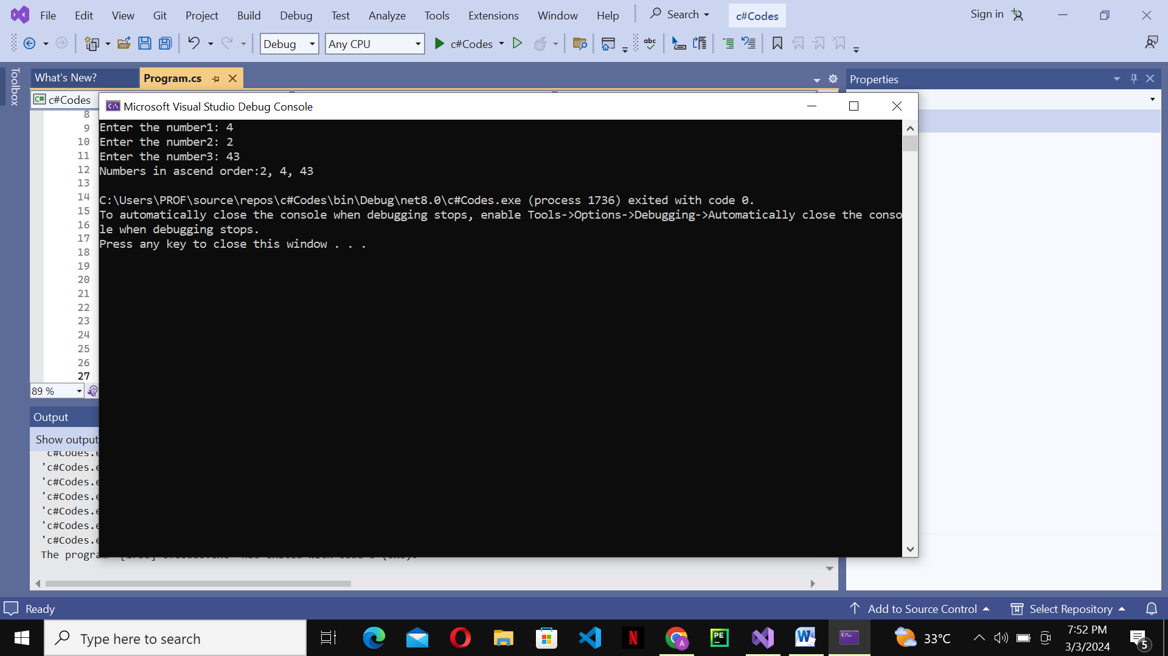

1. Question 2   
   using System;

namespace TestIndex

{

class Program

{

static void Main(string[] args)

{

int[] array = { 5, 3, 11, 4, 8 };

int size = array.Length;

int index = smallestIndex(array, size);

if (index != -1)

{

Console.WriteLine("The smallest element is at index: " + index);

}

else

{

Console.WriteLine("Array is empty or size is invalid.");

}

}

static int smallestIndex(int[] array, int size)

{

if (size <= 0)

{

return -1;

}

int minIndex = 0;

for (int i = 1; i < size; i++)

{

if (array[i] < array[minIndex])

{

minIndex = i;

}

}

return minIndex;

}

}

}

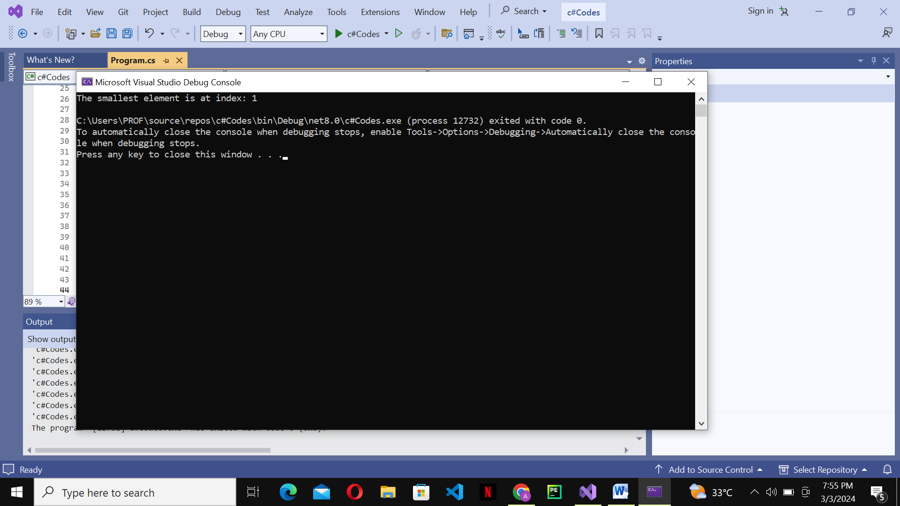

1. Question 3   
   using System;

namespace UpperCaseNum

{

class UpperCase

{

public static void Main(string[] args)

{

Console.WriteLine("input the string");

string input=Console.ReadLine();

char[] arr = input.ToCharArray();

for(int i=0; i<arr.Length; i++)

{

arr[i] = char.ToUpper(arr[i]);

Console.Write(arr[i]);

}

}

}

}

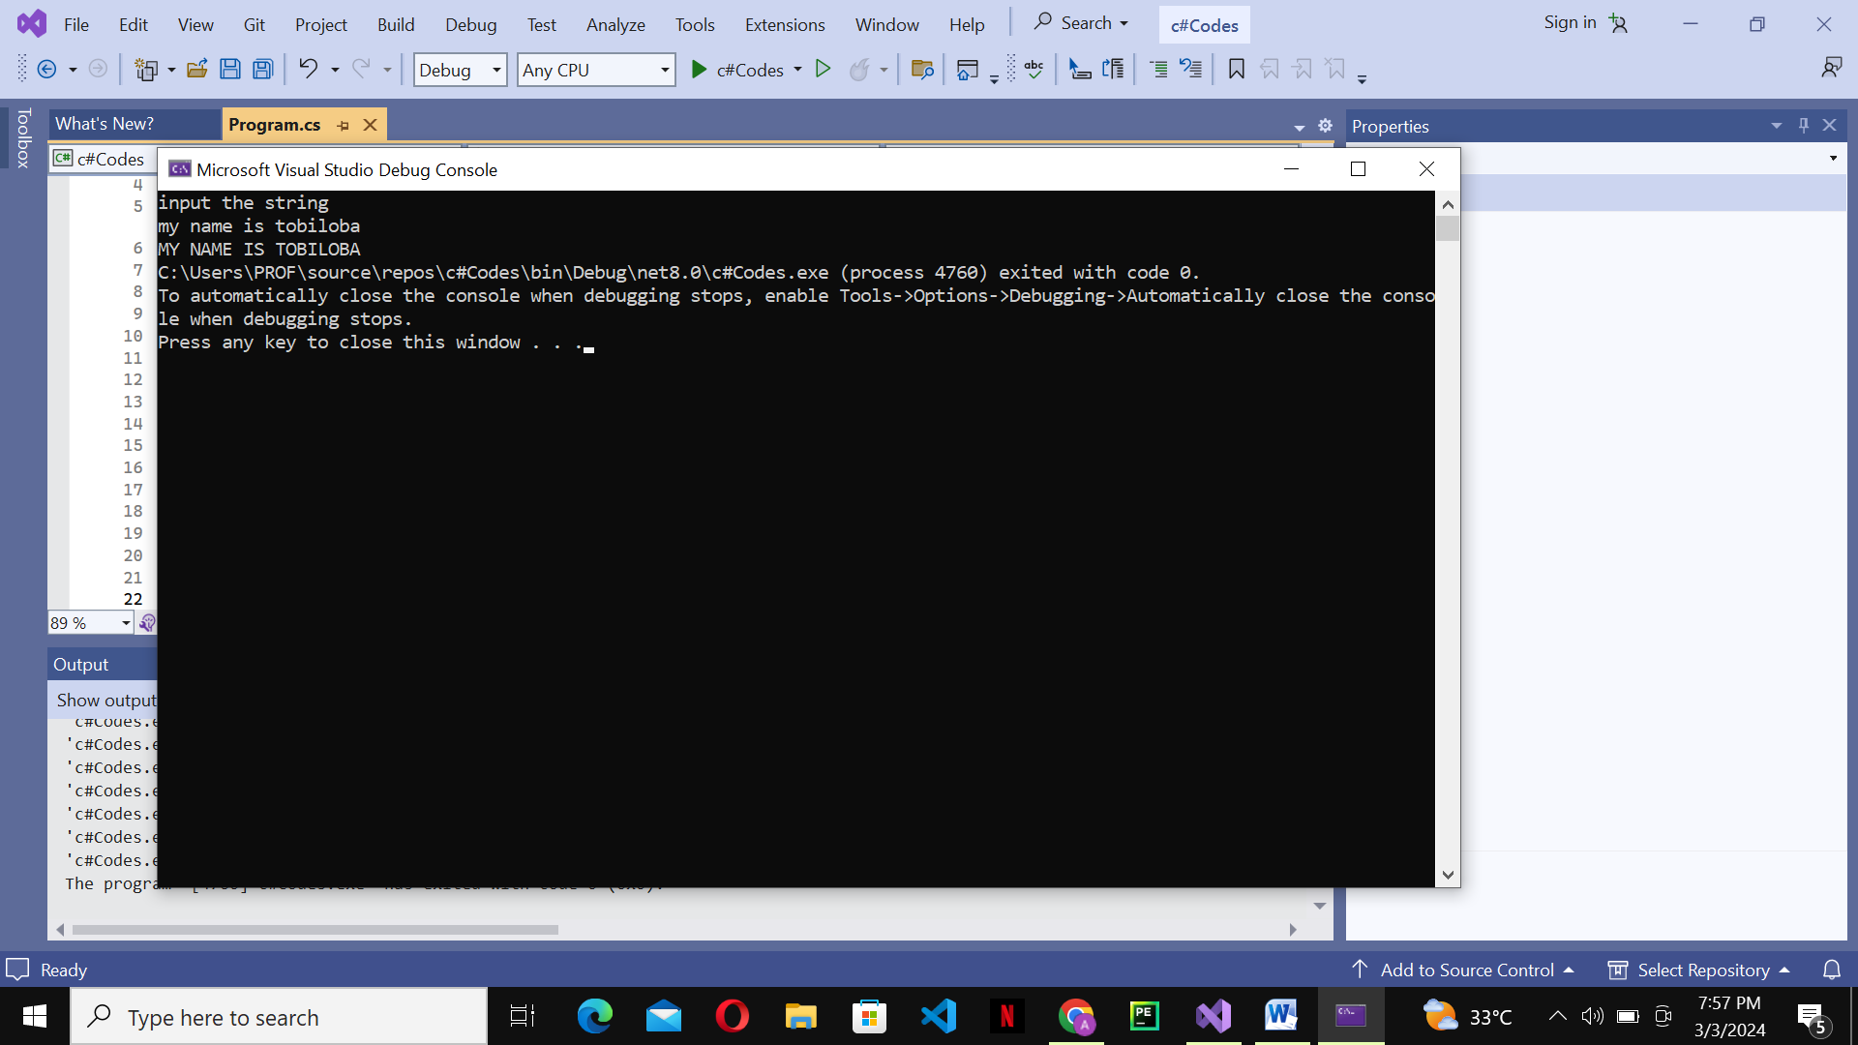

1. Question 4   
   using System;

namespace TwodimenArray

{

class Matrics

{

static void Main(string[] args)

{

Console.Write("Number of rows (N): ");

int N = int.Parse(Console.ReadLine());

Console.Write("Number of columns (M): ");

int M = int.Parse(Console.ReadLine());

int[,] matrix1 = new int[N, M];

int[,] matrix2 = new int[N, M];

Console.WriteLine("Enter elements for the first matrix:");

ReadMatrix(matrix1);

Console.WriteLine("Enter elements for the second matrix:");

ReadMatrix(matrix2);

int[,] result = AddMatrices(matrix1, matrix2);

Console.WriteLine("Result Matrix:");

PrintMatrix(result);

}

static void ReadMatrix(int[,] matrix)

{

for (int i = 0; i < matrix.GetLength(0); i++)

{

for (int j = 0; j < matrix.GetLength(1); j++)

{

Console.Write("Enter element at position [{0}, {1}]: ", i, j);

matrix[i, j] = int.Parse(Console.ReadLine());

}

}

}

static int[,] AddMatrices(int[,] matrix1, int[,] matrix2)

{

int[,] result = new int[matrix1.GetLength(0), matrix1.GetLength(1)];

for (int i = 0; i < matrix1.GetLength(0); i++)

{

for (int j = 0; j < matrix1.GetLength(1); j++)

{

result[i, j] = matrix1[i, j] + matrix2[i, j];

}

}

return result;

}

static void PrintMatrix(int[,] matrix)

{

for (int i = 0; i < matrix.GetLength(0); i++)

{

for (int j = 0; j < matrix.GetLength(1); j++)

{

Console.Write(matrix[i, j] + " ");

}

Console.WriteLine();

}

}

}

}

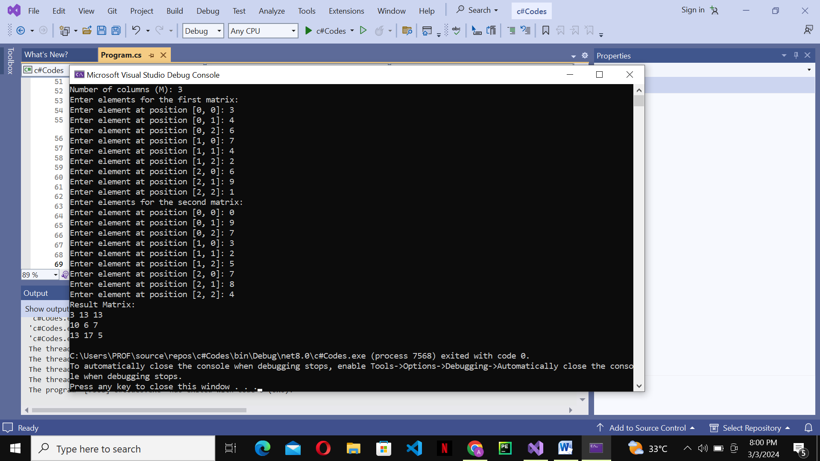

1. Question 5   
   using System;

namespace MyArray {

class Program

{

static void Main(string[] args)

{

float[] alpha = new float[50];

for (int i = 0; i < 25; i++)

{

alpha[i] = i * i;

}

for (int i = 25; i < 50; i++)

{

alpha[i] = 3 * i;

}

Console.WriteLine("the Array elements:");

for (int i = 0; i < alpha.Length; i++)

{

Console.Write(alpha[i] + "\t");

if ((i + 1) % 10 == 0)

{

Console.WriteLine();

}

}

}

}

}

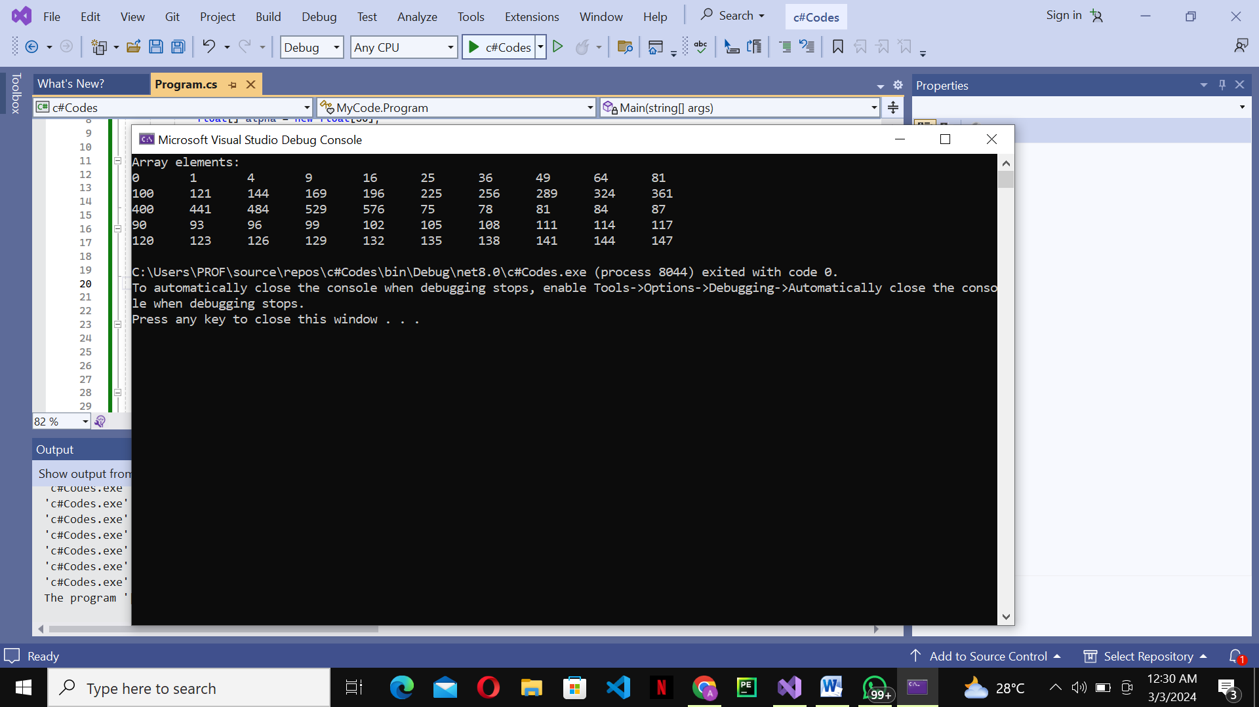

1. Question 6   
     
   using System;

namespace Checking {

class Testing

{

public static void Main(string[] args)

{

Console.WriteLine("Enter the number");

int num = int.Parse(Console.ReadLine());

if (num > 0)

{

Console.WriteLine(num + " is a positive number");

}

else if (num < 0)

{

Console.WriteLine(num + " is a negative number");

}

else

{

Console.WriteLine(num + "your number is zero");

}

}

}

}

