Alexander Watson

CS 4351

Programming Assignment 4

**Task 1: Caesar Cipher**

1. **Decrypt**

Using a decryption setup, we will decrypt the message using ascii lowercase and making the original text lowercase as well.

Running the code with a few keys will show that the 4th shift completes the cipher.

1. **Encrypt**

For the encryption I will use the same logic but in the reverse:

So instead of moving the position to the plain text we are shifting the plain text’s position by 7 as instructed. Running the script I get the following text:

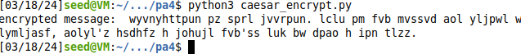

**Task 2: Frequent Analysis**

1. **Relative Frequency**

Using CrypTool this is the relative frequency of the letters in the cypher text:

1. **Frequency Decryption**

The following is an example of the relative frequency of the English language:

The Cipher Text:

lrvmnir bpr sumvbwvr jx bpr lmiwv yjeryrkbi jx qmbm wi bpr xjvni mkd ymibrut jx irhx wi bpr riirkvr jx ymbinlmtmipw utn qmumbr dj w ipmhh but bj rhnvwdmbr bpr yjeryrkbi jx bpr qmbm mvvjudwko bj yt wkbrusurbmbwjk lmird jk xjubt trmui jx ibndt wb wi kjb mk rmit bmiq bj rashmwk rmvp yjeryrkb mkd wbi iwokwxwvmkvr mkd ijyr ynib urymwk nkrashmwkrd bj ower m vjyshrbr rashmkmbwjk jkr cjnhd pmer bj lr fnmhwxwrd mkd wkiswurd bj invp mk rabrkb bpmb pr vjnhd urmvp bpr ibmbr jx rkhwopbrkrd ywkd vmsmlhr jx urvjokwgwko ijnkdhrii ijnkd mkd ipmsrhrii ipmsr w dj kjb drry ytirhx bpr xwkmh mnbpjuwbt lnb yt rasruwrkvr cwbp qmbm pmi hrxb kj djnlb bpmb bpr xjhhjcwko wi bpr sujsru msshwvmbwjk mkd wkbrusurbmbwjk w jxxru yt bprjuwri wk bpr pjsr bpmb bpr riirkvr jx jqwkmcmk qmumbr cwhh urymwk wkbmvb

**Task 3: DES**

Encryption: DES uses 64-bit blocks that use a key length of 56-bits which is derived from the block using 8th -bit as a parity bit, which is the XOR of the previous 7th-bit. The plaintext undergoes a set of substitution and then permutations before finally being encrypted through the XOR function

Decryption: In short, decryption is done by using the same steps but the subkeys are used in reverse order.

**Task 4: AES**

AES has a fixed block size of 128 bits, key length starting from the block size of 128 bits and then growing to either 192 bits or 256 bits. The key length depends on the number of rounds. 10 rounds for 128, 12 for 192, and 14 rounds for 256-bit kyes. The algorithm works by initializing the round through a XOR operation, then using a lookup table provides a nonlinear substitution, treating the bits like a matrix for each block the rows are shifted, and the columns are mixed, the key is XOR and added again. Finally, the AES algorithm repeats the substitution, row shifting, and key addition.

**Task 5: Encryption w/ Different ciphers/modes**

The first mode I chose to use is the aes-256 cypher which converted the text into both unrecognizable symbols of the terminal as well as non-English symbols such as Chinese and Arabic.

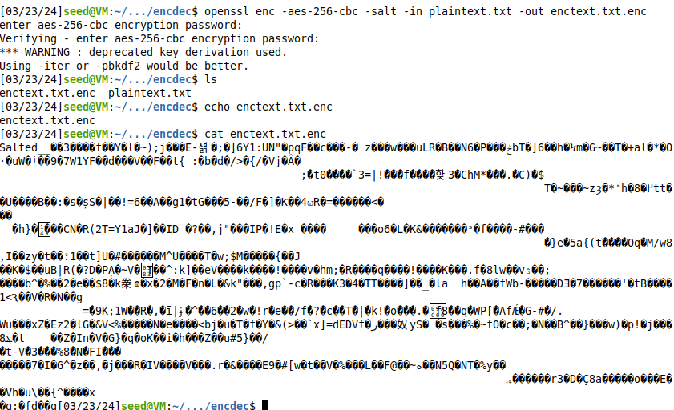

For the next encryption I used DES which produced a bunch of special characters, still including different language characters but also varying different types of other characters as well as a lot of blank space throughout the text.

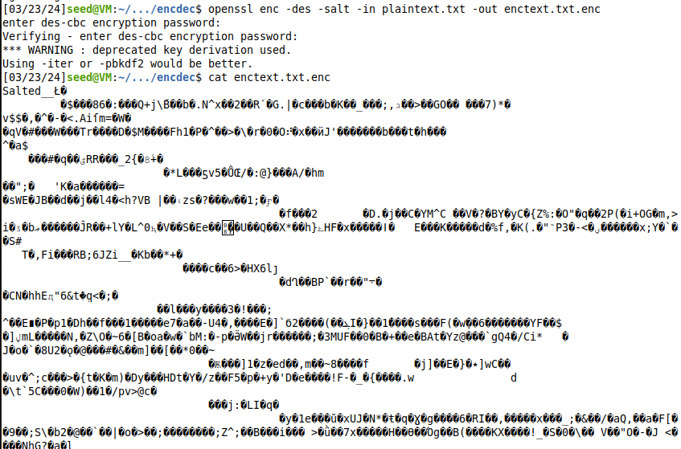

Finally, I used the seed encryption mode and it produced a similar setup to AES-256 however, it appears to be making less whitespace and filling in more characters with special characters rather than alphanumeric characters.

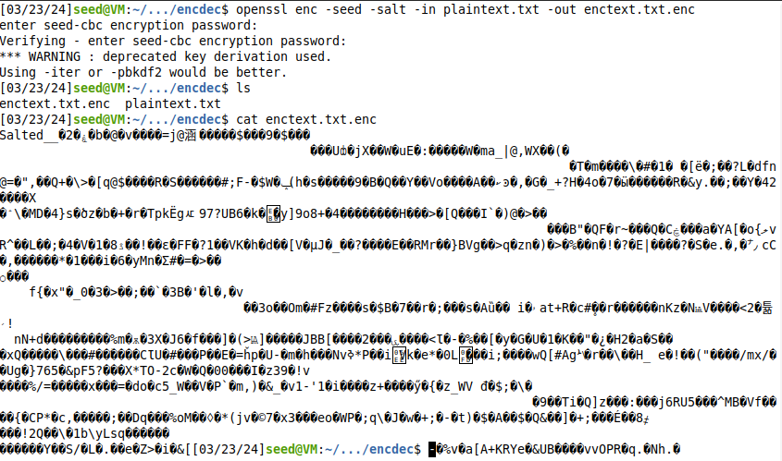

**Task 6: ECB vs. CBC**

**Task 7: Error Propagation – Corrupted Cipher Text**