Functional Requirements Document (FRD) – Illustrated vFinal

# 3.0 Pre-Login & Onboarding

* FR-0001: On first login, the system must require account verification.
* FR-0002: After verification, users must complete a short survey: referral source and role selection (Landlord, Property Manager, Both, Other).
* FR-0003: Provide an onboarding flow guiding users to add a property, add units, and add tenants.
* FR-0004: Users may skip or complete onboarding at will, progress is tracked visibly.
* FR-0005: Onboarding progress must mark tasks as completed.

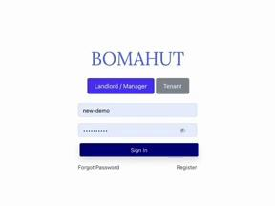

Figure 3.0a: Account verification screen.

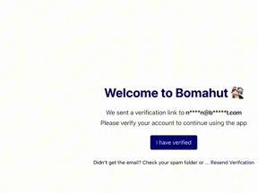

Figure 3.0b: Role selection survey.

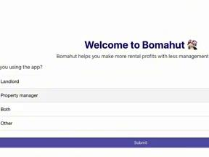

Figure 3.0c: Onboarding flow wizard.

# 3.1 Dashboard

* FR-001: On login, users land on the dashboard.
* FR-002: Dashboard provides quick actions: Send reminders, Record payments, Add utilities.
* FR-003: Dashboard includes 'More Actions' dropdown with extended functions.
* FR-004: Dashboard displays statistics: unpaid balances, amount paid this month, occupancy summary.
* FR-005: Dashboard shows graphical comparison of expected vs. received payments.

# 3.2 Property & Unit Management

* FR-006: Properties are the top-level organizational unit.
* FR-007: Each property can contain multiple units.
* FR-008: Each unit can host exactly one tenant.
* FR-009: Required property fields: Property name, Number of units, Location.
* FR-009a: Properties can define recurring bills (e.g., garbage fees).
* FR-009b: Recurring bills auto-generate alongside rent invoices each month.
* FR-009c: Rent penalty supports fixed amount, % of rent, or % of balance.
* FR-009d: Payment instructions configurable and embedded in invoices.
* FR-010: Extended property fields include water rate, electricity rate, Mpesa Paybill, management fee, tax rate.
* FR-011: Saved properties appear in the property list.

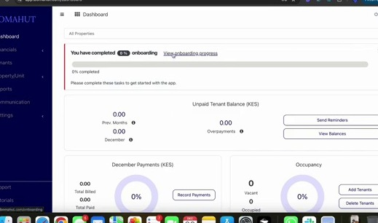

Figure 3.2a: Add Property form.

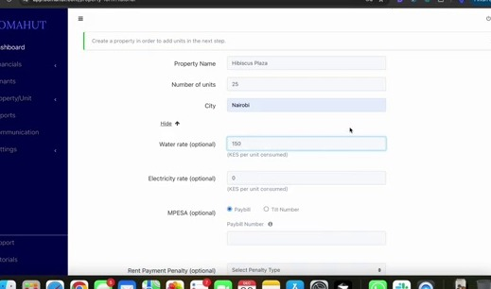

Figure 3.2b: Add Unit form.

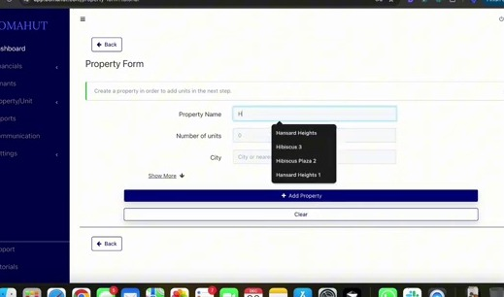

Figure 3.2c: Property list view.

# 3.4 Tenant Management

* FR-016: Tenants are added under the Tenants tab.
* FR-017: Required tenant fields: Name, at least one phone number, National ID.
* FR-018: Optional tenant fields: Email, deposits by type (rent/water/electricity), notes, lease docs, move-in/out dates.
* FR-018a: Support up to 10 phone numbers per tenant.
* FR-018b: Allow 'payer names' for payment reconciliation.
* FR-018c: Optional fields include KRA PIN and multiple deposits.
* FR-018d: Tenants may be archived instead of deleted (data retained, unit vacated).
* FR-019: Account number defaults to unit identifier but can be customized.
* FR-020: System confirms addition and updates property view.
* FR-021: Balance column shows outstanding balance; clicking opens transaction history.
* FR-022: Tenant actions include: Add Invoice, Record Payment, Send Reminder, Send Custom Message, Send/Download Statement, Transfer Tenant, Archive Tenant.
* FR-023: Filtering supports balances, lease expiry, archived tenants, property selector.

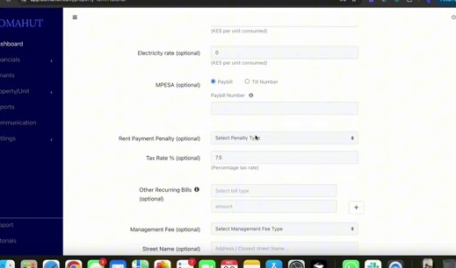

Figure 3.4a: Add Tenant form.

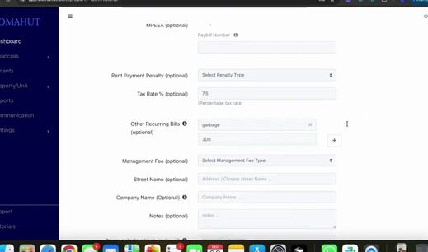

Figure 3.4b: Tenant list with filters and actions.

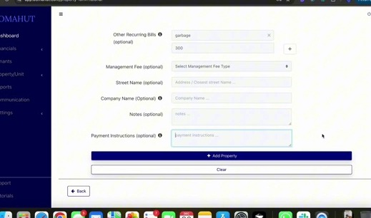

Figure 3.4c: Tenant balance and transaction history.

# 3.6 Transactions: Invoices & Payments

* FR-023: Users can add invoices (rent, utilities, other charges).
* FR-023a: Invoices can be generated manually, in bulk, or for recurring bills.
* FR-023b: Auto-invoicing occurs on the 1st each month unless disabled.
* FR-023c: Prevent duplicate rent invoices in the same month.
* FR-024: Users can add payments manually.
* FR-024a: Payments can also be uploaded via bank statement import with auto-matching.
* FR-024b: Payments not matched must be flagged as 'Unassigned'.
* FR-025: System recalculates balances dynamically after invoices/payments.
* FR-026: Multiple invoices within a month can be combined.
* FR-027: Tenant transaction history shows invoices, payments, and running balances.

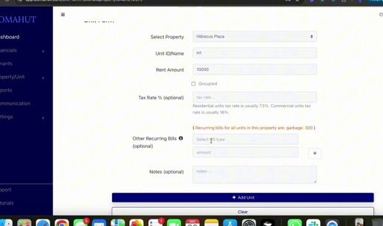

Figure 3.6a: Add Invoice form.

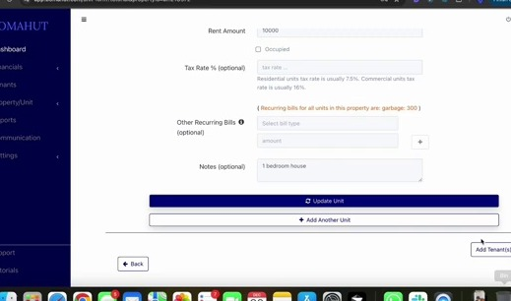

Figure 3.6b: Invoice list view.

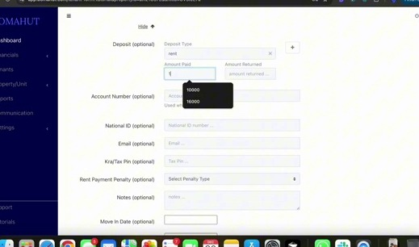

Figure 3.6c: Add Payment form.

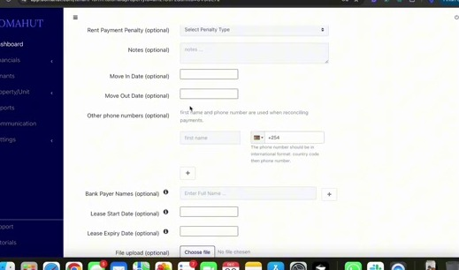

Figure 3.6d: Bank statement upload for payment auto-matching.

# 3.9 Financials & Expenses

* FR-033: Financials tab shows Invoices, Payments, Expenses.
* FR-034: Users can view invoice list and details.
* FR-035: Users can add invoices individually or in bulk.
* FR-036: Bulk invoices preview tenants before confirmation.
* FR-037: Rent invoices generated monthly using unit rent amounts.
* FR-038: Duplicate rent invoices prevented within same month.
* FR-039: Invoice list can be downloaded.
* FR-040: Invoice reminders can be sent in bulk.
* FR-041: Payments recorded by property/tenant selection.
* FR-042: Expenses can be added with optional link to unit.
* FR-043: Expense fields: amount, payment method, category, optional document upload.
* FR-044: Expense records included in monthly financial statements.
* FR-045: Income vs. expenses monthly report generated.

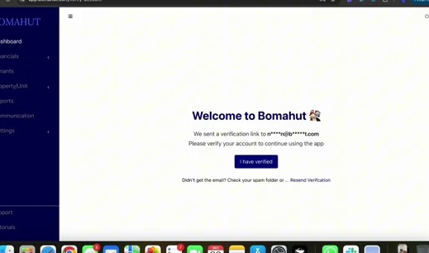

Figure 3.9a: Financials tab overview.

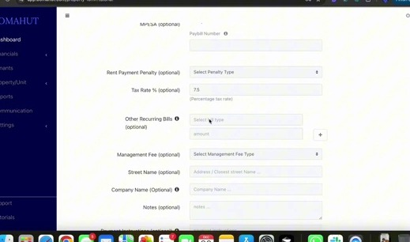

Figure 3.9b: Add Expense form.

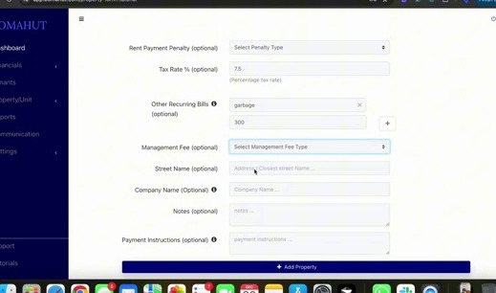

Figure 3.9c: Expenses list.

# 3.10 Utilities Management

* FR-047: Utilities managed per property (e.g., water, electricity).
* FR-048: Utilities can be recorded manually or via bulk upload.
* FR-049: Utility record fields include previous reading, current reading, date.
* FR-050: Current reading must be higher than previous.
* FR-051: After recording, user prompted to create invoices.
* FR-052: Option to send invoices/messages to tenants immediately.

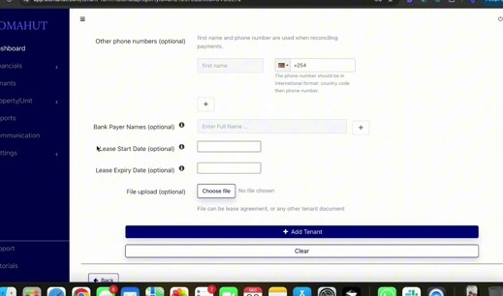

Figure 3.10a: Utilities tab view.

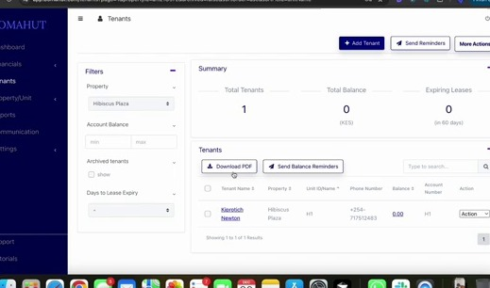

Figure 3.10b: Bulk upload utilities form.

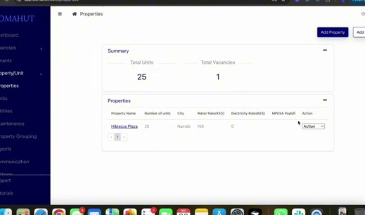

Figure 3.10c: Invoice prompt after saving utility readings.

# 3.11 Maintenance Management

* FR-053: Users can log maintenance issues per property/unit.
* FR-053a: Maintenance can be linked to expense records.
* FR-053b: Linked expenses auto-created in Financials.
* FR-054: Maintenance fields include property, unit, status, category, description, optional photo.
* FR-055: Maintenance records display in a list with statuses.
* FR-056: Records can be closed once resolved.

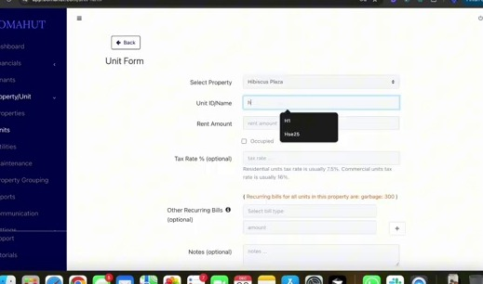

Figure 3.11a: Maintenance tab.

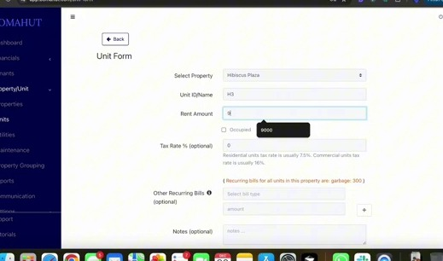

Figure 3.11b: Add Maintenance form.

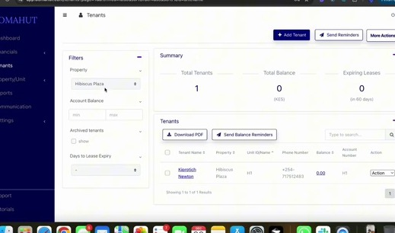

Figure 3.11c: Maintenance list with statuses.

# 3.12 Settings

* FR-057: General settings include company name, address, logo, Mpesa details.
* FR-058: Enable auto-rent invoice generation on 1st of month.
* FR-059: Configure auto-reminders on selected days.
* FR-060: Alerts include payment notifications, email reports (daily/weekly/monthly).
* FR-061: Configure SMS low-balance alerts.
* FR-062: Add team members with roles (Viewer, Editor, Admin).
* FR-063: Landlords tab tracks property owners for managers.
* FR-064: Billing shows subscription dues and SMS balance.
* FR-065: Payments to system provider made via displayed Mpesa Paybill.
* FR-066: Audit trail logs all team member logins and actions.

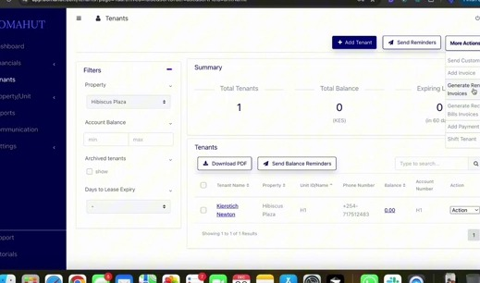

Figure 3.12a: General settings.

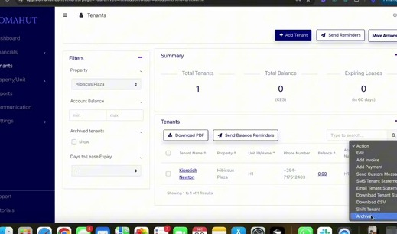

Figure 3.12b: Alerts configuration.

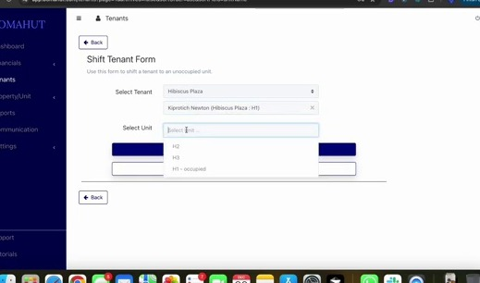

Figure 3.12c: Team roles.

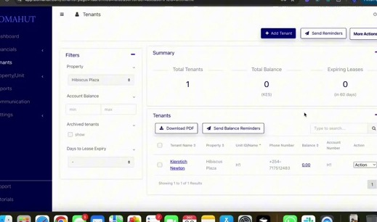

Figure 3.12d: Billing and SMS balance.

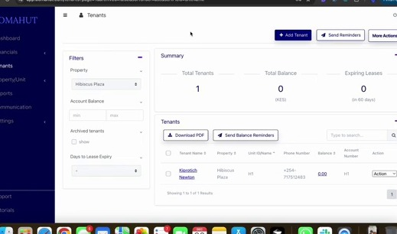

Figure 3.12e: Audit trail.

# 3.13 Reports

* FR-067: Reports must include tenant statements, property statements, arrears, expenses, month-on-month, year-on-year, property groupings.
* FR-068: All reports must be exportable as PDF or Excel.

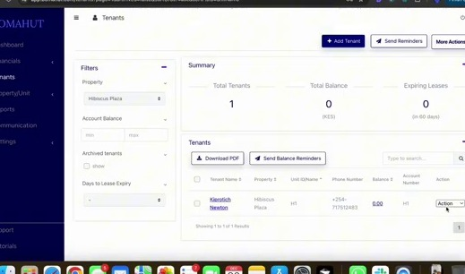

Figure 3.13a: Reports tab overview.

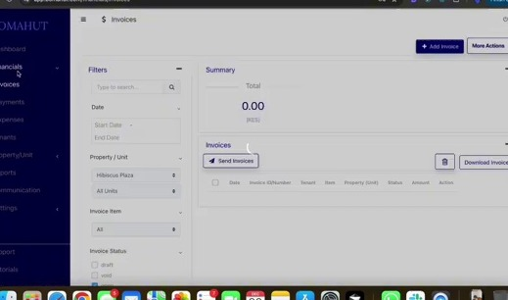

Figure 3.13b: Tenant statement.

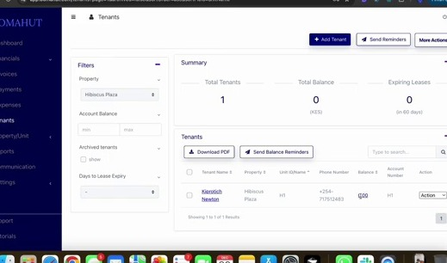

Figure 3.13c: Property statement.

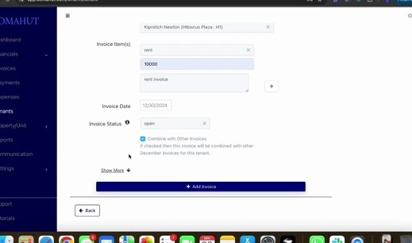

Figure 3.13d: Arrears report.

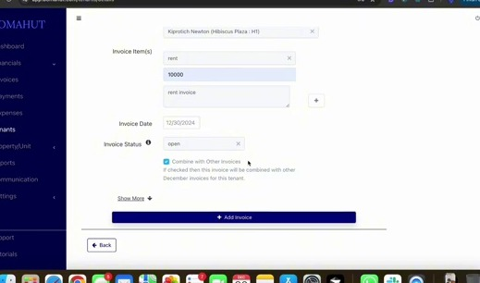

Figure 3.13e: Month-on-month report.