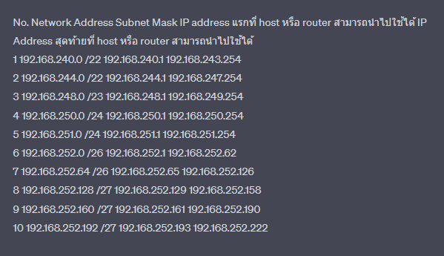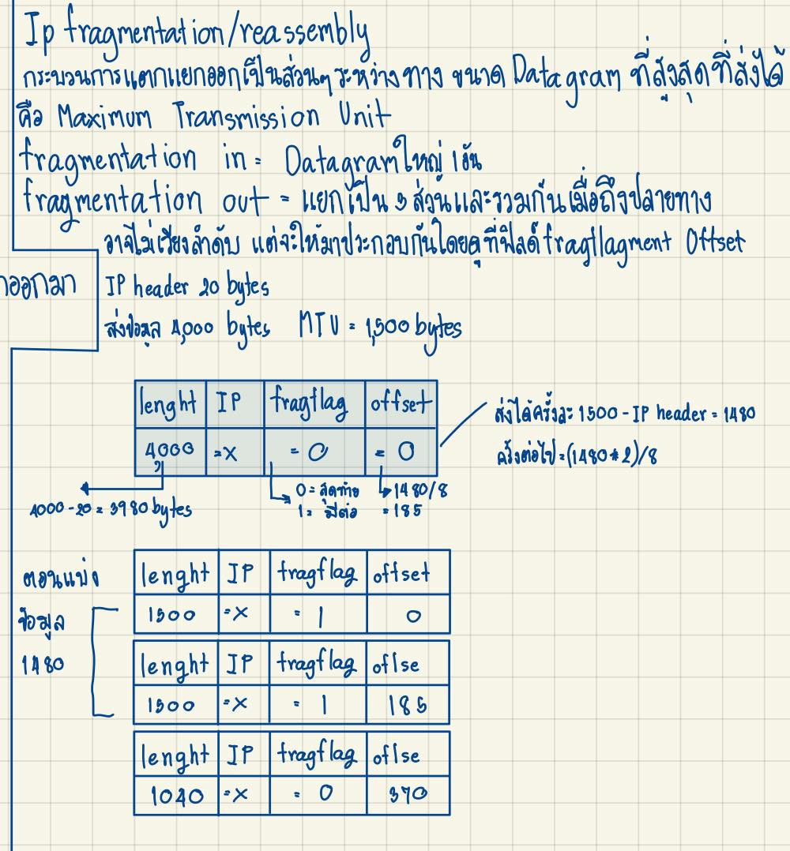

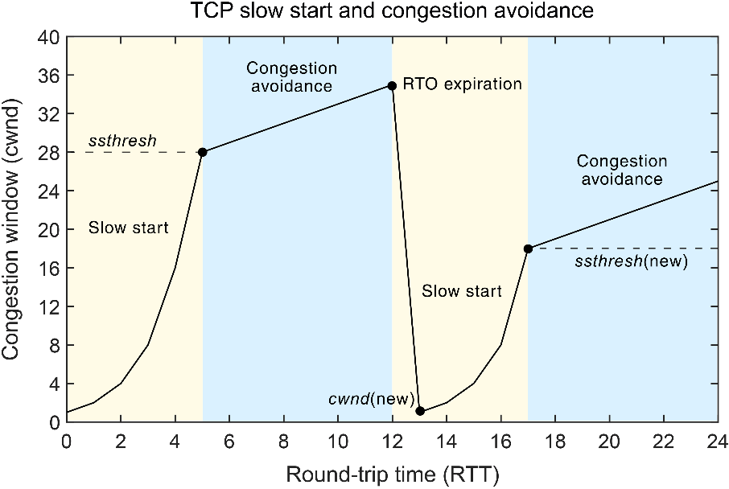

\*\*\* Reno จะลงไปครึ่งนึง TCP Tahoe จะเริ่ม 1 ใหม่

