# Canvas Group Discussion Board Welcome

Authored by Courtney Stowers

**Title:**

Team Collaboration Board

**Message:**

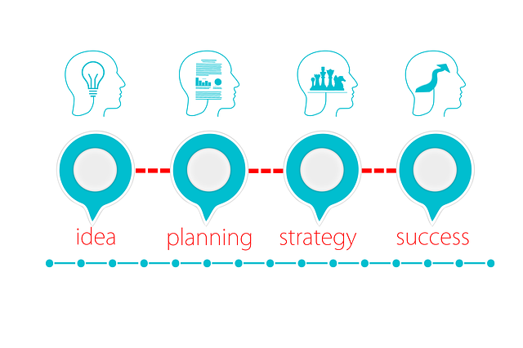

Image by [Gerd Altmann](https://pixabay.com/users/geralt-9301/?utm_source=link-attribution&utm_medium=referral&utm_campaign=image&utm_content=3189797)

## **Feel free to use this discussion board to assist with team communication for your project.**