# Reflection Assignment 02 Week 02

# Authored by Courtney Stowers

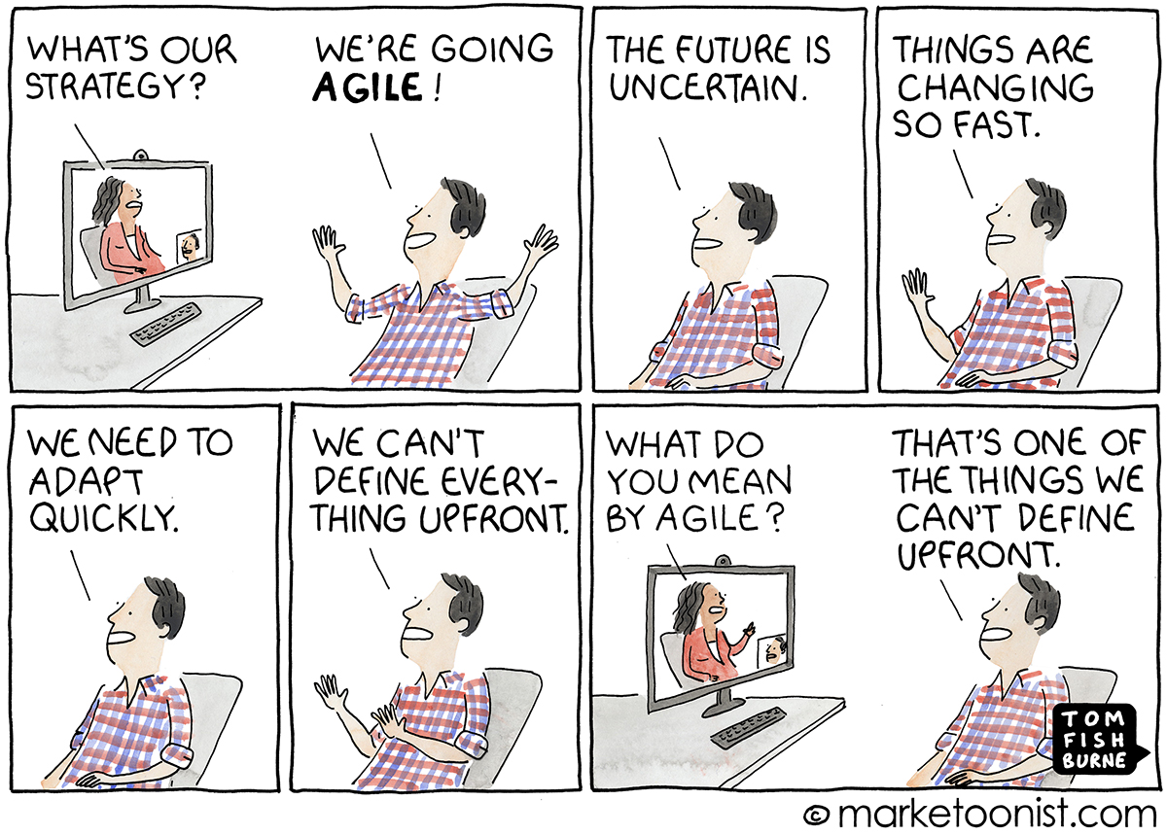

[(Comic by Tom Fishburne, Marketoonist)](https://marketoonist.com/2021/01/were-going-agile.html)

Over the past two weeks, we have discussed a variety of project management tools and strategies including the traditional approach of CRISP-DM, and agile approaches of Kanban, and Scrum. In addition to these processes, as you continue in your career as a data analyst and/or program evaluator, you will likely come across many of the other leading project management terminologies and you may feel overwhelmed by trying to determine the differences and similarities amongst them.

The team at Data Science Process Alliance has created a comprehensive guide that clearly outlines the pros and cons of 9 leading methodologies: <https://www.datascience-pm.com/data-science-process-choices/>

For this week's reflection exercise, review the overview guide and select two methodologies of interest to explore in-depth (if you'd like to learn more about CRISP-DM, Kanban, or Scrum, feel free to select those).

In at least 350 words, consider the benefits and weaknesses/challenges listed in the guide. You can also reflect on the following questions in addition to your own takeaways from the guide:

* Between the two methodologies that you selected, do you believe you would be more inclined to use one or the other?

* Have you previously used either of your selected methodologies (or one of the other 9)? If so, was it helpful? Confusing?

* Are you interested in trying one of the methodologies or a combination of them?

* How has your use of Kanban and CRISP-DM project management strategies impacted your progress on the final deliverable for this course so far?

***Note: Please be sure to include links to your two selected methodologies in your submission.***