# Reflection Assignment 03 Week 03

# Authored by Courtney Stowers

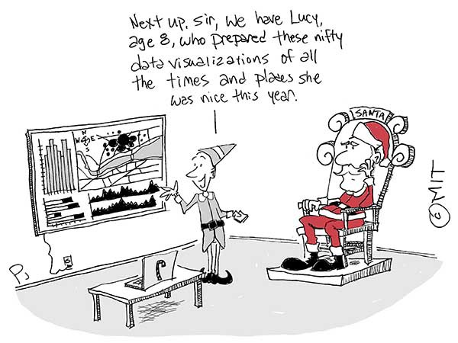

([Comic by Phil Johnson for MIT](https://medium.com/the-coffeelicious/use-data-visualization-to-improve-your-chance-of-making-santa-s-nice-list-cartoon-60bef7d9688b))

This week we explore the data for our final project using descriptive statistics and data visualizations. Data visualization has become a key widespread tool to present information in presentations and reports over the last several years. However, the usefulness of visualizations is not just limited to reports; it is also an important asset to visual communication within project management methodologies.

In the article Visualizations That Really Work, senior editor at Harvard Business Review and author of Good Charts, Scott Berinato writes, "[E]ven information that’s not statistical demands visual expression. Complex systems—business process workflows, for example, or the way customers move through a store—are hard to understand, much less fix, if you can’t first see them."

For this week's reflection assignment, read Berinato's article below and consider in at least 350 words how you can use charts, graphs, and other visual tools (such as Kanban boards, Mind Mapping, etc.) to present data and improve processes in your work as a data analyst and/or program evaluator.

The following are questions to analyze, but feel free to share your own insights:

 This week we explore the data for our final project using descriptive statistics and data visualizations. Data visualization has become a key widespread tool to present information in presentations and reports over the last several years. However, the usefulness of visualizations is not just limited to reports; it is also an important asset to visual communication within project management methodologies.

In the article Visualizations That Really Work, senior editor at Harvard Business Review and author of Good Charts, Scott Berinato writes, "[E]ven information that’s not statistical demands visual expression. Complex systems—business process workflows, for example, or the way customers move through a store—are hard to understand, much less fix, if you can’t first see them."

For this week's reflection assignment, read Berinato's article below and consider in at least 350 words how you can use charts, graphs, and other visual tools (such as Kanban boards, Mind Mapping, etc.) to present data and improve processes in your work as a data analyst and/or program evaluator.

The following are questions to analyze, but feel free to share your own insights:

* Do you have experience using visualizations in your work? If so, what kind and how do you use them? Are they helpful or could they be improved? If you do not have experience using visualizations, are there any aspects of your work that you believe would benefit from visuals?

* In your opinion, what makes a visualization helpful? Do you believe there are instances where simple charts can be more helpful than "smart" dashboards?

* Berinato notes that idea illustration diagrams are often complicated. Do you agree? Why or why not? What could improve these diagrams?

* Optional: A team of public health care workers in the United Kingdom employed mind mapping techniques to rapidly analyze qualitative data. Do you think this is a tool that more analysts and/or non-analysts should use to evaluate data? (see study linked below *Visualizations That Really Work*)

https://hbr.org/2016/06/visualizations-that-really-work

(insert PDF file here, PDF file cpp-528-reflection-03-visualizations-that-really-work.pdf is available in Canvas Reflections Github folder)

***Optional further reading on Mind Mapping***, Burgess-Allen, J. and Owen-Smith, V. (2010), Using mind mapping techniques for rapid qualitative data analysis in public participation processes. Health Expectations, 13: 406-415. <https://doi.org/10.1111/j.1369-7625.2010.00594.x>

(insert PDF file here, PDF file cpp-528-reflection-03-mind-mapping-qualitative-data-analysis.pdf is available in Canvas Reflections Github folder)