# Reflection Assignment 04 Week 04

# Authored by Courtney Stowers

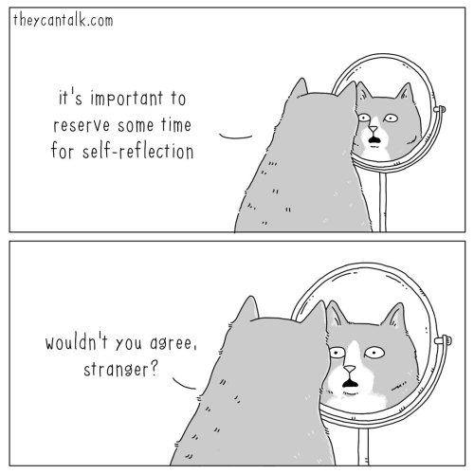

([Comic by Jimmy Craig](https://theycantalk.com/post/638701984504053760/self-reflection))

Reflection and debriefing processes are integral to many project management systems such as the [Atlassian Playbook's 4Ls Retrospective Technique.](https://www.atlassian.com/team-playbook/plays/4-ls-retrospective-technique)These processes largely focus on creating team narratives and consensus on which areas of a project were successful and which areas did not meet expectations. This is a helpful and scientifically proven strategy to help team members collectively reflect on the group's efforts and strive for improvement in the future.

However, within these methodologies, it can sometimes be easy for group members to overlook individual self-reflection. Each member of a team should privately evaluate how their participation in the project contributed to not only the success of the group but also their own progress towards reaching personal goals.

This process is known as a "self-audit" and is helpful to allow individuals to better identify their strengths and weaknesses. Self-reflection and auditing are important aids for self-improvement. They give future leaders the opportunity to develop mindfulness and reiterate the importance of their core values and beliefs outside of a broader group context.

For the final required reflection assignment, review Peter Drucker's article from the Harvard Business Review, *Managing Oneself.* In at least 350 words, reflect on the following questions and any additional insights that stand out to you while reading:

* Do you prefer to be a decision-maker or an advisor?

* Are you a reader or listener?

* How do you learn?

* Do you work well with people or best on your own?

* How would you like your values and strengths incorporated in your career as a data analyst and/or program evaluator?

<https://hbr.org/2005/01/managing-oneself>

(insert PDF file here, PDF file cpp-528-reflection-04-managing-oneself.pdf is available in Canvas Reflections Github folder)