# Reflection Assignment 05 – Extra Credit Week 06

# Authored by Courtney Stowers

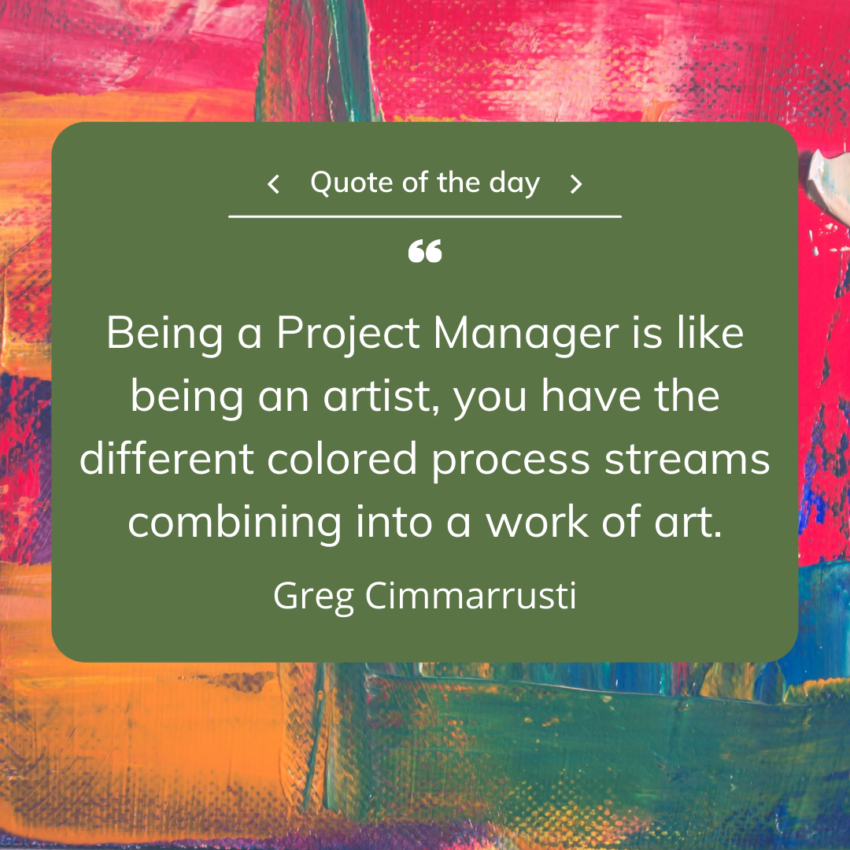

Image designed by Courtney Stowers

Throughout this course, we have read several articles from experts in the field of project management and gotten the chance to serve as project managers within our own groups. Could you summarize all of this knowledge and experience in a couple of sentences? Impossible? Likely! Nevertheless, several project management practitioners have attempted to do just that in various quotes and tidbits of advice that they've shared throughout their careers.

As an extra-credit reflection assignment worth 2 points, in at least 200 words, reflect on all that you've learned in this course over the past few weeks and share a quote that you feel best encompasses your experience. The quote can be from someone else or you can write your own. Also, don't feel obligated to limit the quotes directly to project management. They can also relate to a broader concept that you feel is associated with your career goals and project management such as motivation, perseverance, communication, teamwork, leadership, data analytics, or program evaluation.

To assist with your quote selection, you can browse the links below or conduct research via a search engine:

* **The Digital Project Manager: 161 Inspiring Project Management Quotes** <https://thedigitalprojectmanager.com/project-management-quotes-inspiration/>
* **ProofHub: 17 Project Management Quotes To Help You Learn From The Best** <https://www.proofhub.com/articles/project-management-quotes>
* **Toggl Plan: 50 Project Management Quotes to Inspire You Before Your Next Project** <https://toggl.com/blog/50-project-management-quotes>

***Note: Please be sure to properly attribute the quote to its speaker/writer in your submission.***