Personal information |  |  |  |  |  |  |  |  | 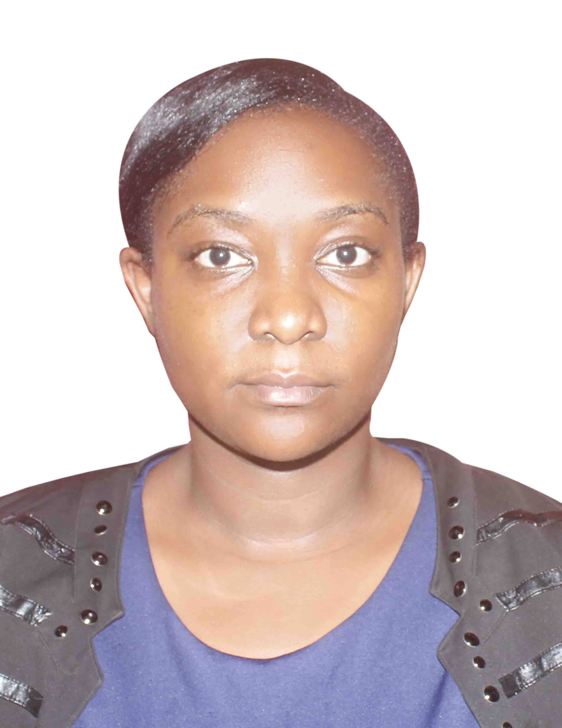
Surname(s) / First name(s) |  |  | LUBEGA JOVAN
mobile(s) |  |  | + 256 – 757280923
E-mail(s) |  |  | Jovanlubega10@gamil.com
Nationality / Residence |  |  | UGANDAN: Namasuba, Kampala Uganda.
Gender |  |  | Female
Professional Objective |  |  | To harness my ability to learn, be flexible, hardworking and committed to quality together with a passion for excellence so as to meet the high standards expected in the job market.
Career Objective |  |  | To see to it that National Economic Polices are based on reliable and accurate information for the realisation of a desired future ie job creation , development and sustainability in the economy.
Work experience and Training
Dates |  |  | 1th July, 2023 to Date
Name and address of company |  |  | Ministry of Education and Sports
Occupation or position held |  |  | Senior Statistician
Dates |  |  | 7th July , 2013 - 30th June 2023
Name and address of company |  |  | Ministry of Agriculture Animal Industry and Fisheries.
Occupation or position held |  |  | Statistician
Dates |  |  | December 2010 - February 2011
Name and address of company |  |  | Sanyu Babies Home
Occupation or position held |  |  | Volunteer
Dates |  |  | 14thJune 2010 - 6th August 2010
Name and address of company |  |  | Rakai District Local Government in the Planning Department.
Occupation or position held |  |  | Intern
Dates |  |  | 9th May 2008 - 9th August 2008
Name and address of company |  |  | Infrastructural Design Forum (id forum)
Occupation or position held |  |  | Research Trainee
Education
2013 to 2016 |  |  | Maters of Arts in Economic Policy and Planning.  Makerere University
2008 - 2012 |  |  | Bachelor of Science in Business Statistics  Makerere University
2006-2007 |  |  | Uganda Advanced Certificate of Education (UACE)  Uganda Martyrs Secondary School, Namugongo
2002-2005 |  |  | Uganda Certificate of Education (UCE)  Uganda Martyrs Secondary School, Namugongo
2000-2001 |  |  | Primary Leaving Examination (PLE)  St. Anthony Nursery and Primary School, Kajjansi.
Personal skills and competences
 |  | Understanding |  |  |  | Speaking |  |  |  | Writing
languages | Self-assessment | Listening |  | Reading |  | Spoken interaction | Spoken production
languages | English | Proficient User |  | Proficient User |  | Proficient User | Proficient User |  |  | Proficient User
languages | French | Fair |  | Fair |  | Fair | Fair |  |  | Fair
languages | Luganda | Proficient User |  | average User |  | Proficient User | Proficient User |  |  | Proficient User
Capabilities and work  Skills |  | Worked on a project for the preparation Greening Kampala City Parishes of KatweI ,Kisenyi II and Bwaise III hence participated in Data collection through Socio- economic and Household survey. Holding Key informant Interview ,Data analysis and Report Preparations  Report preparation, writing, compiling, documentation and presentation skills. Experience in Data entry , recording and mapping.  Exposure in the field carrying out assessments in the different sub counties in the region
Interests |  | Sports & Hobbies; Travelling , Reading (especially journals), Going to the Gym travelling. Swimming , listening to Music.
Achievements |  | A certificate of participation from the Douglass Science Institute, New Jersey from 16rd to 28th July 2006 for achieving academic excellence in Mathematics ,Science ,Engineering and Technology  Participation in Makerere University Institute of Statistics Students Association Sports Week  Competition in Volley Ball between 20th to 25th of September 2010  An Archdiocesian Choir member from 2006 to 2007
Computer skills and competences |  | - Outstanding command of the Microsoft Office Enterprise (Word, Excel PowerPoint, one note, outlook, access and InfoPath)
More skills and competences |  | - Creative, ingenious and innovative at regular work  - Good communication skills (oral and written) , good public relations and organization skills.  - Able to work as a team member and individually, flexible, self-motivated and time conscious  - Commitment to achievement of objectives ,a strong commitment to duty and hunger for results.
References |  | Mrs.Teddy Alako  Principal Economist  Ministry of Finance Planning and Economic Development  Tel: +256 775162 965  Email  teddy.alako@finance.go.ug |  |  | Mrs. Christine Nakazibwe  Principal Statistician  Ministry of Education and Sports  Tel +256-779073713  +256-709036301  Email  cnakazibwe88@gmail.com  Christine.nakazibwe@education.go.ug |  |  | Mr. Kizito Emmanuel.  Senior Civil Engineer  World Food Programme  Tel: +256-782-376514.  Email emmakizito@yahoo.com

