Assignment 2.3

1. ERD

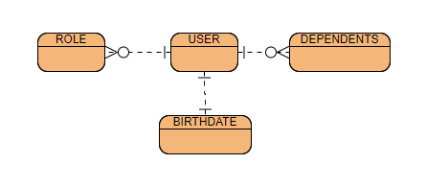

2. Rough JSON “NoSQL” data structure

