Module 5.2 Assignment

1. The ISNULL function returns a 0 or 1 (falsey or truthy) value depending on whether a given value or field is a null value.

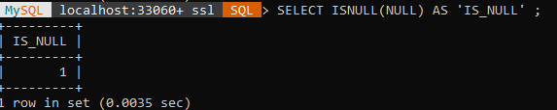

2. Ternary IF & RAND – Used wherever you would use a JS/Java/whatever Ternary operator (or an Excel IF) & wherever you need a random float value between 0<=x<1 respectively.

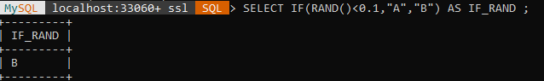3. PI() - literally just returns a floating-point approximation of the value of π, used wherever you need that (like if you’re working with circles)

