Module 6.2 Assignment

Last 2 lines of script output:

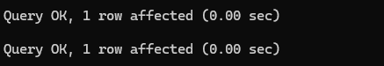

List of Tables:

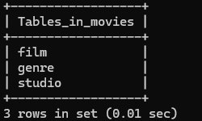

Python Script Output

