Kenneth Smith

Jonathan Waugh

7-18- 2024 11.1

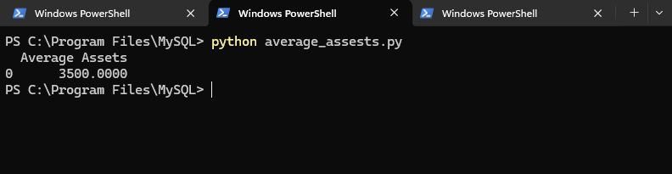

This script was used to display the average amount of assets held by Wilson financial clients. This information can be helpful in making business decisions. Providing the staff with the average amount of assets held by clients can help the staff at Wilson financial.

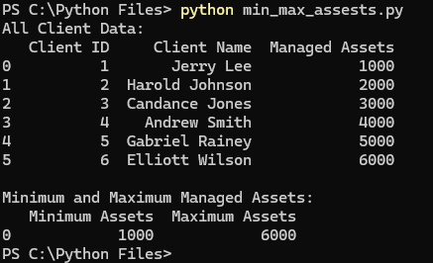

This script displays all the assets held by every client as well as the minimum amount of assets and the highest amount of assets. This can assist the Wilson Financial staff and provide the business with information to make important decisions such as insurance-related choices.

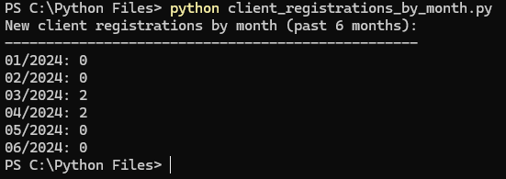

This script displays the number of new client registrations in the past 6 months. This can help the staff get an estimate of how many new clients they can expect. This can help make effective business decisions.