Get robot transforms from MATLAB imported .urdf
Checklist
☒ 1. Import robot URDF and use function “showdetails(robot)”;
☒ 2. Print geometry transformation matrices;
☒ 3. Print joint-axis rotations;
☒ 4. Check for hidden joint-axis rotations;
☒ 5. Construct the MATLAB URDF kinematic chain and compare it to C mex function result;

P.S. MATLAB URDF chain transformation matrix formula used in C to compute the transformation matrix for the end-effector ‘tool0’:
$$T=T_{01}R_{z}\left(q_{1}\right)∙T_{12}R_{y}\left(q_{2}\right)∙T_{23}R_{y}\left(q_{3}\right)∙T_{34}R_{x}\left(q_{4}\right)∙T_{45}R_{y}\left(q_{5}\right)∙T_{56}R_{x}\left(q_{6}\right);$$

- Get familiar with joint hierarchy
To get the hierarchy joints, use the following code functions:
robot = importrobot('abbIrb120.urdf');
showdetails(robot);
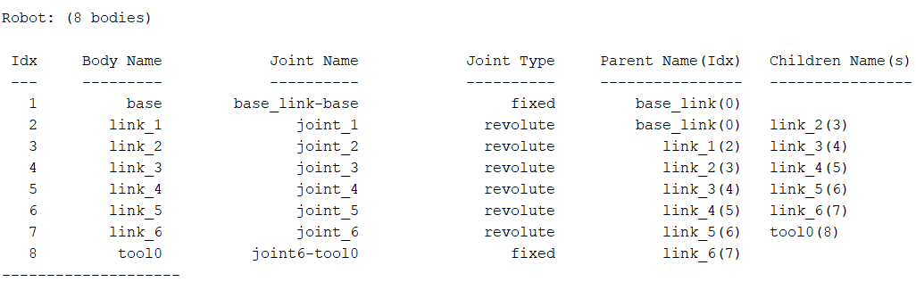

- Print exact urdf geometry transformation matrices
Since the MATLAB importrobot() model is built from URDF transforms, so the target is to get joint transforms which come from joint axis and current angle. Fixed transform comes from JointToParentTransform. So the following code functions must be entered:
% Import unified-robot-data-format
robot = importrobot('abbIrb120.urdf');
robot.DataFormat = 'row';

% Print URDF geometry transformation matrixes
for i = 1:numel(robot.Bodies)
body = robot.Bodies{i};

fprintf('\n%s\n', body.Name);

disp(body.Joint.JointToParentTransform);
end

, where the following output will be 4x4 homogeneous transformation matrices, with the last column providing x, y, z coordinate translations.
- Print joint axis rotations
To construct the kinematic chain MATLAB is using, joint axis rotations must be retrieved which show around which axis each joint is being rotated:
% Import unified-robot-data-format
robot = importrobot('abbIrb120.urdf');
robot.DataFormat = 'row';

% Print joint-axis rotations
for i = 1:numel(robot.Bodies)

body = robot.Bodies{i};

fprintf('\n%s\n', body.Name);

disp(body.Joint.JointAxis);

end

- Check for hidden rotations around axis
To make sure no hidden rotations around axis are being present, use the following code function, where if ‘success’, then for each link, 4x4 identity matrices will be retrieved:
% Import unified-robot-data-format
robot = importrobot('abbIrb120.urdf');
robot.DataFormat = 'row';

% Check for hidden-rotations around axis
for i = 1:numel(robot.Bodies)

body = robot.Bodies{i};

fprintf("\n%s\n", body.Name);

disp(body.Joint.ChildToJointTransform);

end

