For the 3DM-GX5-10 IMU, the datasheet has the following entry for the gyroscope’s noise density:

(0.005°/sec)/sqrt(Hz) (300°/sec)

We interpret this as meaning that at an angular velocity of 300 degrees per second, the “noise density” is 0.005 degrees per second per square root Hertz. This is a relatively unfamiliar unit, but it seems reasonable that this too is an additive noise with no bias, so the expected value is still the actual value. The noise may have a wider Gaussian distribution as the angular velocity increases and a narrower distribution as the angular velocity decreases, given that the noise is provided at a specific angular velocity.

The datasheet also lists a “bias instability” of 8 degrees per hour, which may mean that the measured values can drift from actual values at that rate. As such, it is best not to rely on the data to remain the same when operating this IMU for an extended time.

For the GYVL53L0X laser sensor, we have the following table about accuracy (searching for noise in the datasheet does not produce any results):

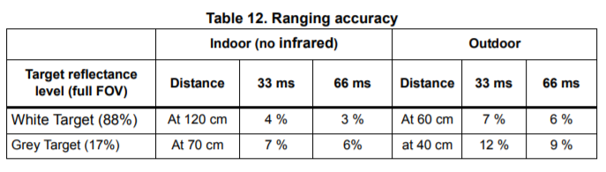

For this laser sensor, then, there is a percent error from the exact value, which we interpret as meaning that for e.g. the 4% accuracy, the measured value can be anywhere between 96% and 104% of the real value. This is therefore an additive noise centered on the real value (no bias, and the expected value is still the actual value), although we are not sure whether the noise is uniformly distributed or whether it is more of a Gaussian.

Note that we looked at the IMU for the Segway and the laser sensor for the paperbot because the other datasheets were more unclear in their information.