# Reference & Resources

## Login Form

<https://codepen.io/khadkamhn/pen/ZGvPLo>

## SideBar

<https://startbootstrap.com/template/simple-sidebar>

## Rating Tab

<https://www.w3schools.com/howto/howto_css_user_rating.asp>

## Review Rating Star

https://codepen.io/jexordexan/pen/yyYEJa

## Pic Reference

Banner pic

<https://fairfieldmeats.co.za/>

Recipe Banner pic

<https://expertphotography.com/food-photography-backgrounds/>

Product Pic

<http://www.pngall.com/>

## Reference

Turning on less secure app

## Css & JS

https://getbootstrap.com/docs/5.0/

<https://owlcarousel2.github.io/OwlCarousel2/docs/started-welcome.html>

https://codepen.io/alexpopovich/pen/zZamKQ

Jquery 3.5.1

https://mark-rolich.github.io/Magnifier.js/

Magnifier

<https://mark-rolich.github.io/Magnifier.js/>

Graph

https://www.chartjs.org/

# Development

## 6 March 2021

* Started to create the project
* Removed various pages and components from ASP.NET Core from MVC template
* Added bootstrap v 5.0 beta 2
* Added to Github

## 8 March 2021

* Added SVG Logo for the website
* Created Header Nav bar with 2 different style on mobile and desktop,
* Created Footer

## 9 March 2021

* Created Login page taken from template online.
* Hooked the navigation header link to the Login page and vice versa.

## 12 March 2021

* Added Bootstrap carousel for homepage topmost banner with picture as well taken from online resource.

## 15 March 2021

* Added Recipe Area with Owl Carousel with button event.

## 16 March 2021

* Added Super Price of the Week Area with Owl Carousel
* Added Card in between the Banner and the middle section of recipe and Super price of the week.
* Added animation on hover with button.

## 17 March 2021

* Added Nav bar sticky if the user is scrolling down larger than the nav bar height on mobile and desktop.
* Added Latest Product section which basically just a copy of the Product card.
* Added Some sales pitch to populate Home page.
* Home page temp view is completed.

## 20 March 2021

* Changed Login form to using modal instead of directing to another page.

The reason being that the bootstrap version the template is using is v4.4 and we are using 5.0 beta1. Although it might work, I decided to look for another template which I think is better. With modal the user did not have to go back and forth just to login.

* Added Signup as well, the signup and login tab might not be noticeable for the user, need some ideas to make it more visible and clickable looking.
* Added Javascript validation for the form by using Regex.

## 21 March 2021

* Added Vue JS to handle categories search bar change.
* Fixed bugs on the navigation and body content did not have correct margin when changing viewport on mobile from landscape to portrait and vice versa.
* Added links to connect things together with login modal.
* SOL change on login modal
* Delete old login page and the methods in controller.

## 22 March 2021

* Temporary visual bug fixes on carousel
* Product page UI Added

## 26 March 2021

* Product page UI completed.
* Recipe page UI completed.
* Contact page UI completed.
* Fixed unintended visual bug on IPad on products and navigation ribbon
* Fixed visual bug on very small Viewport on mobile e.g Samsung Galaxyfold

## 28 March 2021

* Better CSS Management
* Product Details Page UI temp
* Graph tested and it’s working

## 30 March 2021

* Ratings tab added into product details
* Review Added into Product Details
* Temporary Recipe details added.

## 1 April 2021

* Recipe details UI completed

## 2 April 2021

* Password reset UI added
* Fixed multiple issue on landscape viewport
* Created temporary UI for cart

## 3 April 2021

* Cart UI completed

## 6 April 2021

* Checkout UI completed

## 7 April 2021

* Product Card Updated

# Free Thought and TTD

* Adding Username field on Login / Signup modal
* Vue search bar might require change.
* Organize the image with a new folder.
* Problem with IE11.
* Form for ratings
* Paging for ratings
* Similar items?

## Tested function

### Email

#### Account credentials

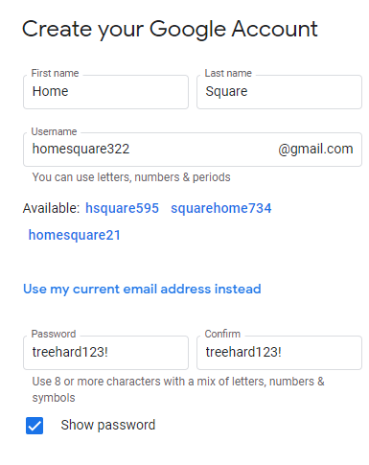

#### Turning less secure app

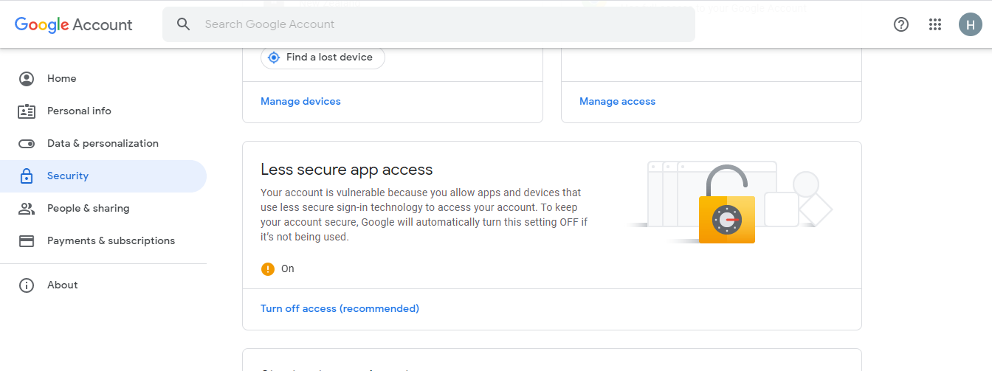

#### Success in receiving data

