EE 4389W Fall 2015
SOLUTION for Homework 3 (10 pts total)
Due Oct. 29, 2015

Problem 1 (Text Problem 4.15)
This problem is about estimating the VC-dimension (h) of the k-neatest neighbors (k-NN) regression.
In the k-NN regression, the estimate (prediction) of y for a given x-value is the mean of y-values of k training samples closest to the given x.

A crude estimate of VC-dimension for k-NN regression can be based on the following arguments,
- for extreme case of k = n (sample size) the model estimate is a constant (single parameter);
- for extreme case of k = 1, the model is n parameters.
So roughly, h ~ n / k.

The training data set (x_{i},y_{i}) is generated according to the target function y = sin² (2π x) +ζ, where the input x is sampled from a uniform random distribution in [0,1], and the distribution of the noise ζ is N(0, 0.1).

The quality of the proposed analytic estimate for VC-dimension can be empirically evaluated by (1) applying the VC bound to available training data and (2) comparing optimal k selected via (1) with the best possible k-value for this data set .

We use two criteria to select the optimal k value:
- VC bound
Assume h = n / k, then the optimal k minimizes the VC bound given in Text (4.14).
- L₂ measure
Suppose the true target is y^{t} = sin² (2π x), then the optimal k minimizes the L₂ measure ∑ (y_{i} -y^{t})². Hence, the L² measure is the MSE between the prediction y_{i} and true target y^{t}.

The assumption is, if the analytic estimate of VC-dimension, h ~ n / k, is good or close to the true one, we should expect consistent optimal k values based on both criteria.
Figure 1 shows the boxplots of the optimal k values for three different sample sizes (n = 25, 50, 100) after 100 random realizations.

The results in Figure 1 reflect that h ~ n / k is not an accurate estimate of the k-NN regression’s VC-dimension. For sample size n = 25, the median k is 24, which means the model prediction is almost the average of training data.

However, we can obtain much better k values if the VC-dimension estimate is taken as h ~ n / (2k), as shown in Figure 2. For sample size n = 25, the median k is 4 for VC bound and L₂ measure criteria. As for sample size n = 50, the median k to both criteria is 6. The results show that h ~ n / (2k) would be a better estimate for the VC-dimension for the k-NN regression.
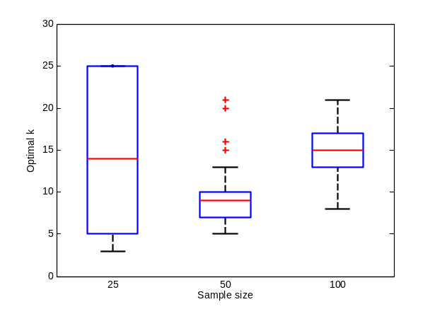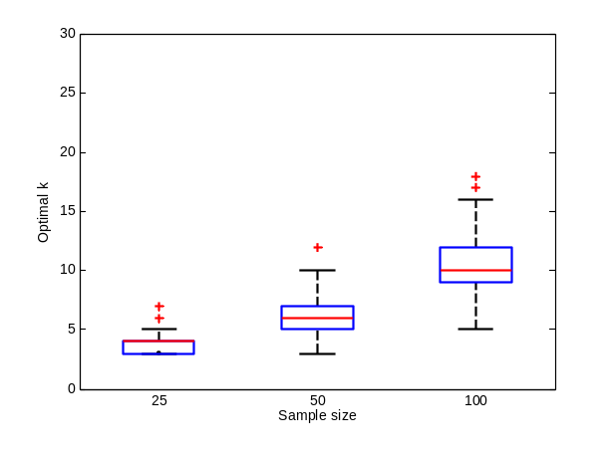
Figure 1. Model selection results based on VC bound (left) and L₂ measure (right). The VC-dimension of the k-NN regression is assumed to be h ~ n / k.
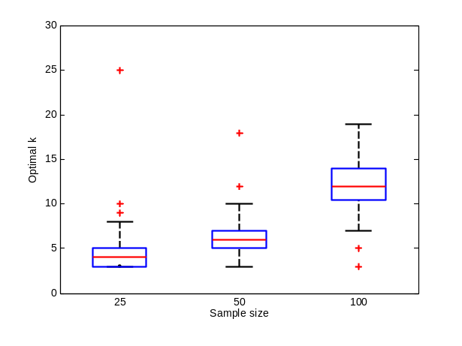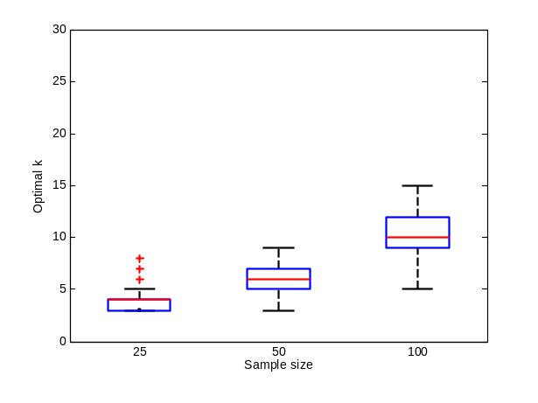
Figure 2. Model selection results based on VC bound (left) and L₂ measure (right). The VC-dimension of the k-NN regression is assumed to be h ~ n / (2k).

Problem 2 (Trading international mutual funds)

In this problem, we apply two learning methods, Linear Classifier and Quadratic Decision Boundary Classifier, to design a trading strategy for an international mutual fund (symbol FIGRX). Our learning model can be generally described as y = f(x₁, x₂), where the input indicators, x₁ and x₂, are the daily closing prices percentage changes of the SP500 stock index (symbol GSPC) and the Euro-to-Dollar exchange rate (symbol EURUSD), respectively. The output y is the next-day FIGRX mutual fund value change in percentage.

Equivalently, the learning method will try to find a model f which gives good predictions on y. The trading decision rule is F = sign(y).

The classification results of a linear classifier are shown in Figure 3.
Figure 4 shows the cumulative account value for the trading strategy using this linear classifier.
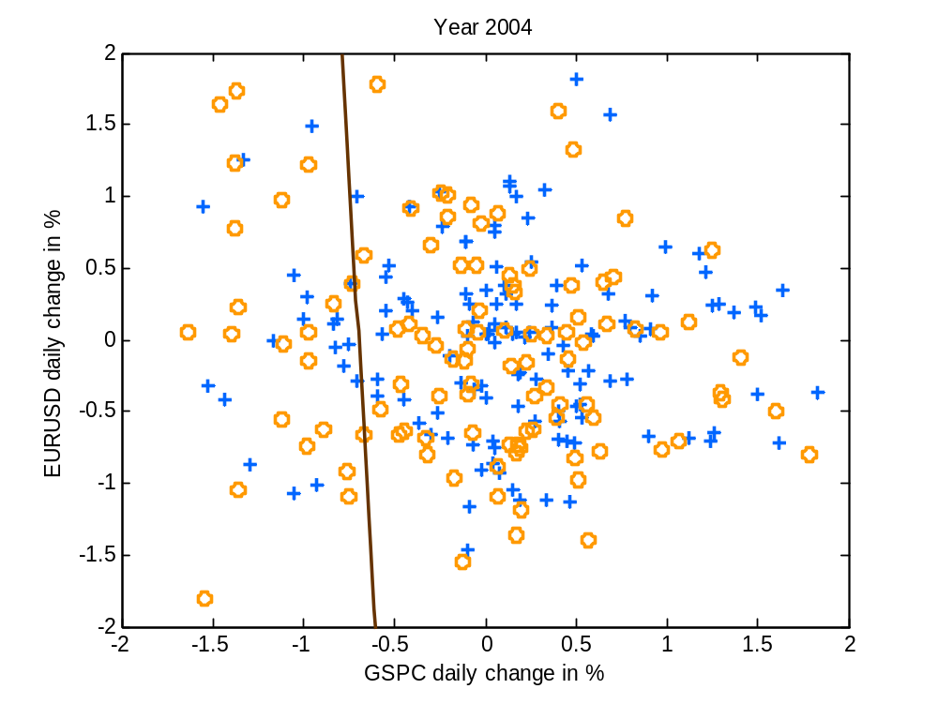
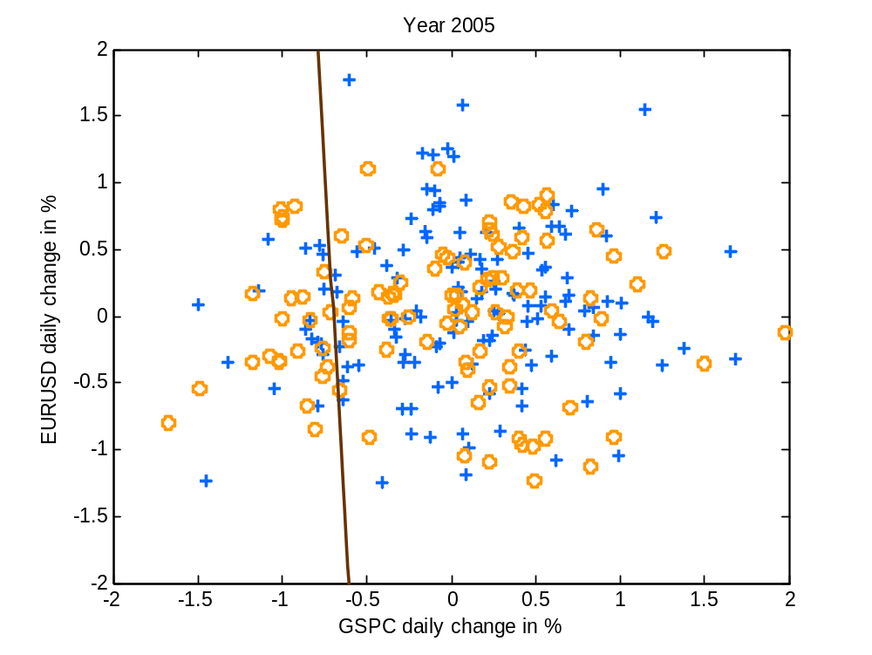
Figure 3. Linear decision boundary estimated using least squares regression overlapped on the training (2004) and test (2005) data.
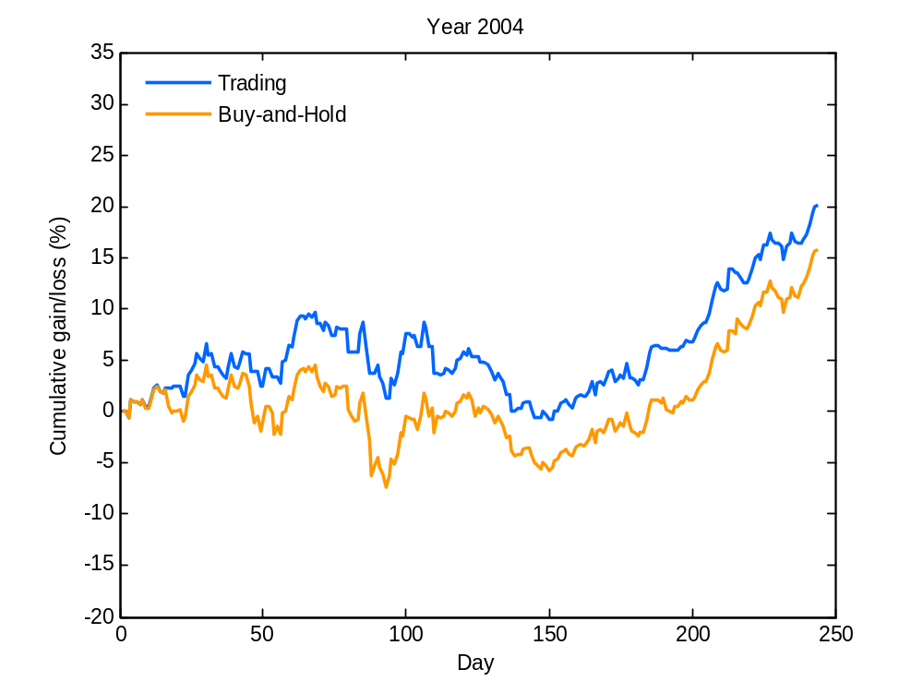
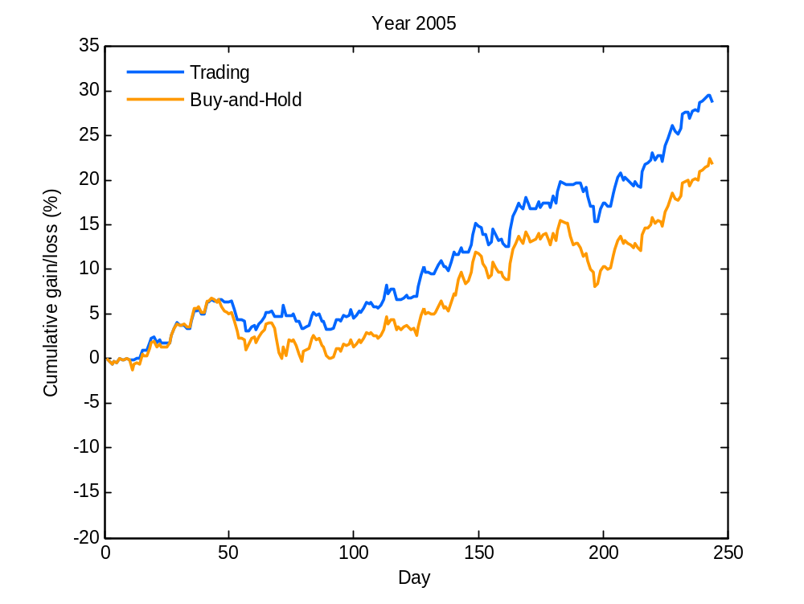
Figure4. Effectiveness of the trading strategy using linear classifier. (a) Account gain/loss during training period (Year 2004). (b) Account gain/loss during test period (Year 2005).

The classification results of a quadratic decision boundary classifier are shown in Figure 5.
Figure 6 shows the cumulative account value for the trading strategy using the quadratic decision boundary classifier.
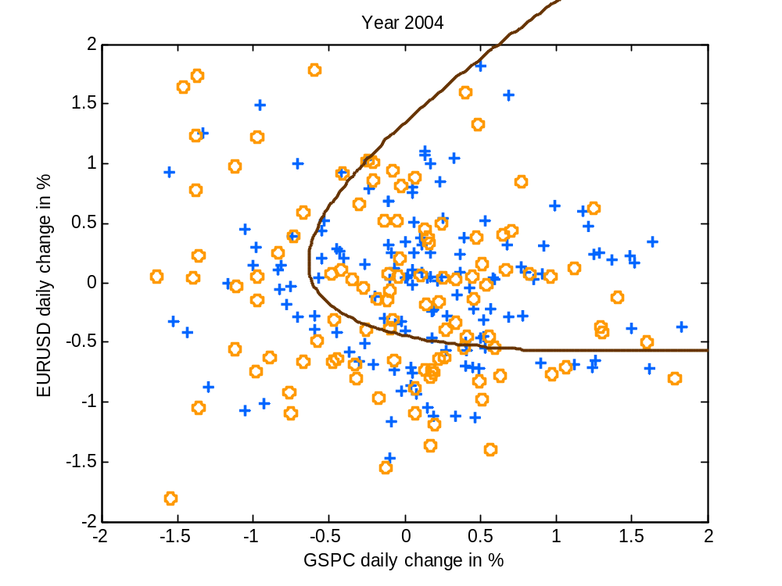
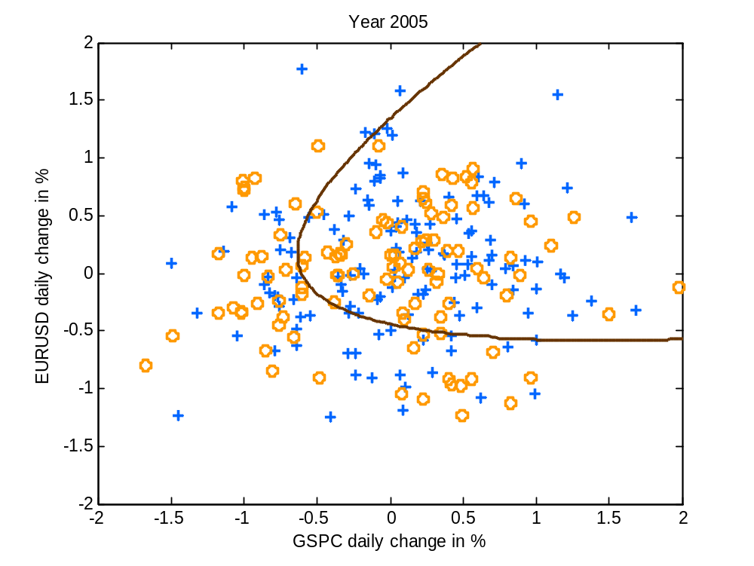
Figure 5. Quadratic decision boundary overlapped on the training (2004) and test (2005) data.
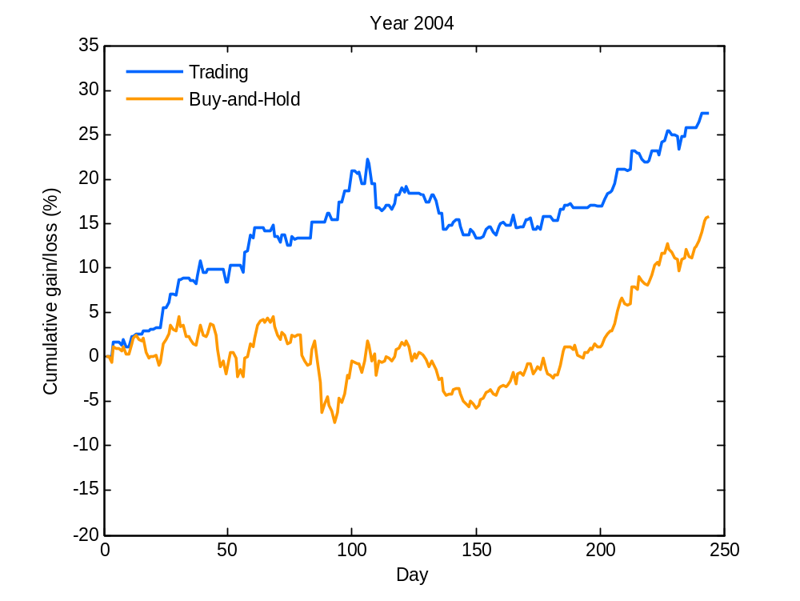
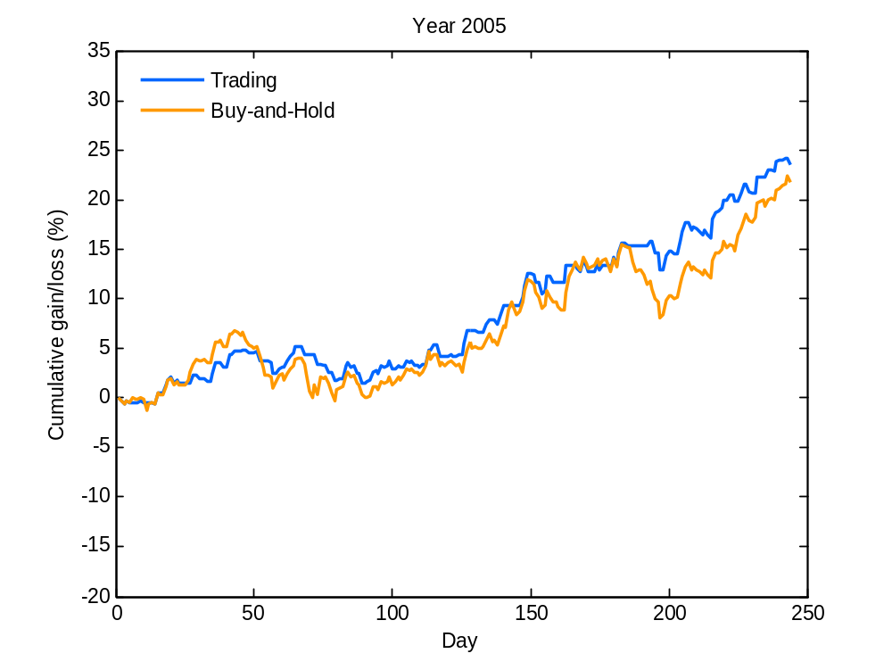
Figure 6. Effectiveness of the trading strategy using quadratic decision boundary classifier. (a) Account gain/loss during training period (Year 2004). (b) Account gain/loss during test period (Year 2005).

- Performance
The training and test errors for two classifiers are summarized in Table 1. The errors are more than 40%. Note that the quadratic decision boundary classifier has about the same training error as the linear classifier, but the test error is higher.

Table 1. The training and test errors in percentage.
 | Training period 2004 | Test period 2005
Linear | 43.21 | 40.33
Quadratic | 43.62 | 45.27

We compare the two classification approaches by the investment performances in Table 2. The Gain is the cumulative gain (or loss) in percentage at the end of the year. The Buy-and-Hold (B-H) shows the price variation through the year. Further, the market exposure is the proportion of days when the account is fully invested in FIGRX. It also indicates how often a classifier assigns a sample to the positive (Up) class. The quadratic decision boundary classifier achieves higher gain in the training period but has lower gain during the test period. However, the market exposure for the linear classifier during both periods is higher (more than 80%). So, arguably, the quadratic model is safer than linear.

Table 2. Summary of investment performance in percentage.
 | Training period 2004 |  |  | Test period 2005
 | Gain | B-H | Exposure | Gain | B-H | Exposure
Linear | 20.09 | 15.75 | 83.54 | 28.71 | 21.74 | 83.54
Quadratic | 27.41 | 15.75 | 56.79 | 23.53 | 21.74 | 62.93

- Discussion
- Can this trading strategy be used in practice?

YES, based on empirical modeling results, trading strategy provides significantly better total return than ‘Buy-and-Hold’. The quadratic decision boundary classifier is better than the linear one because it achieves better performance than ‘Buy-and-Hold’ with lower market exposure (lower risk).

- Why learning methods do not use model complexity control?

Because their model complexity (VC-dimension) is small relative to training sample size. So, good performance during training period implies good performance for test data. This follows from analysis of the VC generalization bound (for classification). Note that in this case, ‘performance’ is measured relative to ‘buy-and-hold’ strategy for the same security, rather than absolute returns during the test period.

- All results/conclusions assume that the unknown statistical characteristics of the stock market do not change, i.e. they are the same for training and test periods. This assumption can be further tested by using year 2005 data as the training period, and year 2004 data as the test period. Most likely, these new empirical comparisons will show similar results, i.e. the effectiveness of trading strategies similar to Figure 3 (linear) and Figure 5 (quadratic).

