[COMP 3500 - Geo-Tagging project] week 3 meeting notes

Semester 1 in 2017.

Group members:

Shijie, Fred, Jacky and Wawin.

Meeting time and location: 2 pm at Hancock Library

*General tasks (should be done together during meeting):*

1. Discussed last week work.
2. Find new model to training data.
3. Discussed the IP agreement.
4. Find a location finder model from internet and training data.
5. Find some methods to optimize the speed of match location with database.
6. Set same tasks for every group members, these works should be done at home before next week. And in next week’s meeting, every group members should bring their works and discuss with each other.

*Take home personal tasks (should be done at home):*

1. Each group member should test the at least 25 webpage with the demo version and record the test details.
2. Fix the gitlab problem. (for Shijie)
3. Everyone pull the code from Gitlab, test the code and go through the whole files and codes of project.

*Project tasks (for everyone, should be done at home and bring to next meeting to discuss):*

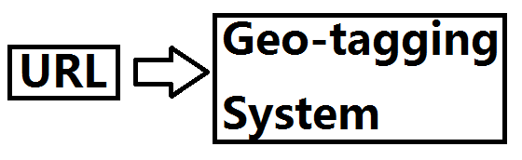

Every group member have to find random webpage links to test the geotagging system. And record the webpage link, time cost, number of words and the accuracy rate of match words with the location database.

*About our management:*

In this semester, we are going to use another way to assign works and manage out group. We used to divide our works into several parts and give to each group members. But we find this way is inefficient and hard to track everyone’s progress, because everyone focus on their own part and ignore the importance of working as a group. It will cause every group member don’t understand others’ work and make the progress of project goes very slow.

But now, we will try to solve some easier problem together at meeting time. For some difficult problems or core part of our project. We leave this as homework, so everyone has time to search information from internet, write some test code and solve the problem in his own way. And everyone will bring his works to next meeting, the we compare everyone’s work and discuss about it. So, it help us solve a problem in different ways, and choose the best from these ways. On the other hand, this way will help us track everyone’s work and solve problem every week until we finish our project. And we could use meeting time to discuss and compare our ideas, rather than spending time on searching and thinking.

*Remarks:*