Shilpa Azure Execution Blueprint
Wayam AI · Product and engineering implementation plan · 18 October 2026 · Version 1.0

1 Executive recommendation
Build Shilpa as an AI CAD agent that turns text, engineering drawings and reference images into inspectable engineering models, supports conversational edits, and delivers validated files. Start with a controlled library of mechanical parts. Add visual 3D generation as a separate pipeline and native SolidWorks automation as a later product milestone.
The recommended sequence is a working CAD demonstration in 2 weeks, a usable web release in 6 weeks, a controlled engineering pilot in 12 to 14 weeks, and a native SolidWorks pilot plus broader visual workflows in 18 to 20 weeks. These are estimates for the staffed team in section 20, after access, sample parts and Azure quotas are available. A production product covering arbitrary industrial assemblies requires further releases.
Shilpa's main intellectual property should be its typed modeling language, CAD adapters, reliable execution and repair loop, geometry validation, design history and evaluation corpus. Reuse existing geometry kernels, identity, storage and model infrastructure.
This package is an execution specification. It does not represent a deployed application, tested CAD engine, provisioned Azure resources or a supplier quote. The workbook contains planned tasks and acceptance tests, all initially unexecuted.

2 What the shared conversation establishes
The supplied conversation asks for a Wayam product inspired by MecAgent, with text to 3D and 2D to 3D inputs. Its latest user question asks how MecAgent works and how to replicate the capability. The discussion converges on a CAD execution system, a planner, bounded correction, geometry validation and eventual desktop integration. [S01]
MecAgent's current public materials describe live work in an existing SolidWorks session, editable features, background tasks, drawing workflows and STEP reconstruction. These are vendor descriptions, not independently reproduced performance measurements. Its proprietary agent implementation is not public. Shilpa's architecture below is our proposed implementation, not a claim about MecAgent's internal code. [S02, S03]
The older response mentions previous TRELLIS work and a monthly INR 30,000 to 75,000 envelope. Those statements came from the earlier assistant and are not explicit commitments in the visible user messages. Treat them as context to validate. This plan uses that range as a possible POC operating envelope, not an approved budget or guaranteed capacity.
Requirement | Basis | Planning treatment
Product name Shilpa | Current request | Use throughout
Azure infrastructure | Current request | Core hosting and inference on Azure
Text and drawing or image inputs | Shared user conversation | Required product direction
MecAgent style engineering automation | Shared user conversation | CAD first roadmap
Web interface first | Recommendation | Fastest path to controlled pilot
Native SolidWorks interface | Capability implied by reference | Separate gated milestone
Visual textured assets | Earlier discussion | Isolated second pipeline
Users, concurrency, residency, budget | Not specified | Explicit assumptions below

3 Product scope and release boundaries
Initial users are mechanical designers, manufacturing engineers and product engineers. The first workflows target mounting plates, simple brackets, spacers, shafts, flanges and basic prismatic enclosures. Each family has a published parameter envelope and supported operations. The CAD specialist must approve the envelope using real sample parts.
Release | Included capability | Explicit boundary
Technical proof in weeks 1 to 2 | Typed specification to solid, STEP and STL, independent geometry checks, 30 reference parts | Deterministic geometry before free form language
Web release by week 6 | Text to supported CAD, clarification, preview, parameters, edits, version history, export | Shilpa recipe is editable; native proprietary history is not promised
Engineering pilot by weeks 12 to 14 | Selected drawing reconstruction, FreeCAD native features for supported operations, simple assemblies, drawing sheets, tenant controls | Drawing interpretation reviewed; no universal reconstruction
Extended pilot by weeks 18 to 20 | SolidWorks companion, native supported features, bounded assembly mates, visual 3D pipeline | Desktop licenses and supported Windows sessions required
Subsequent releases | Broader CAD families, configurations, sheet metal, PDM and PLM connections, stronger DFM checks | Separate benchmark and commercial scope

Do not include arbitrary freeform surfaces, reliable reverse engineering of every STEP, CFD, FEA certification, CAM toolpaths, automatic tolerance design or manufacturing release approval in the initial pilot. Engineering release remains a separate review action. A valid solid does not establish strength, fatigue life, material suitability or safe manufacture.
Initial sizing assumptions are 3 pilot organizations, 25 named users, 5 concurrent interactive sessions and at most 4 concurrent CPU CAD jobs. GPU jobs start at 1 concurrent execution. Inputs are limited to PNG, JPEG, PDF, STEP and Shilpa recipes. Initial limits are 25 MB for images or PDFs, 10 PDF pages and 100 MB for STEP, all configurable after parser benchmarks.

4 The first three builds

4 1 Deterministic CAD foundation
Implement a versioned modeling schema and a headless build123d adapter. Begin with rectangle and circle sketches, extrusion, revolve, through holes, boolean cut, simple patterns and carefully selected fillets. Generate STEP, STL and a tessellated preview from the same evaluated solid. Read the STEP back and compare measurable properties.
The acceptance example is a plate 80 by 40 by 8 mm, centered on XY with its base at Z zero, with four through holes of diameter 6 mm at X plus or minus 30 and Y plus or minus 10 mm. Its bounding box is 80 by 40 by 8 mm and its expected volume is approximately 24,695.2213 cubic millimeters. This example has fully specified positions and an analytic oracle.
Day 10 output is a repeatable command that builds all 30 reference recipes and reports actual dimensions, solids, volume, errors and exports. The first gate requires all 30 deterministic reference recipes to pass. Failures here should delay language features.

4 2 Azure job execution and bounded agent
Build intake, schema constrained specification extraction, missing dimension questions, the state machine, Service Bus dispatch, isolated CAD execution and structured validation. The planner outputs a supported recipe. It never sends unrestricted Python to an application server.
The system must survive duplicate queue delivery, worker termination and a user cancellation without publishing multiple versions. A failed CAD attempt may trigger at most two planner repair attempts. The total workflow budget covers all calls and retries.

4 3 Studio with edits and engineering evidence
Deliver chat, model preview, parameter editing, feature list, validation results, version comparisons and export. Demonstrate the plate, change width to 100 mm while retaining a 10 mm hole edge offset, and show a new version with X hole coordinates plus or minus 40 mm. The previous version remains accessible.
This sequence gives the first client demonstration a concrete geometry result and an edit that can be verified, rather than only a rendered shape.

5 Azure deployment architecture
Use Azure Container Apps for the studio and API, Container Apps Jobs for CPU CAD execution, Azure Machine Learning batch deployments for visual GPU inference, Azure Database for PostgreSQL Flexible Server for transactional state and Azure Blob Storage for artifacts. Container Apps Jobs support finite event driven executions. Azure ML batch inference supports asynchronous jobs and compute clusters configured with zero minimum nodes. [S04, S05, S06]
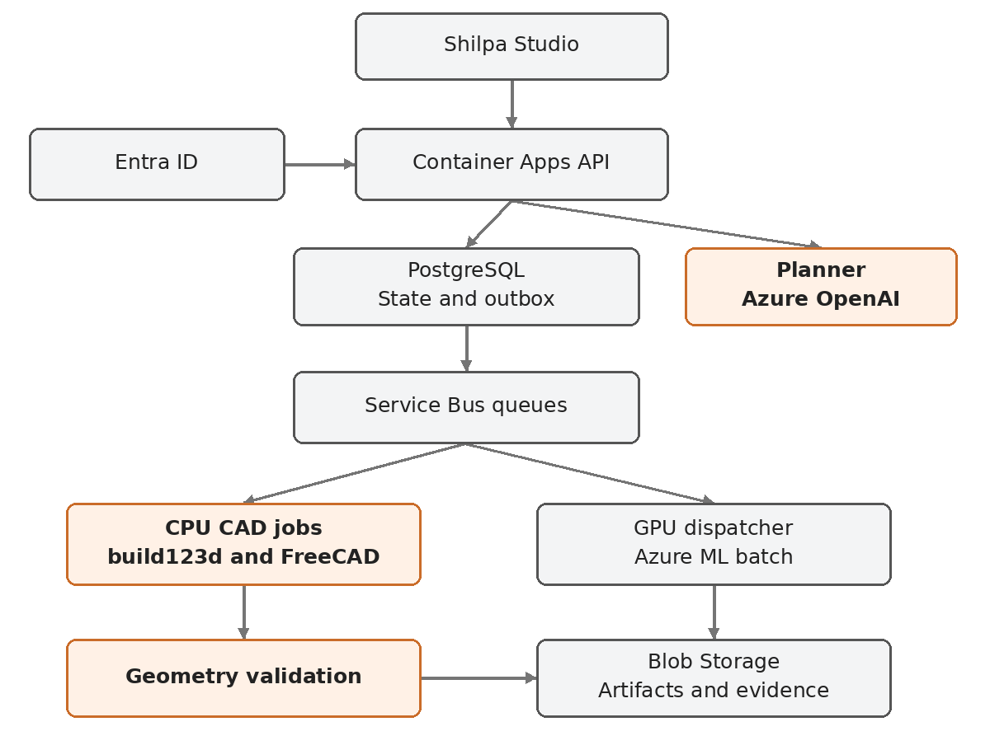
The coordinator is an explicit state machine in the API service codebase, with a separately deployed dispatcher process. PostgreSQL owns workflow state. Service Bus transports work. The model proposes plans and repairs; it does not own state transitions. Do not add a second orchestration engine or Redis queue initially.
Layer | Azure service and initial configuration | Responsibility
Studio | Container Apps web container, 0.25 to 0.5 vCPU starting allocation | React static application and authenticated routes
API | Container Apps, 0.5 to 1 vCPU, 1 to 2 GiB, one warm pilot replica | Auth, projects, specifications, SSE and artifact authorization
Coordinator and dispatchers | Separate Container Apps processes using same service package | Outbox publication, planner work and GPU dispatch reconciliation
CPU geometry | Container Apps event jobs, start benchmark at 2 vCPU and 4 GiB | One bounded recipe per execution; raise memory from evidence
GPU geometry | Azure ML batch endpoint and AmlCompute GPU cluster, min nodes 0, max 1 initially | Versioned visual model inference
LLM | Azure OpenAI deployment in Microsoft Foundry | Structured planning, vision interpretation and optional concept images
Database | PostgreSQL Flexible Server, burstable for POC if available | Tenant state, recipes, events, outbox and usage
Storage | StorageV2 Blob, hot tier for active assets | Inputs, recipes, BREP snapshots, STEP, mesh, preview and validation
Queue | Service Bus Standard for POC | CAD, planning and visual dispatch queues with dead letters
Images | Azure Container Registry | Immutable containers pinned by digest
Secrets | Key Vault plus managed identities | External credentials and certificate material
Telemetry | Application Insights and Log Analytics | Traces, failure alarms and usage audit
Edge | Container Apps managed ingress for POC; Front Door with WAF for external production | TLS, domain routing and edge protection
Provisioning | Bicep plus Azure DevOps pipelines | Reproducible environments and release promotion

All deployment sizes are benchmark starting points. Verify regional support, subscription quotas and allowed resource sizes before selecting final SKUs. Reserve AKS for demonstrated scaling or isolation requirements; it is unnecessary for the first pilot.

6 Regions and network design
Use Central India as the candidate application and data region if the customer requires Indian residency and the selected services are available there. The final region is a launch prerequisite, not a guaranteed combination. Verify Azure OpenAI model deployment type, model location, GPU VM family quota, actual allocation and storage endpoints. A global model deployment can have processing characteristics that differ from a regional deployment.
If a required GPU or model is unavailable, propose an approved alternative Azure region or disable that workflow for the pilot. Do not silently transfer engineering files across regions or send them to a non Azure model host. Core CAD is CPU based and should continue working when visual GPU capacity is unavailable.
For an internal POC, use authenticated managed ingress and network restricted data services. For external enterprise pilots, plan VNet integration, private database access, private endpoints and DNS for supported data and AI services, and controlled outbound connectivity. Private Service Bus connectivity requires an appropriate tier; the Standard cost assumption does not include it.
Browser uploads need an intentional route. If the storage endpoint is publicly reachable under controlled configuration, issue a short lived per blob user delegation SAS after tenant authorization. If public storage access is disabled, upload and download through the authenticated API or an approved private access path. A SAS does not make an unreachable private endpoint accessible. Microsoft documents user delegation SAS as an Entra backed way to delegate storage access. [S10]

7 CAD engine strategy and editable outputs
Use build123d over Open CASCADE for the first deterministic engine. Its API supports STEP export of shapes and assemblies; the recipe and parameter graph provide Shilpa's editable design intent. [S07, S08]
Add a FreeCAD adapter in the engineering pilot. Generate actual Sketcher and PartDesign objects, bind supported dimensions to named parameters, recompute and save FCStd. A STEP imported into FreeCAD is useful geometry but does not automatically recover the original sketch and feature history. A build123d script or BREP likewise does not become native FreeCAD history merely by exporting it.
FreeCAD provides Python and C++ APIs, and TechDraw provides technical drawing tools. Prototype headless TechDraw in the pinned deployment environment before committing its rendering behavior. If a controlled display environment is needed, document and isolate it. [S09, S18]
Artifact | What Shilpa promises | What must be verified
Recipe JSON | Parameters, operation dependencies, semantic references and source evidence | Replay in pinned engine version
STEP | Exchange solid geometry with declared units | Reimport, solid count, dimensions and volume
STL | Tessellated geometry for downstream printing workflows | Watertightness and explicit sidecar units
GLB preview | Browser visualization and picking metadata | Display scale, orientation and triangle count
FCStd | Native FreeCAD supported features from the adapter | Open, edit dimension, recompute, save and reopen
SLDPRT or SLDASM | Native SolidWorks document from Windows adapter | Open, rebuild, edit, save and reopen in supported versions
PDF or DXF drawing | Selected views and dimensions from verified model | Drawing review and traceability to model version

Maintain a capability matrix per adapter. Unsupported operations must return a typed unsupported result before execution. Keep the engine version, OCC version, container digest and schema version on each model version. Replaying a recipe with a new engine creates a new evaluated version.

8 Modeling schema and the worked example
The canonical representation is a typed intermediate representation, or IR. It contains parameters with units, operation IDs, dependencies, datum frames, semantic selectors, assertions, outputs and an assumption register. It is the contract between the planner and every CAD adapter.
{
"schema_version": "1.0",
"intent": "engineering_cad",
"units": "mm",
"parameters": {
"width": 80, "height": 40, "thickness": 8,
"hole_diameter": 6, "edge_offset": 10
},
"frame": {"origin": [0, 0, 0], "normal": [0, 0, 1]},
"features": [
{"id": "base_profile", "op": "centered_rectangle",
"plane": "XY", "width_ref": "width", "height_ref": "height"},
{"id": "base_solid", "op": "extrude", "profile_ref": "base_profile",
"distance_ref": "thickness", "direction": "positive_z"},
{"id": "mount_holes", "op": "corner_hole_pattern",
"body_ref": "base_solid", "diameter_ref": "hole_diameter",
"edge_offset_ref": "edge_offset", "mode": "through_all"}
],
"assertions": {"solid_count": 1, "valid_brep": true},
"exports": ["STEP", "STL", "GLB"]
}
The trusted implementation of corner_hole_pattern derives X as plus or minus width divided by two minus edge_offset, and Y as plus or minus height divided by two minus edge_offset. It validates positive thickness, diameter, clearance and four unique centers. This template demonstrates precision without allowing arbitrary expressions or executable code in the request.
Extend the IR with a restricted expression AST only when needed. Allow numeric constants, parameter references and defined arithmetic operators with cycle detection, unit checking and depth limits. Do not use Python eval. Normalize CAD calculations to millimeters internally, store source units separately and preserve conversion evidence. Angles and lengths must use distinct types.
A fillet must reference a semantic edge query with expected cardinality. Do not persist only an edge index from a tessellated preview. Recompute candidates from the current solid and geometric predicates. If a selector resolves to zero or multiple unexpected entities, pause or return a structured failure. Silent selection of a different edge is unacceptable.

9 Agent execution and correction
Implement one logical agent with explicit stages rather than a group of autonomous agents. Separate responsibilities in code so they can be evaluated individually: intake parser, requirement resolver, plan builder, deterministic tool executor, validator and repair planner.
1. Verify user, tenant, project permission, usage budget and input readiness.
2. Inspect input metadata and parse requirements into typed fields with source provenance.
3. Classify the task as engineering CAD, visual asset, drawing reconstruction or native document edit.
4. Resolve missing critical dimensions, units, intended output and conflicting constraints.
5. Build a capability checked plan and estimate resource requirements.
6. Persist an immutable execution specification and create the queued job in one transaction with its outbox record.
7. Execute supported tools in the selected adapter and record feature results.
8. Validate geometry and compare it to explicit assertions and dimensions.
9. If repairable, send a compact failure report to the repair planner and replay from a successful checkpoint.
10. Publish a new model version only when required validation and artifact checks pass.
Use Azure OpenAI structured outputs with a supported deployed model and a compatible JSON Schema subset. Pin deployment and model version configuration after evaluation. Schema compliance does not prove geometry correctness. Handle model refusals, truncation, timeout and malformed or unsupported plans explicitly. [S11]
Initial budgets are 50 CAD operations, 3 CAD executions total, 2 repair calls, 60,000 total input tokens, 12,000 total output tokens and 15 minutes elapsed per simple CAD job. These are configuration defaults to tune from benchmarks. Network retries consume the same token, attempt and elapsed budgets. Do not multiply independent retry limits across SDK, dispatcher, queue and planner.
Repairable errors include a fillet radius exceeding local geometry, a failed boolean and a stale selector. A conflict in user dimensions requires clarification. A missing hole diameter must never be silently invented in an engineering workflow. The UI labels model supplied noncritical assumptions and records the user's later changes.

10 Workflow state and reliable delivery
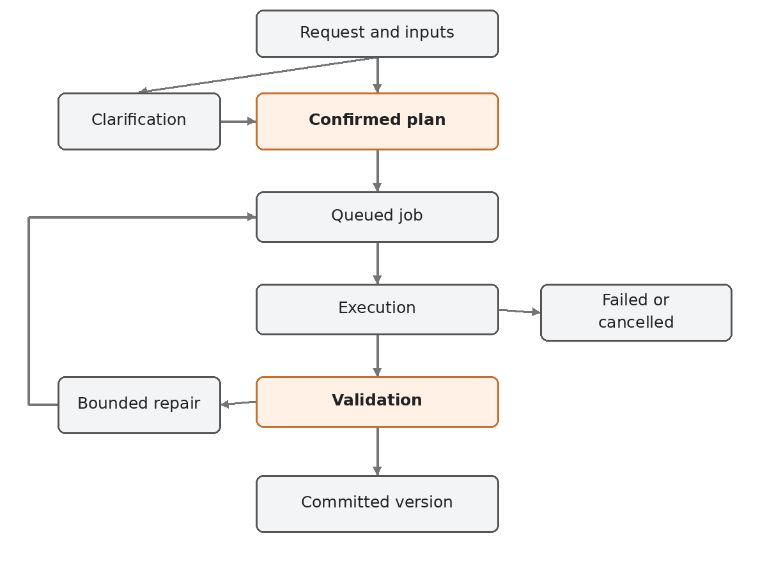
Each transition uses a compare and swap update on job state and revision. Store the job event and business state in the same database transaction. Queue messages contain IDs, operation kind, attempt number, tenant scope and trace ID, never file bytes or bearer credentials.
Service Bus delivery is treated as at least once. Duplicate detection helps with repeated sends but does not replace database idempotency. Use an outbox publisher, unique keys on tenant plus request idempotency key, and unique publication keys on job plus version. [S12]
CPU workers renew their message lock while executing. They complete the message after durable output publication or a durable transition to the next state. Configure finite delivery count and a dead letter queue. A watchdog checks expired job leases and reconciles jobs whose worker ended before acknowledgment.
GPU dispatch is a separate two step workflow. Persist dispatch intent and a stable external job name, submit the Azure ML job, record its ID, then acknowledge the dispatch message. If dispatch acknowledgment is ambiguous, reconcile by stable external job identity before resubmitting. A poller records completion and validates outputs. A 20 minute inference job must not rely on holding a short queue message lock throughout inference.
Cancellation sets a durable flag, requests worker or Azure ML termination, and discards late uncommitted outputs. Check cancellation between modeling operations. A successful artifact commit and cancellation race must resolve through the same transactional state revision check. A completed version remains immutable.

11 Drawing and image reconstruction
A single photograph does not determine exact hidden geometry or scale. Engineering mode requires explicit dimensions or a calibrated reference plus agreement on unresolved features. Visual mode can create plausible geometry with an approximate geometry label.
For drawings, first extract embedded text and vector elements when practical, then use Azure AI Document Intelligence Read for scanned text and a vision model for view interpretation. OCR extracts text; it is not a complete mechanical drawing understanding engine. [S13]
The drawing pipeline must identify page units, title block, orthographic views, section and detail views, dimensions, hole callouts, hidden lines and notes. Every extracted dimension stores page number, bounding box, original text, normalized value, units and review state. Model confidence scores are advisory and require calibration against the pilot corpus.
Create a consistency graph across views. Compare repeated dimensions, overall lengths and derived sums. Flag missing depth, contradictory views, unspecified scale and unreadable callouts. Present unresolved fields in the studio before generating engineering geometry. Begin with clean dimensioned plates, turned shafts and simple flanges. Keep complex castings, weldments and freeform surfaces outside the supported drawing envelope.
The acceptance path is reviewed dimension extraction, confirmed specification, supported recipe generation, geometric validation and engineer comparison against the source drawing. Pixel similarity alone is not an engineering acceptance test.

12 Visual 3D generation
Visual mode handles concept objects, props and textured assets. Keep its geometry, editing behavior and labels separate from engineering CAD. Default output is GLB. OBJ and STL are conversions with format specific limitations. STL has no standard embedded units or material support, so include a units sidecar.
Evaluate TRELLIS.2 as the primary image to 3D candidate and retain original TRELLIS as a lower hardware baseline. The official repositories list Linux testing and minimum GPU memory of 24 GB for TRELLIS.2 and 16 GB for original TRELLIS. Benchmark actual peak VRAM including postprocessing. These minimums do not guarantee runtime or memory headroom. [S14, S15]
For text input, the preferred pipeline is text to approved concept image to image conditioned 3D. Offer the user a reference image checkpoint because changing it can materially change the resulting asset. Original TRELLIS documentation recommends image conditioning for quality. A direct text model can remain an evaluated fallback. [S14]
Hunyuan3D is an alternate candidate, selected only after checking the exact code, model weight and dependency license terms and running the same benchmark. Do not classify every component as permissively licensed based on a repository headline. TRELLIS.2 states MIT terms for its main code and model while identifying separately licensed dependencies. [S15, S16]
Use versioned Azure ML environments and pinned CUDA, PyTorch and native extensions. Bake dependencies into images and stage model weights with hashes. A candidate Azure GPU family must provide sufficient actual VRAM; choose the final SKU only after regional quota and allocation tests. Do not assume a fraction of a 16 GB GPU will support a 24 GB workload.
Visual validation checks finite coordinates, nonempty mesh, connected component count, normals, texture references, bounding box, polygon budget, file load and watertightness when requested. Mesh repair creates a new derivative and preserves its source. Do not advertise automatic STEP export from a generated mesh as recovery of native engineering design intent.
Start visual edits with deterministic scale, rotation, material, decimation and version creation. Geometry changing conversational edits can regenerate a variant and must say so. Localized generative edits require a separate evaluated capability before the UI promises them.

13 Native SolidWorks companion
Use a Windows C# companion or add in that communicates with the installed SolidWorks COM API. The cloud owns planning, project state and usage. The companion owns the local native CAD session. Linux CAD jobs cannot create genuine proprietary native documents simply by renaming STEP files.
Pair the device with the signed in organization using short lived authorization. Establish outbound HTTPS polling or a supported persistent authenticated channel. Never expose an inbound public desktop control port. Each command has a job ID, tenant ID, target document fingerprint, base revision, allowed operation and expiration.
Serialize COM operations on the appropriate local CAD execution thread, enforce one writer per document and require a document revision match before mutation. Read native feature state, create supported sketches and features, rebuild, inspect errors, save a checkpoint and export. Use native persistent references where available and revalidate them after changes. SolidWorks documents APIs for persistent references, but adapter behavior still needs validation across supported versions. [S17]
Start with one explicitly tested SolidWorks version, chosen with the client, then add others. Preserve the original document, provide a visible operation log, pause when the user edits concurrently and support cancellation. A cloud plan must not change a different open document after a user switches tabs.
Background native automation requires a separate licensed supported Windows CAD session with suitable desktop and automation conditions. Do not assume unattended Windows Service execution or shared concurrent sessions are supported. Confirm licensing and deployment terms with the supplier. The initial Azure cost model excludes commercial CAD licenses and hosted Windows native workers.
STEP feature reconstruction is a later constrained pipeline: classify surfaces, identify supported primitives, rebuild candidate history, compare geometry, then engineer review. Matching volume alone cannot prove equivalent shape or recovered design intent.

14 Studio behavior and screens
Use React, TypeScript, Vite and React Three Fiber over Three.js. Keep visual styling flexible for Wayam's team. The product flow should expose engineering evidence in ordinary language without showing infrastructure details.
Screen | Required controls and content
Projects | Organization switcher, searchable projects, access role, recent models
New model | Engineering or Visual mode, prompt, upload, units, required output
Clarification | Missing dimensions, evidence crops, conflicts, editable values and assumption confirmation
Workspace | Left feature and parameter panel, central viewer, right conversation, bottom job progress
Validation | Actual versus requested dimensions, solid validity, export status and unresolved checks
Versions | Parent version, changed parameters, preview comparison, validation changes and restore as new version
Drawing review | Source page, highlighted callouts, extraction table and confirmed dimensions
Export | Available formats, source version, units and download
Organization settings | Members, roles, limits, retention and approved design rules
Operations | Job search, failure reason, retry eligibility, usage and cost estimates

The viewer shows axis orientation and units. Selecting a feature highlights corresponding preview entities through a version specific mapping. Measurements distinguish exact CAD properties from approximate tessellated measurements. Disconnected clients reconnect using persisted event IDs and receive the latest state.
Never report completion when a preview exists but required STEP validation failed. Separate statuses for generated, geometry validated and reviewed for engineering release. Provide keyboard access, visible focus, readable contrast and a fallback artifact list when WebGL is unavailable.

15 API contracts
Use versioned REST endpoints under /v1 and Server Sent Events for progress. Browser traffic uses authenticated API requests. Derive tenant identity from verified membership, not an untrusted request field.
Method and path | Purpose | Important behavior
POST /v1/projects | Create project | Validate organization membership
POST /v1/uploads | Reserve upload | Type and size checks, quarantine blob
POST /v1/uploads/{id}/complete | Finalize upload | Verify bytes, hash and parser readiness
POST /v1/projects/{id}/specifications | Parse prompt and inputs | Return structured fields and clarifications
PATCH /v1/specifications/{id} | Confirm or edit requirements | Require specification revision
POST /v1/projects/{id}/jobs | Run confirmed specification | Idempotency key, quotas and 202 job ID
GET /v1/jobs/{id} | Read state and validation summary | Enforce tenant and project membership
GET /v1/jobs/{id}/events | Stream progress | Resume with Last Event ID
POST /v1/jobs/{id}/cancel | Request cancellation | Idempotent, report terminal races
POST /v1/models/{id}/edits | Create parameter or feature edit | Require base version or return 409
GET /v1/models/{id}/versions | Read immutable history | Paginated, access checked
POST /v1/versions/{id}/exports | Create export derivative | Reuse verified artifact if same settings
GET /v1/artifacts/{id}/download | Authorize delivery | Expiring scoped link or API stream
GET /v1/usage | Read organization usage | Admin or permitted project scope
POST /v1/devices/pair | Pair native CAD companion | Later milestone, short lived grant

Standard error fields are code, message, job_id, feature_id, retryable and trace_id. Use 400 for invalid syntax, 401 for authentication, 403 or non revealing 404 for denied objects, 409 for stale revisions, 422 for unsupported or conflicting geometry requirements and 429 for rate limits. A model refusal or exhausted repair budget is a persisted workflow result, not a misleading HTTP success with an empty artifact.

16 Database and artifact design
Use PostgreSQL migrations and tenant scoped foreign keys. Required entities are tenants, users, memberships, projects, project_memberships, uploads, specifications, clarification_answers, models, model_versions, features, jobs, job_attempts, job_events, artifacts, validation_results, design_rules, usage_events, outbox_events, audit_events and paired_devices.
Entity | Key fields and invariants
specifications | Tenant, project, source IDs, parsed JSON, units, revision, confirmed state
model_versions | Model, parent version, recipe hash, engine versions, validation state, immutable manifest
jobs | Tenant, project, specification revision, state, state revision, idempotency key, lease and budget
job_attempts | Attempt, tool plan hash, worker identity, external job ID, timing and structured error
artifacts | Tenant, version or attempt, blob key, hash, format, byte size, quarantine state
usage_events | Job, attempt, token counts, CPU or GPU duration, image calls, estimated or billed rate
outbox_events | Event ID, aggregate ID, event type, payload, publication status and retry time
audit_events | Actor, tenant, object, action, timestamp and redacted change metadata

Use UUID identifiers. Enforce unique tenant and idempotency key, unique job and published version, and foreign key checks including tenant scope. Enable row level security as defense in depth. API runtime roles must not own tables or bypass RLS. In pooled connections, set tenant context transaction locally, validate it for every transaction and test reuse across tenants.
Blob keys follow tenants/{tenant_id}/projects/{project_id}/jobs/{job_id}/attempts/{attempt}/ and separate committed versions/{version_id}/ paths. A prefix is a naming convention, not an access control boundary. Authorize object access using database ownership and per artifact capabilities.
Write outputs to attempt staging, calculate hashes, validate and then publish a database artifact manifest transactionally. Readers only see committed manifests. Reconciliation removes abandoned staging artifacts after a grace period. Preserve input hashes, recipe, seed, model settings, engine versions and validation report for reproducibility.
Suggested POC retention is 7 days for failed intermediates and 30 days for unneeded previews. Keep committed models for the agreed project retention period. Treat deletion as a workflow covering database rows, blobs, caches, backup expiry and audit obligations. Do not claim immediate deletion from backups.

17 Security and engineering IP
Use Microsoft Entra ID for internal and customer enterprise identities. Add External ID only if public self service onboarding becomes required. Validate issuer, audience, signature, expiry and organization membership. Roles are organization admin, project editor, project viewer and operations admin, with operations access audited.
Use separate managed identities for API, planner, dispatcher and workers. Workers receive only scoped artifact capabilities and required queue permissions. The restricted geometry subprocess receives no model API credentials, database credentials or managed identity access. A container alone is not a complete boundary for executing hostile generated code; the launch design executes trusted operations over validated data.
Run geometry processes without root, host mounts, Docker socket or runtime package installation. Apply supported CPU, memory, execution time and temporary storage limits. Separate parser and geometry processes from credentialed control processes. Test the actual enforcement available in the chosen hosting environment. If arbitrary script execution is added later, move it to a stronger isolated environment with a separately reviewed threat model.
Treat uploads, filenames, drawing notes and retrieved documents as untrusted. Reject embedded macros and scripts, constrain PDF rendering, block decompression bombs and path traversal, and scan uploads before trusted parsing. Uploaded instructions cannot change tenant policy, execute shell commands or access arbitrary network addresses.
Do not log raw CAD files, prompts containing customer designs, signed URLs or tokens by default. Store redacted metadata and allow controlled diagnostic access. Contractually establish customer IP ownership, whether inputs can enter evaluation datasets, processing geography and retention. Customer designs must not automatically become cross tenant training or retrieval material.

18 Deployment and operations
Maintain separate dev, staging and production resource groups, identities and data stores. Dev can use small resources and synthetic examples. Production uses a separately priced baseline. Bicep modules cover network and DNS, registry, storage, database, queues, Container Apps, AI deployments, ML compute, identities, role assignments, telemetry and budgets.
The pipeline runs schema checks, deterministic CAD fixtures, API integration tests and a secret scan. Build containers, create a software bill of materials, scan vulnerabilities, pin digests, deploy staging and run smoke tests. Promote the same digests after acceptance. Use workload identity federation for pipeline access instead of long lived deployment passwords.
Migrations use expand then contract changes. Rollback the application independently of destructive schema changes. Model or geometry engine upgrades run the regression corpus first and are enabled through explicit configuration. Keep the previous deployment and adapter images available for old recipe replay.
Monitor queue age, active leases, dead letters, CAD validity rate, clarification rate, job latency, retry count, GPU OOM, failed exports, API errors and cost per successful job. A failed upload or cancelled job still contributes to consumed cost. Alert on stalled jobs, repeated invalid output, quota exhaustion and authorization anomalies.
Initial pilot targets are API p95 below 1 second excluding uploads and model calls, deterministic simple CAD p95 below 60 seconds of worker runtime, text to supported CAD p95 below 3 minutes excluding queue delay, and visual generation below 15 minutes at p95 after benchmark. Track queue, cold start and inference time separately. These are engineering acceptance targets, not established measurements or contractual SLAs.
For an external pilot, target 99.5 percent monthly API availability, RPO at most 24 hours and RTO at most 8 hours through tested backup and restore procedures. A production tier should reassess zone redundant PostgreSQL, service tiers, private networking, regional recovery and tighter objectives. Azure PostgreSQL documents high availability options, with extra resources and cost. [S19]

19 Testing and release gates
The workbook defines detailed planned tests with fixture, procedure, expected result, owner and execution status. Start with 30 deterministic golden recipes across six families, 60 language requests including ambiguous and impossible specifications, 20 drawing pages, 20 edit sequences and 20 visual references. Maintain a held out set and never tune exclusively on acceptance examples.
Engineering oracles must measure geometry independently of the prompt text. Verify bounding boxes, volume, solid count, hole axes and diameters, center spacing and minimum wall checks where supported. For the initial small part corpus, use a default dimensional comparison tolerance of 0.01 mm and a STEP round trip relative volume difference at most 0.00001. These are software comparison tolerances, not manufacturing tolerances. The mechanical lead may tighten them per fixture.
Gate | Acceptance target | Owner
G0 Foundations | Azure access, quotas, region choice, CAD SME and approved sample corpus | Technical lead
G1 Deterministic CAD | 30 of 30 supported reference recipes valid with expected measurements and exports | CAD engineer
G2 Web release | At least 90 percent completion on supported unambiguous held out text tasks within budget; all mandatory tenant and replay tests pass | AI and QA
G3 Engineering pilot | Confirmed dimensions match approved drawings; all published native edit fixtures reopen and rebuild; critical security tests pass | Mechanical lead and QA
G4 Extended pilot | Supported SolidWorks operations and document locking pass; selected visual model meets published quality and cost envelope | Integration lead

Count every supported submitted task in completion metrics, including failures. Report unsupported tasks and clarifications separately. Do not inflate accuracy by dropping failed cases or counting a plausible mesh as a successful CAD result. Visual quality uses a defined human rubric for silhouette, texture and artifacts, with acceptance targets fixed after the week 1 benchmark.
Required resilience tests cover duplicate messages, expired leases, partial blobs, external ML submission ambiguity, worker crash, cancellation races, stale edits, model timeouts, invalid topology, wrong units, tenant boundary probes and restore from backup. Native tests include dirty documents, tab switches, concurrent edits, missing licenses and unexpected CAD dialogs.

20 Roadmap and team
Weeks | Work and dependency | Demonstrable result
1 to 2 | Scope corpus, region and quota spike, schema, deterministic adapter and measurement oracle | 30 reference parts, analytic plate, export report
3 to 4 | Entra, projects, storage, job state, outbox, Service Bus, planner and bounded repair | Prompt to verified STEP through Azure jobs
5 to 6 | Studio, viewer, parameter edits, versions, downloads and SSE | Web client demonstration with editable plate
7 to 8 | FreeCAD adapter, semantic selectors, edit replay, native feature tests and drawing extraction spike | Supported FCStd edit and confirmed drawing fields
9 to 10 | Constrained drawing reconstruction, TechDraw and simple assemblies | Reviewed drawing to CAD and drawing sheet
11 to 12 | Tenant tests, restore, usage controls, benchmark and pilot feedback | Candidate engineering pilot
13 to 14 | Stabilization, performance work and customer acceptance | Controlled engineering pilot release
15 to 16 | Windows companion, pairing, read and supported write operations; visual model bakeoff | Local native CAD prototype and visual benchmark
17 to 18 | Native edit and export, GPU batch integration and visual workspace | Native supported task plus textured asset
19 to 20 | Interruption tests, packaging, usage calibration and pilot acceptance | Extended pilot on supported scope

The core delivery allocation is 1 backend engineer, 1.5 FTE of CAD automation engineers, 1 AI engineer, 1 frontend engineer and 1 QA automation engineer. Front load the CAD allocation with two CAD capable engineers during the first two weeks, then adjust coverage within the overall allocation. This supports the deterministic engine milestone and later FreeCAD work. Add a technical architect at 0.5 FTE, a DevOps engineer at 0.5 FTE and a mechanical engineering SME at 0.5 FTE. The architect can overlap a senior role only if that person's delivery capacity is reduced explicitly. The SolidWorks milestone needs a C# and native CAD specialist, budgeted separately in the workbook.
Assume 5 working days per week and 75 percent effective delivery time for meetings, review and integration. Use the workbook backlog effort and staffing capacity as a feasibility check, not a guarantee that all roles are interchangeable. CAD specialist availability and customer drawing feedback are schedule constraints even when total team capacity appears adequate.

21 Cost model and commercial planning
The workbook has editable usage, rates, fixed platform allowances and staffing inputs. All initial rates are illustrative planning assumptions in USD or INR as labeled. They are not live Azure prices, negotiated discounts or exchange rates. Replace them using a selected region, currency, SKU and deployment type in Azure Pricing Calculator before authorizing spend. Azure ML cost depends on the underlying compute and related resources. [S20, S21]
The initial calculation assumes 1,000 CAD requests and 200 visual requests per month. Average attempts are 1.2 and 1.3 respectively, average CAD compute is 2 minutes per attempt and visual compute is 8 minutes per attempt plus 2 minutes of billed startup allocation. The illustrative GPU rate is USD 3 per hour. Actual cold starts and billing behavior must be measured.
Token inputs are 12,000 input and 2,000 output tokens per CAD attempt, with illustrative prices of USD 2 and USD 8 per million tokens. Visual orchestration uses 3,000 and 500 tokens per attempt plus an assumed USD 0.05 concept image cost per visual request. Pages use a separately editable OCR allowance. These are workload estimates, not a named model's verified price.
The baseline fixed platform allowance is USD 220 monthly across application runtime, database, queue, artifacts, registry, monitoring, secrets and networking or backup reserve. Variable CPU uses an illustrative USD 0.15 per worker hour. Contingency is 20 percent and USD to INR is an editable assumption of 90, not a live conversion quote.
With these defaults, the estimate is approximately INR 45,025 per month including contingency, before tax, development effort, private enterprise networking and commercial CAD licenses. The workbook is authoritative for the calculated value. Actual production infrastructure can be materially higher. Keeping a USD 3 per hour GPU warm for 730 hours alone would cost USD 2,190 before the rest of the stack.
Track cost per successful CAD job and visual job separately. Variable cost includes failed attempts, model calls, compute startup allocation, postprocessing and retries. Show fully allocated cost separately using an explicit fixed cost allocation convention. Also show success count and failure rate, because a cheaper attempt can be a more expensive successful result.
Use per job reservation against a tenant budget and reconcile actual use. Admission controls enforce concurrency and request budgets. Azure budget alerts support monitoring but are not the application's real time spending stop. Suspend new visual jobs when their configured allowance is exhausted while preserving access to existing models.
The staffing sheet estimates build labor from role, FTE, monthly rate and weeks. It is a planning model rather than a Wayam salary disclosure or client quote. Infrastructure OPEX and one time engineering effort must remain separate in proposals.

22 Main delivery risks
Risk | Effect | Response and early decision
Unreliable topology selection | Edits affect wrong edges or fail | Semantic references, expected cardinality and edit corpus
Drawing ambiguity | Wrong dimensions or hidden geometry | Evidence review, clarification and constrained part families
Native history mismatch | Files open but lack editable features | Separate native adapters and reopen edit tests
GPU region or quota failure | Visual pipeline delayed | Week 1 allocation test; CAD pilot remains independent
Broad product promises | Schedule expands beyond team capacity | Publish supported families and release boundaries
License uncertainty | Cannot distribute or host a component | Exact model and dependency register before selection
Model output drift | Regression in plans or repairs | Pinned deployments and benchmark gate
Queue and crash races | Duplicate cost or corrupted history | Outbox, leases, external job reconciliation and atomic publication
Engineering IP exposure | Cross tenant access or data retention breach | Auth tests, scoped artifacts, retention and diagnostic controls
Slow or expensive inference | Budget and UX failure | Measure billed time and success cost; admission quotas
Native CAD dialogs or threading | Companion hangs or mutates wrong document | Supported version matrix, document locks and interruption tests
Misunderstood validation | Generated model treated as certified design | Separate geometry validation from engineering approval

23 Repository and implementation conventions
Use a monorepo with apps/studio, apps/solidworks-companion, services/api, services/coordinator, workers/cad, workers/visual, packages/contracts, adapters/build123d, adapters/freecad, adapters/solidworks, validators, infra/bicep, evals and docs. Keep CAD processes separate from web request execution.
Generate API clients from OpenAPI and validate all payloads with shared versioned contracts. Store database migrations and seed synthetic fixtures. Use a Python lockfile and a frontend package lock. Pin stable versions after the initial compatibility spike rather than copying versions from a dated example. Each adapter declares its operation vocabulary and export capabilities.
Every feature is complete only when its supported input envelope, output contract, failure behavior, usage recording and relevant acceptance tests are documented. Avoid a generic framework that hides the transaction, queue acknowledgment or artifact publication behavior.

24 Execution checklist for the first ten days
1. Product owner and mechanical SME choose six part families and provide 30 approved reference recipes, including the analytic plate.
2. Technical lead confirms Azure subscription, permitted regions, Entra tenant, model access, GPU quota and pilot data policy.
3. CAD engineer builds the pinned build123d container and verifies STEP import, export and measurable solid properties.
4. Backend engineer implements the recipe schema, validation report and local execution contract before agent integration.
5. AI engineer prepares language fixtures and missing dimension cases; choose model deployment by measured schema and plan quality.
6. DevOps creates dev Bicep modules, registry and CI with workload identity.
7. Frontend engineer builds the viewer against real GLB previews and a typed mock API, then connects to the first verified job.
8. QA implements independent geometry assertions and records failures by stable fixture ID.
9. Demonstrate a width change, version preservation, invalid hole rejection and worker timeout.
10. Review G1 results, measured runtime and cost. Freeze the first supported envelope before adding drawings.
Inputs needed from Wayam are the product owner, one available mechanical SME, representative drawings with usage rights, expected native CAD version, Azure subscription access, residency decision and target pilot users. These are implementation prerequisites. Planning and local deterministic development can start while account access is arranged.

25 Source register
Sources were reviewed on 18 October 2026. Service names, availability, prices and model support can change. Links support specific capabilities; the proposed design, sizing, costs and schedule are our engineering judgments.
- S01 Shared conversation supplied by the user: Open source
- S02 MecAgent features: Open source
- S03 MecAgent live and background demos: Open source
- S04 Container Apps Jobs: Open source
- S05 Azure ML batch endpoints: Open source
- S06 Azure ML batch deployments and compute configuration: Open source
- S07 build123d import and export: Open source
- S08 build123d repository and license: Open source
- S09 FreeCAD source API: Open source
- S10 Azure Storage SAS overview: Open source
- S11 Azure OpenAI structured outputs: Open source
- S12 Service Bus duplicate detection: Open source
- S13 Document Intelligence Read: Open source
- S14 Original TRELLIS official repository: Open source
- S15 TRELLIS.2 official repository: Open source
- S16 Hunyuan3D alternate repository: Open source
- S17 SolidWorks persistent references: Open source
- S18 FreeCAD TechDraw documentation: Open source
- S19 PostgreSQL high availability: Open source
- S20 Azure ML pricing: Open source
- S21 Azure Pricing Calculator: Open source

26 Package navigation
Read this blueprint for product scope and architecture. Use Shilpa_Implementation_Handoff.md for coding agent instructions. Use Shilpa_Execution_Workbook.xlsx for assignable backlog, sprint gates, planned tests, Azure resources, risks and editable cloud and labor cost calculations. The package ZIP contains the same deliverables together.

