**DOKUZ EYLUL UNIVERSITY**

**ENGINEERING FACULTY**

**DEPARTMENT OF COMPUTER ENGINEERING**

**CME3401 DATABASE MANAGEMENT SYSTEMS**

**TERM PROJECT PROPOSAL**

**MY WATCH LIST**

**by**

**Emil Ismayilzada – 2022510029 – emil.ismayilzada@ogr.deu.edu.tr**

**Boran Bereketli – 2022510105 – boran.bereketli@ogr.deu.edu.tr**

**Bedirhan Yenilmez - 2022510159 – bedirhan.yenilmez@ogr.deu.edu.tr**

**Lecturers**

**Assoc. Prof. Semih Utku**

**Res. Asst. Fatih Dicle**

**IZMIR**

**05.11.2024**

**MY WATCH LIST**

My Watch List is a website designed for users to track movies, series, and other content they are currently watching, plan to watch, or have watched before. Users can rate shows, leave comments, and explore profiles of other members. The platform offers advanced search options with various filters, making it easy to discover new content. Users can also track their progress on individual episodes and follow friends and see their profiles. Users can also see detailed statistics about the show they watch.

**INTRODUCTION**

In today's fast-paced world of entertainment, keeping track of what we've watched and discovering new content can be overwhelming. With countless movies and TV series available across various platforms, people need an efficient way to organize their viewing habits and connect with others who share similar interests. My Watch List is a platform designed to help users manage their watchlists and track their progress on individual episodes. This project addresses the growing need for a comprehensive, user-friendly platform where entertainment enthusiasts can stay organized, discover new shows, and engage with a community.

**PURPOSE AND BENEFITS**

The purpose of My Watch List is to provide a centralized, user-friendly platform for entertainment enthusiasts to manage their viewing habits efficiently. By offering tools to track progress, rate shows, leave comments, and explore new content, My Watch List aims to simplify the experience of staying organized in the vast world of movies and series.

The advanced search options and personalized watchlists help users discover relevant content, making it easier to find shows that match their preferences. With features like detailed statistics and episode tracking, My Watch List offers a comprehensive solution that enhances the way people interact with their favorite entertainment, ultimately making viewing experiences more enjoyable and organized.

**MODE, MEDIUM, AND ENVIRONMENT**

My Watch List is intended to be a web-based application accessible through any modern web browser, meaning users can access it from various devices, including desktop computers, laptops, tablets, and smartphones. The environment in which the application will be used includes both personal spaces (home, during commuting) and shared spaces (workplaces, social gatherings) where users may discuss content with friends. The primary mode of user interaction is through a responsive user interface designed for both touch and mouse-based input. The assumption is that users will be familiar with basic browsing habits and have an internet connection to fully access all features. These assumptions influence the design process by ensuring that the platform is mobile-friendly, fast-loading, and intuitive for all levels of technical skill.

**FUNCTIONALITY**

1. Watchlist Management: Users can create and manage their watchlists (plan to watch, currently watching, completed).
2. Episode Tracking: Users can track their progress on individual TV shows, marking episodes as watched.
3. Rating and Reviews: Users can rate content and leave public or private reviews for others to see.
4. Search and Filtering: Search functionality with multiple filters (genre, release year, etc.).
5. Social Features: Users can follow other profiles, and see what others are watching.
6. Statistics: Statistics on viewing habits, such as total hours watched, genre preferences, and more.
7. User Profiles: Users can create and view their profiles, showcasing their favorite shows and reviews.

**HIGH LEVEL ORGANIZATION**

The sitemap illustrates the high-level organization of the "My Watch List" application. It starts from the Home page, allowing users to log in or register. Once logged in, users can access their Profile, which includes features like managing their watchlist, viewing statistics, following others, and profile settings. The sitemap also shows navigation to Search, where users can browse and comment on shows, and Statistics about the website. Finally, users can access support pages like Contact Us, FAQs, and About Us for further assistance.

**FUNCTIONALITY VS POLISH**

We anticipate completing the development of the app within a two-month timeframe. The first six weeks will focus on building core functionality, ensuring all planned features like user profiles, watchlists, comments, and statistics are implemented and fully operational. The final two weeks will be dedicated to polishing the application—this includes refining the user interface, fixing any bugs, improving performance, and enhancing the overall user experience to ensure a smooth and professional product launch.

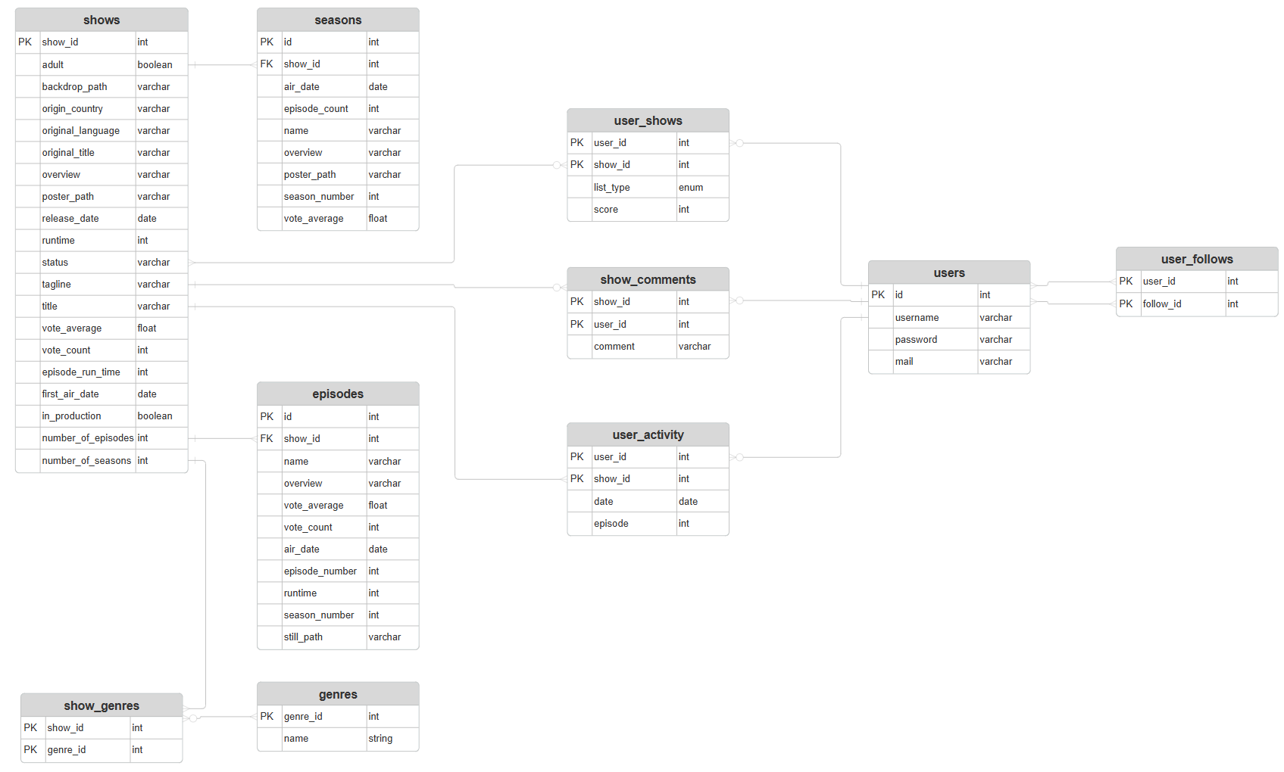

Figure : Database ER Diagram

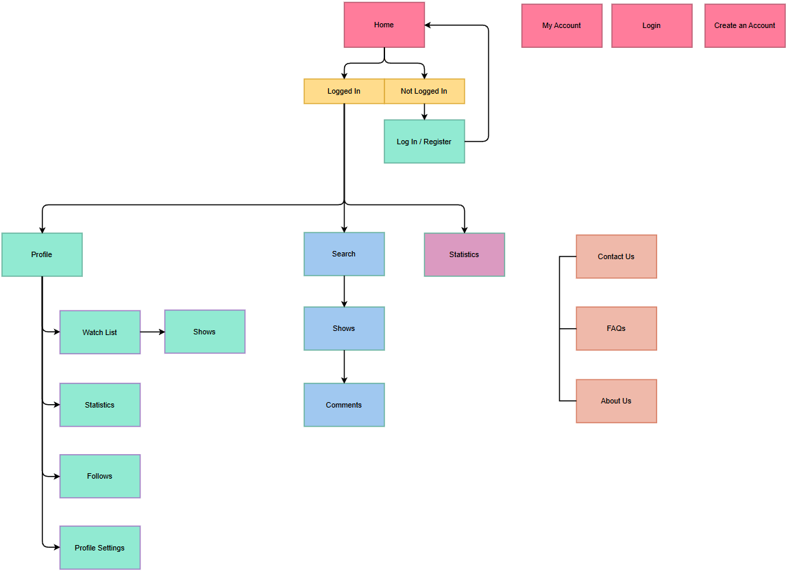

Figure : Sitemap

**MILESTONES AND TIMELINE**

Week 1:

* Research and choose the tech stack for backend and frontend development.
* Set up project repositories and development environments.
* Design basic UI and get approval from team members.

Week 2:

* Develop and integrate initial UI layout for the homepage.
* Set up the database and begin designing the schema for watchlists, episodes, and user data.

Week 3:

Week 4:

* Implement core functionality for managing watchlists (add, remove, mark as watched).
* Develop user profile pages for managing favorite shows and reviews.
* Implement basic user authentication (signup, login, password recovery).
* Develop the search bar with initial filtering options (genre, release year).

Week 5:

* Develop a UI for displaying ratings and reviews on the content pages.
* Ensure search functionality integrates with the database.
* Implement episode tracking feature (mark individual episodes as watched).
* Implement rating and review system for content.

Week 6:

* Allow users to leave comments on movies/series.
* Implement social features like following other users.

Week 7:

* Implement detailed statistics dashboard (total hours watched, genre preferences, etc.).
* Focus on UI/UX improvements, making the platform mobile-friendly and responsive.

Week 8:

* Fix any bugs identified during testing and user feedback.
* Finalize the app and prepare for deployment.
* Deploy the web application to a hosting platform.