**DOKUZ EYLUL UNIVERSITY**

**ENGINEERING FACULTY**

**DEPARTMENT OF COMPUTER ENGINEERING**

**CME3401 DATABASE MANAGEMENT SYSTEMS**

**TERM PROJECT PROPOSAL**

**MY WATCH LIST**

**by**

**Emil Ismayilzada – 2022510029 – emil.ismayilzada@ogr.deu.edu.tr**

**Boran Bereketli – 2022510105 – boran.bereketli@ogr.deu.edu.tr**

**Bedirhan Yenilmez - 2022510159 – bedirhan.yenilmez@ogr.deu.edu.tr**

**Lecturers**

**Assoc. Prof. Semih Utku**

**Res. Asst. Fatih Dicle**

**IZMIR**

**14.01.2024**

**ABSTRACT**

My Watch List is a web-based application designed for users to track their entertainment content, including movies and TV series. Key components include Watchlist Management for organizing shows as "Plan to Watch", "Currently Watching", or "Completed", and Episode Tracking to monitor progress. Users can leave Ratings and Reviews and explore content through advanced Search and Filtering options. Social Features allow users to follow others, view profiles, and share recommendations. The platform is responsive, user-friendly ensuring a seamless experience for entertainment enthusiasts.

**COMPLETION REPORT**

n this project, we successfully implemented the core functionality of the My Watch List application, including Watchlist Management, Episode Tracking, Ratings and Reviews, Social Features, and Search and Filtering options. However, some milestones were not accomplished. Firstly, we were unable to complete the Statistics Dashboard, which was intended to provide users with detailed insights into their viewing habits. Additionally, certain authorization features were not fully implemented, which limited the ability to restrict access to specific functionalities based on user roles or permissions. We also planned to include small details, such as advanced filters or more personalized recommendations, but time constraints and resource limitations prevented their completion.

**FUNCTIONAL DECOMPOSITION**

**HIGH-LEVEL ORGANIZATION**

The sitemap illustrates the high-level organization of the "My Watch List" application. It starts from the Home page, allowing users to log in or register. Once logged in, users can access their Profile, which includes features like managing their watchlist, viewing statistics, following others, and profile settings. The sitemap also shows navigation to Search, where users can browse and comment on shows, and Statistics about the website. Finally, users can access support pages like Contact Us, FAQs, and About Us for further assistance.

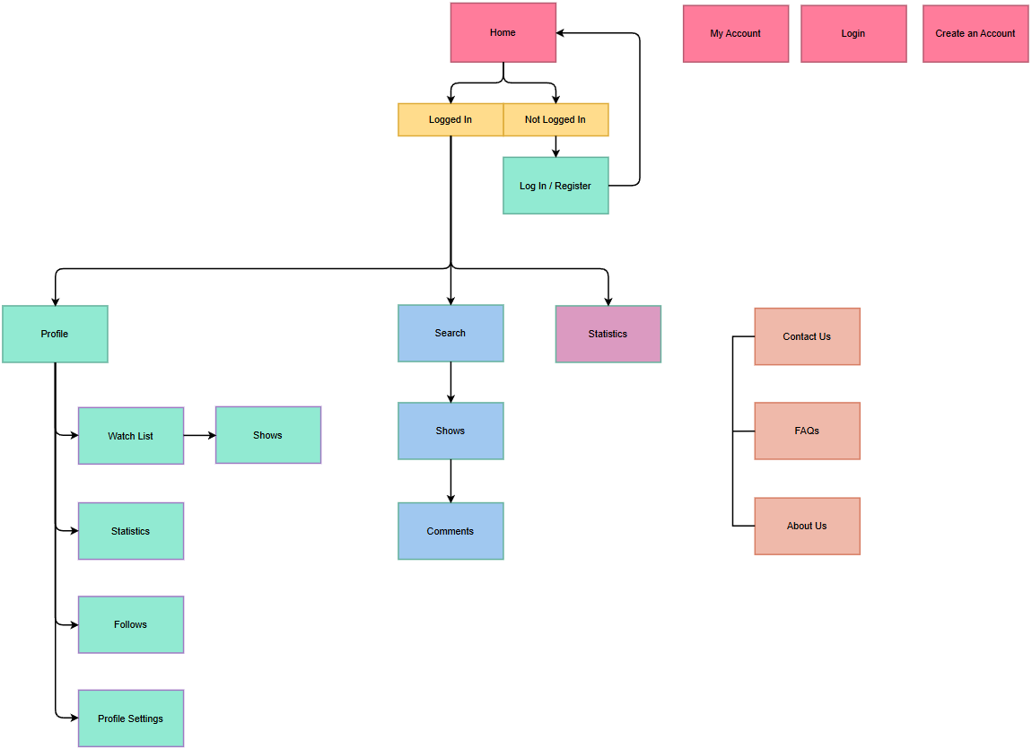

Figure 1: Sitemap

The ER Diagram for the "My Watch List" application represents the database's structure, showing key entities and their relationships. The Users table manages user information, including roles, login credentials, and email, connecting to activities, watchlists, and follower relationships through tables like user_activity, user_shows, and user_follows. The Shows table stores information about movies and TV series, including metadata such as title, overview, and release date, with connections to related entities like episodes, seasons, and genres. The Comments and Ratings tables enable user interactions with shows, while Genres categorize content. Together, these tables create a relational structure to manage user accounts, track viewing habits, and support advanced search and social features.

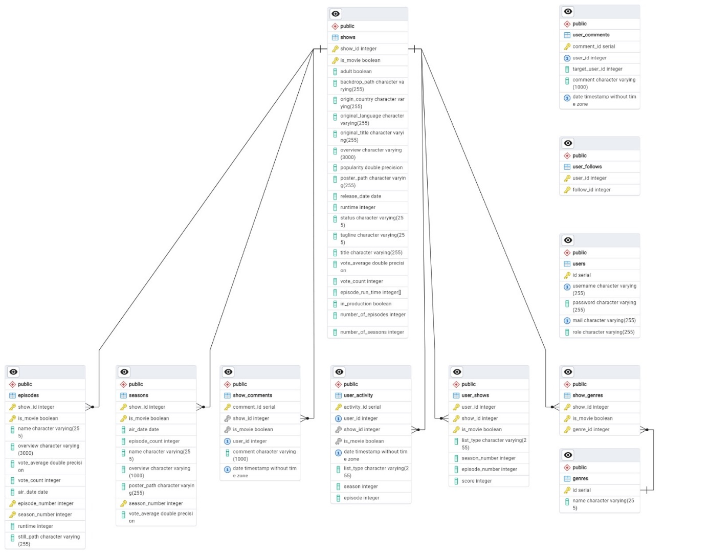

Figure 2: Database ER Diagram

**CLICKSTREAMS**

In the case of the "My Watch List" web application, clickstream data provides valuable insights into user behavior, helping to improve the platform's functionality and overall user experience. Below are the common use cases for analyzing clickstream data within the application.

1. User Registration and Login:

Track the steps users take during account creation and login processes.

Identify any drop-off points to streamline the onboarding experience.

1. Watchlist Management:

Monitor how users add, remove, and update items in their watchlists.

Analyze usage patterns to understand which watchlist categories are most popular (e.g., "Plan to Watch" vs. "Completed").

1. Content Search and Filtering:

Capture user interactions with the search bar and filtering options.

Determine the most commonly searched genres, release years, or other criteria.

1. Episode Tracking:

Record user activity for marking episodes as watched.

Highlight popular shows or episodes based on user engagement.

1. Ratings and Reviews:

Track the flow from viewing content details to submitting ratings or reviews.

Understand how users engage with public and private review features.

1. Social Features:

Analyze user actions related to following other profiles and viewing friend activities.

Measure the impact of social interactions on user retention.

**LAYOUT**

**Primary Views and Descriptions**

1. Homepage

Purpose: The entry point of the application, providing users with quick access to key features.

Features:

* Navigation bar with links to Profile, Search.
* Search bar for quick content discovery.
* Featured content (e.g., popular shows/movies).
* Login/Signup buttons for account access.

1. Search Page

Purpose: Helps users discover new content using advanced filtering options.

Features:

* Search bar at the top of the page.
* Filters for movie or the tv show.
* Display of search results in a list format.

1. Profile Page

Purpose: Allows users to manage their profiles and view personal activity.

Features:

* Display of user details, reviews and some statistics.
* List of followers and following users.
* Settings for managing account preferences.
* Comment to profiles.

1. Show Page

Purpose: Allows users to reach the show and its details effectively.

Features:

* Categorization of items into "Plan to Watch", "Currently Watching", "Completed.", "Dropped" and " On Hold".
* Comment to the shows.
* Progress tracking for TV show episodes and seasons and rate the shows.
* Displaying informations about the shows.

**IMPLEMENTATION**

1. **Home Page:** 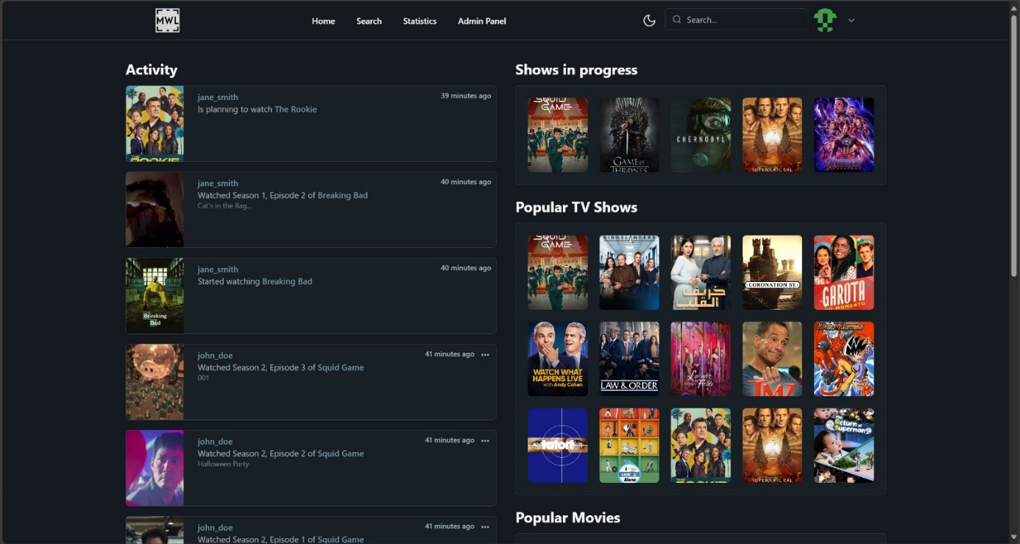

This screenshot shows the **Home Page**, providing an overview of user activity and popular content. On the left, the **Activity Feed** displays recent actions from users, such as watching or planning to watch shows. On the right, sections like **Shows in Progress**, **Popular TV Shows**, and **Popular Movies** highlight trending content and user interests. This page serves as a hub for discovering content and staying updated with community activity.

1. **Search Page**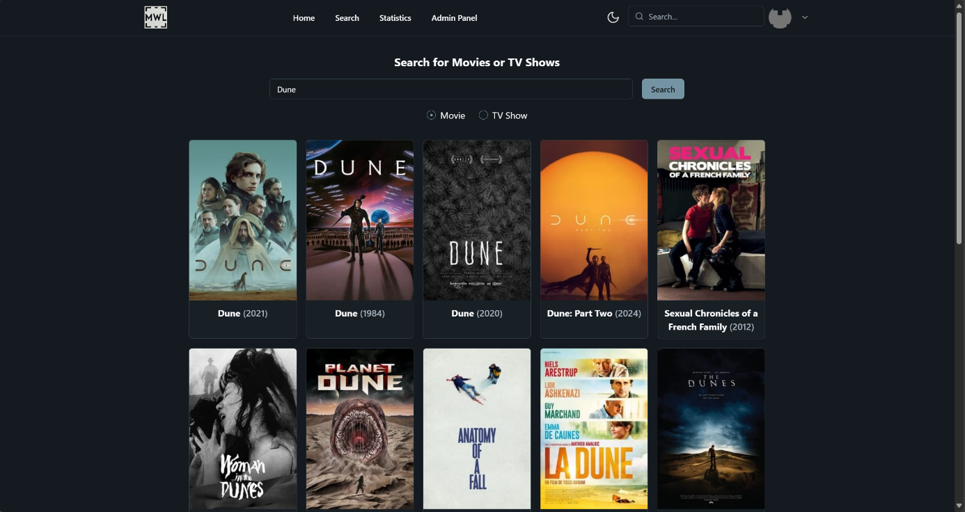

This screenshot showcases the **Search Page** of the "My Watch List" application, where users can search for movies or TV shows and view results in a visually appealing grid format. The navigation bar at the top provides access to other sections like **Home**, **Statistics**, and **Admin Panel**, along with a theme toggle and user profile options. Users can enter a query (e.g., "Dune") in the search input, apply filters to narrow results by type (Movie or TV Show), and click the **Search** button to retrieve relevant content. The results are displayed as clickable cards, each showing a poster, title, and release year, allowing users to select and explore detailed information about specific movies or shows. This page offers an intuitive way for users to discover and interact with entertainment content.

1. **Show Page**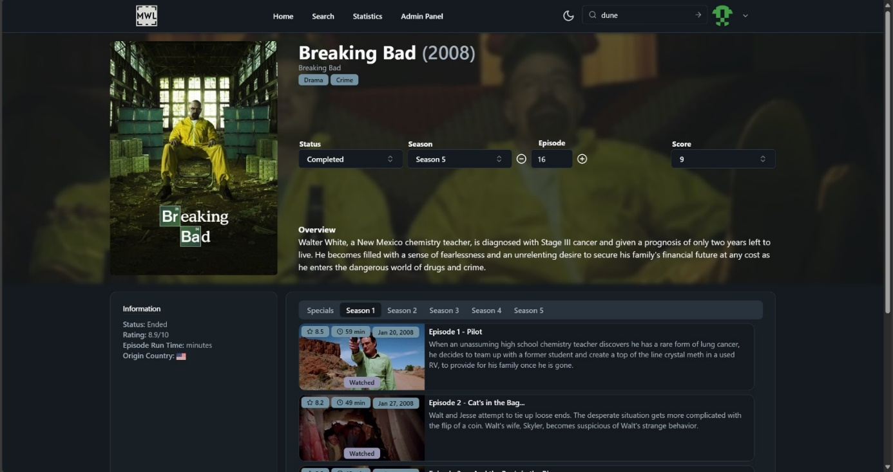

This screenshot displays the **Show Page**, providing detailed information about a specific show or movie. The page includes the title, genre, status, user rating, and an overview of the content. Users can update their progress by selecting the season, episode, and score. Below, episode details are displayed in a tabbed format, allowing users to mark episodes as watched or view their summaries. This page offers a comprehensive view and interaction with individual content.

1. **User Page**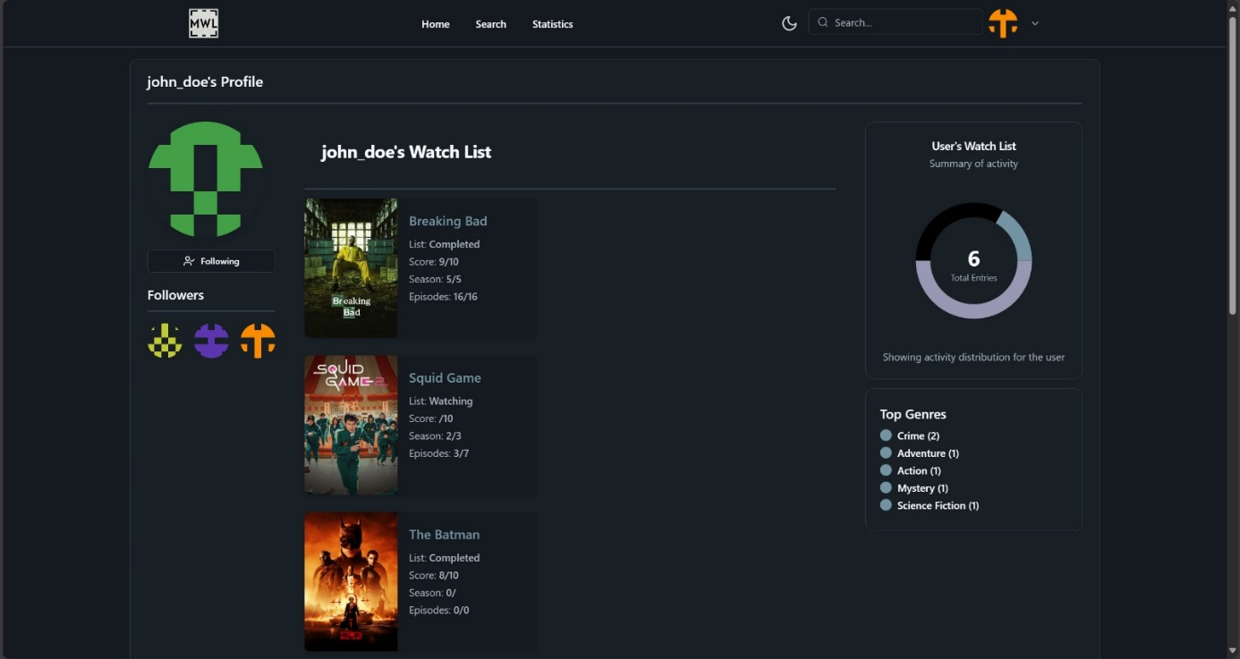

This screenshot shows the **User Page**, providing an overview of a user's activity and preferences. The page includes a profile picture, a follow/unfollow button, and a watchlist with details like status (e.g., Completed or Watching), user ratings, and episode progress. On the right, a summary chart displays the total entries in the user's watchlist, along with their top genres. This page offers a concise view of the user's engagement with the platform.

1. **Admin Page**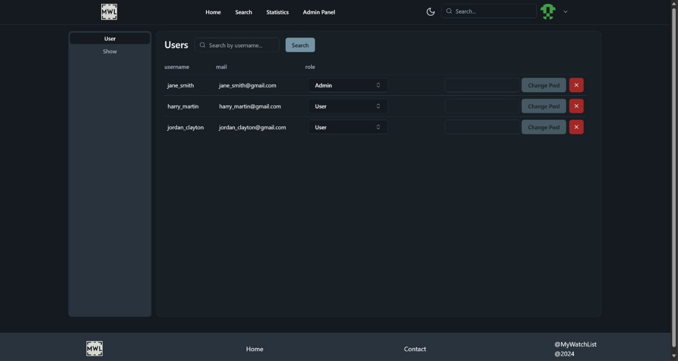

This screenshot depicts the **Admin Page**, specifically the **User Management** section. The interface allows administrators to search for users by username, view a list of users with their associated email addresses and roles, and manage user details. Each user row provides options to change their role (e.g., Admin or User) via a dropdown and reset their password using the "Change Pwd" button. The "X" button enables the admin to delete a user from the system. On the left, a navigation menu allows switching between **User** and **Show** management. This panel is designed to streamline administrative tasks, ensuring effective management of user accounts.

1. **Register And Login Page**

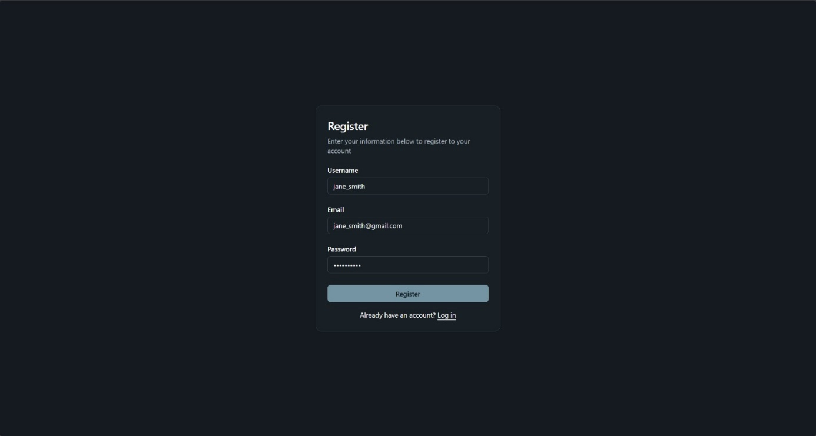

This screenshot represents the **Registration and Login**, where new users can create an account. The form includes fields for the user to input their **Username**, **Email**, and **Password**, along with a "Register" button to submit the details and create the account. Below the form, a link allows users who already have an account to navigate to the login page. This page provides a straightforward and user-friendly interface to onboard new users to the platform.

**FUTURE WORK**

The implementation of "My Watch List" serves as a strong foundation for managing entertainment content and tracking user activity. To further enhance the platform and user experience, additional features are planned for development. These improvements will expand functionality, improve personalization, and provide more in-depth insights into user activity. The key focus areas for future development include a Statistics Page, Advanced User Page, Advanced Filtering While Searching, and Personalized Recommendations.