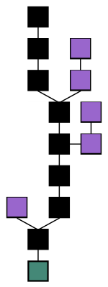**1.6 Blockchain**

**Warm up. Task 1. In pairs, look at the figure on the right and answer the following questions.**

a. What do you think it is? What do the figure and each colour represent?   
b. Do you understand how it works?   
c. How can it be used?  
  
**1b. Look at the following abbreviations, guess what cryptocurrencies they stand for? Match the abbreviations with corresponding icons.**

|  |  |  |  |  |
| --- | --- | --- | --- | --- |
| 1. BTC or XBT | 2. ETH | 3. XRP | 4. LTC | 5. USDT |

|  |  |  |  |  |
| --- | --- | --- | --- | --- |
| **a.** | **b.** | **c.** | **d.** | **e.** |

**Before watching…**

**Task 2a. Match the words that will be mentioned in the video with their definitions.**

|  |  |
| --- | --- |
| *1. distributed ledger* ***d*** | **a**. to start an activity, especially an organized one |
| *2. property* ***g*** | **b**. software such as a virus specifically designed to damage or gain access to a computer system without the user knowing |
| *3. launch* ***a*** | **c.** to protect something so that it is safe and difficult to attack or damage |
| *4. tamper* ***l*** | **d.** a database that is consensually shared and synchronized across multiple sites, institutions, or geographies, accessible by multiple people. |
| *5. malware* ***b*** | **e.** to be strong enough not to be hurt or damaged by extreme conditions, the use of force, etc. |
| *6. validate* ***h*** | **f.** the process or fact of making a substance or place dirty or no longer pure by adding a substance that is dangerous or carries disease |
| *7. secure* ***c*** | **g.** a quality or characteristic that something has |
| *8. proprietary* ***k*** | **h.** to prove that something is true |
| *9. withstand* ***e*** | **i.** legal, or acting according to the law or the rules 11. |
| *10. contamination* ***f*** | **k.** made and sold by a particular company and protected by a registered trademark |
| *11. legit* ***i*** | **l.** to do something that is against your principles or does not reach standards that you have set |
| *12. notify* ***o*** | **m.** to make changes to something without permission, especially in order to damage it |
| *13. counterfeit* ***q*** | **n.** the state of being whole and not divided; the quality of being honest and having strong moral principles |
| *14. verify* ***p*** | **o.** to formally or officially tell somebody about something |
| *15. integrity* ***n*** | **p**. to check that something is true or accurate |
| *16. compromise* ***m*** | **q.** fake; made to look exactly like something in order to trick people into thinking that they are getting the real thing |

|  |  |
| --- | --- |
| 1. | 6. |
| 2. | 7. |
| 3. | 8. |
| 4. | 9. |
| 5. | 10. |

**Task 2b. Find 10 collocations using the words above in the dictionary and add to the table** (e.g. counterfeit goods, etc)  
 **Task 2c. In pairs, try to decipher how and in which domains blockchains are implemented using the prompts below.**

|  |  |  |
| --- | --- | --- |
| …………………… | …………………… | …………………… |
| …………………… | ……………………. | …………………… |
| ……………………. | ……………………. | …………………… |

**Watching the video  
  
Task 3a. While watching the video make the notes completing the table. Share your notes with your partner, have you managed to guess how blockchains are used?** [**https://youtu.be/aQWflNQuP_o**](https://youtu.be/aQWflNQuP_o)

|  |  |  |
| --- | --- | --- |
| *Domain* | *Application* | *Example (company)* |
|  |  |  |
|  |  |  |
|  |  |  |
|  |  |  |
|  |  |  |
|  |  |  |

**Task 3b. Work in small groups of 4. What are possible applications of blockchain technology in other industries as healthcare, Art, etc?  
  
Blockchain Case Studies from Different Industries**

**Task 4. Split up in groups of 3 or 4. You will be given cards with business challenges in various realms. You are supposed to come up with an initiative and attainable result. After brainstorming and presenting your ideas to the rest of the group, you will see how the challenges were actually tackled.**

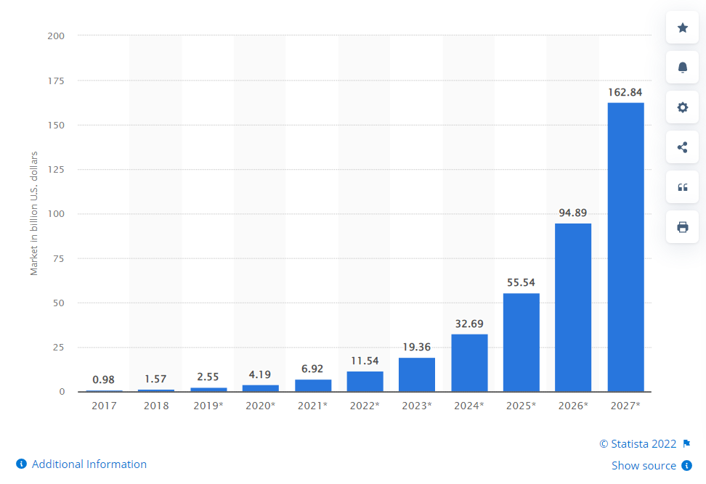Global investment in blockchain technology is skyrocketing (see Figure 1) because blockchain can enhance data exchange in multi-party processes thanks to:

* Enhanced transparency
* Increased speed  
  - Reduced transfer costs.

**Card 1. *Procurement***

**1.** **Marco Polo Network**

*Business challenge:*

For both exporters and importers, international trading can be risky. When an importer pays in advance for goods, the exporter may collect the cash without sending the goods. However, if the exporter agrees to receive payment after delivery, the importer may refuse to pay after receiving the products. To overcome this problem, traders collaborate with third parties such as banks that employ instruments like letters of credit, which guarantee payment once goods are delivered to the importer.

**Card 2a.** ***Supply chain***  
  
 **2. Renault**

Business challenge:   
The automotive sector is highly regulated. Renault, for example, deals with 6,000 regulatory and quality characteristics relating to:  
- Safety regulations  
- Geometric features  
- Material quality  
- Environmental concerns  
A vehicle must meet certain internal and external compliance criteria in order to be offered on the market. A change in regulations needs to be communicated downstream to suppliers and suppliers of suppliers to ensure that they all build according to the new specifications.

**Card 2b. *Supply chain***

**3. Nestle**Business challenge:

After 300,000 newborns were sickened with melamine from powdered milk products in 2008, Chinese parents’ trust in infant nourishment products was damaged. Nestle was looking for ways to reassure Chinese parents about the quality of their newborn nourishment product NAN A2 to penetrate the market effectively.

  
  
**Card 3. *Insurance***

**3. Etherisc**

Business challenge:

Etherisc is an insurtech startup that was looking for ways to speed up the claims processing. Traditional claims processing comprises five processes, as shown in Figure 2. Though the time it takes to settle a claim varies by insurance company and type, it usually takes weeks. However, according to EY, nearly 90% of insureds choose an insurer based on the quality and speed of claims processing.

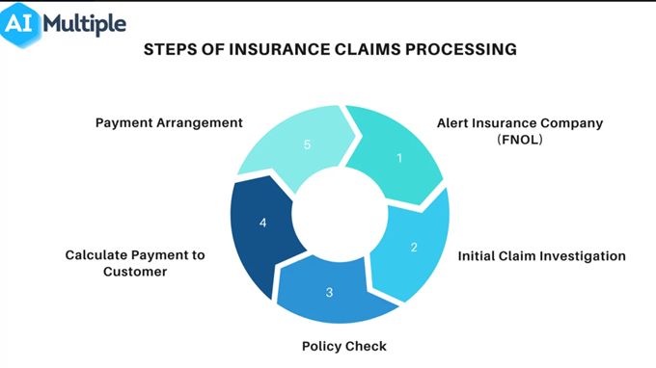

 **Card 4. *Energy***

**4. Tennet**

Business challenge:

Tennet, situated in the Netherlands and Germany, is an energy transmission operator. Because energy demand and supply are not always in balance, electricity distribution is difficult. Energy productivity of sustainable energy supplies varies instantly depending on the state of the weather. Wind turbine electricity generation, for example, differs depending on the wind conditions of the day. Similarly, electricity demand varies within the day. Thus, optimizing electricity distribution becomes a challenging issue.

**Card 5. Legal  
  
5. The tracking of intellectual property (IP): IPwe**

Business challenge:

Many businesses do not have the opportunity to present the true value of their assets to potential investors so some companies are undervalued. IPwe intended to transform the inefficient old IP system, in which patent holders, lawyers, corporations, intermediaries, and global patent office’s lack communication for a variety of reasons, including the inability to transfer information from one source to another transparently.

**Task 5. Read the text and explain how blockchain works.   
An** **Introduction to Blockchain**

**Why Blockchain**

Here are some advantages of blockchain over existing systems of different domains. Blockchain is:  
• Decentralized   
• Distributed   
• Secure and Faster   
• Transparent and Immutable   
The features can be understood well if we look the data structure, data distribution, data validation (Authentication of a piece of data in blockchain) and other related terminologies of blockchain.   
 **The Structure of Blockchain**

According to IBM, blockchain is a shared, distributed ledger that facilitates the process of recording transactions and tracking assets in a network. The asset may be a tangible asset like property, house, vehicle or an intangible asset like digital currency, intellectual property rights, etc. Basically, it stores Data, and records its movements in a distributed environment. Let’s look into its details.

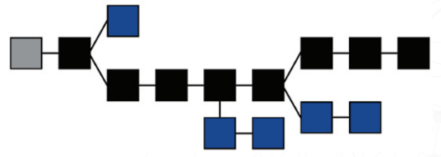It is a distributed database or a public registry that keeps details of assets and its movements/transactions across a P2P network. Each transaction will be secured through cryptography and later all the transaction history will be grouped and stored as blocks of data. Then the blocks are linked together with cryptography and secured from modification. The whole process will create an unforgeable, and immutable record of the transactions that happened across the network. Additionally, this blocks of records are copied to every participating computer in the network, so everyone will have access to it. The great advantage of blockchain is that it can store any kind of asset, its ownership details, history of the ownership and location of assets in the network. Whether it is the digital currency bitcoin, or any other digital assets like a certificate, personal information, a contract, title of ownership of IP, even the real-world objects.

The powerful feature of Blockchain is that we can create a shared reality across non-trusting entities. That is all of these participating nodes in the network do not need to know each other or trust each other because each has the ability to monitor and validate chain for themselves. The irony is that the mutual distrust among participant is the thing which keeps the blockchain secure and verified.

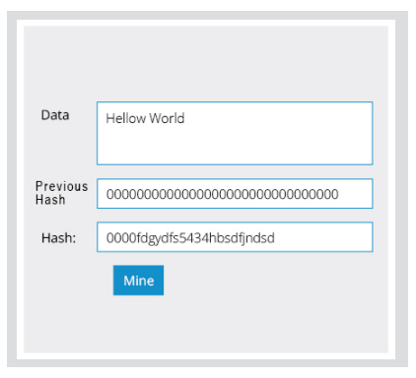**Data Structure of Blockchain**

The data in blockchain is stored as individual blocks, that’s why it is called Blockchain. Just like a linked list, the Blockchain is a collection of blocks linked together. So what does the block actually contain? Each block in a blockchain will have the following fields.

1) Data: Stores the data   
2) Previous hash: Stores the hash of the previous block  
3) Hash: Hash value for the current block which can be used to refer this block

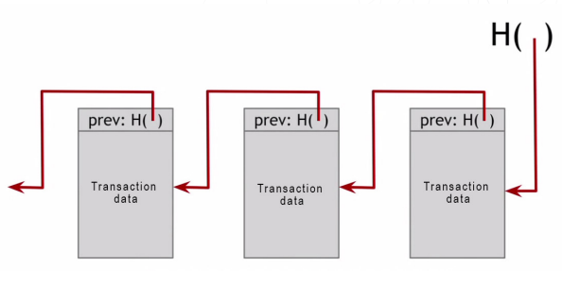As far as the user is concerned the Data field is the most important thing. The actual data (like transaction details, asset details etc.) are stored in this field. Previous hash will store the hash values of the previous block (consider it as a link to the previous block), the blocks are connected through this value.

**Data Distribution in Blockchain**

We saw that blockchain has its own unique Data storage structure, the data distribution in a blockchain has also a different approach. They don’t follow the widely adopted client server model rather the Peer to Peer model. The peer to peer data distribution approach gives the reason behind unfettered nature of Blockchain; there is no central authority to control.

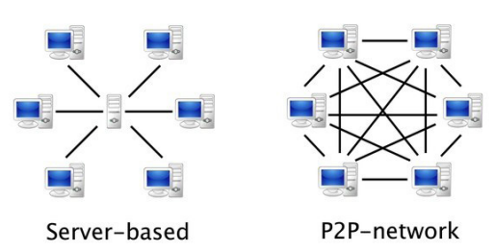Unlike the client-server model, In P2P network the data is stored in all the participant nodes in the network. All the individual nodes will have the copy of the entire ‘Blocks’ and a single change in a particular block will be updated in all the nodes. But here is the problem, in Client-Server model the data is stored in DB (database) after verification of a central authority; but in P2P network there is no central authority, then how does the authenticity of data assured? The answer is the validation process and consensus mechanism of the blockchain network.

**Block validation**

As we described above; the asset and its transactions are stored as connected blocks in blockchain. Only the valid transactions are added to the blockchain. Technically saying, Blockchain validation is simply the process of finding the block hash. In a blockchain, all the blocks are added to the blockchain after validation only. Whenever a transaction takes place in the blockchain it will be added to a block; sometimes one transaction per block and sometimes several transactions per block. It depends on the block size and the nature of the network. When a transaction is added to the block, it must undergo a validation process before it is being added to the blockchain as a valid block. The hash value for the block can be calculated using some algorithms (like sha 256). The hash value has certain properties too. The main thing is that the hash value should be collision-free i.e. no two blocks should have the same hash value. Since each block is represented using the hash value it should be identical. The second property is that the hash values should be irreversible. This means the block data could not be retrievable from the hash value.

**Task 7. Do the quiz on your background knowledge of blockchain and compare your answers with your colleagues.**

1. What does P2P stand for?  
   a. Password to Password

b. Peer-to-Peer  
c. Product to Product  
d. Private Key to Public Key

1. What is a node?  
   a. A type of cryptocurrency  
   b. A Blockchain  
   c. A computer on a Blockchain network  
   d. An exchange
2. Who created Bitcoin?

a. Satoshi Nakamoto

b. Samsung

c. John Mcafee

d. China

1. What is a miner?

a. A type of blockchain

b. An algorithm that predicts the next part of the chain

c. A person doing calculations to verify a transaction

d. Computers that validate and process blockchain transactions

1. Where can you buy cryptocurrency?  
   a. A private transaction  
   b. An exchange  
   c. A Bitcoin ATM  
   d. All of the above
2. What is a blockchain?

a. A distributed ledger on a peer to peer network

b. A type of cryptocurrency

c. An exchange

d. A centralized ledger

1. What incentivizes the miners to give correct validation of transactions?

a. a nonce  
b. a block reward  
c. thumbs up from the community  
d. more memory

1. What is a genesis block?

a. The first block of a Blockchain

b. A famous block that hardcoded a hash of the Book of Genesis onto the blockchain

c. The first block after each block halving

d. The 2nd transaction of a Blockchain

1. Which of the following is first distributed blockchain implementation?

a. Bitcoin

b. Ethereum

1. Bitcoin is based on ________ blockchain?

a. Private

b. Public

c. Public Permissioned

d. Permissioned

1. In blockchain, blocks are linked ________?

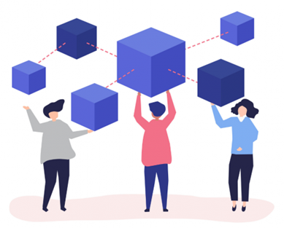a. Backward to the previous block

b. Forward to next block

c. Not linked with each other

1. The primary benefit of immutability is…

a. Scalability

b. Improved Security

c. Tamper Proof  
d. Increased Efficiency

**Task 8. Find in the article above words and phrases with the following meaning.**

|  |  |
| --- | --- |
| 1. shared or spread out |  |
| 2. easily detected or seen through |  |
| 3. that cannot be changed; that will never change |  |
| 4. a thing of value, especially property, that a person or company owns, which can be used or sold to pay debts |  |
| 5. something that does not exist as a physical thing but is still valuable to a company |  |
| 6. unable to be forged |  |
| 7. to use technology to watch somebody/something, especially for reasons of security |  |
| 8. not limited in any way |  |
| 9. to experience something, especially a change or something unpleasant |  |
| 10. that you can get back or make better |  |

**(additional listening) Listen to the podcast “A Day in the Life of an Engineer at Blockchain.com”**

https://podcasts.apple.com/us/podcast/a-day-in-the-life-of-an-engineer-at-blockchain-com/id1536699961?i=1000566346597

**Assignment**.   
1. Watch a Tedtalk ‘Web3, Blockchain, cryptocurrency: a threat or an opportunity? | Shermin Voshmgir | TEDxCERN’, do the tasks

**2. Vocabulary exercise. Replace the underlined words with words from ex 2 and the text. The words have a similar meaning.**

1. Once a change is made to the database it is unchangeable.  
2. The blockchain technology has gone through many changes since its onset in 2009.  
3. The potentials of cryptocurrency can be used to develop a clear economic system   
4. Supervisors should watch/control progress in such cases carefully.   
5. Blockchain allows shared data storage in a more secure and robust way.   
6. Rules on impalpable/nonphysical transfer of software and technology regarding weapons have been introduced.   
7. Blockchain helps identify fake goods by identifying a product's proof of origin, or provenance.   
8. Cryptocurrencies are one of the safest currency systems available today.   
9. The Chinese blockchain platform ChainMaker has been built with technology that can resist assaults from both conventional and quantum computers.   
10. Ex-TikTok gaming head to introduce blockchain games startup as big players keep away.