Student ID: 103083020

Name: Alexandre Waymel

https://github.com/WaymelAlexandre/Build_Query.git

# Task 2 Screenshot

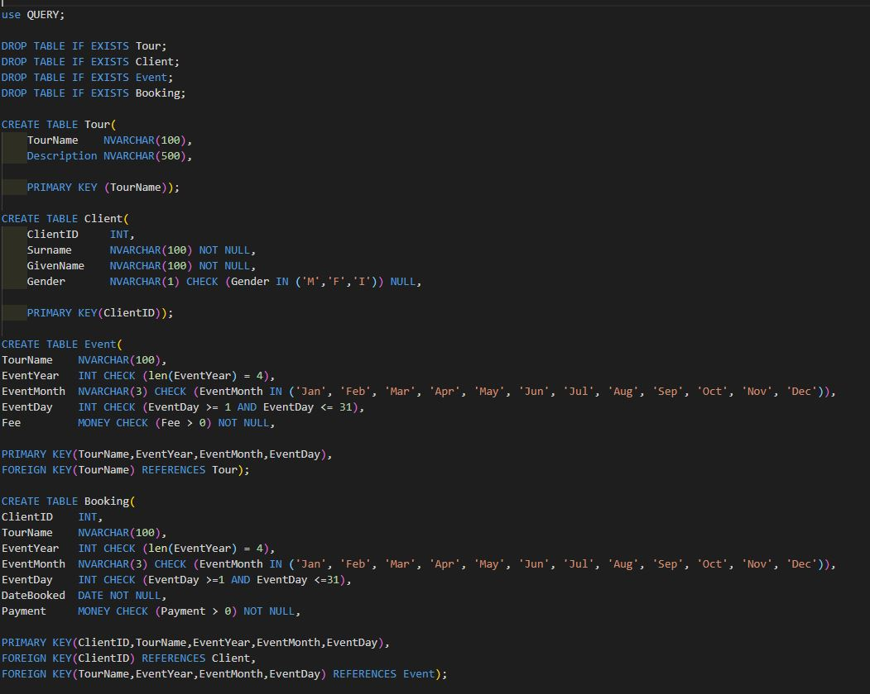

# Task 3 Screenshot

