# Enter SVN Setting

## Right Click and Choice Setting

* TortoiseSVN-> Settings

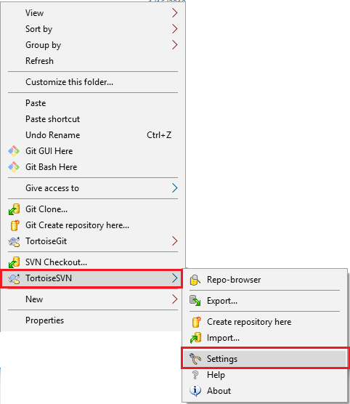

## Add ignore pattern

* In Subversion tab, Add Global ignore pattern

[space].git[space].vsocde

