Issues for Water-Geo

Issue 0001: 01/21/2026
Description:Tall integral signs $\int_{0}^{N}{f} dx$ loose tops and bottoms. :
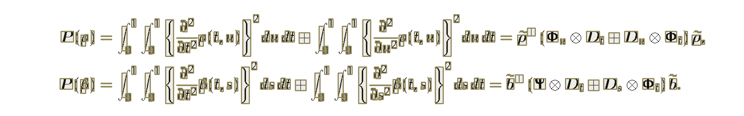

Diagnostics
Chat:
Yes — this is enough data, and it points to two concrete failure mechanisms that can make an integral’s bbox too short.
1) You are deleting small CC fragments (this alone can shorten “∫”)
Your pipeline is running connected components with:
- connectivity: 4
- min_area_px: 9
That combination is harsh on thin, anti-aliased “hooks” at the top/bottom of tall symbols:
- With 4-connectivity, diagonal/curved strokes break into smaller islands more easily.
- Then min_area_px = 9 will drop those islands if the hook fragments fall below 9 pixels.
So even if binarization keeps some hook pixels, they can get split off and then discarded. The remaining CC (the main vertical stroke) is what gets boxed — hence “bbox doesn’t bound the integral.”
Fast test: set min_area_px = 1 (or 2) and re-run just G2/G2b/G2c. If the integral bboxes suddenly look right, you’ve confirmed this is a big part of the problem.
Likely best fix: don’t delete tiny CCs at the CC stage. Keep them, classify them later as speck, and only ignore them downstream when appropriate. Right now you’re throwing away potentially meaningful ink too early.
2) Your binarization stage isn’t logging the decision rule
Your saved G1_binarize.json includes the masks and imageBin, but it does not record the binarization method/threshold parameters (so we can’t directly say “lower threshold” or “switch to Sauvola”) .
That’s a logging hole. You already log G3 params nicely (e.g., MaxChW, MaxChH, etc.) — you should do the same for binarize.
Minimum logging to add to G1 output:
- polarity chosen (black_on_white vs white_on_black)
connecctivity
- method (global, otsu, adaptive_gaussian, sauvola, etc.)
- the numeric threshold(s) actually used
- any morphology applied (dilate/erode/close kernel size)
That way, when a glyph loses its curls, you can tell whether it happened in binarize or in CC filtering.
What I would change first (in order)
- Drop min_area_px to 1–2 (or stop filtering there) and see if the integral hooks reappear.
- If hooks are still missing, add a tiny closing or dilation before CC labeling (1-pixel radius often fixes anti-aliased math curls without wrecking the page).
- Consider 8-connectivity for CC labeling (or keep 4-connectivity but apply the tiny dilation first).
A practical “don’t let this break geometry” backstop
Even after you fix ink loss, you’ll still occasionally get a tall symbol whose hooks are separate components (that’s normal in some fonts/renders). So add a rule:
- When you later tag a CC as “tall-math candidate” (integral/sum/product), union in nearby specks within a small radius proportional to char height, and recompute the bbox from the union.
That preserves semantic extent without forcing you to globally keep specks as “real characters” in the rest of the pipeline.
If you want, paste (or point me to) the current binarize() code in Functions.py. Right now your JSON shows what came out, but not how you decided it, and the fix depends on whether the ink was lost in thresholding or deleted by min_area_px.
________________________________
Solved: Change 4 Connectivity to 8 connectivity. Curved diagonal objects need diagonal connections.
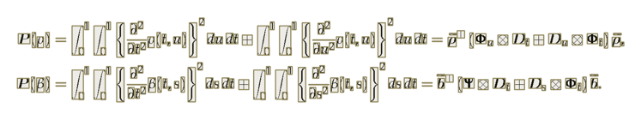
2025-01-22

Issue 0002:

