???????
AI Core Ring ?????????
?? CA/ESL ??? message-level ?? Ring ????
??: ????? / CA ????? / SoC ????????
????: BUS/aicore/tm_ring_*?tm_bus_flow_ctrl?tm_pld?pem_config_cloud.toml
????: ???? Ring ?????????????????????
????: 2026-07-22

????
????? message-level?hop-by-hop??? Ring ????????? RTL AXI ???????????? flit/VC?????????????????????????????????????????

??
1. ????
2. ???????
3. ????
4. ???????
5. ????????
6. ??????????
7. ????
8. ???????
9. ????
10. ??????????
?? A. ?????

1. ????
??????? BUS/aicore ???? Ring ????? AI Core ? Master?? Target ???? CA/ESL ????????????? Ring??? ring stop ? Router ???Master ?? TmRingInf ???Target ?? TmRingTargetPort ???EAST/WEST ???????? TmRingLink ???
?????????????????Router ?????????Link ??????????TargetPort ?? Memory ????????? Fabric ? Router ????????????????????????
- ???????? REQ/RSP ???? subnet?RD?WR?WR_DAT ?? REQ?RD_RSP?WR_RSP?RSP ?? RSP?
- ??????????????? pop ???????????? retry event?????????????
- Link ?? tm_que ??????????? next_send_time ?? packet serialization?????? packet bytes / link width ???
- Target flow control ?? TmBusFlowCtrl????? target slot credit?bandwidth token?target outstanding ? global OSD?
- ?? per-link hotspot ???????? ring ??????????
??? | ???? | ????
???? | ?? Ring | ?? AI Core cluster ????????????????????
???? | message-level / packet-level | ?? flit???? VC?????????????
?????? | Link serialization / target bandwidth / OSD | ??????????????? Target ? outstanding ???
????? | link latency?link width?router input depth?target width?OSD?token | ?? RTL?? CA ????????????

2. ???????

2.1 ????
- ????????? BIU/TmMem ? Ring interconnect CA/ESL ???
- ?? RD?WR?WR_DAT?WR_RSP?RD_RSP?RSP ???????????????????
- ???? Router/Link ???Link serialization?Target response throttle ??????
- ?????????????????? stall?per-link hotspot?fairness?idle ????????
- ?????? pem_config_cloud.toml ??? Master?? Target?interleave?OSD ??????

2.2 ???
- ??? AXI4 ??? RTL ?????? beat-level valid/ready ?????
- ??? flit?VC allocator?switch allocator ??? Router pipeline?
- ??? cache coherence?snoop ???????
- ?? Fabric ??????? txn_ctx???????? payload metadata?NIU/TargetPort ??? FlowCtrl ?????

3. ????
???????????????????? REQ subnet???? RSP subnet?Topology ?????????????Flow Control ?? target credit/token/OSD?
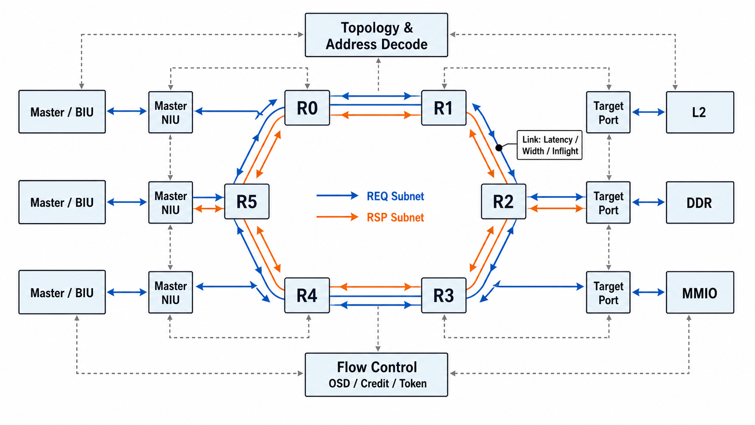
? 1??? Ring ?????????

3.1 ????
?? | ???? | ??
Endpoint ??? | TmRingInf, TmRingTargetPort | ?? BIU/TmMem??????????????????? response throttle?
Ring stop ? | TmRingRouter | EAST/WEST ??????LOCAL ??/????? slot RR ?????????
??? | TmRingLink | ?????REQ/RSP ?? in-flight ??????????????????
??/??? | TmRingTopology, TmBusFlowCtrl | ??? target ???master/target node ??????????target ? credit/token/OSD?
??? | TmPld | ???? cmd?gid?mst/slv id?data buffer?Ring subnet/class/lane ???????

3.2 ??????
?? | ???? | ?? | ??
BIU / API | p_tm_com_inf_t | TmRingInf::bus_inf_ | ???? NIU??????????????
TmRingInf::router_inf_ | connect() | Router LOCAL master inf | Master ?????? Router?????? Router ?? NIU?
Router EAST/WEST output | accept_pkt() | TmRingLink | Router ?????? pop ???
TmRingLink::dst_out_inf_ | connect() | Next Router port_inf(EAST/WEST) | Link ready ???? Router ???????
Router LOCAL target inf | connect() | TmRingTargetPort::ring_inf_ | ???? TargetPort???? TargetPort ?? Router?
TmRingTargetPort::inf_ | connect() | TmMem::rw_inf_ | TargetPort ? Memory ???????/?????

4. ???????
?? | ???? | ?? | ??
TmRingFabric | master_nius_, routers_, links_, target_ports_, topology_, flow_ctrl_ | ??????reset/idle ???API ???????? | ???????????????????
TmRingInf | bus_inf_, router_inf_, rd_cmds_, wr_cmds_, wr_data_, wr_dat_rsp_q_, req_map_, pending_writes_, rd_rsp_states_, rd/wr_outstanding_ | Master ? NIU??? BIU ?????????? Ring??? RD/WR ???????????? Master OSD? | ????? EAST/WEST?????? Router ?? Topology ???
TmRingRouter | port_infs_, req_input_qs_, rsp_input_qs_, local_master_infs_, local_target_infs_, east_link_, west_link_, input/output_rr_ptr_ | Ring stop??? EAST/WEST ?????LOCAL ??/????? slot RR ?????? | ????????????? credit???? OSD bookkeeping?
TmRingLink | dst_out_inf_, inflight_packets_, inflight_count_, next_send_time_, width_bytes_, latency_, stats_ | ??????? propagation latency?serialization cycles?in-flight ???????? | ??????????????????? Router?
TmRingTargetPort | ring_inf_, inf_, rd_req_q_, wr_req_q_, wr_dat_q_, next_req_issue_time_, next_*_rsp_issue_time_ | Target ? NIU??? Ring ????? FlowCtrl??? Memory ????? Memory ????? RSP subnet? | ?????????? Master ?? API ???
TmRingTopology | master_nodes_, target_nodes_, master_id_to_port_, port_to_master_id_ | ?? ring stop ????? target????????master id/port ??? | ???????? packet ???
TmBusFlowCtrl | target slot credit, bandwidth token, target outstanding, global outstanding | Target ?????? busy cycle ??? | ??? Ring ? EAST/WEST ?????

5. ????????

5.1 ?????
- BIU ? API ? TmRingInf::bus_inf_ ?? RD?
- TmRingInf::recv_rd_cmd() ????? rd_cmds_?????? pop bus_inf_?
- TmRingInf::send_rd_cmd() ? payload ?? mst_id?target_id?src_node?dst_node?REQ subnet ? traffic class?
- ???? router_inf_ ???? Router???? Master read outstanding ???
- Router ?? dst_node ?? LOCAL/EAST/WEST???????? TmRingLink?Link ?? header bytes ? serialization cycles?
- ???? Router ??? LOCAL ?? TmRingTargetPort::ring_inf_????? rd_req_q_?
- TargetPort ?? FlowCtrl ? issue timing ???? TmMem????????? RD_RSP ?? RSP subnet ? Master?
- TmRingInf ???? RD_RSP ????? Master read OSD?????????? Target read slot?

5.2 ?????
- WR ???? TmRingInf::wr_cmds_???? payload ????? pending_writes_?
- WR ???? Ring ??? TargetPort::wr_req_q_?TargetPort ??? TmMem ??? write slot?
- TmMem ?? WR_RSP grant?TargetPort ???? RSP subnet?
- TmRingInf ?? WR_RSP ?? gid ? pending_writes_ ?????????clone ???? WR_DAT payload ??? wr_data_?
- WR_DAT ??? REQ subnet ? TargetPort::wr_dat_q_??????? bandwidth token???????? outstanding?
- TmMem ?? RSP?TmRingInf ?????????? Master write OSD ? Target write credit???? pending_writes_?

5.3 Payload ????
?? | ?? | ????
gid | Master ????? | ?? Master ??? gid???? Master ?????? mst_id?
mst_id | ?? Master ?? | ??????? Topology ?? master port?
slv_id | ?? Target ID | ?????? Router ?????? TargetPort?
mst_addr/slv_addr | ??? src_node/dst_node | ???? route context ??
ring_subnet | REQ ? RSP | packet ???????????????
ring_traffic_class | PldCmd ?? | ???? RD/WR/WR_DAT/RD_RSP/WR_RSP/RSP?
ring_rsp_lane | RD_RSP lane | ??????????

6. ??????????

6.1 ??????
??????
????????? send/push ???? pop ????????????????? TmInf/TmQue ? vld/rdy ???????????? retry_event ? notify_after?

6.2 Link latency ? serialization
TmRingLink ????????????????????? inflight_packets_ ? tm_que delay ????????? next_send_time_ ??????? 128B RD_RSP ? 16B/cycle link ???? 8 ????????? message-level packet ?????????? flit?
??? | packet_bytes ?? | ??
RD | ??? 16B | ?????????????
WR | ??? 16B | ??????????/?????
WR_DAT | payload size | ??????????????
RD_RSP | payload size | ??????????????
WR_RSP | ??? 16B | grant/DBID ?????????
RSP | ??? 16B | ?????????????

6.3 Router input buffer
Router ???? EAST/WEST ???????? input FIFO?? req_input_qs_ ? rsp_input_qs_?LOCAL ????? Router buffer??? Master NIU ? TargetPort ????????????????? output buffer??? Link ????????? pipeline/buffer?

6.4 Target Flow Control
?? | ???? | ???? | ??
global OSD | RD ? WR ?????? Target ? | ???/???????? | WR_DAT ????? global transaction?
target slot credit | RD/WR ??? Memory ??? | ????????? | RD slot ? WR slot ?????
bandwidth token | RD ??? WR_DAT ??? Target ? | ? token_update_period ?? | ?? Target ??????
target outstanding | RD/WR ??? Memory ??? | ??????? | ??? hotspot penalty?
next issue time | ??/????????? | ????????? | ?? Target ??????????

7. ????
???????? pem_config_cloud.toml?PEM runtime ?? ARCH/DDR/L2/BIU?Ring demo ?? RING_DEMO ? RING_DEMO.case.*??????? demo ? PEM ?????? OSD?target ??? DDR latency ????
?? | ???? | ???? | ????
num_masters | 4 | Master/NIU ?? | ???????? ring stop ??
num_targets | 4 | TargetPort ?? | ?? memory partition ??????????
target_width_bytes | 32 | Target ??/???? | ?? Target issue/rsp busy cycles????? Link width?
master_fifo_depth | 16 | NIU ?? FIFO ?? | ?? endpoint ????????? OSD?
master_rd_osd/master_wr_osd | 16/16 | Master outstanding | ???? Master ?????????
global_osd | 64 | ?? outstanding | ??????????
target_rd/wr/acc_osd | 16/16/32 | Target slot credit | ???? Target ???????
ring_link_latency | 1 | Link propagation latency | ????????? link_capacity ???
ring_link_width_bytes | 16 | Link serialization width | ?? RD_RSP/WR_DAT ??????????
ring_router_input_depth | 2 | Router EAST/WEST input buffer | ?? Link ???? in-flight????????

8. ???????
????????????????????stall breakdown?fairness?idle ??? per-link hotspot??????????? dominant bottleneck ? per-link hotspot ?????????
??? | ?? | ????
TEST_PERF | ??????????B/cycle?GB/s | ???????????
TEST_STALLS | endpoint/fabric/all stall ?? | ????????????
TEST_BOTTLENECK | global OSD?target slot?token?link stall | ?????????
TEST_LINK_HOTSPOT | Top REQ/RSP link ??????busy?stall | ??? ring ??????????
TEST_FAIRNESS | Jain index | ??? Master ??????
TEST_IDLE | ring/demo/biu/target idle | ?????????????
per-link ??????
? RSP subnet ??? link serialization_busy_stalls ?????? link????? target ????????????????? link ??????? ring ??????? hop ?????????

9. ????
???? | ?? | ????
????? | ? Master ?/??? Master ????????reset ??? | ?????memory check ? mismatch?idle ?? true?
???? | WR -> WR_RSP -> WR_DAT -> RSP??? RD_RSP | WR_DAT ?? grant ????RD_RSP ?????????? Master OSD?
?? | target_fifo_depth ???router_input_depth ???link width ?? | ?????????? retry_event?
???? | LINEAR?XOR_HASH??? stride?? Target hotspot | target ????????????? per-link/target ???
???? | master OSD?global OSD?target OSD?ring_link_width?router input depth | ??????????????dominant bottleneck ????
??? | ?? Master ?????????? | Jain index ?? 1???? Master ???

10. ??????????

10.1 ????
- Link serialization ???? packet ?????????? flit??????? beat-level ?????
- Router pipeline ???????????????? route compute?switch alloc?crossbar traversal ???? stage?
- Target response lane ??????? Memory ??? rsp_count ???????????? burst split ???
- ???????????? latency breakdown ?????????????
- ?????????? RTL?? CA ?????????????????????????

10.2 ????
?? | ?? | ???? | ??
P0 | ????? | ??? case ?????reset/idle/underflow ?????????? | ???????????
P1 | ?????? | ?? per-link/per-target/per-master ????? top hotspot ? CSV? | ?????????
P2 | ???? | ?? link width?target width?OSD?router input depth????????? | ??????????
P3 | ???? | ?? latency breakdown?????????? router pipeline stage? | ??????????
P4 | ??? | ? demo case?????????????????? | ???????

?? A. ?????
?? | ??
BUS/aicore/tm_ring.h / tm_ring_core.cc | Fabric ?????????????????
BUS/aicore/tm_ring_types.h | Ring ?????/??????????
BUS/aicore/tm_ring_inf.h / tm_ring_inf.cc | Master ? NIU???????????API ????????
BUS/aicore/tm_ring_router.h / tm_ring_router.cc | Ring stop?LOCAL/EAST/WEST ??????
BUS/aicore/tm_ring_link.h / tm_ring_link.cc | ?????????????? per-link ???
BUS/aicore/tm_ring_target_port.h / tm_ring_target_port.cc | Target ? NIU?Memory ??/??? response throttle?
BUS/aicore/tm_ring_topology.h / tm_ring_topology.cc | ?????target/master ????????????
BUS/aicore/tm_bus_flow_ctrl.h / tm_bus_flow_ctrl.cc | Target slot credit?bandwidth token?global/target outstanding?
BUS/aicore/tm/tm_pld.h / tm_pld.cc | ?? payload ? Ring metadata helper?
BUS/aicore/tm_ring_demo_test.h / tm_ring_demo_config.* | ?? ESL demo?????????????
BUS/aicore/config/pem_config_cloud.toml | PEM + Ring demo ?????

?? B. ???? Checklist
- ?? Ring stop ??Master ??? Target ???????????
- ?? `target_width_bytes` ? `ring_link_width_bytes` ???? Target ????? Ring ????????
- ?? `master_fifo_depth` ? `master_rd_osd/master_wr_osd` ??????????????????????
- ?? `TEST_BOTTLENECK` ?????????? `TEST_LINK_HOTSPOT` ?????????
- ?? reset ??? case??? idle?credit?outstanding ? pending_writes_ ?????
- ?????????????Link ??? link width/capacity/router input?Target ??? target width/token/OSD?endpoint ??? Master FIFO/OSD?

