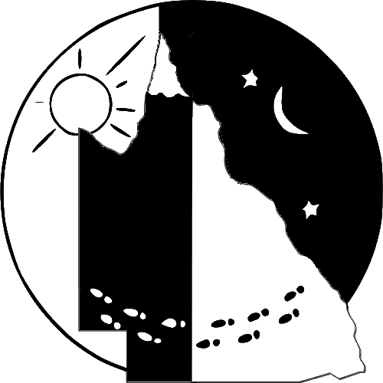 | Queensland Rogaine Association Inc.

24 January 2018

2018 Australasian Rogaining Championships – Location Announcement


The Queensland Rogaine Association is pleased to announce that the 2018 Australasian Rogaining Championships, to be held on 25th and 26th August, will be held in the Gympie Region, in the area surrounding the Manumbar locality. The Association is grateful for the support of local landholders who have generously offered access to their properties for the event. The Association would also like to acknowledge the generous financial support of the Gympie Regional Council (see http://www.visitgympieregion.com.au for information on the region).

The Australasian Rogaining Championships are the most significant event on the annual rogaining calendar in Australia and New Zealand, and is the regional qualifying event for the World Rogaining Championships. Over 300 participants are expected to attend, travelling to the Gympie region from all states and territories in Australia and also New Zealand.

Elite rogainers from all over Australia and New Zealand are expected to compete, including the defending champions David Baldwin and Julie Quinn from the ACT. The course will be set by Richard Robinson, who has over 20 years of course setting and event organisation experience together with a wealth of rogaining technical knowledge.

About Rogaining

Rogaining is the sport of long distance cross-country navigation. The championship rogaine is a continuous 24-hour event. Teamwork, endurance, strategy and map reading are features of the sport. Rogaining originated in Australia, where the sport can be traced to the creation of the rules in 1968 and the first intervarsity 24 hour score orienteering competition in 1969. Rogaines are now held in many countries all over the world, with annual regional championships in Europe, North America and Australasia and regular World Rogaining Championship events.

The objective of rogaining is to collect the highest score by finding checkpoints within a set time limit. Teams of two to five members travel entirely on foot, navigating with the aid of a topographic map and analogue compass. Teams select their own order of visiting checkpoints, in terrain that varies from open countryside to hilly forest.

Media Contact
Paul Guard - paulguard@gmail.com - 0405673986 Website: arc2018.qld.rogaining.org.au

