WHY ENTER A CHAMPIONSHIP ROGAINE?
and that’s what rogaining is all about.
Because they are fun

You enter in fun runs, orienteering events, Coast to Coast, maybe even half marathons. You know you are not going to win but you still enter. Only a few idiots at the top take the competition seriously – everyone else, like you, just wants the fun and satisfaction of doing the best you can. It’s your own challenge.
We only call it a Championship because it has to meet certain quality standards to be eligible as a World Championship pre-qualifying event. This means that you get a well organised event to have fun in.
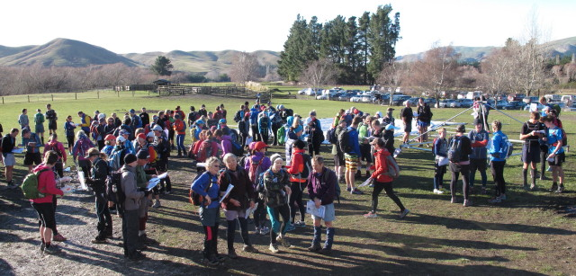
You have done a 6 or 7 hour rogaine, maybe even a 12 hour one. Can you do 24 hours? Probably not, you say. Well, don’t be put off. It’s easier than you think, and definitely not as hard as two 12-hour rogaines. Here’s why.
Firstly, you go slower because you know you have to last longer. Secondly, you go much slower at night because of the extra navigational challenge. It is also cooler, so instead of sweating and chafing, you are cool and dry and really enjoy the walk. Thirdly, you can return to the hash-house for a few hours feed and sleep – many people do. Fourthly, it’s really great walking under a full moon. If you haven’t ever done it, you must.
-And if you are worried about how you would plan a 24 hour course, then try the 15-in-24 course. This restricts you to 15 hours on the course, but it can be at any time you like, so you might plan 8 hours on the Saturday and seven on the Sunday, but ooops – our Saturday took two hours longer. Rather than having to rush back, you stick to your plan and now you know how fast you travel. You can then adjust your Sunday plan to five hours at a slower pace than you first planned. AND you get some sleep!
So for you, this is not a “Championship” – it is a rare occasion to enjoy a great occasion on excellent country.
Come along and enjoy
Comments by Pete Squires

