# Data Insights

Dataset size: 891

Column: PassengerId

|  |  |
| --- | --- |
| Insight | Value |
| mean | 446.0 |
| median | 446.0 |
| null_count | 0 |

Column: Survived

|  |  |
| --- | --- |
| Insight | Value |
| mean | 0.3838383838383838 |
| median | 0.0 |
| null_count | 0 |

Column: Pclass

|  |  |
| --- | --- |
| Insight | Value |
| mean | 2.308641975308642 |
| median | 3.0 |
| null_count | 0 |

Column: Name

|  |  |
| --- | --- |
| Insight | Value |
| unique_count | 891 |
| null_count | 0 |

Column: Sex

|  |  |
| --- | --- |
| Insight | Value |
| unique_count | 2 |
| null_count | 0 |

Column: Age

|  |  |
| --- | --- |
| Insight | Value |
| mean | 29.69911764705882 |
| median | 28.0 |
| null_count | 177 |

Column: SibSp

|  |  |
| --- | --- |
| Insight | Value |
| mean | 0.5230078563411896 |
| median | 0.0 |
| null_count | 0 |

Column: Parch

|  |  |
| --- | --- |
| Insight | Value |
| mean | 0.38159371492704824 |
| median | 0.0 |
| null_count | 0 |

Column: Ticket

|  |  |
| --- | --- |
| Insight | Value |
| unique_count | 681 |
| null_count | 0 |

Column: Fare

|  |  |
| --- | --- |
| Insight | Value |
| mean | 32.2042079685746 |
| median | 14.4542 |
| null_count | 0 |

Column: Cabin

|  |  |
| --- | --- |
| Insight | Value |
| unique_count | 147 |
| null_count | 687 |

Column: Embarked

|  |  |
| --- | --- |
| Insight | Value |
| unique_count | 3 |
| null_count | 2 |

# Correlation Heatmap

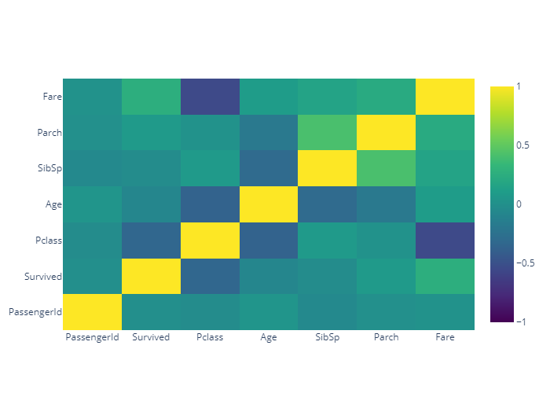

# Dashboard

