Structure

Part 1

1. Echocardiography (TTE/TEE/Stress/Doppler)
2. Image

Part 2

1. 2D Imagining: The parasternal windows: long and short axis views
   1. Explain what parasternal windows is and where it is
   2. Explain long and short axis views
   3. Explain what long axis views allow us to see in the heart
   4. Explain what short axis views allow us to see in the heart
   5. From what is seen, how is coronary heart disease diagnosed?
2. Aspirin Therapy
   1. What is aspirin therapy?
   2. How aspirin work?
      1. Briefly explain how coronary heart disease occur and how aspirin help to relieve it?
   3. Complications of aspirin
      1. Allergies
      2. haemorrhagic stroke
      3. Other diseases that increase bleeding
3. Coronary artery bypass graft
   1. What is it?
   2. How is it done? (Step by Step)
      1. Where is the vein graft from?
   3. Include different ways to do it (with/without pump)
   4. Complications
      1. Infection
      2. Abnormal heart rhythms
      3. Pancreatitis
      4. Pneumonia
      5. Kidney failure
      6. Failure of graft

Part 1 (a) Transthoracic Echocardiography (TTE), Transoesophageal Echocardiography (TEE). Stress echocardiography and Doppler Sonography utilise the mechanism of ultrasound to image the heart. A transducer emits high frequency ultrasound which propagates through the body and the sound waves encounter an obstacle, the sound wave is reflected as echoes and is received by the transducer. Based on the time between emitting ultrasound and receiving an echo, one can measure distance from of the object from the transducer. Moreover, different materials will reflect different intensity of echo. Lastly, an array of transducers allows the creation of a 2D cross sectional image of an organ, a heart in this case. For TTE, ultrasound transducer is placed in between the gaps of the ribcage to image the heart. For TEE, a TEE probe with an ultrasound transducer (like an endoscope) is inserted into the patient down the oesophagus and the heart is imaged. Both TTE and TEE can be used to see the movement of the heart structures live. By assessing the movement of the heart structures, the doctor can assess whether there are blockages in the arteries which is an indicator of coronary heart disease. TEE have better spatial resolution compared to TTE as ultrasound emitted will not be absorbed by the lungs and TEE is much closer to the heart, allowing the use of higher frequencies. For Stress echocardiography, the doctor will image the patient’s heart while at rest. Then the patient will exercise, the heart rate and blood pressure are monitored. When the heart rate reaches a target value, the heart is imaged. Comparing the images of the heart while it is at rest and under stress. Regions of the heart that seems weak during stress and not enough blood flow to the heart, are indicators of blockage and thus coronary heart disease. For Doppler sonography, flow of the blood in the heart is imaged utilising the Doppler effect. Doppler effect results in change in frequency received by transducer when the source is moving in a certain direction. This produces coloured images that indicates the speed of blood flow in the heart and thus the rate of blood flow in the heart. The amount of blood pumped with each heartbeat is an indication of the size of a vessel's opening. If the blood flow is low, it is an indicator of blockage and thus coronary heart disease.

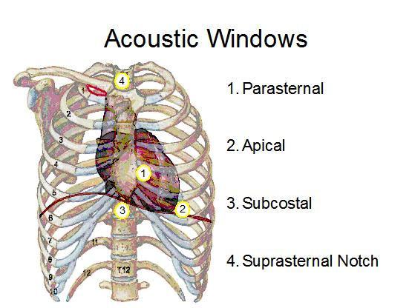Part 1 (b) Figure 1 is captured by transthoracic echocardiography, these shows long axis 4-chamber view of a 77-year-old patient with abnormal heart structure (top) and a 34-year-old healthy person. (bottom) One can observe that the top figure, the chambers are abnormally inflated.

Part 2.1(a) The parasternal window is essentially the region directly on top of the heart. (Area 1 on Figure 2) The gap between the ribcages is used to slot the ultrasonic transducer to image the heart.

Long axis & Short axis views essentially are the orientation of the transducer. As shown on figure 3, long axis view simply means the plane that is parallel to the direction by which the width of the Diagram
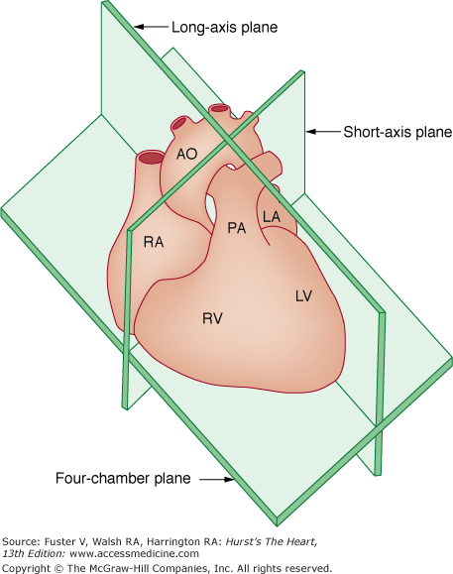heart is long. Short axis view means the plane that is parallel to the direction by which the width of the heart is short.

Figure 2

Figure 1

Combining the terms together, “The parasternal windows: Long and Short Axis views” would mean the scanning plane given that the transducer is located at the parasternal window. Long axis is along the longer width of the heart and short axis is along the shorter width of the heart. (Figure 4) Part 2.1(b)

Figure 4

Figure 3