

GEH1032: Medical Technology in Medicine and Health

CA Final Assessment

By: Linn Htet Aung (A0220705U)

Part 1 (a) Transthoracic Echocardiography (TTE), Transoesophageal Echocardiography (TEE). Stress echocardiography and Doppler Sonography utilise the mechanism of ultrasound to image the heart. A transducer emits high frequency ultrasound which propagates through the body and the sound waves encounter an obstacle, the sound wave is reflected as echoes and is received by the transducer. Based on the time between emitting ultrasound and receiving an echo, one can measure distance from of the object from the transducer. Moreover, different materials will reflect different intensity of echo. Lastly, an array of transducers allows the creation of a 2D cross sectional image of an organ, a heart in this case. For TTE, ultrasound transducer is placed in between the gaps of the ribcage to image the heart. For TEE, a TEE probe with an ultrasound transducer (like an endoscope) is inserted into the patient down the oesophagus and the heart is imaged. Both TTE and TEE can be used to see the movement of the heart structures live. By assessing the movement of the heart structures, the doctor can assess whether there are blockages in the arteries which is an indicator of coronary heart disease. TEE have better spatial resolution compared to TTE as ultrasound emitted will not be absorbed by the lungs and TEE is much closer to the heart, allowing the use of higher frequencies. For Stress echocardiography, the doctor will image the patient’s heart while at rest. Then the patient will exercise, the heart rate and blood pressure are monitored. When the heart rate reaches a target value, the heart is imaged. Comparing the images of the heart while it is at rest and under stress. Regions of the heart that seems weak during stress 1and not enough blood flow to the heart2, are indicators of blockage and thus coronary heart disease. For Doppler sonography, flow of the blood in the heart is imaged utilising the Doppler effect. Doppler effect results in change in frequency received by transducer when the source is moving in a certain direction. This produces coloured images that indicates the speed of blood flow in the heart and thus the rate of blood flow in the heart. The amount of blood pumped with each heartbeat is an indication of the size of a vessel's opening. If the blood flow is low, it is an indicator of blockage and thus coronary heart disease.

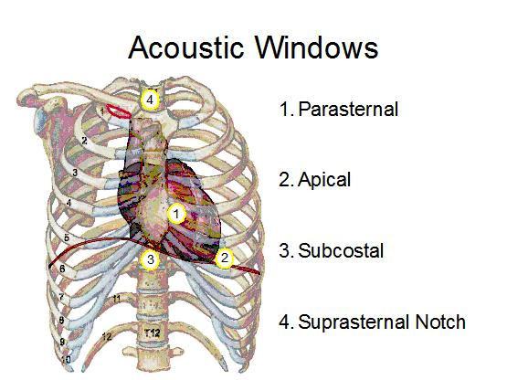Part 1 (b) Figure 13 is captured by transthoracic echocardiography, these shows long axis 4-chamber view of a 77-year-old patient with abnormal heart structure (top) and a 34-year-old healthy person. (bottom) One can observe that the top figure, the chambers are abnormally inflated.

Part 2.1(a) The parasternal window is essentially the region directly on top of the heart. (Area 1 on Figure 2)4 The gap between the ribcages is used to slot the ultrasonic transducer to image the heart.

Figure 2

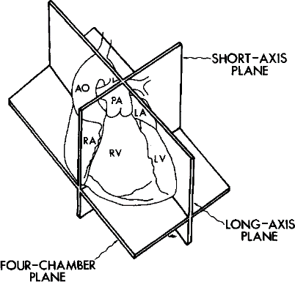Long axis & Short axis views essentially are the orientation of the transducer. As shown on figure 35, long axis view simply means the plane that is parallel to the direction by which the width of the heart is long. Short axis view means the plane that is parallel to the direction by which the width of the heart is short.

Figure 1

Combining the terms together, “The parasternal windows: Long and Short Axis views” would mean the scanning plane given that the transducer is located at the parasternal window. Long axis is along the longer width of the heart and short axis is along the shorter width of the heart. (Figure 4) 6

Figure 3

Figure 4

Part 2.1(b) Different chambers of the heart can be imaged by adjusting the angle of the transducer to search for any indicators of coronary heart disease like narrow blood vessels.

Part 2.2(a) Aspirin therapy is the low dose of aspirin that can prevent heart attack and stroke. Aspirin is an anti-inflammatory drug. When an injury happens, Prostaglandins form at the area of injury and they are responsible for the formation of blood clots. Aspirin work by preventing Prostaglandins from forming thus reducing inflammation. 7Reduction of blood clot reduces the risk of thrombosis leading to a heart attack. Part 2.2(b) However, taking aspirin has risks and complications. People with pre-existing conditions like haemophilia (bleeding disorder), intestinal bleeding, asthma, liver disease, kidney disease or allergy to aspirin are at risk of complications. It also increases the risk of haemorrhagic stroke 8which is the sudden bleeding of an artery inside the brain, and it has a high mortality rate. (51% to 65%).9 Age is a risk factor that increases this risk. (Age $≥$ 60) On the whole, the benefit of aspirin therapy still outweighs the potential negatives due to reduced chance of fatal heart attack and stroke.

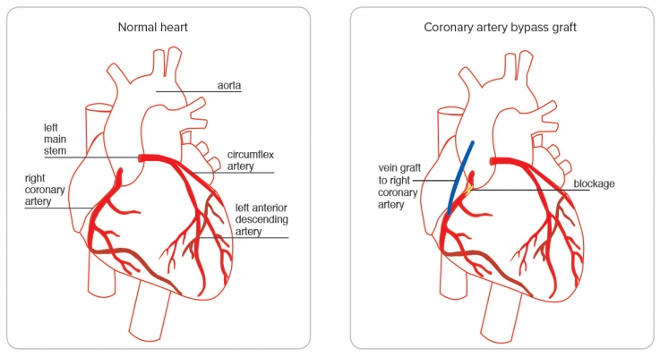Part 3.1(a) Coronary artery bypass graft is a procedure to restore blood flow to a blocked artery. The procedure takes a blood vessel from other part of the body (typically chest or limbs) to circumvent the blocked or narrow blood vessel as shown in figure 5.1011 Part 3.2(b) This procedire only temporaily relief the symtoms of coronary heart disease. This procedure also has risks and complications. For one, after the surgery, there is a chance of infection at the site of surgery and even failure of the graft. There are other potential side effects like pancreatitis, pneumonia and even kidney failure.

Figure 5

References

1. Dobutamine Stress Echocardiogram - Health Encyclopedia - University of Rochester Medical Center. Accessed April 24, 2022. https://www.urmc.rochester.edu/encyclopedia/content.aspx?contenttypeid=92&contentid=p07968

2. Health Library - Tan Tock Seng Hospital. Accessed April 24, 2022. https://www.ttsh.com.sg/Patients-and-Visitors/Pages/Find-Conditions-and-Treatments-Details.aspx?condition=Exercise-Stress-Echocardiography-ESE

3. hkmj198080-fig-2.jpg (2026×1947). Accessed April 24, 2022. https://www.hkmj.org/system/files/hkmj198080-fig-2.jpg

4. Echocardiography Tutorial - Clinical Examination. Accessed April 24, 2022. http://www.vhlab.umn.edu/atlas/echocardiography-tutorial/clinical-examinations.shtml

5. Figure 2 from Report of the American Society of Echocardiography Committee on Nomenclature and Standards in Two-dimensional Echocardiography. | Semantic Scholar. Accessed April 24, 2022. https://www.semanticscholar.org/paper/Report-of-the-American-Society-of-Echocardiography-Henry-DeMaria/0890f62a5ace172e4aff68daed11902bb858db6b/figure/1

6. Parasternal Long Axis Views (1 of 4). Accessed April 24, 2022. https://e-echocardiography.com/page/page.php?UID=1429484731

7. Low-Dose Aspirin. Accessed April 24, 2022. https://www.uspharmacist.com/article/lowdose-aspirin

8. He J, Whelton PK, Vu B, Klag MJ. Aspirin and Risk of Hemorrhagic Stroke: A Meta-analysis of Randomized Controlled Trials. *JAMA*. 1998;280(22):1930-1935. doi:10.1001/JAMA.280.22.1930

9. Hemorrhagic Stroke: Intracerebral Hemorrhage - PMC. Accessed April 24, 2022. https://www.ncbi.nlm.nih.gov/pmc/articles/PMC6188453/

10. Coronary artery bypass graft (CABG) - NHS. Accessed April 24, 2022. https://www.nhs.uk/conditions/coronary-artery-bypass-graft-cabg/

11. Coronary artery bypass graft surgery - Heart Foundation. Accessed April 24, 2022. https://www.heartfoundation.org.nz/your-heart/heart-treatments/coronary-artery-bypass-graft-surgery