**COLIVING**

**Why stay with us**

Discover the Difference: Our Co-Living Experience a Unique  
 Blend of Comfort, Community, and Convenience.

1. **Smart Matching:** Our advanced AI algorithm ensures compatibility based on shared interests and lifestyles, fostering genuine connections among co-living residents.
2. **Comprehensive Listings:** Landlords showcase properties with vivid photos, videos, and detailed descriptions, empowering users to make informed decisions about their potential living spaces.
3. **Seamless User Experience:** A user-centric design simplifies the housing search process with an intuitive interface, supported by a responsive team dedicated to ensuring a stress-free experience.
4. **Personalized Profiles:** Users create profiles highlighting preferences and interests, aiding our matching algorithm and allowing authentic connections with like-minded co-livers.
5. **Waitlist Efficiency:** In a high-demand market, our waitlist feature keeps users informed about upcoming availability, enabling proactive planning for the ideal living situation.
6. **Precision Search Filters:** Tailor your search with advanced filters – location, room size, amenities, and compatibility preferences – ensuring you find a co-living space that suits your lifestyle perfectly.

**Frequently Asked Questions**

Answers to Common Queries: Frequently Asked Questions

Find Quick Solutions to Your Inquiries Here.

1. **How do I find roommates or housemates?**
   * Utilize our advanced AI matching algorithm to connect with compatible individuals based on shared interests, lifestyles, and preferences.
2. **What security measures are in place?**
   * We prioritize your safety with robust security measures, including secure user profiles, encrypted communication, and thorough vetting processes for both landlords and tenants.
3. **Can I choose my location and roommates?**
   * Yes, our platform offers personalized choices. You can refine your search based on location, room size, amenities, and compatibility preferences, ensuring you find the perfect co-living space with the right roommates.
4. **Are Alutric Technologies Inc. spaces pet-friendly?**
   * Yes, we understand the importance of furry companions. Many of our spaces are pet-friendly, providing a welcoming environment for you and your pets.
5. **Are Alutric Technologies Inc. spaces furnished?**
   * Absolutely. Our co-living spaces come fully furnished, offering convenience and comfort so you can move in hassle-free and focus on building meaningful connections with your housemates.

**Our Team**

Get Acquainted with the Passionate Individuals Dedicated to Enhancing Your Co-Living Experience.Top of Form

1. **John H. Doe - CEO:**
   * Forward-thinking CEO, guiding the company with a visionary approach, driving innovation, and ensuring overall success.



1. **Emma Russel - Senior Director:**
   * Seasoned Senior Director, orchestrating strategic initiatives, fostering collaboration across teams, and contributing to the company's long-term goals.



1. **Michael Angelo - Director:**
   * Diligent Director, managing and optimizing operational functions, implementing efficiency measures, and playing a key role in the organization's day-to-day success.



**Our Blogs**

Dive into a wealth of knowledge, trends, and stories that enhance  
 your co-living experience.

1. **Living Harmoniously Together**
   * Explore the art of fostering connections and building a sense of community in shared living spaces.



1. **Navigating the Co-Living Landscape**
   * Stay informed about the latest trends, challenges, and innovations in the dynamic world of co-living.



1. **Personalized Living: Your Co-Living Journey**
   * Discover firsthand experiences and personal stories, highlighting the unique aspects of individual co-living journeys.
2. **Sustainable Practices in Co-Living Spaces**
   * Dive into eco-friendly initiatives, sustainable living practices, and how co-living spaces contribute to a greener lifestyle.

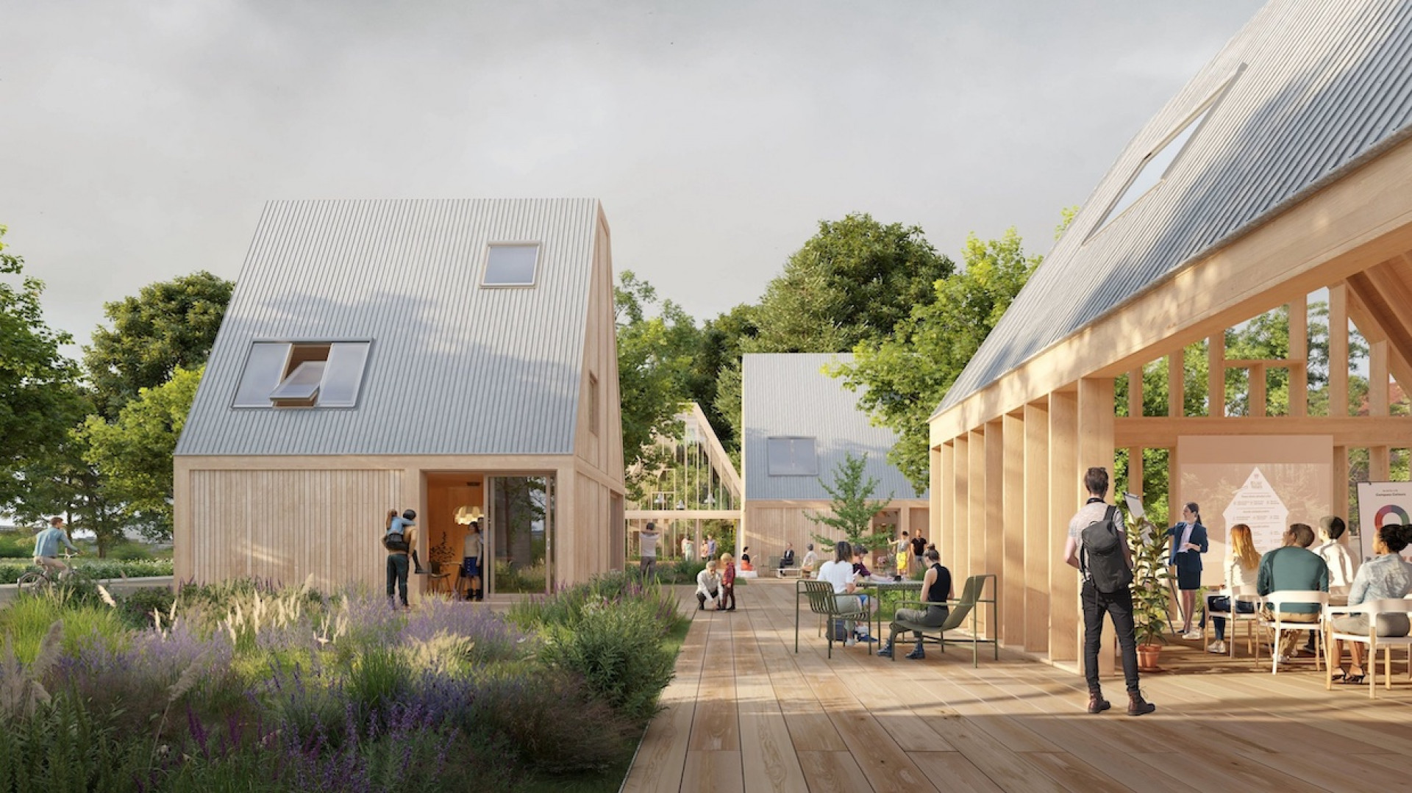

1. **Tech Trends Shaping the Future of Co-Living**
   * Stay ahead with insights on technological advancements influencing the co-living experience and enhancing convenience.



**BLOGS- Single page content**

**Living Harmoniously Together: Unveiling the Art of Co-Living Connections**

In the kaleidoscope of co-living, where shared spaces become vibrant communities, there exists an art—a delicate dance that transforms strangers into companions and houses into homes. Welcome to "Living Harmoniously Together," where we unravel the intricacies of creating not just shared living spaces, but interconnected, thriving communities.

*The Tapestry of Connection:* In the realm of co-living, every interaction, every shared moment, contributes to the creation of a unique tapestry. It's a canvas painted with laughter echoing through communal spaces, conversations that traverse beyond small talk, and the warmth of shared meals. We delve into the strategies that turn these everyday moments into threads that weave a tightly-knit community.

*Strategies for Fostering Community:* Creating a harmonious co-living environment requires more than just matching interests; it's about fostering genuine connections. From communal events that celebrate diversity to structured communication channels that facilitate understanding, discover the strategies that transform a group of individuals into a cohesive community.

*Communication as the Foundation:* Communication, the cornerstone of any thriving community, takes center stage in our exploration. We dissect the art of expressing needs, resolving conflicts, and ensuring everyone's voice is heard. Learn how effective communication not only prevents discord but cultivates an environment where every resident feels valued.

*Shared Experiences that Bind:* In the heart of harmonious co-living lies the power of shared experiences. From collaborative projects that ignite creativity to communal celebrations that mark milestones, explore how these shared moments contribute to a sense of belonging and create lasting bonds among residents.

*Beyond Four Walls:* "Living Harmoniously Together" extends beyond the physical confines of a residence. We examine how co-living communities can actively engage with their broader surroundings, contributing positively to the neighborhoods they inhabit. Discover the ripple effect of harmonious living extending into the greater community.

Join us on this journey where co-living transcends the mundane, where every resident is not just a neighbor but a integral part of a harmonious symphony. "Living Harmoniously Together" is an ode to the artistry of co-living, where shared spaces become vibrant communities, and the residents, the artists, craft a masterpiece of harmonious living.

**Navigating the Co-Living Landscape: A Comprehensive Exploration of Trends, Challenges, and Innovations**

Embark on a captivating journey through the ever-shifting terrain of co-living as we navigate the landscape of shared living spaces. "Navigating the Co-Living Landscape" serves as your compass, guiding you through the currents of trends, challenges, and the transformative innovations that shape the dynamic world of communal living.

*Emerging Trends:* In this intricate exploration, we unveil the emerging trends that dictate the ebb and flow of co-living communities. From flexible living arrangements to the rise of niche-focused spaces, discover how the landscape evolves to meet the diverse needs of a dynamic demographic.

*Challenges Transforming into Opportunities:* Every landscape has its peaks and valleys. "Navigating the Co-Living Landscape" doesn't shy away from the challenges faced by residents and operators. Delve into how these challenges are not roadblocks but opportunities for innovation, fostering a resilient and adaptable co-living ecosystem.

*Innovations Shaping the Future:* At the heart of our exploration lies a focus on the innovations that propel co-living into the future. From cutting-edge technologies enhancing the resident experience to novel architectural designs optimizing communal spaces, witness the transformative ideas that redefine the way we perceive shared living.

*The Human Aspect of Shared Living:* Beyond trends and innovations, this blog uniquely touches upon the human aspect of co-living. Explore the stories of residents who have navigated the landscape, sharing their triumphs, lessons, and the profound connections forged in the midst of shared living experiences.

*From Local to Global Impact:* Co-living communities aren't isolated islands; they are integral parts of the neighborhoods they inhabit. "Navigating the Co-Living Landscape" sheds light on how these communities can extend their positive influence beyond their immediate surroundings, contributing to the social and economic fabric of the broader community.

Join us on this odyssey through the Co-Living Landscape, where trends shift like sand dunes, challenges shape the terrain, and innovations act as guiding stars. This blog is more than a guide; it's an immersive journey, offering a panoramic view of the co-living terrain and providing you with the tools to navigate the dynamic landscape with confidence and curiosity.

**Personalized Living: Your Co-Living Journey - A Chronicle of Unique Narratives**

Step into the intimate realm of "Personalized Living: Your Co-Living Journey," where every story is a testament to the diversity, challenges, and triumphs within the shared living experience. This blog is not just a collection of narratives; it is a canvas painted with the vivid strokes of personal journeys, offering a glimpse into the unique tapestry of co-living.

*Stories Unveiled:* In this immersive exploration, we invite you to uncover the personal narratives of individuals navigating the labyrinth of shared living. Each story unfolds as a mosaic, with experiences, challenges, and moments of revelation that shape the co-living journey into an individualized adventure.

*Challenges Conquered, Lessons Learned:* The heart of "Personalized Living" beats with the rhythm of resilience. Dive into tales of challenges transformed into opportunities and lessons learned through the shared experiences of co-living residents. Discover how adversity becomes a stepping stone for personal growth within the context of communal living.

*Unique Aspects That Define:* Co-living isn't a one-size-fits-all experience; it's a realm where uniqueness thrives. This blog highlights the diverse aspects that define each co-living journey — from communal projects that ignite creativity to shared traditions that foster a sense of belonging.

*Beyond Shared Spaces:* "Personalized Living" transcends the physical confines of shared spaces. It extends into the communities co-livers build, the relationships they forge, and the impact they leave on the neighborhoods they call home. Explore the ripple effect of personalized living extending far beyond the four walls of a residence.

*Celebrating Diversity:* This blog is a celebration of diversity within the co-living landscape. It's a stage where individuals from varied backgrounds, professions, and life stages take center stage, sharing their distinct perspectives on the co-living journey. Witness the mosaic of human experience that defines the collective narrative of shared living.

"Personalized Living: Your Co-Living Journey" is more than a blog; it's a living anthology, a collection of stories that resonate with the joys, struggles, and the profound sense of community that defines co-living. Join us on this odyssey, where individual narratives weave together to create a rich tapestry of shared living experiences.

**Sustainable Practices in Co-Living Spaces: Nurturing Eco-Friendly Communities**

Embark on a journey through the verdant landscape of "Sustainable Practices in Co-Living Spaces," where conscientious living meets shared spaces, and eco-friendly initiatives thrive. This blog is not merely a guide; it's an immersive exploration into how co-living spaces are becoming epicenters of sustainable living, contributing to a greener, more harmonious world.

*The Green Tapestry of Co-Living:* In this lush exploration, we unravel the threads of sustainability that weave through the fabric of co-living communities. From energy-efficient designs to waste reduction strategies, discover how sustainable practices are not just adopted but embraced as integral components of daily living.

*Eco-Friendly Initiatives in Focus:* "Dive into the myriad of eco-friendly initiatives embraced by co-living spaces, where recycling programs, energy-efficient appliances, and sustainable building materials converge to create environments that tread lightly on the planet.

*The Daily Impact of Sustainability:* "Sustainable Practices in Co-Living Spaces" goes beyond theoretical discussions; it delves into the daily impact of sustainable living. Explore how residents actively engage with eco-friendly practices, from community gardens to shared transportation, fostering a culture where sustainability becomes a way of life.

*Co-Living as a Catalyst for Green Living:* This blog intricately examines how co-living communities act as catalysts for wider environmental change. From community-wide conservation projects to collaborations with local sustainability initiatives, witness the ripple effect as co-living spaces extend their green influence into the broader community.

*The Harmony of Sustainable Design:* At the core of this exploration lies the architectural symphony of sustainable design within co-living spaces. Dive into the details of how green roofs, passive solar design, and innovative construction materials harmonize to create spaces that are not just residences but living ecosystems in balance with nature.

Join us on this journey where sustainable living meets the dynamic world of co-living. "Sustainable Practices in Co-Living Spaces" is not just a blog; it's a testament to how shared spaces can become pioneers of eco-friendly living, nurturing communities that thrive on the principles of environmental stewardship.

**Tech Trends Shaping the Future of Co-Living: A Glimpse into Tomorrow's Shared Spaces**

Enter the realm of "Tech Trends Shaping the Future of Co-Living," where innovation and technology converge to redefine the very fabric of communal living. This blog is your portal into the cutting edge, offering a panoramic view of the technological advancements poised to transform the co-living experience into an interconnected, seamlessly integrated future.

*The Smart Symphony:* In this riveting exploration, witness the rise of the smart co-living space, where connected devices orchestrate a symphony of convenience. From intelligent climate control to automated lighting, discover how technology is not just enhancing comfort but reshaping the very essence of shared living.

*AI-Driven Compatibility:* Delve into the core of co-living matchmaking with artificial intelligence. Our blog unveils the intricacies of advanced algorithms that go beyond mere preferences, matching individuals based on nuanced lifestyles, ensuring that residents not only share spaces but harmonize on a deeper, more personal level.

*Virtual Cohesion:* Beyond physical spaces, co-living is entering the virtual realm. Explore how augmented reality (AR) and virtual reality (VR) are revolutionizing the way residents interact with their living environments, creating immersive experiences that transcend the limitations of traditional shared spaces.

*Blockchain and Secure Living:* "Safeguarding the Future" takes center stage as we explore the role of blockchain technology in ensuring security and transparency within co-living communities. Dive into how decentralized ledgers are transforming lease agreements, financial transactions, and access controls, providing a secure foundation for shared living.

*Robotic Companionship:* Meet your new roommate, the robot. Our blog uncovers how robotics is finding its place in co-living, from automated concierge services to robotic cleaning companions. Explore the seamless integration of robotics that not only enhances efficiency but introduces a touch of futuristic companionship to shared living spaces.

This isn't just a blog; it's a virtual tour into the future of shared living. "Tech Trends Shaping the Future of Co-Living" is your guide to a world where technology and co-living coalesce, creating spaces that are not just shared but intelligently connected, seamlessly integrated, and poised to redefine the way we experience communal living in the years to come.